

"Discuss how you would plan and design a project management process for the workplace”.

Joanne Walker –

Lecturer: Gary MetCalfe

Contents
1. Introduction 3
2. What is Project Management? 3
3. Project Management Areas 4
4. Planning & Designing Process 5
5. Planning and Designing a Project Plan 6
6. Key Factors in Project Management 7
7. Stages of the Project Management process 9
8. Conclusion 13
Bibliog (Anon., 2023) (Stepanov, 2023)raphy 14

Introduction

When planning and designing a project management process for the workplace, I have used the research from my first assignment to determine the best one for the workplace and the work I undertake. There were several factors that I had to consider, when ensuring that the right process was chosen.

What is Project Management?
Following on from the research carried out in Assignment 1, I have investigated Project Management in more depth.
The project manager online (Manager.com, 2023)describes project management as a process that allows project managers to plan, execute, track and complete projects with the help of a project team. There are various principles, skills, methodologies, and tools that are required to lead this team through each of the project management steps.
Project management originated in the late 1800’s when Karol Adamiecki created the harmonograph, which was the inspiration for the Gantt Chart, which was later created in 1910 by Henry Gantt, this project tool is still used in project management today. Project management was originated around such industries as construction, engineering, scientific, and military research, over the years that has now grown due to its success.

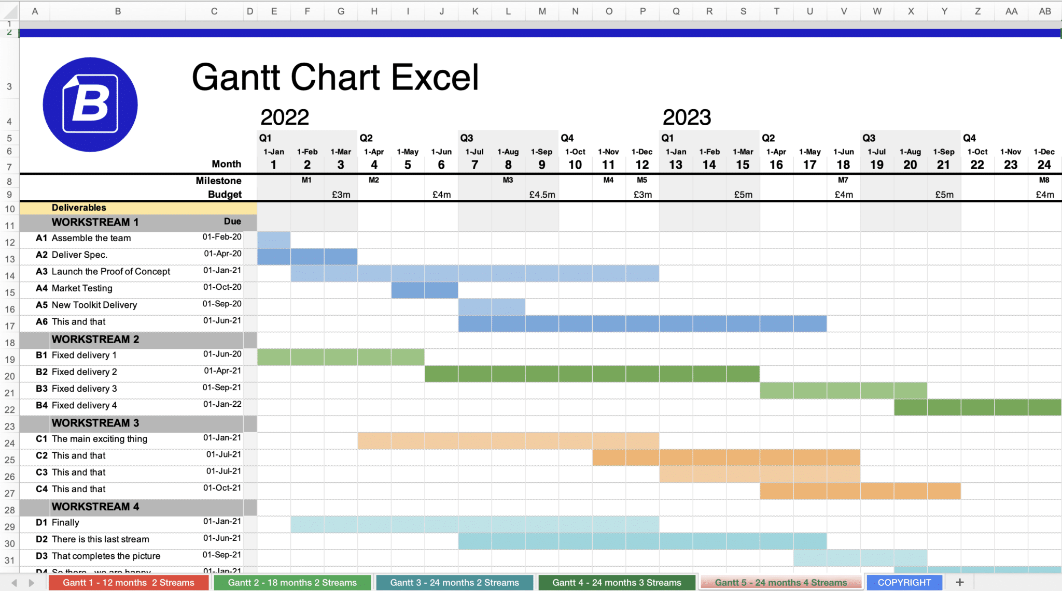
Figure 1- Gantt Chart Excel
(Documents, 2021)

Project Management Areas
The Project Management Institute defined that there are 10 project management areas that should be considered when a project is undertaken.
The PMBoK is considered to be the bible to the Project Management Institute, due to how it standardizes the approach to project management, through this approach it allows there to be a good chance of success when running a project.

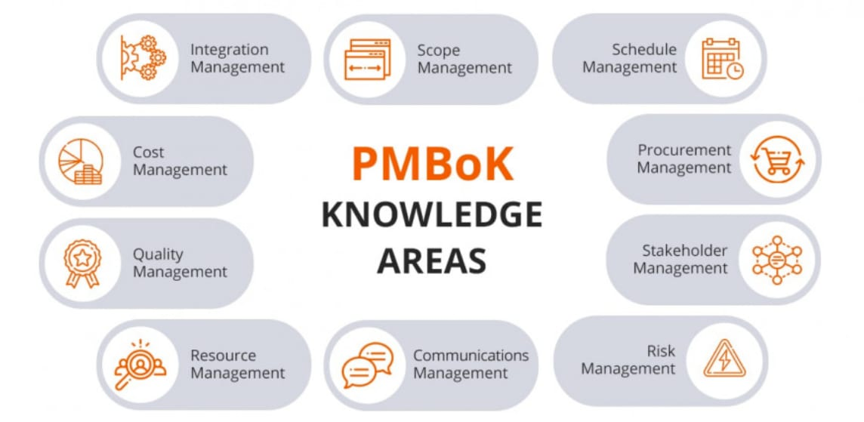
Figure 2 - The Project Management Institute Knowledge Areas for Project Management (Hakoune, 2023)

From my first assignment I carried out careful research into the pros and cons of 3 methodologies, Lean, Agile & Waterfall, and considered if I would look at taking elements from each of them to form a different methodology or whether in fact, I thought that one fitted the organisation that I work in.

Planning & Designing Process
I did acknowledge that if I were to work in a different department for example in Digital Services, my approach may need to be different as the outcomes /expectancies, budgets, and flexibility is different.
I opted to use the Agile method to form within the organisation I work in on the various projects and events that I work on. This was due to the flexibility that was involved with the various areas on project management. I believe this is the best method for the work I am involved in however I would consider that one of the other / or a combination of the 3 might work if I worked in a different department within the organisation as the nature of the project outcomes would be different.
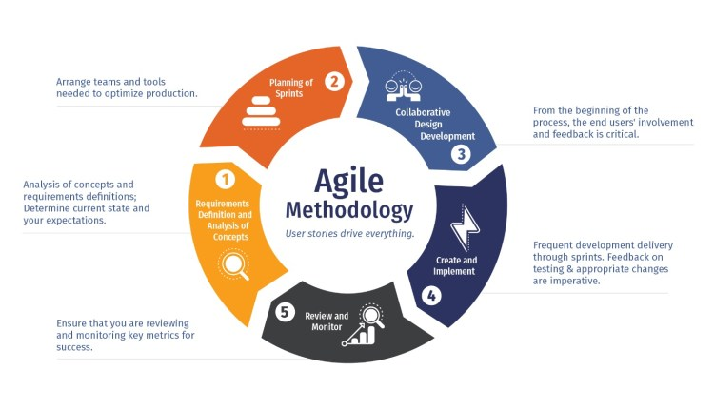
Figure 3- Agile methodology
A key element to also consider is the culture of the organisation, in the organisation I work in we strive to be innovative and promote a culture where people can be expressive and where ideas do not need to be predictable. Agile methodologies align well with this culture, waterfall is more geared towards a cultural of formal processes and predictability. Lean I feel lends more towards a manufacturing organisation as the continuous revision to eliminate waste would be best suited in the food and drink industry or the automotive sector.

Planning and Designing a Project Plan

I recently worked on a project which involved both internal and external stakeholders, the nature of the project was to deliver a 3-day conference to UK & international delegates around the area a specific area of common interest.
The project was already underway when I became involved and a lot of the delegation of key roles had been assigned, as well as what each person had as a responsibility.
My involvement came about due to a link to another project that one of the delegates was going to be engaging with us over, and for this reason we needed a representative to ensure that their needs were met when attending the conference. Whilst attending the conference the delegates would be giving a keynote speech and attending a company visit with ourselves.
Ahead of the delegate attending the conference, I was involved with organising visas, and hotel bookings, and then closer to the arrival, arranging for collection from the airport, ensuring that I communicated with the conference committee to avoid duplication of tasks.
When organising the days when the delegate would speak this needed to be changed a number of times, due to changes in the programme which happened as a result of key speakers dropping out at short notice. This is where Agile methodology works best as it is flexible and allows for these changes to be made quickly and effectively.

Key Factors in Project Management

- Quality
- Scope
- Time/schedule
- Budget/cost

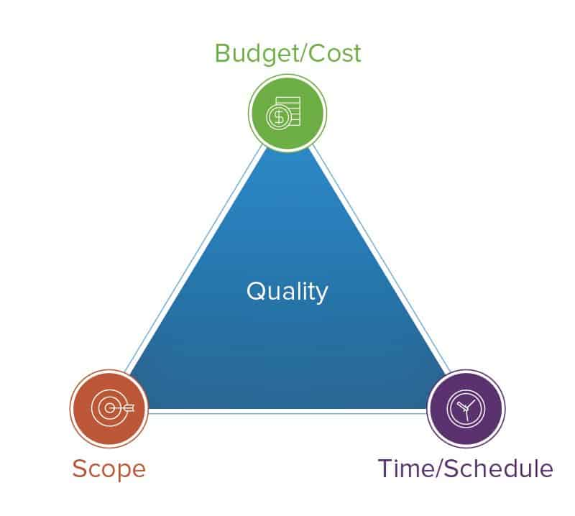
Figure 4 - Project Triangle
(Smartsheet, 2023)
Before even starting to look at the project management process, I would first assess whether the project can be achieved using all 4 elements of the triangle. All these elements are significant and have a large impact on the planning of a project.
Budget – If there will not be adequate budget for the project or movement in the available budget, then this could mean that the project should not be considered from the offset.
Scope – This is susceptible to change and as such there should be flexibility to be able to make changes.
Time/schedule – If the project has a set timeframe to keep to, then capacity of the team available to take on the project needs to be considered before proceeding.
Quality – Can the quality that is expected be delivered within the capability of the team or are the people available to support the team to be able to achieve the desired outcomes.

Once all the elements of the triangle have been considered and if the project seems viable, then the project management process can start to be implemented.
Project Management
I have recently worked on a large project (Project A) which was funded through Welsh Government, the value of this project was £300,000. The project was to successfully produce reports that show how a company could become more productive and achieve greater output based on becoming more digital. Each company would have a report produced and this would impact on future funding opportunities for the company but could also have an impact on how they conduct daily business.
The reports each had a value to them, and would be submitted to Welsh Government and on approval an invoice could be issued from ourselves which paid for this report.
As part of the process, we had to tender for the project, setting out clearly how we would approach it and ensuring that we covered all the key criteria they had stipulated.
We were successful in this tender, the funding would not be issued until completion of reports and authorised by Welsh Government, this presents an element of risk with the project from my experience, as work will be completed, but there may not be a successful outcome.
I was not involved in the initial stages of this process and as a project manager, I feel that was detrimental, as there were a few key elements that were missed on the project planning stage, that as an experienced project manage, I would have had the chance to bring up and change.
I am going to look at each stage of the project and evaluate the actual outcomes and what I would have done differently to have made it a more viable project.

Stages of the Project Management process

(Kissflow.Inc, 2023)
Project Initiation
I am going to look at the process that happened when the project was started, and what I would have done differently to have made the project more achievable.
When the project tender was written, there had not been careful consideration to the team that would be undertaking the work, this is a key element of the project initiation process, this allows a project manager to assess if they have the necessary team to be able to deliver the project.
It also allows for the risks and issues to be identified early on, this was not carried out and as such, the project has run over, and the people’s capacity to support the project has changed due to new projects commencing. There was no allowance with the tolerances for an over run on the project, which has meant that people are now committed to other projects, which leaves a skeletal team to complete the project.
At the start of the process, I would have looked at the team as a while, and identified those people that may end up with new commitments towards the end of the project – on this project we had academic staff so when September has come round, they have teaching commitments. I would have also produced a PID.
The level of detail and involvement with the companies meant that capacity for people to visit companies on multiple occasions was also not taken into consideration, and as such external people were brought in, however they had not been factored into the costing element of the tender, and the required paying on their completion of the reports.
Planning & Designing
In this stage I would look at the various elements of the project and in a planning capacity, plan who would take on each task, and ensure that the right people are put onto the project and how long those tasks are likely to take. I would look to allow for potential to run over, by assessing the risks and issues that might affect either the company involved or actual project.
There are key elements that must be considered as the majority of the companies I would be working with would be manufacturing companies, and I would need to allow for shutdowns that happen as part of their scheduling.
I would need to allow for if there is a change in management/personnel that I may be dealing with at the company.
In turn I would need to ensure that the personal within the team, both have the capacity but are also the capability to successfully deliver the project.
I would want to ensure that the budget was going to cover the work that would be required for the project, and that I had factored in a buffer for if we needed to pay for items such as equipment/travel expenses.
Project A was not planned in this way, and multiple project managers were not brought in until midway through the project, which made it difficult when trying to implement some of these processes.
In future projects I would like to have a project schedule in place, that identifies specific times that elements are due, and these can then be tracked.
Execution Process
To pull the project back, I took charge of the team, and created a process if using teams to house all the documentation. People had access to certain areas, and areas such as finances were restricted to management only. People could submit their reports to the group under the correct headers, this also allowed for other people to add additional work to them. They were also categorised so people knew the stage the reports were out, without the need for lengthy meetings and emails, that could be missed.
I worked with another Project manager who was able to bring the technical element to the project management which had previously been over seen.
Together we successfully achieved a large quantity of completion and payment of the reports and continue to work on the project. We started out with weekly management meetings, where we brought all team members into the meetings, to provide updates and progress on the project. In the latter stages of the project, we have been able to extend these to fortnightly.

Monitoring & Controlling
To evaluate the success of the project as it evolves, following our team meetings we have a regular management meeting, to ensure any risks/issues are identified and dealt with in a timely manner.
In these meetings we discuss the progress being made on the project, and the spend to date, and forecast the coming weeks and what we expect to be submitting and claiming.
This element of the project has been very successfully and is something I would endeavour to get established early in the project, so that people understand the expectations of the management team and the project outcomes.

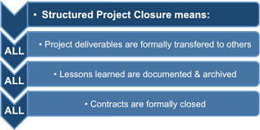
(Books, 2023)Figure 5 - Project Closure
Closure
Project A hasn’t ended yet, as an extension was requested due to issues with computer software, which prevented various tests being carried out. These tests formed a significant part of the report, and so we were not going to complete on time.
I have however recently closed another project in terms of paperwork and reporting to Welsh Government. This project was a collaborative project with another educational establishment and required a different focus when closing the project.
Throughout the project we had maintained regular monthly board meetings, to discuss the 5 work strands we were working on. Towards the end of the project however, it became harder to establish these meetings, and as such some were postponed, and some were cancelled all together.
Towards the end of the project the project manager for the other educational establishment went onto long term sick, and there was not a replacement to do that job. This proved very difficult as due to GDPR and data protection, I was unable to get access to certain parts of the project data and people were harder to arrange meetings with.

Conclusion
In conclusion when I am designing a project management process for the workplace,I will look to follow Agile methodologies. (Asana, 2023)
I must take into consideration the specific needs and requirements of the organisation.
The project management process should be tailored to promote effective communication, collaboration and that each team member is accountabile for their role within the project.
There should be clear strategies put in place to allow for risk management , allocation of resources and that the project can be completed in a timely manner.
The process should allow for flexibiilty to ensure that the project team can adjust to any changes or challenges they may face during the project.
If the project manageent process is designed well and followed, then it will enhance the orgnaisations efficiencys and productivity, thus allowng the team to complete more projects successfully.

Bibliog (Anon., 2023) (Stepanov, 2023)raph (Stepanov, 2023)
Anon., 2023. Kissflow. [Online]
Available at: https://www.google.com/search?sca_esv=565694802&sxsrf=AM9HkKnAa2bLTzAUC4_HMnvw3i3aMx63lg:1694800420653&q=5+basics+phases+of+project+management&tbm=isch&source=lnms&sa=X&ved=2ahUKEwiazabIl62BAxX0T0EAHT8KCqMQ0pQJegQIEBAB&biw=1609&bih=967&dpr=1.5#imgrc=0e7ts
[Accessed 11 09 2023].
Asana, 2023. What is Project Design?. [Online]
Available at: https://asana.com/resources/project-design
[Accessed 09 11 2023`].
Books, F. M., 2023. Free Management Books. [Online]
Available at: http://www.free-management-ebooks.com/faqpm/processes-07.htm
[Accessed 13 09 2023`].
Documents, B., 2021. Business Documents. [Online]
Available at: https://business-docs.co.uk/blog/gantt-chart-excel/
[Accessed 13 09 2023].
Hakoune, R., 2023. Monday.com. [Online]
Available at: https://monday.com/blog/project-management/project-management-knowledge-areas/
[Accessed 09 09 2023].
Kissflow.Inc, 2023. KissFlow. [Online]
Available at: https://kissflow.com/project/five-phases-of-project-management/
[Accessed 11 09 2023].
Manager.com, P., 2023. Project Manager. [Online]
Available at: https://www.projectmanager.com/guides/project-management#:~:text=The%20project%20management%20process%20consists,cycle%20or%20the%20project%20lifecycle.
[Accessed 10 09 2023].
Smartsheet, 2023. Smartsheet - Triple Constraint Triangle Theory. [Online]
Available at: https://www.smartsheet.com/triple-constraint-triangle-theory
[Accessed 10 09 2023].
Stepanov, A., 2023. Gantt Pro. [Online]
Available at: https://www.google.com/search?sca_esv=565694802&sxsrf=AM9HkKkygIyPq9s444oDMl1aydoSQOlnyg:1694800541276&q=gantt+pro+lean+project+principles&tbm=isch&source=lnms&sa=X&ved=2ahUKEwjx_uiBmK2BAxWDQEEAHXrNDqMQ0pQJegQICBAB&biw=1609&bih=967&dpr=1.5#imgrc=vcRIHvBqQ
[Accessed 11 09 2023].

