Developing Workplace Critical Thinking
(BMSK5001_LON)
Module Lecturer’s Name: Dr Husam Helmi
STUDENT NAME: Faisal Ahmed Rana
STUDENT ID:1604528

Table of Contents
Introduction 1
About Nestle 2
My Role at Nestle 2
Definition of Beliefs, Attitudes and Values 3
The Difference and Link Between Beliefs, Attitudes and Values 4
Management Theories Relevant to My Role 6
Critical Assessment of own Beliefs, Attitudes and Values on a Particular Management Theory 7
Contingency theory 7
The Reason to Select a Particular Theorist 9
Critically Assess the Impact of Beliefs, Attitudes and Values on Own Workplace Behaviour. 10
Human Relation Theory 12
How Human Relation Theory Supports the Beliefs, Values, and Attitudes at Nestle 13
The Impact of Workplace Attitude 14
Range of Management Theories 15
Fayol’s management theory 15
System theory 16
Behavioural theory 16
Theory X and theory Y 17
MBO 18
Conclusion 19
Reference 20

List of figures
Figure 1 Difference between Belief, value and attitude 4
Figure 2 link between Belief, value, attitude and behaviour 5
Figure 3 Feidler Contingency model 7
Figure 4 Fayol's management theory 15
Figure 5 Difference between Theory X and Y 17

Introduction
Nestle workplace is suitable for innovating new thing and idea which will help to grow business across the globe. The critical thinking in the workplace helps to understand the role of employee, impact of individual culture, belief and attitude in the workplace. This report is made based on research about value and belief of individual in Nestle. Nestle consider individuals culture and operate their business according to this concept. They localise their product and train employee based on culture, belief and value of society. Here, the impact of belief, value and culture has been analysed critically. Contingency theory, human relation theory, Fayol’s, management theory, system theory, MBO, behavioural theory, theory X and Y also has been discussed here.

About Nestle
Nestle was established in 1905 as a food processing company in Switzerland. The world leading organisation which provide baby food, coffee & tea, ice cream, pet food, dairy products, medical food, snacks etc. Ross (2017) mentioned that Nestle has 447 factories and 339,000 employees. It operates its business in 194 different countries. The purpose of this company is enhancing the quality of life by helping people and raising awareness about life. They inspire people living healthy life contributing to society which ensures the long-term success. The value of this organisation reflects that they always act honestly and legally with their own people who are related to their business.

My Role at Nestle
As a general manager of HR department of Nestle world leading organisation, different management theories have to consider performing the role efficiently. I am responsible for planning and decision making for the employee and organisation. I implement the business planning through several stages. The strategies, improvement of the development program, scheduling meeting, providing guidance, motivating, staffing, performance evaluation etc. are the responsibility of mine at Nestle. I ensure the policies and procedures of the organisation that need to maintain by subordinates. I measure the performance of the employee and ensure customer satisfaction. I also work as a leader and delegate employee to achieve the goal. I have to interact with the customer, seniors, supervisors, worker and third parties of my company to make any deal. Sometimes I have to interact with the legal person to ensure the legal document for the organisation.

Definition of Beliefs, Attitudes and Values
People from the world have different nature and attitude and behaviour toward other people or things. The belief, attitude and values have an effect on an individual’s behaviour.

Attitude: Attitude defines a person reaction toward other person or objects, also like and dislikes a place or person. Attitude is changeable and can change frequently, discussed by Berg (2012). The negative and positive attitude has an impact on the workplace, also in the organisation goal achievement.

Values: This is the core concept about good or bad things what people feel. The value of an individual makes what he is. The value lets people consider about right or wrong things which can be decided by research. This is in the centre of individual self-image which cannot change easily.

Belief: This is the ideas that people experienced from past experience or influenced by religion, social norms etc. Belief does not form based on logic but can be influenced by political, religious and economic issue. This is changeable based on time and strong evidence.

The Difference and Link between Beliefs, Attitudes and Values
The beliefs, value of individual has impact on workplace attitude and performance. They are different but link to each other in human life.

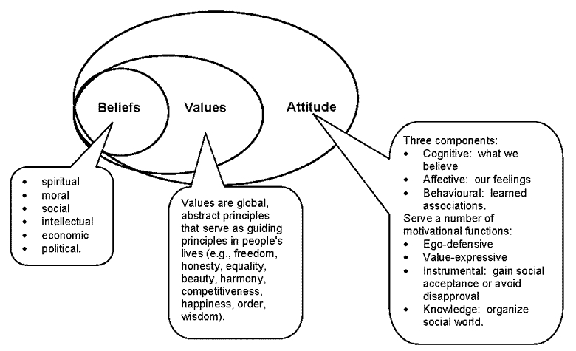
Figure 1 Difference between Belief, value and attitude
Source: Andersson et al. (2017)
The belief of an employee is not based on learning knowledge or physical experience. They constitute with religious ritual or past experience that we accept as a good for our life. Sometimes, seniors of the organisation guide and advice regarding what employee should believe, think and follow. Because of these questions of belief, the employee suffers some problem as conflict and harmony.

Value of a people within an organisation refers to the sense of right and wrong, discussed by Bolognani (2012). It influences to take decision while performing responsibilities and duties. Whether the decision is taking right or wrong will govern by the morality of human life. The daily life changes depending on values and it governs the action. The employees moral and ethics influence to take action toward competitors. An employee from a judicious and democratic society, the social norms of them is an integral part of their value.

Attitude is an action that defines how we react to another person within the organisation. The attitude of an employee comes from the subconscious mind that has been formed over many years, elaborated by Beckford (2016). It is also known as the nature of a person which influences them to like a person or dislike others. For instance, some British employee may not like Japanese culture, belief, and some may like their greetings and attitude. Attitude can be changed based on different location, society believes, organisational environment and time. There is three component of attitude as cognitive that we believe, effective that we feel and behavioural that we make associations with the team.
The belief, value and attitude are linked with each other and influence to form the behaviour of an employee.
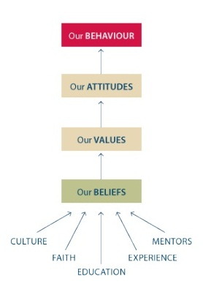
Figure 2 link between Belief, value, attitude and behaviour
Source: Bertalanffy (2015)
In figure 2, there has been shown the link between employee beliefs to behaviour. The belief in an employee constitutes based on their culture, religion, experience and faith. Value is the core concept of the employee which allows thinking about good or bad for life. Value of a person influence or give restrictions regarding how to interact with other person and show the behaviours. The attitude comes from the value and belief of a person. According to Ghofar (2016), attitude is changeable where belief needs a long time to change. The behaviour reflects the personality, culture and norms of an employee. For instance, a manager has freedom in his work to make a decision and guide to the employee. The employee has believed in effective communication that he experienced from past job. While making a decision, the values are influencing to think about the effective communication with the employee.
The general manager communicates effectively with the employee so that the decision and guidance can be efficient, discussed by Berg (2012). He is supporting employees with his behaviour as making a good relation, friendly speaking and body language etc. If the manager beliefs allowed him to show a different attitude as a boss, he might behave with employee differently. So, the belief and value influence to behave with other employee and show the attitude as they are linking together.

Management Theories Relevant to My Role
To manage all these business operations, the general manager has to practice some management theories. These theories assist to contribute the manager role and manage subordinates effectively. Contingency theory argues that manager should take action depending on the particular situation and this considers as the best approach for management, defined by Cook et al. (2014). The system theory considers the organisation as a whole which focuses only on one side as a task or people. This theory allows thinking systematically and making a mathematical decision. Through practising the behavioural theory, the general manager can motivate employee analysing their behaviour. As the different employee comes with different culture, motivating them analysing their culture and value is necessary.

The behavioural theory considers the employee behave within the workplace, based on which that manager can take the strategy of motivation. This theory also practised by the manager. Theory X refer that employees are unmotivated and dislike the work, discussed by Campling (2008). They give punishment and rewards to the employee to make sure that the task is completed. The Y manager views the employee as a resource and thinks that an open communication and collaborative work can motivate the employee to develop their skill.

Fayol’s theory which defined five functions of manager in the workplace as planning, organisation, coordination, commanding and controlling, elaborated by Carrington et al (2010). A manager is responsible to contribute his role for the organisation. MBO is another approach of management which allows improving organisation’s performance with the agreed objective. This theory helps to work on SMART objectives that build a good relation among employee. The manager typically focuses on human relationships while leading employee. A general manager has to perform several business operations to achieve the objectives of the organisation.

Every management theory and leadership theory that has been referring to in the above, are needed to practise by a general manager. Through practising these theories, he can motivate an employee, set objectives, perform the organisation’s functions, making a decision based on the situation, maintain the standard system in several departments etc.

Critical Assessment of own Beliefs, Attitudes and Values on a Particular Management Theory
The general manager of Nestle is from a collectivist society who has the ability of high context communicator. He was trainee before becoming a general manager which gave lots of experience about work. According to Drucker et al (2008), the social norms and culture of the manager help to manage the organisation and employee. The personal value of the manager helped to identify the goods and bad things while interacting with other and works. The attitude within the organisation was the result of the manager’s personal value and belief. These issues influenced him to adopt management theory to operate the organisation. The management and leadership theory relevant to a general manager role is given below-

Contingency theory
The culture of general manager allows accepting the uncertainty of the workplace and makes a decision based on the situation. That’s why he adopted contingency theory to manage people. The goal of the organisation is different and the manager has to decide that whether he will be task oriented or relationship oriented.
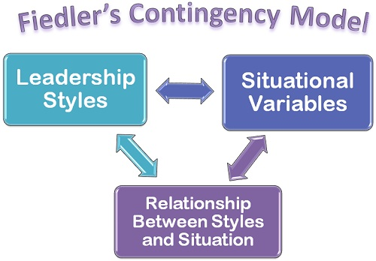
Figure 3 Feidler Contingency model
Source: (Korzynski, 2013)
He adopts a leadership style for the subordinates based on the situation. It helps to manage any situation between the organisation and employee. In this case, the manager has to work identified which leadership style is appropriate for which situation and it evokes critical thinking.
For example, there was a situation on the team as the employee cannot communicate with each other effectively because of cultural difference. The general manager believes that the proper communication is important for teamwork and he showing his attitude to make good relation among members. Practising contingency model, he was able to handle the situation. This model gives him the flexibility of using any leadership style to any situation. But he was in hesitation to decide the leadership style for all members.

This leadership style has disadvantages too as is creates confusion choosing the style. General Manager comes from a different region and country with different belief and attitude that have to work in others culture and employee, elaborated by Hitt (2011). Maybe what manager belief and showing his attitude is not acceptable by subordinates. As the culture of the employee is different, the leadership style for all has to be different. This becomes a challenge for the manager to motivate and satisfying employee by manager behaviour.

The Reason to Select a Particular Theorist
These theories were selected because it covers the whole business operation and provides a guide for managing the human resource of the organisation. Practising several theories by one manager, the organisational activities are performing well by the general manager. The most important theory that is needed to manage the HR in Nestle is contingency theory. McGeorge (2010) defined that contingency theory help manager to make a decision based on the situation being task or relationship oriented. The manager can use a management approach based on employee culture, value, belief and behaviour.
The GM actions depend on the situation and this can increase the performance of the organisation, discussed by Ross (2017). This theory can be followed by three perspectives as human, technology and task oriented. Based on the relationship and task, contingency theory allows taking steps by GM. As the general manager is Asian, he has the ability to communicate with other people and taking the risk. Each situation can be unique and Asian employee accepts the uncertainty and risk. Andersson et al. (2017) discussed that the choosing of leadership and techniques depend on the situation. This has a flexible theory where an HR manager can take the decision independently. As a general manager of Nestle, it was much important to manage employee through practising this theory.
This leadership style has disadvantages too as is creates confusion choosing the style. General Manager comes from a different region and country with different belief and attitude that have to work in others culture and employee. Maybe what manager belief and showing his attitude is not acceptable by subordinates. Berg (2012) mentioned that ss the culture of the employee is different, the leadership style for all has to be different. This becomes a challenge for the manager to motivate and satisfying employee by manager behaviour.

Critically Assess the Impact of Beliefs, Attitudes and Values on Own Workplace Behaviour.
Nestle has own organisational culture which the employees have to maintain in business life. The people of Nestle believe that the organisation has the capacity of Woking as world leading company. The employee belief for Nestle is about the mission and philosophy of the organisation. They become involved with successful activities for the organisation and people contributing their role for the organisational success. Bolognani (2012) mentioned that as Nestle is a food processing organisation, most of the employee is related to the manufacturing sector. The employee belief is, the organisation can make a sustainable position in global and they are working toward this belief.

The value system of Nestle considers the morals issue and ethics for the customer, competitors and employee. Beckford (2016) mentioned that Nestle is working in the global market with integrity avoiding corruption. The employee keeps an accurate record and accounting for the organisation. They report about the performance and lacking exactly to their seniors. The organisation also provides gift and hospitality to the customer, reward to the employee and third parties. They protect the intellectual property and assets. Nestle values influence to avoid conflict and treating fairly to others. The organisation provides a healthy environment and safety workplace to the employee, discussed by Bertalanffy (2015). The organisation is responsible for fair marketing and business policy while competing with competitors. The organisation maintains regulation of the government and performs their responsibility toward local people. The organisation also innovate new food processing and make people live better.

The employee of Nestle comes from a different region and their culture also different. The attitude of the employee is different but the core value of Nestle shapes human behaviour, discussed by Ghofar (2016). Nestle manager think that the task can be done by participating employee actively. The new idea can be generated by employee and manager should establish an effective system of communication. The organisation is showing a positive attitude toward employee from the beginning of the company. The value of the organisation focus on the customer needs considering the trend. Nestle producing the food for consumer analysing their test and needs. The need of the customer is changing and organisation is producing new food to fulfil the demand.

The organisation collect feedback and review of food test to produce the food. The manager is the leader of Nestle and the organisation has the positive attitude toward the manager. The organisation makes sure that the manager does not suffer from the workload. The organisation use decentralises management in the different region. The manager cooperates with other employee and supervises them to complete the task. Nestle make positive attitude in a workplace situation like it provide health and safety workplace for the employee, elaborated by Cook et al. (2014). The security of the workplace is upgraded. The organisation focuses on continuous improvement and need of employee for better work.
The corporate culture of the organisation makes changes in attitude, value and belief of employee in Nestle.

Human Relation Theory
Elton Mayo developed the human relation theory which defines that increasing attention to worker will motivate them and build a good relationship. He identified that most influencing factor to motivate an employee is a relationship and this can also increase productivity. Because of good relationship and support from the team, the team work becomes successful. From the research and analyses of this theory, Mayo found that individual of the organisation want separate attention and want to be treated from manager and organisation is a distinct way. Employee wants to fulfil their need by the organisation to achieve the given goal, discussed by Campling (2008). According to this theory, the worker does want money as the reward but they want attention which can increase their satisfaction level. The informal group of the organisation are expected to give better performance than formal groups. The manager of the organisation has to consider the need of employee as social belongingness and treat the employee with a formal way. Using this theory organisation can complete the task in a sort time that other theory. Through developing employee relation, an organisation can get success.

How Human Relation Theory Supports the Beliefs, Values, and Attitudes at Nestle
This theory focuses on relationship and independence of employee within the organisation that the manager has to consider. The workers are the resources of Nestle that need for organisational growth. The positive attitude of the manager can motivate and influence employee for better performance, mentioned by Carrington et al. (2010). The manager has to encourage employee while decision making and generating an idea. Nestle believes in collective growth and impact on the good relationship with an employee. They provide their service based on local culture building the good relationship with the employee. So, human relation theory is appropriate for Nestle business growth. Nestle use this theory too-

Evaluate employee need: understanding the need of employee is important for Nestle and the organisation is emphasising on it. Because fulfilling employee need, can motivate them to complete the organisational task. Nestle motivate employee through financial and non-financial rewarding process. According to Drucker et al (2008), good relation with employee helps to discuss individual need. The need can be for finance or recognition in society. It the manager focus on the individual need of employee, proper motivational strategy can be applied.

Idea generation and skill improvement: while motivating employee and fulfil the need of the employee, the employee gets satisfaction from the organisation. This assists to generate ideas and improve their skill. For instance, the employee from the sales department wants social recognition and his skill is higher than the post. Here, the manager should give promotion to that employee and this will make him satisfaction form his work. From that satisfaction, he can generate a unique idea and opportunity to develop their skill.

Teamwork: The human relation theory focuses on relationship building and increases the productivity. Using this theory, the manager can motivate an employee for effective teamwork. According to McGeorge (2010), Nestle emphases on employee performance and relationship building. The organisation produces different types of product for global. The organisation ensures the policies and regulation for the employee. The employee feels better and works with independent while contributing decisions making. The human relation theory support organisations belief, value and attitude of Nestle which ensure the employee's performance and organisations objectives.

The Impact of Workplace Attitude
The belief, personal and social value of a manager has an impact on workplace attitude. The manager attitude in the workplace can define many things about the business operational situation and the ability of the manager. The workplace attitude can arise and minimise employee conflict, mentioned by Andersson et al. (2017). The HR general manager should not mix up with personal and business life. The belief and value influence to choose the leadership style and attitude set the behaviour with others. The attitude of the manager reflects whether he is bad or good for the organisation. A positive attitude can create a positive environment for the employee where a negative attitude makes conflict at work. If the manager shows a positive attitude in the workplace, the employee becomes self-motivated. It increases the productivity and teamwork, also the ability to think creatively.

The positive attitude improves the morality which reduces turnover. The employee shares information with others and tries to invent new ideas. The negative attitude can create a critical situation within the organisation and among employee, discussed by Bolognani (2012). It creates hesitation and a bad relationship with an employee. The negative attitude in the workplace reduces product and service quality. If the general manager shows a negative attitude with relevant people of the organisation, it reduces customer engagement. The performance of an employee reduces, also the willingness to invent new ideas. The bad relationship with an employee does not allow working collaboratively. It’s become difficult to overcome an obstacle that leads to depressive feelings. However, it can be said that the positive workplace attitude has a great impact on organisational success.

Range of Management Theories
The HR general manager had to plan for the organisation and implement strategies for business growth. He makes report to seniors about employee and ensured their performance with the delegation. He had to contact many people in the organisation as a supervisor, manager, customer, worker and third parties to deal with. He provides direction to the employee to ensure product quality and service. Practising theory, he hired an employee, trained them and developed their skill to give service to the customer. He is engaged with the corporate officer in strategic planning. The management theories that are relevant to my role is critically discussed below-

Fayol’s management theory
The GM practise the Fayol’s management theory as he has to plan for the organisation. He believes that plan, organising, coordinating, commanding and controlling are the responsibilities of him. He does all the right things for the organisation and employee. His behaviour toward employee is friendly but strict. The social norm and culture influence the manager to do his responsibilities well, elaborated by Gilbreth (2008). He believes that performing responsibilities well can bring the organisation and person’s success. He plans for the organisation and organises resources well. The subordinated get motivation form him as the general manager delegate employee giving direction. He performs his responsibilities by coordinating all the resource and controlling the employee performance.
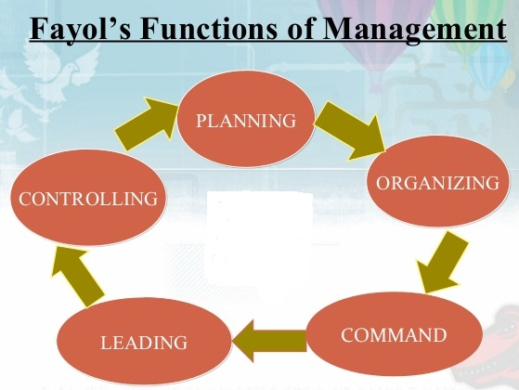
Figure 4 Fayol's management theory
Source: (Drillings el at. 2012)
Fayol’s theory is indicating the manager role within an organisation. For instance, the general manager plans for human resources as staffing, training and requiring them. For this purpose, he gathers all the resources regarding employee skill development and delegates them to improve their performance. He has the power to control and evaluate the employee performance for the organisation. This theory has disadvantages too as every human has the limitation of thinking and physical power. One people cannot be a master of several sides that the general manager has to do. He always remains under lots of pressure and he is responsible for organisation failure.

System theory
The theory is using to perform manager leader role is system theory. This theory helps to adapt the external changes within the organisation. The general manager focuses on the individual goal, also organisational goals. According to Evans (2016), system theory assists to have a mathematical calculation of performance and working as task-oriented to achieve the objectives. The theory is adaptive and focuses on multiple dimensions. The manager makes a decision considering the macro and microenvironment. For instance, Nestle wants to achieve a goal of increasing the sells by 10 per cent. Here, the general manager considers the micro and macro environment to use strategy for increasing sells. He coordinates assets, resource, human resources and equipment counting as a whole.
The individual goal and organisational goal is same while practising this theory. This theory also has some disadvantages as it may not work as practical always and the decision making takes a long time. If the inner relation of an employee does not classify properly, the approach will be productive. This is not applicable for the large organisation and counts as complex. But this theory was adopted by the manager for short-term project goal. It was appropriate to achieve this short-term goal.

Behavioural theory
The behavioural theory considers performance within an organisation, not focusing on individual behaviour. The general manager believes that human relation improvement can achieve the goal of the organisation. The manager view of the different situation of work is complex while practising this theory. The personal value of manager influence to count employee as human but he cannot treat employee considering his norms and values, elaborated by Satinoff (2014). He only focuses on a group or individual performance. Here, the relationship of groups affects by each employee’s cultural belief and social belief. The Nestle general manager uses a behavioural approach to attain objectives emphasis on performance of group or individual.
For instance, the manager does not show sympathy to the employee because of illness and force him to give better performance. Another example, employee work in a team and the manager just focus on the teamwork result not the strong relationship among members. This theory has advantages as a manager can complete the task through the teamwork of employee within the period. This theory also has disadvantages as the conflict can arise among the member and dissatisfaction is the common things in this theory practising.

Theory X and theory Y
This theory allows the general manager to motivate employee with their own belief and values. X theorist manager believes that an employee is unmotivated naturally and do not like to work, elaborated by Herzberg (2017). So, the general manager considers punishment as a reward to motivate employee and complete the task. His beliefs and view toward subordinates are, the employee avoids responsibilities and they need to control. They should supervise in all activities as they have no ambition.
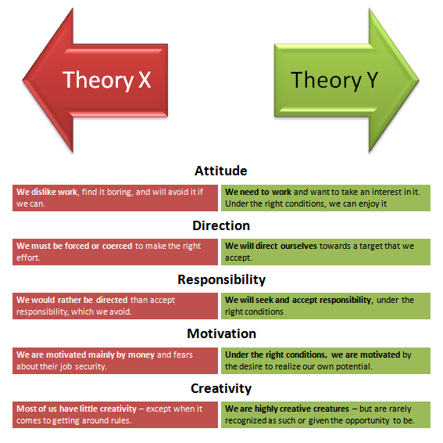
Figure 5 Difference between Theory X and Y
Source: (Gilbreth, 2008)
Theory Y manager tends to believe that his employees are self-motivated toward work seek responsibilities, discussed by Drillings el at. (2012). The employees are satisfied with their work and involvement in decision making. They like to take challenges and solve any problem creatively. They just need little direction and motivation. So, the manager motivates and gives proper direction to his employee. The general manager of Nestle tends to act like theory Y because the subordinates are interested in their work and achieve the new goal. For instance, while the performance of employee decreases, the manager motivate theme and give redirection to improve. He ranks employee based on performance and gives the award which motivates the employee to perform better.

MBO
The general manager manages organisation and employee by objectives as like the employee will perform on the same objectives as the organisation has. The same objectives bring together all employees and achieving this all member of the team has to make good relation with each other. Herzberg (2017) discussed, the general manager believes that working under the same objectives can make good relation and give better output. So, he influences team members to work in one objective and emphases on effective communication.
For example, the manager gives the same objective believing in collaborative work. He allocates different task between team members so that they can achieve the objectives collaboratively. The objective was increasing sales but the task for each member was different. So, they worked on a shared goal and performed better. The disadvantage of this approach is controlling and solving conflict among member. As the members are working is the same objectives even if their belief and attitude are different, these can raise conflict easily. According to Satinoff (2014), the organisational goal becomes the personal goal and employee ignores each other to achieve their own goal.

These theorists have a particular impact on manager role which provides guidance to the general manager. This theory helped to realise the actual responsibilities of him and that’s why he practised this theory while working in with Nestle. Each theory describes particular role and responsibility of HR manager. Practising these theories in the workplace helped to perform general manager role appropriately.

Conclusion
The role of the manager has a great impact on Nestle business growth and performance. The employee of the organisation believes that Nestle can make a sustainable position in the world and they are working for it. Considering the belief, value and attitude, Nestle can know the employee perception and motivation need. Through practising management and leadership theory, the organisation can know the employee need, using an appropriate leadership style etc. In this report, the individual and organisational value, belief and attitude have been discussed. The theory as Contingency theory, human relation theory, Fayol’s, management theory, system theory, MBO, behavioural theory, theory X and Y also has been discussed here.

Reference
Andersson, G., Carmen, R., Labra, I. and Richards, H. (2017). Organisation Workshop. Beyond the Workplace: Large Groups, Activity and the Shared Object. Mind, Culture, and Activity, 25(1), pp.86-99.
Berg, J. (2012). Direct belief. Berlin: De Gruyter Mouton.
Bolognani, M. (2012). Good culture, bad culture…no culture! The implications of culture in urban regeneration in Bradford, UK. Critical Social Policy, 32(4), pp.618-635.
Beckford, J. (2016). The intelligent organisation. London: Routledge.
Berg, J. (2012). Direct belief. Berlin: De Gruyter Mouton.
Bertalanffy, L. (2015). General system theory. New York: Braziller.
Cook, S. and Ma, Z. (2014). The interconnectedness between landowner knowledge, value, belief, attitude, and willingness to act: Policy implications for carbon sequestration on private rangelands. Journal of Environmental Management, 134, pp.90-99.
Campling, J. (2008). Management. Milton, Qld.: John Wiley & Sons Australia.
Teamwork. (2009). Ventura, Calif.: Regal.
Carrington, H. and Rabagliati, A. (2010). Vitality, fasting and nutrition. New York: Rebam Co.
Day, A. (2016). Religion and the individual. Abingdon, Oxon: Routledge.
Drucker, P. and Maciariello, J. (2008). Management. New York, NY: Collins.
Evans, P. (2016). Motivation. [Place of Publication Not Identified]: Psychology Press.
Ghofar, A. (2016). Corporate Governance and Contingency Theory. [Place of Publication Not Identified]: Springer International PU.
Gilbreth, L. (2008). The psychology of management. Charleston, SC: BiblioBazaar.
Herzberg, F. (2017). Motivation to work. [S.1]: Routledge.
Hitt, M. (2011). Relevance of strategic management theory and research for supply chain management. Journal of Supply Chain Management. 47(1).pp.9-13.
Korzynski, P. (2013). Employee motivation in new working environment. International Journal of Academic Research, 5(5), pp.184-188.
Management Insights. (2011). Production and Operations Management, 20(6), p.vii-ix.
McGeorge, C. (2010). Couples, Gender, and Power: Creating Change in Intimate Relationships. Journal of Family Theory & Review, 2(4), pp.428-431.
Nestle. (2007). The nestle water management report. Vevey, Sz.: Nestle.
O'Neil, J., Drillings, M. and O'Neil, H. (2012). Motivation. Hoboken: Taylor and Francis.
Ross, B. (2017). Psychology of Learning And Motivation. [S.L.]: Elsevier Academic Press.
Satinoff, E. (2014). Motivation. [Place of publication not identified]: Springer.

