Junior Richard (1605599)
Lecturer: Husam Helmi
DEveloping Critical thinking
BMSK5001

Contents
Introduction 2
Dixons background 2
Critical thinking 2
Beliefs, attitudes and values. 3
Differences between beliefs, attitudes and values. 3
Impact of beliefs, values and attitude on own workplace behaviour 4
Organization Structure 4
Management 8
Importance of management 9
Management style 10
SWOT analysis 12
PEST Analysis 12

Introduction
This report will develop an understanding of management within a workplace and critically analyse its processes. First and foremost the report will develop an understanding of critical thinking and how to apply it into management. In addition, by the use of diagrams and theoretical literature, management as well as its functions will be defined. The report intends to provide general information about management theories and by the means of research, it intends to pick a specific theory which is relevant to an organisation of chose and develop a critical understanding. Therefore, my organisation of chose would be Currys Pc World (CPW) and my role will be a Team Leader. Additionally, along with management theories, the report will take into consideration of its impact on beliefs, attitudes and values of the organisation. Moreover, this report will explain the importance of values, beliefs and attitudes within the workplace as well as the differences between each other. Additionally, by the use of academic research this assignment will show how management theories will impact my own behaviour, values, beliefs and attitudes as well as other perspectives. In this report I have been assigned to choose an organisation and by using academic literature I will be identifying management theories relevant to the role within the organisation of chose. This report will seek to provide evidence of critical assessment of my attitudes, values and beliefs towards a particular management theory. Using relevant research, I will look into providing a critical assessment of the impact of the relevant management theory relevant to my role and critically analysing how the management theory can help me develop within the workplace. The report will explain how my beliefs, attitudes and values will be impacted in the workplace and seek to ensure that a clear identification of a management theory relevant to my role.

Dixons background
CPW is part of an Dixons Carphone PLC and is considered Europe’s foremost professional electrical retailers. With over 1,300 stores and online presence, across 28 nations and employing 40,000 people. CPW’s European market position is a very strong one due to having well over 100 million customers shopping in-store and online every year. In the United Kingdom and Ireland, CPW have various retail brands which include Currys Pc World , Carphone Warehouse and Dixons. Dixons operates a multi-channel approach to electrical retailing, CPW offers customers a comprehensive range of after sales services (Dixons Carphone plc, 2018). Currys Pc World, before being takeover by Dixons Carphone were to separate stores being Currys and PC world. Firstly, Currys was first founded in Leicester back in 1884 by a gentleman named Henry Curry. As a partnership CPW first open as a store named H. Curry and Sons manufacturing and selling bicycles, motorbikes and accessories. As the company expanded by 1927 with over 130 shops throughout England, H. Curry and Sons ceased the sale of bicycle and motorbike accessories due to the takeover by Currys Limited (London Metropolitan Archives: City of London , 1995). In 1984, Dixons purchased Currys Group and launched their first Currys Superstore in Birmingham selling electrical goods (Dixons Carphone plc, 2018). On the other hand, Pc World was acquired by Dixons retail PLC in 2003 and in 2010 they first opened their 2 in 1 Currys and Pc world stores (Dixons Carphone plc, 2018).

Critical thinking
Critical thinking is now a very common tool of an organisations mission as well there outcome assessment. Critical thinking within the workplace is based on reason, rather than on emotion. Many organisations including CPW would not succeed unless they critically look at facts and data, so that they can use the information to make the choice consistent with their vision. According to Robert Sternberg, critical thinking is defined as “the mental processes, strategies, and representations people use to solve problems, make decisions, and learn concepts” (Shaw, 2014). Consequently, thinking critically within CPW’s workplace will give the capability to analyse an idea or concept objectively, bearing in mind the factual and opposing perceptions to reach a logical decision. Additionally, being a member of the management team will require me to be a critical thinker, this means being a open minded individual who tries to be knowledgeable of their surroundings; recognises conclusions, motives and assumptions; very well posed at judging the quality of an argument, including the appropriateness of its motives, assumptions and evidence. Also, being to be successful as a team leader would consist of me being a critically thinking individual who asks suitable clear questions and also would formulate credible theory and a plan. In addition, it would mean I would be able to draw conclusions when warranted with caution and weighs up all information in list when deciding the outcome of a situation.

Beliefs, attitudes and values.
This section will entail an explanation of the difference between beliefs, attitudes and values which I replicate to CPW as well as critically evaluating the influence of beliefs, values and attitudes on my own behaviour within CPW’s workplace. Beliefs, attitudes and values are significant to our daily lives as they have a tendency to shape our judgements, views and feelings about the surrounding around us.

Differences between beliefs, attitudes and values.
We as individuals have our own sets of beliefs, values and attitudes we follow that define who we are and how we perceive the world. In organisations as well as my own organisation, being in CPW as a member of the management team, you will need to be aware of staff and clients’ different beliefs, attitudes and values along with implementing professional values and not carry out your own interpretations to other members of staff or clients.
Beliefs remain to be the assumptions that those make about other individuals and also about how things are expected to be. Moreover, every individual have their own private beliefs that impact characteristics of their day-to-day life, for instance the way individuals dress, this can impacted or influenced by upbringing, religious and cultural beliefs.
Attitudes is the negative and positive feelings individuals have towards individuals, ideas or things, attitudes is the way individuals expresses or applies their beliefs and values by expressing though words and behaviour. Furthermore, attitudes are established ways of responding to others and situations, where our attitudes are manifested into our behaviour.
Values are how us as individuals ponder things have to be or how individuals should behave, particularly in terms of qualities for instance, trustworthiness, honesty and sincerity. Moreover, for individuals to develop critical thinking ought to have certain morale values, ethical behaviour and positive attitude towards work or colleagues to aid in decision making and logical reasoning.

Impact of beliefs, values and attitude on own workplace behaviour
As stated by Kolb's Learning Cycle (Cooper, 1975), it is not enough just to experience in order to learn, nevertheless it will be vital to reflect on the experience, use our knowledge and recognise new philosophies and perceptions, which can then be used to new situations one may encounter. Cooper also states that, without reflecting, an individual would simply carry on to repeat their mistakes (Cooper, 1975).
Individual’s beliefs come from many factors such as hearing, seeing, experiencing and also from what individuals read and think about. Moreover, from each of these factors, individuals will develop an judgement which they will hold to be true. Assumptions we make ourselves are beliefs and they are about others and how we assume things to be. Individuals have personal beliefs that influence everything they get up to on their daily lives, for instance, the way individuals dress, also by religious and social beliefs. Furthermore, individuals do not always agree with each other due to values, beliefs and attitudes. However, us as humans should critically think that it could be how other individuals have been bought up by relatives. Our beliefs derive from our values, which are either accurate or inaccurate when compared with evidence, nevertheless true to us.
In retail the customer service you provide, the way you interact with others reflects on your own attitudes, beliefs and values. For instance, I tend to treat the service users and employees as is if they are myself because of the values I have acquired from my childhood and I have faith in treating others as if you would want to be treated. A positive behaviour and attitude within the workplace, tend to come back positively, while not every single individual can be satisfied. In CPW , to work effectively it is very important for me to recognise own values, attitudes and beliefs. Furthermore, it is very critical for to understand the importance of not allowing my values, attitude and belief affect the I interact and work within the workplace. Being timeliness, independent, privacy and compassionate are values that are important to me to describe the way I live my life. These values give me a meaning to life and are the foundation of my beliefs, any decisions that I make in my role in CPW would be influenced by these values, also my actions and behaviour will impact the way I would choose to manage. Amongst the employees and customers within CPW workplace have a diverse collection of values with different degrees of importance given to each value. Within the workplace I may have to be conscious and aware of my values or I will have to hold my values subconsciously and act on them but not being consciously aware of them.

Organization Structure
Gibson, Ivancevich, Donnelly Jr and Konopaske (2003) quoted “The importance of structure as a source of influence is so widely accepted that some experts define the concept as those features of the organization that serve to control or distinguish its parts” (Awa, 2016). According to (Pugh & J, 1979) they define organizational structure as the roles, responsibilities, and the system of organisations like CPW’s operations and management structure. For instance, in CPW the management everyday would allocate duties to their peers and manage it by measuring their performance. Additionally, organisational structure governs the way information is passed within the workplace, this could be a top to down approach, bottoms up or on the same level (Pugh & J, 1979). There are various ways an organisation could be setup, so depending of CPW’s aims and objectives they have a specific structure which also determines the approach of CPW’s productivity.

Figure 1
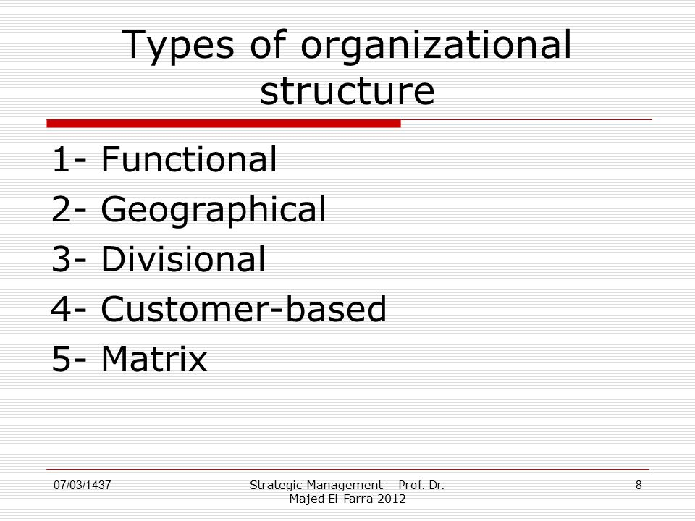
Source: (El-Farra, 2012)

Mainly there are four types of organizational structures (as shown in Figure 1), each of these structures bear their own advantages within the workplace as well as disadvantages. Cockindale (2011) said “Poor organizational design and structure results in a bewildering morass of contradictions: confusion within roles, a lack of coordination among functions, failure to share ideas, and slow decision making bring managers unnecessary complexity, stress and conflict” (Cockindale, 2011). This shows how important it is for organisations like CPW to able to use the appropriate structure, as it is pivotal to their productivity. Having the wrong structure with CPW can impact the way the organisation functions. Therefore, in this section this report plans to pick functional structure as this is relevant to CPW.

Figure 2
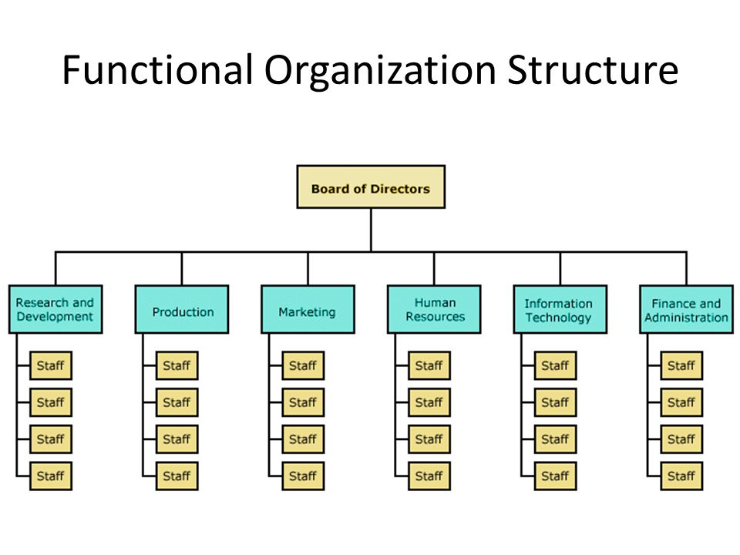
Functional organization is known as a hierarchical structure, whereby individuals are gathered in accordance with their area of expertise. Additionally, these individuals in there area of expertise are supervised by a manager with the same know how as them. For example, CPW Functional structure can be similarly seen in Figure 2 were it shows how staff are grouped into areas and my area as a team leader would be in human resources. Furthermore, because of my role inside the company, my expertise is to manage and lead the staff in one of CPW’s stores in London. CPW have many other departments such as the marketing, finance and production and they have their own dedicated functional manager who has the same expertise (Figure 2). This kind of structure helps managers efficiently utilize the member staffs skills which then eventually supports CPW in accomplishing its corporate objectives. This organizational structure classifies individuals according to role they perform within the organization. Figure 2 shows how each area in CPW has a manager that is accountable for the performance of his area. However, this also helps the organization control the performance quality as well as consistency. Griffin (2014), states that his type of structure will only work well within a stable setting because this structure is not designed for rapid change. He also believes that this structure is predominantly effective where there is slight changes in technology and competition mainly based on cost (Awa, 2016).

Figure 3
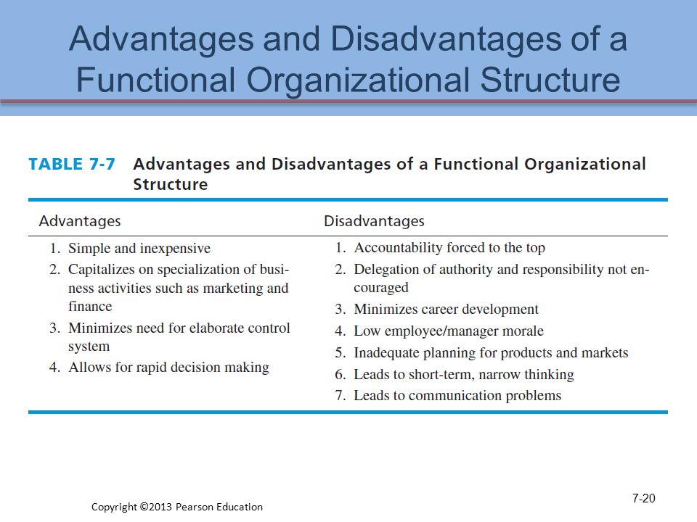
Source: (Pearson Education, 2013)
With some research Figure 3 shows the advantages and disadvantages of CPW’s structure. CPW’s structure has shown some advantages such as in our my department we have a group of individuals who are talented and skilled at sales and customer service, so this can helps me as a team leader to lead a group who already are motivated to sale and ultimately helps me increase performance. On the other hand the disadvantage of being a team leader is delegating responsibility to others as this is not encouraged by the organisation so this would mean being aware of an individual’s excellent skills may not be recognised as much within this type of workplace. Also another challenge is communication within the organisations as CPW find it difficult to communicate with other departments as other departments are believed to have a perception of competing against each other for resources and also because of a lack of understanding of the way the workplace works (Awa, 2016).

Management

Figure 4
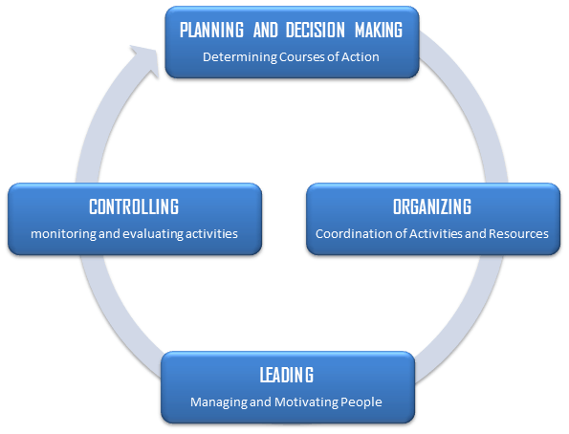Source: (El-Farra, 2012)
According to Laurie Mullins, the word management is a subject to various interpretations. There are a few concepts which attribute the meaning management and to what are a manager is suppose to work. Laurie also mentions “Drucker” views management as representing a function along with the individuals who discharge it, authority, social position, education field and also discipline. “Management is tasks. Management is a discipline. But management is also people. Every achievement of management is the achievement of a manager. Every failure is a failure of a manager” (Mullins, 2013). Management can be considered the science of accomplishing goals through individuals. As a team leader in CPW I would be seen as a supervisor so this can interpret management is “looking over”, for instance, giving individuals tasks and making sure they have been completed (Olum, 2004). Also management comes with four basic functions which are shown in Figure 4;
- Planning – setting CPW goals and making a decision on the best way to accomplish them.
- Organizing- defining how CPW’s actions and resources are gathered and coordinated.
- Leading – influencing CPW’s staff to work together with the best interest for CPW.
- Controlling – controlling CPW’s activities by measuring the results.
Moreover, managers do not always spent time on each function as they may vary. As I have Consequently, as I have found in CPW the higher levelled managers tend to spend more of their time planning and organizing than me who is at the lower level of management. However, leading alternatively takes most of my time as a team leader and with controlling according to Olum (2004) slightly varies between the different levels of management (Olum, 2004).

Importance of management
The road to an organisations success is to clearly be an effective manager and as a team leader I have been given authority and responsibility to take action on individuals to get the best contribution to the groups objectives. Managing a CPW’s workforce would be the team leaders obligation. However, CPW only can accomplish their objectives and aims only through the corresponding hard work of their members. For this to happen this would entail operative management of resourcing individuals. According to Mullins the entry point is to start being supportive and also encouraging wellbeing within the workplace with being good at people management and effective work organisation (Mullins, 2013). Mullins (2013) says providing good management is a very significant attribute of a productive workplace that has a high level of commitment and high employee attendance. It may perhaps be contended that most individuals who come into work with a basic attitude of eagerness to do a great job and also having the longing to perform to the best of their capabilities. Commonly individuals are known to answer in the way that they are being treated. So when performance within CPW fails to achieve its targets this is mostly a consequence of how employees see the way their being treated by me as a team leader or by higher ranked managers. Olum (2004) also states that problems that could arise in management team relationship with individuals within the workplace are not always from management actions or decisions but from the way these actions and decisions are processed. Additionally, Olum (2004) states management is a dynamic element in every organisation and an organisation like CPW being deprived of leadership would only result in resources remaining resources and not becoming production. Nowadays the management quality and performance determines the way the organisation survives and become successful (Olum, 2004).

Management style
These next few paragraphs will explain the management theories that I have identified to be relevant to my role, the impact of attitudes, beliefs and values on these theories and other individuals perception of different beliefs, attitudes and values. Management theories could form the basis of a successful business and leaders in every kind of establishment can acquire knowledge from well-founded management perceptions. In designing an effective organisation structure, beliefs and values of the organisation must be considered. Moreover, management theories are applied to aid in the growth of organizational output and the quality of service. Countless managers not only use a particular concept when applying plans in the work. Supervisors would use a mixture of different theories such as, contingency theory, chaos theory and system theory as they are the most common management theories, but will only be used depending on the purpose and workplace (Mcnamara, 2014).
An organisations success expressively hinges on its management and theories implemented to effectively handle different aspects. Management has remained around for many years nonetheless has been applied in diverse manners. Management has progressed in the method of management theories which were developed from several concepts;
Figure 5

Contingency theory
Systems theory
Classical
Human Relations
Not only one design of organisation. Form of structure, management and success of the organisation reliant on a variety of situational variables.
Integration of classical and human relations theories. Emphasis on the social-technical system. An organisation in the interior of its external environment.
Attentive to social influences at work, groups, leadership, informal organisation and behaviour of individuals.
Emphasising on the drive, formal structure, management hierarchy, common organisational principles.
Source: (Mullins, 2013)

These theories have given theorists their own assumptions and views so that they can be applied into the workplace depending on its needs. Applying management theories would be important to apply in CPW because it will assist the organisation with creating a process or an approach to make the workplace more productive. Applying these theories would enable me with different methods and strategies that can be used to manage CPW and human resources. The key aspect for CPW’s success would be its people and being able to manage them, this would successfully achieve its pre-determined goals. In all aspects of management, management theories, values, beliefs, attitudes, behaviours and organisational structures are somewhere along aligned together. These aspects are different but interconnected, as these are used by CPW to manage its processes, operations and resources (Mullins, 2013). These aspects and management theories will be reported in this report in concern to CPW.
In this section Classical theory will be defined and analyse in CPW’s context. Classical theory is a theory from the works of Max Weber’ theory (bureaucratic) as well as Henri Fayol’s theory ( administrative). Weber suggested that civilization in the western word was moving from value oriented thinking, emotional thinking, precedent thinking to ‘technocratic’ thinking (Olum, 2004, pp. 12-14). His belief was that civilization changed to look for technical optimal results at the cost of emotional content. Furthermore, Weber developed principles for his theory which follows:
“fixed and official jurisdictional areas, a firmly ordered hierarchy of super and subordination, management based on written records, thorough and expert training, official activity taking priority over other activities and that management of a given organization follows stable, knowable rules” (Olum, 2004, p. 13)
This type of bureaucracy was planned as a theory for accomplishing its goals efficiently. Nevertheless, Weber when he critically observed his theory more closely and found that bureaucracy theory the more it succeeds in the workplace the exclusion of emotions such as love are not used in executing tasks. That is why Weber forecasted an organisations which are not personal and will have minimal human interaction between its individuals.
Figure 6
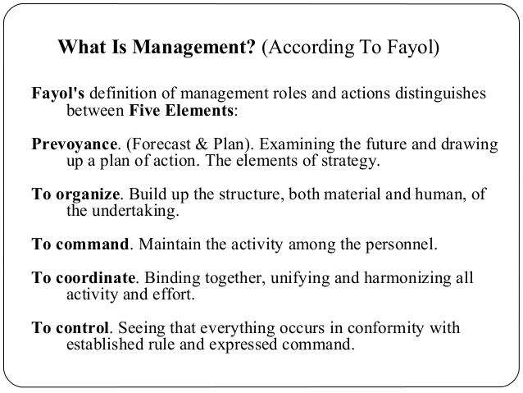
Source: (Ahmed, 2016)
The administrative theory by Henri Fayol focuses on my personal individual duties of management within CPW. This theory is targeted towards managerial layers. In Figure 6 Fayol (1949) thought management has five aspects;
- Planning- This would mean in CPW I would have to examine the future and draw a plan or strategy to achieved what was planned. For example, planning the weekly rota and analysing who is available to work that week and at what hours and then allocating working hours to staff.
- Organise- This would be considered to be the development of CPW’s resources both material as well as human (Olum, 2004).
- Commanding- For example this is me as a team leader being able to keep CPW’s activities and developments running .
- Co-ordinate- In CPW this can be were me and staff combine together for the purpose of CPW goals.
- Control- Control is making sure that all the above actions are achieved along with the right rules and procedures.

SWOT analysis
Figure 7
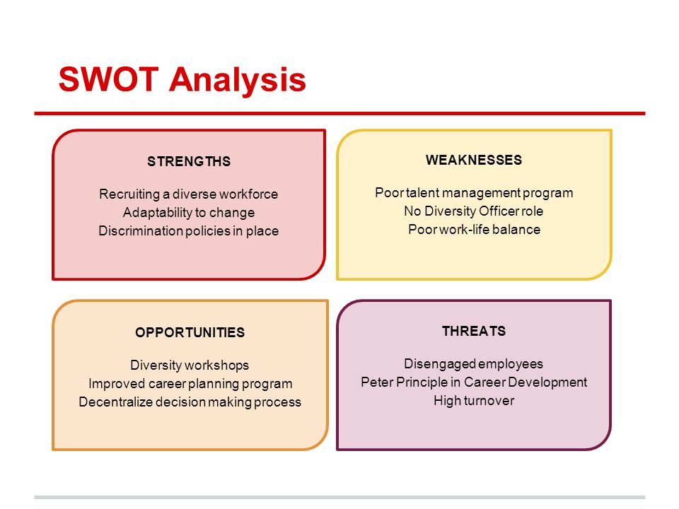

Figure 7 shows how SWOT analysis is a very powerful tool used to understand an individual’s strengths and weaknesses, and also it is used to identify opportunities that are available to the individual as well as the threats the individual faces (Mind tools, 2018). In CPW’s framework, SWOT analysis aids in carving a supportable role within the market. Also, by using SWOT personally within CPW’s workplace it will aid in me developing my career in the way of taking advantage of my skills, capabilities and opportunities (Mind tools, 2018). Figure 6 also shows examples of CPW’s strengths and also their weaknesses, with this information CPW can analyse what their weaknesses are and use their strength to help their weaknesses.

PEST Analysis
Figure 8
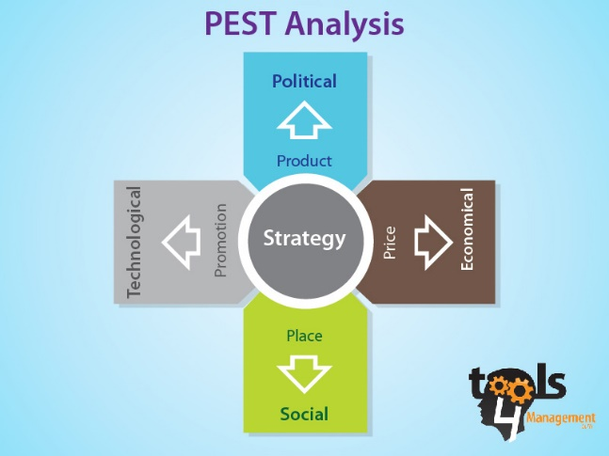
Figure 8 shows PEST analysis as a tool that is used to aid in individuals to analyse the Political, Economic, Social and technological changes to CPW. The diagram shows how PEST can help CPW understand the external influences the organisation will be exposed to. With identifying changes within CPW could generate opportunities for CPW or cause a threat to the organization. For instance, in CPW opportunities would arise from new technologies that help CPW engage new customer and also if any change to the government policies this could generate more opportunities for CPW. The threats detected using PEST analysis for CPW included Brexit and the decrease value of the British sterling.

Conclusion
Management is about achieving tasks and also it is about leading a group of individuals to achieve the organisations goals as well as being able to inspire members of the team to make correct decisions and to take initiative. After some extensive research I found being able to develop critical thinking with CPW is to able to management need skills to motive, lead and influence others.

