

Change makers: Creativity and Value Creation
Ophelia chase 2020346
Module number BMHP5014
Lecturer name: Chloe Harries

Development of a campaign

Alcohol and anxiety

My blog
Nowadays, the world faces a major problem of alcoholism giving rise to several health issues. People are facing various physical and mental disorders due to the increased intake of alcohol out of pleasure as well as sorrow. Alcoholic persons who are consuming alcohol for an extended period both in small and high quantities, often noticed that they develop major heart-related issues and go under depression due to increased levels of mental stress and anxiety (Mayo Clinic, 2018). This blog is constructed to make the people of the world, especially the UK people, become aware of the negative impacts due to intake of alcohol.
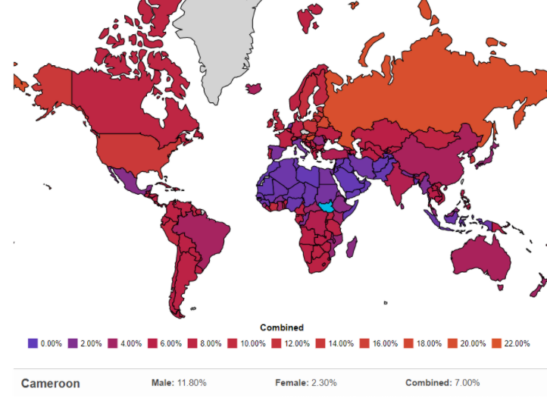
Figure 1: Rate of alcoholics through the world by 2022
(Source: World Population Review, 2022)

Every year 2.8 million people lose their lives prematurely due to the consumption of alcohol throughout the world. An estimate of 107 million people faces alcoholic disorders globally among which 70% are male consumers and approximately 32 million is the number of female consumers. According to the World Population Review (2022), Hungary witnessed the highest rate of alcohol consumers with 21.2% of males whereas Russia witnessed the alcoholic disorder among its male citizens to be 36.9%. The UK witnesses' alcoholic disorders among 13% of its population of which 8.7% are male and 4.3% are female alcohol consumers. These data show that there is an ardent need for various healthcare campaigns for the welfare of society by making them aware of the ill effects of alcohol consumption.
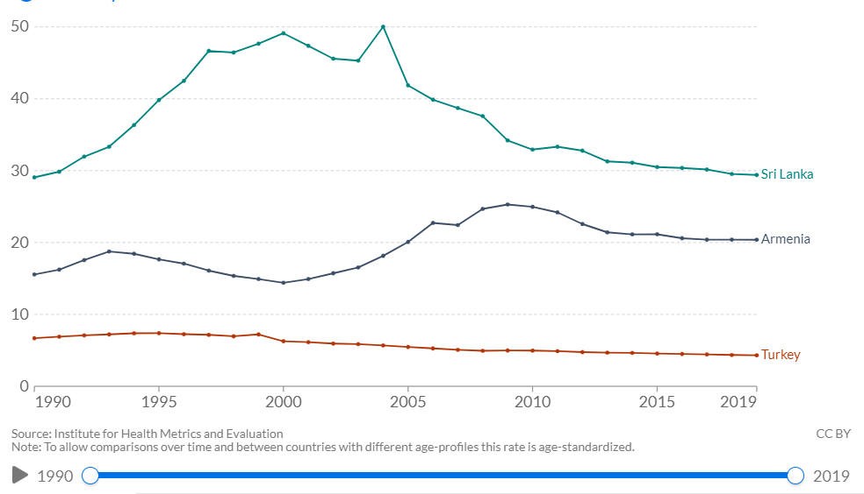
Figure 2: Rate of premature deaths because of alcohol from 1990 to 2019
(Source: Ritchie and Roser, 2022)
Alcoholic addiction is a drug addiction that harms the body often causing several people to face death or death-like diseases or consequences. Alcohol use disorder (AUD) gives rise to various health issues among alcoholics. Among those issues, the most prominent issue is the facing of depression or anxiety. Along with time, the person consuming alcohol once or twice for pleasure often results in being addicted to alcohol. The addiction gives rise to compulsions or strong desires for in-taking continuous alcohol, irrespective of any time or occasion. Once a person becomes addicted it becomes very difficult for them to overcome the addiction and lead a normal life. Addiction causes the person to have involuntary actions and behaviours which can be harmful to their lives as well as their careers. The alcoholics of young age face severe problems to get established and to be successful in their professional career as they do not get a job easily and even if they get, they cannot concentrate properly in the work, eventually hampering the operations of the organisations in which they work. This results in hampering the success of their careers and sometimes they even lose their jobs which gives rise to a sense of depression among them (Evan et al., 2020, pp.244-254).
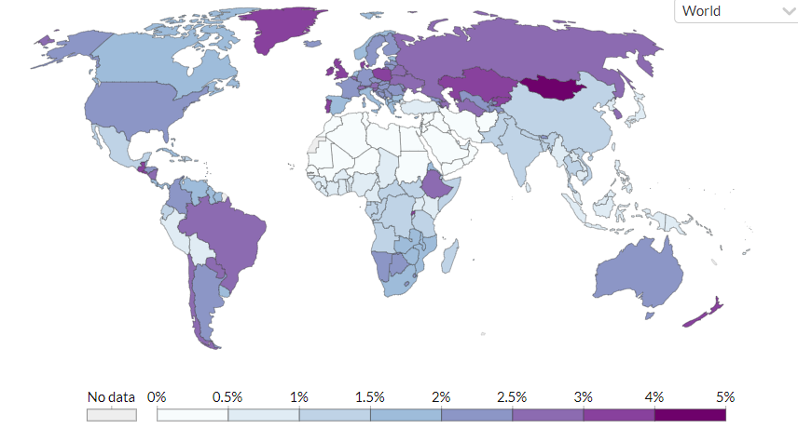
Figure 3: Rate of Alcohol use disorders in 2019
(Source: Ritchie and Roser, 2022)
The feeling of depression creates anxiety and stress which increases with time if not taken proper care and medication by consulting the doctors. Not only does consumption develop the feeling of anxiety in the alcoholics but the workload and work stress also make a person hold the hand of alcohol to get some relief from their tension and work stress. Several alcoholics think that consuming alcohol will give them relief and some space from the workloads and sorrows of their lives and start consuming it as a treatment of their personal and professional problems. However, the consumption of alcohol for a long time affects the mental state of a person as it changes the activities of the brain because of which the person feels stressed and anxious very often. Alcohol can also cause obesity, liver cirrhosis and cardiovascular damage which also gives rise to the sense of depression and stress among those alcoholic individuals making them anxious about their health. Even the lifestyle of the person changes due to the increase in their anxiety levels as they are unable to concentrate on their work and life eventually hampering both (Cherney, 2019). All these factors are the reason behind the increases in the anxiety levels among alcohol consumers which gave rise to the idea of organising campaigns to make people totally and successfully quit the harmful drug- alcohol from their lives.

Figure 4: Anxiety and depression due to alcohol consumption
(Source: PinClipart, 2022)

According to Grossman et al., (2020, p.9189), the increasing rate of unemployment and the low incomes due to the outbreak of the Covid-19 has made people get addicted to alcohol by 60%, eventually making them feel stressed and anxious about their poor situation. Alcohol consumption and anxiety affect and hamper not only the lives and works of alcoholic persons but also the lives associated with them too. The anxiety due to alcohol consumption often causes alcohol abuse in families. So, it is important to grow awareness among the people of the society to learn the ill effects of alcohol and quit them as early as possible with the help of therapists or by taking medications after consulting the doctors. The persons also need to be continuously encouraged by their friends and family members to check their drinking habits to be within limits. They can even show them some short movies or a few live examples regarding the negative impacts of alcohol in different persons' lives. Educating the persons about the ill symptoms and issues due to alcohol consumption can make the persons become more aware and will help the willing persons to effectively give up the habit of drinking.
The bloggers and the social workers can post information regarding the health issues and anxiety due to the intake of alcohol in various social media platforms so that it appropriately reaches many people worldwide within just a few minutes. Various awareness events as well as educating the people about alcoholism and AUD can also help alcoholic people to overcome this bad addiction and lead a happy, addiction-free life. Moreover, showing anxious people some other positive ways like exercise, meditation and sharing their problems with others will help them to release their work stress and personal stress (Brekke et al., 2018, pp.1-9). It will help them to leave the path of alcoholism and choose some other way to brighten their life. That is why educating, and guiding alcoholic people is very much important both for the person as well as for their families and friends. I hope, this blog is liked by all and some reviews and comments regarding this blog of alcoholism and anxiety will be much appreciated.

my Leaflet
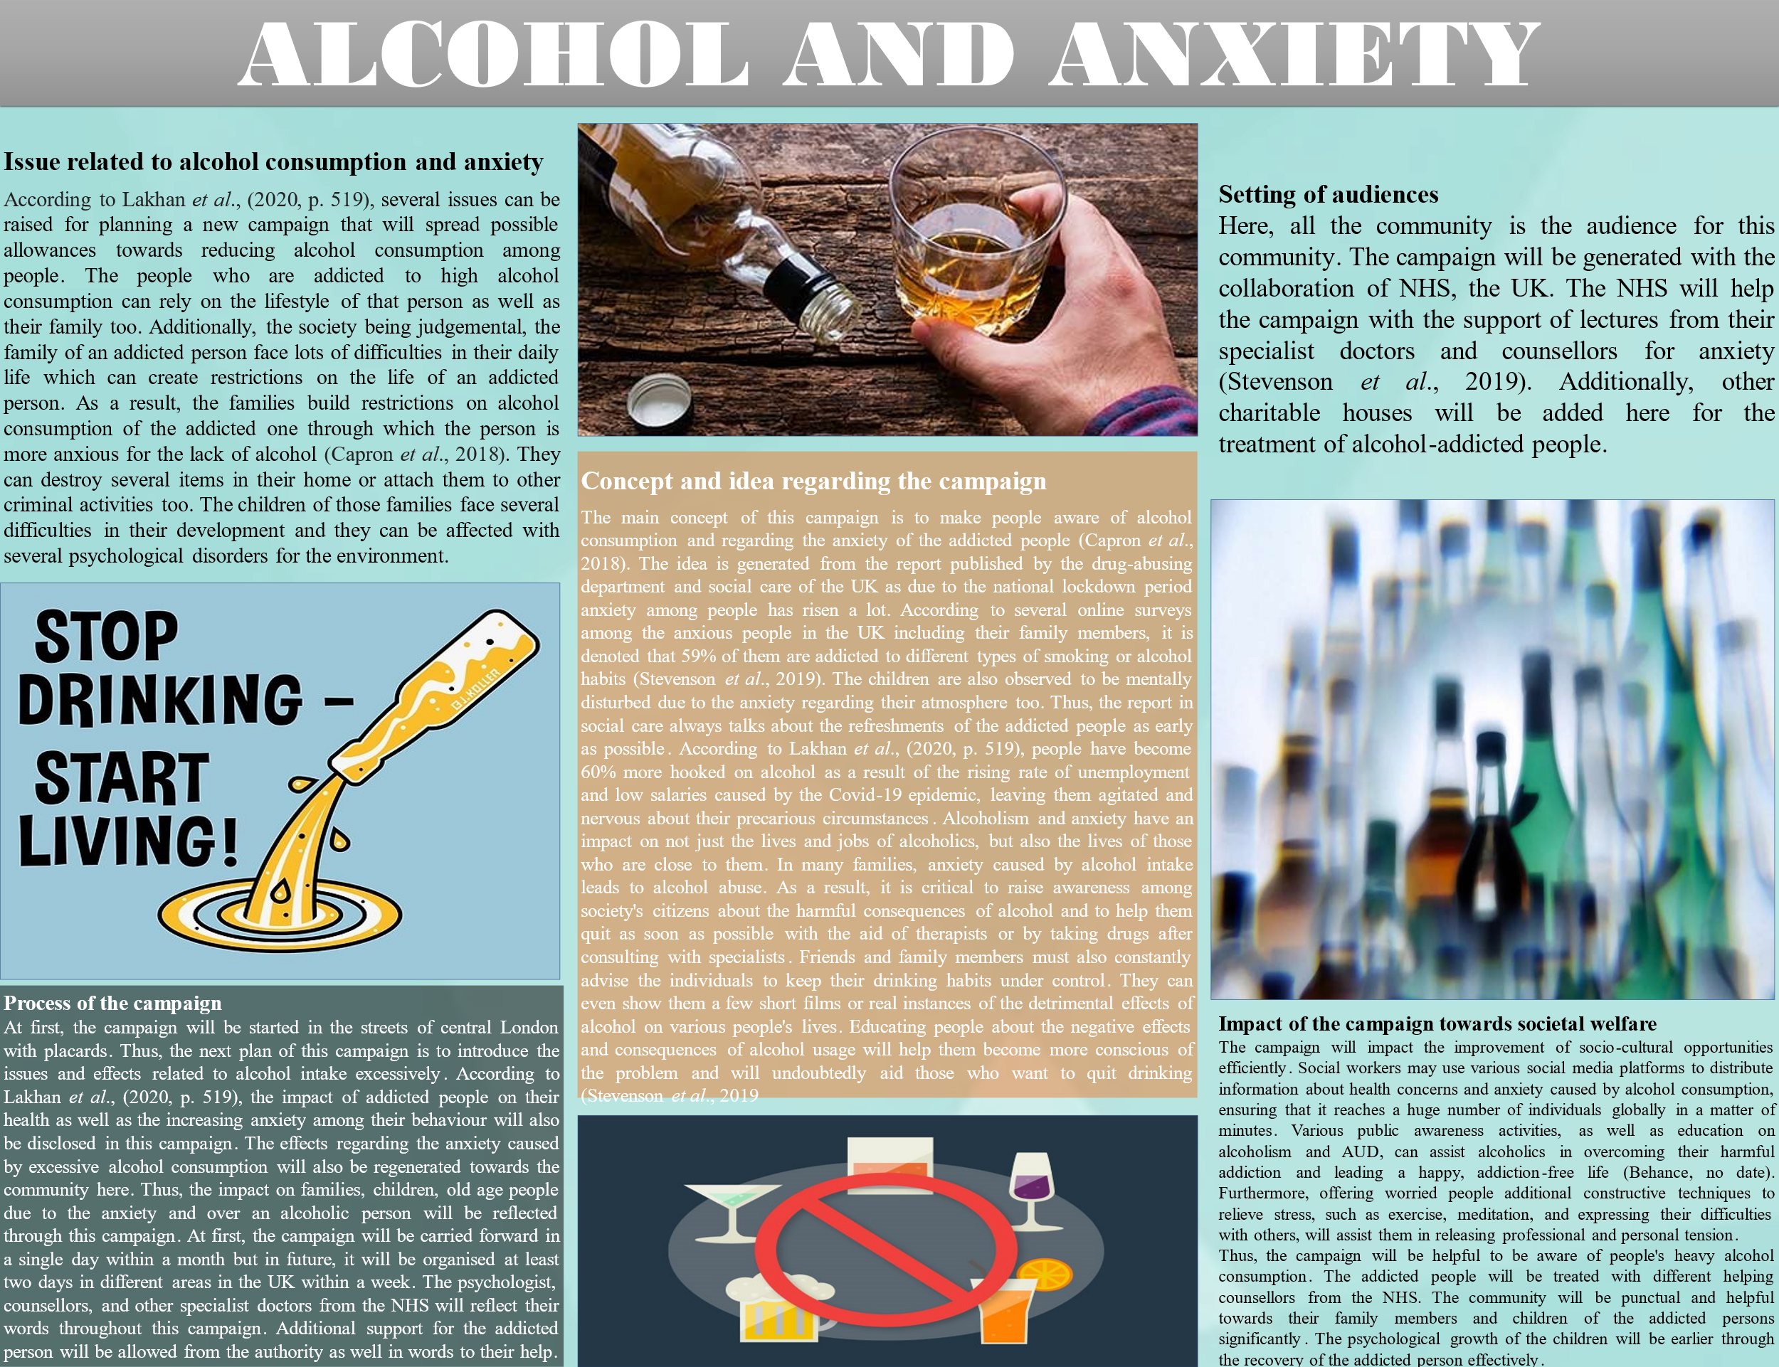
Alcohol consumption is a serious cause affecting anxiety from different ages. It has serious consequences to treat alcohol-addicted people as early as possible. Drinking alcohol for a lengthy period with heavy consumption increases the chances of anxiety that can destroy both the personal and professional life of the corresponding person significantly (Capron et al., 2018).
Issue related to alcohol consumption and anxiety
According to Lakhan et al., (2020, p. 519), several issues can be raised for planning a new campaign that will spread allowances towards reducing alcohol consumption among people. The people who are addicted to high alcohol consumption can rely on the lifestyle of that person as well as their family too. Additionally, the society being judgemental, the family of an addicted person face lots of difficulties in their daily life which can create restrictions on the life of an addicted person. As a result, the families build restrictions on alcohol consumption of the addicted one through which the person is more anxious for the lack of alcohol (Capron et al., 2018). They can destroy several items in their home or attach them to other criminal activities too. The children of those families face several difficulties in their development, and they can be affected with several psychological disorders for the environment.
Concept and idea regarding my campaign
The main concept of this campaign is to make people aware of alcohol consumption and regarding the anxiety of the addicted people (Capron et al., 2018). The idea is generated from the report published by the drug-abusing department and social care of the UK as due to the national lockdown period anxiety among people has risen a lot. According to several online surveys among the anxious people in the UK including their family members, it is denoted that 59% of them are addicted to several types of smoking or alcohol habits (Stevenson et al., 2019). The children are also observed to be mentally disturbed due to the anxiety regarding their atmosphere too. Thus, the report in social care always talks about the refreshments of the addicted people as early as possible. According to Lakhan et al., (2020, p. 519), people have become 60% more hooked on alcohol because of the rising rate of unemployment and low salaries caused by the Covid-19 epidemic, leaving them agitated and nervous about their precarious circumstances. Alcoholism and anxiety have an impact on not just the lives and jobs of alcoholics, but also the lives of those who are close to them. In many families, anxiety caused by alcohol intake leads to alcohol abuse. As a result, it is critical to raise awareness among society's citizens about the harmful consequences of alcohol and to help them quit as soon as possible with the aid of therapists or by taking drugs after consulting with specialists. Friends and family members must also constantly advise the individuals to keep their drinking habits under control. They can even show them a few short films or real instances of the detrimental effects of alcohol on various people's lives. Educating people about the negative effects and consequences of alcohol usage will help them become more conscious of the problem and will undoubtedly aid those who want to quit drinking (Stevenson et al., 2019).
Setting of audiences
Here, all the community is the audience for this community. The campaign will be generated with the collaboration of NHS, the UK. The NHS will help the campaign with the support of lectures from their specialist doctors and counsellors for anxiety (Stevenson et al., 2019). Additionally, other charitable houses will be added here for the treatment of alcohol-addicted people.
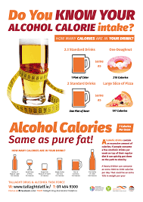
Figure 5: Alcohol control poster
(Source: Behance, no date)
Process of the campaign
At first, the campaign will be started in the streets of central London with placards. Thus, the next plan of this campaign is to introduce the issues and effects related to alcohol intake excessively. According to Lakhan et al., (2020, p. 519), the impact of addicted people on their health as well as the increasing anxiety among their behaviour will also be disclosed in this campaign. The effects regarding the anxiety caused by excessive alcohol consumption will also be regenerated towards the community here. Thus, the impact on families, children, old age people due to the anxiety and over an alcoholic person will be reflected through this campaign. At first, the campaign will be carried forward in a single day within a month but in future, it will be organised at least two days in different areas in the UK within a week. The psychologist, counsellors, and other specialist doctors from the NHS will reflect their words throughout this campaign. Additional support for the addicted person will be allowed from the authority as well in words to their help.
Impact of the campaign towards societal welfare
The campaign will impact the improvement of socio-cultural opportunities efficiently. Social workers may use various social media platforms to distribute information about health concerns and anxiety caused by alcohol consumption, ensuring that it reaches an enormous number of individuals globally in a matter of minutes. Various public awareness activities, as well as education on alcoholism and AUD, can assist alcoholics in overcoming their harmful addiction and leading a happy, addiction-free life (Behance, no date). Furthermore, offering worried people additional constructive techniques to relieve stress, such as exercise, meditation, and expressing their difficulties with others, will assist them in releasing professional and personal tension.
Thus, the campaign will be helpful to be aware of people's heavy alcohol consumption. The addicted people will be treated with different helping counsellors from the NHS. The community will be punctual and helpful towards their family members and children of the addicted persons significantly. The psychological growth of the children will be earlier through the recovery of the addicted person effectively.

References

Books and Journals
Brekke, E., Lien, L., Nysveen, K. and Biong, S. (2018) Dilemmas in recovery-oriented practise to support people with co-occurring mental health and substance use disorders: a qualitative study of staff experiences in Norway. International journal of mental health systems, 12(1), pp.1-9.
Capron, D.W., Bauer, B.W., Madson, M.B. and Schmidt, N.B., (2018). Treatment seeking among college students with comorbid hazardous drinking and elevated mood/anxiety symptoms. Substance use & misuse, 53(6), pp.1041-1050.
Evans, O., Rodríguez‐Borillo, O., Font, L., Currie, P.J. and Pastor, R. (2020) Alcohol binge drinking and anxiety‐like behavior in socialized versus isolated c57bl/6j mice. Alcoholism: Clinical and Experimental Research, 44(1), pp.244-254.
Grossman, E.R., Benjamin-Neelon, S.E. and Sonnenschein, S. (2020) Alcohol consumption during the COVID-19 pandemic: a cross-sectional survey of US adults. International journal of environmental research and public health, 17(24), p.9189.
Lakhan, R., Agrawal, A. and Sharma, M., (2020). Prevalence of depression, anxiety, and stress during COVID-19 pandemic. Journal of neurosciences in rural practice, 11(04), pp.519-525.
Stevenson, B.L., Dvorak, R.D., Kramer, M.P., Peterson, R.S., Dunn, M.E., Leary, A.V. and Pinto, D., (2019). Within-and between-person associations from mood to alcohol consequences: The mediating role of enhancement and coping drinking motives. Journal of Abnormal Psychology, 128(8), p.813.

Websites
Behance, (no date) Alcohol awareness - Poster Available at:https://www.behance.net/gallery/102716361/Alcohol-awareness-Poster [Accessed: 22 February 2022]
Cherney, K. (2019) Alcohol and Anxiety. Available at: https://www.healthline.com/health/alcohol-and-anxiety [Accessed: 22 February 2022]
Mayo Clinic (2018) Alcohol use disorder. Available at: https://www.mayoclinic.org/diseases-conditions/alcohol-use-disorder/symptoms-causes/syc-20369243 [Accessed: 22 February 2022]
PinClipart (2022) Alcohol Cliparts. Available at: https://www.pinclipart.com/pins/alcohol/ [Accessed: 22 February 2022]
Ritchie, M. and Roser, M. (2022) Alcohol Consumption. Available at: https://ourworldindata.org/alcohol-consumption#:~:text=Globally%2C%20107%20million%20people%20are,relative%20to%2032%20million%20females. [Accessed: 22 February 2022]
World Population Review (2022) Alcoholism by Country 2022. Available at: https://worldpopulationreview.com/country-rankings/alcoholism-by-country[Accessed: 22 February 2022]

