Title: Contemporary Software Applications for Business Operations: Evaluation, Practical Implementation, and Collaboration Tools
Student ID:
Student Name:
Module ID:
Module Name:
Table of Contents
Task 1: E-Commerce Website Builders/Software Solutions 5
Introduction 5
Shopify 5
WooCommerce 5
Comparison of Shopify and WooCommerce 6
Task 2: Mind Map of Contemporary Software Applications 6
a. Mind Mapping and Its Benefits in Business Operations 6
b. Contemporary Software Applications Used in Business Operations 7
Task 3. Office Applications for creating, storing, presenting, and analyzing information/data 8
3.1 Microsoft Word 8
3.2 Microsoft Excel 10
3.3 Microsoft PowerPoint 11
Description under Figure 13
3.4 Microsoft Access 13
Description Under Figure 15
Task 3(b): Practical Activity 1 – VLOOKUP in Microsoft Excel 15
Introduction 15
Screenshot 1- Create Employee Data Table 16
Screenshot 2 - Create Search Area 16
Screenshot 3 - Enter VLOOKUP Formula 17
Screenshot 4 - Display the Result 17
Evaluation 18
Task 3(b): Practical Activity 2 – IF Function in Microsoft Excel 18
Screenshot 1 – Create Student Marks Dataset 18
Enter IF Function 19
Screenshot 3 – Display Results 20
Evaluation 20
Task 4: Communication and Collaboration Applications 20
4.1 Communication Application – Microsoft Teams 20
4.2 Online Collaboration Application – Trello 22
4.3 Practical Testing 24
Communication Tool: Microsoft Teams 24
Collaboration Tool: Trello 25
Conclusion 27
Bibliography 28

List of figures
Figure 1: Mind Map of Contemporary Software Applications Used in Business Operations 8
Figure 2: Microsoft Word interface showing the Ribbon, document workspace, and formatting tools 9
Figure 3: Microsoft Excel interface used for organising, analysing, and presenting business data 11
Figure 4: Microsoft PowerPoint interface used for creating and delivering business presentations. 13
Figure 5: Microsoft Access interface used for storing, managing, and retrieving business data. 15
Figure 6: Employee data table created in Microsoft Excel 16
Figure 7: Search area prepared for employee lookup. 16
Figure 8: VLOOKUP formula entered in Microsoft Excel 17
Figure 9: Successful VLOOKUP result returned by Excel 17
Figure 10: Student marks dataset created in Microsoft Excel. 18
Figure 11: IF Function entered in the Result column 19
Figure 12: Results generated using the IF Function 20
Figure 13:Microsoft Teams interface is used for business communication and virtual meetings. 22
Figure 14: Trello interface used for project collaboration and workflow management. 23
Figure 15: Microsoft Teams home dashboard 24
Figure 16: Meeting scheduling screen in Microsoft Teams 24
Figure 17: Successfully scheduled meeting in Microsoft Teams 25
Figure 18: Trello workspace dashboard 25
Figure 19: New project board created in Trello 26
Figure 20: Task card added to the project board 26

List of tables
Table 1: Comparison between Shopify and WooCommerce 6

Task 1: E-Commerce Website Builders/Software Solutions

Introduction
E-commerce site builders are computer programs that allow companies to build, operate, and administer online shops without the need to have high levels of computer programming skills. They offer product management, payment system, tracking of orders and contacting the customers. E-commerce solutions in the modern world enable companies to reach their customers all over the world and enhance customer experience and maximize sales via the Internet. Shopify and WooCommerce were two popular modern-day e-commerce solutions.

Shopify
Shopify is an e-commerce web service that assists companies to set up and operate online stores fast and effectively [1]. It has a convenient interface and a suite of in-built resources that enable users to sell products online without highly technical sophistications. Shopify has several significant characteristics, among them being their pre-designed templates that allow companies to create websites that appear professional. Secure payment methods, inventory administration facilities, mobile flexibility and marketing options like discount codes and email programs can also be found in the platform.
Shopify is not only easy to use, but it is also reliable and has great customer support as its key advantages. Companies are able to open an online shop and process products, orders and customer data through one dashboard. Shopify has certain limitations though. The subscription costs that may be as much as a month are too high in case of small business and their advanced customisation may involve extra payment apps. Small and medium-sized enterprises, the retail stores, and entrepreneurs who need a straightforward yet effective tool to sell their products online are typical users of Shopify.

WooCommerce
WooCommerce is a free e-commerce WordPress website plug-in [2]. It enables a business to convert an already existing online store (WordPress site) into a fully functional online store. WooCommerce is liked due to its flexibility and wide customisation.
WooCommerce has key characteristics such as product management, integration of payment, inventory management, shipping options and thousands of plugins and themes. Since this is open source, users are able to have more control over the design and functionality of the websites than most hosted sites.
WooCommerce offers the main advantages of flexibility, scalability, and reduced start-up costs [3]. Models of stores can be tailored to suit particular needs and can be extended with added functionality.

Comparison of Shopify and WooCommerce
Table 1: Comparison between Shopify and WooCommerce
Feature | Shopify | WooCommerce
Platform Type | Hosted Solution | WordPress Plugin
Ease of Use | Very Easy | Moderate
Customisation | Limited | Extensive
Hosting Included | Yes | No
Technical Knowledge | Low | Moderate
Cost Structure | Monthly Subscription | Lower Initial Cost
In conclusion, Shopify will suit the needs of businesses with a need to have a simple all-in-one e-commerce solution, whereas WooCommerce is more capable of satisfying the needs that organisations may have, with the need to be free and have more options in order of customisation.

Task 2: Mind Map of Contemporary Software Applications

a. Mind Mapping and Its Benefits in Business Operations
Mind mapping is a graphic technique applied in designing information around a topic of focus [4]. It introduces concepts through branches and sub-branches and therefore it is easier to comprehend the relationship of concepts. Mind maps are also very popular in businesses because it helps in planning, brainstorming, problem-solving and making decisions.
Enhanced organisation of information is one of the key advantages of mind mapping. Companies usually have to manipulate extensive volumes of data and concepts, and mind maps assist in outlining this data into explicit groups. This facilitates the comprehension of the complex matters to the employees and managers and the formation of linkages between various business activities.
Mind mapping also inspires creativity and innovativeness. The team members are able to brainstorm and draw pictures which relate to the ideas. The process assists organisations to come up with new products, services, and business strategies. Moreover, mind maps help in the planning of projects by dividing big projects into smaller tasks and activities. They help managers to distribute duties, keep track of the progress, and make sure that project goals are met effectively.
The other advantage is enhanced communication. Through visual presentations, it is also easier to comprehend compared to long documents and thus, the team members can better communicate information to the other team members. Training, knowledge management and strategic planning can also be achieved through mind maps. Consequently, they help enhance organisational productivity and decision-making.

b. Contemporary Software Applications Used in Business Operations
The contemporary organisations depend on diverse software applications to aid their day-to-day activities [5]. The office applications, like Microsoft Word, Excel, PowerPoint, and Access, assist workers in the development of documents, data analysis, presentation creation, and working with databases. Communication tools, such as Microsoft Teams, Zoom, and Google Meet also allow employees to interact and cooperate without considering the location.
Teambuilding software like Trello, Asana and Google Workspace enables teamwork and includes the ability to organize projects and distribute files among users and monitor the progress of tasks. Customer Relationship Management (CRM) software such as Salesforce and HubSpot aid companies in managing customer data, serving the customers better, and achieving higher sales volume [6].
The QuickBooks and Xero accounting software help organisations in organising financial transactions, budgeting and reporting procedures. E-commerce services such as Shopify and WooCommerce can be used to establish online stores and market products online. Google Drive, OneDrive and dropbox are cloud-based storage and access systems that offer safety and convenience when accessing the business information.
In general, modern software applications have a great impact in enhancing organisational speed, communication, coordination and decision making. The mind map that comes with it shows how this software types can be used to complement day-to-day business activities.
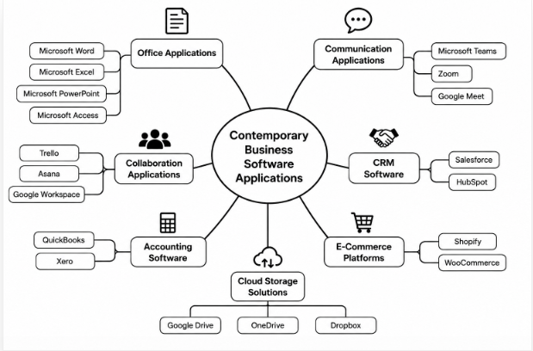
Figure 1: Mind Map of Contemporary Software Applications Used in Business Operations

Task 3. Office Applications for creating, storing, presenting, and analyzing information/data

3.1 Microsoft Word
Microsoft Word is among the popular office applications used in creating, editing, formatting and sharing of documents. It was developed by Microsoft, and it is a component of the Microsoft Office, which are usually implemented in businesses, learning institutions, and governments. Microsoft Word assists users in developing professional documents like reports, letters, proposals, meeting minutes and business correspondence [7].
One of the major features of Microsoft Word is its advanced document formatting capabilities. Fonts, colours, margins, spacing, and page layouts can be customised, allowing users to create professionally looking documents. There are also templates present in the software which assist in the creation of business reports, resumes, newsletters and other documents easily and quickly by its users. The other fundamental feature will be the spell check and grammar check feature that will assist in enhancing the quality and accuracy of the written work. There are also features in Word, like tables, charts, SmartArt graphics, and the insertion of images that allow one to make their documents appealing.
Microsoft Word has a number of advantages as far as running a business is concerned. To begin with, it enhances productivity where employees can make and edit documents effectively. Secondly, there are collaborative tools, including comments, track changes, and , allowing several users to work on the same document simultaneously. This enhances the team's work and saves time and resources when reviewing and approving documents. Thirdly, Word can be integrated with a cloud solution, OneDrive, that enables users to view and share documents across locations and devices [8].
Besides this, Microsoft Word has the option of exporting documents to other formats, such as PDF, which is compatible with other platforms. Although Microsoft Word is very advantageous, it has certain limitations. Massive documents that include many images, tables and graphics can be slow to process. The higher level of formatting might also be elaborate to new users.
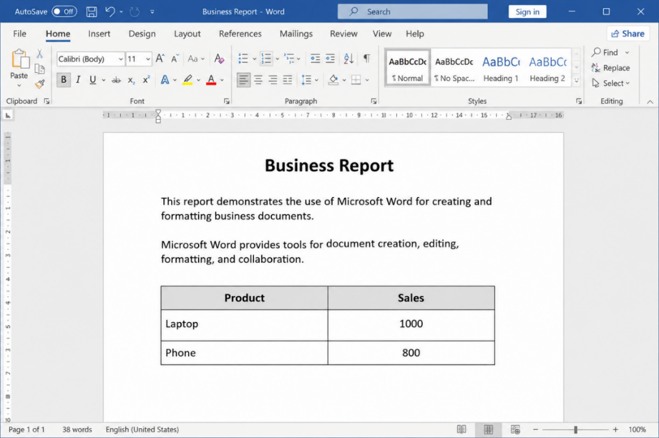
Figure 2: Microsoft Word interface showing the Ribbon, document workspace, and formatting tools
The interface of Microsoft Word is shown in Figure 2. The screenshot displays the Ribbon, which includes the formatting commands, the workspace where one can create content and a table where one can tabulate business information. These attributes can assist users in drawing professional documents effectively.

3.2 Microsoft Excel
Microsoft Excel is a spreadsheet application created by Microsoft and is commonly used in business to enter, compute, analyse, and report data, and make decisions. It allows organisations to handle large quantities of data effectively and convert unprocessed information into valuable insights. Excel is regarded as one of the most significant office programs in contemporary business, as it is versatile and has strong analytical capabilities.
Microsoft Excel is one of the extraordinary applications that are capable of performing some calculations using formulas and functions. Functions like SUM, AVERAGE, IF, VLOOKUP and COUNT can be utilised by the user to process data in an accurate and efficient manner [9]. Excel also offers charting and graphing options, which enable businesses to display information in graphic form. Further, Pivot Tables aid users in summarising and analysing big data in the shortest possible time, which is easier to detect trends and patterns.
Data management is another worthy characteristic. Excel will enable the user to arrange data in rows and columns, sort and filter information as well as to form structured tables. These features enable businesses to handle financial information, sales data, inventory data and even employee information. Moreover, Excel enables conditional formatting, data validation and Goal Seek, data accuracy enhancers and business planning tools.
Microsoft Excel has several advantages for organisations. It enhances efficiency through automation of calculation and increases the amount of work done manually. It helps to make better decisions as well because it offers tools to analyse and report data. The businesses are able to prepare budgets, forecasts, and performance reports, as well as financial statements, effectively. Also, Excel is integrated with other Microsoft Office products, which allows sharing and presentation of information seamlessly.
Microsoft Excel has limitations, even though it has its benefits. Big and complicated spreadsheets might get complicated and might expose one to the chances of making mistakes during data entry. Some of the sophisticated applications and analysis software can be challenging to train inexperienced users. Moreover, Excel does not eminently suit handling very large data bases as compared to specific database management systems.
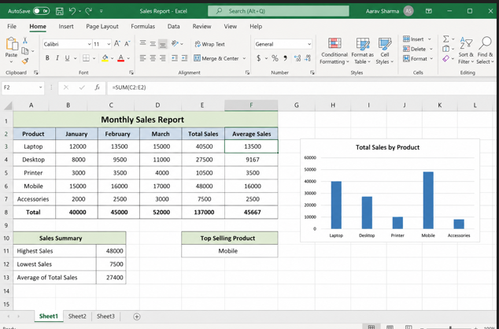
Figure 3: Microsoft Excel interface used for organising, analysing, and presenting business data

3.3 Microsoft PowerPoint
Microsoft PowerPoint is a presentation software program created by Microsoft and is part of Microsoft Office. Businesses, educational institutions and organisations use it extensively to produce professionally made presentations to be used in meetings, training, conferences, sales pitches and project reports [10]. With the help of PowerPoint, people can use a mixture of text, pictures, charts, video and animations to convey information effectively.
Another significant attribute of Microsoft PowerPoint is the presentation that is organized in the form of slides. The user is able to create several slides to arrange the information in a logical and easy-to-view way. The software has numerous templates and themes that enable users to create professional presentations in less time. PowerPoint is also multimedia-supported, enabling a user to add images, audio files, videos, icons and SmartArt graphics to the presentation to make it more exciting to the audience.
The possibility to make charts, tables, and diagrams is another feature. These technologies are used to simplify the presentation of information and data that are complex to the businesses and render them understandable. PowerPoint also has animation and transition effects which can be employed to highlight the main points and enhance the flow of the presentation. Another handy tool is Presenter View, which allows presenting slides to an audience, viewing notes and controlling them.
MS PowerPoint has a number of advantages in business activities. Firstly, it enhances communication since it renders information in a visually appealing and organised format. Secondly, it makes the content interesting and attention-grabbing by incorporating multimedia and interactive content. Thirdly, PowerPoint also encourages teamwork as presentations can be reviewed and edited by various individuals using cloud-based systems like OneDrive. PowerPoint can also be used by a business to develop training, marketing presentations, financial reports, and project updates.
Microsoft PowerPoint, although its strengths, has limitations. A lot of animations, transitions and texts can distract and make the presentation less effective. A high-quality presentation could also be time-consuming and could need some design capabilities. Moreover, the delivery of the presentation may be impacted by technical problems, such as incompatibility or equipment breakdowns.
Altogether, Microsoft PowerPoint is a valuable office software that helps to convey information and facilitates business communication [11]. The fact that it has a variety of design tools, is multimedia and presentation-based, makes it a good solution for an organisation looking to communicate ideas effectively and professionally.
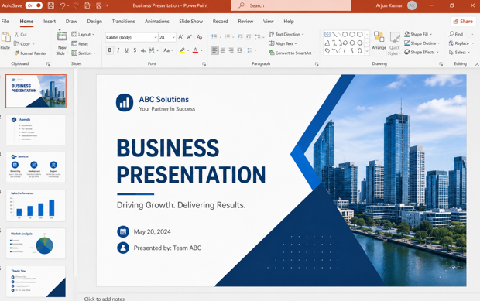
Figure 4: Microsoft PowerPoint interface used for creating and delivering business presentations.

Description under Figure
Figure 4 shows the interface of Microsoft PowerPoint. The screenshot represents the Ribbon with the presentation design tools, slide navigation pane and the presentation workspace that can be used to create professional business presentations. The features allow users to pass information in an effective way by means of visual and multimedia materials.

3.4 Microsoft Access
Infobase Microsoft Access is a database management system invented by Microsoft and featured in select editions of the Microsoft Office. It is created to assist companies in storing, organising, managing and accessing massive information in an efficient manner. Microsoft Access is also specialised to handle structured databases, unlike a spreadsheet/calculation-based program as found in Microsoft Excel. Small and medium-sized organisations usually use it to maintain records of customers, inventory, employee records, and business records.
Among other things, Microsoft Access has demonstrated the capability of creating and managing relational databases [12]. Users can manipulate data into various tables and to create a relationship between them, which limits the duplication as well as enhances the accuracy of the data. Forms are also provided through access, and one can add, update and read data using an easy-to-use interface. This simplifies database administration, particularly for those employees with little technical expertise.
The other notable feature is the query feature. The use of queries allows the user to search, filter and analyse the data fast according to a particular criterion. Queries may be used to produce information like a list of customers, sales transactions or an inventory report. Likewise, Microsoft Access comes with reporting features which enable users to generate professional reports, to analyse business and make decisions. Moreover, macros and automation can be used to simplify routine operations and enhance productivity.
Microsoft Access has various advantages for businesses. It enhances the organisation of data as it stores the information in an organised format and minimises the chances of data duplication. This is also boosted by the fact that the software makes use of the business information rapidly, and it also creates reports automatically. Moreover, Access is integrated with other Microsoft Office products like Excel and Word, which enable organisations to access and analyse data.
Microsoft Access has a few limitations, although it has merits. It is typically applicable in the smaller to medium-scale databases, and it might not work very well with very large data sets or with a huge number of users simultaneously. Specialisation and training may also be necessary to achieve advanced knowledge in database design and database management. Also, organisations having more intricate database needs can willingly favour enterprise-scale database infrastructure like SQL Server.
Generally, Microsoft Access is a commendable office tool in the preservation, arrangement and organisation of business data. It has a powerful database, reporting features, and works with other Microsoft software, which makes this option a good solution to help the business run and enhance its data management.
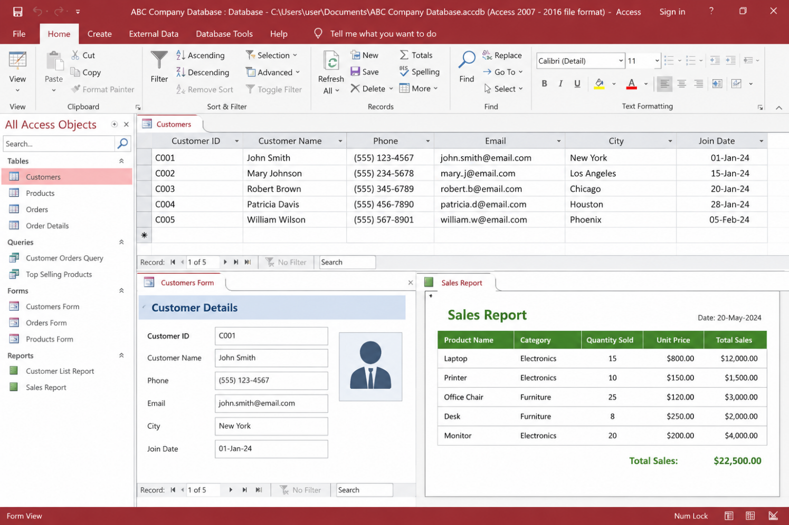
Figure 5: Microsoft Access interface used for storing, managing, and retrieving business data.

Description Under Figure
The Microsoft Access interface is shown in Figure 5. The screenshot depicts database tables, navigation tools, query functions and reporting features to set up and manage business information with ease. These apps help in proper data storage, retrieval and analysis of data in organisations.

Task 3(b): Practical Activity 1 – VLOOKUP in Microsoft Excel

Introduction
VLOOKUP (Vertical lookup) is a Microsoft Excel subroutine, which is employed to look up a particular value in the first column of the table and then provide the corresponding information about that value in the subsequent column. Businesses normally utilise it to access details about customers, employees, product prices, and inventory within very little time and with precision.

Screenshot 1- Create Employee Data Table
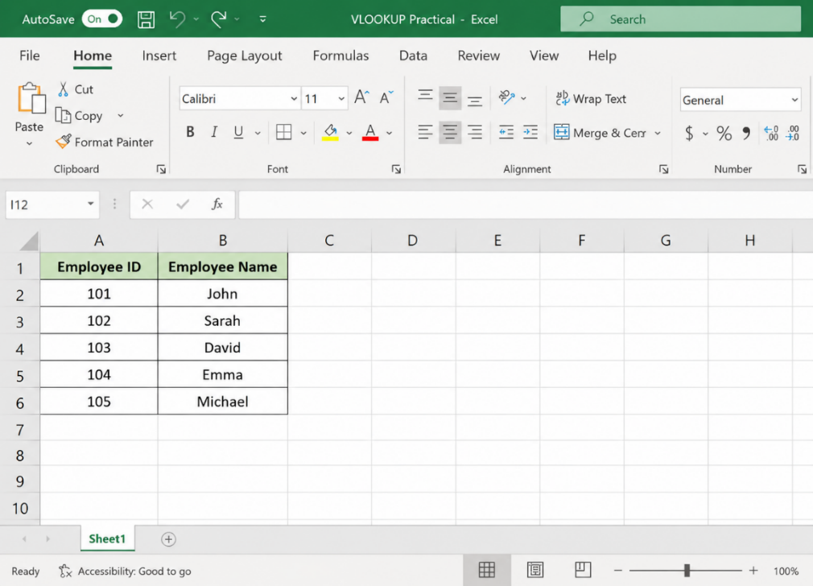
Figure 6: Employee data table created in Microsoft Excel
Description:
The dataset of employees inputted into Excel is represented in Figure 6. The employees IDs and employee names will be placed in the table which will be used in the VLOOKUP function.

Screenshot 2 - Create Search Area
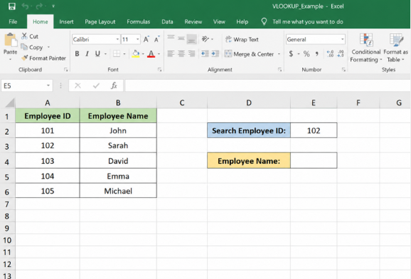
Figure 7: Search area prepared for employee lookup.
Description:
In Figure 7, the search area is where the user keys in an employee ID to get the respective employee’s name through the VLOOKUP function.

Screenshot 3 - Enter VLOOKUP Formula
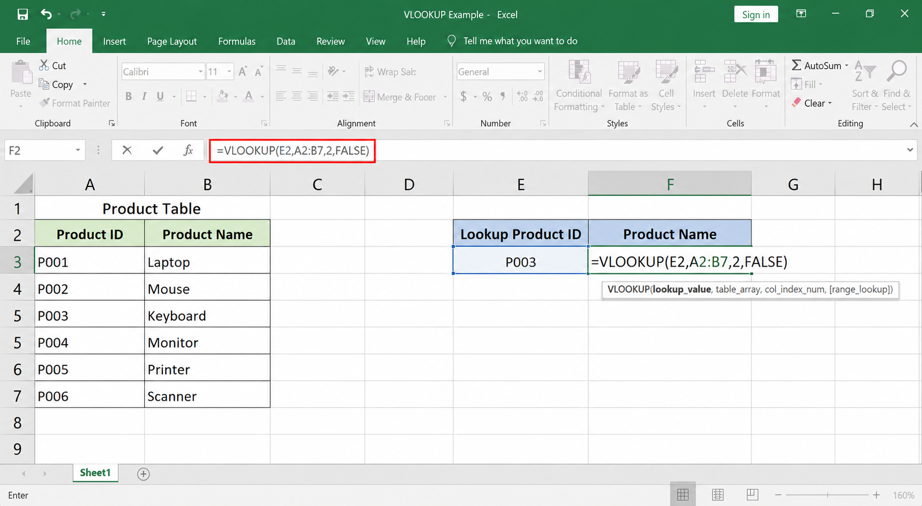
Figure 8: VLOOKUP formula entered in Microsoft Excel
Description:
Figure 8 shows the use of the VLOOKUP tool to find the Employee ID 102 in the dataset and provide the suitable employee’s name in the second column of the table.

Screenshot 4 - Display the Result
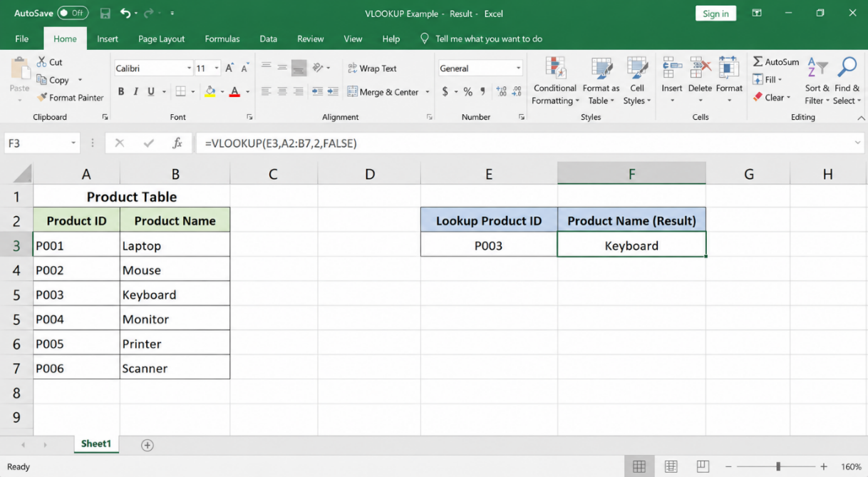
Figure 9: Successful VLOOKUP result returned by Excel
Description:
As shown in Figure 9, the VLOOKUP command did identify the ID number of employee 102 and gave the name of the employee, Sarah. This ascertains the formula is operating properly.

Evaluation
VLOOKUP was found to be useful in the process of accessing data stored in structured data [13]. It minimized man searching and increased precision in the search for employee records. This property comes in handy, especially in business-related issues where large volumes of data have to be searched in a timely manner and efficiently. The real-world test revealed that VLOOKUP would be able to streamline the data search process and help make decisions faster.

Task 3(b): Practical Activity 2 – IF Function in Microsoft Excel
The log tests in the Microsoft Excel IF Function can be utilised to allow the application of logical tests and yield varying output based on the logical test being true or false. The IF Function is popular with businesses to appraise the performance of employees, pass or fail and to compute bonuses and categorise data automatically. This functionality enhances productivity and reduces calculations that are not automated.

Screenshot 1 – Create Student Marks Dataset
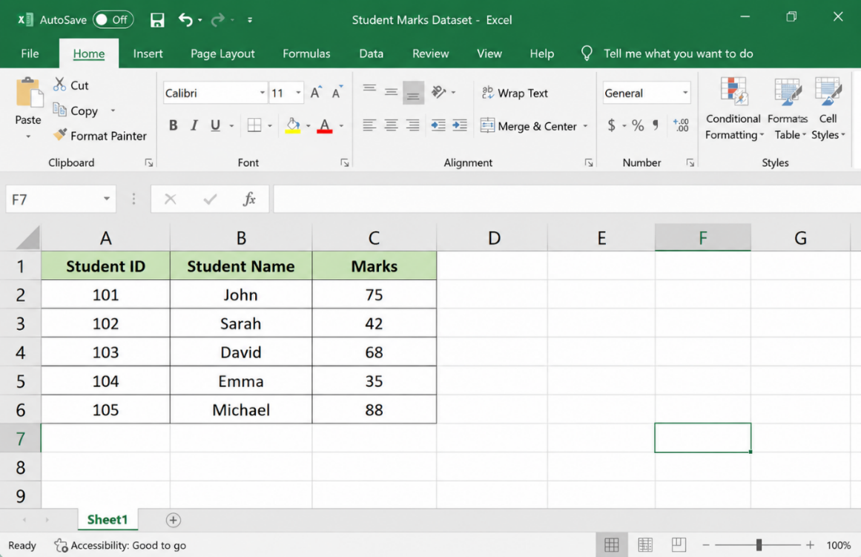
Figure 10: Student marks dataset created in Microsoft Excel.
Description:
Figure 10 represents a worksheet with Student ID, Student Name and Marks. The IF Function will be tested with this data.

Enter IF Function
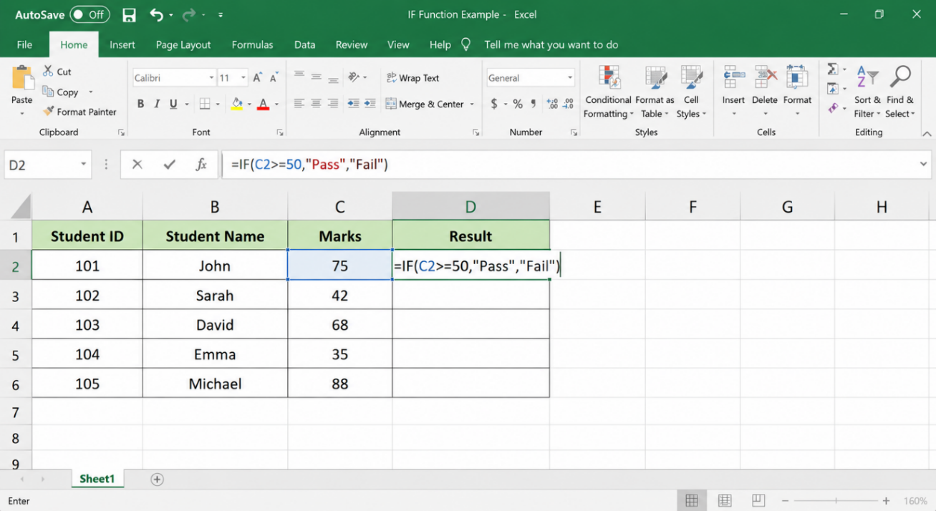
Figure 11: IF Function entered in the Result column
Description:
In Figure 11, the IF Function is being typed into the Result column to find out the status of a student, a failed or a passing.
Formula Used:
=IF(C2>=50,"Pass","Fail")
The formula checks whether the mark is greater than or equal to 50. If the condition is true, Excel returns "Pass"; otherwise, it returns "Fail".

Screenshot 3 – Display Results
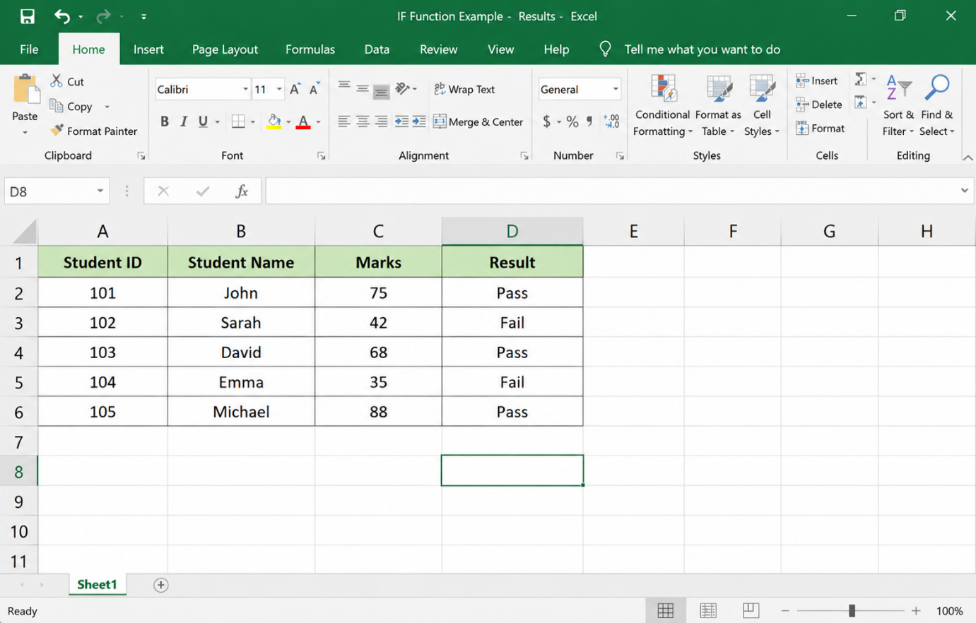
Figure 12: Results generated using the IF Function
Description:
As seen in Figure 12, Excel managed to calculate the mark of each student and displayed the appropriate mark automatically.

Evaluation
The IF Function was effective in automating the decision-making process in a spreadsheet [14]. It minimised manual checking and enhanced accuracy in the classification of student results. The exercise illustrated how logical operations can assist businesses in the analysis of information effectively and facilitate a quicker decision-making cycle. The IF Function is frequently applied in business reporting, employee assessment and performance management.

Task 4: Communication and Collaboration Applications

4.1 Communication Application – Microsoft Teams
Microsoft Teams is a web-based communication platform that was created by Microsoft to allow employees to interact and communicate with one another and hold virtual meetings using a single platform [15]. The growing number of remote and hybrid working approaches has made the application one of the most popular communication tools in contemporary organisations. Microsoft Teams enable businesses to enhance the effectiveness of communication, facilitate teamwork, and ensure productivity regardless of the location of the employees.
Instant messaging is one of the key aspects of Microsoft Teams. Instead of having to exchange emails and spend excessive time on it, employees can interact either one-on-one or in group chats in real time. This attribute enhances the speed of communication and quickens the exchange of information among employees. Audio and video conferencing is another major attribute, through which organisations do virtual meetings, training sessions and presentations with participants who are in other geographical locations. The teams are also screen sharing, which enables the users to share their documents, reports and presentations during a meeting.
Microsystems Microsoft Teams is part of the Microsoft 365 Suite, including Word, Excel, PowerPoint and OneDrive. This connectivity helps employees to view, edit and share files without going outside Teams. Another valuable tool is Channels, where organisations will be able to establish departmental spaces, project spaces, and team spaces. Channels assist in managing discussions and better information management in the organisation.
The primary advantages of Microsoft Teams are enhanced communication, collaboration, and productivity [16]. Desktop computers or mobile devices enable employees to share and communicate great amounts of information regardless of their locations. Teams is also used to facilitate the remote working option, which assists organisations in carrying on with business continuity.
Despite its advantages, Microsoft Teams has some limitations. Effective communication and video conferencing entail having a reliable internet connection. Training may also be needed to familiarise new users with all the features available.
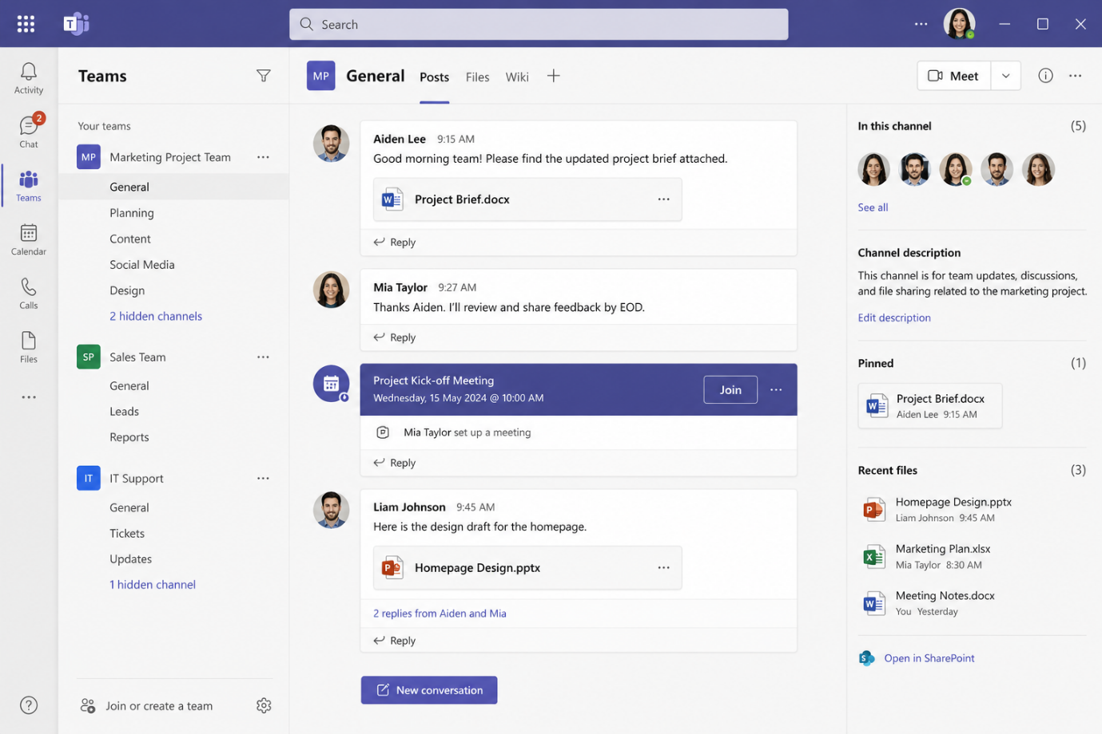
Figure 13:Microsoft Teams interface is used for business communication and virtual meetings.
Description:
The picture shows the Microsoft Teams dashboard with chat facilities, meeting section, and file-sharing, which facilitates communication in organisations.

4.2 Online Collaboration Application – Trello
Trello is an online project management and teamwork tool that assists teams in planning tasks, projects, and tracking workflow processes [17]. It applies a visual method of project management with boards, lists, and cards, which, therefore, makes it simple to help users comprehend the progress and project-related responsibilities. Businesses use Trello due to its ease of use, flexibility, and accessibility.
Trello has a very significant board system. Users have the opportunity to establish unique boards on various projects and categorise work activities in each board. Then lists are drawn up to depict different states of project development that include To Do, In Progress, and Completed. Cards represent individual tasks, which can also have descriptions, due dates, attachments, comments, and checklists.
Task assignment is another important aspect. Team members can be designated with certain duties, which could assist to enhance accountability and completion of tasks in time. Another feature of Trello that enables cooperation is the use of comments and notifications to help team members communicate and update on the activities in the project. Moreover, Trello is connected with multiple business tools, such as Google Drive, Slack, and Microsoft Teams, improving the workflow.
The best point of Trello is the visual interface that is easy to use. The team members are in a position to know the status of the project, how the tasks should be done, and their roles and responsibilities easily. Trello also enhances collaboration as two or more people can work together on the same project board at the same time.
But Trello has its drawbacks as well. Paid subscription plans might be needed to have advanced project management functions. The large organisations with highly complex projects might need a more advanced project management system. Trello.
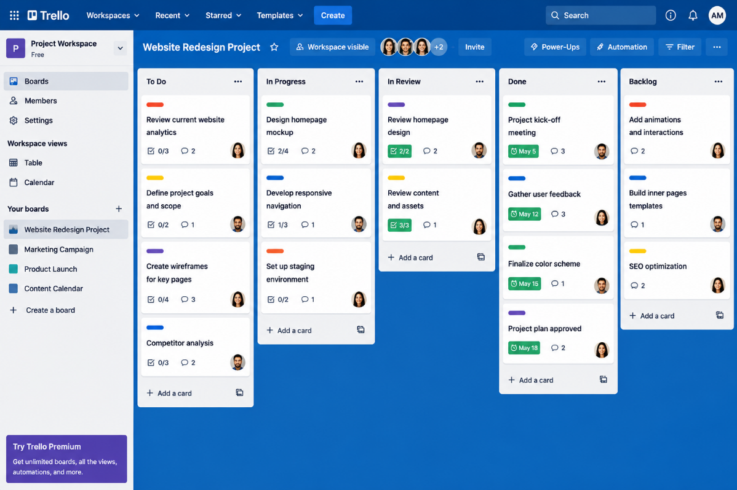
Figure 14: Trello interface used for project collaboration and workflow management.
Description: The image shows a Trello board containing project lists and task cards used to organise and manage team activities.

4.3 Practical Testing

Communication Tool: Microsoft Teams
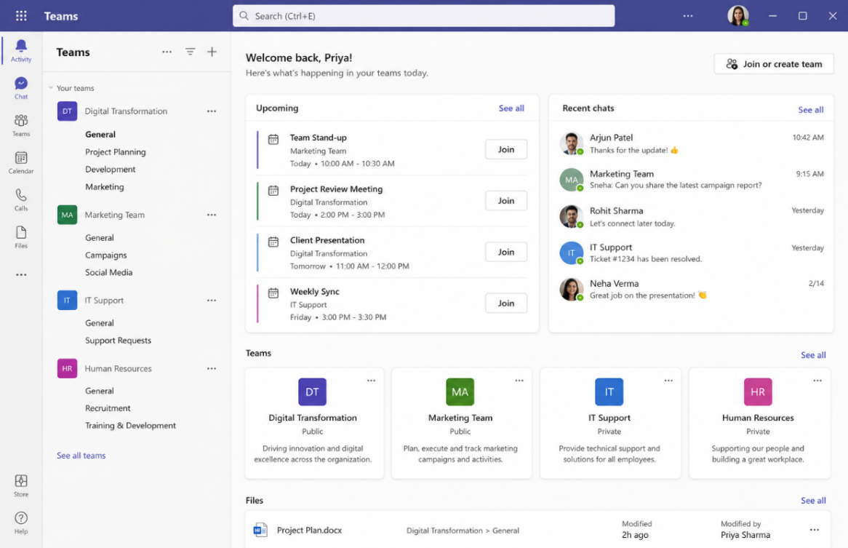
Figure 15: Microsoft Teams home dashboard
Description: The screenshot depicts the Windows Teams platform, which is used to engage in communication, share messages and manage meetings.
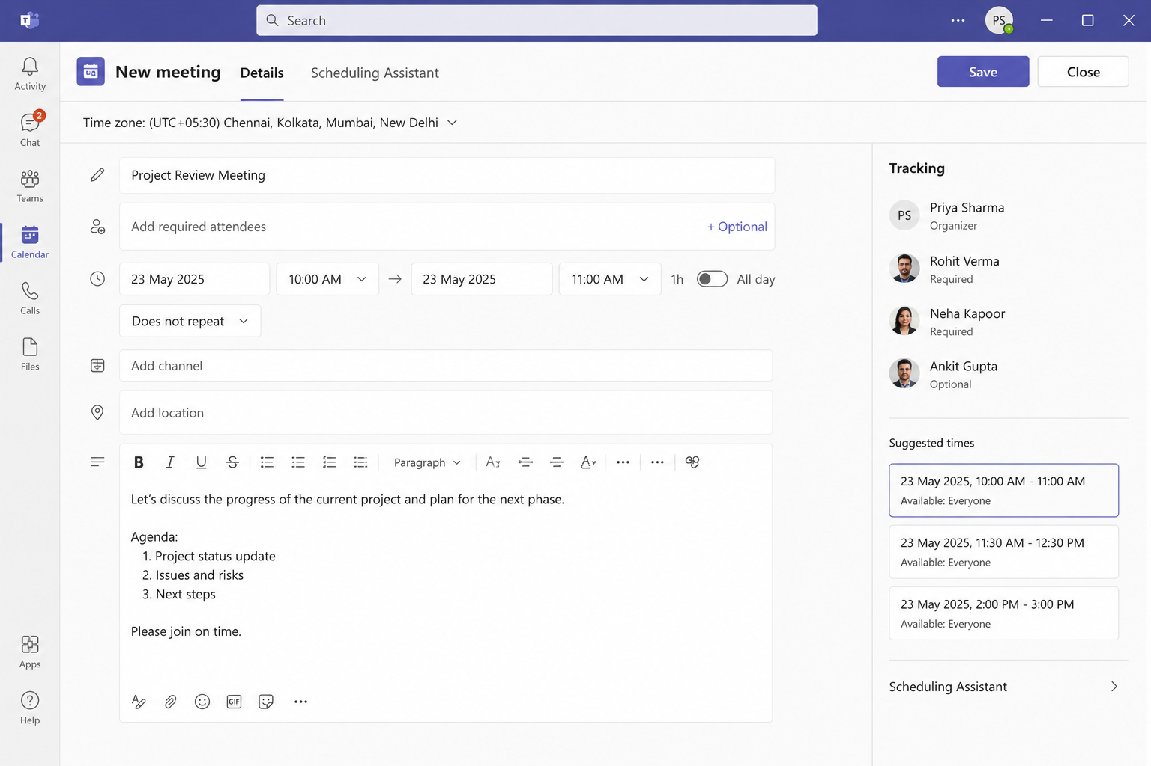
Figure 16: Meeting scheduling screen in Microsoft Teams
Description:
The screenshot illustrates how a new virtual meeting can be created with the use of Calendar and New Meeting options.
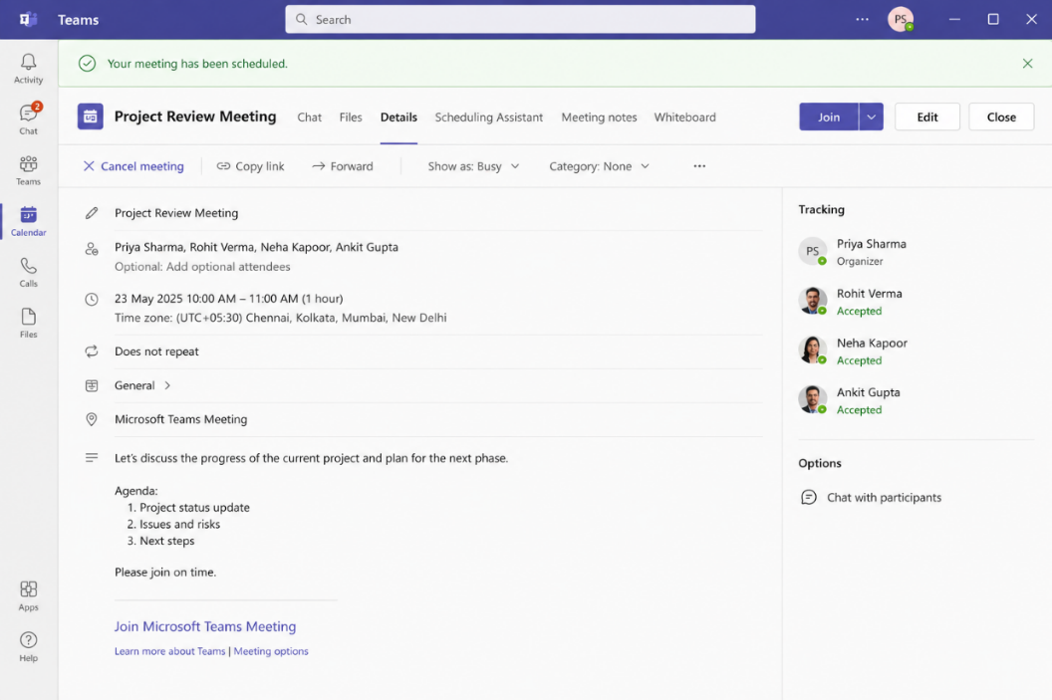
Figure 17: Successfully scheduled meeting in Microsoft Teams
Description:
The screenshot presents a Trello workspace that is utilised to collaborate on projects and manage tasks.

Collaboration Tool: Trello
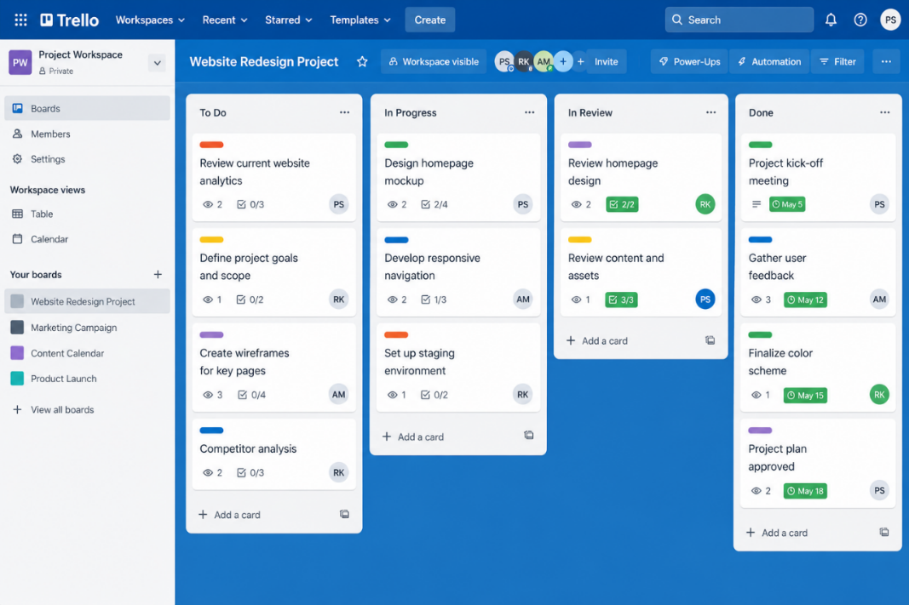
Figure 18: Trello workspace dashboard
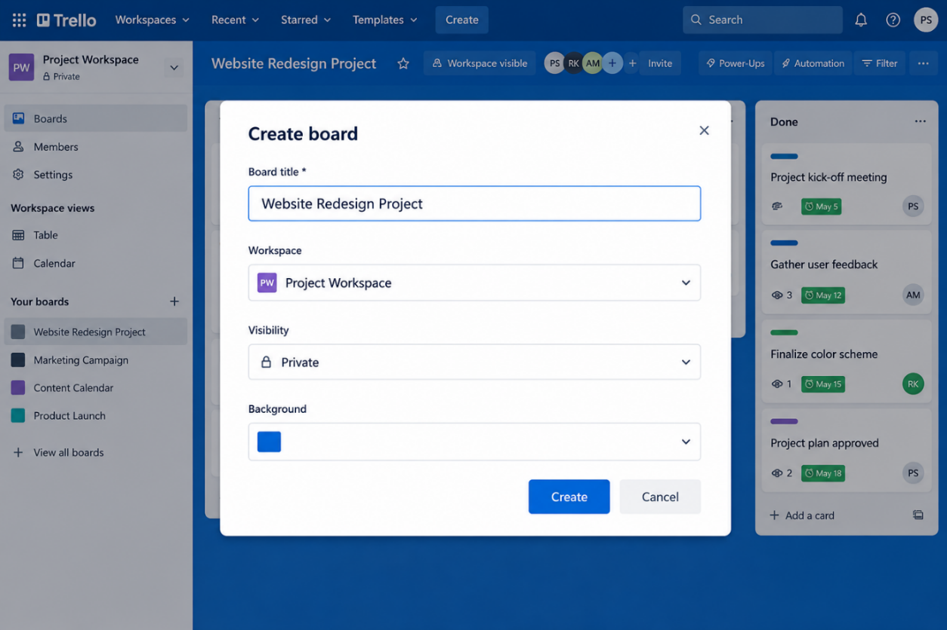
Description: The screenshot shows the project board that was created to arrange project activities.
Figure 19: New project board created in Trello
Description: The screenshot shows the project board that was created to arrange project activities.
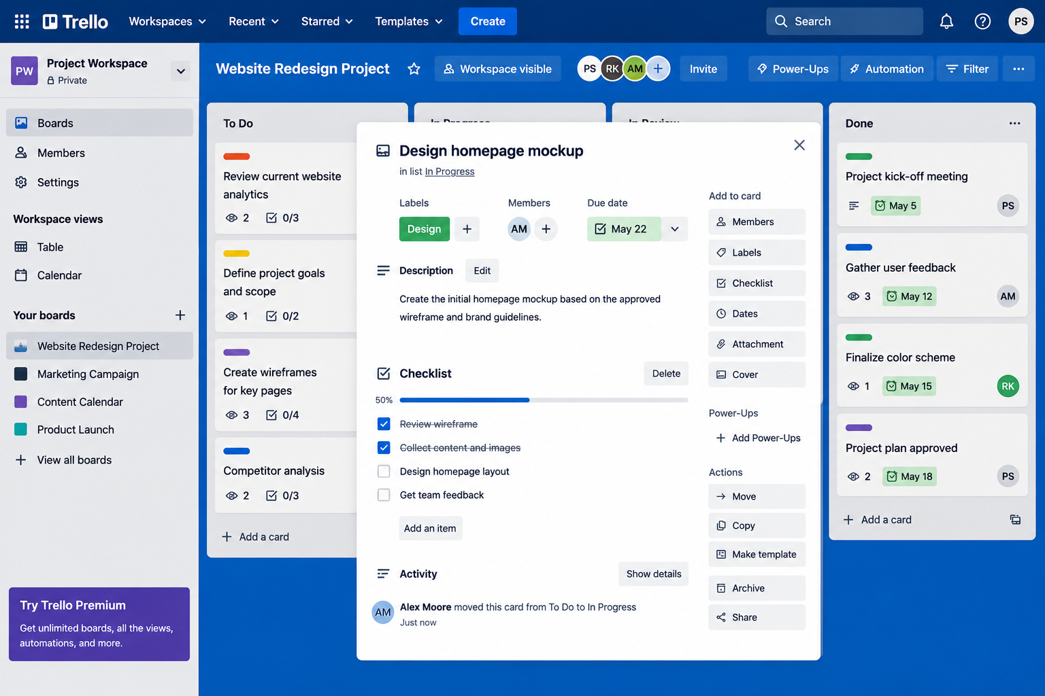
Figure 20: Task card added to the project board
Description: The screenshot displays a task card that has been developed in the project board that indicates how tasks may be allocated and followed.

Conclusion
Microsoft Teams and Trello are useful software programs that enable communication and collaboration within contemporary organisations. Microsoft Teams helps to facilitate communication by providing messaging, meetings, and file sharing, whereas Trello helps in coordinating projects by managing tasks and tracking workflows. The field activities had shown the potential of how both applications can be employed positively to enhance productivity, collaboration and organisational productivity.

Bibliography
[1]
Hamed Taherdoost, “E-Business Models and Strategies,” EAI/Springer Innovations in Communication and Computing, pp. 25–50, Jan. 2023, Available: https://link.springer.com/chapter/10.1007/978-3-031-39626-7_2
[2]
S. Bang, “Top E-Commerce CMS platforms (Shopify / WordPress / BigCommerce),” 2023. Available: https://www.theseus.fi/bitstream/handle/10024/797028/Bang_Seunghun.pdf?sequence=2
[3]
Ganegama Manage, Haneeta Dilki Senadheera, “Design and implementation of a web-based booking system for a startup cleaning company,” Theseus.fi, 2026, Available: https://www.theseus.fi/handle/10024/924158
[4]
Y. Dong, S. Zhu, and W. Li, “Promoting Sustainable Creativity: An Empirical Study on the Application of Mind Mapping Tools in Graphic Design Education,” Sustainability, vol. 13, no. 10, p. 5373, May 2021, Available: https://www.mdpi.com/2071-1050/13/10/5373
[5]
A. Prasanth, D. J. Vadakkan, P. Surendran, and B. Thomas, “Role of Artificial Intelligence and Business Decision Making,” International Journal of Advanced Computer Science and Applications, vol. 14, no. 6, pp. 965–969, 2023, Available: https://thesai.org/Downloads/Volume14No6/Paper_103-Role_of_Artificial_Intelligence_and_Business_Decision_Making.pdf
[6]
M. Rudenko and S. Sotnik, “Classification of CRM systems,” Nure.ua, 2025. https://openarchive.nure.ua/entities/publication/d9fcd54c-cf4a-43b1-b43c-4eae53416076
[7]
F. Omasirichi, “PROFICIENCY IN MICROSOFT OFFICE PROGRAMS AND THE ABILITY TO CREATE REPORTS AND DO STATISTICAL ANALYSIS AMONG OFFICE AND INFORMATION MANAGEMENT GRADUATES OF BUSINESS EDUCATION IN RIVERS STATE,” vol. 7, no. 1, pp. 2774–7471, 2025, Available: https://www.globalacademicstar.com/download/article/proficiency-in-microsoft-office-programs-and-the-ability-to-create-reports-and-do-statistical-analysis-among-office-and-information-management-graduates-of-business-education-in-rivers-state.pdf
[8]
R. Mercurio and B. Merrill, Beginning Microsoft 365 Collaboration Apps. 2021. doi: https://doi.org/10.1007/978-1-4842-6936-7.
[9]
B. Moriarty, B. Held, and T. Richardson, “Microsoft Excel Functions and Formulas,” Google Books, 2021. https://books.google.com/books?hl=en&lr=&id=nnDeEAAAQBAJ&oi=fnd&pg=PP1&dq=Functions+like+SUM
[10]
L. Ginotite, “Achieving a successful workshop: crafting a training for presentation skills,” www.theseus.fi, 2024. https://www.theseus.fi/handle/10024/859905
[11]
T. Okeme and A. Faith, “Microsoft Office Application Competencies Possessed by Office Technology and Management Students for Employability and Self-Reliance - ProQuest,” www.proquest.com, 2021. https://search.proquest.com/openview/93644cf51e7e2ed60b706b972beaaa14/1?pq-origsite=gscholar&cbl=2026366&diss=y
[12]
A. B. A. Altohami, N. A. Haron, A. H. Ales, and T. H. Law, “Investigating Approaches of Integrating BIM, IoT, and Facility Management for Renovating Existing Buildings: A Review,” Sustainability, vol. 13, no. 7, p. 3930, Apr. 2021, Available: https://www.mdpi.com/2071-1050/13/7/3930
[13]
Dr. M. Akpan, “Excel: VLOOKUP, Pivot Tables and SQL,” Emerald Publishing Limited eBooks, pp. 95–127, Jul. 2024, Available: https://www.emerald.com/insight/content/doi/10.1108/978-1-83797-819-920241011/full/html
[14]
J. Stofkova, M. Krejnus, K. R. Stofkova, P. Malega, and V. Binasova, “Use of the Analytic Hierarchy Process and Selected Methods in the Managerial Decision-Making Process in the Context of Sustainable Development,” Sustainability, vol. 14, no. 18, p. 11546, Sep. 2022, Available: https://www.mdpi.com/2071-1050/14/18/11546
[15]
M. Taş and A. Kiraz, “A Model for the Acceptance and Use of Online Meeting Tools,” Systems, vol. 11, no. 12, p. 558, Dec. 2023, Available: https://www.mdpi.com/2079-8954/11/12/558
[16]
B. N. Ilag, D. Tripathy, and Vijay Ireddy, “Microsoft Teams Overview,” Apress eBooks, pp. 1–43, Dec. 2023, Available: https://link.springer.com/chapter/10.1007/979-8-8688-0014-6_1
[17]
H. Hassen, “The use of a project management tool in distance education to enhance students’ engagement in group work,” Journal of Learning Development in Higher Education, no. 30, Mar. 2024, Available: https://journal.aldinhe.ac.uk/index.php/jldhe/article/download/1146/877

