ROBYN TRUBEY
1708724

RESEARCH METHODS
MAY 2018

A REPORT OF THE CORRELATION BETWEEN LEVELS OF IMPULSIVITY AND RISKY DRIVING BEHAVIOUR

Abstract

A framework has been outlined to demonstrate the relationship between an individual’s levels of impulsivity and risky driving behaviour. Copious amounts of previous research state how there is a strong relationship between high levels of sensation seeking and the likelihood of engaging in risky driving behaviour. This study was carried out to test whether or not that hypothesis is in fact correct. A study was carried out where twenty six participants took part in two questionnaires, one at a time. Participants firstly took part in a questionnaire their driving behaviour. Participants were then asked to respond to statements by agreeing or disagreeing about how they feel generally, in regard to measuring their levels of sensation seeking. The results demonstrated that in fact, there was a weak negative correlation between levels of impulsivity (M = 25.89, SD = 4.49) and engaging in risky driving behaviour (M = 14.58, SD = 7.89), with r = -.80, n = 26, p = 0.71. Therefore, the hypothesis in this case was rejected.
Introduction

Over the years, impulsivity and risky driving behaviour has been closely linked, the two variables measured for the purpose of this study. Impulsivity can often be understood as a personality trait an individual could obtain. There are two types of impulsivity identified throughout psychology, known as dysfunctional and functional impulsivity. Dysfunctional impulsivity is when an individual possess the tendency to behave with less anticipation than the average person of similar ability, which can be considered problematic. Whereas, functional impulsivity is an individual’s tendency to act with comparable anticipation, where optimal (Dickman, 1990). Risky driving behaviour can be defined as driving behaviour that can obviously endanger or enable the driver to put themselves or others at risk or in danger. Risky driving behaviour can be deemed deliberate or perhaps unintentional, which can commonly involve behaviours such as speeding, tailgating, improper passage etc. (Jafarpour & Rahimi-Movaghar, 2014). With the relationship between sensation seeking and risky driving behaviour being considered since the early 1970s, there has been a great emphasis on the consequences of such behaviour. With the continuous study of the correlation between risky driving behaviour and sensation seeking, there has been evidence reported to suggest to high levels of sensation seeking are related to risky driving behaviour. In a study conducted by Jonah, Thiessen & Au-Yeung published in 2001, results indicated that individuals demonstrating high levels of sensation seeking were much more likely to speed, not wear a seat belt and drink drive; compared to those who demonstrated low levels of sensation seeking. Likewise, another study was conducted where results found that sensation seeking may influence a driver’s response to alcohol impairment and alter the perceived risk of driving under the influence. The study also established how sensation seeking can be an immediate influencer on an individual’s likelihood of preforming risky driving behaviour and its consequences (Jonah, 1997). After consideration to the results of previous studies, it was hypothesised that there would be a strong positive correlation between impulsivity and risky driving behaviour.

Method

Participants
There were 26 participants involved in the study, 5 males and 21 females. Participants were asked to take part in the study whilst studying for their Research Methods module. The age of participants ranged from between 18 to 60 (M = 27.58, SD = 11.13). The study looked at participant’s driving behaviour, whilst asking what type of driving license they obtained. If participants response stated they had either a provisional or full driving license, they were asked how often they drive.

Design
The design of this study is correlational and within subject. In order to conduct analysis of the whether the correlation is significant and the direction of the correlation, the Pearson’s Product Moment Correlation will be used. There are two variables in the study that exist alongside one another, which are sensation seeking and risky driving behaviour.

Materials
The study was conducted online. Participants were provided with a consent form (see appendix A) to agree to participate in the study. Participants were asked to provide demographic information (see appendix B), stating their gender, age, what type of driving license they held (if they held one at all) and how often they drove. Participants completed two questionnaires, one regarding the individual’s risky driving behaviour taken from a study conducted in 2009 assessing ‘Novice drivers’ risky driving behaviour, risk perception and crash risk: Findings from the DRIVE study’ (see appendix C). Secondly, participants took part in a Brief Sensation Seeking Scale (BSSS), taken from a previous study considering ‘brief measures of sensation seeking for screening and large scale surveys’ conducted in 2003 (see appendix D). Finally, participants were provided with a de-brief summary (see appendix E).

Procedure
The study was conducted online, where participants were asked to complete a consent form in order to agree to participate in the study. Once participants had agreed to take part, they were asked to provide some demographic information about themselves, such as their gender, age, what type of driving license they held, if they held one at all; and if they did, how often do they drive. Participants then completed a questionnaire relating to their driving behaviour. Here, they responded to statements relating to their driving behaviour on a scale of very often to never. Then followed another questionnaire relating to the individual’s sensation seeking, where a Brief Sensation Seeking Scale (BSSS) was used. Participants had to state whether they agreed to disagreed with statements in this part. After completing both questionnaires, participants were provided with debrief of information. This stated the main objectives of the study, the hypothesis and the opportunity to withdraw from the study if participants wished. This was the end of the study for participants.

Results

For the purpose of this study, a correlation study within subjects was piloted to measure whether a relationship could be established between an individual’s risky driving behaviour and their level of sensation seeking. After calculating the results from the study, it demonstrated that there is a weak negative correlation between the impulsivity (M = 25.89, SD = 4.49) and risky driving behaviour (M = 14.58, SD = 7.89), with r = -.80, n = 26, p = 0.71. The original hypothesis for this study (stated above) suggested that there would be a strong positive correlation between levels of impulsivity and risky driving behaviour. However, as the results have demonstrated, this hypothesis must be rejected as the results suggest otherwise.

Discussion

The results from this study have rejected the proposed hypothesis. After taking into consideration previously conducted studies regarding the correlation between impulsivity and risky driving behaviour, it suggested that there would be a clear relationship demonstrated between the two variables measured in this study. It is clear that these results in particular contradict many previous studies in this subject field. From what has been demonstrated through previous literature, a study carried out by Jonah, Thiessen & Au-Yeung in 2001 determined how individuals who experienced higher levels of sensation seeking were much more likely to engage in risky driving behaviour, such as not wearing a seat belt, speeding and so on. From our results, it is demonstrated how this study clearly contradicts the results found previously. Likewise, our results again contradict another study that was carried out in 1997 by Jonah which stated how sensation seeking can have a direct influence on an individual’s likelihood to engage in risky driving behaviour.

One limitation would that be that a rather small number of male participants were used for the purpose of the study. With only 5 males involved in the study, compared to the 21 females, this could have a great influence over the results. The levels of sensation seeking could have greatly differed between male and female participants, alongside the likelihood of such participants engaging in risky driving behaviours. It would be recommended that a broader mix of both males and females could be selected for participants if the study was repeated, in order to obtain a wider scope on both male and female drivers, due to males being a minority in this study.

A further limitation to this study would be that a number of participants may not have held a full driving license. With not all participants within the study being able to drive, their results would be insufficient, due to the study not being able to measure their risky driving behaviours. It could be suggested that the study should target a group of participants which obtained a larger number of experienced drivers. When an individual is an experienced driver it can result in safer, better quality driving, as they have had plenty of experience on the road, time to perfect their driving skills and the ability to adapt to adverse driving conditions. However, experienced drivers could also fall short of developing good driving skills. Instead, more experienced drivers could pick up bad habits, become over confident in their driving abilities and being too relaxed about driving regulations or rules. This could too result in an individual being more likely to engage in risky driving behaviour. Furthermore, if the study was to target more experienced driver for the purpose of the study, they would be able to gather a more thorough understanding of those who experience high levels of sensation seeking and engage in risky driving behaviour.

In conclusion, this study demonstrated a weak correlation between sensation seeking and risky driving behaviour. In the future, further research could be conducted to consider how other factors can influence an individual’s likelihood to engage in risky driving behaviour. For example, the relationship between levels of sensation seeking and risky driving behaviour could be compared across males and females, as well as between different age groups.

Reference List

Dahlen, E. R., Martin, R. C., Ragan, K., & Kuhlman, M. M. (2005). Driving anger, sensation seeking, impulsiveness, and boredom proneness in the prediction of unsafe driving. Accident Analysis & Prevention, 37(2), 341-348.

Dickman, S. J. (1990). Functional and dysfunctional impulsivity: personality and cognitive correlates. Journal of personality and social psychology, 58(1), 95.

Jafarpour, S., & Rahimi-Movaghar, V. (2014). Determinants of risky driving behavior: a narrative review. Medical journal of the Islamic Republic of Iran, 28, 142.

Jonah, B. A. (1997). Sensation seeking and risky driving: a review and synthesis of the literature. Accident Analysis & Prevention, 29(5), 651-665.

Appendix
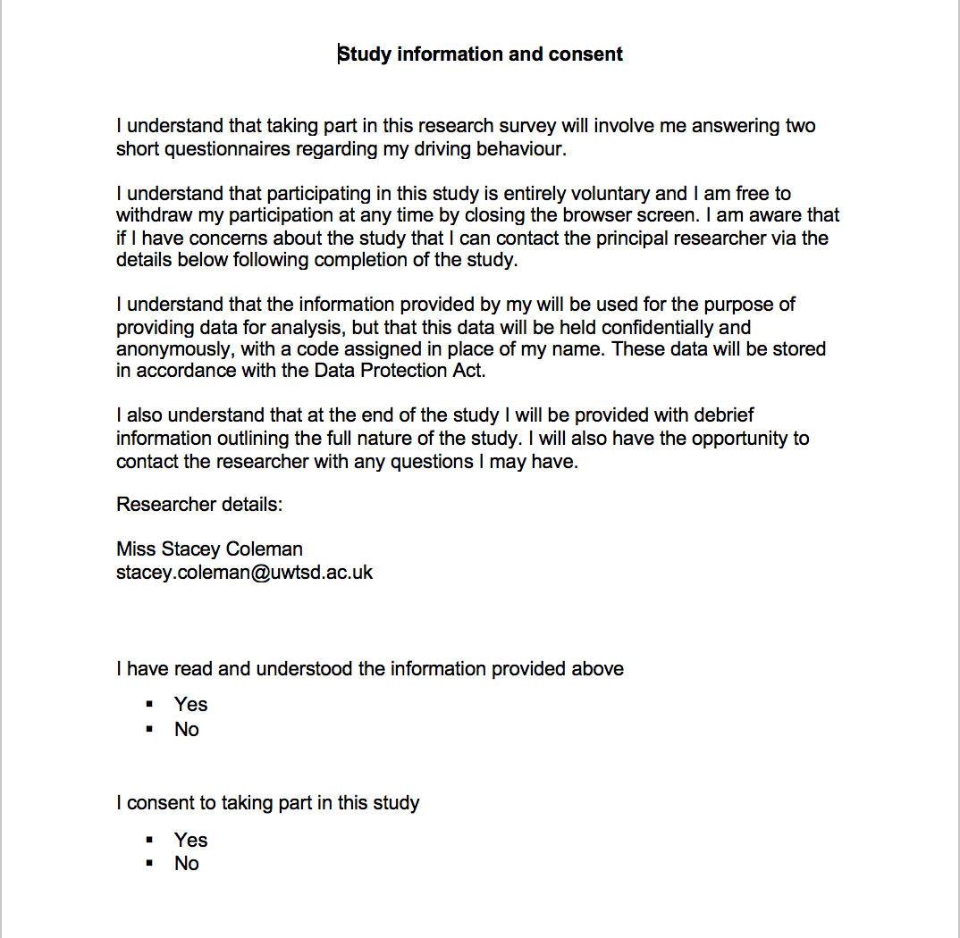
- Consent Form

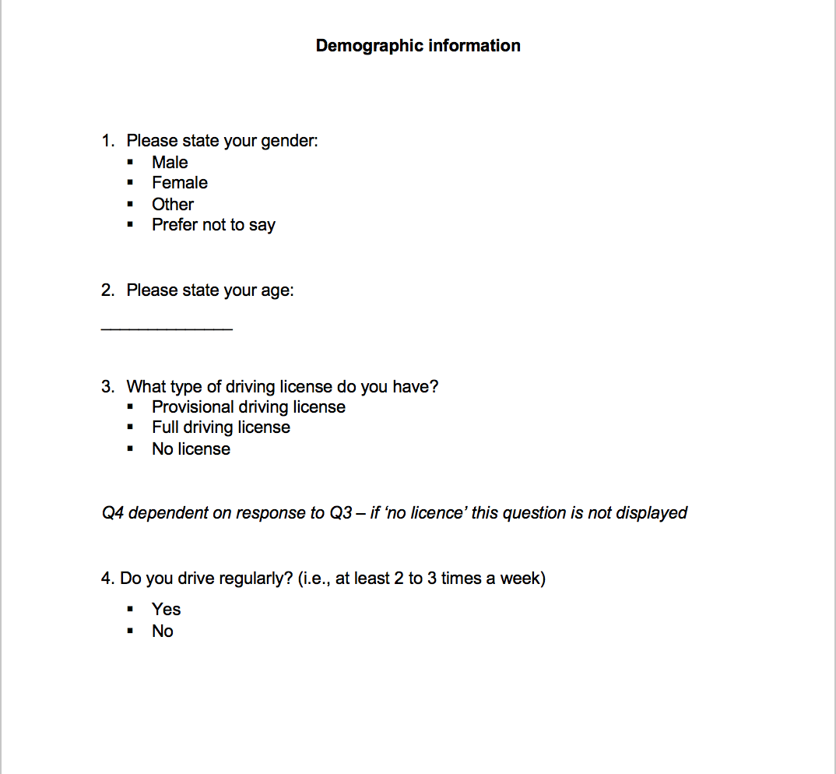
- Demographics

- Risky Driving Behaviour Questionnaire
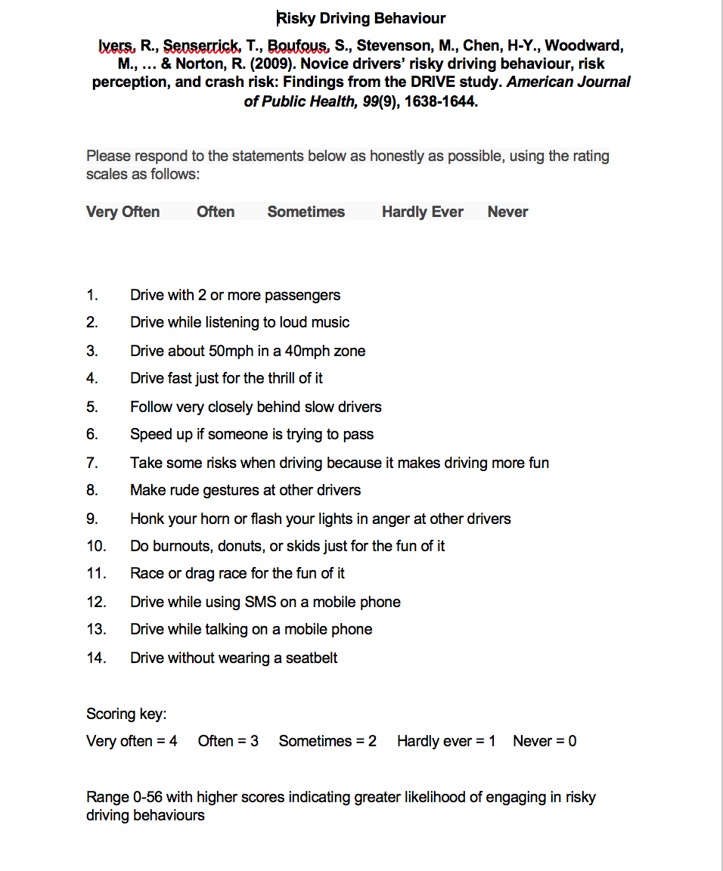

- Brief Sensation Seeking Scale (BSSS) Questionnaire

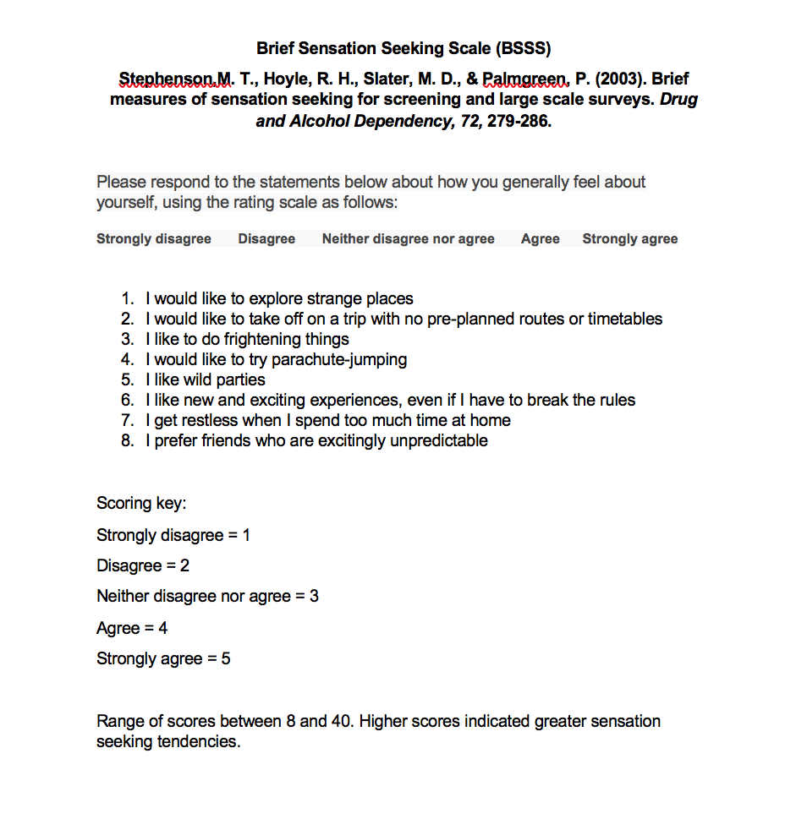

- Debrief Information


