University of Wales Trinity Saint David
School of Engineering
Report on Using Technology and Natural Resources to Improve Business Performance
Lauren Lloyd
2315243
Degree Apprenticeship in Logistics and Supply Chain Management
8th January 2026
Logistics Technologies (ACMA5016)

Table of Contents
List of figures and tables 2
Introduction 3
Question 1 4
Question 2 8
Conclusion 10
Table of prioritised recommendations 11
References 12

List of figures and tables
Figure 1: Growth in AI Damage Detection Market (Chakradhari, 2024) 5
Figure 2: Steps of AI in Quality Control (Gallerneault, 2025) 6

Introduction
Fresh Produce Limited is a company specialising in supplying fruit and vegetables to various sectors throughout the UK. They supply produce in large plastic trays which are then re-used for future deliveries, enabled by the sterilisation process in use, where all returned trays are washed at 60 degrees Celsius to remove any dirt off the trays. However, Fresh Produce Limited have recently been receiving a large volume of complaints from their customers who claim that the trays that they are receiving produce on have been dirty and/ or damaged. In addition to these complaints, Fresh Produce are also struggling with a significant rise in their energy costs which are straining the company’s profit levels. This report aims to investigate how Fresh Produce can detect dirty and damaged trays in their processes to reduce the number of faulty trays they are sending to customers, whilst also exploring methods that Fresh Produce could employ to reduce the amount spent on expenses throughout the business, with an aim to investigate some energy reduction methods that could help Fresh Produce to reach their net zero targets, an ever important topic in recent years.

Question 1
Quality control is a key aspect within businesses, ensuring maintained product excellence, waste reduction, and customer satisfaction (Six Sigma, 2025). In manufacturing, this can involve products being inspected against set standards to ensure every product meets the established requirements, boosting product reliability and consistency (Six Sigma, 2025). Traditionally, the quality control methods in use within businesses have been visual or manual inspection, typically relying upon human performance to make correct judgements. However, there is a general unreliability when using humans alone, as various factors like fatigue, distractions or inconsistent working conditions can significantly impact the inspector’s ability to accurately identify any defects (SBN Software, 2025). This can lead to wrong judgement calls being made, potentially causing defects to escape into the market, resulting in poor brand reputation. The various challenges of relying upon humans alone for quality control has led businesses to seek more technical methods of inspection, moving away from manual inspection in recent years and towards AI detection, seen through the growth in the AI damage detection market in Figure 1 (Chakradhari, 2024).
Figure 1: Growth in AI Damage Detection Market (Chakradhari, 2024)
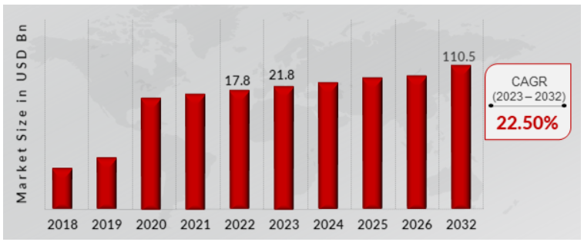

In Fresh Produce Limited, there is not a quality inspection role in place which would help to identify any broken or dirty trays, which could be a main factor as to why there are a number of complaints being received by their customers. There are many methods Fresh Produce Limited could take to resolve this, one being to employ a visual inspector to check tray quality and take corrective action when trays with defects are found. However, as previously mentioned, there can be an unreliability that occurs when using humans alone, and with the rise in ability of technology, it begs the question whether it would be more beneficial to employ AI technology to do the job instead.

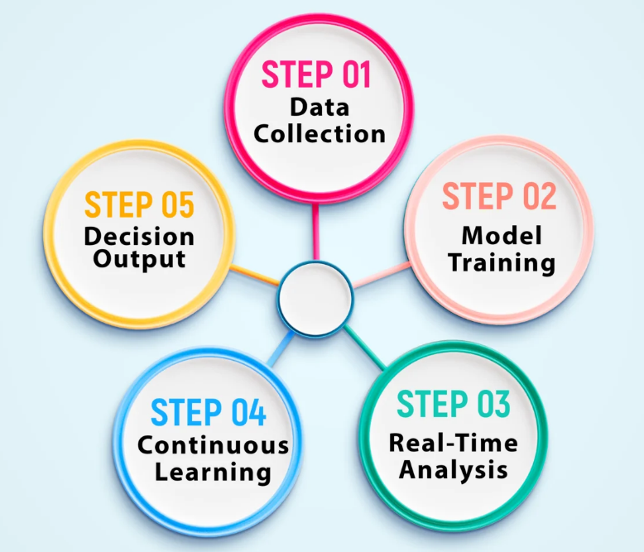
Artificial intelligence in quality control can work through image capture, and then through using algorithms to learn patterns from various data collected, including training the algorithms on what is a good example and what is a bad example, so in time the algorithm will learn and automatically pick up defects (Gallerneault, 2025). The various stages of this can be seen in Figure 2.
Figure 2: Steps of AI in Quality Control (Gallerneault, 2025)

In determining the feasibility of using AI technology to detect dirty and damaged trays, a key aspect of consideration is the technical ability – can AI accurately and consistently detect defects on the trays? A study carried out by The National Library of Medicine showed that through the use of computer vision and deep learning, there is a defect detection accuracy rate of up to 99.86%, highlighting the ability of AI to accurately identify defects (Sundaram & Zeid, 2023). However, an important element to consider is the skill set required to train these algorithms to identify good and bad trays. If this skillset is not currently available within Fresh Produce Limited, and they choose to go ahead with AI detection in quality control, there is a high risk that it will fail as they will not have the adequate resource to work with the machines to train them (Gallerneault, 2025). They will potentially need to recruit for this role which will be an additional cost to consider.

This leads onto the economic feasibility element of exploring the implementation of AI in quality control. If Fresh Produce Limited switch to AI detection methods, there are potential long term monetary savings in the form of improved quality. However, when implementing AI into a business, there are considerably high upfront costs (Bansal, 2024). Fresh Produce would need to do a return on investment calculation to evaluate whether the potential long-term savings would justify the short-term expense.

Another element to consider would be where in the process the AI device could be implemented, and furthermore, how many AI detectors would be required within the process. A critical point where inspection could be beneficial within the process could be post-sanitisation, so that if any trays still have dirt on them, they can be identified and put back through the process prior to packaging and distribution. In addition to this, it may be beneficial to implement an AI quality checker in the receiving process, prior to the trays going through sanitisation. This quality station could help to identify damaged trays prior to them going through the sanitisation process, saving Fresh Produce time and money as putting trays through the sanitisation stage can be an energy intensive process. However, if they haven’t been sanitised it may make identifying any damage to the trays harder to detect.

Overall, AI implementation could offer various benefits to Fresh Produce, seen in the high technical ability to identify defects, enabling Fresh Produce to pick up any issues with the trays and take corrective action prior to sending them to customers. In turn, this would result in a reduction in the number of complaints from customers and hopefully improved brand reputation. In addition to this, AI inspection methods are considered to be more accurate than traditional inspection methods, and are considered to be faster, and more consistent, which plays a key role in quality inspection (Guy, 2024).
However, though AI quality checking methods can be considered feasible for Fresh Produce Limited, the challenges and barriers of this must also be addressed. Implementing AI into operations can be expensive upfront, but this is not the only cost that Fresh Produce will incur as they will also require highly skilled personnel to train the AI and maintain it’s abilities. Fresh Produce must consider whether the improved quality, accuracy, and speed outweigh the expense, resource requirements, and integration complexity.

Question 2
Since 2021, the average electricity price for non-domestic users in the UK has increased by around 75%, with the UK having the highest industrial electricity pricing in the IEA (Office for National Statistics, 2025). Fresh Produce Limited has been facing a struggle with increasing energy pricing due to the energy intensive nature of their business. In addition to the rising energy costs, the cost of fuelling vehicles is also high, with fuel margins remaining at persistently high levels (Competition and Markets Authority, 2025).

Within Fresh Produce Limited, there is a requirement to sanitise all trays at a temperature of 60°C before they are re-used. The impact this has on the business is that the amount of water in use is extremely high, and water is an expensive commodity (Kurth, et al., 2025). Ultimately, the aim would be to reduce the amount of money spent on acquiring and heating up the water and to do this, there are many different elements the business can explore.

Rainwater harvesting is becoming increasingly popular within the UK, with over 400 harvesting systems implemented annually, attributed to the increasing water prices making rainwater harvesting more favourable (Business Wales, n.d.). The use of rainwater harvesting within a business has many benefits, including a reduction of the amount needed to spend on water bills, low maintenance requirements, and it ties in closely with their sustainability goals, as through using rainwater, there is a reduction in demand for mainstream water, helping to reduce water scarcity (Lopes, et al., 2017). Although it is a good method in theory, there are other elements to take into consideration when determining the feasibility of this, such as the high initial set up costs, unpredictability of the rainfall (though average rainfall levels in an area can be considered), and high space that will be required for the storage tanks (Pala, et al., 2021).

In addition to the above, another element to consider is alternative methods of getting energy to heat the water to 60°C. One of the more popular ways to generate electricity sustainably is through the use of solar panels – Fresh Produce Limited could use solar thermal technology to convert sunlight into thermal energy which can significantly reduce their energy consumption (Hartman, 2025). A consideration of this would be whether the investment would be worth it due to the unpredictable weather in the UK, though studies show that solar panels are in fact highly effective in the UK as even on an overcast day, the solar panels can still produce energy (Lawrence, 2025). However, it would mean that in the winter months, Fresh Produce Limited would not be able to fully rely on this solar technology due to shorter daylight hours, meaning they would have to rely more on other energy sources which are more expensive, though depending on the amount of solar panels they purchase, in the summer months if they generate more energy than they require, they can sell it and make profit that way. They must also consider where they would place these solar panels in their business, such as on a south facing roof, side walls, or on unused excess outside space. However, they must evaluate where they place solar panels very carefully, as they must not place them in areas that could block potential expansion opportunities if that is something to consider for the future.

If Fresh Produce Limited currently discard water that is dirty after each sanitisation process, a more environmentally conscious way of using water would be to implement a basic water filtration system. Installing a filtration system would enable water to be reused multiple times, resulting in a reduced need to heat up fresh, cold water which uses far more energy to heat up compared to water that is already warm. In addition to this, the effectiveness of the water could also be improved as filtered water removes the larger dirt particles, enabling the trays to be cleaned more effectively. This should also help to reduce the number of dirty trays that are getting to the customer. Implementing even a basic filtration system would significantly reduce their energy costs, and reduce their impact on the environment, helping them to reach their net zero goals (Rushing, 2025). However, a barrier to implementation would be the high initial costs of installing the filtration system, ensuring it integrates effectively with the equipment that is currently in place, along with any maintenance requirements to ensure it is operating correctly (Rushing, 2025).

Conclusion
In Conclusion, the practicality of implementing AI into the business as a quality checking function can be considered high. Previous studies on AI accuracy rates proved highly successful, highlighting that their technical ability is effective and consistent. However, there are still challenges that Fresh Produce may face if they opt to implement AI into their operation - specifically cost, integration, and resource availability. The key element that Fresh Produce must consider is whether the potential long-term benefits outweigh the costs, or other suitable methods of quality control, such as human checkers.

Additionally, whilst the requirement of heating the trays up to 60 degrees Celsius is a requirement that contributes significantly to high energy costs, this report has explored multiple methods to either reduce energy consumption, or reduce the costs associated with high energy usage. Rainwater harvesting along with filtration is a strong option to consider in terms of feasibility of implementing into the operation which can reduce energy costs, and solar thermal technology would help Fresh Produce to generate their own energy for heating up the water for the sanitisation process. Each of these methods have their own benefits and strengths, but overall are options worthwhile considering for Fresh Produce to be able to retain more of their profits and enabling them to meet their net zero goals.

Overall, there are various elements that Fresh Produce Limited could explore to both reduce energy costs and reduce the number of damaged trays escaping their process. For each potential option, there will be cost implications that Fresh Produce will have to consider, though the overall improved quality, customer satisfaction, and reduction in energy consumption as a result of these measures suggests that they are highly feasible.

Table of prioritised recommendations
Priority | Recommendation | Rationale | Expected Impact
High | Implement a filtration system | Less water gets discarded unnecessarily; water can be reused | Reduced water costs, water can be maintained at 60°C
High | Implement AI for quality checking (computer vision) | Dirty and damaged trays are identified and measures taken to counter-act | Less dirty and damaged trays will be sent to customers, resulting in improved customer satisfaction
High | Installation of solar panels | Energy can be generated onsite to fuel sanitisation process | Mainstream energy usage reduction resulting in reduced energy costs
Medium | Rainwater harvesting | Water is captured and re-used in process, better for sustainability goals | Less cost spent on traditional water acquisition

References
Bansal, A., 2024. Maximizing Cost Savings And Efficiency With AI-Driven Quality Control: A Business Perspective. [Online]
Available at: https://www.forbes.com/councils/forbestechcouncil/2024/06/06/maximizing-cost-savings-and-efficiency-with-ai-driven-quality-control-a-business-perspective/
[Accessed 5 January 2026].
Business Wales, n.d. Rainwater harvesting. [Online]
Available at: https://businesswales.gov.wales/topics-and-guidance/sustainability-and-social-responsibility/resource-efficiency/water/rainwater-harvesting
[Accessed 23 December 2025].
Chakradhari, L., 2024. AI for Defect Detection in Manufacturing Industry: A Comprehensive Guide. [Online]
Available at: https://kritikalsolutions.com/ai-for-defect-detection-in-manufacturing-industry/
[Accessed 4 January 2026].
Competition and Markets Authority, 2025. Fuel margins remain “persistently high” and this is not explained by operating costs, CMA finds. [Online]
Available at: https://www.gov.uk/government/news/fuel-margins-remain-persistently-high-and-this-is-not-explained-by-operating-costs-cma-finds
[Accessed 23 December 2025].
Gallerneault, M., 2025. Machine Learning in Quality Control. [Online]
Available at: https://ai-innovate.com/machine-learning-in-quality-control/
[Accessed 6 January 2026].
Guy, J., 2024. AI Quality Inspection vs Traditional Inspection Methods. [Online]
Available at: https://www.loopr.ai/blogs/ai-quality-inspection-vs-traditional-inspection-methods-a-comparative-analysis
[Accessed 4 January 2026].
Hartman, E., 2025. Sustainable Water Heating Alternatives For UK Homes: A Guide to Eco-Friendly Solutions. [Online]
Available at: https://fastsolar.uk/blog/sustainable-water-heating-alternatives-for-uk-home
[Accessed 23 December 2025].
Kurth, T. et al., 2025. What Is Water Really Worth?. [Online]
Available at: https://www.bcg.com/publications/2025/what-is-water-really-worth
[Accessed 6 January 2026].
Lawrence, K., 2025. Which? - Are solar panels worth it?. [Online]
Available at: https://www.which.co.uk/reviews/solar-panels/article/solar-panels/are-solar-panels-worth-it-aIzWf7E3P0dO
[Accessed 23 December 2025].
Lopes, V. A., Marques, G. F., Dornelles, F. & Medellin-Azuara, J., 2017. Performance of rainwater harvesting systems under scenarios of non-potable water demand and roof area typologies using a stochastic approach. Journal of Cleaner Production.
Office for National Statistics, 2025. The impact of higher energy costs on UK businesses: 2021 to 2024. [Online]
Available at: https://www.ons.gov.uk/economy/economicoutputandproductivity/output/articles/theimpactofhigherenergycostsonukbusinesses/2021to2024
[Accessed 23 December 2025].
Pala, G. K. et al., 2021. Rainwater harvesting - A review on conservation, creation & cost-effectiveness. Materials Today: Proceedings, 45(7), pp. 6567-6571.
Rushing, B., 2025. What is Water Filtration System: Benefits and Insights. [Online]
Available at: https://watersystemplus.com/what-is-water-filtration-system-benefits-and-insights/
[Accessed 23 December 2025].
SBN Software, 2025. What are the challenges of manual inspection processes?. [Online]
Available at: https://sbnsoftware.com/blog/what-are-the-challenges-of-manual-inspection-processes/
[Accessed 21 December 2025].
Six Sigma, 2025. The Guide to Quality Control in Manufacturing: Strategies, Tools, and Best Practices. [Online]
Available at: https://www.6sigma.us/manufacturing/quality-control-in-manufacturing/
[Accessed 21 December 2025].
Sundaram, S. & Zeid, A., 2023. Artificial Intelligence-Based Smart Quality Inspection for Manufacturing. Micromachines (Basel), 14(3).

