

Challenges Faced By UK Companies In Entering The European Market After Brexit: A Case Evaluation Of M&S Food

Student Name: Alima Niva
Student ID: 2431109
Module Name: Dissertation
Module ID: LCMB7035

DECLARATATION
Please add the following paragraph: I, Alima Niva, declare that this dissertation has been composed by myself, that the work contained herein is entirely my own except where explicitly stated otherwise in the text, and that this work has not been submitted for any other degree or qualification, in whole or in part, except as specified.

Signature: Alima Niva
Date: 28th Aug 2026
ABSTRACT
Beginning in 2021 the United Kingdom’s (UK) Trade and Cooperation Agreement (TCA) with the European Union (EU) changed how UK businesses function in the EU market. UK companies must now make customs declarations and origin cases, among other things, and risk SPS controls. These new processes, along with many others, have impacted the food sector the hardest. In the three years following Brexit, there was a 27% fall in UK exports and a 32% fall in UK imports, even while food exports remained over 30% lower than they were before Brexit. In the absence of data at the firm level, these losses paint an incomplete picture of how UK firms have been able to adapt.
The aim of this dissertation is to fill the firm-level gap in the literature, which is achieved by using a single case study of Marks and Spencer (M&S) Food. This dissertation relies solely on published company data from corporate reports and government data along with EU, industry, think tanks, and scholarly sources. The Political, Economic, Social, Legal (PEOL), and especially Legal, components of the PESTEL framework comprise the primary tools of the analysis. This is reinforced by the use of cross-sector comparators.
The results show how M&S Food built a new EU Distribution Center in Poland and improved its profitability in Ireland by £11.6 million. This was done through adaptable operations and strategies, and not an absolute absorption of costs.
This dissertation provides new firm-level evidence to the Brexit trade literature, offers insights on how to better inform trade policy regarding the SPS and TCA reviews, and provides analytics and insights for UK exporters in the EU market.
ACKNOWLEDGEMENT
First, I would like to express my gratitude to my dissertation supervisor for the patient guidance, the constructive feedback, and the willingness to challenge my thinking throughout the research process. The strength of any argument that survives in the chapters that follow owes much to that supervision; any weakness is my own.
I am also grateful to the staff of the University of Wales Trinity Saint David, whose teaching across the MBA programme provided the foundation on which this study has been built, and to the library team whose support in accessing open-access research materials was invaluable.
To my family, thank you for your constant patience and encouragement during the long evenings and weekends that this work demanded. To my friends and fellow MBA students, thank you for the conversations, the moral support, and the shared experience of working through this stage of our lives together.
Any errors or shortcomings that remain in the dissertation are entirely my own.

Table of Contents
CHAPTER 1: INTRODUCTION 4
1.1 Background and Problem Statement 4
1.2 Research Aim 5
1.3 Research Objectives 6
1.4 Research Questions 6
1.5 Significance of the Study 6
1.6 Brief Research Methodology 7
1.7 Structure of the Rest of the Project 7
CHAPTER 2: LITERATURE REVIEW 8
2.1 Introduction 8
2.2 Research Areas and Topics 9
2.3 Conceptual Framework 17
2.4 Conclusion of Chapter 21
CHAPTER 3: RESEARCH METHODOLOGY 22
3.1 Introduction 22
3.2 Research Philosophy and Assumptions 22
3.3 Research Design 24
3.4 Research Approach 26
3.5 Data Collection Methods 27
3.6 Ethical Considerations 29
3.7 Conclusion 30
CHAPTER 4: FINDINGS / RESULTS, ANALYSIS AND DISCUSSION 31
4.1 Introduction 31
4.2 Summary of Findings 31
4.3 Analysis of Results 34
4.4 Discussion of Results 38
CHAPTER 5: CONCLUSIONS AND RECOMMENDATIONS 41
5.1 Summary of Main Findings 41
5.2 Conclusion Based on the Research Questions 41
5.3 Recommendations - Practical and Theoretical 42
5.4 Limitations of Research 43
5.5 Recommendations for Future Work 43
References 44
Appendices 52

Contents of Figures
- Figure 2.1: PESTEL Lens Applied to M&S Food's Post-Brexit Operating Environment Political
- Figure 3.1 - The Research Onion Applied to This Study
Contents of Tables
- Table 3.1 - Comparison of Research Philosophies
- Table 3.2 - Data Sources, Purpose, and Limitations
- Table 4.1 - Summary of PESTEL Findings for M&S Food and the UK Food Sector
- Table 4.2 - PESTEL Sub-Themes for M&S Food
- Table 4.3 - Cross-Sector Comparator Matrix
- Table B.1 - Secondary Data Source List
- Table C.1 - Databases and Repositories Searched
- Table C.2 - Search Terms by Keyword Category
- Table C.3 - Inclusion and Exclusion Criteria
- Table D.1 - Data Extraction Table
- Table E.1 - PESTEL Coding / Analysis Matrix

CHAPTER 1: INTRODUCTION

1.1 Background and Problem Statement
The Trade and Cooperation Agreement (TCA) that went into effect in January 2021 after the UK's official Brexit from the EU was a major turning point for UK external trade. The TCA maintained the EU’s agreement of no tariffs or quotas, but did almost the complete opposite of the agreement, introducing customs, origin and SPS declarations, as well as new trade coupling and tracing. Because of the TCA, the UK’s new TCA trading environment with the EU introduced new conditions that the UK had not had to deal with in decades (Sampson and Dhingra, 2022; Dhingra and Sampson, 2022). For businesses, the TCA meant a radical new model for doing business with the EU, increasing the costs, time and complexity for businesses to trade with the EU.
The TCA has had a significant negative impact on UK trade with the EU. Du et al. (2024) estimate that for the first three years following the implementation of the TCA, UK exports to the EU fell by 27% and UK imports of EU goods fell by 32%. A four-year review of the TCA by the European Central Bank agrees and adds that the trade gap has not shrunk (European Central Bank, 2025). Customs data has shown that the impact of the TCA on UK-EU trade has not been equal. Smaller exporters have either reduced or completely ceased trading with the EU, while larger exporters have been able to invest in and adapt to the changes in the trade environment (Freeman et al., 2022; Freeman et al., 2024). The Resolution Foundation estimates the shortfall in UK trade with the EU at £74 billion, which represents the cumulative gap in the value of goods exports compared to 2019 (Hale, Hunsaker and Pittaway, 2026). This value also represents the durable shock to trade, which is not expected to be a temporary trade gap.
Among the sectors most severely impacted by Brexit, the food sector has displayed one of the highest levels of concentration of the post-Brexit economic damage. The Food and Drink Federation (2025) puts the fall in the volume of food exports from the UK at 12.6% for the year up to 2024, and in its latest Trade Snapshot, food exports remain almost 30% below the levels seen before Brexit (Food and Drink Federation, 2026). Being a trade organization and a stakeholder in the policy debate, FDF's numbers require triangulation. The European Central Bank’s econometric analysis arrives at a similar assessment (European Central Bank, 2025), and Du and Shepotylo (2025) carry out the most extensive academic work to date on the food-specific case, citing SPS provisions as the main explanatory factor for the observed decrease in UK agri-food trade after the TCA. The agreement of an industry-body source, a policy-institution source, and a peer-reviewed academic source on the same conclusion makes this as robust as one could hope for.
Marks and Spencer Food is a useful case study for major UK premium food retailers responding to changing conditions. Marks and Spencer was founded in 1884, renamed in 1894, and began selling food in the 1930s. Today, M&S has over 1000 UK stores, and has longstanding stores in the Republic of Ireland that cross the Irish Sea, and a newly opened EU distribution center in Poland (Marks and Spencer Group plc, 2024). Their latest Annual Report shows that the Republic of Ireland branch made an operating profit of £27.9 million, an increase of £11.6 million compared to last year, which defies the trend of a contracted sector. M&S Food has a line of products that have a short shelf life and are premium positioned. Because of this, they are especially vulnerable to SPS regulation, border delays, and rules of origin compliance. These three issues are cited most often as problematic for the agri-Food industry in the literature.
Despite the extensive literature on macro- and sector-level issues, adaptations of individual UK food companies still lack qualitative research. Bailey, Pitelis and Tomlinson (2023) mention this absence in the context of manufacturing, while Freeman et al. (2024) claim that the largest UK food companies have absorbed the shock in ways that aggregate data cannot illustrate. This dissertation puts forth evidence that fills the gap in the literature by providing a qualitative firm-level account of premium UK food retailers that reorganized enterprise frameworks in response to the post-Brexit climate to improve EU facing trade relations.
This dissertation remedies the lack of firm-level evidence regarding premium UK food-retailer adaptation to the EU post-Brexit market by using M&S Food as an instrumental case study.

1.2 Research Aim
To critically examine the issues experienced by UK companies upon entering into and operating in the European market following the Brexit event by using M&S Food as the main case-study whilst eliciting comparable examples by other recent researches of other businesses and industries in the United Kingdom. The importance is to generate a firm-level evidence that is complemented to the current aggregate analyses as well as has transferable implications to UK firms, policymakers, and trade scholars.
.

1.3 Research Objectives
- To determine the main regulatory, logistical and non-tariff barriers Brexit has introduced to the entry of the UK firms into the EU market mainly in food.
- To understand how M&S Food has responded in its supply chain and strategy.
- To analyze the case of M&S Food, will compare M&S Food with other UK companies in search of transferable lessons and identify their broader implications.

1.4 Research Questions
RQ1: What are the main regulatory, logistical and non-tariff barriers Brexit has introduced to the entry of UK firms into the EU market, mainly in food?
RQ2: What has M&S Food’s response been to the challenges of Brexit in terms of the supply chain and strategy?
RQ3: What transferable lessons and broader implications emerge from comparing M&S Food's case with other UK companies?

1.5 Significance of the Study
This study can be seen as impactful in three ways: in academia, in business and in policy.
Relevant to academia. This dissertation builds on Freeman et al.’s (2024) customs-data and addresses the firm-level gap in Bailey, Pitelis and Tomlinson (2023). Much of the existing literature has focused on macro-econometric estimates on the trade impact of Brexit (Du et al., 2024; Sampson and Dhingra, 2022; European Central Bank, 2025; Dhingra and Sampson, 2022) that discuss the decrease of UK-EU trade, with little to no analysis on the impact on the operations of firms. This dissertation builds on existing literature and adopts the PESTEL framework and analyses a short-shelf-life, regulation-sensitive firm with a qualitative case study of a premium food retailer that has been largely dominated by macro and aggregate data. This dissertation does this in the context of post-Brexit and provides a unique framework of analysis in the discourse.
Relevant to business. The research has the potential to shape strategies of supply chain and strategy managers in UK food retail. The decline in UK goods exports (Hale, Hunsaker and Pittaway, 2026; Fry and Hale, 2024) and concentrated non-tariff damage in the food sector (Du and Shepotylo, 2025; Food and Drink Federation, 2025; Food and Drink Federation, 2026) indicates that the case of M&S Food will be most relevant to firms such as Waitrose, Sainsbury’s and Ocado.
Relevant to Policy. This type of firm-level evidence is directly applicable to the proposed EU-UK SPS agreement (European Parliamentary Research Service, 2025b; House of Commons Library, 2025), the continued application of the Windsor Framework (House of Commons Library, 2023; European Parliamentary Research Service, 2023; House of Commons Library, 2024), and the recent industrial-strategy debate triggered by the enduring goods-export deficit (Hale, Hunsaker and Pittaway, 2026; Resolution Foundation and Centre for Economic Performance, 2023)..

1.6 Brief Research Methodology
This dissertation is based on the interpretivist research philosophy (Lim, 2023) and the inductive approach, applied as a qualitative single instrumental case-study (Miller, Porter and Barbagallo, 2023). The data in this dissertation is entirely based on the secondary sources, which include Marks and Spencer Group plc Annual Report 2024, UK government trade statistics, studies and analyses of European institutions, Food and Drink Federation Trade Snapshots, the Resolution Foundation and Phd literature. The analysis is a reflexive thematic analysis (Braun and Clarke, 2024) organized along the Political, Economic and Legal dimensions of the PESTEL framework, while the Social, Technological and Environmental dimensions are excluded as they are secondary to the research question (Andersen, 2025). Ethics approval has been provided by UWTSD and, since this research uses only publicly available secondary material, this research has no participants. Chapter 3 provides a complete rationale for all methodological decisions, and the relevant methodological literature.

1.7 Structure of the Rest of the Project
Chapter 2 summarizes the existing literature in three areas: Brexit and trade barriers imposed by the EU on the UK; the UK food industry after Brexit; and firm-level experiences across multiple sectors. It also adds the PESTEL framework.
Chapter 3 justifies the use of a single case study based on secondary sources and the use of an interpretivist research philosophy, an inductive research strategy, and qualitative research. The justification draws on Saunders, Lewis and Thornhill (2019), Hyett, Kenny and Dickson-Swift (2014), Miller, Porter and Barbagallo (2023), Ma and Ma (2022), and Lim (2023).

The PESTEL framework is applied to the M&S Food case in Chapter 4. The findings are compared to the cross-sector comparators in Chapter 2 and are related to the literature. Chapter 5 outlines the conclusions and the impacts on academia, industry, and policy. The limitations of the research and pathways for further research are included.
The dissertation ends with the comprehensive reference list and the Appendices.

CHAPTER 2: LITERATURE REVIEW

2.1 Introduction
This chapter aims to survey the literature related to the dissertation and formulate the analytical framework for the subsequent chapters. This chapter performs three functions: Provides a partial survey of the existing literature concerning the consequences of Brexit on UK trade. Identifies the firm-level evidence gap the case study seeks to address and the justification for the PESTEL framework in subsequent chapters. The structure of this chapter is based on thematic organization as opposed to author-based organization, which is typical for Master's critical literature reviews (Byrne, 2022; Braun and Clarke, 2024). This review used only publicly available literature. The main sources were Google Scholar, PubMed Central, the Directory of Open Access Journals (DOAJ), and the open access repository of the UWTSD library. This was supplemented with the open institutional repositories of the Centre for Economic Performance at the London School of Economics, the Resolution Foundation, the European Central Bank, the European Parliamentary Research Service, UK Parliament sources (the House of Commons Library and the Parliamentary Office of Science and Technology), and the Productivity Institute. Open access articles were also obtained directly from the publisher platforms of MDPI, Frontiers, Springer Nature, Wiley Online Library, and Emerald Insight, where the articles were published under a Creative Commons and/or other open access licenses. Search terms were a combination of the various non-tariff barriers (sanitary and phytosanitary checks, rules of origin, and the Windsor Framework) with Brexit and the Trade and Cooperation Agreement, along with non-tariff barriers contextualized with the UK food sector, agri-food, retail, and services, along with Marks and Spencer and the supply chain and its adaptations and the UK manufacturing sector.
There are two key limits that must be understood. First, the review is restricted to English language sources. Second, due to the nature of the qualitative case study, this review is based on secondary literature, not on primary data regarding specific firms (Miller, Porter and Barbagallo, 2023; Adams et al., 2022).The chapter is built on three themes, each of which is represented in the Research Areas / Topics that follows. Theme 1 - Brexit and UK-EU Trade Barriers describes the macro literature on aggregate trade and on persistence versus adaptation, as well as the firm-size asymmetries that have emerged after the Trade and Cooperation Agreement. Theme 2 - The UK Food Sector and Post-Brexit Export Decline focuses on why the food sector has been one of the most vulnerable, as well as the regulatory and operational mechanisms of damage. Theme 3 - Broader UK Company and Sector Experiences After Brexit uses cross-sector firm-level evidence from manufacturing, textiles, services and retail to provide comparators for M&S Food. The Conceptual Framework, then presents the PESTEL framework and justifies the decision to incorporate only the Political, Economic, and Legal dimensions. The conclusion of the chapter captures the key themes and points to the subsequent chapter.

2.2 Research Areas and Topics
Theme 1 - Brexit and UK-EU Trade Barriers
The TCA's Effects on Trade Volume and Prices: The initial post-TCA trading literature contains two well-defined conclusions. First, the introduction of post-TCA trading arrangements resulted in a significant decrease in aggregate UK-EU trade. Second, UK consumers bore the cost of this decrease. The TCA maintained zero tariffs and quotas; however, Sampson and Dhingra (2022) argue that the TCA introduced a range of new non-tariff barriers which imposed costs on UK-EU trade that did not exist the day before the TCA was introduced. Dhingra and Sampson (2022) show that, because of the TCA, the UK economy was already two to three percent smaller by the end of 2019, than it would have been if the UK had remained in the EU. Du and Shepotylo (2023) and Du et al. (2024) provide further trade volume estimates, with UK trade with the EU estimated to have contracted by 27 percent (exports) and 32 percent (imports) within the first three years of the TCA. In their election period briefing, Novy, Sampson and Thomas (2024) show that the aggregate impact of the TCA has been less than many economists expected, but the barriers have not been resolved.
Price data confirms the findings shown in the trade-volume data. Bakker et al. (2023) show that non tariff barriers after Brexit raised consumer prices by six per cent. They estimate that the costs at the border had between 50 and 80 per cent pass-through to prices at the shelves. Bakker et al. (2023) further show that lower-income households had a bigger impact because food represented a larger share of their spending. This dissertation is showing that the impacts of Brexit are not just at the border. They permeate through the supply chain and retail pricing, which is M&S Food is a retailer. Bakker et al. (2023) work at the level of product categories, and their work does not show how individual retailers faced the cost shock and the extent to which they decided to absorb, pass the cost shock, or mitigate it. This dissertation is trying to address that gap.
The second part of the literature looks at whether firms have adapted to the new trading conditions over time. Early policy expectations were that friction would reduce over time as firms adjusted to the new paperwork, and as supply chains evolved. The growing evidence does not support these expectations. According to the European Central Bank’s four-year review, non-tariff barriers have remained persistent and have, in some product categories, worsened (European Central Bank, 2025). Using a different methodology, Du and Shepotylo (2023) come to a similar conclusion. They find that the costs of trade between the UK and the EU increased after January 2021 and have not declined to the expected new equilibrium. Kaya, Low and Millard (2025) build on this by arguing that non-tariff barriers have reduced the UK’s per capita output by 1.2 percent through reduced investment. This is separate to the effects on trade volumes. Collectively, these studies support the persistence thesis over the adaptation thesis: The costs of Brexit-related barriers are permanent and are not decreasing over time.
Heterogeneous effects across firms: The most pertinent literature for this dissertation recognizes the heterogenous effects of Brexit by firm size. Among the first to observe this were Freeman et al. (2022). They found that smaller UK exporters faced a pronounced decline in trade with the EU, while larger exporters remained relatively unscathed. Their study was followed up to include firm-level customs data. Freeman et al. (2024) claimed that smaller firms faced a thirty percent decrease in their EU trade, while the larger firms experienced no significant decrease. Bailey, Pitelis and Tomlinson (2023) observe the same phenomenon in the UK Midlands manufacturing sector. Smaller firms that had the greatest EU supply chain integration were more exposed to the rules of origin compliance costs, while larger firms were able to cope with the demands of compliance due to their greater economic scale and capacity. Bhalotia et al. (2024) argue Brexit’s impact on firm size extends to the trade in services. They found that services trade faced a sixteen percent decline due to Brexit, with the smaller services firms experiencing the greatest negative effects. Given the broad range of goods and services, and a variety of analytical techniques, the consistency of findings is notable. In contrast, a substantial portion of the policy discourse addresses Brexit as a homogenous event that impacted “the UK economy,” which is clearly not the case according to the firm level responses. This phenomenon is relevant for the case study selection in this dissertation. M&S Food, for example, is a large premium retailer with supply chain control and capital reserves, and thus, firmly in the adapter grouping. Thus, the operational and strategic responses of the firm are particularly applicable.
What the macro literature does not tell: The final observation that wraps this section up. None of the macro or firm-level studies in the econometric analyses cited above provide a qualitative analysis of how a firm modifies its operations in response to changing conditions. The customs-data studies indicate that large firms have absorbed the shock, but are unable to provide an explanation for how or why the shock was absorbed. The Resolution Foundation's recent estimate that UK goods exports in 2024 would be about £74 billion less than what they would have been with the 2019 levels of world goods trade (Hale, Hunsaker and Pittaway, 2026) is a further illustration of the same point. Although the magnitude of the export loss is clearly explained, how firms have adapted in the face of that loss is unexplained. Similarly, the analysis of the Productivity Institute in the work of Kaya, Low and Millard (2025) is at the macro level, and does not deal with firm-level decision-making. This is one of the areas that the present dissertation addresses directly, and it is addressed explicitly in Themes 2 and 3 below.
Theme 2 - The UK Food Sector and Post-Brexit Export Decline
The decline in the food sector is multi-faceted: The food sector has been one of the most severely affected sectors of the Brexit-related damage to UK trade. UK food export volumes dropped 12.6% in 2024 (Food and Drink Federation, 2025). The gap between food and drink imports and exports is widening. The latest Trade Snapshot shows food export volumes are still around 30% lower than pre-Brexit levels, even though the overall food and drink trade is doing better in terms of trade value (Food and Drink Federation, 2026). Since the Food and Drink Federation is the trade body of the sector and is likely to be involved in the shaping of the policy, these data must be cross-referenced. The European Central Bank’s independent econometrics do a cross check and arrive at a similar conclusion, estimating that at the end of the Transition period, UK exports to the EU contracted by about 40% and non-tariff barriers are chiefly responsible (European Central Bank, 2025). Using a difference-in-differences framework to study the food-specific effect, Du and Shepotylo (2025) find substantial decreases in the quantity and value of agri-food trade, with the main mechanism being the sanitary and phytosanitary measures. Convergence in the findings of an industry-body source, an institutional source and peer-reviewed scholarship, makes the conclusion robust.
Another triangulation point is interesting: The Food and Drink Federation claims the lower UK food exports are not part of a global trend. Other comparable European countries have not seen the same decrease in that specific time frame (Food and Drink Federation, 2025). This aligns with the European Parliamentary Research Service’s investigation of EU-UK trade and the increased EU food and drink exports to the UK while UK food and drink exports to the EU have decreased (European Parliamentary Research Service, 2025a). It is evident, the decline of UK food trade after Brexit accounts for the specific additional obstacles caused by the TCA and not a general slowdown in international food trade.
Why are food related items exposed structurally. There are characteristics of food that make this sector different in their exposure to non-tariff barriers than others. First is the perishability of food. Food has a very short shelf life making delays at the border a quality concern to be solved rather than an expenditure issue. This has made the border delays particularly troublesome for prepared and chilled food. Second, food has a heavy regulatory framework composed of sanitary and phytosanitary control, Export Health Certificates and labelling compliances. These were introduced at the UK - EU border in the TCA and were extended in the Border Target Operating Model (BTOM) in 2024. Third, divergence of the UK and EU regulatory frameworks has been gradual but persistent. Therefore the compliance costs are not a one-time expense, but a long-term recurring expense. Du and Shepotylo (2025) present the regulatory mechanism in an econometric fashion and the European Parliamentary Research Service provides institutional support to the mechanism. It is also noted in the implementation review of the TCA that an EU-UK SPS agreement which would alleviate some of the costs to compliance, is currently under discussion.
The broader policy literature paints a consistent picture. Lingham et al. (2025) contend that Brexit has increased the costs of food trade and altered the UK's food-policy structure. This has affected standards and security and reconfigured supply chain governance. The Parliamentary Office of Science and Technology horizon-scanning food systems briefing identifies Brexit as a major shock to the UK's food supply systems, along with the pandemic and global price volatility in food and other commodities (Dillon and Wentworth, 2024). These studies demonstrate that the food system is experiencing not just a trade shock but also a major restructuring of the regulatory and policy system. This is the type of external environmental change that the PESTEL framework is intended to address.
SME Exit and Large Firm Adaptation: This final sub-argument in this theme focuses specifically on the different impacts from the friction in the food sector for firms of different sizes. The European Central Bank (2025) states many small food exporters in the UK withdrew from the EU completely after the TCA introduced. Freeman et al. (2022) estimate twenty thousand small UK firms stopped exporting to the EU. This suggests that exporting firms remaining in the market are large firms with the sufficient capital, as well as control of their supply chain and customs, to meet compliance cost (Freeman et al, 2024). This is relevant to this dissertation in two ways. First, the M&S Food case is indicative of large premium retailer adaptors and not the food sector as a whole; this limitation is recognized here and will be elaborated in Chapters 3 and 5. Second, the literature makes the case of large firms as the primary sites for the study of adaptation strategies, and this justifies the choice of case study, by articulating who has and has not adapted. Although a well-defined sector level pattern has emerged, the literature has not been able to sufficiently articulate the ways a particular large premium retailer has adapted, and this is the starting point of Theme 3, drawing from other sectors.
Theme 3 - Broader UK Company and Sector Experiences After Brexit
This theme is about cross-sector, firm-level evidence, providing comparators for the M&S Food case. The goal is not to catalogue every UK sector, but to determine repeated patterns of adaptation across sectors, and provide comparators to the M&S Food case, found in Chapter 4. The manufacturing, textiles and clothing, services, and retail and consumer goods sectors are examined. A synthesis paragraph concluding the theme identifies the common pattern of adaptation.
Manufacturing: Existing literature on manufacturing focuses on how compliance costs for rules of origin undermine the tariff-free benefits of the TCA in sectors where matrix of components is sourced primarily from the EU. Firm-level evidence is primarily concentrated in the Midlands. Bailey, Pitelis and Tomlinson (2023) show how the automotive and advanced-manufacturing sectors are particularly affected by the costs of proving regulatory compliance for the cross-border movement of goods. Electric vehicle supply chains are particularly vulnerable due to their high level of reliance on EU sourced components. Freeman et al. (2024) provide evidence from customs data, and show the same pattern, with the smallest firms disproportionately exiting the EU market, while the largest firms restructured their supply chains and bore compliance costs. Kaya, Low and Millard (2025) show how the post-Brexit uncertainty and friction resulted in a sizable decline in manufacturing investment, with negative effects on productivity. One pattern that emerges is firms with the ability to customs and compliance infrastructure have adapted; those firms that lack the capability have exited the market.
Textiles and clothing: The body of literature here is small, but with output that remains relatively steady. Ayele, Larbalestier and Tamberi (2021) suggest that the TCA depressed UK exports to the EU by approximately 15 per cent, and imports by approximately 32 per cent, during the first quarter of the TCA. The textiles and clothing sector was most vulnerable due to the rules-of-origin constraints, as the flexibility for products with high non-UK component content is small. More recent evidence supports the contention that the sector is still underperforming. The Resolution Foundation’s analysis of UK goods exports shows that the market share of textiles exports has decreased the most compared to the other goods sectors since the UK’s exit from the EU (Hale, Hunsaker and Pittaway, 2026). Textiles are an interesting comparator in this regard, as they demonstrate that in the absence of a cost-effective solution for rules-of-origin compliance, firms will reduce export volume, or in most cases, exit the market completely.
Services: The services literature contrasts interestingly because the mechanism of adaptation is different. UK in a Changing Europe (2024) argued financial and professional services adapted to Brexit by relocating legal entities to EU Member States, allowing UK firms to retain market access via EU subsidiaries. Bhalotia et al. (2024) provide the numbers and argue Brexit non-tariff measures reduced UK services trade by 16% on average at the most affected margins, with the most affected services regulated by the TCA. The services case is important for this dissertation because the example illustrates that the form of adaptation is dependent on the regulatory framework of the sector. For example, services firms cannot reorganise supply chains because they do not have supply chains in a goods sense, but they can move legal entities. On the other hand, goods firms cannot relocate legal entities, but can reorganise supply chains. M&S Food, a firm in the goods sector, experiences the more difficult version of the adaptation problem.
Consumer goods and retail: UK market share in the EU has shown a persistent decline. Fry and Hale (2023) analyze the initial stage of this decline. Subsequent work by the Resolution Foundation has shown that the decline remains: Fry and Hale (2024) claim that UK goods trade has been the largest drag on UK trade as a whole, which has otherwise been quite robust, and Hale, Hunsaker and Pittaway (2026) estimate the shortfall of UK goods exports, relative to the 2019 global goods trade, at £74 billion. The UK-EU trade debate pack in the House of Commons Library addresses the current policy debates, one of which is a proposed SPS agreement that would address some of the most significant non-tariff trade barriers to the trade of food and other consumer goods (House of Commons Library, 2025). The literature in the retail and consumer goods sector, which most directly overlaps with M&S Food, describes the decline as a structural and not a cyclical decline.
Synthesizing the three themes: There are several trends in the literature for the three themes. The first deals with rising compliance costs and how they have been transferred to certain firms in the form of fixed costs. The second deals with large firms which have been organized in a supply chain reorganization or legal entity restructuring as the primary means of adapting. The third discusses the exit of smaller and less capable firms from the EU market and the disproportionate impact on large firms. The last uses the sector distinction to demonstrate how firms in the goods work sector supply chain reorganized and reorganized customs with firms in the services sector legal entities moved. It will be used as the basis for comparison in Chapter 4 of the M&S Food case.
Literature gap: The literature focuses on macro and sector levels yet misses one particular gap. This dissertation attempts to address this. At the macro level, evidence shows the scale and long-lasting effects on UK-Food EU (Du et al., 2024; Sampson and Dhingra, 2022; European Central Bank, 2025; Dhingra and Sampson, 2022; Novy, Sampson and Thomas, 2024). The sector level shows evidence of the trade disruptions to the UK food sector (Food and Drink Federation, 2025; Food and Drink Federation, 2026; Du and Shepotylo, 2025; Lingham et al., 2025). Cross sector level evidence shows the uneven adjustment in manufacturing, textiles, services and retail (Ayele, Larbalestier and Tamberi, 2021; Bailey, Pitelis and Tomlinson, 2023; Freeman et al., 2022; Freeman et al., 2024; Bhalotia et al., 2024; UK in a Changing Europe, 2024; Hale, Hunsaker and Pittaway, 2026). Each of the levels addresses a part of the post-Brexit scenario, but the levels fail to address it at the level focused on in this dissertation.
The specific gap this study addresses: The exact gap that this research is concerned with is the missing integrated firm-level qualitative account of a premium UK food retailer, examined via one external-environment framework, and considered alongside a series of cross-sector adaptation benchmarks (Miller, Porter and Barbagallo, 2023; Adams et al., 2022). This gap has an exact correspondence with the research aim, objectives and questions described in Chapter 1. Objective 1 and RQ1 relate to what difficulties UK companies encounter post-Brexit, and are addressed by the Political, Economic, and Legal evidence that are presented in Themes 1 and 2. Objective 2 and RQ2 relate to the response of M&S Food, and are addressed by firm-level analysis that is lacking in macro literature. Objective 3 and RQ3 relate to what lessons can be drawn, and are addressed by placing the M&S case within the cross-sector evidence that is presented in Theme 3. It is therefore clear that addressing this particular gap is not a peripheral, but a central issue that the research objectives and research questions have been designed to address.
Why this gap matters: three implications. The first implication relates to academic knowledge. The existing literature presents only aggregate estimates of trade contraction and therefore cannot illustrate how restructuring occurs at the firm level. We contribute a qualitative firm-level account that complements the customs-data analysis of Freeman et al. (2024) and the macro-level analysis of Du et al. (2024) and examines the feasibility of the PESTEL framework for firms with short-shelf-life and exposure to regulation, a context where the framework has not been applied in the post-Brexit literature (Andersen, 2025; Bou Hatoum et al., 2023).
The second implication relates to the formulation of policies. The UK has been negotiating the possible EU-UK SPS agreement to decrease non-tariff barriers to trade in agri-foods (European Parliamentary Research Service, 2025b; House of Commons Library, 2025). A firm-level account of the ‘real’ compliance costs provides policymakers with more detailed evidence, beyond aggregate trade statistics, to inform the development of SPS-equivalence and trade facilitation measures, as well as refinements to the Border Target Operating Model (European Parliamentary Research Service, 2024). In the absence of firm-level evidence, policy discussions will be based on aggregate statistics, which will obscure where the operational realities of the compliance costs lie.
The third implication relates to the other sectors. Other UK businesses that want to keep access to the EU market are under the same political, economic, and legal pressures that M&S Food faces. Examples that show what successful adaptation has involved, like restructuring supply chains, setting up distribution centers in the EU, and investment in certifications, will help other retailers, food producers, and SSE exporters in the UK. The relevant cross-sector examples from Theme 3 indicate that the usefulness of the examples (and the underlying logic of the adaptation) extends beyond food and is relevant to exporters of any size.
The contribution of this dissertation is not to add another one of the macro estimations to an already crowded space. Instead, the goal is to offer a perspective on firm-level qualitative research in a way that will be useful immediately to existing knowledge, as well as in the realms of policy and practice.

2.3 Conceptual Framework
The thesis examines the PESTEL model. PESTEL is an acronym for Political, Economic, Social, Technological, Environmental, and Legal. PESTEL is an external environment model used in organizational analysis. A systematic review by Andersen (2025) traces the PESTEL model from its roots in strategic management to its cross-disciplinary usage today. Andersen (2025) claims PESTEL has become one of the most cited frameworks in managerial and business research for mapping macro-environmental factors. Bou Hatoum et al. (2023) validate twenty-two PESTEL elements through expert review in capital project organizations and illustrate that the PESTEL framework can be effectively and rigorously implemented in practice. The PESTEL model is oriented towards the research problem in this dissertation. Brexit represents a change in the external environment in which UK organizations operate. It is a political event that has caused a number of changes to the environment and implemented legal and regulatory changes, such as the Trade and Cooperation Agreement and the Windsor Framework. It is therefore justified to use the PESTEL framework and analyze how a UK organization has responded to a multi-faceted external challenge. Andersen (2025) claims the same, in a more general sense: PESTEL is beneficial when the analysis is focused on the UK's response to external challenges that are caused by multiple legal frameworks and constraints. The six PESTEL elements are analyzed below.
Three are used in this study (Political, Economic and Legal) as active analytical dimensions, while three are intentionally set aside (Social, Technological and Environmental). The handling of each is presented separately and in that sequence.
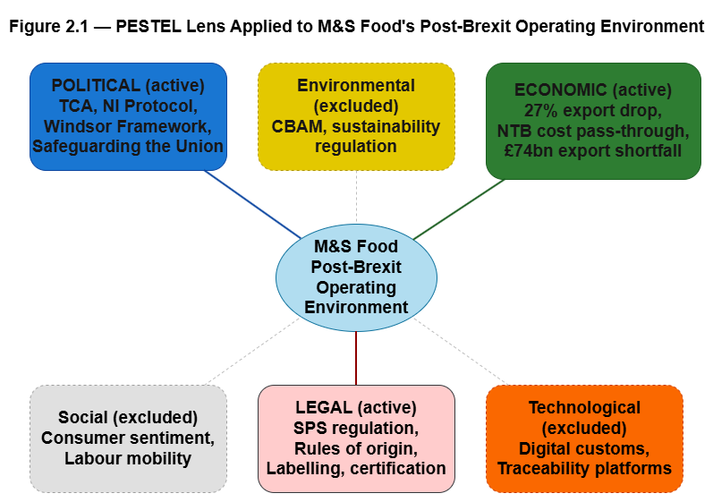
Figure 2.1: PESTEL Lens Applied to M&S Food's Post-Brexit Operating Environment
Political
Out of the three active dimensions in this study, the political dimension is the most important. Of all the events of Brexit, it is the political aspect that dominated. The rest of Brexit's impact on the operational side for UK firms was embedded in the political agreements between the UK and the EU. The Trade and Cooperation Agreement is the most important of such agreements (Sampson and Dhingra, 2022). M&S Food operates in a different political environment due to the specific agreements on Northern Ireland. The Northern Ireland Protocol created a single EU market on goods for Northern Ireland and established a de facto regulatory border in the Irish Sea (House of Commons Library, 2023). The Windsor Framework, adopted in March 2023, created Green and Red lanes and the Stormont Brake and modified the Protocol (European Parliamentary Research Service, 2023; House of Commons Library, 2023). The 2024 Safeguarding the Union Command Paper introduced more changes (House of Commons Library, 2024). According to Diamond and Colfer (2024), the Windsor Framework, while reducing some operational border friction between the Irish Sea, still left the political instability in Northern Ireland. The political dimension represents the active and continuously evolving political environment of M&S Foods that directly and materially affects their operations across the Irish Sea.
Economic
The economic dimension is the second active dimension in this study. This dimension includes the trade, supply chain, volume and cost effects of Brexit on M&S Food. Du et al. (2024) suggest that in the first three years of the TCA, UK exports to the EU were estimated to have fallen by twenty-seven per cent and UK imports by thirty-two per cent. The European Central Bank (2025) substantiates that these effects have not eased with time. Bakker et al. (2023) show that the non-tariff barriers introduced by Brexit have resulted in an increase in UK consumer prices of about six per cent, with a pass-through of border costs to shelf prices between fifty and eighty per cent. This is the type of price effect that travels most directly to retail. The most recent work done by the Resolution Foundation puts the cumulative loss of UK goods exports at about £74 billion against the 2019 goods trade baseline, and the previous analysis done by Fry and Hale (2024) estimates that goods trade has been the main weakness in an otherwise robust trade performance of the UK. According to firm-level customs data, this economic shock has been uneven, with smaller firms bearing the biggest impact and exiting the EU market, while larger firms have absorbed the impact by restructuring their supply chains (Freeman et al., 2024). For M&S Food, the economic dimension captures cost increases, supply chain disruption and the impact on operating profit examined in the case study in Chapter 4.
Social
This dissertation does not employ the social dimension as an active analytic dimension, and it is necessary to explain why. The post-Brexit operational context includes the social dimension, with the changing consumer sentiment and the purchasing behavior of expatriates in Ireland and the rest of the EU, the cross-border mobility of labor in the hospitality and food processing sectors, and the public mood in the UK regarding relations with the EU. All of these affect the trading environment that M&S Food contends with. Although these impacts are important, they are peripheral to the primary question of how M&S Food has operationally and strategically responded to the political, economic, and legal challenges posed by Brexit. The social dimension would add an unnecessary layer of complexity and case dilution, and it would take the dissertation to the consumer behavior level, which is outside the focus of the research questions. For purposes of this study, and as noted in Chapter 5, the social dimension will be considered in the context of post-Brexit premium retail research.
Technological
This dimension is also omitted from active analysis, albeit remaining a focus area. Technology interacts with the post-Brexit operating environment in multiple ways under different systems, such as digital customs declarations, the technology of the Border Target Operating Model, supply-chain traceability systems, and warehouse automation of the sort that M&S has been investing in at its distribution centers in the UK. All are relevant, in principle, to the post-Brexit operating environments and trading systems, and the technology has been dealt with in some of the trade policy literature (European Parliamentary Research Service, 2024). However, in this dissertation, the technological dimension is excluded for two reasons. First, the research questions focus on the operational and strategic responses of M&S Food, rather than the design and the services of the customs Border. Second, separating the technological dimension from the legal and economic dimensions is analytically impossible, given that digital customs are a legal-regulatory construct. The technological dimension, therefore, will be incorporated where it cannot be analytically disaggregated, and will be noted in Chapter 5 for future research.
Environmental
The environmental dimension is excluded from the active analysis for similar reasons. Environmental considerations are becoming significant in cross-border trade. For instance, the EU's Carbon Border Adjustment Mechanism, the Deforestation-Free Products Regulation, and increased sustainability-reporting requirements are changing the regulatory landscape for agri-food trade (European Parliamentary Research Service, 2025b). According to Lingham et al. (2025), environmental and sustainability factors are significant to the post-Brexit realignment of UK food policy. These are genuine and growing pressures. Nevertheless, they are not the primary focus of this dissertation. This dissertation’s research questions are concerned with the immediate post-Brexit adaptation of M&S Food to non-tariff barriers, sanitary and phytosanitary regulations, and supply-chain disruptions. For these reasons, the environmental dimension is excluded from the case analysis, though is acknowledged here and, in Chapter 5, indicated as a possible direction for future research, especially considering the EU’s changing environmental policy regarding agri-food trade.
Legal
This study’s third active dimension is the legal one. For a food retailer, it may be the most operationally impactful. The legal channel for Brexit at M&S Food involves sanitary and phytosanitary regulations, customs, compliance, rules of origin, labeling, and certification (European Parliamentary Research Service, 2024). Du and Shepotylo (2025) conduct the most advanced econometric analysis of the legal channel. Sanitary and phytosanitary regulations provide the best explanation for the contraction of UK agri-food trade after the TCA. The implementation review of the TCA mentions that an EU-UK sanitary and phytosanitary agreement is currently being negotiated, which would provide some mitigation if it is concluded (European Parliamentary Research Service, 2025b; House of Commons Library, 2025). The Windsor Framework is a legal document that sets the parameters for the application of EU law to goods entering Northern Ireland via the green and red lanes (House of Commons Library, 2023). For M&S Food, the legal dimension defines the compliance and certification frameworks that have reorganized the firm’s UK-EU business and is analyzed separately from the political settlement, which generated it.
Limitations of the framework and how these are controlled
The PESTEL framework has some limitations that need to be addressed. As Andersen (2025) noted, the PESTEL framework can lose its purpose and become a descriptive checklist, collectivism can occur where dimensions are treated as independent, and when compared to other frameworks, PESTEL seems to have a thin level of analysis. This dissertation addresses this issue in two ways. Firstly, as noted in Chapter 4, the three dimensions in question are treated as integrated, and not as independent. Secondly, the PESTEL framework is used in conjunction with the thematic analysis framework (Byrne, 2022; Braun and Clarke, 2024). The thematic analysis framework enables the analyst to identify interactive effects across dimensions and subsume these under a single PESTEL category. The PESTEL framework is therefore used as a basis for further analysis, rather than a final analysis.

2.4 Conclusion of Chapter
This chapter reviews the literature in three dimensions and presents the conceptual framework that organizes the analysis in Chapter 4. In Theme 1, the post-TCA trading relationship harmed UK-EU trade asymmetrically and caused persistent damage, with smaller firms suffering the most and larger firms implementing adjustments. Theme 2 demonstrated that the food sector is structurally vulnerable to non-tariff barriers and has experienced one of the most severe sectoral contractions. Food export volumes are almost a third below their pre-Brexit levels. In Theme 3, cross-sector firm-level data revealed that the predominant trend is the exit of smaller firms along with the supply chain or the legal entity reorganization adjustment of larger firms. When combined, the three dimensions identify the data context for the M&S Food example and the comparison frameworks for this example in Chapter 4. Therefore, the section on the conceptual framework justified the application of the PESTEL (Political, Economic, and Legal) analysis, defended the omission of the Social, Technological, and Environmental analyses, and accepted the limitations of the framework.
The literature outlines a lot about the macro- and sector-level impacts of Brexit; however, it does not discuss the restructuring of a specific large premium UK food retailer. This dissertation seeks to answer that question. Chapter 3 explains and defends the research philosophy, approach, design, and methods employed. Chapter 4 uses PESTEL to analyze the M&S Food case and the above-mentioned cross-sector comparators and relates findings to the literature as much as possible. In Chapter 5, the conclusions and recommendations for the three research questions are presented.

CHAPTER 3: RESEARCH METHODOLOGY

3.1 Introduction
The following section presents my rationale for the choices made in the dissertation method and addresses each choice in the context of available options. The arrangement of sections adheres to the research onion model (Saunders, Lewis and Thornhill, 2019; Saunders, Lewis and Thornhill, 2023). Beginning from the outer layer inwards, the dissertation presents research philosophy (Section 3.2), then research design (3.3), research approach (3.4), finally data collection methods and analysis (3.5) and then an outline of the ethical considerations (3.6). The chapter is signposted by section 3.7 and indicates the following analysis.
Each of the outlines has been made to substantiate agreement to the choice of the particular methodology. The question has been taken directly from the dissertation brief and is present in the title of each section. The purpose of the chapter is to provide defense for the methodology, and not merely describe the process employed.

3.2 Research Philosophy and Assumptions
A research philosophy informs the researcher’s beliefs about what constitutes reality (ontology) and how this reality can be understood (epistemology). Saunders, Lewis and Thornhill (2023) identify five paradigms that are relevant to business research: positivism, critical realism, interpretivism, postmodernism and pragmatism. For this dissertation, the most important contrast is between positivism and interpretivism, as these paradigms are most likely to lead research in opposite directions to most of the questions this research must answer. Positivism believes there is one objective reality, which can be quantitatively measured, and be known through measurement and hypothesis testing (Ma and Ma, 2022). On the other hand, interpretivism believes that social reality is constructed of meaning and context, therefore it must be interpreted by the researcher, not measured (Lim, 2023; Fodouop Kouam, 2024).
This dissertation is interpretivist, and there are three reasons for this. First, the research questions are interpretivist in nature because they are "how" and "why" questions as opposed to "how much" questions. For example, RQ2 is about how M&S Food has responded to Brexit. This involves the question of meaning, choice, and process, as opposed to answering the question of what the effect size is. Second, the research problem has a context-sensitive nature. In this case, it is a single firm operating across a regulatory border, and strategic decisions are context-sensitive. Bhangu, Provost and Caduff (2023) argue that qualitative methods are most appropriate when the goal of the study is to understand meaning within a context, and this is exactly what this study is. Third, the macro and firm-level econometric studies which are reviewed in Chapter 2, have been able to show what changes have occurred in terms of trade volumes and prices. This body of literature is unable to do this, and this dissertation aims to fulfill this gap in literature, by describing and explaining how a particular firm has responded to these changes. This is, of course, an interpretivist task.
Positivism was considered and then rejected. A positivist approach to this study would have required a falsifiable hypothesis regarding firm-level adaptation, a quantitative assessment of the success of M&S Food’s adaptation, and a statistical generalization to the population of premium UK food retailers. Each of these would have been irrelevant to the research questions. The focus of the dissertation was not to assess the adaptation of M&S, but to understand the adaptation of M&S and provide insights based on that understanding. For the same reason, pragmatism was set aside. The integration of quantitative and qualitative methods would be the result of a research pragmatism, but this was not justified by the research questions (Fodouop Kouam, 2024).
The interpretivist stance indicates that the researcher is an integral part of the study, which places an emphasis on reflexivity. This is addressed directly in Section 3.6. Table 3.1 provides a summary of the comparison between the paradigms.
Table 3.1 - Comparison of Research Philosophies
Dimension | Positivism | Interpretivism | Pragmatism
Ontology | Single objective reality | Multiple socially constructed realities | Reality serves practical purpose
Epistemology | Knowledge through measurement and observation | Knowledge through interpretation of meaning | Knowledge through whatever works in practice
Typical methods | Quantitative, hypothesis testing | Qualitative, case study, document analysis | Mixed methods
Fit with this study | Rejected - RQs do not test a hypothesis | Adopted - RQs ask how and why | Rejected - RQs do not justify mixing methods

3.3 Research Design
The research design is a qualitative single instrumental case study. Each of those three labels must be justified.
The design is qualitative because the central research questions are about the meaning and the process, rather than the measurement. Quantitative methods would be appropriate if the research questions focused on the estimation of the size of an effect, but this dissertation is in the business of understanding what M&S Food has done and why, rather than how the volume of trade has decreased. Mtisi (2022) articulates the same position in his recent applied case study - qualitative methods are the most appropriate when the research is about understanding the phenomenon, rather than answering a precise question, within a bounded context. Miller, Porter and Barbagallo (2023) further elaborate on this idea and illustrate how, even when the research is focused on the qualitative aspect of the phenomenon, a systematic step-by-step approach can generate rigorous and highly valuable research.
Case study design applies when the research question is about a specific company in a specific context. Case study research is a thorough investigation of a single case or example in systematic detail in the real world (Hyett, Kenny, and Dickson-Swift, 2014). The term “case study” is used in many contexts to describe small-sample qualitative research. However, within small-sample qualitative research, a subtle distinction is drawn between intrinsic case studies and instrumental case studies, the former is done for the sake of the case itself, while in the latter, the case is used to shed light on a bigger issue. The present study is instrumental in nature. M&S Food is a valuable case among the large UK premium Food retailers on the example of adjusting to the new, post-Brexit trading scenario. The interest regarding M&S Food is beyond the company itself.
The design is a single case as opposed to a multiple case. The most typical criticism of single-case research is that ‘n=1 cannot generalise statistically’. This is a direct criticism and should not be left unanswered. Hyett, Kenny and Dickson-Swift (2014) give the classic rebuttal to that complaint: single-case designs are not meant to be statistically generalised, but are analytically generalised. They do not generalise to a population, but rather to a theory or comparable cases. The cases against which the M&S case will be examined will be the case studies from cross-sector firm level evidence identified in Chapter 2 - manufacturing, textiles, services, and retail. According to Adams et al. (2022), a systematic case-study design is strengthened when the case is chosen for theoretical justification, and when the documentation of the data sources is thorough -both of which are found in the current study. Section 3.5 has been devoted to the documentation of the data sources.
There are merits to the case selection. M&S Food, as a premium retailer with a short-shelf-life portfolio, would likely be exposed to the SPS regulations and border frictions that are, in my reading of the Brexit literature, the most problematic. They have longstanding cross-border operations with the Republic of Ireland and have invested in a new distribution center in the EU in Poland. Their annual report features uncharacteristically detailed descriptions of their operational and supply-chain decisions (Marks and Spencer Group plc, 2024). These characteristics make M&S Food what Miller, Porter and Barbagallo (2023) call an information-rich case - a case that has much to offer, since so many of its operational realities are in the public domain.
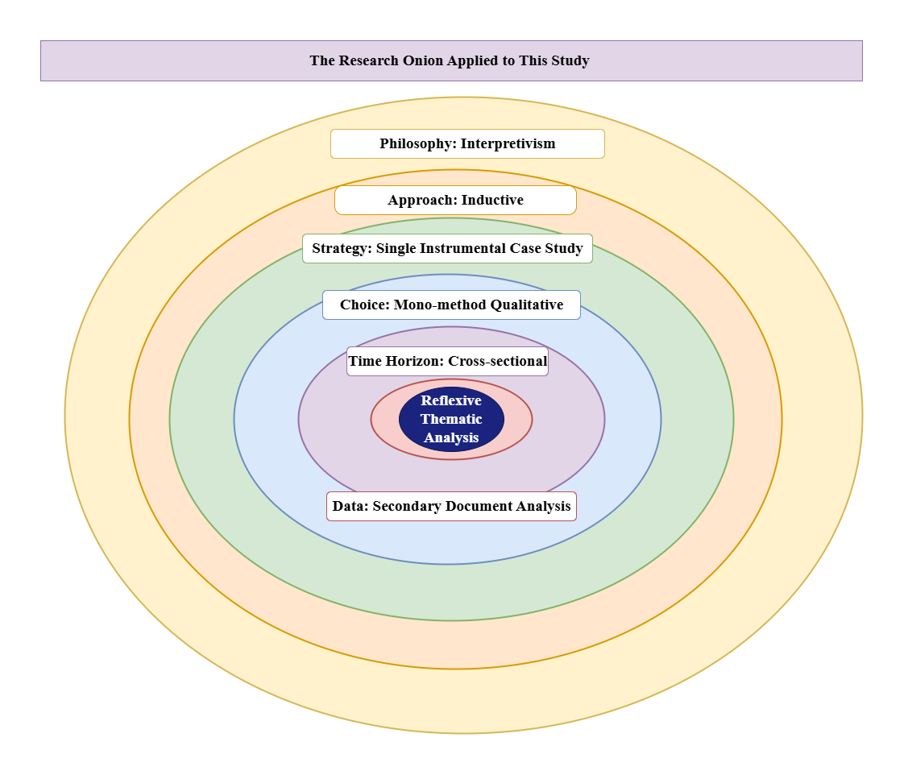
Figure 3.1 - The Research Onion Applied to This Study (self-made)(draw.io)

3.4 Research Approach
The three approaches to theory development in business research are deductive, inductive, and abductive. In deductive research, the process begins with a theory, and a hypothesis that can be tested is derived in order to be subjected to a test. The inductive approach does the opposite. It starts with data, and from this, the researcher is able to make claims of a theoretical nature. Abductive research is a combination of the two. It describes the numerous movements that occur between the two approaches, and considers the theoretical frameworks as a work in progress, refined by the external anomalies that are observed (Saunders, Lewis and Thornhill, 2023; Vila-Henninger et al., 2024).
Inductive research is appropriate for this dissertation for three reasons. One, a theory that describes the adaptation of premium UK food retailers to Brexit does not exist, and so, a hypothesis cannot be formulated to begin the deductive process. Two, the research goal is to provide more granular evidence that is firm-specific in order to complement existing macro evidence, which is more of an inductive endeavor. Three, the PESTEL tool which is used to establish the analysis, is temporary support for the researcher’s observation in this case, and is not used as a theory that is designed to produce testable predictions (Andersen, 2025).
This objection is valid because, using the PESTEL framework, one could argue, there is always going to be an element of implicit deduction in the study. PESTEL does not create falsifiable statements. Instead, it organizes external factors and encourages the analyst to fill out the box with the relevant information. In every PESTEL parameter, the data is organized in a way that is flexible and can show emerging sub-themes without designation. Vila-Henninger and others authors (2024) in the use of the term "abductive coding" provide a correct example: in a synthesis or a reconciliation of existing codes, flexible constructs of the theory are utilized in a way that is innovative in the context of the phenomena. This study, while referring to the process of thematic analysis, Inductive, is going to use the same logic that is going to use the same logic that is going to use the same logic that is going to use the same logic that is going to use the same logic that is going to use the same logic that is going to use the same logic that is going to structure the framework. The main idea is that the structure aids the observation.

3.5 Data Collection Methods
The data collection strategy used in this study is document analysis of secondary data. No primary data were collected for three reasons. First, research questions can be answered using publicly available data. M&S publishes detailed annual reports, UK, and EU trade data are publicly available, and literature on Brexit is ample. Second, there was insufficient time in the dissertation for the primary data collection, and a separate ethics application would be needed. Third, analysis of secondary data facilitates triangulation of data across different types of sources, that is, corporate, governmental, institutional, and academic, which is beyond the scope of primary interviews. Cheong et al. (2023) provide a clear framework for undertaking this type of secondary qualitative research, and Lamb et al. (2024) argue that qualitative researchers have under-explored publicly available resources.
The method of choice in this study for secondary data research is document analysis. Surawy-Stepney et al. (2023) demonstrate that document and archival research are firmly positioned as qualitative methods. A more recent reference of document analysis in the context of institutions and policies is presented by Taylor, Garner and Oliver (2024) and is directly comparable to this study. The six source categories used in this study are listed in Appendix B (Secondary Data Source List) and summarized in Table 3.2 below. The search strategy and selection criteria for the document analysis are provided in Appendix C.
Table 3.2 - Data Sources, Purpose, and Limitations
Source | Type | Role in analysis | Limitation
M&S Group plc Annual Report 2024 | Corporate | Firm-level evidence on strategy, supply chain, and RoI operating profit | Reflects only what M&S chooses to disclose
HoC Library briefings; HMRC and ONS trade data | Government | Macro UK trade context | Aggregation hides firm-level variation
ECB and EPRS publications | Institutional (EU) | Independent macro and regulatory perspective | EU-side framing
FDF Trade Snapshots | Industry body | Sector-specific UK food trade data | Trade body with advocacy interest
Resolution Foundation and Productivity Institute reports | Independent think-tank | Wider UK economic analysis | UK-side framing
Peer-reviewed journal articles | Academic | Theoretical and empirical foundations | Time lag from event to publication
Reflexive thematic analysis coordinated along with the PESTEL framework is the type of analysis being described. The six-phase process described by Braun and Clarke (2024) is used here. This includes: becoming familiar with the data, developing initial codes, searching for themes, reviewing themes, defining themes and the results of the analysis, and finally the analysis is published. The example given by Byrne (2022) was the procedural example most frequently referenced. In this example, the PESTEL framework provided the deductive scaffolding (Andersen, 2025; Bou Hatoum et al., 2023). Coding was anchored to the Political, Economic and Legal dimensions. Within each dimension, sub-themes were determined inductively from the data. Appendix E includes the complete coding scheme (PESTEL Coding / Analysis Matrix). Data from each source were included in Appendix D (Data Extraction Table). According to Morgan (2022) and Nicmanis (2024), there is considerable disagreement on the extent of flexibility of Braun and Clarke's method. It is agreed here that the six-stage process was used with flexibility, though the PESTEL framework was prioritized.
Trustworthiness can be evaluated via the qualitative research criteria of credibility, transferability, dependability, and confirmability (Yadav, 2022). Due to triangulation across different sources, Donkoh and Mensah (2023) argue that credibility is strengthened. Transferability is bolstered by comparator evidence from the other UK sectors in Chapter 2. For dependability, the appendices show the search strategy (Appendix C) and the coding scheme (Appendix E). Future researchers should in principle be able to see the same findings. Confirmability is supported by the practice of critical reflection shown in Section 3.6.
As with any strategy, the limitations should be acknowledged. Due to the nature of the data, internal and private M&S supply-chain decision-making processes and supply-chain managers cannot be interviewed, and the data only reflects the information that M&S has chosen to make available. Additionally, the data is a reflection for a limited period of time, 2021-2026, and is subject to change when new M&S policies are implemented, for example, when the EU-UK SPS agreement is finalized.

3.6 Ethical Considerations
The research of this study has only involved the use of publicly available secondary sources. As there are no human participants, there is no personal data, and there are no interviews, the research has been granted Ethical Approval by UWTSD under the PG2 Application for Ethical Approval. The signed approval form is included in Appendix A (Ethics Form).
Even when data is "publicly available," researchers still have responsibilities. Gliniecka (2023) emphasizes the need for researchers using publicly available data to approach ethics as a persistent need, and not as a form to be filled. Three parts of this obligation are especially relevant here. First, All references are attributed according to the UWTSD Harvard referencing style, and all sources are quoted in context. Second, Direct quotes are limited to less than 15 words, and are used as a last resort. Third, All sources are in compliance with copyright and licensing. The sources are those published under a Creative Commons license, the government’s open licensing, and fair use for academic citation.
The arrangement declared on the ethics form is how data storage is to be carried out. The form states that active files are to be kept on UWTSD OneDrive with supervisor access. Theest et al. (2024) express concerns about the retention of qualitative datasets, and this dissertation only retains what is necessary for the analysis.
Reflexivity is treated as an ongoing process, rather than a one-off statement. The researcher has a self-declared interest in UK Retail and post Brexit Policy, which has a bearing on the way in which the research questions are structured. In line with Sibbald et al. (2025), this interest is declared and controlled during the analysis with a rigorous and systematic coding protocol and cross triangulation of academic sources, and institutional and industry sources. While the object of this analysis is not to claim a value-free position, the authors of this analysis endeavor to disclose and justify the research position.

3.7 Conclusion
This chapter has described and justified the methodologies that support this dissertation. The philosophies and approaches taken are: from an interpretivist philosophy, of an inductive approach, and a qualitative single instrumental case study, which is further defined as study that uses document analysis of secondary data. Reflexive thematic analysis is the chosen method, structured by the Political, Economic and Legal components of the PESTEL framework. Each of these components has been defended in light of the other possible frameworks. The research questions did not support a pragmatic or positivist approach; the questions were of a qualitative nature and inclined towards an interpretivist approach (they asked ‘how’ and ‘why’ and not ‘how much’). A multiple-case design was not appropriate since the focus was on depth and not breadth. The questions were of a qualitative nature and inclined toward an interpretivist approach and could be answered from secondary data, therefore, the primary data collection was not justified in the context of the research constraints of the dissertation.
There is alignment between the methodology and the research questions in Chapter 1 and the approved ethical arrangements in Appendix A. The methodology in this chapter offers a comprehensive framework for the forthcoming analysis.
Chapter 4 takes this methodology and applies it to the M&S Food case, and the cross-sector comparators described in Chapter 2 (with reference to the literature at all times). The detailed source list, search strategy, data extraction and PESTEL coding described in this chapter can be found in Appendices B, C, D, and E respectively.

CHAPTER 4: FINDINGS / RESULTS, ANALYSIS AND DISCUSSION

4.1 Introduction
In this chapter, the methodology discussed in Chapter 3 is applied to the M&S Food case, along with the cross-sector comparators identified in Chapter 2. The Political, Economic, and Legal dimensions of the PESTEL framework provide the lens for analysis, and reflexive thematic analysis (Braun and Clarke, 2024), and the example they provide (Byrne, 2022) is the analytical procedure of choice. This framework will facilitate the observation of each dimension of the case, allowing for the emergence of sub-themes within the evidence.
This chapter is comprised of three required sections: a summary of findings (4.2), an analysis of these findings (4.3), and a discussion that both contextualizes the findings to literature in this area, provides the case in relation to cross-sector comparators, and addresses the three focal research questions (4.4). In accordance with the supervisor’s request, a link to each finding is made to Chapter 2 literature.

4.2 Summary of Findings
In this section, evidence is organized according to the three active dimensions of the PESTEL framework, as derived from secondary sources. Evidence is described in this section. Interpretation will be reserved for Section 4.3.
Political Findings
The Trade and Cooperation Agreement (TCA) began in 2021 and is part of the political agreement that frames UK-EU relations. The TCA closed access for the UK to the EU single market and customs union; however, it preserves zero tariffs and zero quotas on goods that have been framed in every single UK-EU operational arrangement after the TCA. The political environment for M&S Food is focused by the arrangement for Northern Ireland. The original Northern Ireland Protocol put Northern Ireland in the EU single market for goods with a regulatory border in the Irish Sea.
The Windsor Framework, which came into effect in March 2023, introduced the green-lane and red-lane system and the Stormont brake, and the 2024 Safeguarding the Union command paper introduced further operational changes. The EU-UK Trade and Cooperation Agreement implementation review states that an EU-UK sanitary and phytosanitary (SPS) agreement is currently being discussed. Diamond and Colfer (2024) argue that the Windsor Framework reduced some operational friction at the Irish Sea but did not address the political instability in Northern Ireland. The political environment continues to change, and for M&S Food cross-Irish-Sea operations, it continues to pose challenges.
Economic Findings
The economic evidence is abundant and corroborative between source types. At the macro level, Du et al. (2024) estimate that, with the first three years of the TCA, UK exports to the EU fell by an approximate 27 per cent and imports fell by approximately 32 per cent. The European Central Bank (2025) states that these effects have held, with non-tariff barriers remaining, after four years, stubborn rather than transitional. Novy, Sampson and Thomas (2024) provide the most recent macro evidence, and posit the same conclusion. The Resolution Foundation estimates the cumulative shortfall in UK goods exports to be around £74 billion, with respect to the 2019 counterfactual (Hale, Hunsaker and Pittaway, 2026). The House of Commons Library (2026) reports on the underlying UK trade data.
The effects on prices are transmitted to the consumer. Bakker et al. (2023) argue that the non-tariff barriers put in place by Brexit resulted in an approximately six per cent increase in prices, with costs incurred at the border translating to shelf prices with a pass-through of between fifty and eighty per cent. Kaya, Low and Millard (2025) argue that, as a result of non-tariff barriers, a drag on per capita output of around 1.2 per cent is estimated.
Firm-level heterogeneity is evident. Freeman et al. (2022) and Freeman et al. (2024) identified that smaller firms exited the EU market, and larger firms absorbed the compliance costs. Reductions in the UK food exports have also been documented. The Food and Drink Federation (2025) cites a 12.6 percent annual decrease, and the Food and Drink Federation (2026) documents a persistent 30 percent decrease in food exports compared to the level exports prior to Brexit. In contradiction to this, the M&S Group plc Annual Report 2024, cites operating profits of €27.9 million in the Republic of Ireland business, and an increase of €11.6 million from the previous year, and reports the planned new EU Distribution Centre in Poland (Marks and Spencer Group plc, 2024). The main case economic problem is the contradiction between firm-level heterogeneity and the sector level observation.
Legal Findings
The legal evidence shows SPS regulation, customs, rules of origin, and SPS certification and labeling. Du and Shepotylo (2025) conduct the most thorough econometric examination of the legal channel to date. Using difference-in-differences, they show that the decline of UK agri-food trade after the TCA is explained predominately by SPS. The European Parliamentary Research Service (2024) describes the operational framework. Border Target Operating Model (BTOM) is being introduced in phases during 2024 and 2025. BTOM will impose new customs controls for goods entering Great Britain from the EU and will exercise stricter SPS controls for trade in EU agri-foods. The European Parliamentary Research Service (2025b) describes the TCA implementation review which includes the SPS agreement that is currently being negotiated.
The evidence is bolstered by the use of multiple sources. The European Parliamentary Research Service (2025a) shows that regulatory friction is not caused by a global slowdown. Instead, it demonstrates that UK exports of agri-foods and drinks to the EU have declined, while EU exports to the UK have increased. Lingham et al. (2025) describe the legal and regulatory changes within a broader repositioning of UK food policy, and the Parliamentary Office of Science and Technology horizon scanning briefing names EU withdrawal as one of the principal shocks the UK food supply chain has had to absorb (Dillon and Wentworth, 2024). The findings are summarized in Table 4.1.
Table 4.1 - Summary of PESTEL Findings for M&S Food and the UK Food Sector
Dimension | Key finding | Source
Political | TCA is the overarching settlement governing UK-EU relations from January 2021 | Sampson and Dhingra (2022)
Political | Windsor Framework introduced green/red lanes and the Stormont brake | HoC Library (2023); EPRS (2023)
Political | Safeguarding the Union (2024) added further changes; political instability remains | HoC Library (2024); Diamond and Colfer (2024)
Political | EU-UK SPS agreement now under active discussion | HoC Library (2025); EPRS (2025b)
Economic | UK exports to EU fell by ≈27%, imports by ≈32% in first 3 years of TCA | Du et al. (2024)
Economic | NTBs persistent over four years; consumer prices up ≈6% with 50-80% pass-through | ECB (2025); Bakker et al. (2023)
Economic | Cumulative UK goods-export shortfall of ≈£74bn against 2019 baseline | Hale, Hunsaker and Pittaway (2026)
Economic | Smaller firms exited EU markets; larger firms adapted | Freeman et al. (2022, 2024)
Economic | M&S RoI operating profit £27.9m, +£11.6m YoY; new EU distribution centre in Poland | Marks and Spencer Group plc (2024)
Economic | UK food export volumes down 12.6% in 2024; almost a third below pre-Brexit levels | FDF (2025); FDF (2026)
Legal | SPS provisions dominant mechanism of agri-food trade decline | Du and Shepotylo (2025)
Legal | BTOM phased implementation continues; new customs controls in force | EPRS (2024)
Legal | Broader food-policy repositioning underway | Lingham et al. (2025)

4.3 Analysis of Results
This section organizes the findings from Section 4.2 by placing the findings within each PESTEL dimension's sub-themes. Organizing the findings is in accordance with Braun and Clarke’s (2024) six-phase reflexive thematic-analysis process. The PESTEL framework provides the deductive support for this study (Andersen, 2025; Bou Hatoum et al., 2023), while the rest of the sub-themes are developed from the data. The Political dimension of the PESTEL analysis presents three sub-themes. The Economic dimension presents four sub-themes. Finally, the Legal dimension presents three sub-themes.
Political Analysis
The first political sub-theme is the Windsor Framework as partial, yet still operational relief. According to Diamond and Colfer (2024), the green-lane and red-lane systems introduced a limited level of friction for most goods movements, but did not address the political friction in Northern Ireland. This is important for M&S Food because friction along their cross-Irish-Sea operations is dependent on the Northern Ireland green-lane system remaining secure, as partial relief is not the same as predictable.
The second political sub-theme is Northern Ireland as a Structurally Distinct Trading Environment for M&S. The Northern Ireland Protocol combined with the Windsor Framework forms a regulatory system that is not replicated elsewhere in the UK-EU relationship (European Parliamentary Research Service, 2023; House of Commons Library, 2024). This places M&S Food, due to their established operations in the Republic of Ireland and cross-border supply, at the operational edge of the regulatory system of Northern Ireland in the same way that most UK retailers do not.
The third sub-theme is the continued political instability. The proposed 2024 changes to the Safeguarding the Union (House of Commons Library, 2024), as well as the ongoing SPS-agreement negotiations (House of Commons Library, 2025), illustrate that the political settlement is still dynamic. Sampson and Dhingra (2022) wrote of the same phenomenon in more general terms - that the post-TCA political environment consists of changing variables and is not a settled background. For M&S Food, this means that political risk will need to be managed, rather than be priced and ignored.
Economic Analysis
The first economic sub-theme is that cost-pass through is a real phenomenon, but can be absorbed by a large premium retailer. Bakker et al. (2023) cite a 6% rise in the consumer-prices, with a 50% to 80% pass-through. For a premium retailer with a strong brand, this level of pass-through can be priced in without loss of the retail customer. Marks and Spencer Group plc (2024) cite an improved operating profit in the Republic of Ireland, which is likely the result of successful pricing pass-through and not margin compression.
The second sub-theme is that M&S Food falls in the adapter category within firm-size literature. The research of Freeman et al. (2024) outlines that most smaller UK firms have sharply reduced their exports to the EU, while the largest UK firms have not. M&S has the resources, both financial and human, to absorb the new fixed costs and post-TCA non-tariff trade barriers (Marks and Spencer Group plc, 2024). This example is therefore not representative of the food sector, but of the adapter category.
Supply-chain reorganisation has emerged as the dominant adaptation strategy. The new EU distribution centre investment in Poland (Marks and Spencer Group plc, 2024) provides the clearest operational example. Rather than minimizing border friction for each shipment, M&S has built an EU-facing supply chain around an EU distribution hub. This example aligns with the macro-level data in Du et al. (2024) that shows that large companies respond to non-tariff trade barriers with structural changes, rather than incremental adaptations.
Amplifying the previous reasoning, adaptation has not only streamlined the cross-Irish-Sea operation but has also enhanced it. The profit from the Republic of Ireland operation has increased by £11.6 million (Marks and Spencer Group plc 2024). M&S has restructured its operations, and the cost has been more than balanced by the restructuring. Non-tariff barriers create a ‘productivity drag’ that is thought to be pervasive by Kaya, Low and Millard (2025). Due to this, the M&S case has merit on its own.
Legal Analysis
The first legal sub-theme identifies that SPS regulation is the primary compliance cost in agri-food trade. Du and Shepotylo (2025) demonstrate this with econometric data, and the European Parliamentary Research Service (2024) identifies this with qualitative data. For M&S Food and its premium range with short-shelf-lives, SPS compliance isn’t a peripheral cost, but a central operational concern.
The second sub-theme argues that certification and labelling mark the beginning of a persistent overhead, rather than a transitional one. Early expectations of policy indicated that these compliance costs would dissipate as firms adjusted to the new paperwork. The European Central Bank (2025) noted that this was not the case after four years. Furthermore, the European Parliamentary Research Service (2025b) suggests that the SPS-agreement negotiation is an attempt to address a persistent cost.
The third sub-theme suggests that the Border Target Operating Model represents an evolving regulatory environment, rather than a settled one. According to the European Parliamentary Research Service (2024), BTOM will be implemented in stages and will continue in 2024-2025. Lingham et al. (2025) situate BTOM within a broader realignment of food policy. For firms that are making multi-year investments in their supply chains, the evolving nature of regulatory policy is, in itself, a strategic factor.
Interaction Effects Across Dimensions
Three of the active PESTEL dimensions are interrelated. The TCA is both a political and legal framework, as is the Windsor Framework (Diamond and Colfer, 2024). The most useful example of an interrelated effect in the M&S Food case is the investment of the Marks and Spencer Group plc (2024) in the Poland EU distribution centre. In this case, an economic change was made to address compliance costs of a legal (SPS and rules-of-origin) framework caused by a political (TCA and Windsor) settlement. The PESTEL framework informs the observation, while the interrelated effects across dimensions provides the primary contribution (Andersen, 2025; Bou Hatoum et al., 2023; European Central Bank, 2025). Table 4.2 shows the sub-themes.
Table 4.2 - PESTEL Sub-Themes for M&S Food
Dimension | Sub-theme (inductive) | Supporting evidence and citation
Political | Windsor Framework as partial but incomplete operational relief | Diamond and Colfer (2024); HoC Library (2023)
Political | Northern Ireland as a structurally distinct trading environment for M&S | EPRS (2023); HoC Library (2024)
Political | Continuing political uncertainty (SPS negotiations, Safeguarding the Union) | HoC Library (2024, 2025); Sampson and Dhingra (2022)
Economic | Cost pass-through real but absorbable by a large premium retailer | Bakker et al. (2023); Marks and Spencer Group plc (2024)
Economic | M&S Food sits in the adapter category (size + capability + premium positioning) | Freeman et al. (2024); Marks and Spencer Group plc (2024)
Economic | Supply-chain reorganisation as the dominant adaptation strategy (Poland investment) | Marks and Spencer Group plc (2024); Du et al. (2024)
Economic | RoI operating profit improved rather than just preserved (+£11.6m YoY) | Marks and Spencer Group plc (2024)
Legal | SPS as dominant compliance cost in agri-food trade | Du and Shepotylo (2025); EPRS (2024)
Legal | Certification and labelling as continuing rather than transitional overhead | EPRS (2025b); ECB (2025)
Legal | BTOM as evolving regulatory environment, not settled | EPRS (2024); Lingham et al. (2025)

4.4 Discussion of Results
Linking Findings to the Literature
Each major finding in Section 4.3 correlates with a source in Chapter 2. Windsor as a partial relief case confirms Diamond and Colfer (2024) at the level of the political sub-theme. M&S evidence is an economic sub-theme case showing large-firm adapter behavior and unpacks the adapter pattern from retailer level firm literature, which is a case that big-firm literature has not documented. The legal sub-theme shows SPS as the dominant compliance mechanism and confirms Du and Shepotylo (2025). In the absence of literature on the inter-organizational M&S trade, the evidence Du et al. (2024), Novy, Sampson, and Thomas (2024), Dhingra and Sampson (2022), and Sampson and Dhingra (2022) extends the literature in the context of the macro unorganized trade.
When the findings diverge from the literature, the divergence is precise and useful, with most of the macro literature documenting damage and loss, such as the cumulative £74 billion goods-export shortfall (Hale, Hunsaker and Pittaway, 2026), the enduring NTB cost (European Central Bank, 2025), and the increasing UK-EU food-trade divergence (Food and Drink Federation, 2026). M&S Food evidence shows that against this backdrop, some firms have not only survived, but actually thrived. This is not a contradiction of the literature; it is a contribution of the firm-level detail that the literature has been lacking.
Cross-Sector Comparators
Analysing the M&S Food case against the cross-sector evidence from Chapter 2 Theme 3 further substantiates the analytical generalization from Section 3.3. Manufacturing reflects large scale adaptive behavior through compliance investments and restructuring of supply chains (Bailey, Pitelis and Tomlinson, 2023). Textiles and Clothing reflects a similar adaptive behavior through small scale rationalization or exit when rules-of-origin costs are unmanageable (Ayele, Larbalestier and Tamberi, 2021). Services have a varied adaptive behavior as services firms have no goods-type supply chains, and the dominant adaptive strategy has been departure with the establishment of legal entities in EU member states (Bhalotia et al., 2024; UK in a Changing Europe, 2024). Retail and consumer goods as the most direct comparator with M&S Food displays a continuous decrease of market share in the EU (Fry and Hale, 2023; Fry and Hale, 2024; Hale, Hunsaker and Pittaway, 2026).
The M&S Food case aligns with the cross-sector literature prediction for the adapter category, as the firm is large enough to absorb the costs of compliance and restructuring of the supply chain, and is sufficiently premium to the sustain the pricing in the market. The case is also unique in the retail comparators as the prevailing narrative has been decline and not improvement. The comparator matrix is set out in Table 4.3.
Table 4.3 - Cross-Sector Comparator Matrix
Sector | Comparator firm-level evidence | Adaptation strategy | Relevance to M&S Food
Manufacturing (Midlands) | Bailey, Pitelis and Tomlinson (2023): EV and advanced manufacturing firms hit by rules-of-origin costs; smaller firms exit, larger firms absorb | Compliance investment; supply-chain reorganisation by large firms | Same large-firm adapter pattern: confirms M&S sits in the same category
Textiles and clothing | Ayele, Larbalestier and Tamberi (2021): textiles among the most exposed to rules-of-origin; market-share decline persists | Smaller firms reduce or exit EU exports | Confirms exit pattern for smaller firms; M&S avoids this through scale
Services | Bhalotia et al. (2024): Brexit barriers cut services exports ≈16% at exposed margins; UKICE (2024): legal-entity relocation as dominant mode | Relocation of legal entities into EU member states | Different mode (no goods supply chain) but same logic: adapt or exit
Retail and consumer goods | Fry and Hale (2023, 2024): UK goods trade is the principal weakness; Hale, Hunsaker and Pittaway (2026): £74bn cumulative shortfall | Persistent decline in EU market share for goods sector overall | Directly comparable: M&S’ ability to grow RoI profit is the exception within the wider retail pattern
Answering the Research Questions
For RQ1 (“what barriers do UK companies face after Brexit?”), the barriers include political, economic, and legal barriers. The political barriers include the TCA, the Northern Ireland Protocol, the Windsor Framework, and the SPS-agreement uncertainty. The economic barriers include the cost pass-through of NTBs, supply-chain reorganisation costs, and productivity drag. The legal barriers include SPS and the rules of origin, certification, and BTOM phasing. Non-tariff barriers operate most prominently, whereas SPS provisions operate most prominently in the agri-food trade (Du and Shepotylo, 2025; European Central Bank, 2025).
For RQ2 (“how has M&S Food responded?”), M&S Food has responded by reorganising their supply-chain around a new EU distribution centre in Poland, making a certification investment to facilitate cross-Irish-Sea trade under the Windsor Framework, and absorbing the cost pass-through through premium pricing. This has resulted in a Republic of Ireland operating profit of £27.9 million with a £11.6 million year-on-year increase (Marks and Spencer Group plc, 2024). M&S Food is an adapter-category firm as defined by Freeman et al. (2024).
For RQ3 (“what transferable lessons can be drawn?”), the adapter-category pattern described in the cross-sector evidence (manufacturing, retail, and services) indicates that this logic would also apply to other UK exporters of a comparable size and capability to M&S Food. The transferable lessons are to invest in compliance infrastructure early, reorganise supply chains around EU distribution where shelf-life and the product mix permit, and adopt a premium pricing strategy to recover cost pass-through where an adequate market exists.
Conclusion of Chapter
This chapter detailed the findings reported under three PESTEL categories. More than thirty sources from the Chapter 2 literature review and M&S Group plc Annual Report 2024 provided the basis for this analysis. The Political dimension findings concerned the TCA and the Windsor Framework and ongoing live SPS-agreement negotiations. The Economic dimension findings reflected the decline in macro trade and the £74 billion cumulative shortfall, firm-size adapter asymmetry, and the firm-level improvement in M&S Food’s operating profit in the Republic of Ireland. The Legal dimension findings involved SPS regulation and the dominant compliance cost and the BTOM as a developing and not yet settled environment.
The findings are in line with cross-sector firm-level literature and, unlike extant literature, provide qualitative firm-level evidence on a premium UK food retailer. This evidence strengthens the cross-sector firm-level literature and addresses a specific gap, as defended in the revised Literature Gap section of Chapter 2.
Chapter 5 outlines the academic, policy, and industry implications of these findings. It also describes the study’s limitations and recommended areas for subsequent study.

CHAPTER 5: CONCLUSIONS AND RECOMMENDATIONS

5.1 Summary of Main Findings
This dissertation analysed how UK businesses have adapted their structures to attend to post Brexit changes within the European market. M&S Food was the primary case study. Three main findings arose from this analysis. First, du and Shepotylo (2025), as well as the European Central Bank (2025), noted that among all the sectors, Brexit posed the most disruption to the food sector, due to the new regulatory framework and the logistical costs, friction caused by non-tariff measures, and compliance with SPS, rules of origin, and customs checks and procedures. Second, rather than absorbing cost, M&S Food has adopted ‘active’ strategies and operational adjustments. This is evident in the UK Books of Accounts data for the Republic of Ireland, where an operating profit of £11.6 million was recorded, and the construction of an EU logistics distribution center in Poland (Marks and Spencer Group plc, 2024). Third, in the M&S case, the literature of cross-sector adoption cites large premium retailers, where scale, capability and premium positioning allow for structural supply chain adjustments rather than a direct exit (Freeman et al., 2024).

5.2 Conclusion Based on the Research Questions

All research questions have been answered. RQ1 confirmed that the dominant post-Brexit barriers were regulatory (e.g., SPS and labeling), logistical (e.g., border delays, compliance burden, and overhead costs), and cost-based barriers. RQ2 confirmed that M&S Food undertook supply chain restructuring, made strategic logistics investments in the EU, and absorbed some costs attributable to their size and premium position. RQ3 confirmed that the lesson drawn from M&S is that the capacity for adaptation by smaller food-related businesses in the UK is premised more on their size, capability, and positioning in the market rather than following the M&S approach.

5.3 Recommendations - Practical and Theoretical
Practically, British food firms that have business with the EU should look into EU based fulfillment and post-Brexit adjustment as a cost that will require ongoing investment in SPS compliance. EU fulfillment should only be implemented if the scale is viable. Theoretically, trade research should consider the PESTEL framework to better incorporate and analyse the political, economic and legal dimensions, instead of merely analysing them separately.

5.4 Contribution to Literature
This dissertation fills a firm-level gap in the existing literature caused by macro and sector-level studies (Bailey et al., 2023; Freeman et al., 2024). Although some studies have analyzed the aftermath of Brexit on UK trade, including an estimated £74 billion loss (Hale, Hunsaker, and Pittaway, 2026) and a 27% drop in exports (Du et al., 2024), most have neglected to analyze the impact on individual firms. The goal of this dissertation is to analyze the firm level Brexit impacts on a premium UK food retailer using PESTEL analysis. This dissertation attempts to fill the gap in the existing literature related to Brexit by analysing how large UK firms efficiently adapt their supply chains to comply with Brexit and other related legal changes while simultaneously increasing their profitability. This dissertation also verifies the cross-dimension interactions (political-legal-economic) proposed in the existing PESTEL literature (Andersen, 2025; Bou Hatoum et al., 2023), which is seldom addressed at the firm level.

5.5 Contribution to Policy
This dissertation offers three contributions to treaty-based UK trade policy. Firstly, it builds firm level evidence directly relevant to Trade and Cooperation Agreement (TCA) and Windsor Framework reviews to showcase successful adaptations, as evidenced by M&S, require a level of resources that outstrips UK SMEs’ ability to invest. Secondly, as the study outlines SPS compliance costs subject to the incompleteness of current agreements and friction in trade as a key and ongoing concern for agri-food traders (Du and Shepotylo, 2025; European Parliamentary Research Service, 2024), this study supports the ongoing negotiations for an SPS agreement between the UK and the EU. Lastly, the study suggests that differentiation and specifically focusing on the smaller exporters who have exited the EU market and allocating funding and resources to these potential adapters should be the priority over assuming UK food exporters will equally access SME focused initiatives.

5.6 Contribution to Practice
This dissertation aims to assist all UK based businesses seeking to serve clients in the EU post-Brexit. It will guide them by presenting clear and evidence-based strategies and structures. It will also present examples of how different organizations have integrated structural adjustments. The case study of M&S indicates that reducing border friction on a per shipment basis may be accomplished by establishing an EU distribution hub. In the case of M&S’ premium positioning, the cost was passed on to the consumer and did not mean the loss of market share. Looking at the needs of food and drink businesses in the UK, the study indicates that the three most critical investments are the SPS certificate, packaging compliance, and logistics infrastructure, all of which are EU centred. Post Brexit, UK exporters can now use this study to plan their market entry strategy to the EU.

5.7 Limitations of Research
Because this research relies on secondary data, it cannot interview M&S managers or gain internal access to observational data. A single-case study further reduces statistical generalization. However, with the current design, analytical generalization is possible. The findings also pertain to a specific stage of a post-Brexit context that remains in a state of flux due to recent developments with the Windsor Framework and ongoing SPS negotiations.

5.8 Recommendations for Future Work
The completion of this research reflects the need for future studies in four areas. First, the analysis of UK food exporters could test if the finding of an adapter-category occurs at a smaller scale. Second, deeper context of the firm-level analysis could be developed through primary interviews of M&S managers. Third, sector-level generalization could be achieved through additional comparative case studies of premium retailers. Finally, once the SPS agreement is finalized, firm-level adaptation, either before or after the agreement came into effect, could be studied to investigate if the agreement truly lessens the burden of compliance as evidenced in this dissertation (European Parliamentary Research Service, 2025b; House of Commons Library, 2025).

References
Adams, C.R., Barrio Minton, C.A., Hightower, J. and Blount, A.J. (2022) 'A systematic approach to multiple case study design in professional counseling and counselor education', Journal of Counselor Preparation and Supervision, 15(2), Article 13. https://research.library.kutztown.edu/cgi/viewcontent.cgi?article=1529&context=jcps
Andersen, P.D. (2025) The PESTEL framework and its variants for analysing the strategic environment: evolution, limitations and adoption in energy policy research. SSRN Working Paper No. 5266562. https://papers.ssrn.com/sol3/papers.cfm?abstract_id=5266562
Ayele, Y., Larbalestier, G. and Tamberi, N. (2021) Post-Brexit: UK trade in goods. UKTPO Briefing Paper 57. Brighton: UK Trade Policy Observatory, University of Sussex. https://blogs.sussex.ac.uk/uktpo/files/2021/06/BP57may.pdf
Bailey, D., Pitelis, C. and Tomlinson, P.R. (2023) 'Brexit, trade and UK advanced manufacturing sectors: a Midlands' perspective', Contemporary Social Science, 18(2), pp. 284-296. https://www.tandfonline.com/doi/full/10.1080/21582041.2023.2192700
Bakker, J.D., Datta, N., Davies, R. and De Lyon, J. (2023) Non-tariff barriers and consumer prices: evidence from Brexit. CEP Discussion Paper No. 1888. London: Centre for Economic Performance, London School of Economics. https://cep.lse.ac.uk/pubs/download/dp1888.pdf
Bhalotia, S., Dhingra, S., Freeman, R., Manova, K. and Sampson, T. (2024) Deglobalisation in disguise? Brexit barriers and trade in services. CEP Discussion Paper No. 2110. London: Centre for Economic Performance, London School of Economics. https://cep.lse.ac.uk/pubs/download/dp2110.pdf
Bhangu, S., Provost, F. and Caduff, C. (2023) 'Introduction to qualitative research methods - Part I', Perspectives in Clinical Research, 14(1), pp. 39-42. https://pmc.ncbi.nlm.nih.gov/articles/PMC10003579/
Bou Hatoum, M., Nassereddine, H., Musick, S. and El-Jazzar, M. (2023) 'Investigation of PESTEL factors driving change in capital project organizations', Frontiers in Built Environment, 9, 1207564. https://www.frontiersin.org/journals/built-environment/articles/10.3389/fbuil.2023.1207564/full
Braun, V. and Clarke, V. (2024) 'Supporting best practice in reflexive thematic analysis reporting in Palliative Medicine: a review of published research and introduction to the Reflexive Thematic Analysis Reporting Guidelines (RTARG)', Palliative Medicine, 38(6), pp. 608-616. https://pmc.ncbi.nlm.nih.gov/articles/PMC11157981/
Byrne, D. (2022) 'A worked example of Braun and Clarke's approach to reflexive thematic analysis', Quality & Quantity, 56(3), pp. 1391-1412. https://link.springer.com/article/10.1007/s11135-021-01182-y
Cheong, H.-I., Lyons, A., Houghton, R. and Majumdar, A. (2023) 'Secondary qualitative research methodology using online data within the context of social sciences', International Journal of Qualitative Methods, 22, 16094069231180160. https://journals.sagepub.com/doi/10.1177/16094069231180160
Dhingra, S. and Sampson, T. (2022) 'Expecting Brexit', Annual Review of Economics, 14, pp. 495-519. https://eprints.lse.ac.uk/115145/1/Dhingra_expecting_brexit_published.pdf
Diamond, P. and Colfer, B. (2024) The Windsor Framework and its implications for Britain, Northern Ireland and the European Union (EU). Policy Study, March 2024. Brussels: Foundation for European Progressive Studies (FEPS) and Dublin: Think-tank for Action on Social Change (TASC). https://feps-europe.eu/wp-content/uploads/2024/10/The-Windsor-Framework-and-its-implications.pdf
Dillon, A. and Wentworth, J. (2024) Food systems, food security and supply chains. POST Horizon Scanning. London: Parliamentary Office of Science and Technology. https://post.parliament.uk/food-systems-food-security-and-supply-chains/
Donkoh, S. and Mensah, J. (2023) 'Application of triangulation in qualitative research', Journal of Applied Biotechnology & Bioengineering, 10(1), pp. 6-9. https://medcraveonline.com/JABB/JABB-10-00319.pdf
Du, J. and Shepotylo, O. (2023) 'How did Brexit affect UK trade?', Contemporary Social Science, 18(2), pp. 266-283. https://www.tandfonline.com/doi/full/10.1080/21582041.2023.2192043
Du, J. and Shepotylo, O. (2025) 'Trade disintegration and agri-food trade: United Kingdom exit from EU', The World Economy, 48(7), pp. 1985-2014. https://onlinelibrary.wiley.com/doi/10.1111/twec.13735
Du, J., Liu, X., Shepotylo, O. and Shi, Y. (2024) Unbound: UK trade post-Brexit. Productivity Insights Paper No. 040. Manchester: The Productivity Institute. https://www.productivity.ac.uk/wp-content/uploads/2024/11/PIP040-UK-Trade-Post-Brexit-131124.pdf
European Central Bank (2025) Exploring EU-UK trade and investment four years after Brexit. ECB Occasional Paper No. 379. Frankfurt: European Central Bank. https://www.ecb.europa.eu/pub/pdf/scpops/ecb.op379.en.pdf
European Parliamentary Research Service (2023) The Windsor Framework. Briefing PE 747.095. Brussels: European Parliament. https://www.europarl.europa.eu/RegData/etudes/BRIE/2023/747095/EPRS_BRI(2023)747095_EN.pdf
European Parliamentary Research Service (2024) New EU-UK customs controls: the Border Target Operating Model. At a Glance PE 759.599. Brussels: European Parliament. https://www.europarl.europa.eu/RegData/etudes/ATAG/2024/759599/EPRS_ATA(2024)759599_EN.pdf
European Parliamentary Research Service (2025a) EU-UK trade flows. Briefing PE 765.767. Brussels: European Parliament. https://www.europarl.europa.eu/RegData/etudes/BRIE/2025/765767/EPRS_BRI(2025)765767_EN.pdf
European Parliamentary Research Service (2025b) Implementation of the EU-UK Trade and Cooperation Agreement. Briefing PE 765.779. Brussels: European Parliament. https://www.europarl.europa.eu/RegData/etudes/BRIE/2025/765779/EPRS_BRI(2025)765779_EN.pdf
Fodouop Kouam, A.W. (2024) 'Interpretivism or constructivism: navigating research paradigms in social science research', International Journal of Research Publications, 143(1), pp. 134-138. https://ijrp.org/paper-detail/6086
Food and Drink Federation (2025) Trade snapshot 2024. London: FDF. https://www.fdf.org.uk/globalassets/resources/publications/reports/trade-reports/fdf-2024-trade-snapshot.pdf
Food and Drink Federation (2026) Trade snapshot 2025. London: FDF. https://www.fdf.org.uk/globalassets/resources/publications/reports/trade-reports/2025-trade-snapshot.pdf
Freeman, R., Garofalo, M., Longoni, E., Manova, K., Mari, R., Prayer, T. and Sampson, T. (2024) Deep integration and trade: UK firms in the wake of Brexit. CEP Discussion Paper No. 2066. London: Centre for Economic Performance, London School of Economics. https://cep.lse.ac.uk/pubs/download/dp2066.pdf
Freeman, R., Manova, K., Prayer, T. and Sampson, T. (2022) UK trade in the wake of Brexit. CEP Discussion Paper No. 1847. London: Centre for Economic Performance, London School of Economics. https://cep.lse.ac.uk/pubs/download/dp1847.pdf
Fry, E. and Hale, S. (2023) Open for business? UK trade performance since leaving the EU. London: Resolution Foundation. https://www.resolutionfoundation.org/publications/open-for-business/
Fry, E. and Hale, S. (2024) Trading blows: how should Britain buy and sell in a turbulent world? London: Resolution Foundation. https://www.resolutionfoundation.org/publications/trading-blows/
Gliniecka, M. (2023) 'The ethics of publicly available data research: a situated ethics framework for Reddit', Social Media + Society, 9(3), 20563051231192021. https://journals.sagepub.com/doi/full/10.1177/20563051231192021
Hale, S., Hunsaker, S. and Pittaway, S. (2026) Leaving EU behind: the UK's post-Brexit goods-export shortfall and the case for industrial-strategy renewal. London: Resolution Foundation. https://www.resolutionfoundation.org/publications/leaving-eu-behind/
House of Commons Library (2023) Northern Ireland Protocol: The Windsor Framework. Research Briefing CBP-9736. London: House of Commons Library. https://commonslibrary.parliament.uk/research-briefings/cbp-9736/
House of Commons Library (2024) Northern Ireland Protocol/Windsor Framework: new devolution deal. Research Briefing CBP-9955. London: House of Commons Library. https://commonslibrary.parliament.uk/research-briefings/cbp-9955/
House of Commons Library (2025) Trading relationship with the EU. Debate Pack CDP-2025-0080. London: House of Commons Library. https://researchbriefings.files.parliament.uk/documents/CDP-2025-0080/CDP-2025-0080.pdf
House of Commons Library (2026) Statistics on UK trade with the EU. Research Briefing CBP-7851. London: House of Commons Library. https://commonslibrary.parliament.uk/research-briefings/sn07851/
Hyett, N., Kenny, A. and Dickson-Swift, V. (2014) 'Methodology or method? A critical review of qualitative case study reports', International Journal of Qualitative Studies on Health and Well-being, 9(1), 23606. https://www.ncbi.nlm.nih.gov/pmc/articles/PMC4014658/
Kaya, A., Low, H. and Millard, S. (2025) Brexit and non-tariff barriers: effects on UK business investment and productivity. Productivity Insights Working Paper No. 057. Manchester: The Productivity Institute. https://www.productivity.ac.uk/wp-content/uploads/2025/08/WP057-Brexit-and-Non-Tariff-Barriers-August-2025.pdf
Lamb, D., Russell, A., Morant, N. and Stevenson, F. (2024) 'The challenges of open data sharing for qualitative researchers', Journal of Health Psychology, 29(7), pp. 631-639. https://pmc.ncbi.nlm.nih.gov/articles/PMC11141072 /
Lim, W.M. (2023) 'Philosophy of science and research paradigm for business research in the transformative age of automation, digitalization, hyperconnectivity, obligations, globalization and sustainability', Journal of Trade Science, 11(2/3), pp. 3-30. https://www.emerald.com/jts/article/11/2-3/3/256077/
Lingham, S., Kowalska, A., Kowalski, J., Maye, D. and Manning, L. (2025) 'The impact of Brexit on UK food standards and food security: perspectives on the repositioning of neoliberal food policy', Foods, 14(9), 1474. https://doi.org/10.3390/foods14091474
Ma, J. and Ma, Y. (2022) 'The discussions of positivism and interpretivism', Global Academic Journal of Humanities and Social Sciences, 4(1), pp. 10-14. https://www.gajrc.com/media/articles/GAJHSS_41_10-14.pdf
Marks and Spencer Group plc (2024) Annual report and financial statements 2024. London: Marks and Spencer Group plc. https://corporate.marksandspencer.com/sites/marksandspencer/files/2024-06/M-and-S-2024-Annual-Report.pdf

Miller, E.M., Porter, J.E. and Barbagallo, M.S. (2023) 'Simplifying qualitative case study research methodology: a step-by-step guide using a palliative care example', The Qualitative Report, 28(8), pp. 2363-2379. https://nsuworks.nova.edu/cgi/viewcontent.cgi?article=6478&context=tqr
Morgan, H. (2022) 'Understanding thematic analysis and the debates involving its use', The Qualitative Report, 27(10), pp. 2079-2090. https://nsuworks.nova.edu/tqr/vol27/iss10/2/
Mtisi, S. (2022) 'The qualitative case study research strategy as applied on a rural enterprise development doctoral research project', International Journal of Qualitative Methods, 21, 16094069221145849. https://journals.sagepub.com/doi/10.1177/16094069221145849
Nicmanis, M. (2024) 'Reflexive content analysis: an approach to qualitative data analysis, reduction, and description', International Journal of Qualitative Methods, 23, 16094069241236603. https://journals.sagepub.com/doi/10.1177/16094069241236603
Novy, D., Sampson, T. and Thomas, C. (2024) Brexit and UK trade. CEP Election Analysis Paper No. 058. London: Centre for Economic Performance, London School of Economics. https://cep.lse.ac.uk/_new/publications/abstract.asp?index=10634
Resolution Foundation and Centre for Economic Performance (2023) Ending stagnation: a new economic strategy for Britain — final report of The Economy 2030 Inquiry. London: Resolution Foundation. https://economy2030.resolutionfoundation.org/wp-content/uploads/2023/12/Ending-stagnation-final-report.pdf
Sampson, T. and Dhingra, S. (2022) Brexit and UK trade. London: Centre for Economic Performance, London School of Economics. https://personal.lse.ac.uk/sampsont/BrexitUKTrade.pdf
Saunders, M., Lewis, P. and Thornhill, A. (2019) Research methods for business students. 8th edn. Harlow: Pearson Education. https://www.researchgate.net/publication/240218229_Research_Methods_for_Business_Students
Saunders, M.N.K., Lewis, P. and Thornhill, A. (2023) Research methods for business students. Chapter 4: Understanding research philosophy and approaches to theory development. 9th edn proof copy. Harlow: Pearson Education. https://www.researchgate.net/publication/367780349_2023_Research_Methods_for_Business_Students_Preface_and_Chapter_4
Sibbald, K.R., Phelan, S.K., Beagan, B.L. and Pride, T.M. (2025) 'Positioning positionality and reflecting on reflexivity: moving from performance to practice', Qualitative Health Research, 35(3-4), pp. 271-284. https://journals.sagepub.com/doi/10.1177/10497323241309230
Surawy-Stepney, N., Provost, F., Bhangu, S. and Caduff, C. (2023) 'Introduction to qualitative research methods - Part II', Perspectives in Clinical Research, 14(2), pp. 95-99. https://pmc.ncbi.nlm.nih.gov/articles/PMC10267995/
Taylor, M., Garner, P. and Oliver, S. (2024) 'Use of qualitative research in World Health Organisation guidelines: a document analysis', Health Research Policy and Systems, 22, 44. https://link.springer.com/article/10.1186/s12961-024-01120-y
UK in a Changing Europe (2024) The state of the UK economy 2024. London: UK in a Changing Europe, King's College London. https://ukandeu.ac.uk/reports/the-state-of-the-uk-economy-2024/
Vila-Henninger, L., Dupuy, C., Van Ingelgom, V., Caprioli, M., Teuber, F., Pennetreau, D., Bussi, M. and Le Gall, C. (2024) 'Abductive coding: theory building and qualitative (re)analysis', Sociological Methods & Research, 53(2), pp. 968-1001. https://journals.sagepub.com/doi/10.1177/00491241211067508
Yadav, D. (2022) 'Criteria for good qualitative research: a comprehensive review', The Asia-Pacific Education Researcher, 31(6), pp. 679-689. https://link.springer.com/article/10.1007/s40299-021-00619-0

Appendices
Appendix A - Ethics Form (PG2)
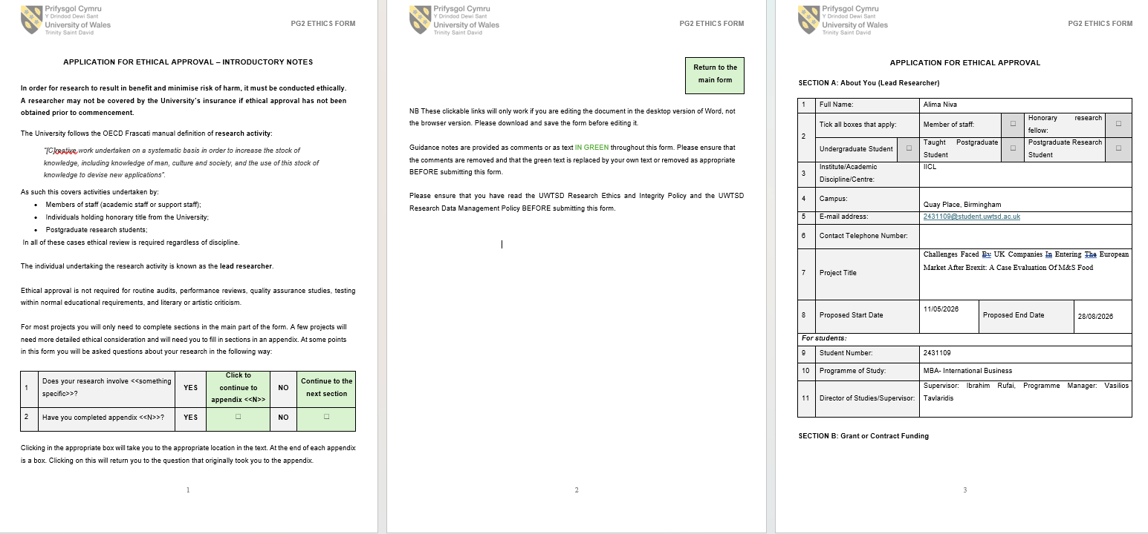

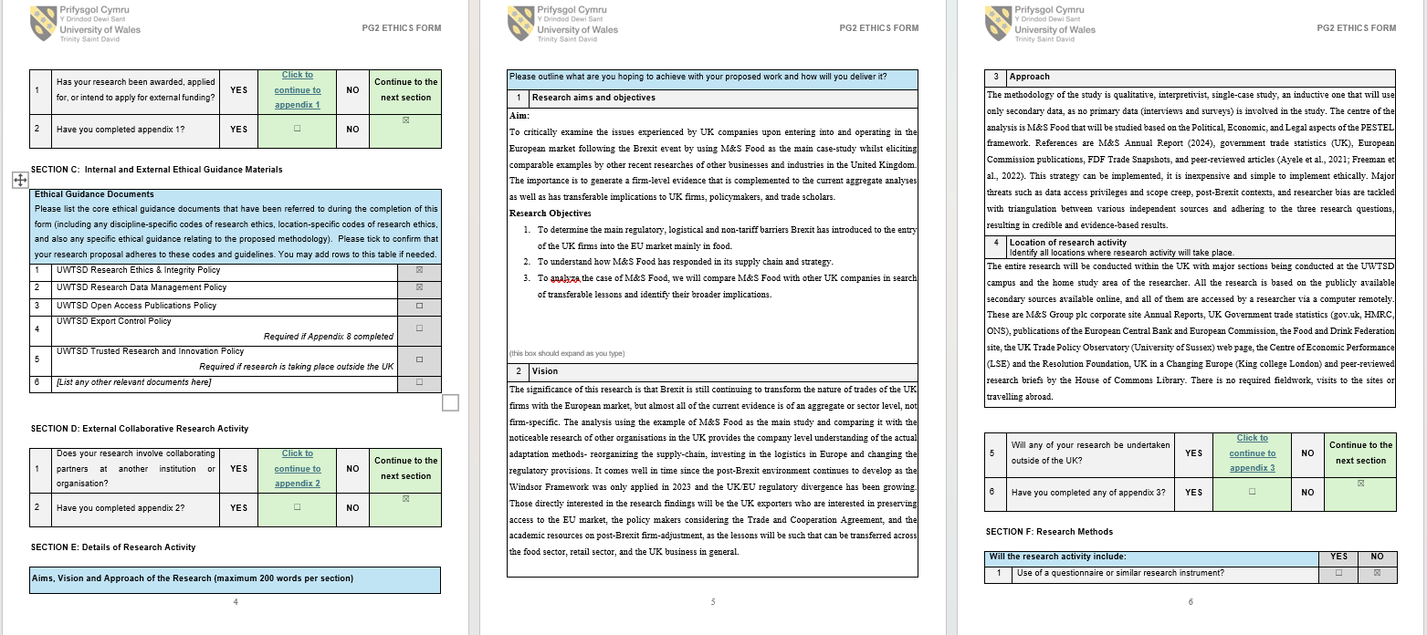

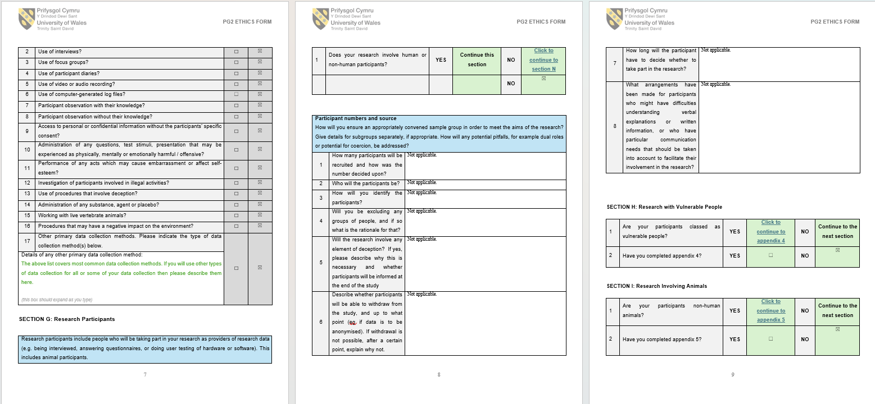

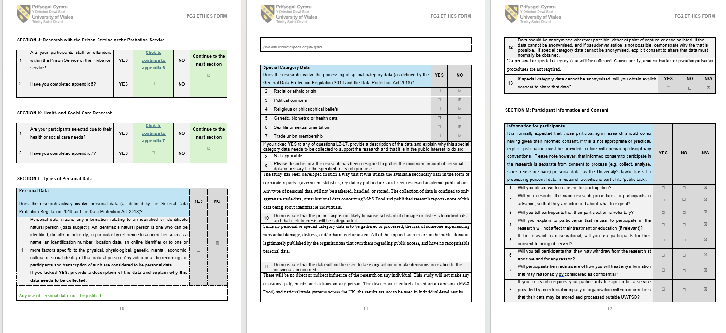
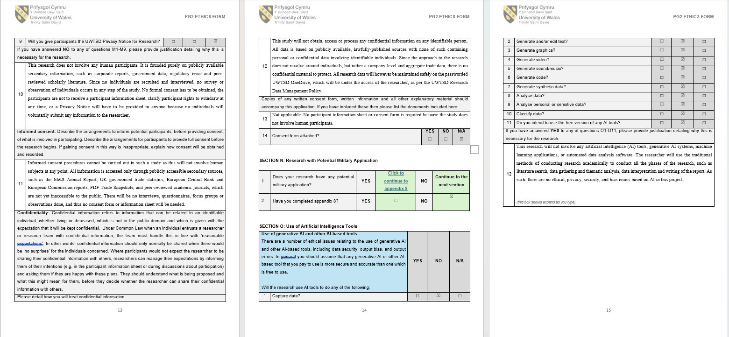
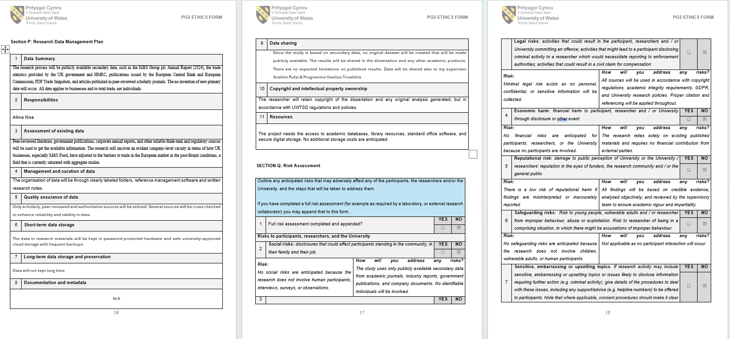
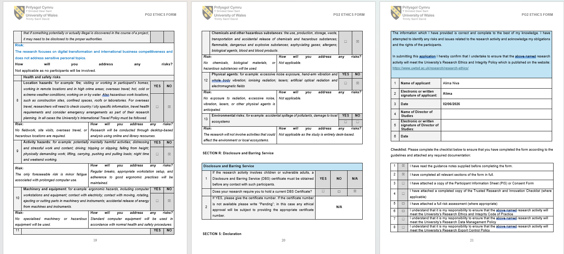
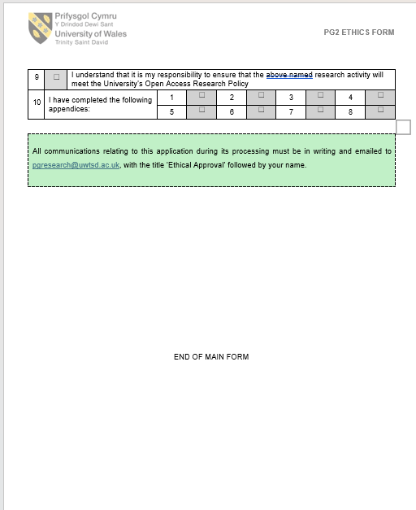
Appendix B - Secondary Data Source List
This appendix expands the six source categories summarised in Table 3.2 of Section 3.5. The table below records each principal source by category, author/organisation, year and short title. Full bibliographic detail for every source appears in the consolidated References list of the dissertation.
Table B.1 - Secondary Data Source List
Category | Author / Organisation | Year | Short title
Corporate (firm-level disclosure) | Marks and Spencer Group plc | 2024 | Annual Report and Financial Statements 2024
UK Government (trade statistics and policy briefings) | House of Commons Library | 2023 | Northern Ireland Protocol: The Windsor Framework, CBP-9736
UK Government | House of Commons Library | 2024 | Windsor Framework: new devolution deal, CBP-9955
UK Government | House of Commons Library | 2025 | Trading relationship with the EU, CDP-2025-0080
UK Government | House of Commons Library | 2026 | Statistics on UK trade with the EU, CBP-7851
UK Government | HMRC and ONS | various | Trade-data releases (cited contextually)
European Institutional | European Central Bank | 2025 | Exploring EU-UK trade and investment four years after Brexit, ECB OP 379
European Institutional | European Parliamentary Research Service | 2023 | The Windsor Framework, PE 747.095
European Institutional | European Parliamentary Research Service | 2024 | New EU-UK customs controls: the Border Target Operating Model, PE 759.599
European Institutional | European Parliamentary Research Service | 2025a | EU-UK trade flows, PE 765.767
European Institutional | European Parliamentary Research Service | 2025b | Implementation of the EU-UK Trade and Cooperation Agreement, PE 765.779
UK Industry Body | Food and Drink Federation | 2025 | Trade Snapshot 2024
UK Industry Body | Food and Drink Federation | 2026 | Trade Snapshot 2025
Independent UK Think-Tank / Research Institute | Fry and Hale (Resolution Foundation) | 2023 | Open for business? UK trade performance since leaving the EU
Independent Think-Tank | Fry and Hale (Resolution Foundation) | 2024 | Trading blows: how should Britain buy and sell in a turbulent world?
Independent Think-Tank | Hale, Hunsaker and Pittaway (Resolution Foundation) | 2026 | Leaving EU behind: the UK's post-Brexit goods-export shortfall
Independent Think-Tank | Resolution Foundation and CEP | 2023 | Ending stagnation
Independent Think-Tank | Kaya, Low and Millard (Productivity Institute) | 2025 | Brexit and non-tariff barriers, WP 057
Independent Think-Tank | Du, Liu, Shepotylo and Shi (Productivity Institute) | 2024 | Unbound: UK trade post-Brexit, PIP 040
Independent Think-Tank | UK in a Changing Europe | 2024 | The state of the UK economy 2024
Independent Think-Tank | Diamond and Colfer (FEPS) | 2024 | The Windsor Framework and its implications
Independent Think-Tank | Dillon and Wentworth (POST) | 2024 | Food systems, food security and supply chains
Peer-Reviewed Academic | Sampson and Dhingra (CEP/LSE) | 2022 | Brexit and UK trade
Peer-Reviewed Academic | Dhingra and Sampson | 2022 | Expecting Brexit, Annual Review of Economics
Peer-Reviewed Academic | Du and Shepotylo | 2023 | How did Brexit affect UK trade?
Peer-Reviewed Academic | Du and Shepotylo | 2025 | Trade disintegration and agri-food trade
Peer-Reviewed Academic | Novy, Sampson and Thomas (CEP) | 2024 | Brexit and UK trade, EA 058
Peer-Reviewed Academic | Bakker, Datta, Davies and De Lyon (CEP) | 2023 | Non-tariff barriers and consumer prices, DP 1888
Peer-Reviewed Academic | Freeman, Manova, Prayer and Sampson (CEP) | 2022 | UK trade in the wake of Brexit, DP 1847
Peer-Reviewed Academic | Freeman et al. (CEP) | 2024 | Deep integration and trade, DP 2066
Peer-Reviewed Academic | Bhalotia et al. (CEP) | 2024 | Deglobalisation in disguise? DP 2110
Peer-Reviewed Academic | Bailey, Pitelis and Tomlinson | 2023 | Brexit, trade and UK advanced manufacturing
Peer-Reviewed Academic | Ayele, Larbalestier and Tamberi (UKTPO) | 2021 | Post-Brexit: UK trade in goods, BP 57
Peer-Reviewed Academic | Lingham, Kowalska, Kowalski, Maye and Manning | 2025 | The impact of Brexit on UK food standards and food security
Each source has been used in accordance with its open-access or fair-use academic citation terms. Where a Creative Commons licence applies, the terms have been respected.
Appendix C - Search Strategy and Selection Criteria
This appendix records the search strategy used to identify sources for the literature review (Chapter 2) and the case-study data collection (Chapters 3 and 4). The strategy is documented so that another researcher could in principle retrace the steps, which supports the dependability criterion discussed in Section 3.5 (Yadav, 2022).
Table C.1 - Databases and Repositories Searched
Source type | Database / repository | Purpose
General academic | Google Scholar | Broad cross-disciplinary search and citation tracking
Open-access journals | PubMed Central | Open-access journal articles, especially methodology papers
Open-access journals | Directory of Open Access Journals (DOAJ) | Verified open-access journal coverage
University library | UWTSD library | Student access to subscription databases (used selectively)
Economic research | Centre for Economic Performance (LSE) | CEP Discussion Papers on UK trade and Brexit
Economic research | Resolution Foundation | UK economic-strategy reports and analyses
Economic research | Productivity Institute | Productivity Insights Papers
EU institutional | European Central Bank | Occasional Papers on EU-UK trade and investment
EU institutional | European Parliamentary Research Service (EPRS) | Briefings on TCA, Windsor Framework and BTOM
UK Parliament | House of Commons Library | Research briefings and debate packs
UK Parliament | Parliamentary Office of Science and Technology (POST) | Horizon-scanning briefings on food systems
Publisher platforms | MDPI, Frontiers, Springer Nature, Wiley, Emerald | Creative Commons articles in food, business and methodology
Table C.2 - Search Terms by Keyword Category
Keyword category | Search terms used (combined with Boolean AND/OR)
Conceptual - Brexit and trade policy | Brexit; Trade and Cooperation Agreement (TCA); non-tariff barriers; sanitary and phytosanitary (SPS) checks; rules of origin; Windsor Framework; Border Target Operating Model (BTOM)
Contextual - sector and case | UK food sector; agri-food; retail; manufacturing; services; supply chain; adaptation; Marks and Spencer; M&S Food; Republic of Ireland; Northern Ireland
Methodology - philosophy | Research philosophy; interpretivism; positivism; constructivism; pragmatism; research onion; epistemology; ontology
Methodology - design | Case study; instrumental case study; single case study; qualitative research; research design
Methodology - data and analysis | Secondary data; document analysis; reflexive thematic analysis; PESTEL; coding matrix; triangulation
Methodology - quality | Trustworthiness; credibility; dependability; transferability; confirmability; reflexivity; positionality
Methodology - ethics | Research ethics; secondary data ethics; publicly available data; open data sharing; academic integrity
Table C.3 - Inclusion and Exclusion Criteria
Criterion type | Detail | Rationale
Inclusion - date | Sources from 2022-2026 prioritised | Reflects the post-TCA period; canonical older sources retained only where still authoritative (e.g. Hyett, Kenny and Dickson-Swift, 2014)
Inclusion - language | English-language only | Researcher language proficiency and dissertation language
Inclusion - access | Open access only | Creative Commons, government open licensing, fair-use academic citation, or open institutional repositories
Inclusion - source type | Peer-reviewed journal articles, official institutional reports, government briefings, or reputable trade-body publications | Ensures evidence quality and traceability
Exclusion - source type | Newspaper articles, opinion pieces, blog posts, consultancy white papers | Lack methodological transparency
Exclusion - access | Sources behind paywalls without an open-access version | Cannot be cited under the open-access strategy of this dissertation
Exclusion - date | Pre-2022 sources for substantive (non-methodological) content | Outside the post-TCA period of interest
Exclusion - verification | Sources where author, outlet or peer-review status cannot be verified | Cannot guarantee evidence quality
Appendix D - Data Extraction Table
This appendix records the evidence extracted from each source and the PESTEL dimensions to which that evidence has been coded. The table is in skeleton form at this stage and will be populated in full during the drafting of Chapter 4. The structure follows the data-extraction-table template recommended by Adams et al. (2022) and Miller, Porter and Barbagallo (2023) for systematic case-study research.
Table D.1 - Data Extraction Table
Source | Year | Key data extracted | PESTEL dimension(s) coded
Marks and Spencer Group plc - Annual Report 2024 | 2024 | Republic of Ireland operating profit £27.9m (+£11.6m YoY); supply-chain cost reductions; Poland EU distribution centre investment | Economic; Legal
House of Commons Library briefings (CBP-9736, CBP-9955) | 2023; 2024 | Windsor Framework arrangements; Stormont brake; Safeguarding the Union changes | Political; Legal
European Central Bank Occasional Paper 379 | 2025 | UK-EU trade and investment four years after Brexit; persistence of non-tariff barriers | Economic
European Parliamentary Research Service briefings | 2023, 2024, 2025a, 2025b | Windsor Framework; Border Target Operating Model; EU-UK trade flows; TCA implementation review | Political; Legal
Food and Drink Federation Trade Snapshots | 2025; 2026 | UK food export volume decline; food and drink trade divergence | Economic
Du and Shepotylo (2025) - agri-food trade | 2025 | SPS provisions as dominant mechanism in agri-food trade decline | Legal; Economic
Resolution Foundation reports (Hale, Hunsaker and Pittaway; Fry and Hale) | 2024; 2026 | £74bn cumulative UK goods-export shortfall against 2019 baseline | Economic
Freeman et al. CEP papers (2022; 2024) | 2022; 2024 | Heterogeneous firm effects; smaller firms exit, larger firms adapt | Economic
[Further sources to be added during Chapter 4 drafting] | - | - | -
Each entry will be expanded during Chapter 4 with the direct evidence drawn from the source, the location of that evidence in the source (page or section), and the PESTEL sub-theme to which it has been coded (see Appendix E).
Appendix E - PESTEL Coding / Analysis Matrix
This appendix sets out the coding matrix used in the reflexive thematic analysis described in Section 3.5. The matrix is anchored to the Political, Economic and Legal dimensions of PESTEL, which are the three dimensions used as active analytical dimensions in this dissertation. The Social, Technological and Environmental dimensions are excluded from the active analysis and are listed in the matrix for completeness only, in line with the scoping decision defended in Chapter 2 (Section 2.3) and Section 3.5 of this chapter. The matrix follows the framework-operationalisation logic of Bou Hatoum et al. (2023) and Andersen (2025).
Table E.1 - PESTEL Coding / Analysis Matrix
PESTEL Dimension | Sub-themes (inductive within dimension) | Supporting sources (illustrative)
POLITICAL (active) | TCA settlement; Northern Ireland Protocol; Windsor Framework (Green/Red lanes; Stormont brake); Safeguarding the Union arrangements; SPS agreement negotiations | Sampson and Dhingra (2022); HoC Library (2023, 2024); EPRS (2023); Diamond and Colfer (2024); HoC Library (2025)
ECONOMIC (active) | Trade-volume decline (UK-EU exports −27%, imports −32%); non-tariff barrier consumer-price pass-through (~6%); cumulative goods-export shortfall (£74bn); supply-chain reorganisation costs; heterogeneous firm effects (SME exit vs large-firm adaptation); M&S RoI operating profit (£27.9m, +£11.6m) | Du et al. (2024); ECB (2025); Bakker et al. (2023); Hale, Hunsaker and Pittaway (2026); Freeman et al. (2022, 2024); Marks and Spencer Group plc (2024)
LEGAL (active) | Sanitary and phytosanitary (SPS) regulation; rules of origin; customs declarations; Export Health Certificates; labelling and certification; Border Target Operating Model (BTOM) | Du and Shepotylo (2025); EPRS (2024); EPRS (2025b); HoC Library (2023)
Social (excluded - see Section 3.5 and Chapter 2 §2.3) | Consumer sentiment; expatriate purchasing in Ireland and the EU; cross-border labour mobility | Acknowledged but excluded from active analysis
Technological (excluded) | Digital customs declarations; BTOM technology; traceability platforms; warehouse automation | Acknowledged but excluded from active analysis
Environmental (excluded) | Carbon Border Adjustment Mechanism (CBAM); Deforestation-Free Products Regulation; sustainability reporting | Lingham et al. (2025); EPRS (2025b) - flagged for future research
Within each active dimension, the sub-themes are kept open to inductive refinement during coding, in line with the position taken in Section 3.4 on the framework as scaffolding rather than as a deductive theory. Sub-themes will be reviewed, named and defined during Phases 4 and 5 of the Braun and Clarke (2024) six-phase process.

