Rhiannon Rees-Givelin
2112680
Principles of Learning and Teaching.
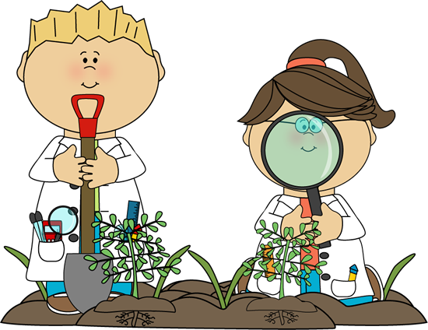
Have you ever heard of the theorist Friedrich Froebel?
Friedrich Froebel (1782-1852) was an academic theorist.
Everyone is familiar with the term kindergarten, and know that the term means "Garden of Children" as coined by Friedrich Froebel. Furthermore, a few will be aware of the richness and depth of thought of Froebel, as well as the depth of this interpretation in the care and education of children today (White, 2020).

By Rhiannon Rees-Givelin | 8th December 2022
Outdoor Classroom cliparts #2881907 (license: Personal use) (n,d.)

Children and nature - The power of learning outdoors

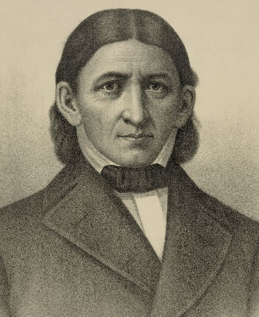
Froebel’s Approach.
- Froebel constructed a curriculum for young children based on 'play and activity' and 'the nurturing of creativity' to help them progress and grow (Care for Kids, 2017).
- Froebel believed that play is an important part of learning in early childhood. (Froebel’s trust, n.d)
- Froebel outlined play as “the highest expression of human development in childhood, for it alone is the free expression of what is in the child’s soul” (Louis & Powell, n.d).
- He wanted children to become more adventurous and tried to get them out of their comfort zone. He motivated children to learn more physically (Tovey, 2022).
- Play is a way for children to relate and express their inner thoughts and feelings, and with these experiences it they start to think, imagine, and create on a new level. This is a resource to help them for their future. (Froebel’s trust, n.d).

(Curtis & Gregerson, n.d.)

Froebel’s key principles:
- Freedom with guidance
- Unity, connectedness, and community
- Engaging with nature
- Learning through self-activity and reflection
- The crucial importance of play
- Creativity and the power of symbols
- Knowledgeable and nurturing educators. (Tovey, n,d.)

To learn and understand more on Froebel’s theory – watch this clip. Froebel’s Kindergarten: The Origins of Early Childhood Education - YouTube (2022)

Why is Froebel’s theory a successful way to support children and young people within education?
All children should be treated as an individual according to Froebel, as everyone is different and it will allow personal abilities to be supported to grow (HRF, n.d). He believed that through learning of play it would allow children to explore their full potential as a student within education (HRF, n.d).
Were you aware that the key aim of a Froebel instruction is to educate the child in all developmental zones: socially, academically, emotionally, physically, and spiritually? (Care for kids, 2017). Play is a way for children to relate and express their inner thoughts, feelings and with these experiences, they start to think, imagine, and create on a new level. This is a resource to help them for their future. (Froebel’s trust, n.d).
Supporting children to make choices – assisting them to decide what resources they need for what they are participating in. (Tovey, n.d)
Giving opportunities to move freely – within the classroom and the outdoors (Tovey, n.d).
Assisting children to become more adventurous – helping them use real life tools safely (Tovey, n.d).
Showing guidance to help children think for themselves – Listening and respecting their own ideas and others (Tovey, n.d).
To help children understand and develop self-discipline – for them to understand the consequences of their actions and how it can impact others’ feelings (Tovey, n.d).
Froebel stresses that parents/guardians are the primary educators for children, as there ought to be close connections between home and school. Relationships are of central importance in a child’s life. (Care for kids, 2017). What better way for children to engage in nature and learning in the outdoors, than having that key adult that they feel comfortable learning with and who shares the same curiosity and eagerness about nature. We can inspire and support children throughout their time learning within the outdoors by offering forest schools. All children should be treated as an individual according to Froebel, as everyone is different, and it will allow personal abilities to be supported to grow. He believed that through learning of play it would allow children to explore their full potential as a student within education (HRF, n.d).
What better way for children to engage in nature and learning in the outdoors than having that key adult that they feel comfortable learning with and who shares the same curiosity and eagerness about nature.? We can inspire and support children throughout their time learning within the outdoors.
If you were a learner these days, would you take the opportunity to learn in the outdoors? I know I would!

References Blog 1
(2022) YouTube. Sprouts. Available at: Froebel’s Kindergarten: The Origins of Early Childhood Education - YouTube (Accessed December 4, 2022)
Care for Kids (2017) The froebel approach, CareforKids.com.au. Care for Kids. Available at: https://www.careforkids.com.au/child-care-articles/article/157/the-froebel-approach (Accessed: December 4, 2022).
Curtis , S.J. (n,d.) Friedrich Froebel, Encyclopædia Britannica. Edited by G. Erik. Encyclopædia Britannica, inc. Available at: https://www.britannica.com/biography/Friedrich-Froebel (Accessed: December 3, 2022).
Friedrich Froebel's theory of Education explained (n.d) HRF. Available at: https://healthresearchfunding.org/friedrich-froebels-theory-of-education-explained/ (Accessed: December 4, 2022).
Froebel’s Kindergarten: The Origins of Early Childhood Education (2022) Sprouts Learning Videos Social Sciences. Available at: https://sproutsschools.com/froebels-kindergarten-the-origins-of-early-childhood-education/ (Accessed: December 4, 2022).
Froebelian Principles (n.d) Froebel Trust. Available at: https://www.froebel.org.uk/about-us/froebelian-principles (Accessed: December 4, 2022).
Louis, S. and Powell, S. (no date) About Friedrich Froebel, who invented "Kindergarten", Froebel Trust. Available at: https://www.froebel.org.uk/about-us/the-power-of-play/about-friedrich-froebel (Accessed: December 4, 2022).
Outdoor Classroom cliparts #2881907 (license: Personal use) (n, d.) kid science clipart - Clip Art Library. Available at: http://clipart-library.com/clipart/801614.htm (Accessed: November 29, 2022).
The power of play (n,d) Froebel Trust. Froebel Trust. Available at: https://www.froebel.org.uk/about-us/the-power-of-play (Accessed: December 4, 2022).
The power of play (n,d.) Froebel Trust. Froebel Trust. Available at: https://www.froebel.org.uk/about-us/the-power-of-play (Accessed: November 29, 2022).
Tovey, H. (2022) Froebel Trust | Homepage, Froebel Children and Nature. Available at: https://www.froebel.org.uk/uploads/documents/An-introduction-to-Froebel-children-and-nature.pdf (Accessed: December 3, 2022).
White, P.J. (2020) Learning in the outdoors and listening to Froebel, Early Childhood Outdoors. Available at: https://www.earlychildhoodoutdoors.org/learning-in-the-outdoors-and-listening-to-froebel/ (Accessed: November 29, 2022).
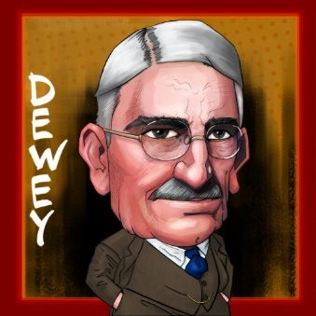
How to help our students learn better? John Dewey’s ideas of a child-centred approach and linking school to real-life experiences are just as relevant today” (Currell, 2020).
(Linsenmayer, 2020)
To learn and understand more on Dewey’s theory – watch this clip. John Dewey’s 4 Principles of Education - YouTube (2021).

By Rhiannon Rees-Givelin | 13th December 2022
Who is John Dewey and why is his theory important in education?

About John Dewey and his theory.
Who is he?
John Dewey is an American theorist and educator. His prospective was that children need to be active associates with their own learning, and not to have knowledge from the past. He insisted that learning should be an experience for children and not boring (Mhlongo, 2021).
Did you know that Dewey was also a functionalist? He was enthusiastic about the ideas of Charles Darwin, in reckoning that humans grow an adaption to their environment (Nickerson, 2022).
Dewey once famously said – “It’s not a preparation for life, education is life itself.” (Mhlongo, 2021). What do you think?
“Dewey is one of the central figures and founders of pragmatism in America, despite not himself identifying as a pragmatist. Pragmatism teaches that things which are useful — meaning that they work in a practical situation — are true, and what does not work is false” (Mike, n.d)
John Dewey was a keen believer that we learn by doing.
He thought that each child:
- Was active.
- Inquisitive.
- Wanted to explore. (Mike, n.d)
He acknowledged that children need to co-operate by working with others such as their peers and adults, but also working alone (Lorina, 2022). “According to John Dewey, development for children when they engage with their surroundings and participate in the institution’s learning plan” (Opinaldo, 2022). This will help them gaining confidence of working with others and independently.

Is John Dewey’s theory a successful way to support the learning of children within education?
Yes. According to Dewey, children study and grow as a result of their experiences and collaborations with the world. The children will gain different conceptions, practices, and understandings as an outcome of these experiences, which are then continued throughout a learner’s life encounters and social relationships (Lorina, 2022).
He recommends a curriculum where children can freely walk in and out of classrooms. In doing so, students can seek their own interests and construct their own method of learning. Teachers should always recognise children’s interests. They should also help the children better their critical thinking skills (Janse, 2019). The teacher’s role should be more of a facilitator than an educator when it comes to John Dewey’s theory of learning.
By establishing Dewey’s’ theory in education, it can open new possibilities for social interaction. But how? You’re more likely to see children participating in group work with a lot of conversation and collaboration. This is good for children as they get to communicate with their peers while working and learning (Opinaldo, 2022).
Did you know that according to Dewey, learning should be related to the four "impulses" of students? These impulses are natural resources that promote growth (Currell, 2020). He stated that learning should be an experience for children.
- The social impulse – this refers to communication. Dewey once said, “the language instinct is the simplest form of the social expression of the child and the greatest of all educational resources.”
- The instinct to make - The urge to create and innovate rather than to be passive and follow rules.
- The innate desire to investigate - how kids like to act and observe to see what happens.
- The art instinct - where children express themselves and imagine by telling or making.
(Currell, 2020)

References Blog 2
So, how can you incorporate his theory into your own practice?
- Ask the students questions at the start of the lesson that links to their own individual experiences.
- Integrate their home lives to your lessons.
- Look for creative ways to incorporate learning through experiences. These could be school trips, inviting specialists to teach skills in the classroom, or asking community members to pass on hobbies or life skills.
(Currell, 2020)
- Make the classrooms interactive. He supposes that engagement with the environment is essential for the learning process. (Mhlongo, 2021)
(2021) YouTube. Sprouts. Available at: https://www.youtube.com/watch?v=y3fm6wNzK70 (Accessed: December 7, 2022).
Currell, J. (2020) Who is John Dewey and why is he still so relevant today?: MNP Blog, Maths. Maths – No Problem! Available at: https://mathsnoproblem.com/blog/teaching-practice/legacy-of-john-dewey/ (Accessed: December 7, 2022).
Janse, B. (2019). John Dewey Theory. Available at: https://www.toolshero.com/change-management/john-dewey-theory/ (Accessed December 7, 2022).
John Dewey theory (2019) Toolshero. Available at: https://www.toolshero.com/change-management/john-dewey-theory/ (Accessed: December 7, 2022).
Lorina (2022) John Dewey's theory, Aussie Childcare Network. Available at: https://aussiechildcarenetwork.com.au/articles/child-development/john-deweys-theory (Accessed: December 7, 2022).
Mhlongo, S. (2021) John Dewey's principles of learning, Edupstairs. Available at: https://www.edupstairs.org/john-deweys-principles-of-learning/ (Accessed: December 7, 2022).
Mike (n.d.) D is for John Dewey: His approach to education, The Positive Encourager. Available at: https://www.thepositiveencourager.global/john-deweys-approach-to-doing-positive-work/ (Accessed: December 7, 2022).
Nickerson, C. (2022) John Dewey: Biography, philosophy, pragmatism, & education, John Dewey | Biography, Philosophy, Pragmatism, & Education - Simply Psychology. Available at: https://www.simplypsychology.org/John-Dewey.html (Accessed: December 7, 2022).
Opinaldo, N. (2022) John Dewey theory: Pragmatism, templates, and Education, GitMind. Available at: https://gitmind.com/john-dewey-theory.html (Accessed: December 7, 2022).

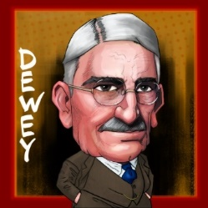
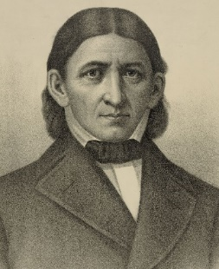
By Rhiannon Rees-Givelin |5th January 2023
Why is Froebel’s theory a successful way to support children within education?
Giving opportunities to move freely – within the classroom and the outdoors. (Tovey, n.d). By using this this strategy, it gives children the opportunity to participate more. By making the learning fun they will be more motivated to learn.
Why is Dewey’s theory a successful way to support children within education?
The innate desire to investigate how kids like to act and observe to see what happens. (Currell, 2020) This is also a fun and visual way to help the children learn.
These are benefits for both theories because it is going to benefit the child and will encourage them to learn. They will have a better opportunity to succeed in education if the learning is interesting and it is something they enjoy. By giving children a lot to write they will become unmotivated and bored. This will affect the child’s education.
E
Would you consider using either theory in your educational setting? I know I would!
Both philosophers established that child-centred practice is a higher quality of learning for children. Learning by ‘doing’ is key to both theorists. Both academics believed that practical learning is better for children as they will be more engaged and motivated while learning. Froebel believed that play is an important part of learning in early childhood (Froebel’s trust, n.d). He wanted children to become more adventurous and tried to get them out of their comfort zone. This will increase motivation and confidence for our learners. He motivated children to learn more physically (Tovey, 2022), while Dewey believed that learning should be an experience for children and not boring (Mhlongo, 2021). The impact of boring learning will increase slow development of pupils as they will be less willing to cooperate during lessons.
Friedrich Froebel constructed a curriculum for young children based on 'play and activity' and 'the nurturing of creativity' to help them progress and grow (Care for Kids, 2017). In addition to this, John Dewey supposes that engagement with the environment is essential for the learning process (Mhlongo, 2021), once again showing similarity in their theories.
Furthermore, according to the theorists, there ought to be a good connection between school and home. Relationships are a central of importance of a child’s life (Care for Kids, 2017). Dewey believes that integrating the children’s home lives to lessons will be beneficial for the learners, whilst Froebel stresses that Parents/Guardians are the primary educators for children. If the child’s parents/guardians are involved and the encouragement of learning at home the learners will be more likely to cooperate and will find it easier to get into a routine.

To learn and understand more on Froebel’s theory – watch this clip. Froebel’s Kindergarten: The Origins of Early Childhood Education - YouTube (2022)
To learn and understand more on Dewey’s theory – watch this clip. John Dewey’s 4 Principles of Education - YouTube (2021).

(Curtis & Gregerson, n.d.)

(Linsenmayer, 2020)
Did you know that both theories help learners to develop and increase their social skills? Dewey once said, “the language instinct is the simplest form of the social expression of the child and the greatest of all educational resources” (Currell, 2020). By establishing Dewey’s theory into education, you are more likely to see children participating in group work with a lot of conversation and collaboration. This is good for children as they get to communicate with their peers while working and learning (Opinaldo, 2022). The key aim of a Froebel instruction is to educate the child in all developmental zones with one being socially (Care for kids, 2017). It helps children to respect their own ideas as well as others (Tovey, n.d).
According to Dewey, children’s interests should always be recognized by educators (Janse, 2019). The teacher’s role should be more of a facilitator than an educator when it comes to John Dewey’s theory of learning. In the opinion of Froebel, all children should be treated as an individual as everyone is different, and it will allow personal abilities to be supported to grow. He believed that through learning of play it would allow children to explore their full potential as a student within education (HRF, n.d). As stated by Froebel, play is a way for children to relate and express their inner thoughts and feelings, and with these experiences it they start to think, imagine, and create on a new level. This is a resource to help them for their future (Froebel’s trust, n.d). However, Dewey once famously said – “It’s not a preparation for life, education is life itself”. What is your opinion on this? Who do you agree with?

Are Froebel’s and Dewey’s theories similar? Let us find out.
Froebel and Dewey: Their impact on early childhood education.

(2021) YouTube. Sprouts. Available at: https://www.youtube.com/watch?v=y3fm6wNzK70 (Accessed: January 5, 2023).
References Blog 3
(2022) Froebel Trust | Homepage, Froebel Children and Nature. Available at: https://www.froebel.org.uk/uploads/documents/An-introduction-to-Froebel-children-and-nature.pdf (Accessed: January 5, 2023).
(2022) YouTube. Sprouts. Available at: Froebel’s Kindergarten: The Origins of Early Childhood Education - YouTube (Accessed December 4, 2022)
Care for Kids (2017) The froebel approach, CareforKids.com.au. Care for Kids. Available at: https://www.careforkids.com.au/child-care-articles/article/157/the-froebel-approach (Accessed: January 5, 2023).
Currell, J. (2020) Who is John Dewey and why is he still so relevant today?: MNP Blog, Maths. Maths – No Problem! Available at: https://mathsnoproblem.com/blog/teaching-practice/legacy-of-john-dewey/ (Accessed: January 5, 2023).
Friedrich Froebel's theory of Education explained (n.d) HRF. Available at: https://healthresearchfunding.org/friedrich-froebels-theory-of-education-explained/ (Accessed: January 5, 2023).
Janse, B. (2019). John Dewey Theory. Available at: https://www.toolshero.com/change-management/john-dewey-theory/ (Accessed January 5, 2023).
Mhlongo, S. (2021) John Dewey's principles of learning, Edupstairs. Available at: https://www.edupstairs.org/john-deweys-principles-of-learning/ (Accessed: January 5, 2023).
Opinaldo, N. (2022) John Dewey theory: Pragmatism, templates, and Education, GitMind. Available at: https://gitmind.com/john-dewey-theory.html (Accessed: January 5, 2023).
Tovey, H. (2022) Froebel Trust | Homepage, Froebel Children and Nature. Available at: https://www.froebel.org.uk/uploads/documents/An-introduction-to-Froebel-children-and-nature.pdf (Accessed: January 5, 2023).

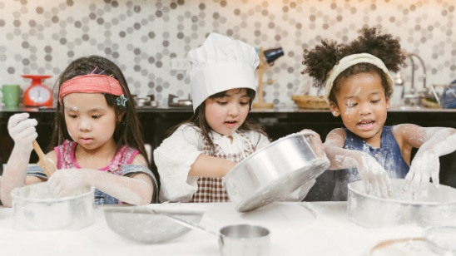
As teachers, we all know what our key role is to help pupils learn. But what exactly makes teaching and learning effective? How do we make sure that pupils are engaged and are enjoying their learning? To find out, keep reading.

- The power of play
Play is the one of the most important resources that children must help them grow, study, and relate to people and the world around them and their imagination (Louis & Powell, n.d.).
Forest schools - https://forestschoolassociation.org/what-is-forest-school/ click on this link to find out what forest schools about in a nutshell!
Here at our school, we provide an extra opportunity for our learners who we think will benefit from forest schools. Why forest schools? Forest School is learner-centred, the main message is that progress in Forest School is process-based, not goal-based (Spencer-Milnes, 2021). We want our young people to have the opportunity to work in the outdoors and develop a relationship with nature. Forest schools also helps with confidence and well-being. We want to make sure that they know when they have done something good, so we praise them for that. It helps them socialise with their peers, learn about various things and of course it is great to see our leaners happy.
How can forest schools help a young person?
- Improve critical thinking skills.
- Develop self-regulation skills.
- Build resilience.
- Gain a sense of achievement.
- Build positive relationships with peers and adults.
- Increase motivation and concentration.
A typical day of forest schools.
The excitement of the children is in the air. The children are dressed in their wellingtons and overalls. We gather around the open fire, sitting on tree stumps. We have little chit chat about their day and how their feeling. As a group, the children then go onto do a treasure hunt – this is so lovely to see the children interacting with each other in the outdoors, rather being stuck inside all day. The students then make themselves a cuppa, whether it is tea, coffee, or hot chocolate – they do this by using an outdoor kettle and the fire. Then more activities are on the go. “Froebel constructed a curriculum for young children based on 'play and activity' and 'the nurturing of creativity' to help them progress and grow” (Care for Kids, 2017).
Children thoroughly enjoy being in the outdoors, I would recommend this to any educational setting!

- Learning by doing
“The American theorist, John Dewey, first popularized learning by doing. For Dewey, this meant a heavy emphasis on student engagement” (Boser, 2020). In a secondary school, we provide a nurture group which involves cooking, where the pupils have the opportunity to cook. Before this, they have to make a shopping list to see what ingredients are needed to make the recipe. When it comes to cooking, they learn elements of sensory play, mathematical concepts, home safety, and following processes.

We give our pupils art equipment so that they are able to experience themselves in a sensory way and they can express themselves through art. This works well with individuals who struggle to express their thoughts and feelings.

During literacy interventions we play board games with our pupils. You might think, board games? They are not going to learn from that! In fact, they learn a lot. It is not just about the shapes, the numbers, and the colours, it is also about improving social skills and turn-taking.

We provide the intervention Lego therapy for our pupils. Who doesn’t love a little bit of Lego? This is a chance for the students to work as a team to make an artistic piece out of Lego. There are three roles and they must stick to them. That is a challenge in itself for some children, but with practice it can be done. Also, problem solving skills are being used when it comes to Lego Therapy. They need to recognise various shapes, sizes, colours and make sure the right piece is in the right place. This is all learner led as they decide on who is playing what role and they make all the decision. The teacher just observes the intervention. The children thoroughly enjoy it!

By Rhiannon Rees-Givelin | 17th December 2022
(no date) https://www.sitters.co.uk/blog/the-15-best-activities-for-children-to-help-them-learn-through-play.

Effective teaching and learning within a secondary school setting.
References Blog 4

(no date) https://www.sitters.co.uk/blog/the-15-best-activities-for-children-to-help-them-learn-through-play.aspx#:~:text=Sand%20play%20is%20a%20fantastic%20opportunity%20for%20the,work%2C%20whilst%20also%20building%20their%20muscles%20and%20coordination.
Boser, U. (2020) Learning by doing: What you need to know, The Learning Agency Lab. Available at: https://www.the-learning-agency-lab.com/the-learning-curve/learning-by-doing/ (Accessed: December 14, 2022).
Care for Kids (2017) The froebel approach, CareforKids.com.au. Care for Kids. Available at: https://www.careforkids.com.au/child-care-articles/article/157/the-froebel-approach (Accessed: December 14, 2022).
Louis , S. and Powell , S. (no date) About Friedrich Froebel, who invented "Kindergarten", Froebel Trust. Available at: https://www.froebel.org.uk/about-us/the-power-of-play/about-friedrich-froebel (Accessed: December 14, 2022).
Spencer-Milnes, X. (2021) What is a forest school?: Benefits & key principles, The Hub | High Speed Training. High Speed Training. Available at: https://www.highspeedtraining.co.uk/hub/what-is-a-forest-school/ (Accessed: December 14, 2022).
The 15 best activities for children to learn through play (no date) www.sitters.co.uk. Available at: https://www.sitters.co.uk/blog/the-15-best-activities-for-children-to-help-them-learn-through-play.aspx (Accessed: December 14, 2022).

