Foundation Art And Design
Swansea College Of Art UWTSD
Dynevor Campus,
Swansea,
SA1 3EU
23rd May 2018

1, Clients Road,
Clientsville,
Clientstown,
CL1 7AB

Dear Mr Marcus WoodStock and Mrs Mandy Stephens,
The total costs for the project ‘A Child’s Safety Film’ are as follows: -
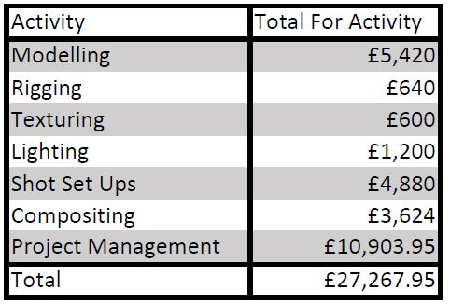
The project will begin on Monday 28th June 2018 and the project deadline is Monday 27th August 2018. It is important to us that you get a chance to give us your feedback during the production process and therefore, we would like to invite you to view our progress on the following dates: -
- Wednesday 4th July 2018
- Monday 16th July 2018
- Tuesday 24th July 2018
- Friday 3rd August 2018
We look forward to your visits and please do not hesitate to contact us on 01792 123456 or thisisafakeemail@live.co.uk should any further communication be needed. Below is a copy of the schedule.
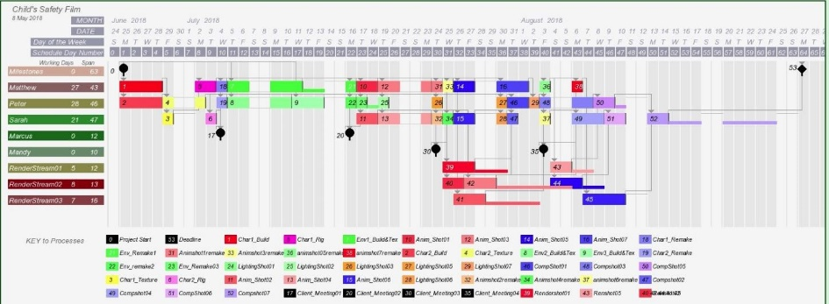

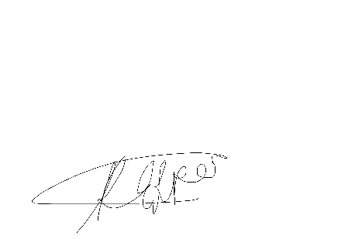

Yours Sincerely,

Miss Rachel Piper
Project Manager

Foundation Art And Design
Swansea College Of Art UWTSD
Dynevor Campus,
Swansea,
SA1 3EU
23rd May 2018
2, Modellers Way,
Riggingville,
Animation Town,
AM11 3BA

Dear Matthew,
I am writing to inform you of your working dates throughout the summer period on the project ‘Child’s Safety Film’. Your skills and rates have been taken into account and your schedule is as follows: -
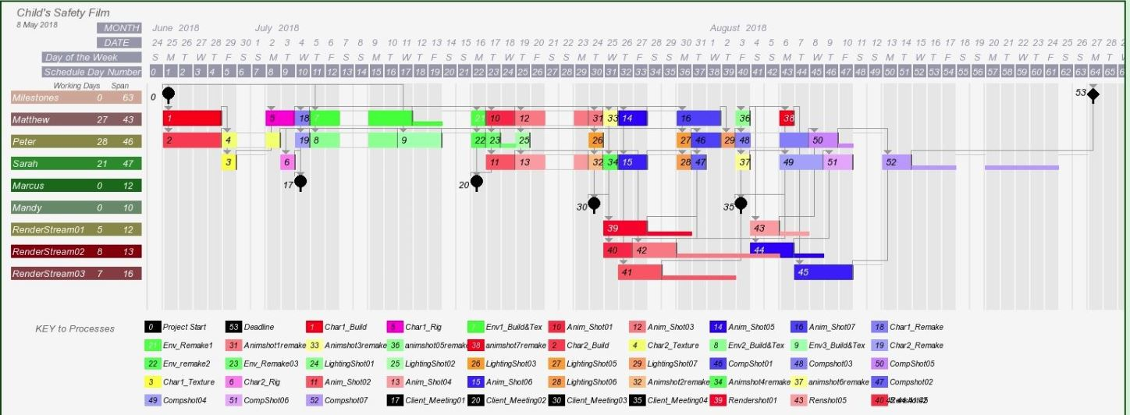

- Schedule starts Monday 25th June 2018
Character 1 Modelling
- Starts on Monday 25th June 2018 for 4 days and finishes on Thursday 28th June 2018.
Character 1 Rigging
- Starts on Monday 2nd July for 2 days and finishes on Tuesday 3rd July 2018.
Character 1 Alterations
- Wednesday 4th July 2018 for 1 day only.
Environment 1 Modelling and Texturing
- Starts on Thursday 5th July 2018 for 5 days and finishes on Wednesday 11th July 2018 with 2 days slack.
Environment 1 Alterations
- Monday 1th July 2018 for one day only.
Animation Shot 01
- Starts on Tuesday 17th July 2018 for 2 days and finishes on Wednesday 18th July 2018.
Animation Shot 03
- Starts on Thursday 19th July 2018 and finishes on Monday 23rd July 2018.
Animation Shot 01 Alterations
- Tuesday 24th July 2018 for one day only.
Animation Shot 03 Alterations
- Wednesday 25th July for one day only.
Animations Shot 05
- Starts on Thursday 26th July 2018 for 2 days and finishes on Friday 27th July 2018.
Animation Shot 07
- Starts on Monday 30th July 2018 for 3 days and finishes on Wednesday 1st August 2018.
Animation Shot 05 Alterations
- Friday 3rd August 2018 for one day only.
Animation Shot 07 Alterations
- Monday 6th August 2018 for one day only.

- Schedule ends Sunday 26th August 2018
You will be paid according to your rates on your rate card, therefore your final total payment at the end of this project will be: -
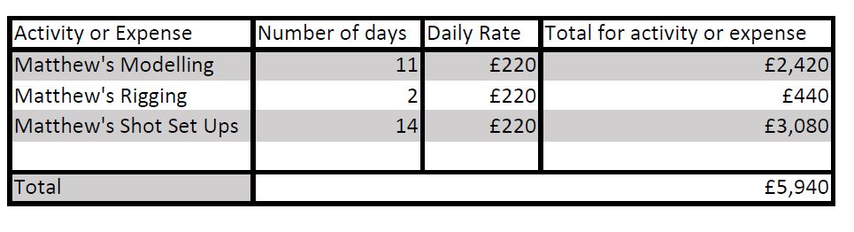
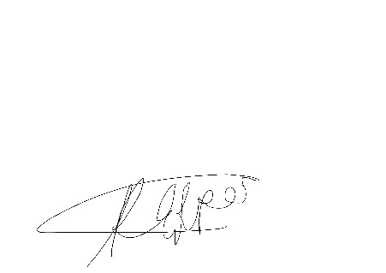
If you do have any further questions, please do not hesitate to contact me on 01792 123456 or email me on thisisafakeemail@live.co.uk.
Yours sincerely,

Miss Rachel Piper
Project Manager

Foundation Art And Design
Swansea College Of Art UWTSD
Dynevor Campus,
Swansea,
SA1 3EU
23rd May 2018
3, Lighting Avenue,
Rendering Abbey,
Compositing City,
CM13 1AK

Dear Peter,
I am writing to inform you of your working dates throughout the summer period on the project ‘Child’s Safety Film’. Your skills and rates have been taken into account and your schedule is as follows: -
- The project schedule starts Monday 25th June 2018.

Character 2 Modelling
- Starts on Monday 25th June 2018 for 4 days and finishes on Thursday 28th June 2018.
Character 2 Texturing
- Starts on Friday 29th June 2018 for 2 days and finishes on Monday 2nd July 2018.
Character 2 Alterations
- Wednesday 4th July 2018 for one day only.
Environment 2 Modelling and Texturing
- Starts on Thursday 5th July 2018 for 4 days and finishes on Tuesday 10th July 2018.
Environment 3 Building and Texturing
- Starts on Wednesday 11th July 2018 for 3 days and finishes on Friday 13th July 2018.
Environment 2 Alterations
- Monday 16th July 2018 for one day only.
Environment 3 Alterations
- Tuesday 17th July 2018 for one day only with one day slack.
Lighting Shot 01
- Thursday 19th July 2018 for one day only.
Lighting Shot 02
- Thursday 19th July 2018 for one day only.
Lighting Shot 03
- Tuesday 24th July 2018 for one day only.
Lighting Shot 05
- Monday 30th July 2018 for one day only.
Compositing Shot 01
- Starts on Tuesday 31st July 2018 for 2 days and finishes on Wednesday 1st August 2018.
Lighting Shot 07
- Thursday 2nd August 2018 for one day only.
Compositing Shot 03
- Starts on Friday 3rd August 2018 for 3 days and finishes on Tuesday 7th August 2018.
Compositing Shot 05
- Starts on Wednesday 8th August 2018 for 2 days and finishes on Thursday 9th August 2018 with 1 slack day.
- Schedule ends Sunday 26th August 2018
You will be paid according to your rates on your rate card, therefore your final total payment at the end of this project will be: -
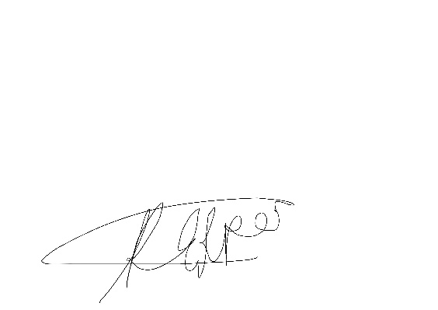
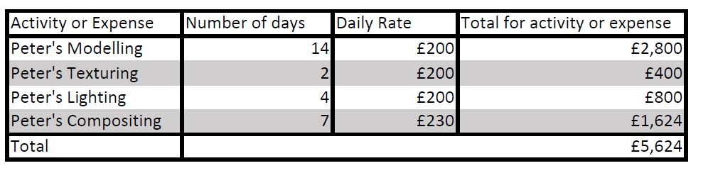
If you do have any further questions, please do not hesitate to contact me on 01792 123456 or email me on thisisafakeemail@live.co.uk.
Yours sincerely,

Miss Rachel Piper
Project Manager

Foundation Art And Design
Swansea College Of Art UWTSD
Dynevor Campus,
Swansea,
SA1 3EU
23rd May 2018
4, Render Lane,
Mayaville,
Texture Town,
TT11 8MM

Dear Sarah,
I am writing to inform you of your working dates throughout the summer period on the project ‘Child’s Safety Film’. Your skills and rates have been taken into account and your schedule is as follows: -

- The project schedule starts Monday 25th June 2018.
Character 1 Texturing
- Friday 29th June 2018 for one day only.
Character 2 Rigging
- Tuesday 3rd July 2018 for one day only.
Animation Shot 02
- Starts on Tuesday 17th July 2018 for 2 days and finishes on Wednesday 18th July 2018.
Animation Shot 04
- Starts on Thursday 19th July 2018 for 3 days and finishes on Monday 23rd July 2018.
Animation Shot 02 Alteration
- Tuesday 24th July 2018 for one day only.
Animation Shot 4 Alterations
- Wednesday 25th July 2018 for one day only.
Animation Shot 06
- Starts on Thursday 26th July 2018 for 2 days and finishes on Friday 27th July 2018.
Lighting Shot 06
- Monday 30th July 2018 for one day only.
Compositing Shot 02
- Tuesday 31st July 2018 for one day only.
Animation Shot 06 Alterations
- Friday 3rd August 2018 for one day only.
Compositing Shot 04
- Starts on Monday 6th August 2018 for 3 days and finishes on Wednesday 8th August 2018.
Compositing Shot 06
- Starts on Thursday 9th August 2018 for 2 days and finishes on Friday 10th August 2018.
Compositing Shot 07
- Starts on Monday 13th August 2018 for 2 days and finishes on Tuesday 14th August 2018 and 8 days slack.
- The schedule finishes on Sunday 26th August 2018.
You will be paid according to your rates on your rate card, therefore your final total payment at the end of this project will be: -
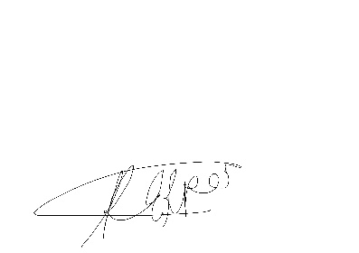
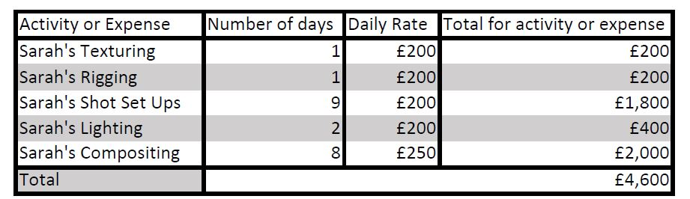
If you do have any further questions, please do not hesitate to contact me on 01792 123456 or email me on thisisafakeemail@live.co.uk.
Yours sincerely,

Miss Rachel Piper
Project Manager

Not to be included in letters. Full rate card.


