
Module Name: Social Epidemiology and Public Health Development
Module Code: LCHS7000

Title: Ethnicity and Health Inequalities in the UK: A Critical Analysis of Healthcare Inequalities in the Immigrant Elderly Population in the UK

Component 2

Analytical Report

Lecturer: Jolly Nwankwo

Student Name: Keshaben Jayeshbhai Khanpara
Student ID : 2505873
Table of Contents
Task 1: Health Inequalities Report 4
1. Introduction 4
1.1 Definition of Target Group 4
1.2 Why the Target Group Is at Risk of Health Inequalities 4
2. Contextual Background and Underlying Factors 5
2.1 Higher Rates of Mental Illness 5
2.2 Low Rates of Access to Healthcare 5
2.3 Mortality Rates Among the Elderly Group 6
2.4 Social Isolation and Loneliness 6
2.5 Poverty 7
2.6 Housing Issues 7
3. National Response to Reduce Health Inequalities 8
3.1 NHS Long Term Plan (2019) 8
3.2 CORE20Plus5 8
4. Organisations Supporting the Chosen Group 8
4.1 Overview of Chosen Organisation: Age UK 8
4.2 Age UK Supporting The Age Group 9
4.3 Age UK Goals and Impact 9
Task 2: Epidemiological Analysis 10
1. Introduction 10
1.1 Definition of the Health Problem 10
1.2 Social, Cultural, and Health Consequences 10
1.3 Global and UK Incidence 10
2. Main Body 11
2.1 Public Health Measures (3 Ps: Prevention, Protection, Promotion) 11
2.2 Key Determinants and Risk Factors 11
2.3 Epidemiological Studies & Health Needs Assessment 12
2.4 Identifying Affected Population 12
2.5 Epidemiological Approaches & Surveillance Systems 12
2.6 Determining Public Health Impact 13
2.7 Designing an Intervention Programme 13
2.8 Evaluating Intervention Impact 14
2.9 Strengths and Weaknesses of the Epidemiological Approach 14
3. Conclusion 15
References 16

Task 1: Health Inequalities Report

1. Introduction

1.1 Definition of Target Group
The target population includes older adults (65 years or above) of immigrant origin in the United Kingdom, namely individuals born in other countries, and who migrated to the United Kingdom, such as refugees, asylum-seekers, and long-term economic migrants. The population of this group is diverse in terms of ethnicity (South Asian, Black African and Caribbean, Eastern European, Middle Eastern, and others), immigration statuses, languages, and socioeconomic status. To be precise, the analysis is devoted to immigrant elders of different backgrounds.

1.2 Why the Target Group Is at Risk of Health Inequalities
Older adults who are immigrants have intertwined vulnerabilities, such as language and cultural barriers decreasing healthcare navigation; socioeconomic disadvantage as a result of immigration makes people vulnerable to poverty (Sharma, Dutt and Ahmed, 2025). Additionally, the cumulative lifetime experience of discrimination and unfavorable social determinants adds to the burden of chronic diseases (Zarah Batulan, Bhimla and Higginbotham, 2024). Later presentation, poor follow-up, and worse control of long-term conditions are motivated by structural barriers, namely, restricted access to culturally competent primary care, inconsistent eligibility to certain services, and mistrust due to prior experiences. These aspects act in conjunction with digital exclusion, which minimizes access to appointment systems and the advantages of making claims.

2. Contextual Background and Underlying Factors

2.1 Higher Rates of Mental Illness
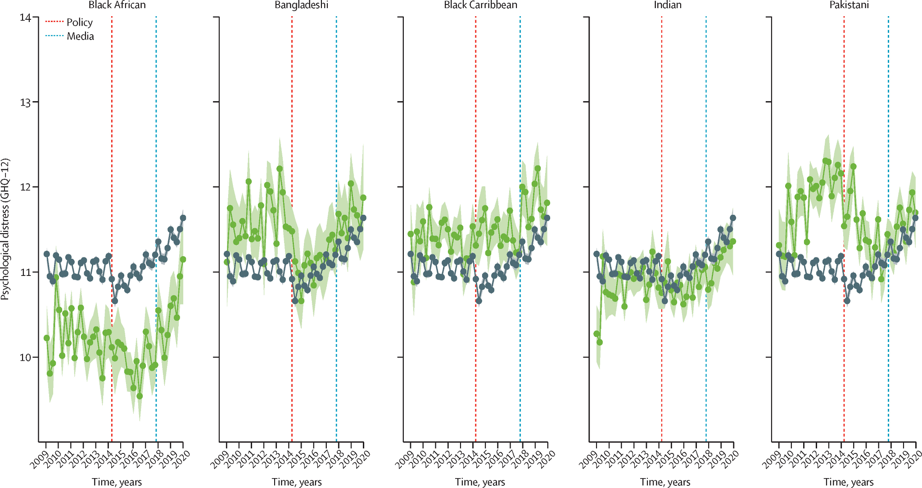
Figure 1: Mental Health Trends in Older Adult Immigrants
(Source: The Lancet, 2023)
The above graph maps the trends recorded in the mental health patterns in older adults in the UK, showing an upward curve with the increase in age. Some particular immigrant groups depict greater rates of depression, 68% to be precise, with anxiety, and trauma-related disorders, especially forced-migrant groups that hold pre-migration trauma (Côté-Olijnyk et al., 2024). Among migrant elderly, bereavement, acculturative stress, and social isolation are risk factors of late-life depression and cognitive impairment (Maleku et al., 2021). Under-detection is due to cultural stigma and the lack of tested screening instruments in the minority languages; presentations made in primary care are frequently missed with the use of somatised or culturally-framed presentations. The result of this combination is a treatment gap, as there is a need, services to identify and provide culturally adapted evidence-based treatments.

2.2 Low Rates of Access to Healthcare
The barriers to access are tangible and quantifiable: the inconsistencies in the registration of GPs, the absence of professionally interpreting funds to primary care, an appointment system designed without language features, and misunderstandings regarding the right to services (Al Shamsi et al., 2020). The fear of sharing this data with immigration authorities or the imagined fear impacts the interaction of certain groups. The practical implication is reduced uptake of preventive services (cancer screening, flu vaccination), intermittent management of chronic diseases (hypertension, diabetes), and the overuse of emergency departments in the treatment of problems that are otherwise treatable by primary care.

2.3 Mortality Rates Among the Elderly Group
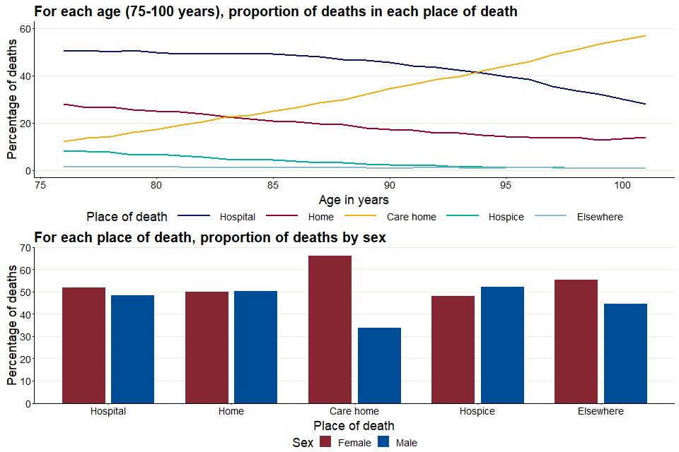
Figure 2: Death in People Older than 75 in the UK
(Source: GOV.UK, 2025)
The graph above portrays the proportion of death in older adults, older than 75, and then compared by gender division. The heterogeneous but worrying pattern in mortality is as follows: certain groups of migrants are more likely to die of cardiovascular diseases and diabetes complications, indicating a delay in diagnosis and inadequate control of the disease. Most policy and research data display generalized, or aggregate, ethnically defined groups of people, which conceal disparities in subgroup mortality in terms of country of origin, length of residence, and socioeconomic status (Ventura et al., 2025). Inability to disaggregate the data covers high-risk areas and allows no focus on their intervention.

2.4 Social Isolation and Loneliness
The elderly migrants often do not have any local family contacts, have transport and mobility restrictions, and cultural exclusion. Loneliness is no small quality-of-life problem; it portends bad cardiovascular health, cognitive deterioration and high use of healthcare (Syed Mohammed Usama et al., 2024). The local services often do not screen loneliness in immigrant elders and do not scale to culturally relevant social prescribing, which leads to unaddressed psychosocial risk factors that increase health deterioration.

2.5 Poverty
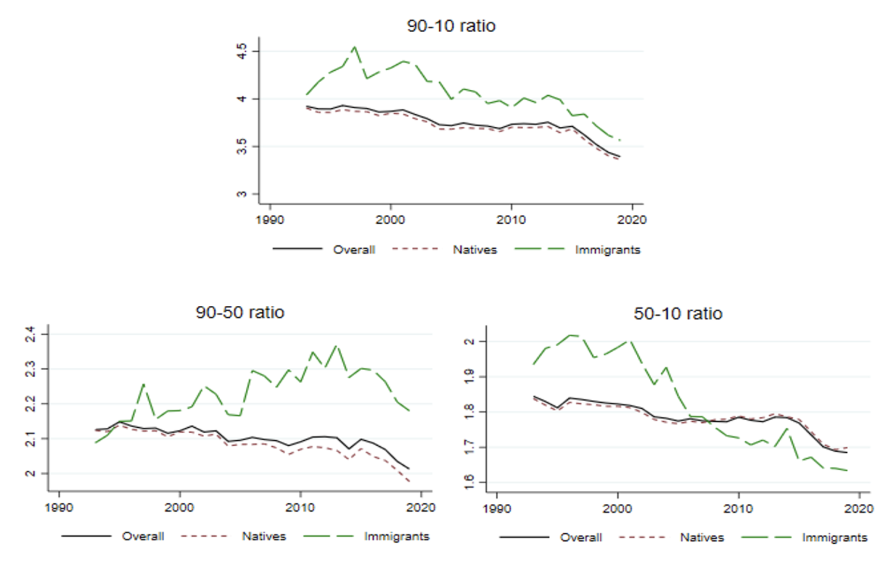
Figure 3: Inequality and Immigration
(Source: CEPR, 2025)
The above graph represents the inequality in immigrant wages and quality of life throughout the UK. Financial insecurity is caused by pension entitlement gaps, an interrupted history of contributions, reduced lifetime earnings, and a small amount of personal savings. With poverty, access is limited to proper nutrition, household heating, assistive mobility, and paid home care services (Tonn et al., 2025). Complicated, often entirely digitalized benefits systems are a disadvantage to people with low literacy or lacking English fluency. Economic burden has a direct negative effect on the health outcomes and indirectly diminishes medication compliance and attendance at specialist visits.

2.6 Housing Issues
The older adults belonging to immigrant groups are also disproportionately prone to reside in housing that is crowded or in poor housing, in households with more than one generation, thus making it hard to adapt to the disability, or in accommodations that have low levels of accessibility. Poor housing worsens breathing issues, fall risks, stress, and interferes with the ability to live on their own and recuperate after a disease (Howden-Chapman et al., 2022). Lack of security in housing makes provision of home-based healthcare or rehabilitation even more difficult.

3. National Response to Reduce Health Inequalities

3.1 NHS Long Term Plan (2019)
The NHS Long Term Plan recognizes health inequalities and is determined to intervene at the population level and community-based care routes (NHS West Suffolk, 2025). It is a practical framework yet it does not have particular and quantifiable targets and special lines of funding for the immigrant older adults. The absence of ringfenced resources to interpret, culturally-sensitive community navigators, and tracking by migration status will make its ambitions just rhetoric. Programs often prioritize system-wide interventions over resource-intensive target interventions that are required by the immigrant elders.

3.2 CORE20Plus5
The targeting tool of Core20PLUS5, which targets the 20% most deprived and five clinical priorities, is a pragmatic tool of targeting; however, commissioning practice has focused on geographic deprivation and larger ethnic groups, frequently overlooking small migrant groups and non-geographically concentrated vulnerabilities (NHS England, 2021). Statutory equality duty has a requirement that public bodies are obligated to pay attention to equality, but there is little enforcement or commissioning incentives. The outcome is that policy frameworks are in existence, but do not have operational accountability and metrics that are specific to migration-related determinants.

4. Organisations Supporting the Chosen Group

4.1 Overview of Chosen Organisation: Age UK
Age UK is one of the largest national charities offering older people information, advocacy, befriending and local services throughout the UK (Cameron et al., 2021). It gives pension, housing, and benefits advice, and operates befriending and community connector programmes which target a large number of older people.

4.2 Age UK Supporting The Age Group
Age UK has helplines, community connectors, local partnerships and befriending schemes that can be tailored to the immigrant elderly (Giebel et al., 2020). It has advice services to support benefits claims and housing matters, and local branches occasionally collaborate with migrant-led organizations to reach out.

4.3 Age UK Goals and Impact
The evidence-based methods of reducing loneliness and enhancing wellbeing in its strategic goals by Age UK, and their policies, influence the issues discussed at the national level (McDaid et al., 2022). Nonetheless, the mainstream services provided by the organisation tend to presuppose English literacy and mainstream cultural standards; the representation of the minority immigrant populations is not uniform and can be offered based on the capacity of the local branches.

Task 2: Epidemiological Analysis

1. Introduction

1.1 Definition of the Health Problem
Type 2 Diabetes Mellitus (T2DM) is a metabolic condition that is long-term and is marked by insulin resistance, impaired insulin secretion that is impaired and constantly high blood glucose levels (Galicia-Garcia et al., 2020). T2DM does not exist as a biomedical condition among immigrant older adults in the UK, but it is a structurally produced inequality, with its roots in socioeconomic deprivation, cultural patterns of eating that are the result of migration, limited access to preventive care, and chronic stress factors related to discrimination and marginalisation.

1.2 Social, Cultural, and Health Consequences
Unmanaged T2DM causes premature frailty, impaired mobility, stroke, kidney disease, cardiovascular death, neuropathy, and vision loss (Strain et al., 2021). Socially, the disease adds to the financial burden in terms of drug use, nutritional demands and increased health use. Older migrants can normalize symptoms, use traditional remedies, or experience stigma about chronic illness culturally. Language barrier is a barrier to effective self-management and lesser knowledge of HbA1c goals, medication adjustment, and dieting (Anwar Noor Althubyani et al., 2024). Finally, diabetes further aggravates familial dependency, restricts autonomy, and promotes social isolation, which creates the cycle of deterioration.

1.3 Global and UK Incidence
The population of migrant South Asian, African, Middle Eastern and Caribbean migrants all over the world has been found to have a much higher rate of T2DM infections than the indigenous populations (Farmaki et al., 2021). In the UK, South Asian adults are six times more susceptible to the development of T2DM and African and Caribbean populations have a bigger rate of severe complications. The incidence is increasing rapidly by age, although the older migrants are underrepresented in screening programs.

2. Main Body

2.1 Public Health Measures (3 Ps: Prevention, Protection, Promotion)
Prevention: T2DM preventive interventions, which include screening pre-diabetes, annual reviews and lifestyle programmes, are systematically underutilized by immigrant elders (Chauhan, 2023). Invitations in English only, computer-only reservations and culturally insensitive food-related recommendations make the national prevention approaches useless. The prevention should then include multilingual outreach, community screening programs as well as culturally modified lifestyle coaching.
Protection: Protection is concerned with clinical surveillance (HbA1c, lipid profiles, renal functioning, retinal screening). The language needs and mistrust of authorities are not considered when providing annual checks to many immigrant elders who miss such services offered by GP systems. This raises the chances of spontaneous development of complications. Protection will involve compulsory interpreting, continuity of care and culturally competent diabetic nurses.
Promotion: The promotion of health often depends on the Western dietary standards and presupposes the knowledge of the English language (Worsley, 2020). They do not deal with culturally insensitive heavy carbohydrate diets, gender-based obstacles to exercise, and mistrust in formal health institutions. The promotion should be collaboratively designed with the communities of migrants to transform risk behaviours in a credible and respectful way.

2.2 Key Determinants and Risk Factors
Genetic and physiological susceptibility: There are some groups (South Asian, African, Middle Eastern) that use up more insulin and have more central adiposity at lower body mass index.
Socioeconomic deprivation: Low income limits access to healthy food, physical exercise centres and modes of transportation to appointments (Ziso, Chun and Puglisi, 2022).
Traditional eating habits: The traditional diets tend to be based on high-glycaemic foodstuffs; suggestions seldom take into consideration cultural considerations.
Migration-associated stress: Chronic psychosocial stress is a cause of dysregulation of metabolism (Misiak et al., 2020).
Barriers to access to healthcare: Shortage of interpreters, GP registration, digital exclusion, and communication barriers slow the diagnosis.
Poor health literacy: Misconception of insulin dosage, nutrition-insulin interactions and risks of complications.
The combination of these variables forms a multi-level risk space peculiar to the immigrant elders.

2.3 Epidemiological Studies & Health Needs Assessment
Epidemiological perspectives have repeatedly shown high prevalence of T2DM among ethnic minorities, but most of them do not study migration age, length of stay, or language skills- important risk modifiers. Numerous studies combine the different groups in African American or Asian populations without revealing subgroup differences. Assessments that are based on GP records only are Health Needs Assessments that are underestimated due to the exclusion of the unregistered older migrants (Wallace and Wilson, 2021). An appropriate HNA to this issue will need to integrate regular data, multilingual community surveys, biochemical screen outreach, and participation in cultural associations in order to identify concealed populations with unidentified diabetes.

2.4 Identifying Affected Population
The affected population will cover all foreign-born adults aged 65 years and above residing in the UK, the highest burden being South Asian, African, Middle Eastern, and Caribbean elders. Late migrant women have especially high undiagnosed rates because they have low contact with the health system. The isolated elders, refugees, individuals with low English proficiency, and those dwelling in deprived urban areas are subgroups that are placed in risk of extreme danger.

2.5 Epidemiological Approaches & Surveillance Systems
The current system of surveillance in the UK records ethnicity, but not migration status, an epidemiological weakness that hides the true trends of risks. To be more closely monitored it would be necessary:
- Coding country of birth in all primary and hospital records.
- Routine HbA1c monitoring templates that are stratified on migration and language requirements.
- Syndromic surveillance to identify undiagnosed diabetes manifesting through infections or even fatigue.
- Longitudinal cohorts of progression, complication rates and mortality among older migrants.
- In the absence of migration-sensitive surveillance, the response to the health of the population is structurally blind.

2.6 Determining Public Health Impact

Short-Term Effects | Long-Term Effects
Higher cardiovascular complications and acute episodes requiring urgent care. | Higher cardiovascular mortality and progressive renal failure leading to dialysis.
Rapid deterioration in glycaemic control, increasing risk of foot ulcers and infections. | Increased likelihood of amputation and diabetic retinopathy progressing to blindness.
Early frailty, reduced mobility, and immediate dependence on informal carers. | Elevated susceptibility to dementia, advanced frailty, and long-term functional decline.
Increased GP visits, emergency admissions, and escalating short-term NHS expenditure. | Significant cumulative financial burden on the NHS and local authorities due to complications and long-term management.
Sudden drops in independence affecting daily routines and household functioning. | Premature reliance on social care services, increased institutionalisation, and substantial reduction in overall quality of life.
Table 1: Public Health Impact
(Source: Self-Developed)

2.7 Designing an Intervention Programme
An effective diabetes intervention to immigrant elders should be culturally competent, multilingual and community-based. Key components include:
- Multilingual diabetes navigators in GP surgeries to handle appointments, new diagnoses and drug refills.
- Culturally modified dietary counselling based on familiar food, portion models and traditional cooking habits.
- Mobile community-based diabetes clinics with HbA1c screening and foot examination and retina screening in mosques, temples, gurdwaras and community centres.
- Compulsory interpreting, not at the discretion of GPs.
- Social Care and Pharmacology Diabetes management support to isolated elders taught in the home.
- Education groups led by peers, conducted by trained elders in the community, in order to enhance trust and compliance.
The interventions should be directed to the medical management, as well as the upstream factors- poverty, housing, isolation and language exclusion.

2.8 Evaluating Intervention Impact
Appraisal should be on the basis of clear and migration-sensitive indicators:
- Reduction in HbA1c in 6 and 12 months.
- Retinal, foot and kidney screening.
- Emergency patient admission reduction.
- There is an improvement in medication adherence.
- The patient-reported outcomes in the area of understanding, confidence and trust.
- Qualitative judgments of the cultural acceptability and impediments.
The cost-effectiveness modelling has to be provided to show the long-term savings due to avoiding complications. More importantly, all assessments should be disaggregated by migration status, language need and age on migration unless the gains will not be seen.

2.9 Strengths and Weaknesses of the Epidemiological Approach
The epidemiological method has a number of advantages when analysing Type 2 Diabetes in older adults who are immigrants (Bennet et al., 2020). It allows measuring the prevalence, incidence, and rates of complications of the disease, and it is clear that there is a significant disparity between migrant groups and the native population of the UK. It is also through epidemiology that modifiable determinants are identified, such as poverty, cultural dietary factors, housing quality, and barriers to healthcare access, which enable the implementation of targeted interventions as opposed to generic universal policies.
Nevertheless, there are significant limitations to the use of epidemiology on this population. The greatest weakness is a systematic invisibility of data, with national data that do not contain migration status, arrival age, English proficiency or immigration pathway, so the true burden of T2DM in older migrants is half concealed (Agyemang, van der Linden and Bennet, 2021). Categories that are aggregated, like the Asian or Black ones, hide in-group variations, resulting in misclassification and dilution bias. Epidemiological research tends to be based on GP records, and unregistered or digitally excluded elders, that is, the most at risk, are excluded.

3. Conclusion
In conclusion, an epidemiological study of Type 2 Diabetes among older adults is immigrant-specific and proves that the disease is not just a metabolic disease but a structurally enhanced inequality. High prevalence is disproportional, the disease develops rapidly, and has a high incidence of complications, caused by social deprivation, cultural barriers, linguistic exclusion, and inaccessibility of health systems. Although epidemiology recognises such inequalities and informs the design of intervention, current systems of surveillance hide the true prevalence by being unable to capture the data on migration. This gap needs to be tackled to create effective, culturally-grounded, and equitable diabetes services

References
Agyemang, C., van der Linden, E.L. and Bennet, L. (2021). Type 2 diabetes burden among migrants in Europe: unravelling the causal pathways. Diabetologia, 64(12), pp.2665–2675. doi: https://doi.org/10.1007/s00125-021-05586-1.
Al Shamsi, H., Almutairi, A.G., Al Mashrafi, S. and Al Kalbani, T. (2020). Implications of Language Barriers for healthcare: A Systematic Review. Oman Medical Journal, [online] 35(2), pp.1–7. doi: https://doi.org/10.5001/omj.2020.40.
Anwar Noor Althubyani, Gupta, S., Tang, C.Y., Batra, M., Rahul Krishna Puvvada, Higgs, P., Markandeya Joisa and Thomas, J. (2024). Barriers and Enablers of Diabetes Self-Management Strategies Among Arabic-Speaking Immigrants Living with Type 2 Diabetes in High-Income Western countries- A Systematic Review. Journal of Immigrant and Minority Health. doi: https://doi.org/10.1007/s10903-023-01576-0.
Bennet, L., Udumyan, R., Östgren, C.J., Rolandsson, O., Jansson, S.P.O. and Wändell, P. (2020). Mortality in first- and second-generation immigrants to Sweden diagnosed with type 2 diabetes: a 10 year nationwide cohort study. Diabetologia, 64(1), pp.95–108. doi: https://doi.org/10.1007/s00125-020-05279-1.
Cameron, A., Johnson, E.K., Lloyd, L., Willis, P. and Smith, R. (2021). The contribution of volunteers in social care services for older people. Voluntary Sector Review, 13(2). doi: https://doi.org/10.1332/204080521x16244744548937.
CEPR (2025). Redirect Notice. [online] Google.com. Available at: https://www.google.com/url?sa=i&url=https%3A%2F%2Fcepr.org%2Fvoxeu%2Fcolumns%2Finequality-and-immigration&psig=AOvVaw23ayDtJjVIUE5sdErs32ip&ust=1764760360622000&source=images&cd=vfe&opi=89978449&ved=0CAMQjB1qFwoTCOCC4-TinpEDFQAAAAAdAAAAABAV [Accessed 1 Dec. 2025].
Chauhan, H. (2023). Importance of Cultural Tailoring: Identifying a Type 2 Diabetes Prevention Intervention for the San Joaquin Valley Punjabi Population Through Qualitative Interviews - ProQuest. [online] Proquest.com. Available at: https://search.proquest.com/openview/f064d7ee89c5153f021843c9183a119e/1?pq-origsite=gscholar&cbl=18750&diss=y [Accessed 29 Nov. 2025].
Côté-Olijnyk, M., J. Christopher Perry, Marie-Ève Paré and Kronick, R. (2024). The mental health of migrants living in limbo: a mixed-methods systematic review with meta-analysis. Psychiatry Research, 337, pp.115931–115931. doi: https://doi.org/10.1016/j.psychres.2024.115931.
Farmaki, A.-E., Garfield, V., Eastwood, S.V., Farmer, R.E., Mathur, R., Giannakopoulou, O., Patalay, P., Kuchenbaecker, K., Sattar, N., Hughes, A., Bhaskaran, K., Smeeth, L. and Chaturvedi, N. (2021). Type 2 diabetes risks and determinants in second-generation migrants and mixed ethnicity people of South Asian and African Caribbean descent in the UK. Diabetologia, [online] 65(1). doi: https://doi.org/10.1007/s00125-021-05580-7.
Galicia-Garcia, U., Benito-Vicente, A., Jebari, S., Larrea-Sebal, A., Siddiqi, H., Uribe, K.B., Ostolaza, H. and Martin, C. (2020). Pathophysiology of type 2 diabetes mellitus. International Journal of Molecular Sciences, [online] 21(17), pp.1–34. Available at: https://pmc.ncbi.nlm.nih.gov/articles/PMC7503727/. [Accessed 30 Nov. 2025]
Giebel, C., Hassan, S., Harvey, G., Devitt, C., Harper, L. and Simmill‐Binning, C. (2020). Enabling middle‐aged and older adults accessing community services to reduce social isolation: Community Connectors. Health & Social Care in the Community, 30(2). doi: https://doi.org/10.1111/hsc.13228.
Howden-Chapman, P., Bennett, J., Edwards, R., Jacobs, D., Nathan, K. and Ormandy, D. (2022). Review of the Impact of Housing Quality on Inequalities in Health and Well-Being. Annual Review of Public Health, [online] 44(1). doi: https://doi.org/10.1146/annurev-publhealth-071521-111836.
Maleku, A., España, M., Jarrott, S., Karandikar, S. and Parekh, R. (2021). We Are Aging Too! Exploring the Social Impact of Late-Life Migration among Older Immigrants in the United States. Journal of Immigrant & Refugee Studies, 20(3), pp.1–18. doi: https://doi.org/10.1080/15562948.2021.1929643.
McDaid, D., Qualter, P., Arsenault, L., Barreto, M., Fett, A.-K., Hey, N., Johnson, S., Kharicha, K., Matthews, T., Pearce, E., Pitman, A. and Victor, C. (2022). Tackling loneliness evidence review. [online] www.gov.uk. Available at: https://eprints.lse.ac.uk/113578/ [Accessed 2 Dec. 2025].
Misiak, B., Piotrowski, P., Beszłej, J.A., Sylwia Kalinowska, Chęć, M. and Jerzy Samochowiec (2020). Metabolic Dysregulation and Psychosocial Stress in Patients with Schizophrenia Spectrum Disorders: A Case-Control Study. Journal of Clinical Medicine, 9(12), pp.3822–3822. doi: https://doi.org/10.3390/jcm9123822.
NHS England (2021). Core20PLUS5 an Approach to Reducing Health Inequalities. [online] www.england.nhs.uk. Available at: https://www.england.nhs.uk/about/equality/equality-hub/national-healthcare-inequalities-improvement-programme/core20plus5/ [Accessed 1 Dec. 2025].
NHS West Suffolk (2025). Putting you first Prevention, health inequalities and personalised care strategy West Suffolk NHS Foundation Trust. [online] Available at: https://www.wsh.nhs.uk/CMS-Documents/public-health/PHIPC-Strategy.pdf [Accessed 2 Dec. 2025].
Sharma, J., Dutt, R. and Ahmed, S.K. (2025). Health Disparities Among Immigrants: Bridging Past Challenges, Present Barriers, and Future Solutions. Undergraduate Research in Natural and Clinical Science and Technology (URNCST) Journal, [online] 9(1), pp.1–9. doi: https://doi.org/10.26685/urncst.684.
Strain, W.D., Down, S., Brown, P., Puttanna, A. and Sinclair, A. (2021). Diabetes and Frailty: An Expert Consensus Statement on the Management of Older Adults with Type 2 Diabetes. Diabetes Therapy, 12(5). doi: https://doi.org/10.1007/s13300-021-01035-9.
Syed Mohammed Usama, Yash Lalit Kothari, Karthikeyan, A., Syed Anjum Khan, Sarraf, M. and Nagaraja, V. (2024). Social Isolation, Loneliness, and Cardiovascular Mortality: The Role of Health Care System Interventions. Current cardiology reports, 26(7), pp.669–674. doi: https://doi.org/10.1007/s11886-024-02066-x.
The Lancet (2023). Redirect Notice. [online] Google.com. Available at: https://www.google.com/url?sa=i&url=https%3A%2F%2Fwww.thelancet.com%2Fjournals%2Flanpsy%2Farticle%2FPIIS2215-0366%252823%252900412-1%2Ffulltext&psig=AOvVaw2qqK7Q314ZtZAEgDO9BsWd&ust=1764760060241000&source=images&cd=vfe&opi=89978449&ved=0CAMQjB1qFwoTCOju-djhnpEDFQAAAAAdAAAAABAL [Accessed 2 Dec. 2025].
Tonn, B., Hawkins, B., Rose, E. and Marincic, M. (2025). Income, housing and health: Poverty in the United States through the prism of residential energy efficiency programs. Energy Research & Social Science, 73, p.101945. doi: https://doi.org/10.1016/j.erss.2021.101945.
Ventura, M., Petrelli, A., Napoli, A.D., Leone, S., Grande, E., Pappagallo, M. and Frova, L. (2025). Socioeconomic inequalities in mortality among Italian and immigrant residents: A longitudinal population-based study. Journal of Migration and Health, [online] 11, pp.100316–100316. doi: https://doi.org/10.1016/j.jmh.2025.100316.
Wallace, M. and Wilson, B. (2021). Age variations and population over-coverage: Is low mortality among migrants merely a data artefact? Population Studies, 76(1), pp.81–98. doi: https://doi.org/10.1080/00324728.2021.1877331.
Worsley, T. (2020). Nutrition Promotion. Routledge eBooks. Informa. doi: https://doi.org/10.4324/9781003116608.
Zarah Batulan, Bhimla, A. and Higginbotham, E.J. (2024). Chronic Conditions in Women and the Structural and Social Determinants of Health. [online] Nih.gov. Available at: https://www.ncbi.nlm.nih.gov/books/n/nap27757/ch7/ [Accessed 2 Dec. 2025]
Ziso, D., Chun, O.K. and Puglisi, M.J. (2022). Increasing access to healthy foods through improving food environment: A review of mixed methods intervention studies with residents of low-income communities. Nutrients, [online] 14(11), p.2278. doi: https://doi.org/10.3390/nu14112278.

