

Program: CertHE Business skills for the Workplace
Module name: Managing Enterprise in the 21st Century
BMSW4006
Students: Ioana Otrocol 2125444
Livia Dragan 2130234
Valentina Dinca 2131463
Lecturer: Mr Umar Sadaat

Table of Contents

Overview of the business idea, product and/or service. 3
Ownership and Legal format of the startup. 4
Management of the company (Owner, employees and the requirements for external professional service/ experts). 5
PESTEL analysis 6
Marketing Mix 7
Financial plan 9
Cash flow for our bakery 9
Sales estimate 11
Forecast profit and loss account 11
Reference list 13

Overview of the business idea, product and/or service.

The concept of starting a bakery business has been around for centuries and has been a key part of many cultures for generations. The business idea for this bakery is to provide high quality products to customers that value quality, taste, and freshness. We plan to offer a wide range of products starting from simple products like bread, puff pastries to mini pizza and other delicious treats made in a traditional way. Our bakery will also offer the possibility to enjoy our products in the location along with freshly made coffee. We want to give our clients a unique experience that they won't find anywhere else. We plan to use the freshest ingredients when we create our products, ensuring the highest quality product available. Our goal is to create a business that is not only profitable, but also enjoyable and rewarding for all involved.
Bakeries encounter various obstacles related to creating highly perishable food items. Numerous customers appreciate freshly baked goods; hence bakery businesses must strike a delicate balance between producing enough to fulfill demand and avoiding overproduction that results in wasted fresh products. (Webstaurant,2022)
Overall, our bakery aims to provide an exceptional customer experience by delivering high-quality and delectable treats that engage all the senses, giving customers a warm, welcoming environment in which to indulge in their favorite baked goods.

Ownership and Legal format of the startup.

Starting a new business is an exciting endeavor that requires careful planning and decision-making. One such crucial decision is selecting the appropriate legal structure for the business. After considerable research and analysis, I have chosen to establish my new business as a Limited Liability Company (LLC) based on several factors.
One of the primary reasons for selecting an LLC is the limited personal liability it offers. An LLC separates personal assets from business-related debts, ensuring that I'm not held personally responsible for the company's liabilities, should unfortunate situations arise. This protection provides peace of mind for the business owner, preserving personal assets from being seized in lawsuits or to cover business debts. (DNS Accountans,2022)
An LLC offers flexibility when it comes to ownership and management structures. There are no restrictions on the number of members an LLC can have, and it accommodates various management structures, ranging from a single member managing the business to delegating management to a board. (Investopedia,2022)
Another advantage of an LLC is its flexibility regarding taxation. By default, LLCs are taxed on a pass-through basis, meaning that the profits and losses flow directly to the owner's personal tax return, avoiding double taxation. This flexibility allows us to evaluate and choose the taxation structure that is most beneficial to our business's situation.

Management of the company (Owner, employees and the requirements for external professional service/ experts).

Overseeing a business entails a multifaceted approach that demands proficiency in various domains. This business will start with 3 owners which will play the role of employees as well until our business grows. There will be a continuing switch as the company needs someone responsible for the overall management and direction of the company and someone to be responsible for the day-to-day operations. Moreover, the involvement of external specialists and professionals might be necessary for delivering specific services. These professionals must have the appropriate qualifications and experience to ensure that the company's goals and objectives are met.

PESTEL analysis

To better understand the opportunities and challenges our business might face and to enable us to make wise decisions that will help it succeed in the market, we must assess the viability of our bakery by considering a variety of external factors that could have an impact on its operations. One useful framework for analyzing these factors is PESTEL analysis, which stands for Political, Economic, Sociocultural, Technological, Environmental, and Legal factors which we will describe next.
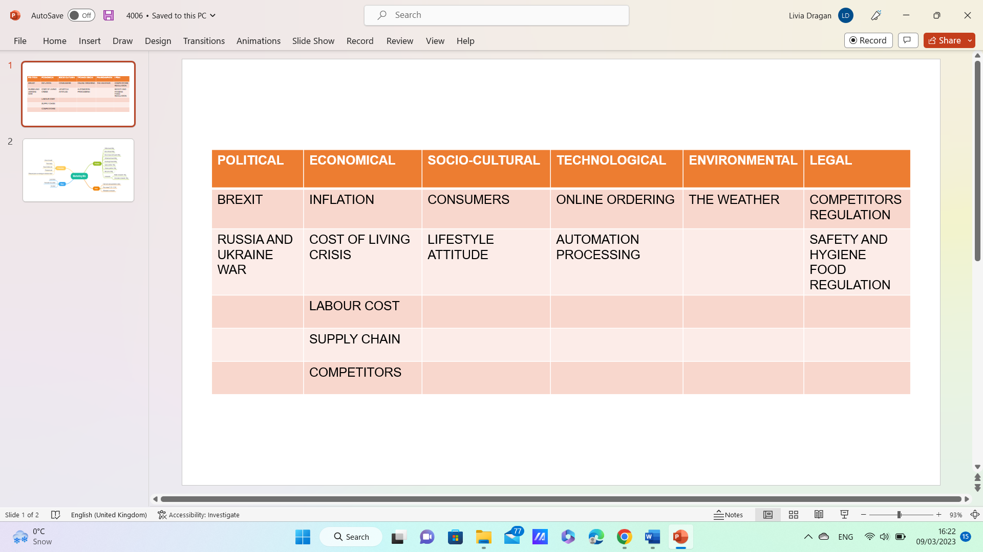
Table 1. PESTLE analysis
The ongoing conflict between Russia and Ukraine has had a severe impact on the economy, leading to rising costs of labor, ingredients, and services, including energy. The disruption caused by BREXIT has also affected imports and exports, leading to supply chain issues and inflation rates. These factors have contributed to a cost-of-living crisis and higher prices for final products, potentially reducing demand for baked goods and leading to a shift in consumer preferences toward lower-priced options.
As a small bakery, we may face challenging competition with larger bakeries with automated production processes. To expand our customer base and meet market demands, investing in technology is necessary, although this can be costly, making it difficult to produce larger volumes of bread at a competitive price while maintaining quality and profitability.
Environmental factors, such as weather, can also significantly impact the baking business, affecting the availability and sustainability of key ingredients such as wheat, sugar, and oil. Legal factors, including competitor and food safety regulations, are also essential to consider for growth and success in the bakery industry.

Marketing Mix

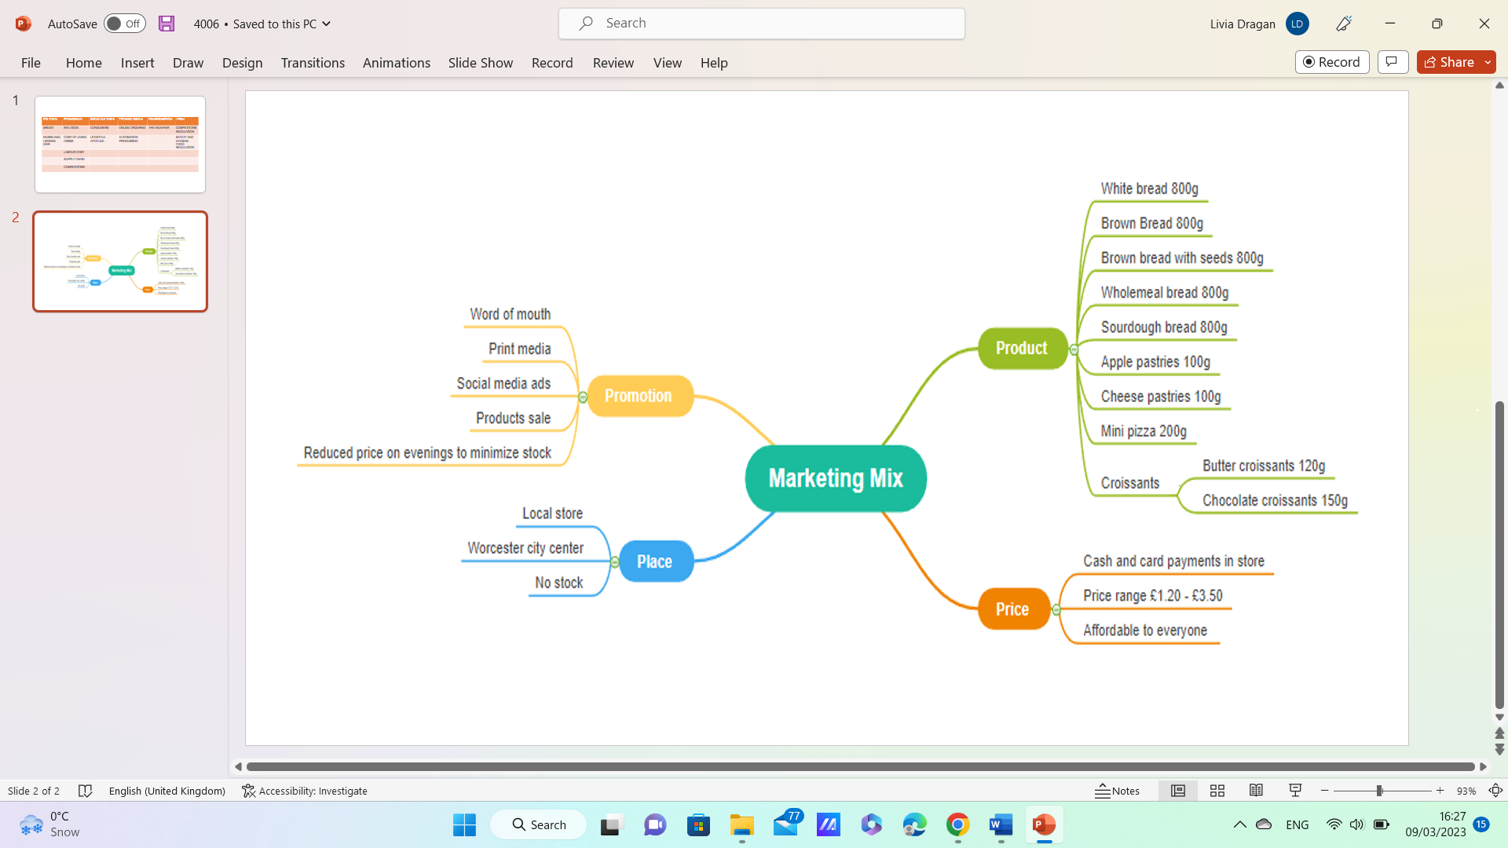
Now that we are aware of the factors outside the bakery's control, we can focus on creating a marketing mix using McCarthy’s (1960) marketing mix model that incorporates strategies for product development, pricing, promotion, and place to meet the customers’ needs. The marketing mix refers to the collection of marketing strategies employed by a company to
Table 2. Mix marketing
achieve its marketing goals within its target market (Kotler, Ang, Leong, and Tan, 1999). To stay up to date with market trends and marketing methods, theories regarding marketing management and strategy must adapt and evolve over time (Goldsmith, 1999).
Product: We offer a variety of high-quality baked goods on an authentic recipe, including bread, pastries, and pizza as well as specialty items such as gluten-free or traditional Christmas cake to a wider range of customers. We use eco-friendly packaging to reduce our environmental impact and our bakery products comply with regulations for allergies and intolerances.
Price: The price of our bakery's products is competitive with other bakeries in the area, while still reflecting the quality of the ingredients used. We offer special deals and promotions to attract new customers and to make our product affordable to price-sensitive customers as well as to lower stock levels.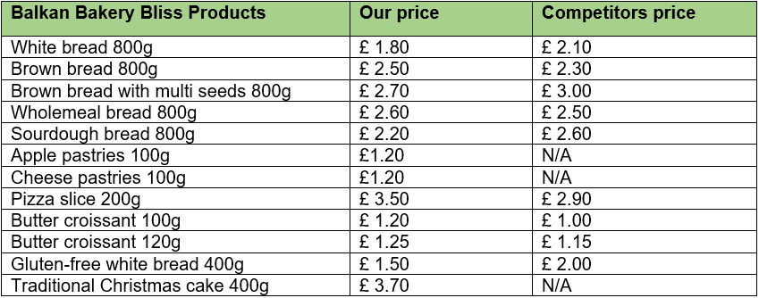
Table 3. List of products
Promotion: For brand awareness, word-of-mouth promotion, and to encourage consumers to try our products, we use flyers and social media advertising, participate in local artisan food festivals, and give a 3 for 2 deal on Monday and Tuesday.
Place: The location of the bakery is in the city center, as foot traffic and high visibility are important drivers of sales. We also offer a comfortable and inviting atmosphere to encourage customers to try and enjoy our products.

Financial plan

Financial planning is the process of estimating the capital required to start a business. The process of formulating financial policies for corporate finance, investment and management. (Blackwell, 2011)
In the beginning, we need £50,000 to buy all the essential materials to start the business.
We choose 2 kinds of funding, personal investment and money from family.
For our company, saving is the easiest and cheapest way to self-finance. Savings is a safer form of debt than many other forms of debt, such as: Commercial Loans. Unlike bank loans and private equity investments, they are not automatically tied to a fixed amount of principal.
Personal investment £ 42,000; Ioana £16,000, Livia £16,000, Valentina £10,000
The second choice, to borrow money from family, from Valentina brother £8,000 it was considered “usual route for start-ups”, because banks are unlikely to consider lending to individuals without a track record and reliable cash flow. (Hardoon, 2011)

Cash flow for our bakery
Sales Revenue = £233,000
Cost of goods sold = £64,000
(raw material ,packaging) £5000 per month
Gross profit = £169,000
Expenses = £189,464
EBIT = - £20,464
EBT = EBIT – 19% = - 16,575
Less tax 19%
Net Profit = - £16,575
Yearly expenses
Month | April | May | June | July | Aug | Sept | Oct | Nov | Dec | Jan | Feb | March
Expenses
Electricity, gas | 650 | 500 | 500 | 400 | 400 | 400 | 400 | 500 | 700 | 500 | 500 | 500
Water | 500 | 400 | 400 | 400 | 400 | 400 | 400 | 500 | 650 | 500 | 500 | 500
Council tax | 180 | 180 | 180 | 180 | 180 | 180 | 180 | 180 | 180 | 180 | 180 | 180
Salary(included taxes) 3 pers | 4,092 | 4,092 | 4,092 | 4,092 | 4,092 | 4,092 | 4,092 | 4,092 | 4,092 | 4,092 | 4,092 | 4,092
Maintenance | 700 | 400 | 400 | 400 | 400 | 400 | 400 | 400 | 400 | 400 | 400 | 400
Advertising | 1,000 | 1,000 | 1,000 | 1,000 | 1,000 | 1,000 | 1,000 | 1,000 | 1,000 | 1,000 | 1,000 | 1,000
Broadband | 50 | 50 | 50 | 50 | 50 | 50 | 50 | 50 | 50 | 50 | 50 | 50
Machinery | 10,000 | 2,000 | 2,000 | 2,000 | 2,000 | 2,000 | 2,000 | 2,000 | 2,000 | 2,000 | 2,000 | 2,000
Stationary | 1,500 | 1,000 | 1,000 | 1,000 | 1,000 | 1,000 | 1,000 | 1,000 | 1,500 | 1,000 | 1,000 | 1,000
Total outgoing | 25,672 | 14,622 | 14,622 | 14,522 | 14,522 | 14,522 | 14,522 | 14,522 | 17,572 | 14,722 | 14,722 | 14,722
Table 4: Expenses
Salary: £1,634/pers included taxes *3 = 4,902

Sales estimate
Name | Price £ | Pieces per day | Sales per day £ | Pieces per month | Sales per month £ | Sales per year  £
Bread | 2,50 | 150 | 375 | 4,500 | 11,250 | 135,000
Puff pastry | 1,20 | 60 | 72 | 1,800 | 2,160 | 25,920
Mini pizza | 3,50 | 30 | 105 | 900 | 3,150 | 37,800
Croissants | 1,50 | 40 | 60 | 1,200 | 1,800 | 21,600
Hot drinks | 2,50 | 15 | 37,5 | 1,125 | 1,125 | 13,500
Total per year |  |  | 649,5 |  | 19.485 | 233,000
Table 5: Sales per day, month, year

Forecast profit and loss account
Period: Year to 31 March 2024 | £ | Total
Sales | 233,000 | 233,000
Variable costs  Raw materials | 64,000
Total direct costs |  | 64,000
Gross profit  Fixed costs  wages  Electricity  Water  Council tax  Maintenance  Advertising  Broadband  Machinery  Stationary | 169,000  49,104  5,950  10,050  2,160  5,100  12,000  600  32,000  12,500
Total fixed costs |  | 189,464
Net profit |  | -20,464
Break-even point |  | 233,000*189,464/64,000 = 689,767
Table 6: Profit and loss account
As we can see, at the end of the first year we have a loss, of around £20,464.
Our plan for 2024 is to cover this loss that we had registered, we try to invest more money in advertiser to attract more consumers and in 2025 we estimate to grow our business by 20%.

Reference list

- ‘Better Business: Cashflow - Financing nailed’ (2009) Print week, p. 25–.

A Complete Guide to Limited Liability Company (LLC) (2022). Available at: https://www.dnsassociates.co.uk/limited-liability-company-uk-definition-liability-advantages (accessed:28 March 2023)
- Blackwell, E. (2011) How to prepare a business plan. 5th ed. London ;: Kogan Page.
- Financial planning. (1984). Atlanta, GA: [International Association for Financial Planning].
- Goi, C.L., 2009. A review of marketing mix: 4Ps or more. International journal of marketing studies, 1(1), pp.2-15.
- Goldsmith, R.E. (1999), The Personalised Marketplace: Beyond the 4Ps, Marketing Intelligence & Planning, Vol. 17, No. 4, pp. 178 - 185.
- Hardoon, A. (2011) Borrowing from family and friends. Available at : https://smallbusiness.co.uk/borrowing-from-family-and-friends-23312/ (accessed: 24 March 2023)
- Investopedia (2022), What is an LLC? Limited Liability Company Structure and Benefits Defined. Available at: https://www.investopedia.com/terms/l/llc.asp (accessed: 28 March 2023)
- Kotler, P., Ang, S.H., Leong, S.M. and Tan, C.T. (1999), Marketing Management - An Asian Perspective, 2nd Ed., Prentice Hall.
- McCarthy, E. J. (1960). Basic Marketing, A Managerial Approach. IL: Richard D. Irwin.
- Webstaurant (2022), How to start a bakery. Available at: https://www.webstaurantstore.com/article/12/start-a-bakery-with-three-planning-essentials.html (accessed: 28 March 2023)
- Workspace Group. (2023), Investing your own money into your business. Available at : https://www.workspace.co.uk/content-hub/business-insight/investing-your-own-money-into-your-business (accessed: 24 March 2023)

