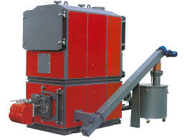  Glangwili hospital Biomass Boiler | Programme: MSc Property & facilities management.  Module: Sustainable processes  Module code: m7x01815  name: christopher paul hill  student number: p139516  lecturer: dr juan a ferriz-papi  submission deadline: 30th april 2019

Table of Contents
Introduction 3
Background 3
Method 4
Conclusion 5
References 6
Appendices 7
Appendix 1 – Waste Acceptance Criteria Analysis 7
Appendix 2 – Wood Chip Material Flow diagram 10
Biomass Boiler Process Map 11
Appendix 3 – Emails exchanged with concrete manufacturers 12
Appendix 4 – Photographs of the Biomass Boiler at Glangwili Hospital 18

Introduction
The world today is facing many challenges such as global warming, and all walks of life have witnessed frequent adverse weather outbreaks over the last decade. The need to change our way of living has never been so prominent. Civilisation is making attempts to change and improve and our nation has moved from a linear economy where resources are thought to be infinite, to a reuse economy where items are recycled. However more needs to be done and the global population must strive to achieve circular economy in order to avoid irreversible damage. Circular economy is a process where resources are kept in use for the maximum time possible, thus extracting the maximum value from them. Once the resource has been exhausted it is recovered and regenerated to reduce the need for virgin materials and creating new opportunities for growth (WRAP, 2019). Circular economy aims to eliminate waste from the system and help establish a more competitive economy, whilst at the same time reducing our impact on the environment (Ellen Macarthur Foundation, 2017).

Circular economy encourages the use of biodegradable materials during the manufacturing process, thus reducing harm to the environment when they reach the end of their life cycle. However biodegradable materials are not always suitable for all applications; therefore, designers should focus on designing products which can be easily reintroduced into the manufacturing process, thus reducing reliance on raw materials and reducing waste. When faced with instances where this is not possible the resource should be recycled ensuring no harm to the environment (Sustainability for all, 2018).

Background
The aim of this assignment is to select a building and identify a waste stream generated from its day to day use. Waste quantities must then be estimated along with the potential for up-cycling the waste for circular economy.

The building for this case study is Glangwili General Hospital. It opened in 1949 and is an Acute General Hospital managed by Hywel Dda University Health Board (HDUHB). HDUHB is made up of four general Hospitals namely; Glangwili, Prince Philip, Withybush, and Bronglais. Glangwili Hospital comprises of 21 wards, 340 beds, 9 operating theatres, and a range of specialist services. It provides primary, secondary, community, mental health and learning disability healthcare to the population of Carmarthenshire and the surrounding area. HDUHB employs 10,000 plus staff and has an annual budget of approximately £800,000,000.

Having explored various avenues of waste streams within the organisation I decided to analyse the biomass boiler to establish if the process has any potential for circular economy. The biomass boiler was installed in 2015 by British Gas as part of a 10-year energy performance contract. The boiler was manufactured in Italy by Uniconfort and is rated at 999kw and boasts an efficiency rate of 93%, and benefits from automated cleaning and ignition (Uniconfort, 2019). Its function on site is steam generation and operates in conjunction with three heavy fuel oil boilers. The steam generated is utilised by various production processes such as, laundry machinery, catering appliances, sterile services equipment, along with providing heating and hot water to the site. The biomass boiler has been designed to handle the base load of the Hospital with the oil boilers firing during peak demand times. This is to ensure that the biomass boiler runs at a continuous rate because it does not have the same control capabilities as oil or gas boilers. The boiler burns approximately 150m3 of woodchip per week spread across two deliveries via an articulated lorry. The wood is supplied by Celtic Community Wood Fuel located in Hirwaun, Aberdare. The wood chip is a mix of larch, douglas fir, and spruce which are all locally sourced.

One benefit of biomass boilers is their low carbon as the carbon dioxide released through the burning process is equal to the amount absorbed by the plant during its life cycle. This process is sustainable providing new plants are introduced following cultivation. Research shows that emissions are generated during the agriculture, transportation, and manufacturing process, but these can be reduced by sourcing local materials (Energy Saving Trust, 2019). Another benefit is that organisations profit through financial support from the Government in the form of a renewable heat incentive (RHI), where organisations receive revenue for using renewable energy systems.

In terms of estimating waste, the boiler burns very efficiently therefore the waste volumes are relatively small, generating approximately 10 tonne per year, or two large skips worth. Currently the waste ash goes to landfill, however under the landfill directive the waste had to be classified to establish if it was hazardous. Therefore, a waste acceptance criteria analysis had to be undertaken (Appendix 1) in order to comply with British Standard European Norn BSEN 12457 (ALS Environmental, 2017). The waste is classified as non-hazardous and therefore safe for landfill.

Method
In order to visually understand the system a process map was designed (Appendix 2). The map shows the process of the boiler from start to finish highlighting the various inputs and outputs, and also identifies ash as the waste product. Having completed the process map the next step was to establish possible reuses for the waste ash to avoid sending it to landfill.

Research around biomass boilers and waste ash highlighted two possible avenue streams for reuse. The first possible is to incorporate the ash into the manufacturing process of cement. Ash has been used in cement since the 1930s as a supplementary cementitious material. When used with Portland cement it supplements the properties of the hardened concrete through hydraulic or pozzolanic activity (Cement.org, 2007). Other benefits include improved workability, decreased water demand, reduced heat of hydration, and improved durability and strength (Federal Highway Administration, 2017). Armed with this information the next step was to contact cement manufacturing companies. Telephone conversations were held with Tarmac, Hanson, Cemex, G D Harries & Sons, and Abergwili Concrete. Various email conversations also took place with these companies (Appendix 3). Most companies confirmed that ash is commonly used in their manufacturing process, however they indicated that it must firstly be processed before being reused, which is something the Hospital is unable to carry out. The greatest concern acknowledged by Tarmac, Hanson, and Cemex was the small volume of waste generated, in order for them to consider taking the ash they would need to receive thousands of tonnes per year which the Hospital cannot provide. Abergwili Concrete are a small local company and had not heard of using ash in the manufacturing process. They said they would carry out their own research and contact me if they were interested, however no contact has been made to date.

G D Harries & Sons were very helpful and were fully aware of the benefits of using ash in cement manufacturing. A conversation was held with a Mr Gari Batte, however yet again the small quantities and the need for the waste to be processed were a hurdle and therefore made it unviable for them to consider taking it. He did however provide details of a company who may be interested and directed me to a Mr Richard Stroud of Cenin Cement in Bridgend. They carry out lots of research into sustainable cement alternatives with low carbon footprint, and currently produce an ultra-low carbon cement designed to complement recycled aggregates. However, they too declined due to the small volume of waste.

I then explored reusing the ash as a fertilizer in agriculture or gardening. Wood ash is a great source of lime which is useful for grounds which have a high acidity value. It also contains around 3% potassium which provides nutrients that plants require to flourish, with young wood containing a higher potassium level than older wood (The Royal Horticultural Society, 2019). A conversation was held with Celtic Community Wood Fuel as they have biomass boilers on site, to establish how they dispose of their waste ash. They indicated that their waste was going to local allotments in their community, however as their quantities have increased their waste now gets given to a local farmer. A request has been made to see if the same farmer would be interested in taking Glangwili’s ash for free and using it as a fertilizer on his land. I am still awaiting his response and If the farmer is not interested, then adverts will be placed in local newspapers offering the waste for free in the Carmarthenshire area. Utilising the ash as a fertilizer will reduce the requirement for artificial fertilizers thus reducing costs to the farmer, it will also reduce the Hospitals costs of sending the waste to landfill and will ultimately reduce the environmental impact.

Conclusion
This research has established that waste ash is not feasible for reuse in cement manufacturing due to the small volumes and processing requirements. There is however a possibility to reuse the ash in agriculture or horticulture, and I will continue to source a viable avenue. If one does present itself then the Hospital would save approximately £1000 per year by not sending the ash to landfill. Arguably this is not a huge sum of money, however the greatest benefits are to the environmental as the reliance and use of fertilizers will be reduced.

References
ALS Environmental (2017) Technical datasheet waste acceptance criteria. Available at: https://www.alsenvironmental.co.uk/media-uk/pdf/datasheets/waste-management/als_wm_waste-acceptance-criteria_td_uk_2017.pdf (Accessed: 14th February 2019).

Cement.org (2007) Optimizing the use of fly ash in concrete. Available at: https://www.cement.org/docs/default-source/fc_concrete_technology/is548-optimizing-the-use-of-fly-ash-concrete.pdf (Accessed: 14th February 2019).

Ellen Macarthur Foundation (2017) What is circular economy? Available at: https://www.ellenmacarthurfoundation.org/circular-economy/concept (Accessed: 16th February 2019).

Energy saving trust (2019) Biomass. Available at: https://www.energysavingtrust.org.uk/renewable-energy/heat/biomass (Accessed: 12th March 2019).

Federal highway administration (2017) Fly ash facts for highway engineers. Available at: https://www.fhwa.dot.gov/pavement/recycling/fach03.cfm (Accessed: 12th March 2019).

Sustainability for all (2018) What is circular economy? Available at: https://www.activesustainability.com/sustainable-development/what-is-circular-economy/ (Accessed: 11th February 2019).

The royal horticultural society (2019) Wood ash: using in the garden. Available at: https://www.rhs.org.uk/advice/profile?pid=621 (Accessed: 15th March 2019).

The waste and resources action programme (2019) What is circular economy? Available at: http://www.wrap.org.uk/about-us/about/wrap-and-circular-economy (Accessed: 11th March 2019).

Uniconfort biomass boilers and CHP plants (2019) EOS biomass boiler. Available at: https://www.uniconfort.com/en/products/remote-heating/eos.html (Accessed: 12th March 2019).

Appendices

Appendix 1 – Waste Acceptance Criteria Analysis
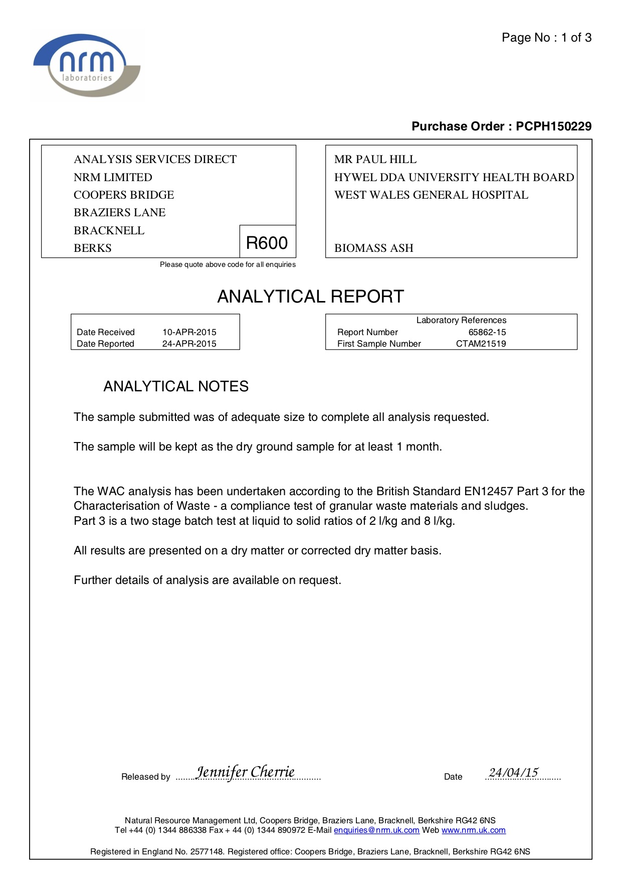

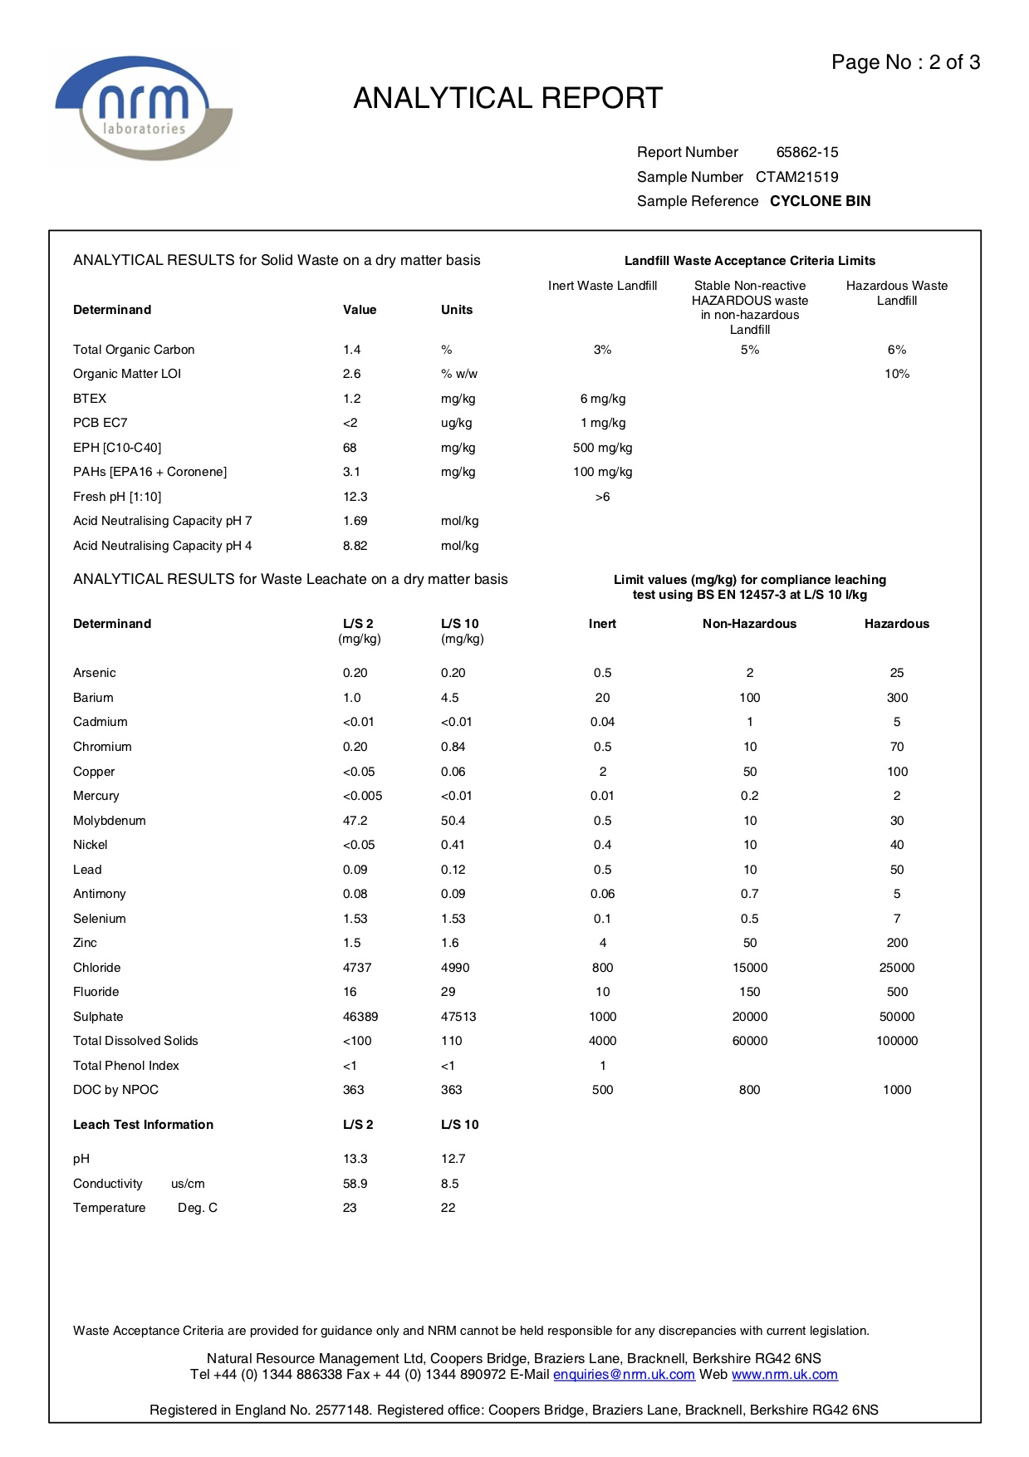

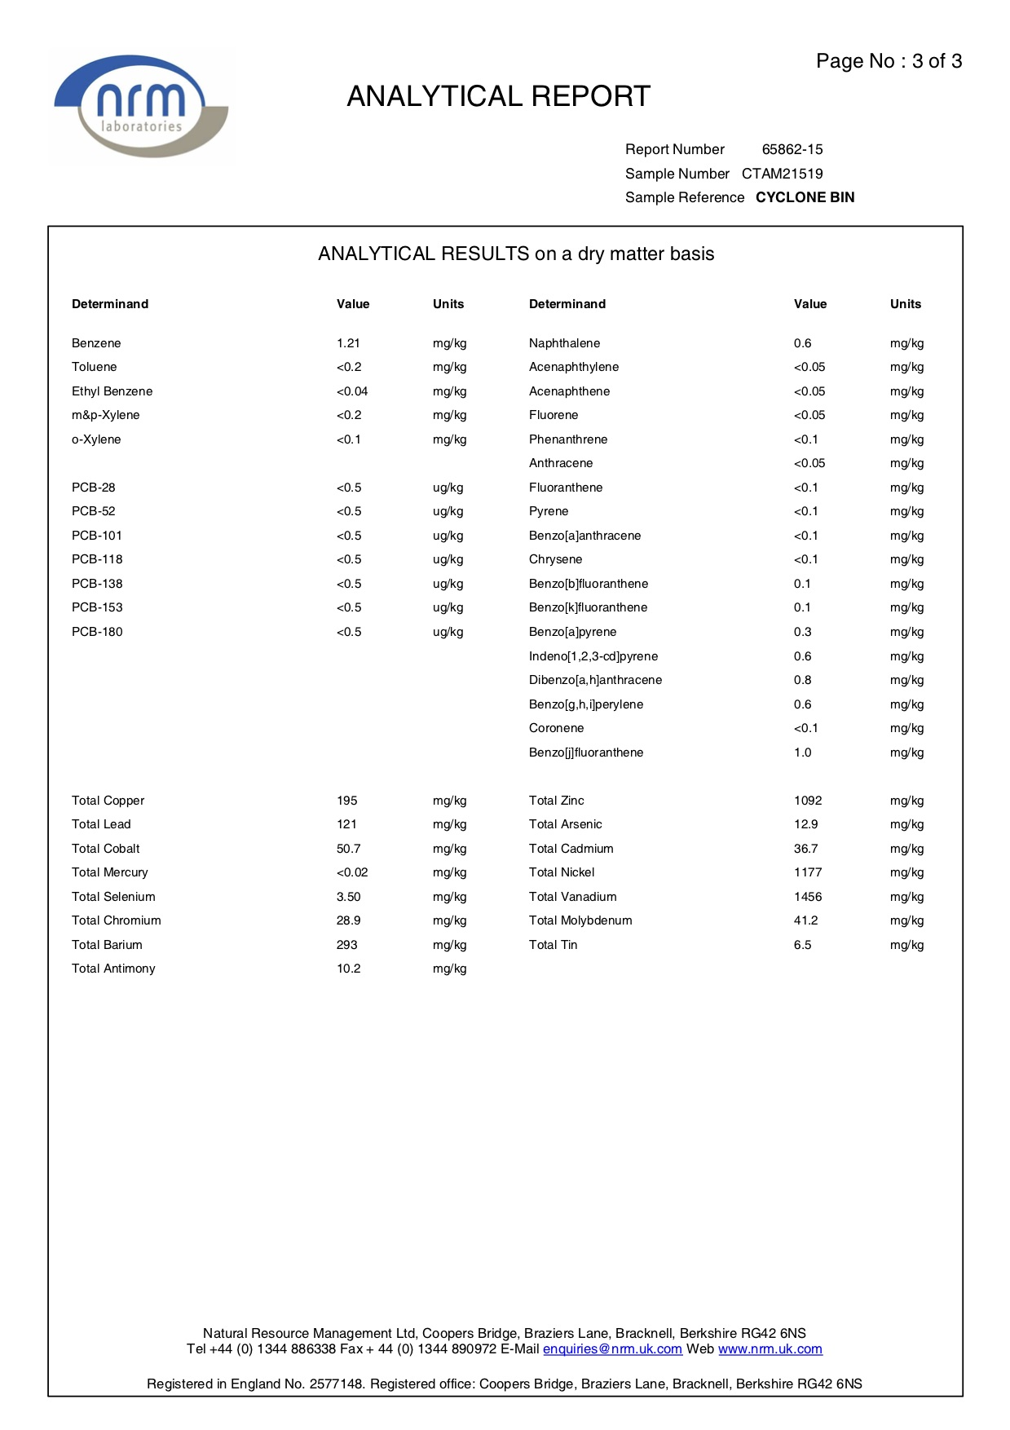

Appendix 2 – Wood Chip Material Flow diagram

Receival of wood chip at site
Inspect Quality of wood chip
Transport wood chip to site
Raw material (wood chip)

Wood chip converted into ash
Ash transported to waste skip
Wood chip burnt in biomass boiler

Ash reused in agriculture

Biomass Boiler Process Map
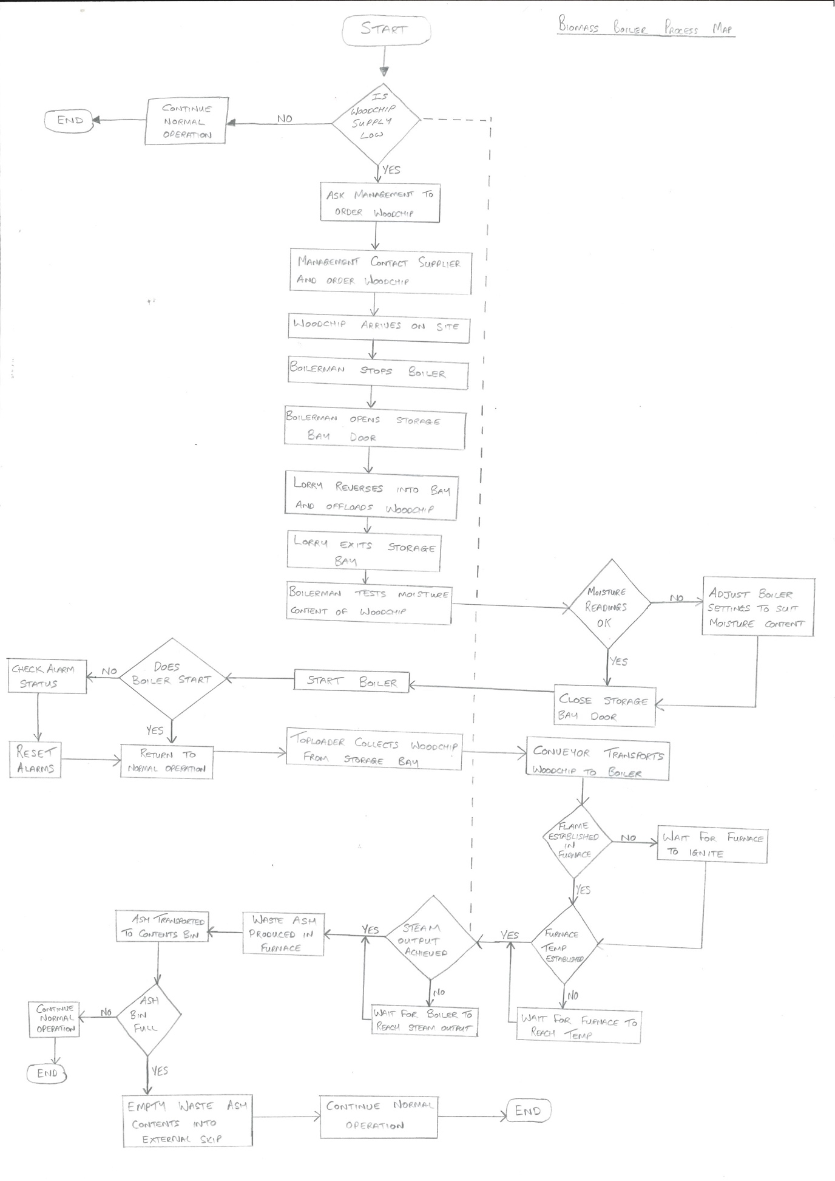

Appendix 3 – Emails exchanged with concrete manufacturers

Email conversation with G.D Harries shown below.

From: paul hill (Hywel Dda UHB - Operations Support Officer)
Sent: 11 March 2019 12:35
To: 'Garry Batte' <garry@gdharries.co.uk>
Cc: Janet Phillips <janet@gdharries.co.uk>
Subject: RE: Glangwili Hospital - Biomass Ash

Hi Garry
It was great speaking to you earlier and thank you for all the information you provided.
I will contact Martyn at Cenin and see if our waste ash is of any use to their manufacturing process.

Thank you again.

Regards
Paul
Paul Hill
Operations Officer
Hywel Dda University Health Board
Glangwili General Hospital, Estates Department, Dolgwili Road, Carmarthen, SA31 2AF
* E-mail: paul.hill3@wales.nhs.uk
( External: 01267 227942 / 07817 947994
( WHTN: 2017 (Bleep 144)

From: Garry Batte <garry@gdharries.co.uk>
Sent: 11 March 2019 12:32
To: paul hill (Hywel Dda UHB - Operations Support Officer) <paul.hill3@wales.nhs.uk>
Cc: Janet Phillips <janet@gdharries.co.uk>
Subject: RE: Glangwili Hospital - Biomass Ash

Hi Paul
Good to speak to you earlier.
As discussed, we would need approx. 3000 tons plus of PFA if your waste product was in compliance with BS450-1 and be compatible with BS197-1 CEM1.
I understand that your early waste volume is about 10 ton.
An unprocessed PFA wouldn’t be of use to our concrete. However, I may know of a company that might be interested in taking the waste off you. Cenin cement replacements 01656 789 970 Martyn Popham.

Kind Regards
Garry Batte
Readymix Technical Manager

Rowlands View, Templeton, Narberth,
Pembrokeshire SA67 8RG
Mobile 07785 455716
Tel 01834 860464
Fax 01834 869156
Email garry@gdharries.co.uk
www.gdharries.biz

From: Janet Phillips <janet@gdharries.co.uk>
Sent: 09 March 2019 07:02
To: Garry Batte <garry@gdharries.co.uk>
Subject: FW: Glangwili Hospital - Biomass Ash

From: paul hill (Hywel Dda UHB - Operations Support Officer) [mailto:paul.hill3@wales.nhs.uk]
Sent: 08 March 2019 08:55
To: info <info@gdharries.co.uk>
Subject: Glangwili Hospital - Biomass Ash

Good Morning
My name is Paul Hill and I work in the maintenance department at Glangwili General Hospital in Carmarthen. We have a Biomass boiler on site which burns woodchip and the waste product from the process is ash. Currently this waste ash goes to land fill, and I was wondering if your company would be interested in using this ash in your concrete manufacturing process?

I have carried out some research and have found that ash is sometimes used in the concrete process as it reduces the amount of cement required. If the ash can be recycled then it would obviously help the environment by reducing waste to land fill.

I look forward to your reply.

Kind Regards
Paul

Paul Hill
Operations Officer
Hywel Dda University Health Board
Glangwili General Hospital, Estates Department, Dolgwili Road, Carmarthen, SA31 2AF
* E-mail: paul.hill3@wales.nhs.uk
( External: 01267 227942 / 07817 947994
( WHTN: 2017 (Bleep 144)

Email conversation with Hanson Cement

From: Parkinson, Lucy (Ribblesdale) GBR <lucy.parkinson@castlecement.com>
Sent: 06 March 2019 09:22
To: paul hill (Hywel Dda UHB - Operations Support Officer) <paul.hill3@wales.nhs.uk>
Subject: RE: Glangwili Hospital - Biomass Ash - MMID:729063

Many thanks Phil

I have re-forwarded the email below to our Technical Director and also my colleague Paul Taylor who is responsible for the Category that your Ash would fall into

Kind regards
Lucy

From: paul hill (Hywel Dda UHB - Operations Support Officer) [mailto:paul.hill3@wales.nhs.uk]
Sent: 05 March 2019 12:29
To: Parkinson, Lucy (Ribblesdale) GBR <lucy.parkinson@castlecement.com>
Subject: RE: Glangwili Hospital - Biomass Ash - MMID:729063

Hi Lucy
Thank you for your reply.

With regards to quantities they are relatively small, I would estimate one large skip every 6 months.

Regarding the chemical composition, the ash is from burning woodchip. We have had a WAC analysis carried out previously to establish if the waste is safe to send to landfill, which it is. I can forward this report if it will be of use to you?

Do you need additional chemical composition information? I am not from a chemical background so my knowledge is very limited I am sorry.

I understand that our volume is fairly small but I would love to see this waste product being re-used and not sent to landfill.

I look forward to your response.

Kind Regards
Paul

Paul Hill
Operations Officer
Hywel Dda University Health Board
Glangwili General Hospital, Estates Department, Dolgwili Road, Carmarthen, SA31 2AF
* E-mail: paul.hill3@wales.nhs.uk
( External: 01267 227942 / 07817 947994
From: Parkinson, Lucy (Ribblesdale) GBR <lucy.parkinson@castlecement.com>
Sent: 05 March 2019 11:31
To: paul hill (Hywel Dda UHB - Operations Support Officer) <paul.hill3@wales.nhs.uk>
Subject: FW: Glangwili Hospital - Biomass Ash - MMID:729063

Good Morning Paul
Can you please advise the volume available and the chemistry composition?
Many thanks

Kind regards
Lucy
Lucy Parkinson MCIPS
National Category Manager
Hanson
Ribblesdale Works
Clitheroe
Lancashire
BB7 4QF
Mob: 07713685684
Email: lucy.parkinson@hanson.biz

From: paul hill (Hywel Dda UHB - Operations Support Officer) [mailto:paul.hill3@wales.nhs.uk]
Sent: 01 March 2019 11:04
Subject: FW: Glangwili Hospital - Biomass Ash

Good Morning
My name is Paul Hill and I work in the maintenance department at Glangwili General Hospital in Carmarthen (South Wales). We have a Biomass boiler on site which burns woodchip and the waste product from the process is ash. Currently this waste ash goes to land fill, and I was wondering if your company would be interested in using this ash in your concrete manufacturing process?
I have carried out some research and have found that ash is sometimes used in the concrete process as it reduces the amount of cement required. If the ash can be recycled then it would obviously help the environment by reducing waste to land fill.
I look forward to your reply.

Kind Regards
Paul Hill
Operations Officer
Hywel Dda University Health Board
Glangwili General Hospital, Estates Department, Dolgwili Road, Carmarthen, SA31 2AF

* E-mail: paul.hill3@wales.nhs.uk
( External: 01267 227942 / 07817 947994
( WHTN: 2017 (Bleep 144)

Email conversation with Cenin cement

From: Richard Stroud <Richard.Stroud@cenin.co.uk>
Sent: 02 April 2019 11:22
To: paul hill (Hywel Dda UHB - Operations Support Officer) <paul.hill3@wales.nhs.uk>
Subject: RE: Completed WAC reports

Paul,
I’m afraid we would not be interested at present due to the very small volumes
Regards

Richard
Richard Stroud
Business Manager

The Research Centre | Parc Stormy |Stormydown |Bridgend |CF33 4RS
(t) +44 (0)1656 789970 (m) +44 (0) 7710 300715 (w) www.cenin.co.uk

Connect with us:
Please consider the environment before printing this e-mail
Meddyliwch am yr amgylchedd cyn printio'r e-bost hwn

From: paul hill (Hywel Dda UHB - Operations Support Officer) [mailto:paul.hill3@wales.nhs.uk]
Sent: 26 March 2019 16:55
To: Richard Stroud
Subject: FW: Completed WAC reports

Hi Richard

It was great speaking to you on the phone regarding the possibilities of recycling our Biomass waste ash. As promised please find attached a copy of our WAC report from NRM Laboratories.

I would be grateful if you could offer some advice if our waste is of any use to your company, and if not are you able to offer any alternative solutions for its use? The waste is currently going to landfill and I am very keen for it to be re-used if possible.

I look forward to your reply.

Regards
Paul

Paul Hill
Operations Officer
Hywel Dda University Health Board
Glangwili General Hospital, Estates Department, Dolgwili Road, Carmarthen, SA31 2AF

* E-mail: paul.hill3@wales.nhs.uk
( External: 01267 227942 / 07817 947994
( WHTN: 2017 (Bleep 144)

From: Jenni Cherrie <jenni.cherrie@nrm.uk.com>
Sent: 24 April 2015 09:28
To: paul hill (Hywel Dda UHB - Site Works Supervisor) <paul.hill3@wales.nhs.uk>
Subject: Completed WAC reports

Hi,

Please find attached your completed WAC reports. A hardcopy of the report and your paid invoice has been put into the post for your records.

Regards,
Jenni Cherrie
NRM Laboratories
Environmental Section Head
Switchboard: 01344 886338
Direct: 01344 899034
Fax: 01344 890972
View website  View our e-Brochure | View website  View our e-Brochure | View website
Sciantec Analytical, NRM Laboratories and Sci-Tech Laboratories are divisions of Cawood Scientific Ltd

This email and any attachments to it may be confidential and are intended solely for the use of the individual or entity to whom it is addressed. If you are not the intended recipient of this email, you must neither take any action based upon its contents, nor copy or show it to anyone. If you believe you have received this email and any attachments in error, please inform the sender immediately and delete this material from your system. This email message has been checked for the presence of computer viruses.
NRM is a trading division of Cawood Scientific Limited which is registered in England and Wales at Coopers Bridge, Braziers Lane, Bracknell, Berkshire RG42 6NS. Registration Number: 5655711.

Appendix 4 – Photographs of the Biomass Boiler at Glangwili Hospital

The photograph below shows the outside of the biomass boiler building. Behind the roller shutter door is the woodchip storage shed where the lorry dispenses the wood. The waste ash is placed in the yellow skip.

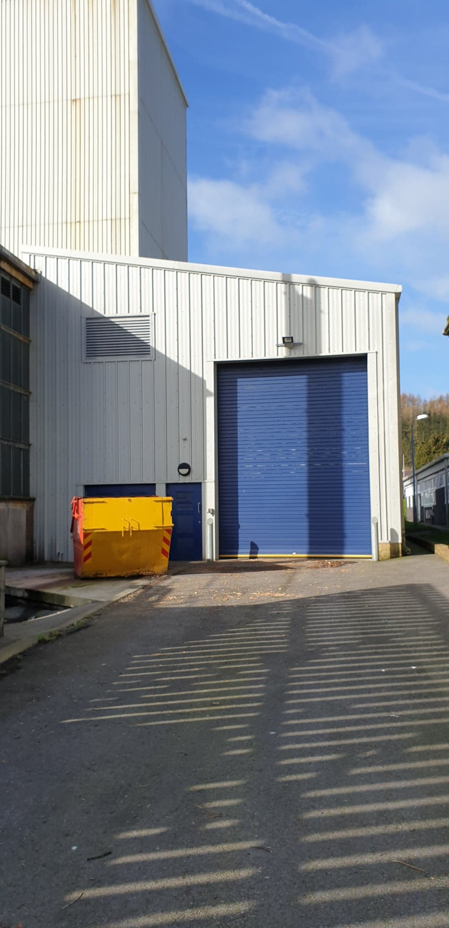

The photograph below shows the woodchip store with the roller shutter door open. As you can see the storage shed is approximately half full of woodchip.

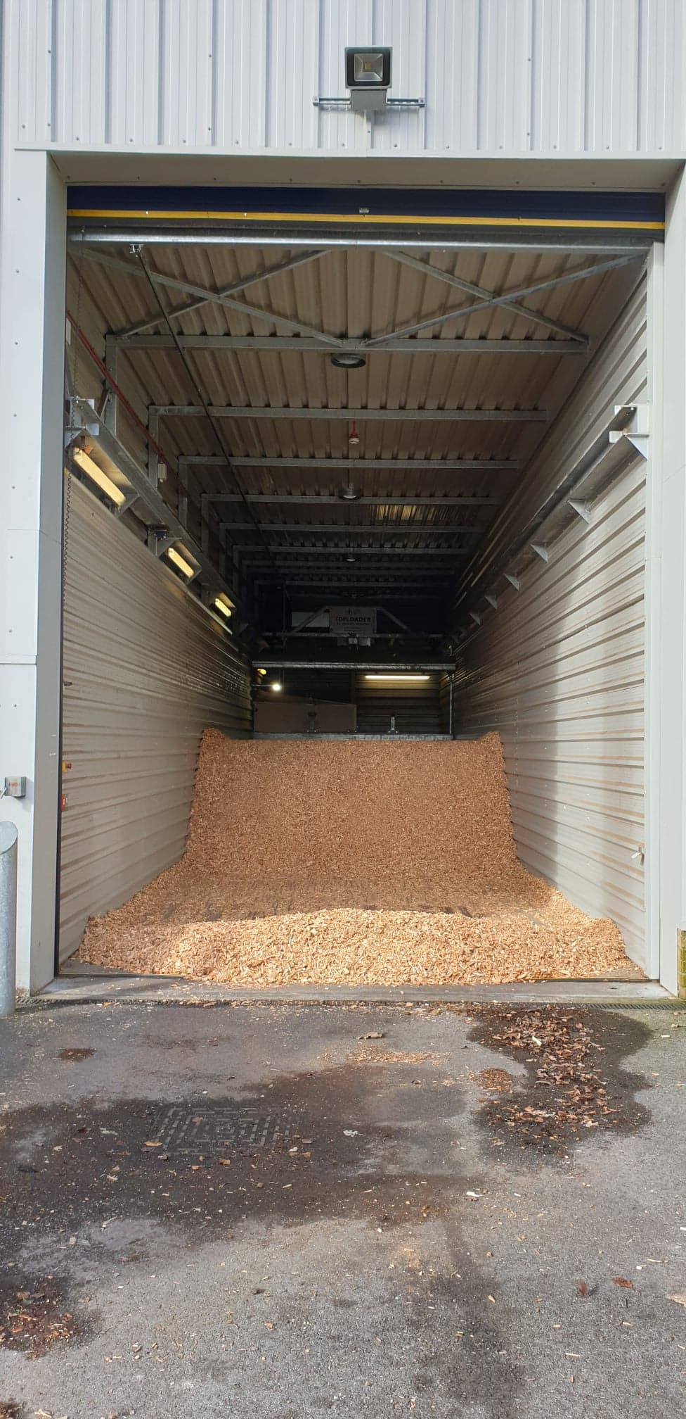

The photograph below shows the top loader. This automated mechanical device travels at high level along the length of the woodchip store and automatically lowers a metal blade which drags woodchip back towards a conveyor where it is dispensed.

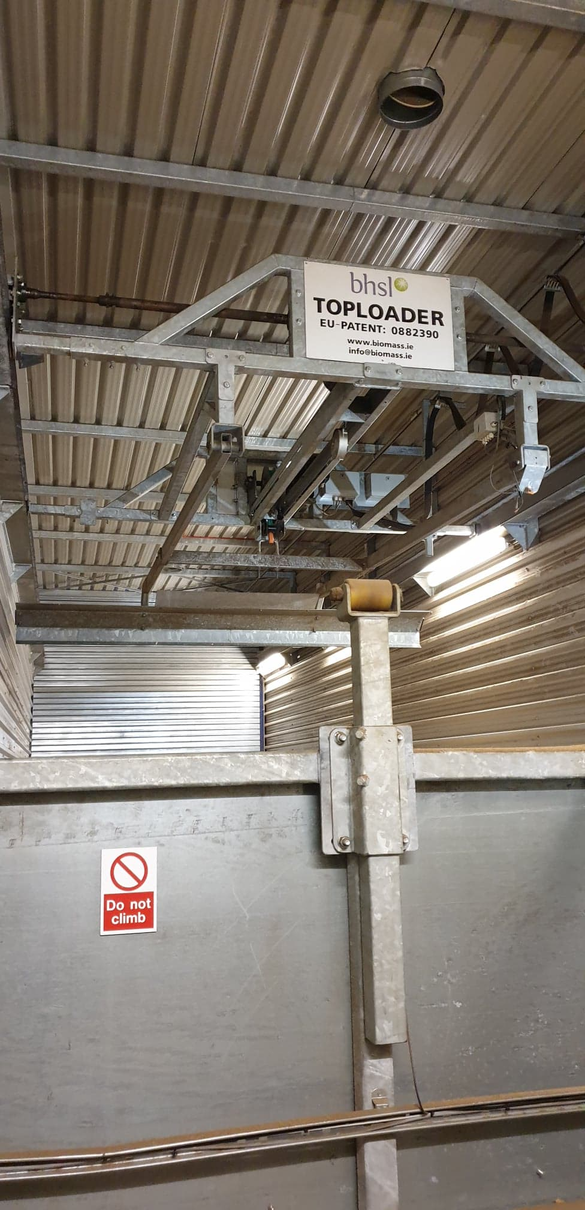

This photograph shows the top loader has reached the front of the storage bay and is in the process of lowering the blade. Sensors stop lowering the blade before it makes contact with the floor. The top loader than traverses back and the blade follows the contours of the woodchip whilst scrapping a thin layer of woodchip.

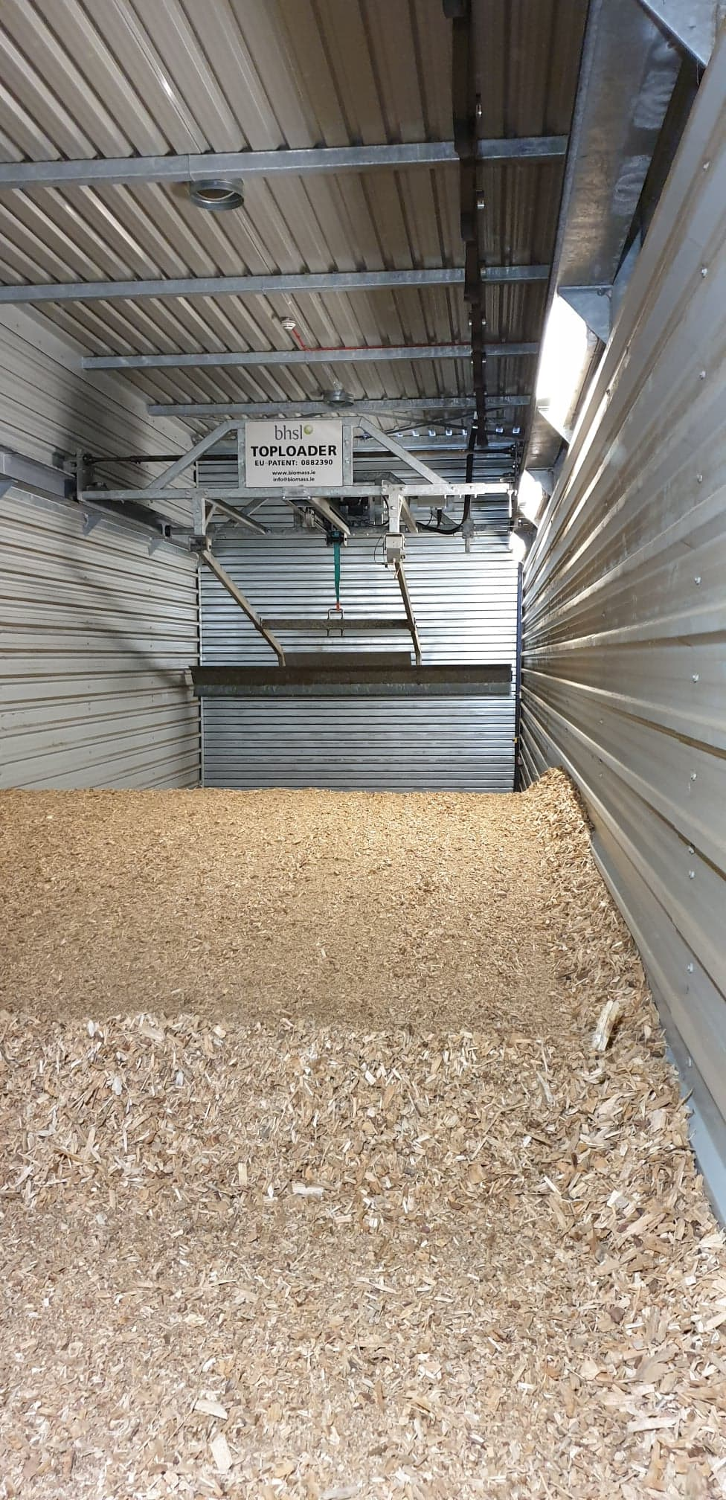
The photograph below shows the top loader scrapping a layer of woodchip off the top of the stock pile and moving it towards the conveyor system.

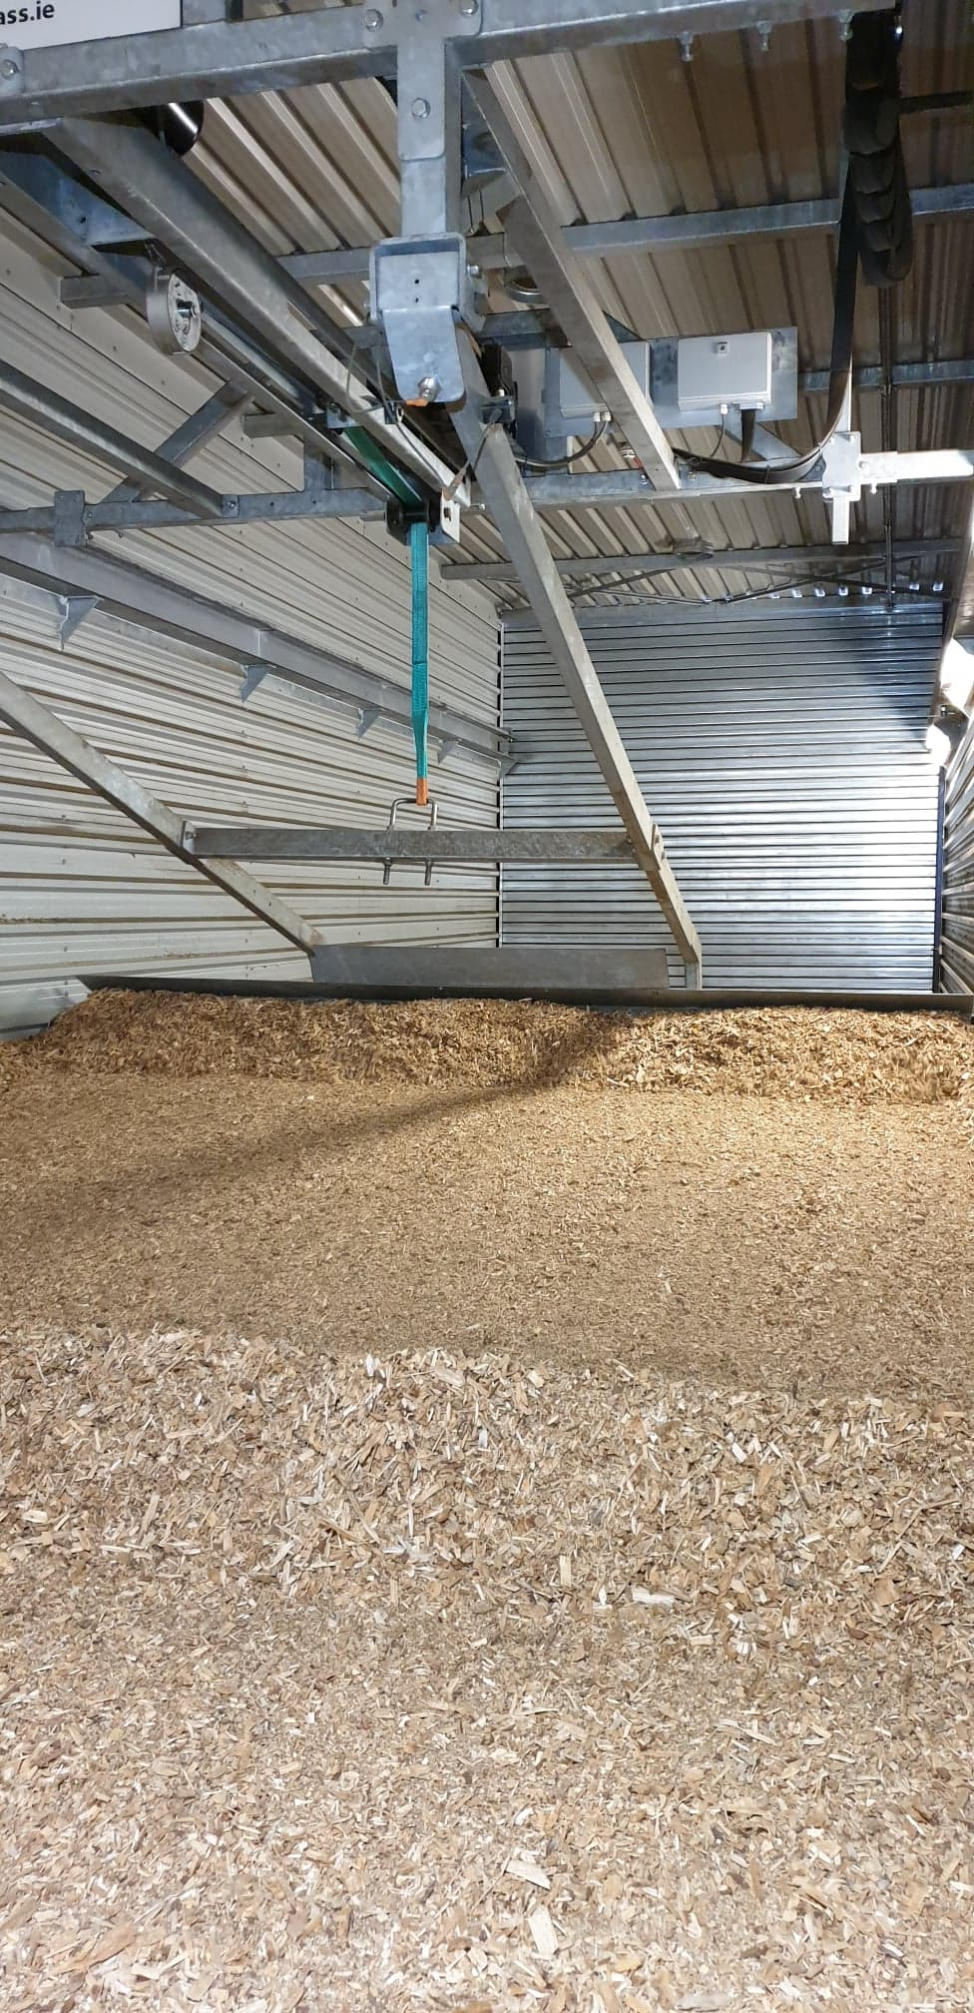

The photograph below shows the top loader main control panel.

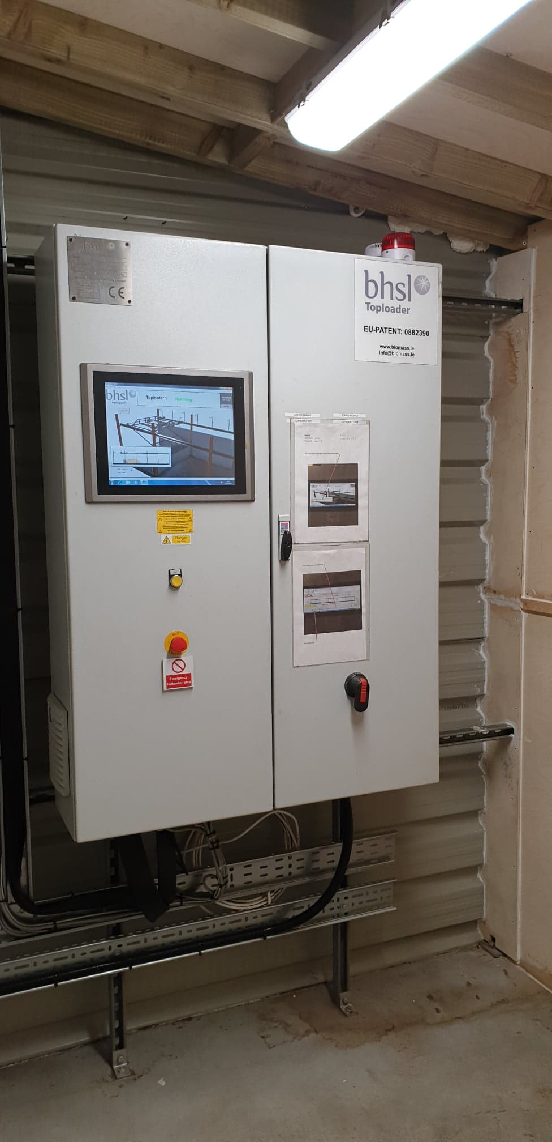

The photograph below shows the conveyor system where the woodchip is dispensed.

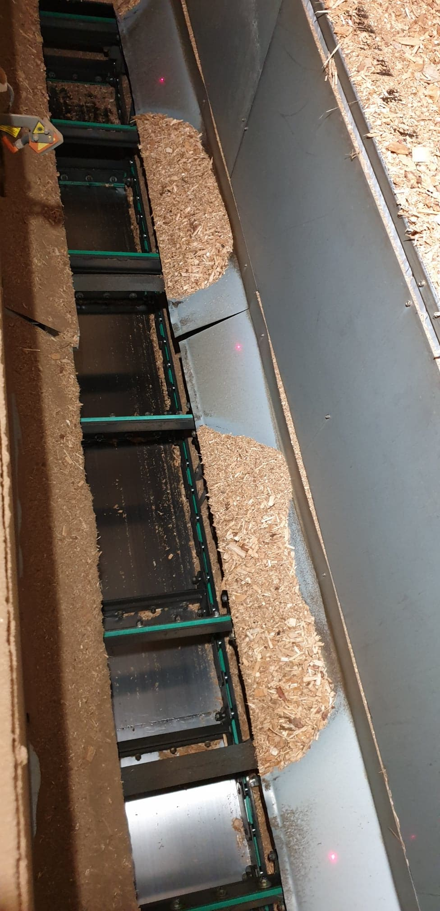

The photograph below shows the conveyor system which automatically transports the woodchip to the boiler. When the conveyor system becomes empty it will automatically start the top loader and dispense more woodchip.

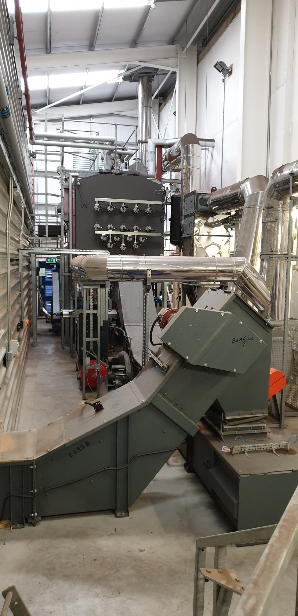
This photograph shows the front of the boiler.

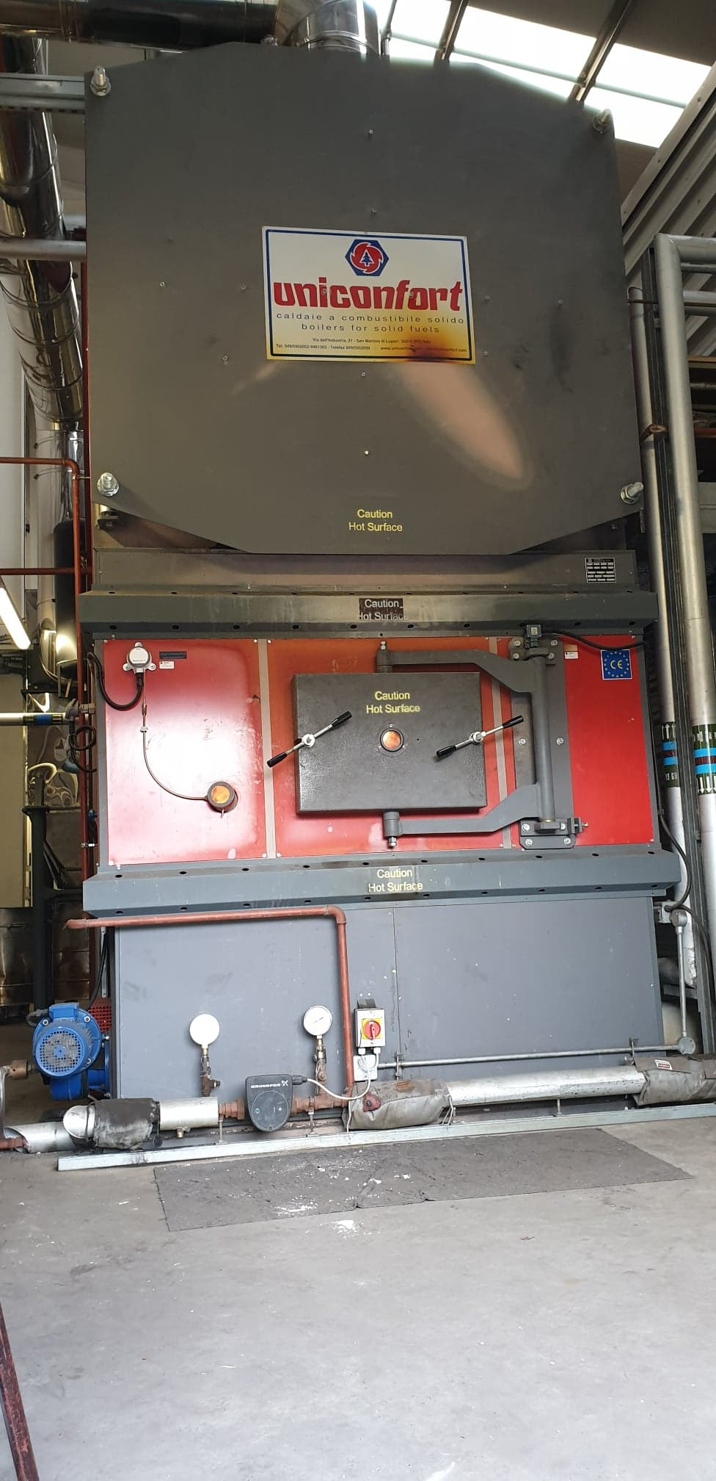
Ash auger cooling circuit
Furnace

The photograph below shows the main electrical control panel.

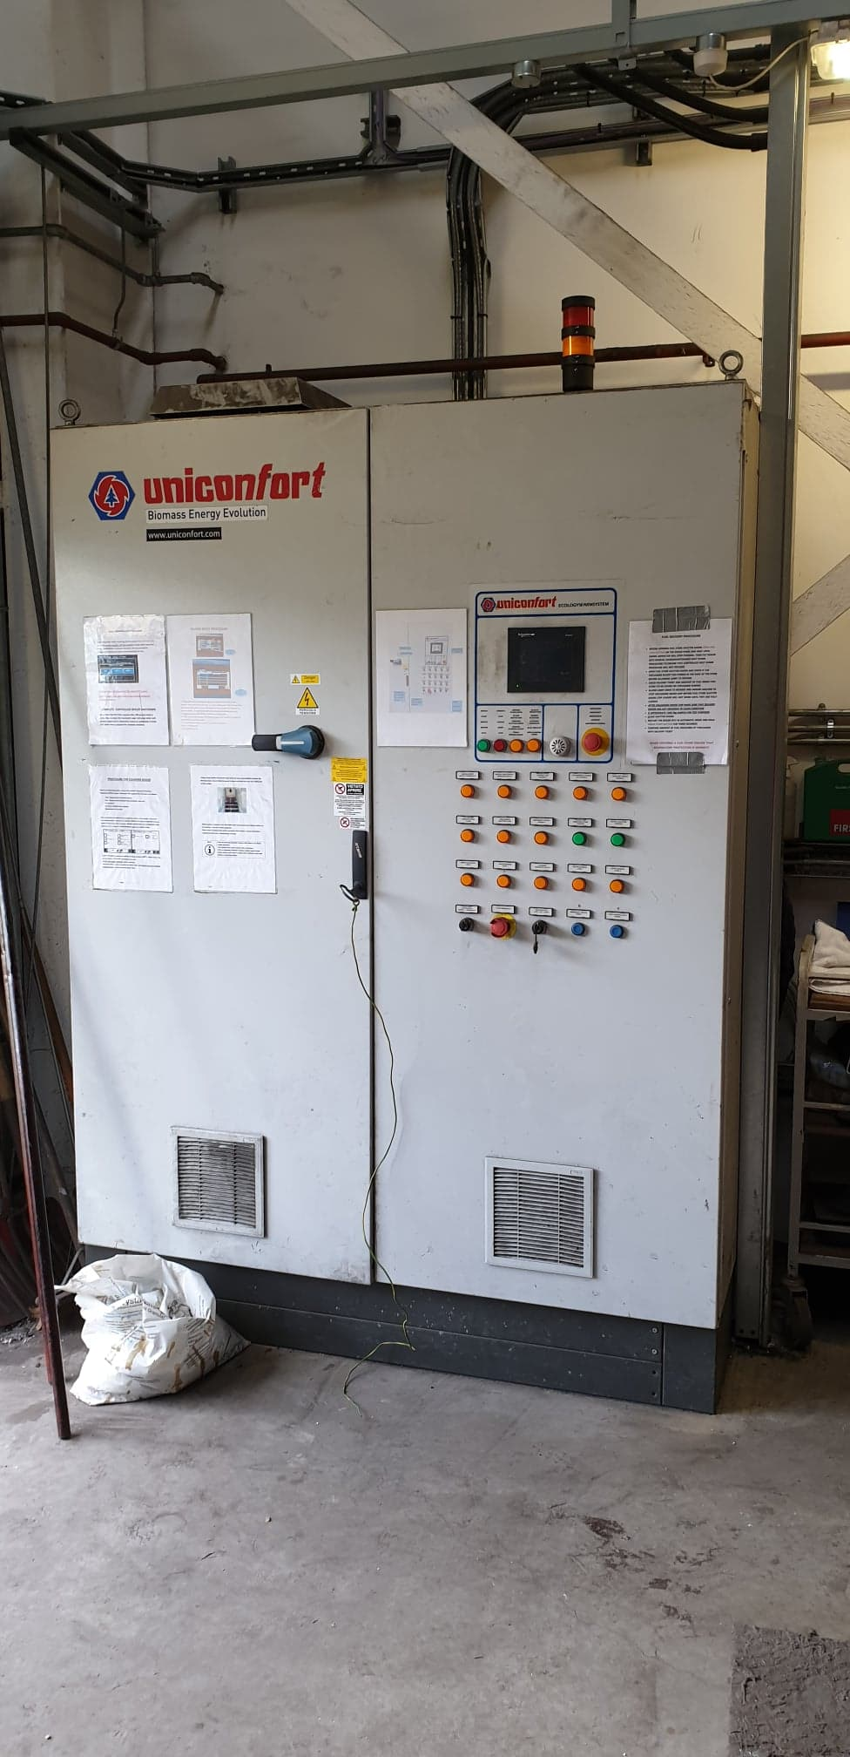

This photograph shows the ash collection bin. The ash is cooled at the base of the boiler by the ash cooling circuit and then transported up the conveyor and dispensed in the bin. Once the bin is full the boiler man manually empties the contents into the skip outside.

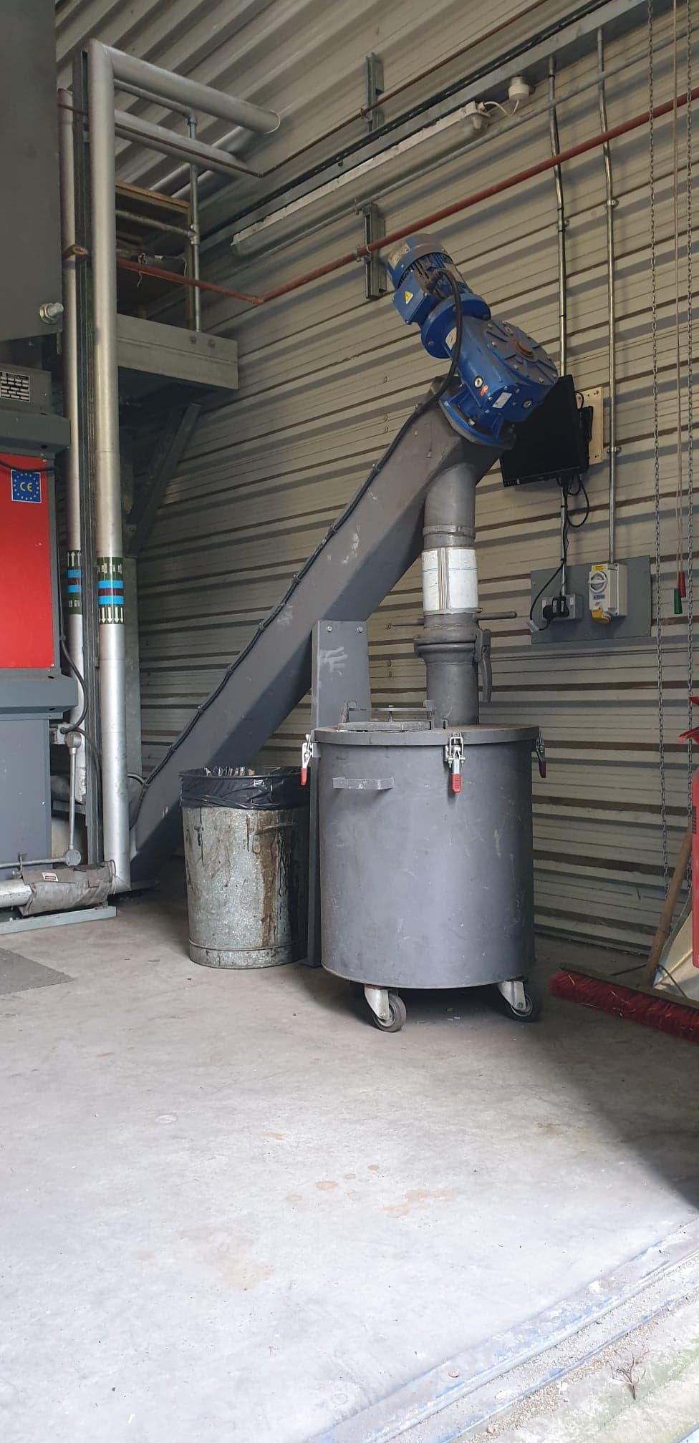
This photograph show the external skip for housing the waste ash.

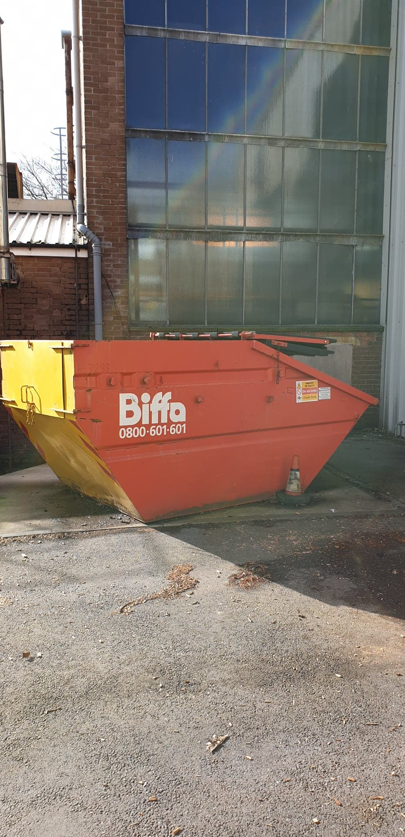

This photograph shows the waste ash contents inside the skip.



