Digital Surveying and Highway Design
Building Survey
Dylan williams
2514117
University of Wales Trinity St David

Contents
- INTRODUCTION
- PLANNING
- COMPLETION OF SURVEY
- ANALYSIS

Introduction
Building surveys are used throughout the construction industry to identify defects and any issues throughout a building, these are mostly needed and undertaken during pre-construction before any building works have began. There are many different types of surveys that are used in construction all are relevant in their own way, the equipment and process of these surveys have evolved as technology has become more frequent in the industry.
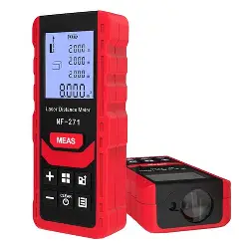
There has been a lot of development with digital technology and tools within construction, most of this is in relation to surveying equipment improving the accuracy of engineering tasks while on site through theodolites and total stations. Pre-construction surveys such as building surveys have also been modernised, these surveys that include taken measurements of buildings, understanding existing structural elements such as services, materials, etc, which used to be undertaken through manual measuring via tapes and more recently hand held lasers are now completely digital and can be undertaken without any engineers assistance other than setting the equipment up.
In this assignment I will be identifying the planning requirements prior to any surveying being undertaken including the purpose, survey area, site assessments and risk associated with the works, then undertaking the survey and summarising findings and problems encountered and finally analysing the data and comparing manual methods against digital for accuracy, time and completeness.

Planning
We will be undertaking both a manual and digital building survey of the first floor internal corridors in the IQ building of University of Wales Trinity St. David, the purpose of undertaking this survey is to obtain a detailed floor plan from both a manual method and a digital method and compare the validity and accuracy of both against each other. When undertaking this survey we will be collating as much detail from the areas as we can, this will be easier with one of the methods than the other and this will be discussed in my analysis. When undertaking the survey we will be capturing as many physical features as possible such as doors, windows, external services, heating appliances bulkheads, etc by doing this we are creating a more detailed and accurate floor plan that be used when undertaking any works and understanding any obstacles in this area. Prior to beginning the surveys, a site assessment must be undertaken as part of the planning process. This will include access points, locations of the digital scanner, lighting locations and any safety requirements we may come across. For the area where we are completing the survey different considerations will be raised for the type of survey being undertaken,
Firstly, the areas being surveyed are remaining the same so the access and egress points will be the same, there is access to the first floor via a lift, three staircases which also are means of fire escapes in the risers of the building but also the main staircase located in the atrium of the building with access to the first floor only.
The next consideration when planning the survey are the locations of the equipment, when undertaking the digital survey with a total station the tool is placed on a tripod in a location and shoots a 360’ laser to collect the information of the survey area. This means the location of where the equipment is placed is important in receiving accurate data while also trying to complete the survey in quick duration as we are in a live school so pupils and staff will be present and walking around these corridors. When deciding on locations for the station, you want each scan to be slightly overlapping the last one as this will create an easy end and start point for creating a continuous and accurate survey. For the manual survey due to the size of the survey area, it will require the survey to be completed in two parts to maximise accuracy as collecting manual survey data is more time consuming and requires concentration to capture every aspect you are measuring, as this will be collected using free hand drawings.
As mentioned prior we will be undertaking both surveys in a live school so pupils and staff will be around and possibly interfering with the survey, during the manual survey we will be using equipment like measuring tapes for the shorter spans and more concise measurements but for the larger spans a laser measure will be used, this is a more modern piece of manual surveying equipment as a measuring wheel could also be used. However, the use of this equipment can be manipulated to work around a live environment and this shouldn’t effect the validity of the survey. However, when using the digital surveying equipment, the accuracy can be effected with people interfering. When the total station has been placed and begins if someone was to walk through the designated area there is a chance that this will block certain areas of the survey and when the survey has been complete this area could be missed and effect the overall accuracy of the survey. Other safety conditions which need to be taken into consideration during the survey is the conditions on the day, on the current day it is expected to be undertaken there is going to be a heatwave, this is relevant due to using digital equipment in the heat can cause difficulties and malfunctions to the equipment so a clear plan to work with and around the heat is key for a successful survey.
During the survey, certain risks need to be understood and assessed. The risks associated with this type of work are low and are unlikely to encounter any high risk activities. Some risks which we need to take into consideration during our surveys are the pupils and staff moving through the survey area, the potential risk associated with this are collisions with both us undertaking and the equipment during the survey and tripping over this also. This can be controlled by making classrooms aware that you will be working in this area with prior verbal warnings or signs put up during the survey.
Completion of surveys
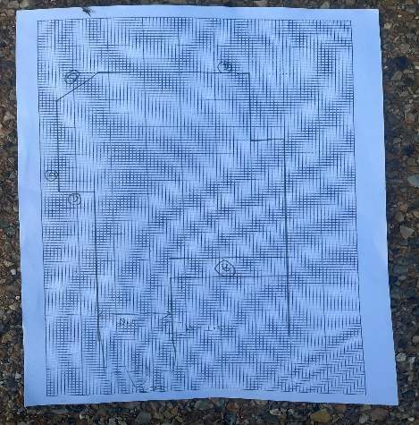
When undertaking the surveys, we split to undertake both manual and digital at the same time. My first method of surveying the area was using manual measuring tools, using our planning we split the area in 2 to maximise productivity between us and create a joining floor plan covering both sections, my group felt the best way to begin the survey was to roughly draw our working area as a floor plan not to any scale to allow us to strategically measure sections as we went. Then we undertook the digital scan, this was produced using a handheld LiDAR scanner rather than a static station which was expected during planning. This allowed for a much easier and quicker survey than first expected, this did then mean a change to a few of our planning conditions had to happen on the day.
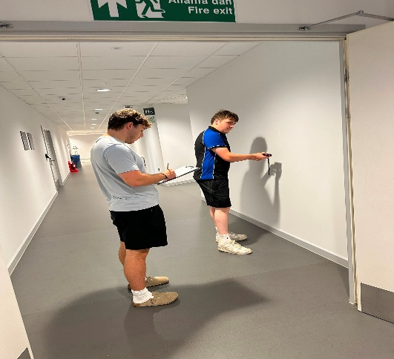
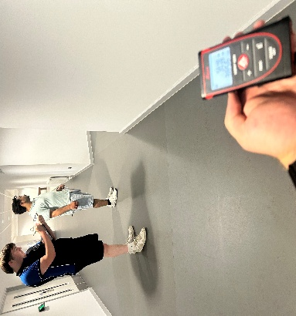
The survey area contained various features such as window openings, doors, long and small stretches of wall, glazed partitions, internal exposed services and pillars. To accurately measure these features we used various pieces of equipment both measuring tapes that allowed us to be more precise with the smaller features and the laser measure for the long corridor aspect. During the manual survey, we did not come across any obstructions from other pupils or staff as we planned to do these during quieter periods of the day when the corridors had less traffic, the only obstructions were from furniture in some areas such as desks, chairs and other FFE pieces. These were easy to work around with the equipment we have as other parts of the walls were able to be measured. During the digital survey, these features were easy to capture as the handheld scanner allowed you to control what was scanned rather than having to position a static scanner and move it around to capture elements hidden behind other features. This also allowed the survey to be completed in one complete sweep of the floor unlike our planning of having to combine different scans into one complete survey.
At the start of our survey, we did come across some oversights in our planning which if covered would have allowed the start of the survey to run more efficiently. This was trying to record to much information on one piece of paper, by doing this it made the survey information hard to understand and would have been an issue at the end of our survey when connecting the other half of the survey. Instead we labelled sections within our floor plan and split the survey into more manageable areas to produce a more clear final measure. As mentioned in our safety requirements, we did complete this during a hotter da which meant the university was quite warm therefore we did need to use the equipment with care and if any overheating occurred to allow time for it to cool down and not overuse the equipment as it may have effected the validity of the survey, moreover due to the digital scanner being completed via a heandheld scanner this now meant that even though the results would be digital, there was more human control over the survey, this meant the likelihood of any slips, trips and falls were increased, therefore we had to undertake a small risk assessment on the day and introduce some mitigation measures such as having someone direct the person holding the scanner around any possible hazards from furniture but also other pupils or staff as their concentration would now be on the scan rather than anything else.
Analysis
When comparing the use of both traditional and digital methods of building surveying, there are pros and cons of each.
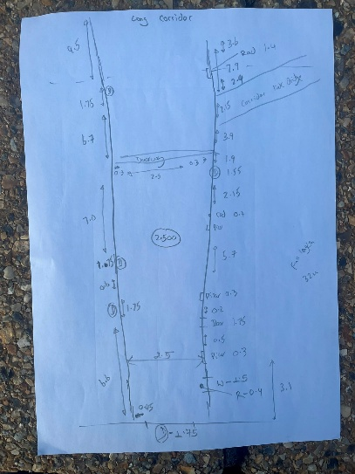
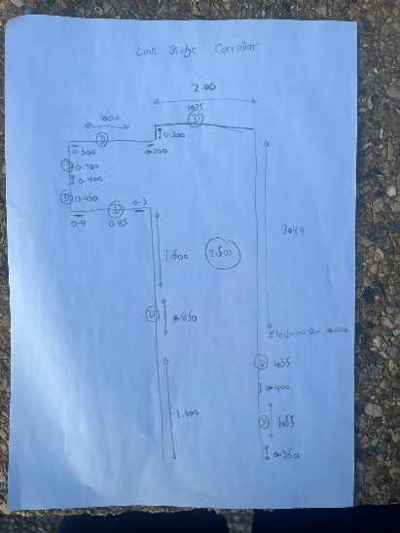
The most noticeable difference was the amount of time required. The digital survey method was completed much quicker because the scanner captured all of the measurements in a matter of minutes. Although several scan positions were needed to cover the whole building, the overall data collection process was efficient. However, you same the majority of time through the data processing as all measurements are used to created a detailed plan using point cloud data. In comparison, the manual method completed using the laser measure and tape measure took significantly longer. Every wall, door, window and room dimension had to be measured and recorded manually, requiring careful coordination between team members. This made the survey more labour-intensive and increased the risk of missing important measurements.
Cost was another key difference between the two methods. We recognised that the LiDAR scanner is considerably more expensive than traditional measuring equipment due to the cost of the hardware, software and specialist training required to operate it effectively. In contrast, the laser measure and tape measure are inexpensive, readily available and simple to use. For a small building survey, the traditional method would therefore be the more economical option, although for larger or more complex building the efficiency of LiDAR could justify the higher investment.
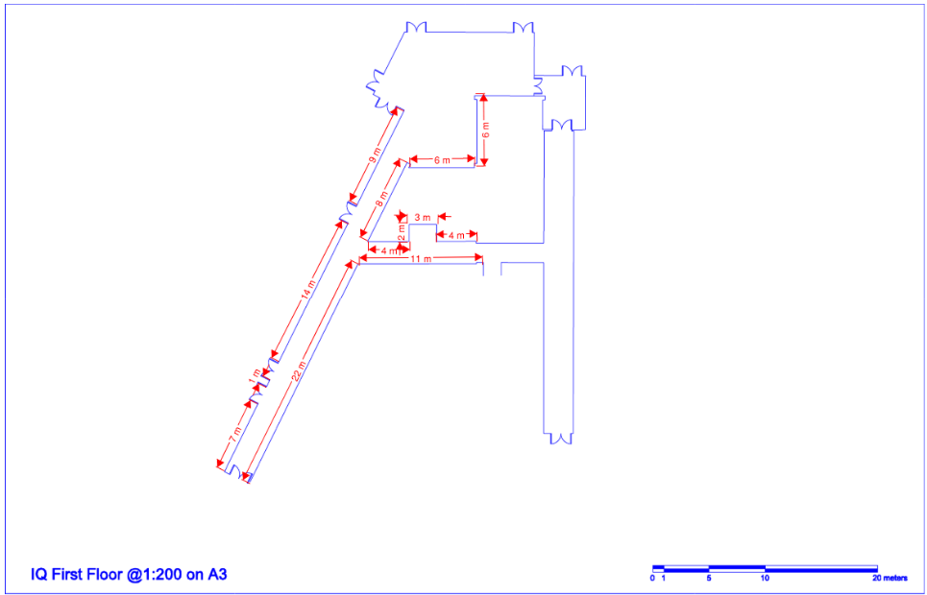
When comparing accuracy, we found that the LiDAR survey produced a much more detailed representation of the building. The point cloud captured every visible surface, allowing measurements to be taken later without returning to site. This reduced the likelihood of human error and gave us greater confidence in the final results. Although we achieved accurate measurements with the laser measure and tape measure, the process relied heavily on careful recording and communication. Small errors when reading, recording or transferring measurements could easily affect the final drawings.
The completeness of the surveys also differed considerably. The LiDAR scan provided a comprehensive digital record that could be revisited at any time to extract additional dimensions or check details that had initially been overlooked. During the manual survey, however, we had to ensure every required measurement was collected while on site. If any dimensions had been missed, another visit would have been necessary, resulting in additional time and effort.
Overall, completing both surveys demonstrated that LiDAR is the more efficient, accurate and comprehensive surveying method, particularly for complex buildings. However, the laser measure and tape measure remain practical and cost-effective tools for smaller projects where budgets are limited and a lower level of detail is acceptable. Experiencing both methods gave us a better understanding of the strengths and limitations of each approach and highlighted the importance of selecting the most appropriate surveying technique for the specific project.

