Academic Research Proposal

From Online Presence to Business Performance: Evaluating the Real Impact of Digital Marketing on SMEs
Student Name Ionut Hrisca
ID: 2243953

Contents
Introduction and Background 3
Research Aim 3
Research Objectives 3
Research Questions 4
Literature Review 4
Theoretical Framework 5
Research Methodology 6
Expected Contribution 7
Limitations 8
Proposed Timeframe 8
References 9

Introduction and Background

Digital marketing for SMEs allows them to directly market to their target audience through social media, search engines, websites and email while also providing greater tracking of the results of their digital marketing campaigns than most traditional marketing campaigns. The use of various digital marketing channels has been shown to provide benefits to SMEs in relation to their brand and business performance (Sharabati et al., 2024). However, research indicates that the effect of digital marketing on the business performance of SMEs significantly relies upon the capabilities of those SMEs, especially in relation to their ability to implement digital tools and strategies into their businesses (Zahara et al., 2023; Prakasa et al., 2024).
More specifically, SMEs often have lower initial budgets, teams, and technological capabilities compared to larger businesses. Thus, while digital marketing allows them to overcome some of these constants of SMEs through activities like targeting a specific audience or expanding their reach internationally to increase their competitiveness in their local markets, simply going online does not guarantee that they will experience an increase in business performance. Furthermore, SMEs should also measure any digital marketing efforts to determine if they are successfully acquiring customers, increasing their sales, expanding their markets, or gaining competitive advantages over other SMEs in the same industry (Hokmabadi et al., 2024; Sharabati et al., 2024). Thus, the purpose of this proposal is to review the current literature regarding the influence that digital marketing has upon the business performance of SMEs.

Research Aim
The aim of this study is to evaluate the real impact of digital marketing on the business performance of SMEs.

Research Objectives
1. To examine the role of digital marketing in shaping SME business performance.
2. To identify the key digital marketing practices that influence SME growth and competitiveness.
3. To explore the relationship between digital marketing capabilities and SME performance outcomes.
4. To evaluate the challenges that affect SMEs’ ability to convert online presence into measurable business results.

Research Questions
1. How does digital marketing affect the business performance of SMEs?
2. Which digital marketing practices contribute most to SME growth and competitiveness?
3. What is the relationship between digital marketing capabilities and SME performance?
4. What challenges prevent SMEs from converting online presence into business results?

Literature Review

There is existing literature that illustrates how digital marketing is an emerging strategic resource for SMEs rather than just a means of engaging in promotional activities. For instance, one recent study of SMEs that implemented electronic marketing strategies, such as online advertising, search engine optimization, social media marketing, and customer engagement determined that not just was there a positive impact upon the SMEs’ performance, but that these marketing activities were found to be more effective than other marketing activities that they attempted to implement for those SMEs (Sharabati et al., 2024). Additionally, other literature on digital marketing strategy and organisational performance indicates that factors like the managerial capabilities of SME owners, the innovativeness of those SMEs, and the proactiveness of their managers can have a powerful role in determining the impact that digital marketing can have upon that organisation (Wu et al., 2024).
Digital marketing capability is another area of study within the literature regarding SMEs and digital marketing. More specifically, digital marketing capability indicates the competency that an SME has within the planning and management of digital marketing tools and activities. For instance, Zahara et al. (2023) have studied the role that digital marketing capabilities can play as a mediator between an SME’s entrepreneurial marketing activities and its marketing performance. As a result of the study, Zahara was able to conclude that SMEs that had the appropriate skills to implement digital marketing strategies experienced enhanced marketing performance. Prakasa et al. (2024) have performed a similar study, revealing similar results regarding the impact of digital marketing capabilities upon SME performance.
In addition to reviewing the capabilities of SMEs in the digital marketing space, another area of interest within the academic literature is in reviewing how SME performance can be better measured. Beyond sales and profitability, SME performance can also be measured in relation to its sales, the physical and virtual expansion of its markets, the quality of its customer relations, and its enhancing of brand exposure with potential customers (Hokmabadi et al., 2024). Additionally, SMEs with enhanced digital marketing capabilities are found to exhibit increased competitiveness in relation to both their customers’ needs and market demands.

Theoretical Framework

This research will use the Resource Based View (RBV) and Technology–Organisation–Environment (TOE) framework. According to the Resource Based View, firms can outperform their competitors if they can create capabilities that are valuable, rare, and difficult to be duplicated by their competitors. If the digital marketing capabilities that SMEs have allow them to gain a competitive advantage over their other competitors, then this would indicate a relationship between digital marketing and business performance outcomes. This aligns with previous research that relates digital marketing with marketing and business performance (Zahara et al., 2023; Prakasa et al., 2024).
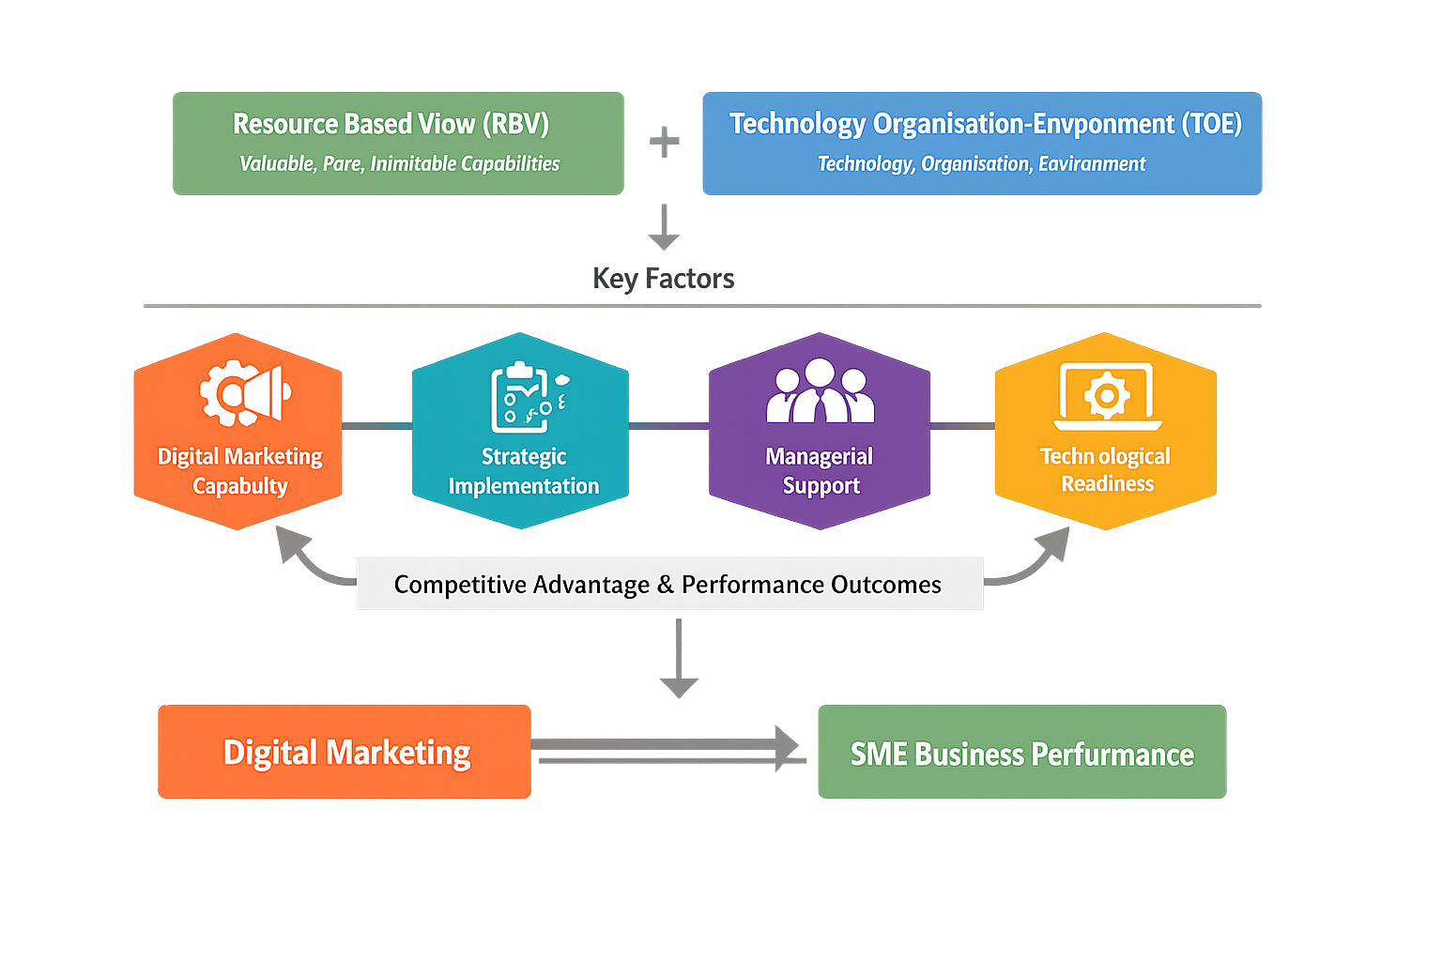
Figure 1: Theoretical Framework Linking Digital Marketing Capability to SME Business Performance through RBV and TOE Perspectives
By using these theories, it becomes possible to propose that the major factors that impact the relationship between digital marketing and the business performance of SMEs are their digital marketing capability, the way in which they strategically implement digital marketing processes, the support of the managers of that SME in those processes, and their technological readiness to adopt those digital technologies.

Research Methodology

Research Philosophy and Approach
The philosophy of research to be undertaken in this project will be the positivist philosophy. This philosophy aims to objectively determine the existing evidence regarding the relationship between digital marketing and the performance of SMEs. This philosophy is appropriate for this study as it aims to analyse existing research studies. Furthermore, the deductive approach will be employed wherein the theories regarding the effectiveness of digital marketing will be tested using existing research studies (Creswell and Creswell, 2018; Saunders, Lewis and Thornhill, 2019).

Research Design and Data Sources
The research that will be undertaken will be based on secondary research. No data will be collected from SME owners or managers. Instead, 10 recently published peer-reviewed journal articles will be used from different areas of SMEs. These articles will be published in scholarly and academic journals to ensure their quality and reliability.
PRISMA Flow Process for Study Selection
The PRISMA (Preferred Reporting Items for Systematic Reviews and Meta-Analyses) framework will be followed for the selection of the research studies that will be used within the research paper. The PRISMA framework will involve four separate stages: identifying the studies, screening the studies, determining the eligibility of the studies and finally including the selected studies. Searches will be undertaken on databases such as Google Scholar and Scopus. Duplicates will then be removed. Studies will be screened based on their titles and abstracts. The eligibility of the studies will be determined by analysing their full text articles. Finally, 10 articles will be selected.
Data Analysis Method
The data from the selected studies will be analysed using thematic analysis. Thematic analysis entails determining the main themes within a series of research studies. These themes can include different digital marketing tools, the engagement of customers with these tools and the growth of sales of SMEs as a result of these tools. Thematic analysis will allow conclusions to be drawn from the studies regarding the impact of digital marketing on SME performance.

Expected Contribution

This literature review will not only help to reveal the impact that digital marketing has upon SME performance, but also that having an online presence is not sufficient for SMEs without the appropriate digital marketing in place (Sharabati et al., 2024; Wu et al., 2024).
Furthermore, the findings of such a research study can aid SME owners and managers in determining which digital marketing efforts will increase the performance of their business and which digital marketing capabilities they should develop (Zahara et al., 2023; Prakasa et al., 2024).

Limitations
This study has several limitations. First, it relies only on secondary data, so its findings depend on the quality and consistency of existing studies. Secondly, the domain of digital marketing is ever-evolving and thus, some results might become irrelevant with that release of new tools or platforms. Third, SMEs are a highly diverse group of firms and what is found in one sector or country may not carry over to others. Finally, differences in the way studies define performance may complicate direct comparison.

Proposed Timeframe

The project is expected to be completed in 10 weeks .
Activity | Week 1-2 | Week 3-5 | Week 6-8 | Week 9-10
Introduction | ✓
Literature review | ✓ | ✓
Questionnaire design |  | ✓
Data collection |  | ✓ | ✓
Data analysis (SPSS) |  |  | ✓
Writing report |  |  | ✓ | ✓
Final submission |  |  |  | ✓

References
Braun, V. and Clarke, V. (2006) ‘Using thematic analysis in psychology’, Qualitative Research in Psychology, 3(2), pp. 77–101.
Creswell, J.W. and Creswell, J.D. (2018) Research Design: Qualitative, Quantitative, and Mixed Methods Approaches. 5th edn. Los Angeles: Sage.
Faiz, F. et al. (2024) Determinants of digital technology adoption in innovative SMEs’, Journal of Innovation & Knowledge.
Hokmabadi, H. et al. (2024) Business resilience for small and medium enterprises and startups by digital transformation and the role of marketing capabilities’, Systems, 12(6), 220.
Johnston, M.P. (2014) ‘Secondary data analysis: A method of which the time has come’, Qualitative and Quantitative Methods in Libraries, 3(3), pp. 619–626.
Prakasa, Y. et al. (2024) Linking digital capability to small business performance’, Cogent Business & Management.
Saunders, M., Lewis, P. and Thornhill, A. (2019) Research Methods for Business Students. 8th edn. Harlow: Pearson.
Sharabati, A.A.A. et al. (2024) The impact of digital marketing on the performance of SMEs’, Sustainability, 16(19), 8667.
Wu, C.W. et al. (2024) The empirical study of digital marketing strategy and organizational performance’, Technological Forecasting and Social Change.
Zahara, Z. et al. (2023) Entrepreneurial marketing and marketing performance: the role of digital marketing capabilities’, Cogent Business & Management.

