Task 1: Locating Sources
Identify and locate three different sources (a report, a journal article, and a website) related to the question
“What employability skills do university graduates need to succeed in the workplace?”
Show how you used keywords, search terms, and Boolean operators to find them, and explain how you know which type of source each one is and why it is appropriate for the research question.

Source Type & Why It Is Appropriate | URL/DOI | What search engine did you use? Google/Online Library/Library AI Assistant | Keywords/Boolean Operators Used
book | https://librarysearch.uwtsd.ac.uk/permalink/44WHELF_UWTSD/18o90jg/alma99100107610202421 | Library on Moodle | ‘Business Skills’ AND ‘Success’
It is relevant to the question asked, its title is nearly identical

Task 2: Evaluating Information (CRAAP Test)
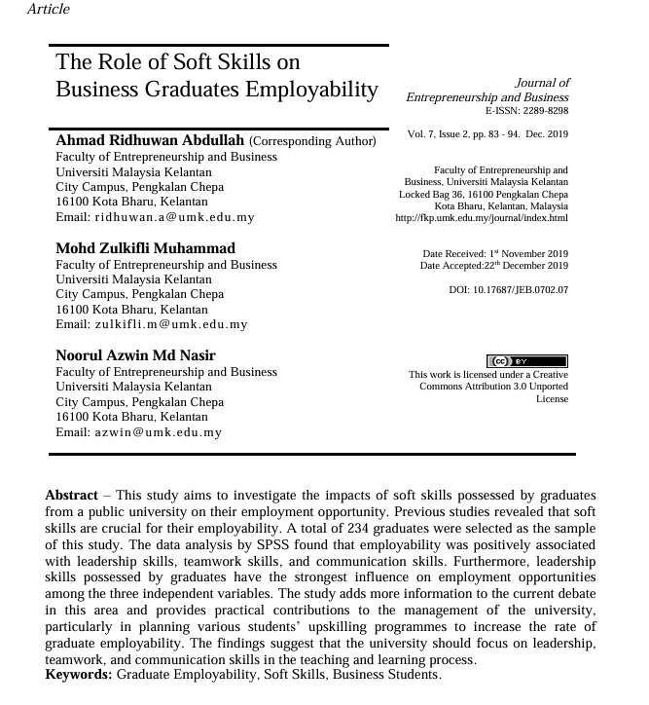
Your colleague has forwarded you a source from a peer reviewed journal, and they are not sure whether it is appropriate to use and has asked for your help. Your task is to evaluate the source by using the CRAAP Test to assess its appropriateness for the following question “What employability skills do business university graduates need to succeed in the workplace?”

CRAAP Test
Currency | Unfortunately the piece is from 2009, so it is quite outdated as today’s trends and technology have changed massively compared to 2 decades ago
Relevance | The article does talk about how work skills, personal skills and academic skills can all be integrated to assure success in in the workplace. As a student it is quite relevant because it does talk about my worries
Authority | The book is written by Sheila Cameron
Accuracy | The author has worked as a director of the Open University Business School. Sheila has been involved in the making of the school's MBA programme, And has tutored undergraduate business courses for over two decades. Sheila has also been an examiner at a multitude of universities therefore she has a large amount of expertise in her field and I think is quite credible due to the amount of experience she has.
Purpose | The purpose of the book is to inform undergraduates of how to implement skills they might have learned at past ‘amateur’ jobs, their personal skills and skills theve learned at school to achieve success in a professional workplace related to Business
Task 3: Source Analysis
Your manager has provided you with a short extract from a source and has asked you to analyse the source by Identifying one strength, one weakness, and providing a brief explanation of the strength and weakness identified.
If you want to read the article online, please click the following link: https://www.universitiesuk.ac.uk/latest/news/strong-demand-graduates-employers

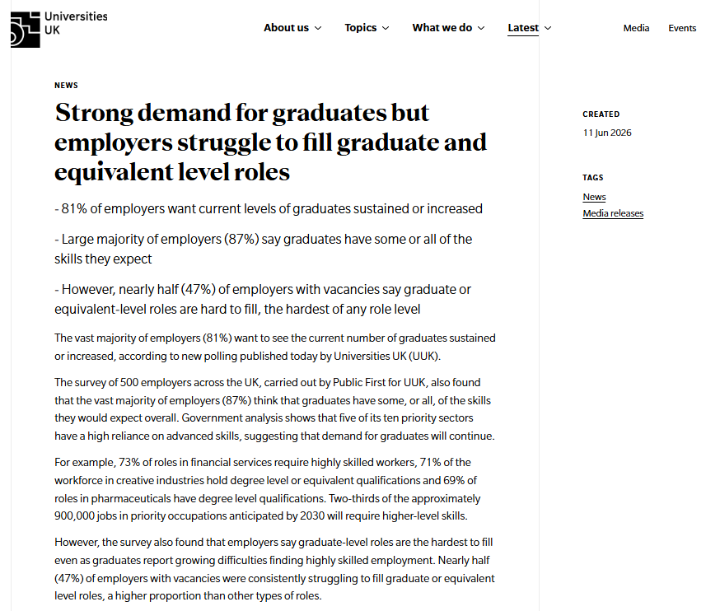
.

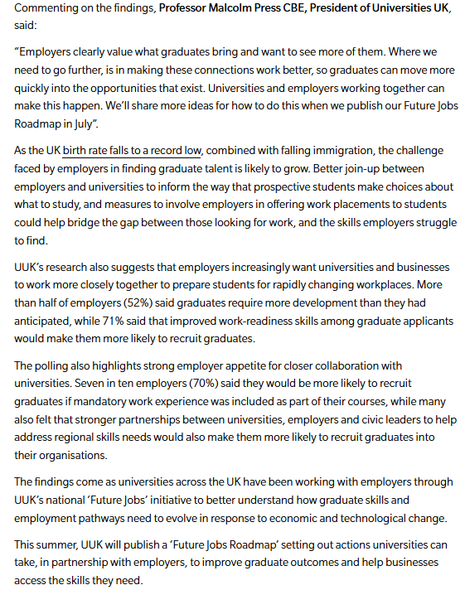

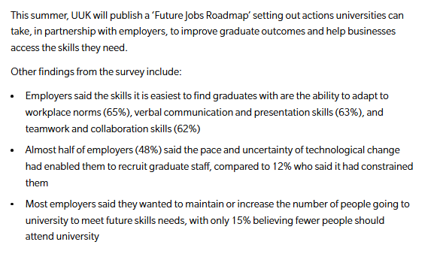

Strength of the Source:
The source is closely related to the question and talks extensively in an encouraging manner of how already existing skills a student might have could help them in the professional field and aid with success in the workplace and employment. The author is a highly accomplished woman and has decades of experience in the field of business and tutoring

Weakness of the Source:

The source is outdated by a large amount of years and therefore might not apply to today’s trends when it comes to modern businesses, and what those business are looking for.

