Entrepreneurship
Assessment 2 : Business plan

Student name: Radoslava Hristova
Student ID: 2110952

Executive Summary
The report aimed to present a business plan for a catering service in the UK market. The legal structure of the company will be a sole proprietorship and it will serve consumers, hence, following a B2C model. An industry analysis has been provided through VRIO and porter’s five forces analysis. This will use both digital and traditional marketing to promote itself and a complete financial plan has been provided as well. The financial forecasts reflect that the bank loan and owner’s contribution are the sources of funds for the business. Moreover, high and increasing sales are predicted for the business, which is going to help it in achieving financial sustainability.
Table of Contents
Introduction 4
Business Description/ Intellectual property and legal considerations 4
Industry analysis 5
Operations and management team plan 6
Marketing Plan 7
Financial plan 9
Market research 11
Conclusion 13
Reference List 14

Introduction
A business plan refers to the roadmap created to provide a detailed and cohesive idea of how a new business can be developed (Ritter and Schanz, 2019). It is an important detail that is required for the owners of a business to make as without this the proper functioning of a company can not be possible. In this study, a detailed business plan for a catering business will be created. it will provide a description of the business that the owner aims to establish along with legal considerations for it. an overview of the industry in the UK will be provided including the macro-environmental analysis. Details of the operations and management team will be given in addition to a marketing plan and financial plan.

Business Description/ Intellectual property and legal considerations
The new idea for the startup is a catering business which will be focused on providing high-quality food along with excellent catering service. The service that the company will offer to its customers is food service. It will provide high-quality and tasty foods according to the choices of customers and will offer a wide range of cousins to choose from. The mission statement of the company is to provide consumers value by serving the best food using the freshest and best ingredients (refer to assignment 1). The vision of the company is to offer the best service that will be able to provide value for their money. It will try to strive to offer the best service to its customer and improve itself by taking the feedback of customers into consideration. The legal structure of the company will be a sole proprietorship and the owner will be the sole decision-maker for all the decisions of the company. Though a proper management team will be set up to help the owner with the operation of the company.

Industry analysis
The catering market in the UK is an ideal market to start a business in. As of 2023, the market size in the county is estimated at $1.4 billion which indicates the huge market that is available in the UK (IBIS World, 2022). Though the global pandemic had a negative impact on the industry, in comparison to this, it is expected to grow by 1.4% in 2023 which indicates the numerous opportunities that the catering business will gain from this.
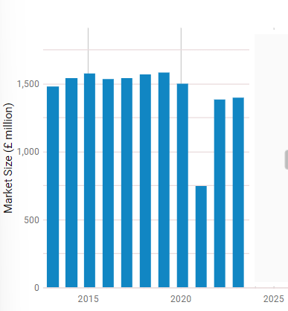
Figure 1: Catering market size in the UK
(Source: IBIS World, 2022)
For further analysis of the market, a VRIO analysis will be conducted.
Factors | Valuable | Rarity | Imitability | Organisation
Employees | Yes | No | Yes | No | Competitive parity
Services | Yes | No | Yes | Yes | Competitive parity
Financial resources | Yes | No | No | Yes | Sustainable competitive advantage
Shareholders | Yes | Yes | No | Yes | Sustainable competitive advantage
Table 1: VRIO Table
Analysis: The above table presents that employees and the services of the company are two of the factors that will provide the catering business with competitive parity. On the other hand, proper and efficient use of shareholders and financial resources will provide a sustainable competitive advantage to the catering company.
Porter’s five forces analysis:
Competitive rivalry: As of 2023, around 7154 catering businesses already operate in the UK namely Bovingdons Catering Ltd, The London Kitchen, Eden Caterers, and more making competitive rivalry in the market high (IBIS World, 2022).
Threat of substitution: The services that the new company will provide are food service which is nothing new and can easily be substituted with other options. Thus, the threat of substitution is high.
Threat of new entrants: The UK is quite a preferable place for establishing a business and considering that a 2% increase in the number of catering businesses within a year in the UK market indicates that the threat of new entrants is also high (IBIS World, 2022).
Buyer’s power: With the huge number of businesses operating in the UK, consumers will have more options to choose from which indicates that the buyer’s power in the case of the catering service is high.
Supplier’s power: Many suppliers are available in the UK market for which the new business will not find much difficulty in sourcing its materials. However, with the UK leaving the European Union, it may find challenges in supplies. Hence, the supplier’s power is moderate.

Operations and management team plan
The catering company will be a B2C business model for its revenue stream. A business-to-customer or B2C is a business model in which the products and services of a company are sold to customers (Silva, Duarte, and Almeida, 2020). The catering business will employ a sole proprietorship for its legal structure. A sole proprietorship is a business in which the entirety of the business is owned and managed by one person and no other individual is responsible for the decisions (Lip, 2022). This is ideal for this business plan as a startup business, the simplest form of the legal structure will help in its management. Additionally, this provides the owner full control of managing the company and the rules and regulations for this are also fewer in comparison to others. Though the issue with this is that the owner bears all legal liabilities, hence, in the case of a loss, the owner will bear all consequences. There are other business structures such as partnerships, limited liability companies, corporations, and more, however, due to the complexity associated with these structures, the catering business will not follow these.
The management team of the catering business will enlist employees who will be in charge of ensuring that the company is working in a satisfactory manner. In the initial stage of the business, it will have an accountant who will manage all financial aspects of the company. Two persons each will be included for managing the marketing and sales aspect of the company in which they will come up with strategies for marketing. And lastly, an operations manager will be hired to overlook the supply management and the whole servicing process.

Marketing Plan
In order to carry out a marketing plan, the marketing mix will be conducted which is a popular tool used to create plans for promoting the products of a company.
Product: This is one of the most important parts of a marketing plan as the entire plan is developed around this. The product for this specific business will be catering services. As a catering business, it will provide tasty and healthy foods to the customers. It will also offer customised food options according to the preferences of customers.
Price: Price is another important part of marketing as this determines the monetary value that will be put on a product. It is quite vital to ensure that the price of a product is suitable enough to attract customers. In this regard, the company will use a competitive pricing method. In this pricing strategy, the price of the products will be kept at a reasonable price which will ensure that the price is cheaper than others but enough to generate profit for the company.
Promotion: the element of promotion is focused on ensuring that the customers are aware of the product. In this case, the promotions will be based on the services of the company. It will use both traditional and digital marketing methods to gain the attention of customers. In the traditional method of marketing, newspaper and television advertisements will be used along with using hoardings to promote themselves. Social media marketing will be another marketing method that will be used as well. The social media penetration in the UK stands at 84.4% which is quite high (Statista, 2023). Using this high penetration rate to its benefit, the company will use social media platforms such as Facebook, Twitter, and Instagram to promote itself.
Place: Place in a marketing mix refers to the locations where the products of the company will be available. The place where the company will operate its business will be the UK. As the product of the company is its catering services, it will only be available in offline mode.

Financial plan
Sources of funds
To establish a new business venture, substantial funds are needed (Cavallo et al., 2019). The funds for this catering business are going to be sourced from the owner’s contribution and bank loan. An amount of £45,000 is expected to be the start-up costs for this business. Approximately £40,000 is going to be sourced from a bank loan while the rest £5,000 is going to be sourced from the owner’s contribution.
Use of funds
Details | Month 1 | Month 2 | Month 3 | Month 4 | Month 5 | Month 6
Sales revenues
Sales made on cash | £ 4,500 | £ 8,100 | £ 10,800 | £ 14,700 | £ 19,500 | £ 23,700
Decrease in trade receivables | £ - | £ - | £ - | £ 600 | £ 1,050 | £ 300
 | £ 4,500 | £ 8,100 | £ 10,800 | £ 15,300 | £ 20,550 | £ 24,000
Fixed Costs
Rent on premises | £ 600 | £ 600 | £ 600 | £ 600 | £ 600 | £ 600
Staff salaries and wages | £ 1,200 | £ 1,200 | £ 1,200 | £ 1,200 | £ 1,200 | £ 1,200
Insurance premium | £ 100 | £ 100 | £ 100 | £ 100 | £ 100 | £ 100
Loan interest | £ 200 | £ 200 | £ 200 | £ 200 | £ 200 | £ 200
Marketing and advertising | £ 150 | £ 150 | £ 150 | £ 150 | £ 150 | £ 150
Legal and accounting charges | £ 100 | £ 100 | £ 100 | £ 100 | £ 100 | £ 100
 | £ 2,350 | £ 2,350 | £ 2,350 | £ 2,350 | £ 2,350 | £ 2,350
Variable Costs
Material purchase | £ 1,350 | £ 2,430 | £ 3,240 | £ 4,590 | £ 6,165 | £ 7,200
Electricity expenses | £ 90 | £ 162 | £ 216 | £ 306 | £ 411 | £ 480
Other utility expenses | £ 360 | £ 648 | £ 864 | £ 1,224 | £ 1,644 | £ 1,920
Transportation costs | £ 135 | £ 165 | £ 205 | £ 255 | £ 295 | £ 320
Maintenance and repairs | £ 450 | £ 810 | £ 1,080 | £ 1,530 | £ 2,055 | £ 2,400
Other miscellaneous costs | £ 150 | £ 150 | £ 175 | £ 150 | £ 175 | £ 200
 | £ 2,535 | £ 4,365 | £ 5,780 | £ 8,055 | £ 10,745 | £ 12,520
Profit | - £ 385 | £ 1,385 | £ 2,670 | £ 4,895 | £ 7,455 | £ 9,130
Opening Cash | £ - | - £ 385 | £ 1,000 | £ 3,670 | £ 8,565 | £ 16,020
Closing Cash | - £ 385 | £ 1,000 | £ 3,670 | £ 8,565 | £ 16,020 | £ 25,150
Table 2: Sources and Uses of Funds and Six-month Cash Budget Forecast
The sales of the business reflected above in the cash budget show that it is going to achieve financial sustainability. This is because due to the high and increasing sales of the business, its cash flows or total funds will be negative in the first month. However, positive and increasing cash flows are to be achieved from the second month itself.

Market research
From the above industry analysis, it can be stated that the market for catering services in the UK is quite prospective for developing a new company. The macro-environmental factors which are needed to be carefully considered will be analysed through a pestle analysis.
Political
Corruption rate: In the UK, as of 2022, the corruption index scored 73 out of 100 which is a positive factor for a startup company (Trading Economics, 2023). This indicates that there are fewer corrupt practices in the UK which will ensure that external influences do not interfere with the company activities.
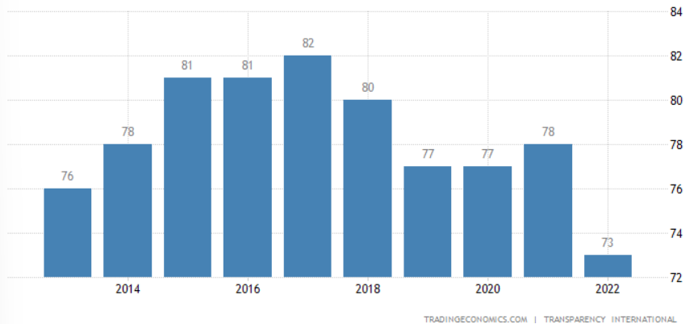
Figure 2: Corruption Rate in the UK
(Source: Trading Economics, 2023)
Economic
Inflation rate: The economic condition of the UK is quite unstable with the inflation rate of the country reaching 9.2% as of January (ONS, 2023). Though the rate has been gradually decreasing over the past year, the rate is still significantly high indicating that the prices of daily necessities such as fuel, food, and more will increase. This will have a profound negative impact on the company as it will increase production costs at the same time reduce the purchase ability of customers.
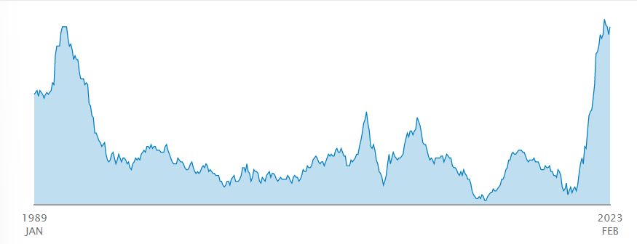
Figure 3: Inflation Rate in the UK
(Source: ONS, 2023)
Social
Household income: The household income in the UK has shown a slight downfall of 0.3% in 2022 which can possess a threat to the new company (ONS, 2023). As the income is decreasing in comparison to the increasing price of necessities, it will impact their purchase capabilities which will affect the business.
Technological
Internet penetration rate: As of 2023, around 34.62% of the whole population in the UK uses the internet on a daily basis which will provide great opportunities for the new catering business (Statista, 2023). This high internet penetration will help the company to use the internet for promotional purposes to connect to a wider customer base.
Legal
Food and Safety Act 1990: This act demonstrates that all organisations in this market are responsible for ensuring the quality of food for health purposes (Scarborough.gov.uk, 2023). As a catering business, if the company does not abide by this law, it will lead to the company facing legal action from the UK government.
Environmental
The Environmental Protection Act 1990: According to this act, a company will need to ensure to protect the environment by reducing its waste production (Gov.UK, 2023). In order to operate in the market, the company will have to adhere to this law.

Conclusion
The report presented a detailed business plan for a catering startup. From the market analysis of the business, this can be stated as one of the most prospective industries in the UK. The business has decided to follow the legal structure of a sole proprietorship and the management structure has been provided. A completed finance and marketing plan has been included in the plan along with a macroenvironmental analysis using the pestle framework.

Reference List
Cavallo, A., Ghezzi, A., Dell'Era, C. and Pellizzoni, E. (2019) Fostering digital entrepreneurship from startup to scaleup: The role of venture capital funds and angel groups. Technological Forecasting and Social Change, 145, pp.24-35.
Gov.UK (2023) Litter and refuse: code of practice. Available at: https://www.gov.uk/government/publications/code-of-practice-on-litter-and-refuse#:~:text=The%20Environmental%20Protection%20Act%201990,for%20which%20they%20are%20responsible. (Accessed: 27 February 2023)
IBIS World (2022) Catering Services in the UK - Market Size 2011–2029. Available at: https://www.ibisworld.com/united-kingdom/market-size/catering-services/ (Accessed: 28 February 2023)
Indeed (2022) What Are Management Teams? Definition and How To Build Them. Available at: https://www.indeed.com/career-advice/career-development/management-team (Accessed: 28 February 2023)
Lip, G. (2023) Sole Proprietorship. Available at: https://corporatefinanceinstitute.com/resources/management/sole-proprietorship/ (Accessed: 28 February 2023)
ONS (2023) Average household income, UK: financial year ending 2022. Available at: https://www.ons.gov.uk/peoplepopulationandcommunity/personalandhouseholdfinances/incomeandwealth/bulletins/householddisposableincomeandinequality/financialyearending2022#:~:text=Median%20income%20for%20non%2Dretired,FYE%202013%20to%20FYE%202022 (Accessed: 27 February 2023)
ONS (2023) Inflation and price indices. Available at: https://www.ons.gov.uk/economy/inflationandpriceindices#:~:text=Consumer%20price%20inflation%2C%20UK%3A%20February%202023&text=The%20Consumer%20Prices%20Index%20including,up%20from%208.8%25%20in%20January. (Accessed: 27 February 2023)
Ritter, M. and Schanz, H., (2019) The sharing economy: A comprehensive business model framework. Journal of cleaner production, 213, pp.320-331.
Scarborough.gov.uk (2023) Food safety regulations. Available at: https://www.scarborough.gov.uk/home/business-licensing-and-grants/food-hygeine/food-safety-regulations#:~:text=The%20Food%20Safety%20Act%201990,out%20in%20a%20hygienic%20way. (Accessed: 27 February 2023)
Silva, S.C., Duarte, P.A.O. and Almeida, S.R. (2020) How companies evaluate the ROI of social media marketing programmes: insights from B2B and B2C. Journal of Business & Industrial Marketing, 35(12), pp.2097-2110.
Statista (2023) Active social media users in the United Kingdom (UK) 2023. Available at: https://www.statista.com/statistics/507405/uk-active-social-media-and-mobile-social-media-users/#:~:text=The%20United%20Kingdom%20(UK)%20was,the%20population%20of%20the%20UK. (Accessed: 25 February 2023)
Statista (2023) Internet penetration in the United Kingdom (UK) 2000-2020. Available at: https://www.statista.com/statistics/468663/uk-internet-penetration/ (Accessed: 27 February 2023)
Trading Economics (2023) United Kingdom Corruption Index. Available at: https://tradingeconomics.com/united-kingdom/corruption-index (Accessed: 27 February 2023)

