
Module: Marketing Fundamentals (LCBB4004)
Student Name: Yancho Georgiev
Student ID:2112958
Assignment: Blogging to communicate
Lecturer: Mohammad Rahman

Introduction
Blog marketing is utilizing blog postings to promote a product, service, or website. Jack Cohen started Tesco in 1919, becoming a big worldwide retailer during the last century (Taqatqa, 2021). The organization's headquarters are located in Welwyn Garden City, England. Cohen wanted to create several stores to sell off his perishable food stock. In 1939, the first Tesco branch opened for business. Due to its thriving business, the firm will have more than 100 locations around the nation within a decade.
Due to the expansion of supermarkets in the 1970s, customers' shopping habits changed. Tesco constructed stores in England with forethought to meet the needs of its increasing customer base. Tesco is expanding rapidly to become one of the world's biggest supermarket chains. Tesco PLC, which now serves 22.7% of all retail customers in the United Kingdom, is the largest grocery chain in the country. The company is the ninth-largest grocery store in the world by sales and operates in eight different countries.
In addition to its initial focus on food shopping, this company now offers various items and services, including furniture, toys, fashion, banking, stationery, electronic devices, and software. Throughout the 1990s, to attract a bigger audience, the company modified its strategy and repositioned itself as a low-cost store (Taqatqa, 2021). Tesco's stock is valued at £18.1 billion on the London Stock Exchange. Since 2016, the company's growth has been constant.
Tesco employs blogs, another new media, to market their goods and facilitate consumer interaction. This is because users of the Tesco website are permitted to discuss any topic; for instance, the company has built a section of the website where customers can discuss products available in the store before choosing to purchase them. The Report will describe a series of blog postings designed for specific audiences.
Product strategy
Tesco is one of the leading retailers in the United Kingdom (Rosnizam et al., 2020). It offers an extensive variety of products at its many retail locations. The product range is comprehensive to meet the needs and preferences of clients from all market categories. Tesco provides many products, such as food, apparel, stationery, cosmetics, technology, and financial services, among others. It accommodates its expanding consumer base in every imaginable manner. In almost every area, it offers products from reputable producers. It also has its brands. The private brands carried by Tesco include Everyday Value, Tesco Lotus, Tesco Value, and F&F Clothing (Samdani, 2020). However, it is essential to note that the variety of product categories available to clients varies on the kind of stores they visit. Tesco began offering vegan desserts in 2021 as part of a plan to enhance new product sales by 30% by 2023. The company's latest offerings include Passion Fruit Panna Cotta, Cherry and Chocolate Dessert, and Chocolate Orange Sundae. The company will target youth and middle-class consumers to make its products accessible to a bigger audience. In addition, it will continue to use its current consumer targeting approach, which considers the consumers' interest in product quality, cost, and other factors.

Additionally, it will assist clients in improving their health and taking better care of themselves. Tesco is now using an immersive positioning strategy to stamp its brand image on its target market. The company used a multi-segment positioning approach to choose how to promote its future vegan dessert offerings. This will aid the company in establishing a tailored marketing strategy to reach specialized markets more successfully.
Price strategy
Tesco currently employs a pricing strategy based on cost leadership to provide consumers with access to a selection of items at accessible prices without sacrificing quality (Keiningham et al., 2020). A potential disadvantage of this technological approach is competition from new entrants who provide equivalent products at lower prices. To improve its market share, the company will forsake its current pricing strategy, dubbed "The Big Price Drop," in favour of a new approach. By implementing this strategy, management will progress toward its goal of increasing market share. To give a range of advantages to its customers, the company stresses continuous, transparent cost-cutting.
Tesco's low-price approach has been a tremendous success over the years, helping the firm surpass long-established rivals like Sainsbury and become the most popular grocery chain in the United Kingdom. Through its "club card" program, Tesco allows its customers to earn cash back on purchases (Kumar and Reinartz, 2018). Offering special discounts is an excellent way to thank returning customers and attract new ones. This pricing approach allows for future price reductions, which increases sales without substantially cutting earnings.
Companies have altered their pricing tactics in response to the price wars, which are a direct consequence of increasing costs and more competition. As households purchase new products, the method will reduce their financial burden. With this pricing strategy, Tesco will be better able to compete with Asda and other retailers. The strategy proposes that the firm reduce its prices by at least 30%. All vegan desserts will be priced at £3.50. The price is less than what other firms charge for similar products.
Place strategy
The 3968 shops managed by the corporation in the United Kingdom will be the first locations to carry the company's new products. The retail stores are filled with the company's current offerings, including food and clothing. Once management determines sufficient demand, Tesco plans to market these products in Thailand. The company plans to open 750 new convenience shops while shifting its focus from cash and carriers to small boxes. A well-planned retail strategy will make purchasing more convenient for consumers (Anderson and Sin, 2020). And it will help Tesco increase its current profitability and sales.
In addition, Tesco is considering testing a fresh concept in its finest stores, which would offer solely premium private label products. The company's leadership is also concentrating on a separate set of initiatives that will allow it to seize fresh growth prospects. Additionally, the firm wants to offer its new products to its target market through Distribution Channel 3. According to Tesco's plan, the company will sell its products directly to consumers, bypassing traditional intermediaries. Additionally, it will assist the organization in minimizing distribution costs.
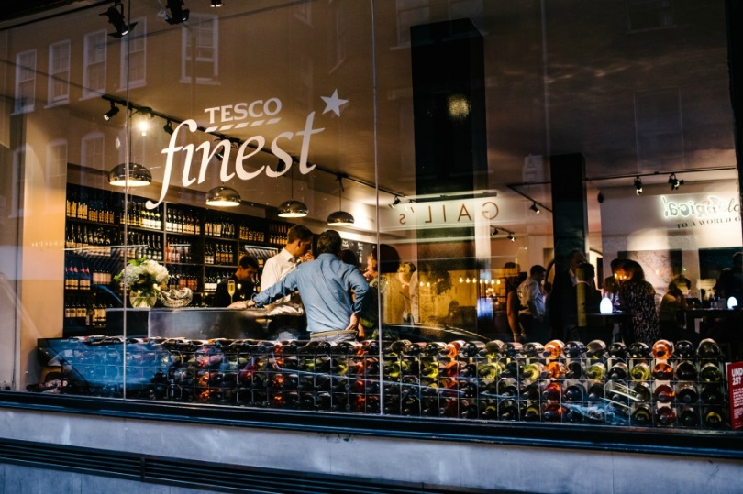
Process strategy
In the context of Tesco's marketing strategy, "process" refers to the company's attempts to retain customer happiness by providing speedy billing services and accessible product purchases in-store and online. Tesco can do this by investing in staff training and listening to and resolving consumer issues. Tesco has partnered with a Vietnamese retailer as part of a new business strategy to offer its private label products to customers across various price points and demographics (Burt et al., 2019). In addition, it has teamed with Takeoff, a specialist in robots, to assist Tesco's leadership in establishing mini DCs in the merchants' warehouses. This would reduce the time required to process orders and increase the efficiency with which Vegan sweet meals are delivered to the company's target customers through online channels. Micro-fulfillment requires automation to be effective. The company hopes that the new technology will increase the efficiency of internet-based meal delivery. Additionally, Tesco's in-store logistics will become more efficient. The company continues to be prudent with its capital expenditures and closely evaluates the success of the retail store technology it has implemented.
Tesco lost its direct operations in 2018, but it looks to have identified a successful niche in e-commerce, thus investing in this strategy. If the firm wants the business to succeed, it must use the web's capabilities as part of a comprehensive Omni-channel strategy. The investments made by Tesco will increase production and back-end awareness.
Promotional strategy
The competitive advantage of Tesco is its low costs (Rosnizam et al., 2020). This distinguishes it from other grocery shop chains. And this is how it enhances its market reputation. Its principal objective has always been to raise income while maintaining a pleasant public image. To attain this objective, the corporation utilizes a variety of marketing initiatives, including television advertisements, discounts, sponsorship of charitable events, point-of-sale approaches, etc. Every advertisement for Tesco highlights the store's rock-bottom costs. Customers may also take advantage of the organisation's seasonal and year-round specials. As they navigate the aisles of this supermarket, customers can readily locate offers such as "buy one, get one free" and "half off." A key objective is to enhance sales by creating the appearance that buyers are receiving a discount. Tesco uses the Clubcard program to provide consumers with extra discounts. Using this solution, Tesco can better comprehend client demand and the market. This allows them to segment the market into smaller categories and adjust their strategies to each category.
In the past, the company has relied on traditional marketing strategies to promote product sales. Given the rising popularity of digital marketing, Tesco plans to move its advertising budget away from more conventional methods and toward online platforms (Ponzoa and Erdmann, 2021). Thus, digital platforms will get around 30% of the company's total marketing budget. Tesco will be able to contact niche audiences that less specialized advertising methods have not been able to attract. Tesco's most recent marketing effort aggressively invites people to contribute their Food Love Stories.
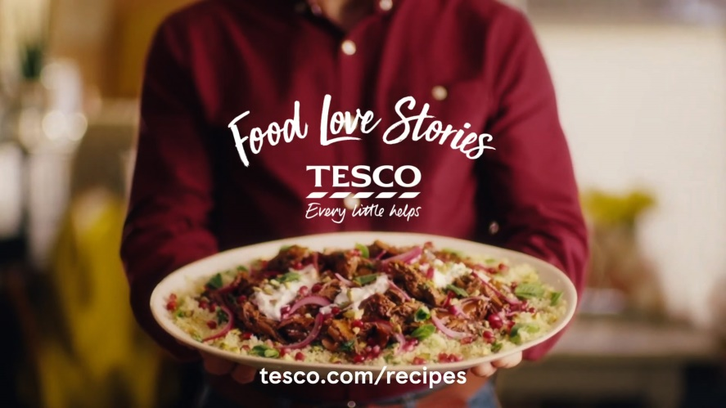
Customization is required to compete in the modern marketing environment. In response to the business's emphasis on customer service, Tesco's marketing department has developed several unique projects. The company will distribute printed promotions on the customer's birthday directly to their doorsteps. Tesco will utilize social media platforms such as WhatsApp, Snapchat, etc., to officially promote new product offers. Tesco will also offer its clients an Order & Collect service as part of the agreement.
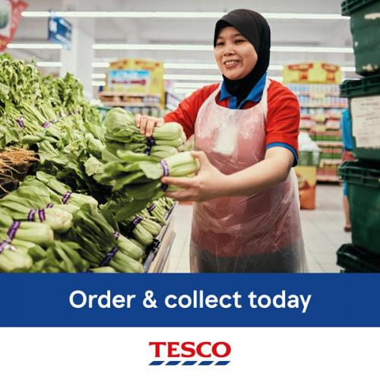.
Physical evidence strategy
Tesco stores are always beautiful, well-kept and attractive (Shin et al., 2020). Because everything is well-organized, clients can quickly and easily locate the desired items. Concrete evidence includes the brand's color scheme, logos, labelling, and equipment. In addition, offers are positioned in such a way as to entice clients into purchasing more than they need, even though they believe they are preserving their financial resources. In addition, the corporate website will aid in providing prospective clients with vital information about the new products the company will provide. Customers of Tesco who shop online will enjoy the same efficient experience they have come to expect in the company's physical locations. Customers may rapidly add products to their shopping carts and monitor their purchases by using the tools located on the right side of the screen while viewing a category page for the business.
Tesco plans to stop using materials in their canned multipack items. Customers can purchase many individual tins at the same price as the previous multipack under the multi-buy promotion. In addition, Tesco intends to phase out the use of non-recyclable plastics; however, consumers may continue to depend on the store's excellent value multipacks.
People strategy
The sales crew is integral to the company's human resources strategy. Tesco provides initiatives, such as "Save As You Earn," "Colleague Privilege," and "Buy As You Earn," that reward employee for their dedication to the company (Alam and Raut-Roy, 2019). Tesco will seek individuals from diverse backgrounds. This may help the business community promote diversity and inclusion more effectively.
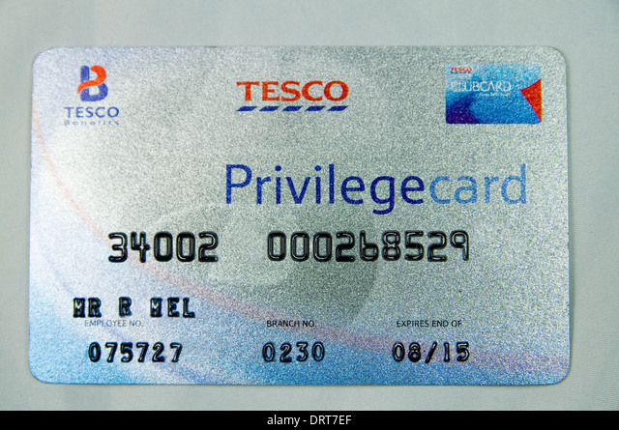
In addition, management will give employees a range of advancement opportunities. They will be motivated to exert more effort to support the organization's goals. Tesco will also give training and development opportunities for its employees to enhance their present skill sets. All new retail workers in Thailand will get training in business management. Training in the local language and culture might be advantageous for existing personnel. Current and prospective employees will benefit from the programs' guidance when assuming leadership responsibilities.
Conclusion
In conclusion, the marketing mix is vital when presenting a new product or service to existing customers. It helps businesses establish, execute, and plan their product or service marketing strategy. In other words, it assists businesses in avoiding wasteful expenditures. Tesco's web design emphasizes usability by making all portions of the site easily navigable so consumers can quickly locate the product and service information they need. This has the effect of easing the customer's search process. Tesco has also implemented a Price Checker on its website to attract more consumers by enabling them to compare costs across brands.

References
ALAM, S. & RAUT-ROY, U. 2019. Evaluating the Effectiveness of Reward Strategy at Tesco: Evidence from Selected Stores in UK. Indian Journal of Industrial Relations, 55.
ANDERSON, S. & SIN, L. G. 2020. The influence of store atmosphere on purchasing decisions and customer satisfaction: A case study at the Pacific Restaurant, Blitar. Journal of the Community Development in Asia (JCDA), 3, 70-78.
BURT, S., COE, N. M. & DAVIES, K. 2019. A tactical retreat? Conceptualizing the dynamics of European grocery retail divestment from East Asia. International Business Review, 28, 177-189.
KEININGHAM, T., AKSOY, L., BRUCE, H. L., CADET, F., CLENNELL, N., HODGKINSON, I. R. & KEARNEY, T. 2020. Customer experience driven business model innovation. Journal of Business Research, 116, 431-440.
KUMAR, V. & REINARTZ, W. 2018. Loyalty programs: Design and effectiveness. Customer relationship management. Springer.
PONZOA, J. M. & ERDMANN, A. 2021. E-commerce customer attraction: Digital marketing techniques, evolution and dynamics across firms. Journal of Promotion Management, 27, 697-715.
ROSNIZAM, M. R. A. B., KEE, D. M. H., AKHIR, M. E. H. B. M., SHAHQIRA, M., YUSOFF, M. A. H. B. M., BUDIMAN, R. S. & ALAJMI, A. M. 2020. Market opportunities and challenges: A case study of Tesco. Journal of the Community Development in Asia (JCDA), 3, 18-27.
SAMDANI, T. 2020. Impact of Tesco's Private Label brands on buying behaviour of Millennials in terms of brand preference in Irish market. Dublin, National College of Ireland.
SHIN, S., KIM, H. & KIM, W. 2020. Transnational corporations’ localization strategies via retail attributes: Focus on Chinese Market. Journal of Retailing and Consumer Services, 55, 102088.
TAQATQA, A. 2021. 5 Tesco. Business Management Case Studies: Pran-RFL, Netflix, Mc Donalds, Google, Tesco, Apple, COCA COLA, PSA Group, Mercedes, Tesla, Toyota, Beximco, KFC, LBC Lao Brewery Company, 97.

