EFFECTIVE TEAM WORKING AND COMMUNICATION

COMPONENT 1

08.11.2021



PROJECT BY

USHA KRISHNA RAJ

STUDENT NO: 2022598

DHL’s Team work strengths within the Organisation

Background and Context:

DHL is the global leader in the logistics industry, specializing in international shipping, courier services and transportation.

The company was founded in San Francisco, in 1969 by Adrian Dalsey, Larry Hillblom and Robert Lynn.Their 4 divisions are;
- Express
- supply Chain
- post/e-commerce/Parcel
- Global Forwarding & Freight

DHL strategy:

The DHL CEO Appel (2019) says that they have invented their strategy-2025 which is, investing EUR 2 billion in digitalization to enhance customer experience, employee experience and increase operational excellence.(1)

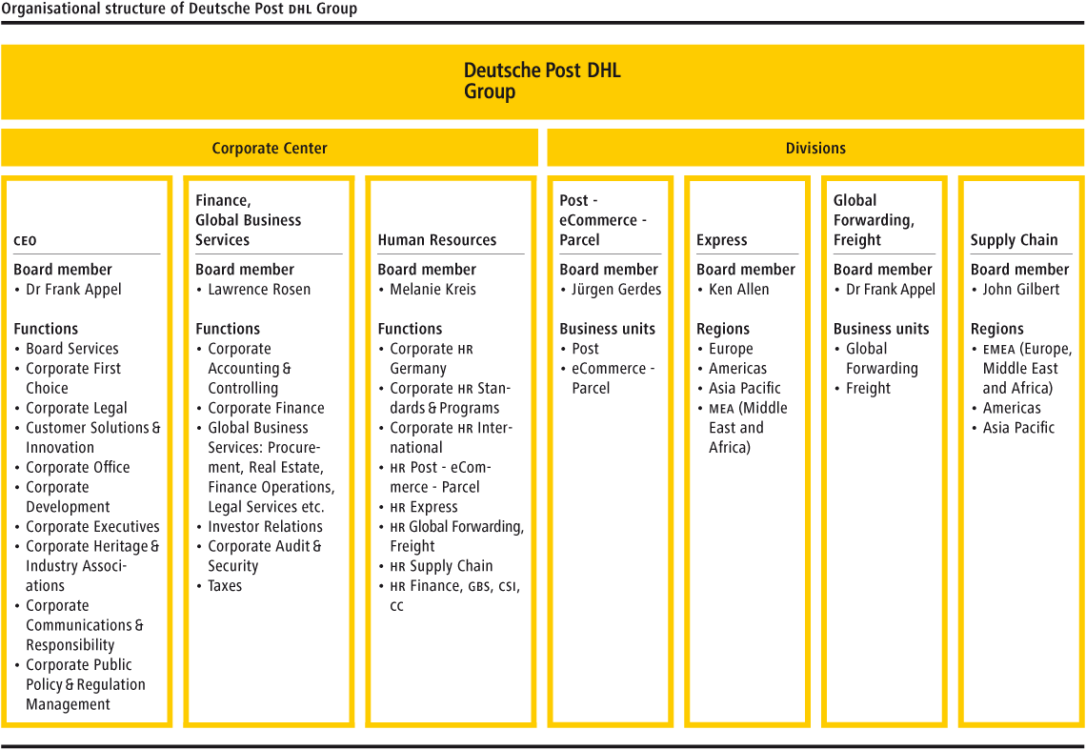
Relating Belbin’s Team roles to DHL team within their Organization ;(2)

Cerebral Oriented role:

John Person, the CEO of DHL stated that DHL team, with their institutional memory, forecast knowledge and close contact with customers, they have saved the Organization from a major decline in revenue in 2020.(3)
Here, the DHL team has acted as
- Plant : Using creative technique in keeping close contact with customers;

- Monitor Evaluator : Forecasting all options available and judging problems accurately;

- Specialist: Inputting their specialized knowledge about the core of their Organization and thus saving it from a major decline.

People Oriented role:

DHL CEO also stated during this pandemic, DHL executive team co-ordinated perfectly and accomplished their goal of avoiding Layoffs and promoting business in a wider range.(4)

Although the executive team of DHL paid careful attention to a variety of business predicts made in relation to the pandemic, they played as a
- Coordinator: By focussing on their key objective of avoiding laying off Employees and
- Resource investigator: By exploring and scrutizing team’s ideas and bringing in a huge need of their services to the customers.
- Hence the team joined together as Team Players and accomplished their goal of avoiding Layoffs and promoting business.

Action Oriented role:

DHL’s Global Communicator Bach interprets the speech of Larry St.Onge, the President of DHL’s Life Sciences & Health care that their team faced border closures during the pandemic and faced a tougher challenge in transporting vaccines. He appreciates the team saying he couldn’t be more proud of them as they have planned every step of their process, handling and quality control with 100 % precision, accuracy and timely delivery.(5)

Here I identify the DHL team as a
- Shaper: by driving themselves forward with courage against the obstacles to help patients.
- Implementer: by planning practical ideas and executing them, and
- Complete finisher: by monitoring the work carefully to avoid any faults and ensuring timelydelivery.

Tuckman’s theory of team development applied in the

Origin of Disaster Response team in DHL: (6)

Forming:

DHL’s Director of Humanitarian affairs states, in 2005 about 35 DHL employees from various DHL divisions volunteered for the pilot team with uncertainty about their role.

Storming:
The Pilot team was sent to handle Srilanka’s Tsunami crisis at Columbian Airport for doing unloading, storing and reloading goods. As they were new and deployed to the affected airport, conflicts raised.

Norming:
Leaders sought army’s help to improve their skills. This stabilized and strenghthened DHL staffs.

Performing:
The Team had clear vision of their responsibility and turned the affected airport into an efficient air hub.

Adjourning:
The Leaders were proud and recognized the contribution of the team. The DRT Pilot team was formed successfully. (7)

Kilmann’s theory:

Various roles of DLF management relating to Kilmann’s conflict handling roles; (8)

Competing – DHL Trade Union

Author Whittaker (2021) states DHL Trade Union held a 24 hours strike over redundancy pay competing with the Management.(9)

Compromising – DHL HR team

DHL HR policy is to create common understanding among employees and provide fair working conditions. (10)

Collaborating – Compliance management

DHL Compliance team comprises rules and standards intended to ensure laws and to promote appropriate behaviour.(10)

Accommodating - DHL IT team

They support DHL by providing strong cyber-security to the supply-chain automation process.(10)

Avoiding – Media team

DHL Media plays diplomat, spreading only optimistic news and avoids conflict news.(10)

References:

1.PR Newswire, (2019).‘Strategy 2025: Deutsche Post DHL Group accelerates growth in core businesses and invests EUR 2 billion in digital transformation. [Press Release – by Frank Appel, CEO –DHL] Publisher - Markets Insider.

2.Belbin, M. (1993). ‘Team Roles at work’.

3.Harvard Business Review, (2021). ‘How DHL Express Navigated the Pause – and Rebound – of Global Trade’ – Globalization [Press Release – by John Pearson, CEO of DHL and Steven A.Altman, Director of the DHL initiative on Globalization at NYU] May 18, 2021.

4. Harvard Business Review, (2021). ‘How DHL Express Navigated the Pause – and Rebound – of Global Trade’ – Globalization

Press Release – by John Pearson, CEO of DHL and Steven A.Altman, Director of the DHL initiative on Globalization at NYU] May 18, 2021

5. Delivered-The Global Logistics Magazine, (2020). ‘All Hands on Deck: How critical life sciences and health care cargo keeps moving to safeguard patient health during the global Covid 19 crisis’- [Press Release by Michelle Bach, DHL’s Global Communicator]. March 2020.

6.Tuckman, B. (1965). ‘Tuckma’s stages of group development’

7.Delivered-The Global Logistics Magazine, (2020). ‘Master of Disaster’. [Press Release by Chris Weeks, DHL’s Director of Humanitarian affairs ], June 2020. Available

8.Thomas, K. and Kilmann, R. (1974). ‘A Theory of Conflict’.

9. Whittaker, A.(2021). ‘DHL workers to strike again over redundancy pay’- Nottinghamshire Live.

10. DHL website : https://www.dhl.com/gb-en/home/about-us.html

