
Author: Amy Williams – P151979

Dissertation submitted as part of the requirements for the award BA (Hons) Business Management.

To critically analyse management styles within the fitness industry and their effects on employee motivation and retention.
Case study: Xercise4less
Declaration 1

This work has not previously been accepted in substance for any degree and is not being concurrently submitted in candidature for any degree.

Signed........................................

Date...........................................

Statement 1

This dissertation is being submitted in partial fulfilment of the requirements for the degree of BA.

Signed........................................

Date...........................................

Statement 2

This dissertation is the result of my own independent work/investigation, except where otherwise stated. A bibliography is appended.

Signed........................................

Date...........................................

Statement 3

I hereby give consent for my dissertation, if accepted, to be available for photocopying and interlibrary loan, and for the title and summary to be made available to outside organisations.

Signed........................................

Date...........................................
Statement 4

I hereby give consent for my dissertation, if accepted, to be available on the university’s IT system to those who have consent to use the system.

Signed........................................

Date...........................................

Acknowledgements

I would like to dedicate this dissertation to my Mamgu, Sheila Williams. Whose strength throughout her illness these last couple of years has inspired and driven me to stay strong and motivated myself.
I would like to thank my dissertation supervisor Ian Jackson for offering continuous support and keeping me calm throughout not only my dissertation but my degree.
I would also like to thank Caroline Jawad, Gareth Hughes and Julie Hayward for the support, guidance, and friendship along the process of the last three years.
I would like to thank both my parents Kaye Jones and Anthony Williams for providing me with the necessary skills and tools to complete a degree. Also, my grandparents Terence, Janet and Peter.
Finally, thank you to my partner Joseph Chiffi for keeping me calm and motivated.

To critically analyse management styles within the fitness industry and their effects on employee motivation and retention.
Case study: Xercise4less
Amy Williams
P151979

Contents
Table of figures 7
Abstract 8
1.0 Chapter 1 - Introduction 9
1.1 Case study: Xercise4less 9
1.2 Background and literature review 10
1.3 Rationale 12
1.4 Research Aim 13
1.5 Research objectives 13
1.6 Research Design and Methodology 14
1.6.1 Philosophies 15
1.6.2 Research approaches 15
1.6.3 Strategies 16
1.6.4 Research Choices 16
1.6.5 Time Horizons 16
1.6.6 Techniques and procedures 17
1.6.7 Research sample 17
1.6.8 Limitations 17
1.6.9 Ethical Risks 18
1.6.10 Reliability and Validity of results 18
1.7Resources and planning 18
1.7.1 Resources 18
1.7.2 Gantt Chart 19
2.0 Chapter 2 - Introduction 20
2.1 Fitness industry 20
2.2 The theoretical framework of management styles 21
2.2.1 Definition of management 21
2.2.3 Management theories 21
2.2.4 Motivation 27
2.2.5 Retention 28
2.2.6 Management styles, motivation and retention within the fitness industry 28
2.3 Conclusion of literature review 29
3.0 Chapter 3 – Introduction 29
3.1 Research Onion 30
3.1.1 Philosophies 30
3.1.2 Research approaches 31
3.1.3 Strategies 32
3.1.4 Research Choices 32
3.1.5 Time Horizons 32
3.1.6 Collection and analysis 33
3.1.7– Sampling 35
3.1.8 Reliability and Validity 36
3.1.9 Limitations 36
3.1.10 Ethical Risks 37
3.2 Conclusion of methodology 37
4.0 Analysis of results 37
4.1 Introduction 37
4.2 Quantitative data analysis 38
4.2.1 Sample Characteristics 38
4.2.2 Gender/ Length of employment at Xercise4less 39
4.2.3 Management style / Employee satisfaction with manager 40
4.2.4 Do employees see a future with Xercise4less 41
4.2.5 Main motivating factor / What is more important pay or getting along with colleagues? 43
4.2.6 Should managers have full control? 44
4.2.7 Which factors are applicable to management at Xercise4less 45
4.2.8 Hierarchy 46
4.2.9 Do you enjoy your job? 47
4.3 Qualitative data analysis 48
4.3.1 Theme of low retention and no future career path 49
4.3.2 Theme of management style best if paternalistic and supportive 50
4.3.3 Pay is main motivator theme 51
4.3.4 Hierarchy within Xercise4less, should managers have complete control? 52
4.3.5 Fayols principles of management 53
4.3.6 Does the employee enjoy their job and are they motivated 54
4.3.7 Does your manager affect your motivation and retention? 55
4.4 Conclusion of Analysis of results 55
5.0 Conclusion 56
5.1 Introduction 56
5.2 Achievement of objectives 56
5.3 Main Findings 57
5.4 Recommendations 58
5.5 Limitations 59
5.5.1 Implications 60
5.5.2 Bias 60
5.6 Future Research 61
5.7 Conclusion 61
APPENDIX A – Fayol (1954) 14 principles of management 63
APPENDIX B – Questionnaire 63
APPENDIX C – Ethics form 68
APPENDIX D – Interviews 79
6.0 References 84

Table of figures

Figure 1 – Research Onion (Saunders, Lewis, & Thornhill, 2009). 14
Figure 2 - Gantt Chart 20
Figure 3 - Fayol (1916) five functions of management 24
Figure 4 Maslow (1943) Hierarchy of needs 26
Figure 5 - Hertzburg (1959) Hygiene factors 27
Figure 6 - Research Onion (Saunders, Lewis, & Thornhill, 2009) 31
Figure 7 - Data sourced and analysed by Williams (2019) 40
Figure 8 - Data sourced and analysed by Williams (2019) 41
Figure 9 - Data sourced and analysed by Williams (2019) 43
Figure 10 - Data sourced and analysed by Williams (2019) 44
Figure 11 - Data sourced and analysed by Williams (2019) 45
Figure 12 - Data sourced and analysed by Williams (2019) 46
Figure 13- Data sourced and analysed by Williams (2019) 47
Figure 14 - Data sourced and analysed by Williams (2019) 48
Figure 15 - High-level word cloud of Retention and career path (Xercise4less Interview Data, 2019). 50
Figure 16 - High-level word cloud of management style (Xercise4less Interview Data, 2019). 52
Figure 17 - High-level word cloud of main motivator (Xercise4less Interview Data, 2019). 52

Abstract

This dissertation is being conducted under the requirements for a BA (Hons) degree in Business Management. The dissertation aims to critically analyse management styles within the fitness industry and how they affect motivation and retention of employees. The case study is Xercise4less and primary research will be conducted on employees of this organisation using both questionnaires and interviews.
The fitness industry has a bad reputation of having a low retention of employees. High retention rates costs organisations considerable amounts of money on both the hiring and training of new employees. By improving motivation and retention of employees organisations can boost productivity and save money thus increasing profit.
The researcher has conducted an extensive literature review in order to gain knowledge on managements affects on motivation and retention of employees. There was no literature regarding this topic within the fitness industry, so the literature review has instead used research conducted within other industries on managements affects on motivation and retention of employees to form themes which can then be compared with the results from the primary research conducted within the fitness industry in this dissertation.
Based on the theories and themes within the literature review the researcher conducted both quantitative and qualitative data collection methods to test the themes in regards to the fitness industry. The software’s SPSS and NVIVO were then utilised to analyse data collected.
This dissertation found that there was a low retention of employees within the fitness industry, thus showing there is a problem with motivation and retention within the fitness industry, so this dissertations results and recommendations will be of use to the fitness industry. Length of employment of employees interviewed was short and most stated they felt there was no future career path within the fitness industry. The primary research also found that employees prefer a supportive manager, as suggested by Mayo (1927) and not a strict controlling manager as suggested by Taylor (1911). Throughout the questionnaires there was a clear theme of satisfaction with paternalistic managerial style and dissatisfaction with authoritarian management style. This was further supported in the interview data by all three interviewees.

1.0 Chapter 1 - Introduction

This dissertation will aim to evaluate how management styles are affecting employee motivation and retention within the fitness industry. The researcher will evaluate each management style and then test whether there is a correlation between a particular style and employee motivation level, which ultimately will show on employee retention. Tests will be conducted through surveys and interviews. The researcher aims to make recommendations to the fitness industry on the best management style for managers to uptake to motivate and retain their staff, this will save organisations money on hiring and training. It is widely known there is a link between motivation and management styles but academics are yet to define what impact a particular management style will have on employees in the fitness industry. ‘Leadership and motivation are like brother and sister. It is difficult to think of a leader who does not motivate others’ (Adair, 2009, p.7). Although Adair (2009) states it is difficult to find a leader who does not motivate, it begs a question as to why retention rates appear low within the fitness industry (Huffen, 2018). Although there is research on management styles, motivation and retention academics are yet to look specifically into the fitness industry. This dissertation hopes to fill this gap and provide recommendations specific to the fitness industry.

1.1 Case study: Xercise4less

Xercise4less is a budget gym located throughout the United Kingdom, the researcher will take this into account and evaluate whether Xercise4less being a budget gym has any affect on its staff members. Their aim ‘is to offer the best value for money in the industry’ (Xercise4less, 2018). Xercise4less also claim they currently have a retention rate of 93%. This retention rate will be examined due to uncertainty around the accuracy of the figure due to lack of date and conflicting information on indeed (Indeed.co.uk, 2018). This dissertation is not looking to ascertain the actual retention figure within Xercise4less. Xercise4less have 50 gyms and approximately 750 members of staff. Xercise4less has grown immensely since it opened its doors in 2009 and is continuing to expand (Xercise4less, 2018). Due to this, the researcher believes the recommendations from this dissertation will benefit the company greatly.

1.2 Background and literature review

Researchers have made statements claiming that motivated and happier staff work harder and drive productivity.
‘‘Employees who have good quality jobs and are managed well, will not only be happier, healthier and more fulfilled, but are also more likely to drive productivity, better products or services, and innovation. This mutual gain view of motivation and people management lies at the heart of employee engagement’’ (CIPD, 2017, N.P).

This dissertation aims to look at which management style results in highest employee motivation in order to make recommendations. Zareen, Razzq and Mujtaba (2014) conducted academic research. Their findings showed that the three management styles they researched positively impacted employee motivation within the banking sector. They stated it was important that managers or leaders adopt an appropriate style depending on the given situation.
Research for an online public policy and research document concluded there is a link between employee satisfaction and management style but in the sense that ‘It should be known that the achievement of the leaders goal is dependent on employees satisfaction’ (Osabiya, 2015, p.204).
A published dissertation found ‘‘There was a significant interaction of organization types and management styles affecting mental health professionals retention rates’’ (Johnson, 2018, p.135).
A government report considered why some employers are more successful in retaining staff to others. There was a link with management styles and retention. ‘‘It is down to a combination of factors which vary in their relative importance from provider to provider. These start with recruitment and induction and span human resources, management styles, company culture and communication’’ (Ekosgen, 2013, p.55).
There are many theories covering management styles and how to motivate employees. In 1880 Fredrick Taylor began to apply science to the process of management. He increased the status of managers; Taylor believed that employees were lazy and mainly motivated by pay. ‘‘The principal object of management should be to secure the maximum prosperity for the employer, coupled with the maximum prosperity for each employee’’ (Taylor, 1911, p.1).
Elton Mayo conducted the Hawthorn studies between 1927 and 1933 and the results contradicted Taylor’s theory. Analysing the study resulted in Mayo’s theory of motivation and he believed that employees were not just motivated by pay, instead believed the work group getting along was equally important.
In 1954 Maslow looked into the psychological aspects of management rather than scientific and created the hierarchy of needs theory. Maslow suggested it was important to look at the psychological needs of employees and suggested there were five levels that needed to be fulfilled at work. He believed once the bottom need was met this would motivate the employee to meet the next level.
Based on Maslow’s theory Frederick Hertzburg created his own theory in 1959. Hertzburg created a list of factors that related to the organisation rather than Maslow’s which related to the employees. Hertzburg believed that hygiene factors needed to be present before managers could use motivation techniques on employees.
In 1960 Douglas McGregor created the X and Y theory, McGregor agreed with Maslow and believed the strongest motivator for employees was fulfilment of their tasks. McGregor also believed there were two styles of managing people. One being authoritarian (theory X), this style is based on the employees being unmotivated and not enjoying work. In this situation the manager must be strict and manage every little detail to motivate and involve the employee. The second style is Participative (theory Y). This style of management is more laid back to the employees being self motivated and enjoying their work. ‘Theory X places exclusive reliance upon external control of human behaviour, whereas Theory Y relies heavily on self-control and self-direction’ (McGregor, 1960, p.12).

1.3 Rationale

It has become clear that leading academics have studied each aspect separately and have not grouped the effects of these factors on a holistic approach. Although other academics have tried to fill this gap by conducting similar research to this dissertation title, there is a gap in that no academic has considered the fitness industry specifically. This dissertation aims to fill that gap.
The fitness industry has grown immensely over recent years and is now deemed one of the fastest growing business sectors within the United Kingdom, with the sector being worth billions and predicted to grow by at least eight percent every year (Walker, 2018). This will result in an abundance of people being employed within the fitness industry making this dissertation an important piece of research.

1.4 Research Aim

The aim of this dissertation is to critically analyse the affects of management styles on employee retention and motivation within the fitness industry using Xercise4less as a case study.

1.5 Research objectives

There are 3 main objectives this dissertation will follow in the hope to fulfil the overall aim. The objectives are:
- Evaluate the literature in relation to traditional management styles and their impact on motivation.
This will be completed by composing an extensive literature review. The dissertation will use peer reviewed articles, journals; academic theories and books. This dissertation will look at all main management and motivation theories and review the reasoning behind these. All this will build a knowledge and understanding of management styles and motivation, which should hopefully result in clear links and impacts upon employee’s motivation and retention.

- To analyse the impact management styles have on motivation and retention within the fitness industry using primary research.
Primary research will be collected by using questionnaires and interviews distributed to Xercise4less’ employees. Questions will be based on management styles to see how this affects the employee’s motivation and retention.

- To make recommendations to the fitness industry on the adoption of a suitable management style.
This dissertation will provide recommendations based on the findings from the research to Xercse4less and others within the fitness industry on how to motivate and retain their employees.

1.6 Research Design and Methodology

Research can be defined as ‘‘a process that people undertake in a systematic way in order to find out things, thereby increasing their knowledge’’ (Saunders, Lewis and Thornhill, 2016, p.5). Saunders, Lewis and Thornhill have outlined the path of research in ‘The research onion’ illustrated below. One of the advantages of the research onion is that it helps the researcher with the structure of the research process and guides them on what to do at each stage (Monette et al, 2005).
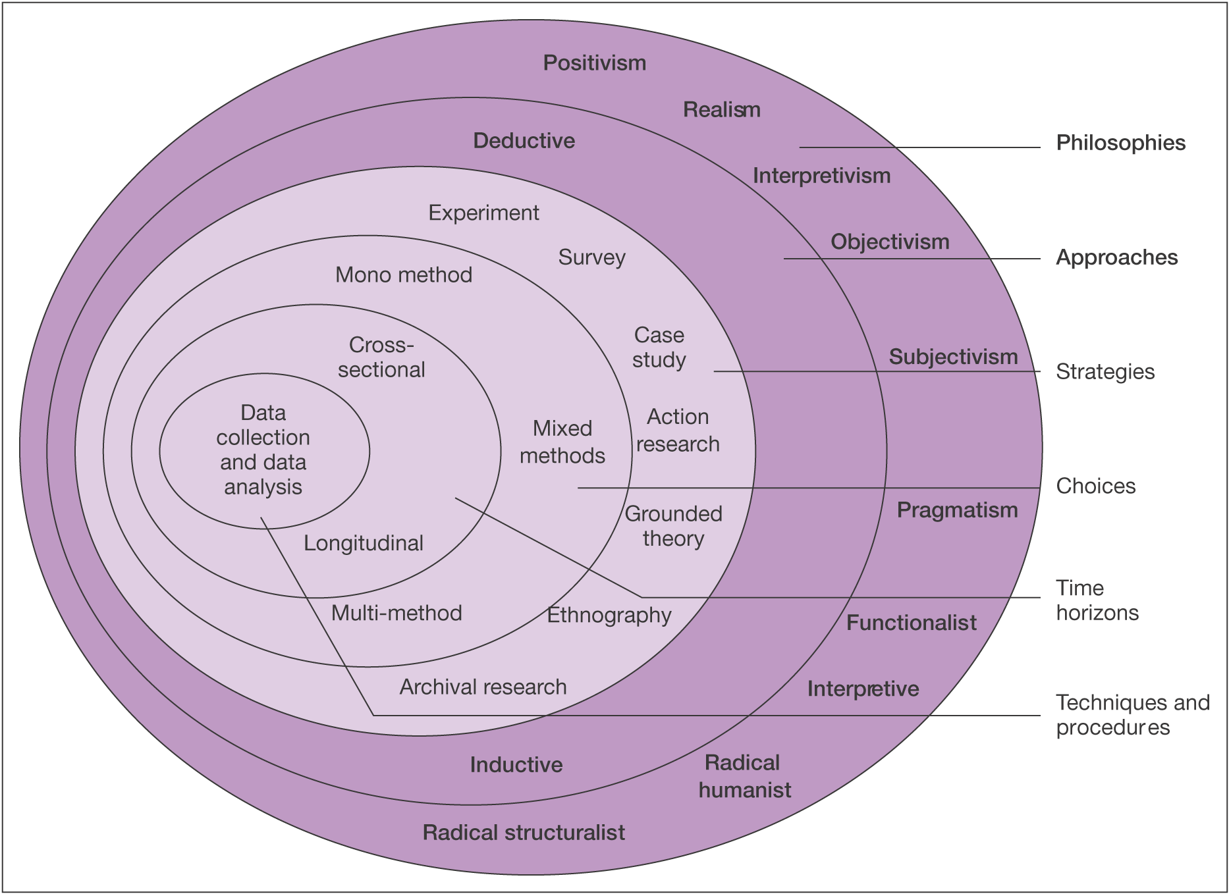
Figure 1 – Research Onion (Saunders, Lewis, & Thornhill, 2009).

1.6.1 Philosophies

This dissertation will use both positivism and interpretivism philosophies. Johnson and Clark (2006) state it is important that researchers know what philosophical commitments they are making due to their choice of strategies, because it will seriously impact both what will be done and the understanding of the investigation.
Positivism is based on the collection of scientific evidence and believes that reality exists independently regardless of what is being studied (Newman, 1998). Positivism results in statistical results which can be repeated by future researchers. Positivism uses bigger samples and generates quantitative data. This applies to this dissertation due to the use of questionnaires that will be distributed across a large sample and will provide quantitative data to analyse.
‘‘Crucial to the interpretivist philosophy is that the researcher has to adopt an empathetic stance. The challenge here is to enter the social world of our research subjects and understand their world from their point of view’’ (Saunders, Lewis and Thornhill, 2009, p116).

The interpretivist philosophy will be applied during the interview research for this dissertation and will provide qualitative data to analyse.

1.6.2 Research approaches

Due to both positivism and interpretivism philosophies being applied both inductive and deductive approaches will be used. The deductive approach is the movement from general to particular. So basic knowledge is collected first and then more specific knowledge is retrieved during the research process, the two are then compared (Kothari, 2004). The deductive approach will be used for the positivism philosophy and research; this approach will help with the questionnaire and quantitative data.
The inductive approach leads to theory by observations and testing. The aim of the inductive approach is to help the researcher get from specific to general (Bryman & Bell, 2011). The inductive approach will be used for the interpretivism philosophy and research; this approach will help with the interviews and qualitative data.

1.6.3 Strategies

The first strategy is questionnaires, these will be distributed to Xercise4less staff through their Facebook page, work emails and in person. This will allow the researcher to gain a large sample of primary research in the form of quantitative data. The software survey monkey will be used in order to create professional questionnaires and the software SPSS will be used to analyse the collected data. The aim of this strategy is to find a pattern from the large sample, a deductive approach will be used to analyse the data from this research.
The second strategy will be interviews with both employees and managers. The researcher will conduct the interviews, after a pattern from the questionnaires has emerged, thus being able to develop further relevant questions, that can help test the pattern found. The software NVIVO will be used to analyse the data from the interviews and an inductive approach will be used to analyse the qualitative data that will result from this strategy.

1.6.4 Research Choices

This dissertation has chosen to use mixed methods, due to the collection of both qualitative and quantitative data, in the form of questionnaires and interviews. The biggest difference with mixed and multi methods is that the mixed method of research uses a combined methodology that results in a single dataset (Flick,2011).

1.6.5 Time Horizons

The researcher will be using a cross sectional time horizon. Cross sectional is best suited where there is a limited time frame unlike longitudinal is for when there is an extended time in which to conduct the research (Saunders, Lewis and Thornhill, 2016).
A Gantt chart will be created to guarantee all research is completed on time. A Gantt chart is commonly used to help researchers coordinate their project to ensure it is completed in time (Saunders, Lewis & Thornhill, 2009).

1.6.6 Techniques and procedures

The researcher plans to use semi-structured interviews. These interviews often consist of open-ended questions which will encourage the gathering of detailed qualitative data (Piercy, 2004). In order to analyse results from the survey and interviews the researcher will use software such as SPSS to analyse the quantitative data and NVIVO to analyse the qualitative data.

1.6.7 Research sample

This dissertation will use probability sampling due to the use of surveys.
‘‘Probability sampling (or representative sampling) is most commonly associated with survey-based research strategies where you need to make inferences from your sample about a population to answer your research question(s) or to meet your objectives’’ (Saunders, Lewis and Thornhill, 2009, p.214).

1.6.8 Limitations

The first limitation is that the sample used, in this case Xercise4less staff, may not be a true representation of the fitness industry as a whole. Nevertheless it provides future researchers with knowledge and possible hypotheses. The second limitation is that the research is constrained to a time limit which may mean the research is not as thorough as hoped. The researcher will make a Gantt chart to try and stay on track. A limitation that may occur with the survey is people misunderstanding questions and bias. To avoid bias the questionnaire will not ask for names and will try to make questions as clear as possible.

1.6.9 Ethical Risks

This dissertation has submitted an ethics form separately which considers all possible ethical risks. A risk may occur during the questionnaire and interviews stage, from the collection of sensitive data or data that may be seen to cause a risk to their job. All data will be collected anonymously; kept private and stored under a password. All participants will be voluntary and over the age of eighteen.

1.6.10 Reliability and Validity of results

McNeill, P. & Chapman, S. (2005) state that validity is whether the data collected is accurate to the study. Reliability is where the data collected reflects the fact the study was completed both consistently and correctly (Denscombe, 2003). In this case the interviews will have high level of validity and low level of reliability unlike the questionnaire which will have a high level of reliability and low level of validity.

1.7Resources and planning

1.7.1 Resources

The primary research will be conducted using questionnaires and interviews which will be analysed on software such as SPSS, this will require the use of IT equipment to access the software needed. This dissertation will include a literature review which will consist of secondary data which has helped the researcher develop an understanding of the topic. The secondary data will be collected from textbooks, academic journals and online sources.

1.7.2 Gantt Chart

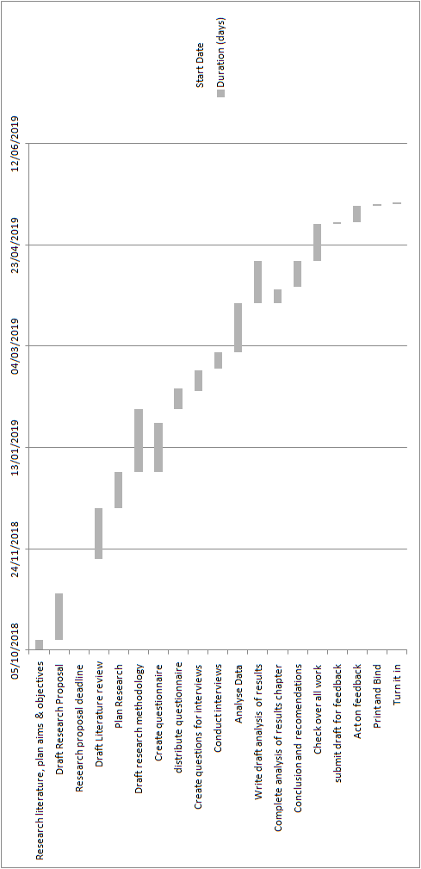
Figure 2 - Gantt Chart

2.0 Chapter 2 - Introduction

This chapter will conduct a thorough review of literature surrounding “the affects of management styles upon employee motivation and retention within the fitness industry”. This chapter will cover the first objective stated in chapter one which is to ‘‘evaluate the literature in relation to traditional management styles and their impact on motivation’’. This objective will be achieved by reviewing the main management and motivation theories including Taylor’s scientific theory; Fayol’s administrative theory; Weber’s Bureaucratic theory and Mayo’s Human relations theory. These theories will assist in identifying links between the impacts of management techniques on employee’s motivation and retention, which can then be applied to the fitness industry. A wide variety of secondary data will be used such as internet sources; peer reviewed journals, articles and academic books from both the online UWTSD library and campus library. This chapter will assist the researcher in conducting primary research.

2.1 Fitness industry

The fitness industry has grown immensely over recent years and is now deemed one of the fastest growing business sectors within the United Kingdom, with the sector being worth billions and predicted to grow by at least eight percent every year (Walker, 2018). Within today’s society gymnasiums and health clubs prove to be an extremely successful business sector with around seven thousand gyms, containing approximately ten million members within the United Kingdom alone (Minton, 2018). Social media along with commercial advertising has been responsible for the growth and popularity of the fitness industry, with models portraying what seems to be the ideal body image (Roxby, 2014 & Smith Maguire, 2008). The International Health, Racquet and Sports Club Association (IHRSA) stated that in 2012 the fitness industry earned around seventy-five billion pounds revenue during 2012 (IHRSA, 2013). Within the United Kingdom memberships within gymnasiums has increased at a steady pace and a public survey undertaken in 2000 showed around fourteen percent of the population regularly attend a gymnasium (Crossley, 2006). The fitness industry was originally viewed as a male dominated industry, but a landmark for the fitness industry occurred during 1985, when the movie and book ‘‘Pumping Iron II’’ was released which was based on four women preparing for a fitness competition. This made a huge influence on women’s participation and their acceptance within the fitness industry (Heffernan, 2017). The fitness industry is an ever-growing market which is expanding greatly with an increase in the number of gymnasiums and health clubs which is in return offering an abundance of employment to society (Stern, 2011).

2.2 The theoretical framework of management styles

2.2.1 Definition of management

There are a number of definitions of what a manager is. Stewart (1967) believes that a manager is a person who completes tasks by receiving help off people and resources. Boddy (2008) similarly believes that managers are someone who complete tasks by managing their business which ultimately adds value to their business.

2.2.3 Management theories

There are many theories covering management styles and how to motivate employees. In 1880 Fredrick Taylor began to apply science to the process of management. Taylor who originally was an American engineer is considered to have made fundamental contributions to the development of management theories. He published ‘‘The Principles of Scientific Management’’ during 1911 and it is seen as an essential milestone for management theories (Rose, 1988). Taylor increased the status of managers and believed that employees were lazy and mainly motivated by pay.
‘‘The principal object of management should be to secure the maximum prosperity for the employer, coupled with the maximum prosperity for each employee’’ (Taylor, 1911, p.1).
Taylor stated that by using a methodical study along with scientific principles it was possible to establish the ‘‘one best way’’ to complete a task or job. Thus it was important to have an abundance of knowledge in regards to the work jobs, for each individual job he believed it was best to break the job down into smaller jobs. Taylor believed that previously man was first but it was essential in the future that system comes first (Taylor, 1911). The second factor was that Taylor (1911) believed man should be given a job rather than picking what job he wants, he also thought it was essential that managers ensure all work is being done in accordance to the principles of science. The scientific management proposed by Taylor (1911) was one of the first attempts at producing a theory for organisations to implement. At its time it certainly increased productivity due to it being designed around the current circumstances within organisations but was quick to be questioned once circumstances changed. One of the main challenges of Taylor’s theory was that it dehumanised employees which lead to motivation decreasing and the only motivator Taylor believed in was money which does not motivate everyone (Caldari, 2007). Conducting work on the basis of precise analysis can be successful and is still used within organisations today (Colvin, 2000 & Cardoso, 2014).
A later advancement on Taylor’s theory was developed by Henri Fayol (1916) and was called administrative management. Henri Fayol used his experience of running a successful mining company to develop his theory, known as five functions of management. Fayol aimed to utilise facts to generate rules which he called principles (Silva, 1960). The difference between Taylor’s scientific management and Fayols administrative management is that Fayol analyses management using a top-down perspective, unlike scientific management which looks at management from a down-top perspective (Fayol, 1916). Fayol believed that some aspects of an organisation are crucial to a management point of view, regardless of their size and that family size organisations should be managed using the same principles as a large organisation. Although, the larger the organisation the more important management knowledge becomes (Karin, 2010). Fayol (1916) states the fundamental management principles are planning; organisation; commands; coordination and control. These aspects all make up the process for managers to follow (Wren & Bedeian, 2009). These elements are described in figure 1 below. This model is significant to this dissertation as it will be used to assess whether fitness managers follow Fayols principles in today’s society.
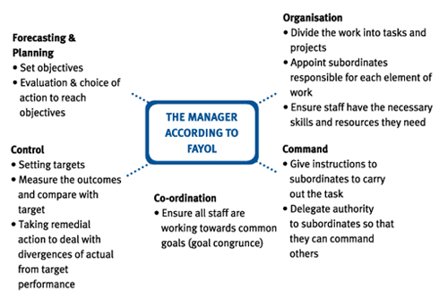
Figure 3 - Fayol (1916) five functions of management
Fayol (1954) later made advancements to the theory and transferred the five elements into the 14 principles of management. The 14 principles of management can be seen in appendix A. The 14 principles will be significant to this dissertation as they will be used to see if managers within the fitness industry use any of Fayols 14 principles. Administrative management has proved to be successful for organisations and studies have provided evidence that some organisations implement Fayols principles in today’s society. Studies have all proven organisations who do not utilise all of the principles at least utilise some of them (Rodrigues, 2001).
It did not take long until organisations were expanding and becoming bigger than ever and more complex. This enhanced the need for rules and hierarchy to control the large organisations. Max Weber (1905) introduced the theory of Bureaucratic management. This theory was believed to introduce much needed structure to organisations (Boddy, 2008). Weber was heavily influenced by his parents, whom both ascertained strong religions and political beliefs (Gerth,1958). There are six aspects to Weber’s theory, it is important to identify that Weber’s theory provides knowledge for future academics to create theories. The first aspect is specialisation which refers to giving each employee a specific job to complete. The second aspect is hierarchy which is referring to employees being supervised by someone higher up than themselves. The employees are assigned their job roles by employees above them who are accountable for them completing the jobs assigned (Henslin, 2014). The third aspect is rules, which states that it is essential for regulations to be implemented and followed. Aspect four is impersonality, this refers to employees following rules and not just doing whatever they want. This fifth aspect is referring to fair employment and that employees are hired based on their qualifications not on whom they are as a person or who they know (Wren & Bedeian, 2009). The final aspect refers to employees making their wage and future within the company a motivating goal. Jaffee (2001) states that in today’s society bureaucracy is implemented within organisations but not everyone understands or supports the theory, it is known for causing poor performance (Styhre & Börjesson, 2006). “In everyday language and ‘for the man on the street’, bureaucracy is a pejorative term, in many cases denoting a series of negative or frustrating encounters with authorities” (Styhre & Börjesson, 2006).
Mary Parker Follet and Elton Mayo both saw limitations with proposed management theories and believed that management theories would be more successful on implementation if bureaucracy was replaced with human relations (Boddy, 2008). Follet proposed that the importance of people should be highlighted and that employees should be able to analyse and solve problems so they could then implement themselves as part of the solution. Follet believed that all employees on all levels should have an input on the decision process and share power, contradicting previous theories (Boddy, 2008). Elton Mayo conducted the Hawthorn studies between 1927 and 1933 and the results contradicted Taylor, Fayol and Weber. The study analysed workers productivity while changing the conditions in which the workers were in. Analysing the study resulted in Mayo’s theory of motivation and he believed that employees were not just motivated by pay, instead believed the work group getting along played an important part in motivation and productivity (Dingley, 1997; Duncan, 1999; Wren & Greenwood, 1998). This theory proposed by Mayo will be tested during the methodology stage of the dissertation to ascertain whether within the fitness industry, employees work group getting along is an important motivator.
In 1943 Maslow looked into the psychological aspects of management rather than scientific and created the hierarchy of needs theory. Maslow suggested it was important to look at the psychological needs of employees and suggested there were five levels that needed to be fulfilled at work. He believed once the bottom need was met this would motivate the employee to meet the next level (Maslow, 1943). Maslow’s model is significant to this dissertation as it will be used to see whether employees need certain needs to be fulfilled in order to be motivated within the fitness industry.

Figure 4 Maslow (1943) Hierarchy of needs
Based on Maslow’s theory Frederick Hertzburg created his own theory in 1959. Hertzburg created a list of factors that related to the organisation, rather than Maslow’s which related to the employees. Hertzburg believed there were two factors. The first being motivational factors, which he referred to as satisfiers these would increase satisfaction of employees. The second factor was hygiene factors which he referred to as disatisfiers which do not motivate employees (Pardee, 1990). Hertzburg believed that hygiene factors needed to be present before managers could use motivation techniques on employees (Hertzburg, 1959). This model is similar to Maslow’s previous model and will be significant to this dissertation in deciding which theory is more applicable and successful for the managers within the fitness industry to motivate their staff.
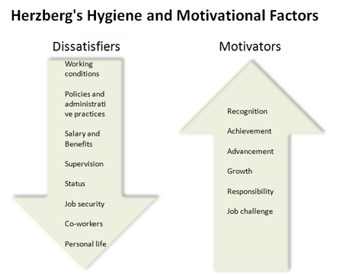
Figure 5 - Hertzburg (1959) Hygiene factors
In 1960 Douglas McGregor created the X and Y theory, McGregor agreed with Maslow and believed the strongest motivator for employees was fulfilment of their tasks. McGregor also believed there were two styles of managing people (McGregor,1960). One being authoritarian (theory X), this style is based on the employees being unmotivated and not enjoying work. In this situation the manager must be strict and manage every little detail to motivate and involve the employee. The second style is Participative (theory Y). This style of management is more laid back to the employees being self motivated and enjoying their work. ‘‘Theory X places exclusive reliance upon external control of human behaviour, whereas Theory Y relies heavily on self-control and self-direction’’ (McGregor, 1960, p.12). McClelland then separated specific needs into three separate groups. The first group was need for achievement this included humans who were motivated and driven to be successful. The second group was need for affiliation which included the people who wanted to be part of a group or society. The final group was need for power and this group referred to positions of power within the organisation (Shanks, 2007).

2.2.4 Motivation

The concept of management theories has been discussed and has created a basis for motivation theories to be discussed. There are numerous definitions of motivation, one of which was by Hertzburg (1959) and he stated that motivation is a person performing a work based task because they want to. Smith (1994) believes it is important to motivate employees because it is essential for the company to survive. Amabile (1993) agrees with smith and states that motivated employees will result in better productivity and will help the organisation grow and be successful. Amabile (1993) also argues that unmotivated employees will lack effort in their work and are more likely to quit their jobs. It is known that motivating employees can be a complex task because different employees can be motivated by different things (Lindner, 1998). Motivation tools are often separated into two different categories the first being intrinsic motivators and the second being extrinsic motivators (Staw, 1976). The Intrinsic motivation includes employees who are motivated from within from things such as interest, enjoyment and personal challenge. The extrinsic motivation will include employees who are more motivated by things such as pay or rewards (Amabile, 1993). Deci (1972) states that extrinsic motivators are things such as money and praise unlike internal motivators which comes from within the person, they are not seeking rewards, merely completing the task is a reward in itself. Deci (1972) and Amabile (1993) are in agreement and state that employees are able to be motivated by either intrinsic or extrinsic or even both.

2.2.5 Retention

Organisations often lose talented employees due to them being unmotivated within their job (Coff, 1997). Thus leads this dissertation on to the next important aspect, retention. Retention of employees within all industries and organisations is a major challenge. A main reason why employees leave organisations tends to be because they are unhappy with the job role or unhappy with the management and/or pay (Kemelgor & Meek, 2008). Johnson (2007) states that retention of employees is heavily dependent on the management skills, if the manager lacks training and people skills their employees will exit the organisation. It often occurs within organisations that efficient and productive staff are appreciated and encouraged to stay unlike inefficient and unproductive staff are not appreciated and pressurised to leave the organisation. It would benefit organisations greater if they were to retain all staff, this would save the organisation a large amount of money that would have been spent on hiring and training new staff members (Sigler, 1999). By having a high retention rate of employees it allows the organisation to utilise their time to create and expand within the industry rather than wasting time on constantly training new employees (Vasquez, 2014). Whitcomb (2012) states that keeping employees happy and retaining them will result in better quality work, thus will result in overall better customer satisfaction which will lead to the organisation receiving a better reputation and higher profit margins.

2.2.6 Management styles, motivation and retention within the fitness industry

Griffiths (2017) stated that employee retention within gymnasiums is low due to management not motivating their staff or providing them with career opportunities. The low employee retention also negatively impacts member retention, both of which cost the organisation money impacting their profits. Huffen (2012) stated that retention of employees within the fitness industry is one of the biggest challenges and statistics between the years 2008 – 2012 showed an employee turnover peaking at 83%. Fitness managers are often under intense pressure which is passed down to employees who are often only told the end result expected from them and are not supported nor told how to obtain the end result (Jordan, 2016). There is a lack of literature in regards to management styles, motivation and retention as a whole. This dissertation hopes to fill this gap and provide literature and data for future academics to expand on.

2.3 Conclusion of literature review

This chapter has met the needs of objective one. There has been substantial research on management theories throughout the years and the importance of management styles should not be underestimated (Carmichael, et al., 2011). There are studies on retention within the fitness industry; however there is very limited research on both management styles and motivation within the fitness industry. This dissertation hopes to fill this gap.
This chapter will assist in the development of the thesis, in particular the methodology. Although research on management styles, motivation and retention has been done, academics have not linked them to the fitness industry specifically nor grouped the effects of these factors on a holistic approach.

3.0 Chapter 3 – Introduction

This chapter aims to assist chapter four with objective two of the dissertation, this being:

2. To analyse the impact management styles have on motivation and retention within the fitness industry using primary research.
The methodology of this dissertation will follow the structure of Saunders et al (2009) research onion. The research onion will assist the researcher in identifying and justifying which research strategy, data collection and data analysis techniques to use.
Collis and Hussey (2009) stated that research is an enquiry and investigation process which is often systematic and increases the researcher’s knowledge. A modern definition that will be used in this dissertation is ‘‘a process that people undertake in a systematic way in order to find out things, thereby increasing their knowledge’’ (Saunders, Lewis and Thornhill, 2016, p.5).

3.1 Research Onion

Saunders, Lewis and Thornhill have outlined the path of research in ‘the research onion’ illustrated below in figure 6. One of the advantages of the research onion is that it helps the researcher with the structure of the research process and guides them on what to do at each stage (Monette et al, 2005).
Figure 6 - Research Onion (Saunders, Lewis, & Thornhill, 2009)

3.1.1 Philosophies

This dissertation will use both positivism and interpretivism philosophies. Johnson and Clark (2006) state it is important that researchers know what philosophical commitments they are making due to their choice of strategies, because it will seriously impact both what will be done and the understanding of the investigation.
Positivism is based on the collection of scientific evidence and believes that reality exists independently regardless of what is being studied (Newman, 1998). Positivism results in statistical results which can be repeated by future researchers. Positivism uses bigger samples and generates quantitative data. This applies to this dissertation due to the use of questionnaires/surveys that will be distributed across a large sample and will provide quantitative data to analyse.
‘‘Crucial to the interpretivist philosophy is that the researcher has to adopt an empathetic stance. The challenge here is to enter the social world of our research subjects and understand their world from their point of view’’ (Saunders, Lewis and Thornhill, 2009, p116).
The interpretivist philosophy will be applied during the interview research for this dissertation and will provide qualitative data to analyse.

3.1.2 Research approaches

Due to both positivism and interpretivism philosophies being applied both inductive and deductive approaches will be used. The deductive approach is the movement from general to particular. So basic knowledge is collected first and then more specific knowledge is retrieved during the research process, the two are then compared (Kothari, 2004). The deductive approach will be used for the positivism philosophy and research; this approach will help with the questionnaire and quantitative data. The inductive approach leads to theory by observations and testing. The aim of the inductive approach is to help the researcher get from specific to general (Bryman & Bell, 2011). The inductive approach will be used for the interpretivism philosophy and research; this approach will help with the interviews and qualitative data.

3.1.3 Strategies

A survey is ‘‘a method of collecting primary data based on communication with a representative sample of individuals’’ (Zikmund et al., 2013, p.185). The first that will be used is surveys, distributed to Xercise4less staff through their Facebook page, work emails and in person. This will allow the researcher to gain a large sample of primary research in the form of quantitative data. The software survey monkey will be used in order to create professional questionnaires and the software SPSS will be utilised to analyse the data. The aim of this strategy is to find a pattern from the large sample, a deductive approach will be used to analyse the data from this research. The second strategy will be interviews with both employees and managers. The researcher will conduct the interviews, after a pattern from the questionnaires has emerged, thus being able to develop further relevant questions, that can help test the pattern found. The software NVIVO will be utilised to analyse the data and an inductive approach will be used to analyse the qualitative data that will result from this strategy.

3.1.4 Research Choices

This dissertation has chosen to use mixed methods, due to the collection of both qualitative and quantitative data, in the form of questionnaires and interviews. The biggest difference with mixed and multi methods is that the mixed method of research uses a combined methodology that results in a single dataset (Flick,2011).

3.1.5 Time Horizons

The researcher will be using a cross sectional time horizon. Cross sectional is best suited where there is a limited time frame unlike longitudinal is for when there is an extended time in which to conduct the research (Saunders, Lewis and Thornhill, 2016).
A Gantt chart will be created to guarantee all research is completed on time. A Gantt chart is commonly used to help researchers coordinate their project to ensure it is completed in time (Saunders, Lewis & Thornhill, 2009).

3.1.6 Collection and analysis

3.1.6.1 Collection

This dissertation will be collecting both qualitative and quantitative data. This dissertation aims to provide a detailed analysis of management styles impact on motivation and retention of staff, so decided a mono-method would not have provided sufficient data to analyse. Instead a multi method has been chosen. The multi method consists of both qualitative and quantitative research methodologies in order to assist in answering the research questions (Lavrakas, 2008).
Triangulation is the ‘‘use of multiple sources of data to investigate the same phenomenon in a study’’ (Collis & Hussey, 2009, p.71). Triangulation will be applicable to this dissertation and will be implemented to reduce bias by carrying out an in depth review of the literature and triangulating the information found within the results of the data analysis. The triangulation design will assist the researcher in comparing both the qualitative and quantitative data (Castro et al., 2010).
The first method of collection will be a self-completion questionnaire which will comprise of approximately 15 questions. The questionnaire will be generic and each participant will be asked the same questions to prevent bias. This collection method will help the researcher ascertain a large amount of data within a time frame (Saunders et al., 2009). The researcher hopes to ascertain a pattern from the data and then can analyse in more depth using a second collection method, interviews.
The researcher plans to use semi-structured interviews. These interviews often consist of open-ended questions which will encourage the gathering of detailed qualitative data (Piercy, 2004). In order to analyse results from the survey and interviews the researcher will use software such as SPSS to analyse the quantitative data and NVIVO to analyse the qualitative data.

3.1.6.2 Online Questionnaire

The first collection method will be an online questionnaire, the questionnaire will comprise of approximately fifteen questions, distributed to a minimum of 100 Xercise4less employees. The questions aim to ascertain the participant’s opinions on management styles; motivation theories and how they interlink to affect retention. Most of the questions will be closed giving the participant a multiple choice answer, due to closed questions being the most successful for collecting statistical data (Cameron & Price, 2009). Multiple choice answers are a more effective method due to making it easier to classify and analyse the data (Thomas, 2003).
The Likert scale will be utilised within the questionnaire. The Likert scale comprises of a balance of both positive and negative items and is often recommended to reduce respondent’s bias. The respondents will be given a choice of multiple answers to indicate their feelings towards a question such as ‘’strongly agree; agree; undecided; disagree and strongly disagree’’ (Likert, 1932 & Desselle, 2005).
The Likert scale questions will be followed by a couple of open ended questions towards the end of the questionnaire. The open ended questions will allow for the researcher to gather more detailed information from the participants (Cameron & Price, 2009). The researcher hopes to ascertain a pattern from the data and then can analyse in more depth using a second collection method, interviews.
All questions will be written as clear as possible to ensure participants fully understand each question to ensure answers are accurate. The final copy of the questionnaire can be found in appendix B.

3.1.6.3 – Pilot Study

Before the official distribution of the online questionnaires a pilot study will be conducted among five peers to ensure the questionnaire is suitable. A pilot study is a practice run on a smaller scale. It is done in preparation and allows the researcher to try out the method to see how it will work during the actual trial, allowing the researcher to modify accordingly (Blaxter, Hughes & Tight, 1996).

3.1.6.4 – Interviews

The second collection method will be interviews, the researcher plans to use semi-structured interviews. These interviews often consist of open-ended questions which will encourage the gathering of detailed qualitative data (Piercy, 2004). Semi-structured interviews are often centred on a particular topic or goal. The researcher will guide the participant through specific topics using open ended questions to gather more detailed information (Hutchinson & Skodol-Wilson, 1992). An advantage of using semi- structured interviews is that it can expand and gather more detail than a questionnaire (Austin, 1981) and it also allows the researcher to build a relationship with the participant, allowing for more honest and detailed responses (SiCicco-Bloom & Crabtree, 2006).

3.1.7– Sampling

This dissertation will use purposive sampling to gather data. Purposive sampling is defined as
‘‘A type of non-probability sampling in which the researchers judgement is used to select the sample members based on a range of possible reasons and premises’’ (Saunders & Phillip, 2012, p138).
A purposive sample for both questionnaire participants and interviewees will be used to gather primary data, due to time restraints for data collection and analysis. Purposive samples ensure all data collected has direct relevance to the dissertation (Lavrakas, 2008). In this dissertation the sample will consist of Xercise4less employees who work within the fitness industry, the researcher believes this will be the best sample due to them being able to answer all research questions and meet objectives of the study. The questionnaire will be distributed among the employees by using their work emails, Facebook page and in person. The sample size will be at least one hundred participants due to larger sample sizes better replicating the entire population (Collis & Hussey, 2009). Once a pattern has emerged from the questionnaires the researcher will conduct interviews with on a smaller scale to expand and get more detailed information.

3.1.8 Reliability and Validity

Reliability and validity are equally important during the process of research studies as they ensure all findings are consistent and accurate thus making sure all findings are credible (Kirk & Miller, 1986).
McNeill, P. & Chapman, S. (2005) state that validity is whether the data collected is accurate to the study. Reliability is where the data collected reflects the fact the study was completed both consistently and correctly (Denscombe, 2003). In this case the interviews will have high level of validity and low level of reliability, unlike the questionnaire which will have a high level of reliability and low level of validity.

3.1.9 Limitations

The first limitation is that the sample used, in this case Xercise4less staff, may not be a true representation of the fitness industry as a whole. Nevertheless it provides future researchers with knowledge and possible hypotheses. The second limitation is that the research is constrained to a time limit which may mean the research is not as thorough as hoped. The researcher will make a Gantt chart to try and stay on track. A limitation that may occur with the survey is people misunderstanding questions and bias. To avoid bias the questionnaire will not ask for names and will try to make questions as clear as possible.

3.1.10 Ethical Risks

An area of this research that could impose an ethical risk is the questionnaire or interview stage, due to questions being based around the job role and managers. Participants could see this has imposing a risk to their job role (Burgard et al., 1982). To limit this factor all data will be collected anonymously; kept private and stored under a password. All participants will be voluntary and over the age of eighteen. This dissertation has submitted an ethics form separately which considers all possible ethical risks.

3.2 Conclusion of methodology

To conclude this chapter has laid the ground work for chapter four in order to meet objective two of the dissertation. This chapter has concluded that by using both quantitative and qualitative methods of research that it will provide more in depth information to analyse in chapter four, thus providing the researcher with a broader understanding to make conclusions (Saunders et al., 2009).

4.0 Analysis of results

4.1 Introduction

This Chapter aims to fulfil all objectives but will mainly concentrate on objective two of the dissertation, this being:
2. To analyse the impact management styles have on motivation and retention within the fitness industry using primary research data.
To collect data this dissertation utilised a multi-method approach using both qualitative and quantitative research in the form of questionnaires and interviews. This chapter will first analyse the quantitative data using a deductive approach, the reason for this is it will allow the researcher to use a large sample to find themes and then the qualitative data can be analysed using a inductive approach to support or contradict the themes where possible.

4.2 Quantitative data analysis

The software SPSS statistics 24 has been utilised to analyse the data collected from the questionnaires. SPSS allows the data to be converted into a quantitative form. The questionnaires were distributed to four branches of Xercise4Less and 120 employees participated. The total number of branches within Xercise4less is 50 and they have approximately 750 members of staff at the moment.

4.2.1 Sample Characteristics

Babbie (2007) stated that for research to be fair cross- sectional gender dispersion should be present if possible. This has been utilised in this research sample with an almost even dispersion of 52 female participants 68 male participants. Thus indicating employment at Xercise4less is neither male nor female dominated. All participants were over the age of 18 and were currently employed by Xercise4less.

4.2.2 Gender/ Length of employment at Xercise4less

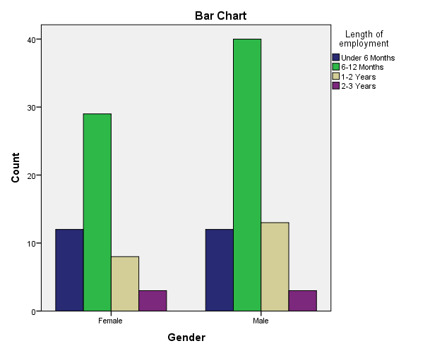
Number of participants
Gender
Figure 7 - Data sourced and analysed by Williams (2019)

This cross tabulation is looking at the gender of employees their length of employment within the fitness industry, specifically Xercise4less. In regards to gender of employees out of the 120 participants 52 were female and 68 were male, thus suggesting the fitness industry is not dominated by a particular gender. In regards to length of employment 103 of the participants, 77.5%, have been employed for 1- 12 months. In contrast only 6 participants, 5%, had been employed for 2-3 years. Thus provides evidence of a high retention rate within the fitness industry, this dissertation will further analyse whether the high turnover rate is due to managers and lack of motivation. These statistics contradict Xercise4less’ claim of having an employee retention rate of 93%, but supports Griffiths (2017) statement that employee retention within gymnasiums being low due to management not motivating their staff or providing them with career opportunities. Employees were also asked their age, from the analysed data 83 of the participants which equated to 69% were aged between 18 -34 thus suggesting those employed within the fitness industry are the younger demographic.

4.2.3 Management style / Employee satisfaction with manager

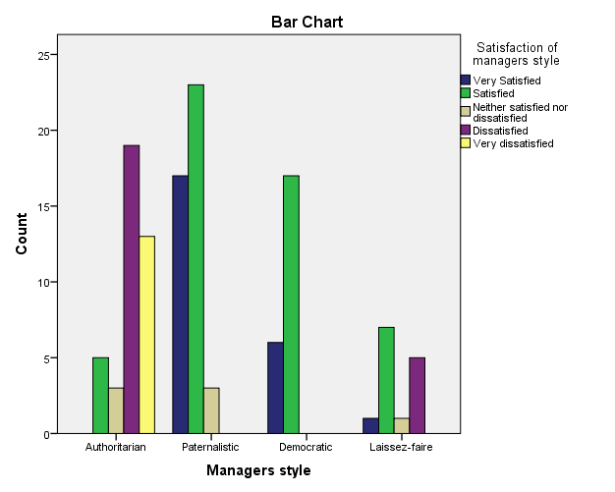
Number of participants
Figure 8 - Data sourced and analysed by Williams (2019)

This cross tabulation considered what management style the employees believe their manager utilises and how happy overall they are with that style.40 of the participants believed their manager was Authoritarian, of these 40 participants 32 were either dissatisfied or very dissatisfied and only 5 stated they were satisfied with the management style. 43 participants selected paternalistic management style and 40 of these participants were satisfied or very satisfied. 23 participants selected democratic and all 23 were satisfied or very satisfied. Lastly, 14 selected Laissez Faire and 8 of these were satisfied or very satisfied and 5 were dissatisfied. Analysis of these results would suggest that the main management styles utilised within Xercise4less are authoritarian and paternalistic, those who have authoritarian managers are extremely unhappy with the management style unlike those with a paternalistic manager are happier. Thus would suggest that the employees do not appreciate strict managers whom do not consult with employees and instead prefer a manager whom is still dominant yet addresses employees wants and needs also, thus contradicts Weber (1905) theory that strict managers would be most effective. Weber (1905) theory is dated and perhaps a reason why these results contradict his theory. Overall 76 of the 120 participants are satisfied or very satisfied with their manager’s style compared with 44 who are not satisfied. These statistics would suggest management styles are not the main impacting factor on the low retention levels displayed in figure 7. This contradicts Coff (1997), Kemelgor & Meek (2008) and Johnson (2007) statements that management’s styles are often the main impacting factor on retention and motivation of the staff.

4.2.4 Do employees see a future with Xercise4less

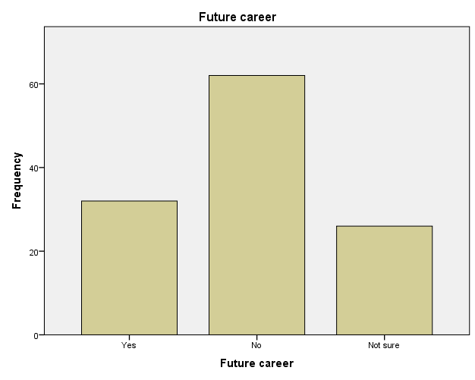
Number of participants
Figure 9 - Data sourced and analysed by Williams (2019)
This data was analysed for frequencies on whether employees see a future career path within Xercise4less. Griffiths (2017) states that employee retention within the fitness industry is low due to management not providing and encouraging employees to pursue career paths within the organisation. It does rise the question whether retention is affecting the career path within the fitness industry. The statistics in figure 9 support Griffiths (2017) statement, showing that 74% of the employees have selected not sure or no when asked if they see a future career path within Xercise4less, which could be a reason behind the low retention rates displayed in figure 7 has suggested by Grifiths (2017). This data suggests that management not providing clear career paths to employees could be impacting motivation and retention of employees within the fitness industry, thus supporting Grifiths (2017) and Huffen (2012). It contradicts Taylor (1911) theory that pay is the only motivator that employees care about. It could be argued the results support Maslow (1943) and Hertzburg (1959) in that psychological or hygiene factors are not being met within the organisation which means motivation is low and not possible until they’re met.

4.2.5 Main motivating factor / What is more important pay or getting along with colleagues?

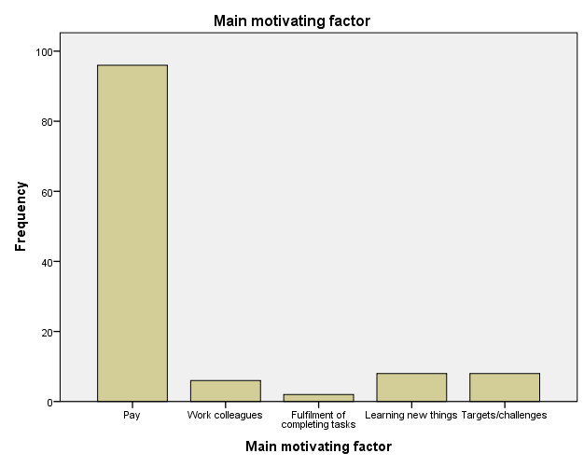
Number of participants
Figure 10 - Data sourced and analysed by Williams (2019)

Taylor (1911) stated that employees were motivated by pay only, this theory is dated and perhaps no longer applicable to organisations in today’s society. The statistics in figure 10 contradict the fact that pay is the only motivator due to 24 employees selecting other factors than pay, but the statistics mainly support his theory in that 96 of the employees selected pay as their main motivating factor. Due to the low retention rates shown in figure 7 these statistics could question whether pay and pay incentives such as bonuses are implemented to their full potential within the fitness industry. Employees were also asked whether pay or getting along with the work group was more important. 95% selected that pay was more important to them than getting along with the work group. These statistics further support Taylor (1911) theory but contradict Mayo (1927) theory that getting along with the work group was equally important. These statistics show that within the fitness industry most employed are motivated by money.

4.2.6 Should managers have full control?
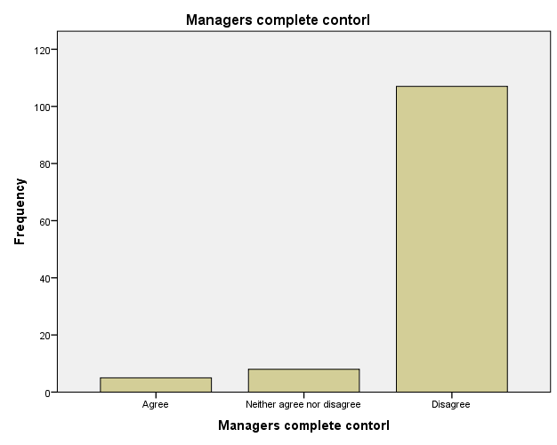
Should managers have complete control?
Number of participants
Should managers have complete control?
Number of participants
Figure 11 - Data sourced and analysed by Williams (2019)
The statistics from satisfaction of management style in figure 8 suggests that employees within the fitness industry prefer a paternalistic style, in which managers are dominant yet consult with their employees. The statistics from figure 11 support this further in that 89% believed that managers should not have complete control within the organisation. These results contradict Webber (1905),Taylor (1911) and Fayol (1954) whom all believed organisations would be most effective if management were in complete control. The results support Mayo (1927) theory that human relations were important to employees and would positively impact their performance and motivation.

4.2.7 Which factors are applicable to management at Xercise4less
How many of Fayol (1954) Principles utilised by manager?

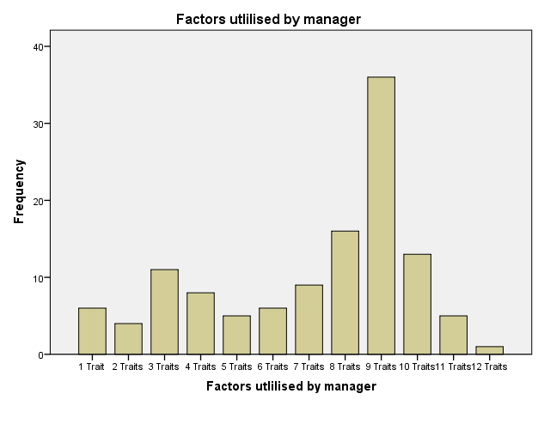
How many of Fayol (1954) Principles utilised by manager?
Number of participants
Figure 12 - Data sourced and analysed by Williams (2019)
Fayol (1954) proposed that there were 14 essential principles that managers should utilise in order to be an efficient manager. The 14 principles of management can be seen in appendix A. 54.1% of the participants believed their managers utilised 8-10 of the traits and in comparison only 17.5% believed their manager utilised 1-3 traits. Figure 7 analysis showed that 76 out of 120 participants were happy with their management; this would support Fayol’s theory in that the majority believe at least 8-10 traits are implemented and this may be way the majority are happy with their management. The statistics in figure 12 also support Rodrigues (2001) statement that organisations in today’s society implement some if not all of the principles suggested by Fayol (1954). Analysis of this question has provided evidence of managers within the fitness industry implementing most of the principles and perhaps if more managers implemented more of the principles satisfaction statistics would rise.

4.2.8 Hierarchy

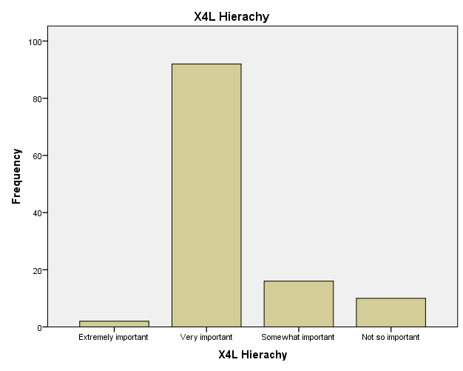
Number of participants
Figure 13- Data sourced and analysed by Williams (2019)
Webber (1905) proposed that hierarchy is essential within organisations. Participants were asked how important they believe hierarchy is within Xercise4less and 94 out of the 120 selected that it was extremely important/very important. These statistics support Webber (1905) theory that hierarchy is essential within organisations and also supports Jaffee (2001) statement that most organisations implement Webers (1905) theory. This would show that employees within the fitness industry to want and need structure within the organisation. Within Xercise4less there is a set structure. At the bottom is jobs such as cleaners, receptionists and sales team, this rises to general managers of clubs whom below report to; general managers then report to senior general managers; who then report to the regional business mangers; above the regional managers are the employees of head office such as financial directors; Business directors and the CEO.

4.2.9 Do you enjoy your job?

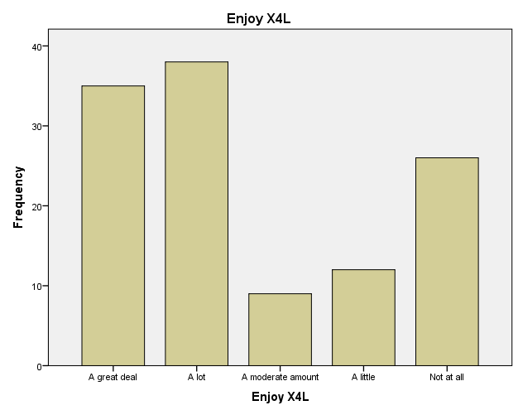
Number of participants
Figure 14 - Data sourced and analysed by Williams (2019)
Participants were asked whether they enjoy their job. 73 of the participants stated they do enjoy their job compared to 38 participants who do not enjoy their job. When asked in a separate question if they were satisfied with their management style 76 said they were satisfied compared to 44 not happy, these statistics are displayed in figure 8. Statistics from figure 8 and 14 are close in comparison with 73 enjoying their job and 76 satisfied with management style. This would suggest management style does impact motivation, retention and satisfaction within the fitness industry.
Participants were also asked an open question to describe the characteristics of a good manager. Most stated they want a supportive manager whom is involved yet not too strict. There was a pattern in that most made a comment that a good manager does motivate them and impact their mood within the workplace. These results further support the statistics in figure 14.

4.3 Qualitative data analysis

This chapter will now move on to the one to one interviews. Once 120 questionnaires had been completed the researcher moved on to interviews to see if the themes from the questionnaires would be supported or contradicted. The interview qualitative data was analysed using an inductive approach and the software NVIVO was utilised.
Due to time constraints, only 3 members of staff were interviewed. Thus being a limitation, but it allowed the researcher to gather some rich detailed information just to see if the themes from the 120 questionnaires would be supported or not.
The interviews were carried out on a one to one basis within the Swansea Xercise4less branch, lasting approximately 10 minutes. The full interviews are available in appendix D.
The personal information of all three participants has been removed from the data in keeping with the confidentiality aspect of the ethics forms shown in appendix C.

4.3.1 Theme of low retention and no future career path

Using Nvivo the researcher established all interview data correlating to the theme of low retention and no future career path under one node. This was split into sub categories of length of employment and future career path.

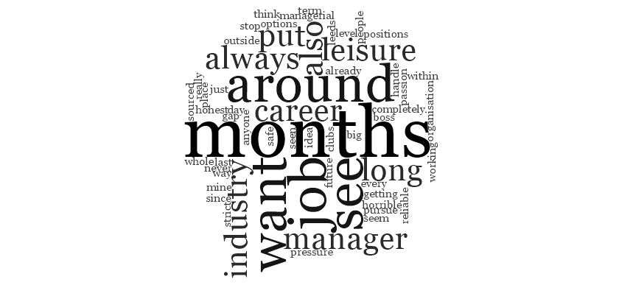
Figure 15 - High-level word cloud of Retention and career path (Xercise4less Interview Data, 2019).

Running a high-level query on the node low retention and no future career path, the word cloud shows that the most frequent words used by interviewers whilst talking about retention and future career. The word cloud indicates that most mention they have only been there for a few months and management is also mentioned frequently linking management to retention and career paths. This would show correlation to Griffiths (2017) statement that employee retention within gymnasiums is low due to management not motivating their staff by providing them with career opportunities.
The overall theme is that employees feel they have no career path and that retention is low within the fitness industry. This was firstly shown as a theme within the questionnaires and has now been supported by all three interviewees.
‘‘No career options and also from what I have seen already people don’t seem to last long in managerial positions and I would want a safe and reliable job’’ (Interviewee 1, 2019)

‘‘You never see anyone from our level getting into the big manager jobs, they’re always sourced from outside or from the clubs up Leeds way. Also I don’t think I could handle the pressure that’s put on those managers every day’’ (Interviewee 2, 2019)

‘‘I want to pursue a career within the leisure industry its always been a passion of mine but since working for such a strict horrible boss its completely put me off the organisation and whole idea of being in the leisure industry’’ (Interviewee 3, 2019).

4.3.2 Theme of management style best if paternalistic and supportive

Throughout the questionnaires there was a clear theme of satisfaction with paternalistic managerial style and dissatisfaction with authoritarian management style. This was further supported in the interview data by all three interviewees.
Interviewee one selected paternalistic and stated ‘‘I would say I have a great relationship with my manager he keeps me busy but doesn’t boss me around and be nasty’’ (Interviewee 1, 2019).
Interviewee two also selected paternalistic for her manager and stated ‘he’s great, he keeps us in the loop and lets us know what needs to be done but is also our friend and talks to us and helps us out’’ (Interviewee 2, 2019).
Interviewee 3 selected authoritarian and stated ‘‘She’s extremely strict, she micro- manages everything. You cannot relax. If she could use like giving praise and ensuring employees are happy that would be something’’ (Interviewee 3, 2019).
These results along with the questionnaire results show that employees are happier with paternalistic managers whom support and consult employees rather than a strict manager, thus contradicts Weber (1905) theory that strict managers would be most effective but supports Follet and Mayos theories of human relations within management is effective. Using NVIVO the researcher made a node for management style and ran a high level query and presented it in a word cloud. The most frequently used words when speaking about managers style was supportive, help, friend and happy.

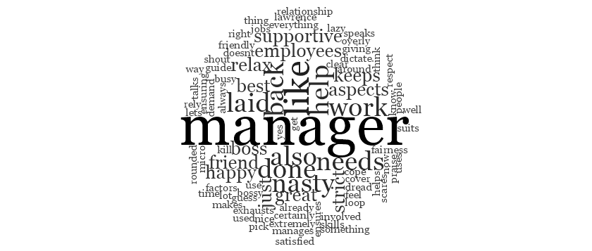
Figure 16 - High-level word cloud of management style (Xercise4less Interview Data, 2019).

4.3.3 Pay is main motivator theme


Figure 17 - High-level word cloud of main motivator (Xercise4less Interview Data, 2019).

Running a high-level query on the node main motivator, the word cloud shows that the most frequent words used by interviewers whilst asked what motivates them most was pay. Thus supporting the results of the questionnaires where the majority selected pay as their main motivator.
Thus would support Taylor (1911) that pay is the main motivating factor for employees. Interviewee one supported Taylor (1911) theory by stating ‘‘I’m extremely money orientated and look forward to my pay every month’’ (Interviewee 1, 2019). Interviewee two also supported Taylor (1911) theory and said ‘‘my pay at the moment is the main thing keeping me at Xercise4less’’ (interviewee 2, 2019).
Although, Interviewee 3 supported Mayo (1927) theory that getting along with work colleagues is equally as important and stated ‘‘Pay I guess although getting along with colleagues would be great, be nice to have both really’’ (Interviewee 3, 2019).
These results along with the questionnaires show that pay is a main motivator within Xercise4less in the fitness industry, thus supporting Taylor (1911) theory.

4.3.4 Hierarchy within Xercise4less, should managers have complete control?

There was a clear theme within the questionnaire results which showed that employees did not agree with management having complete control over employees but they stated that hierarchy was important to Xercise4less as an organisation.
The interviews further backed these themes. Interviewee one was asked whether or not managers should have complete control and responded ‘‘definitely not, the employees see everything first hand so can give vital advice to the company and help them improve. Also for me to happy I like to know I’m listened to and mean something to the company’’(interviewee 1, 2019).
Interviewee two and three both answered similarly stating that employees can give vital information to the company and that mangers should not have complete control. These results contradict Webber (1905),Taylor (1911) and Fayol (1954) whom all believed organisations would be most effective if management were in complete control. The results instead support Mayo (1927) theory that human relations were important to employees and would positively impact their performance and motivation.
When asked how important hierarchy is to Xercise4less all three interviews responded saying it was extremely important to them and that it was clear whom they needed to escalate problems to.
‘‘Extremely important to them, I guess they’re a large business now so it is important to have structure and I guess its good for us because we know who to escalate things to if needs be’’. (Interviewee 1, 2019).
‘‘It is important to them, it’s a multi million pound business so I guess they need hierarchy to make sure everything runs smoothly and jobs are done. It’s good to know who’s above us too in case I needed to escalate something or had a problem with my manager’’ (interviewee 2, 2019).

‘‘Very important to them, they always make the hierarchy clear to all employees too’’ (Intervewee 3, 2019).

Thus support Webber (1905) theory. This would show that employees within the fitness industry do want and need structure within the organisation. The results also support Jaffee (2001) statement that the majority of organisations do implement a hierarchy.

4.3.5 Fayols principles of management

Fayol (1954) proposed that there were 14 essential principles that managers should utilise in order to be an efficient manager. The 14 principles of management can be seen in appendix A.
Interviewee one stated that his manager utilised 10 of the listed factors. The interviewee was then asked if he believed that his manager would be better if he utilised more of the factors and responded ‘‘yes, he’d certainly be all rounded and cover a lot as a manager and help most aspects if he used all those factors but in fairness he already uses most of them’’ (Interviewee 1, 2019).
Interviewee two believed that her manager utilised 9 of the factors. Once asked if she believed her manager would be better if he utilised more of the factors she responded ‘‘Yes, he’s already a good manager but I guess if more were used he would be even better’’ (Interviewee 2, 2019).
Interviewee three believed his manager only utilised 3 of the factors and was extremely dissatisfied with his manager’s style. When asked whether he believed his manager would be better if she utilised more of the factors he responded saying ‘‘Yes one hundred percent, if she could use like giving praise and ensuring employees are happy that would be something’’ Interviewee 3, 2019).
The results from the questionnaires and interviews support Rodrigues (2001) statement that organisations in today’s society implement some if not all of the principles suggested by Fayol (1954). Results also supports Fayol (1954) theory that managers would be more effective if they implemented the 14 principles. Analysis of this question has provided evidence that the more principles utilised the happier the staff and more effective the manager.

4.3.6 Does the employee enjoy their job and are they motivated

Interviewee one stated that he enjoyed his job and felt motivated. Once asked why he enjoyed and felt motivated he responded saying ‘‘I have a good manager and pay is good and they use pay incentives for hitting target’’ (Interviewee 1, 2019).
Interviewee two stated she also enjoys her job and feels motivated. Once asked why she responded ‘‘I am happy with my pay and also happy with my manager and colleagues’’ (Interviewee 2, 2019).
Interviewee three stated that he does not enjoy his job and does not feel motivated. He stated the reason for this was ‘‘My manager just makes me not want to be in work. I am looking for a new job just to get away from her as soon as I can. My manager has completely affected my motivation and made me want to leave the job’’ (interviewee 3, 2019).
These statements support Taylor (1911) theory that pay influences employee’s satisfaction and motivation within a job. The results contradict Mayo (1927) in that the employees do not find getting along with colleagues equally as important as pay but support the theory in the aspect of human relations being important when it comes to management, due to the manager being an influence on their motivation.

4.3.7 Does your manager affect your motivation and retention?

The final question asked to the interviewees is whether they believe managers affect their motivation and retention. All three interviewees stated their manager affects both their motivation and retention, thus positively answering the dissertation question.
‘‘Yes definitely having had a bad manager before this job it made me not want to go to work nor work hard because I didn't want to help her. Pay also affects my motivation and retention though’’ (interviewee 1, 2019).
‘‘Yes one hundred percent. I really couldn’t enjoy my job if I didn’t like my manager never mind actually be motivated’’ (Interviewee 2, 2019).
WHAT TO SAY HERE??

4.4 Conclusion of Analysis of results

To conclude this chapter has analysed the results from both the questionnaires and interviews to provide the researcher with adequate knowledge to construct recommendations within chapter five to managers within the fitness industry on how to motivate and retain their employees. The next chapter will also summarise the main findings from this chapter.

5.0 Conclusion

5.1 Introduction

This final chapter will summarise the conclusions and limitations of this dissertation. This chapter will also offer recommendations to the fitness industry in order to improve motivation and retention of employees within the fitness industry.

5.2 Achievement of objectives

- Evaluate the literature in relation to traditional management styles and their impact on motivation.
This objective was met by completing an extensive literature review in chapter 2. The dissertation used peer reviewed articles, journals; academic theories and books. The dissertation looked at all main management and motivation theories and reviewed the reasoning behind these in chapter 2. All this built a knowledge and understanding of management styles and motivation, which has resulted in clear links and impacts upon employee’s motivation and retention.
- To analyse the impact management styles have on motivation and retention within the fitness industry using primary research.
Primary research was collected by using questionnaires and interviews distributed to Xercise4less’ employees. The Questions were based on management styles to see how they affected the employee’s motivation and retention. The data from the questionnaires was analysed using SPSS and the results are displayed in chapter 4. The interview data was analysed using NVIVO and the results are also displayed in chapter 4. The analysis in chapter 4 met objective 2 and provided data on the impact of management styles on motivation and retention of employees within the fitness industry.

- To make recommendations to the fitness industry on the adoption of a suitable management style.
This dissertation will provide recommendations within this final chapter based on the findings from the research in chapter 4. The recommendations will be to Xercse4less and other organisations within the fitness industry on how to motivate and retain their employees.

5.3 Main Findings

The dissertation found that there was a low retention of employees within the fitness industry, thus showing there is a problem with motivation and retention within the fitness industry, so this dissertations results and recommendations will be of use to the fitness industry. Length of employment of employees interviewed was short and most stated they felt there was no future career path within the fitness industry. The primary research also found that employees prefer a supportive manager, as suggested by Mayo (1927) and not a strict controlling manager as suggested by Taylor (1911). Throughout the questionnaires there was a clear theme of satisfaction with paternalistic managerial style and dissatisfaction with authoritarian management style. This was further supported in the interview data by all three interviewees.
The employees were asked whether management styles affect their motivation and retention and the outcome was that most felt managers do affect their motivation and retention thus positively answering the dissertation question. Along with management styles this dissertation found that pay also affected motivation and retention of the employees as suggested by Taylor (1911).
This dissertation found that most fitness industries have a strict hierarchy which is deemed as important by the employees thus agreeing with Weber (1903). But this dissertation found that employees strongly believe that managers should not have complete control thus contradicting Webber (1905),Taylor (1911) and Fayol (1954) whom all believed organisations would be most effective if management were in complete control. The results instead support Mayo (1927) theory that human relations were important to employees and would positively impact their performance and motivation.
This dissertation looked at Fayol (1954) theory which proposed 14 principles that make a good manager, these principles can be seen in appendix A. This dissertation found that the managers whom utilised more of these principled had a higher level of satisfied staff. The employees were asked whether they believe by implementing more of the principles would their management improve and all answered yes. Thus supporting Fayol (1954) theory, which suggests by implementing the 14 principles management will be better and result in a higher level of motivation and retention of employees.
Majority of employees stated they enjoyed their job. The dissertation found that the main impacting factors on motivation and retention of staff were management and pay. Thus positively answers the dissertation question but also shows management is not the sole impacting factor on motivation and retention as pay is also a contributing factor. Majority of participants in both the questionnaires and interviews stated they believe management impacts their motivation and retention.

5.4 Recommendations

1. Create clear future career paths, ensuring they are clear to all employees and that all employees understand the next step in their career. Managers can use this to motivate staff to ensure they stay motivated and have a goal to work towards.
2. Hold internal training within the organisation to help employees progress within the company, ensuring they feel valued. Some training courses should be specific to helping the employee progress to the next level of employment to ensure they know they can progress and are not stuck in a dead end job.
3. Management need to take a paternalistic management style in which they are supportive, consult with employees and take human relations into account as suggested by Mayo (1927). The manager needs to be able to be strict where necessary but not become too strict due to it causing employees to become unmotivated thus impacting retention, the manager needs to find a balance.
4. The manager needs to ensure pay incentives are utilised and maximised due to majority of employees stating pay impacts their motivation, as suggested by Taylor (1911). Pay bonuses for hitting targets would be a good incentive to ensure productivity and motivation remains high within employees.
5. There needs to be a clear hierarchy within the organisation as employees find it important to know whom to escalate problems to, as suggested by Weber (1905). Although it is important to allow employees to contribute within the organisation and for managers not to have complete control over them as this lowers motivation within employees.
6. Managers need to utilise as many of Fayols 14 principles as possible as they positively impact motivation and retention of employees. For this management training will be necessary to ensure they understand the principles and how to impose them.
7. Lastly, it is important all managers understand that they affect motivation and retention of their staff. Regular training for managers should be utilised and managers should ensure they understand their team and what motivates them.

5.5 Limitations

A limitation is that due to time constraints the researcher only managed to distribute questionnaires to one organisation within the fitness industry, this being Xercise4less. This means that results could have differed if other organisations within the fitness industry had been included. Interviews were also conducted using only Xercise4less staff and unfortunately due to time constraints only three members of staff were interviewed. Thus if the research was to be conducted again with a longer time constraint the researcher would use numerous organisations within the fitness industry to gather more data and compare data to ensure conclusions are a true representation of the fitness industry as a whole. Nevertheless this dissertation has provided a basis for future researchers to build on. Nevertheless it provides future researchers with knowledge and possible hypotheses.

5.5.1 Implications

The results from this dissertation support the academic literature that has been mentioned in the literature review regarding management affecting motivation and retention of staff within other industries. This piece of work is original and is the first to look at managements affects within the fitness industry on the motivation and retention of employees due to this there was no literature to compare with or use as a foundation for this dissertation.
This dissertation will provide managers and organisations within the fitness industry with recommendations and knowledge on how to motivate and retain their staff thus ensuring a high level of productivity and saving money on hiring and training of new staff. This will help improve the reputation of the fitness industry which is currently seen as having a low retention rate.
This dissertation has concluded that supportive managers whom take a paternalistic management style and provide employees with sufficient pay can motivate and retain their work force.
MORE TO SAY??

5.5.2 Bias

‘‘Bias is any trend or deviation from the truth in data collection, data analysis, interpretation and publication which can cause false conclusions’’ (Šimundić, 2013). Another limitation was that the researcher and author of the dissertation was a member of staff within Xercise4less during the time of data collection for the dissertation. The researcher tried to avoid causing bias but this may have affected the writing of the dissertation. WHAT TO SAY HERE?

5.6 Future Research

This dissertation is original and the first to provide research on managements affects on employee motivation and retention within the fitness industry. Thus the dissertation has filled a gap within the academic world and provided future researchers with a foundation to build upon.
Unfortunately due to time constraints this dissertation was unable to provide as thorough research has hoped and only managed to conduct research on one organisation within the fitness industry. This dissertation would recommend that future researchers allow a longer time frame to conduct research on a number of organisations within the fitness industry to compare and contrast results to see whether particular management styles work best for certain organisations. For example Xercise4less is a budget gym so perhaps paternalistic management styles work best for their staff but a higher end gym may find a different style works best for their staff.
Also has mentioned the researcher of this dissertation worked within the fitness industry and organisation that the research was carried out on, this may have caused bias within the research. So this dissertation recommends that future research is carried out by an academic whom is not involved within the organisations to avoid bias.

5.7 Conclusion

This dissertation was the first to look at the links between managements affects on motivation and retention of employees within the fitness industry. It is has concluded there is a link between management and motivation and retention of employees. This information will be essential for organisations within the fitness industry, due to the issues with motivation and retention of employees within the fitness industry. This dissertation recommends further study in order to get a true representation of the whole industry. With the future study the academic could use this dissertation has a basis but extend the research by including a variety of organisations within the fitness industry rather than just one and also expand on the primary research.
All three objectives were achieved within the dissertation. Objective one was achieved within chapter two, during chapter two a gap in the literature was identified in that no research had been conducted linking management styles with motivation and retention. This dissertation has filled that gap. Chapter three outlined the research methodology using ‘The research onion’ this chapter also considered ethical issues.
Analysis of the data within chapter four concluded that management do affect motivation and retention of staff. Along with management pay is also an influencing factor. The study also concluded that the best management style to uptake is paternalistic and aspects of all theories within the literature review are still applicable to management in todays society. For example Taylor (1911) stated pay was a motivating factor and this has proved correct. Weber (1905) stated hierarchy was important to employees, this was proved correct. Fayol (1954) stated there was 14 esential principles for managers to uptake, this was also proved correct. Mayo (1927) stated managers need to consider human relations, this was also proved correct.
This dissertation has concluded management styles do affect employee’s motivation and retention. The main theories which were researched within the literature review are all to some extent applicable to managers within today’s fitness industry.

APPENDIX A – Fayol (1954) 14 principles of management

1. Division of work | 8. The degree of centralization
2. Authority and Responsibility | 9. Solar chain
3. Discipline | 10. Order
4. Unity of Command | 11. Equity
5. Unity of direction | 12. Stability of tenure of personnel
6. Subordination of Individual Interest | 13. Initiative
7. Remuneration | 14. Esprit de corps
(Fayol, 1954)

APPENDIX B – Questionnaire

Employee Questionnaire

Xercise4less survey

This questionnaire is being conducted through the University of Wales Trinity Saint David. The purpose of this survey is to collect data on how management affects the motivation and retention of employees. This survey will take no longer than 5-10 minutes. The survey is part of an undergraduates final year and the researcher would be extremely grateful for the participation. If participants have any queries regarding the survey or would like to request the results please email the researcher on awilliams151979@student.uwtsd.ac.uk.

Q1. I hereby acknowledge that the data collected is confidential and all data submitted will be used at the University of Wales Trinity Saint David for academic purposes. (Please circle/tick answer).
YES
NO

Q2. I hereby acknowledge that the data collected is confidential and all data submitted will be used at the University of Wales Trinity Saint David for academic purposes. (Please circle/tick answer).
YES
NO
Q3. What gender do you identify as? (Please circle/tick answer).
FEMALE
MALE
OTHER
PREFER NOT TO SAY

Q4. What Branch Xercise4Less are you from? (Please circle/tick answer).
SWANSEA
BRISTOL
NEWPORT
SOUTHEND
OTHER (please specify):

Q5. What is your age? (Please circle/tick answer).
UNDER 18
18-24
25-34
35-44
45-54
55-64
65+

Q6. What is your length of employment at Xercise4Less? (Please circle/tick answer).
UNDER 6 MONTHS
6-12 MONTHS
1-2 YEARS
2-3 YEARS
3-4 YEARS
4+ YEARS

Q7. Are you a full or part time employee? (Please circle/tick answer).
FULL TIME EMPLOYEE
PART TIME EMPLOYEE
OTHER

Q8. What management style is most applicable to your manager? (Please Circle/Tick One)
AUTHORITARIAN (MAKES ALL DECISIONS, STRICT AND LITTLE CONSULTATION WITH EMPLOYEES)
PATERNALISTIC (DOMINANT YET SOFTER AND ADDRESSES EMPLOYEE WANTS/NEEDS)
DEMOCRATIC (INVOLVES ALL EMPLOYEES IN DECISION MAKING)
LAISSEZ-FAIRE (GIVES FREEDOM, LITTLE INPUT FROM MANAGER)

Q9. Are you satisfied with the management style in Xercise4Less? (Please circle/tick answer).
VERY SATISFIED
SATISFIED
NEITHER SATISFIED NOR DISSATISFIED
DISSATISFIED
VERY DISSATISFIED

Q10. Can you see a future career path with Xercise4Less? (Please circle/tick answer).
YES
NO
NOT SURE

Q11. Select one factor from the list that motivates you most during work. (Please circle/tick answer).
PAY
WORK COLLEAGUES
FULFILMENT OF COMPLETING TASKS
LEARNING NEW THINGS
TARGETS/CHALLENGES
OTHER (PLEASE SPECIFY):

Q12. Do you agree managers should have complete control and employees have little say in terms of how the business is run? (Please circle/tick answer).
STRONGLY AGREE
AGREE
NEITHER AGREE NOR DISAGREE
DISAGREE
STRONGLY DISAGREE
Q13. What is more important to you? (Please circle/tick answer).
GETTING ALONG WITH MY WORK GROUP
PAY

Q14. Research has indicated there are a number of factors that managers should posses, please tick/circle all utilised by your manager.
DIVIDES ALL WORK FAIRLY
AUTHORITATIVE (GIVES ORDERS)
IMPOSES DISCIPLINE
IMPOSES A CLEAR VISION/GOAL
PUTS COMPANY INTERESTS FIRST
OFFERS REWARDS (MONEY/PRAISE)
GIVES YOU CLEAR LINE OF AUTHORITY (IF YOU HAD TO ESCALATE SOMETHING YOU KNOW THE PROCESS?)
ORGANISED
TREATS EVERYONE EQUALLY
ENSURES EMPLOYEES ARE HAPPY AND STABLE
HAS INITIATIVE
ENCOURAGES LOYALTY

Q15. How important would you say hierarchy/management is within Xercise4Less? (Please circle/tick answer).
EXTREMELY IMPORTANT
VERY IMPORTANT
SOMEWHAT IMPORTANT
NOT SO IMPORTANT
NOT AT ALL IMPORTANT

Q16. Please number these principles in order of which you believe needs to be fulfilled first (1 being most important, 5 being least important)
PHYSIOLOGICAL NEEDS (WATER, FOOD, REST)
SAFETY NEEDS (SECURITY, SAFETY)
RELATIONSHIPS (FAMILY, FRIENDS)
ESTEEM (FULFILMENT, ACCOMPLISHMENT)
SELF ACTUALISATION (REACHING FULL POTENTIAL)

Q17. Out of the management styles below please tick/circle one that you believe would motivate you most.
MANAGER WHOM IS STRICTER, MANAGES EVERY DETAIL AND INVOLVES EMPLOYEES
MANAGER WHOM IS LAID BACK, LEAVES STAFF TO IT AND DOESN'T GET INVOLVED

Q18. Do you enjoy your job? (Please circle/tick answer).
A great deal
A lot
A moderate amount
A little
Not at all

Q19. What do you believe are characteristics that a manager should have?
..

APPENDIX C – Ethics form
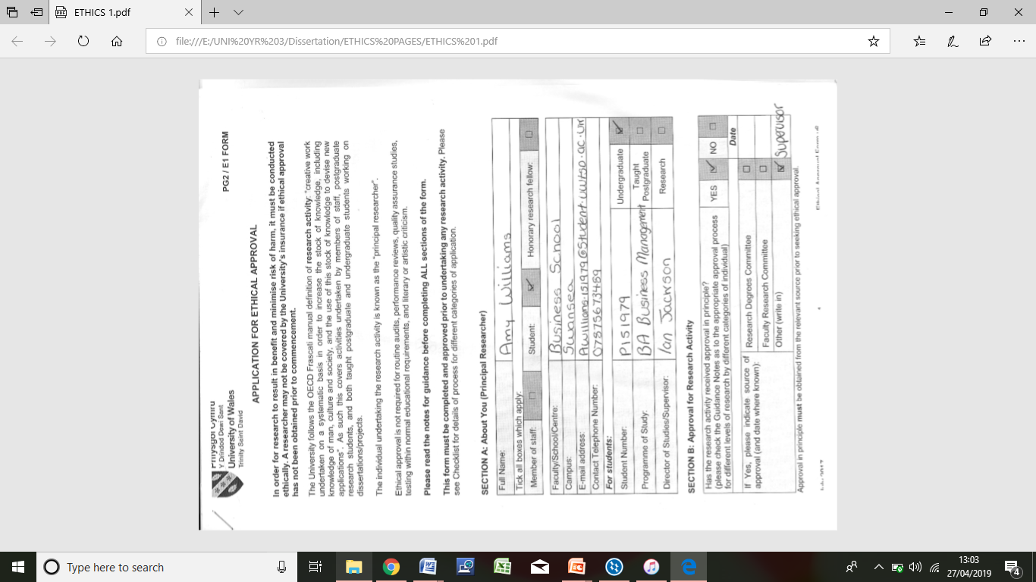

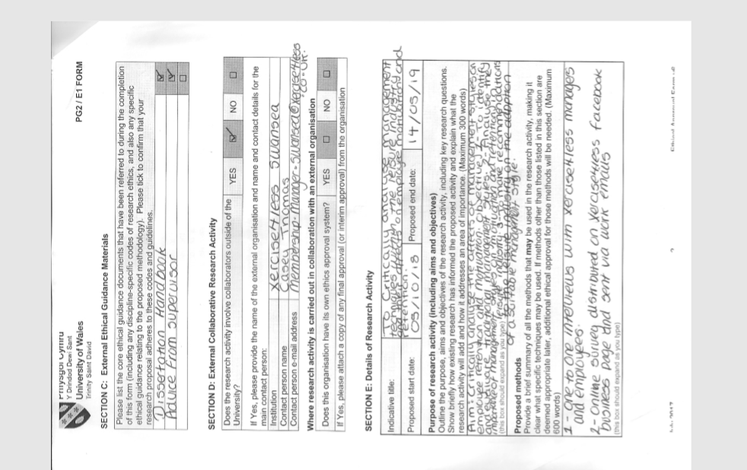

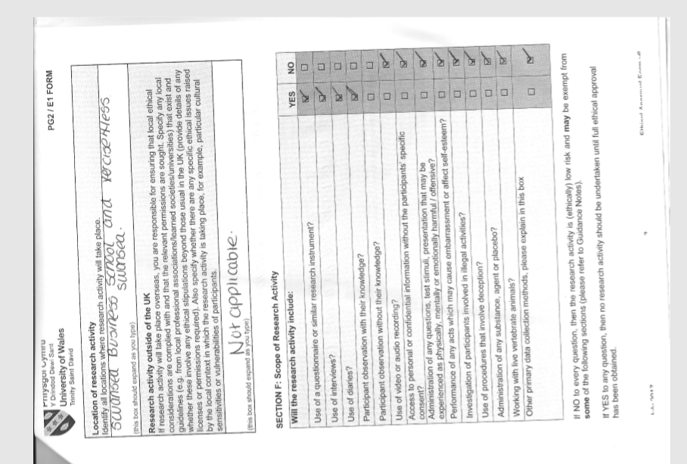

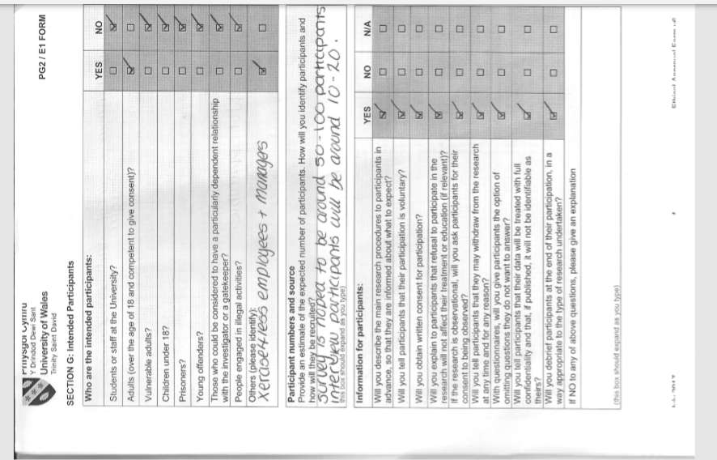



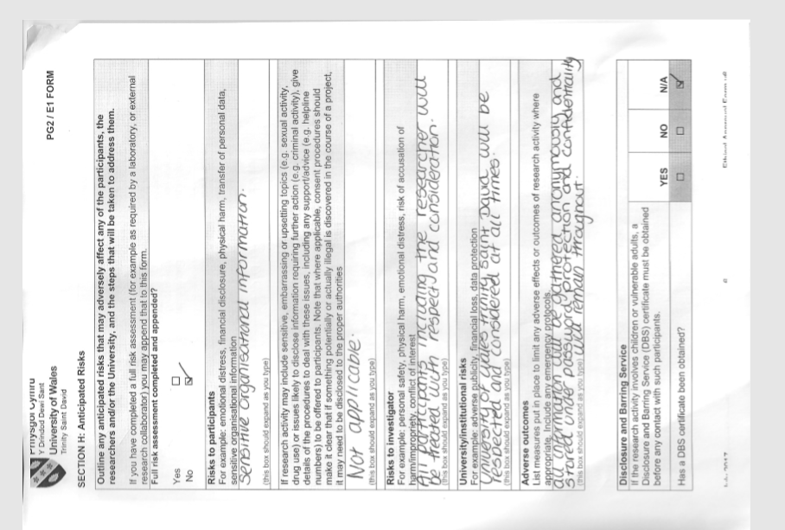

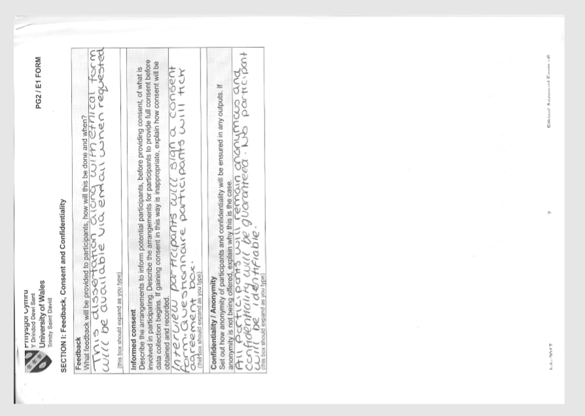

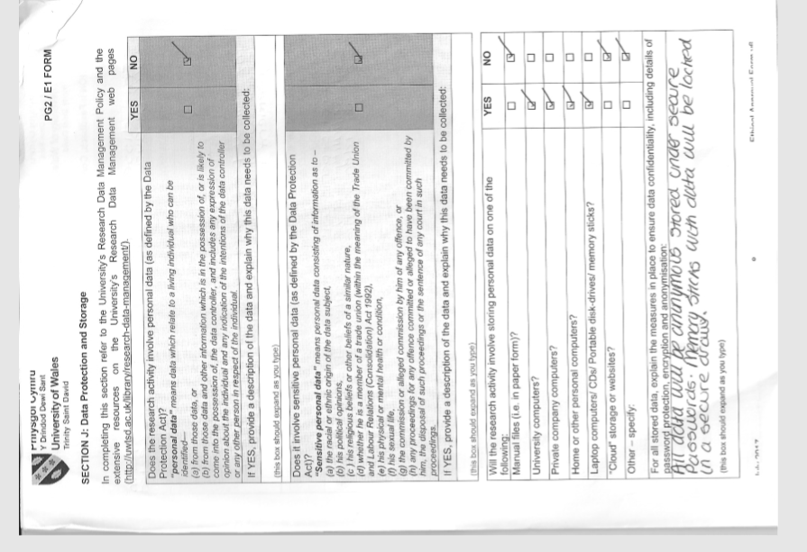

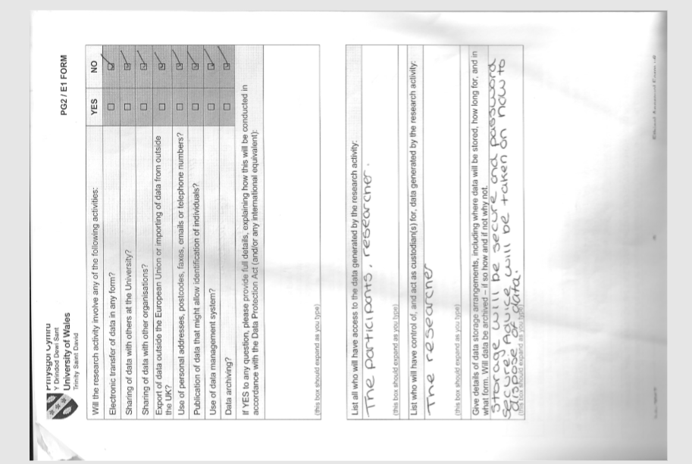
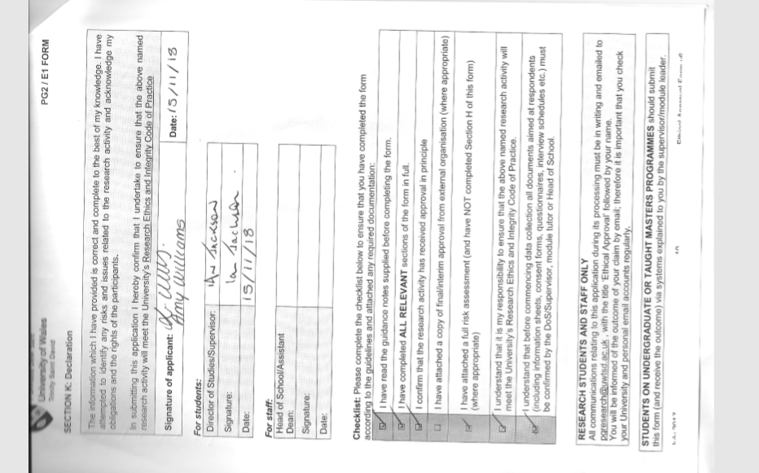

APPENDIX D – Interviews

INTERVIEW 1

Ok it's the 6/04/2019 and I’m here with P1 in Xercise4Less Swansea and he's having an interview with me Amy Williams.
So P1 just to check you understand that this is all confidential and everything's admitted is only for University of Wales Trinity Saint David and is for academic purposes only.
Yes
Do also hereby acknowledge that all data is confidential and would only be submitted for the academic purposes of this dissertation.
Yes
Ok great on to the first question I have for you which is what branch of Xercise4less are you from P1.
Swansea Branch
ok great how old are you?
19.
ok great so how long have you been employed by Xercise4less?
Under 6 months, around 2 months.
Thank you, now are you a part-time or full-time employee.
Full time.
What would you say is your managers style? what would you say is most applicable would you say strict, dominant but yet soft approach, involves all employees or laid back and little input?
Um i would go for the second option, he is the boss and tells us what needs to be done but isnt too strict and speaks with all of us and makes sure we are happy.
Ok thank you, Would you say you were satisfied with this management style?
Yes I am satisfied, I would say I have a great relationship with my manager he keeps me busy but doesnt boss me around and be nasty.
Thank you, Can you see a future career path with Xercise4less?
Honestly, No. I don’t see it has a long term place for me, more of a stop gap.
Why?
No career options and also from what I have seen already people don’t seem to last long in managerial positions and I would want a safe and reliable job, my girlfriend is desperate for children soon haha.
Haha, what would you say motivates you most during work?
Definitely my pay, I’m extremely money orientated and look forward to my pay every month.
Would you work somewhere if pay wasn’t great but you loved the job?
I don’t think I would, I don’t see the point of working if you don’t get good pay.
Thanks, do you believe managers should have complete control over their employees, leaving employees with little say on how the business is run?
Definitely not, the employees see everything first hand so can give vital advice to the company and help them improve. Also for me to happy I like to know I’m listened to and mean something to the company.
Ok great, I think I know the answer to this but would you say getting along with work colleagues is most important or pay?
Pay, getting along with work colleagues is a bonus but not essential to me.
Out of the list of factors below can you count how many are utilised by your manager and tell me?
Um,10.
Do you think if he utilised more of the factors he’d be a better manager?
Yes, he’d certainly be all rounded and cover a lot as a manager and help most aspects if he used all those factors but in fairness he already uses most of them.
How important would you say hierarchy is to Xercise4less?
Extremely important to them, i guess they’re a large business now so it is important to have structure and I guess its good for us because we know who to escalate things to if needs be.
Looking at the 5 aspects below can you just order them in which you would want fulfilled first.
Ye so I guess the order they’re in. First would be Physiological, then safety, then relationships, then esteem and self actualisation.
Thank you, if you had to pick would you prefer a strict manager or laid back manager?
Haha um can I have in between? Joking, well if I had to pick one I guess stricter so the place doesn't fall apart and become chaos and we’d know what we were doing.
Do you enjoy your job?
Yeah I would say I enjoy it quite a lot.
What are the characteristics you believe a manager should have?
I like a manager to be supportive, be involved and guide me but not be overly strict where he or she scares me and I cannot relax in work.
Would you say you’re motivated in work at the moment?
Yes.
Why?
I have a good manager and pay is good and they use pay incentives for hitting target.
Would you say your manager impacts your motivation and retention?
Yes definitely having had a bad manager before this job it made me not want to go to work nor work hard because I didn't want to help her. Pay also affects my motivation and retention though.
Great, thank you for completing the interview with me.
No probs.

Interview 2 –
It's the 6/04/2019 and I’m here with P2 in Xercise4Less Swansea and she's having an interview with me Amy Williams.
P2, just to double check you understand that this is all confidential and everything's admitted is only for University of Wales Trinity Saint David and is for academic purposes only.
Yes I understand
Do you also hereby acknowledge that all data is confidential and would only be submitted for the academic purposes of this dissertation?
Yes I do
Ok thanks, first question I have for you which is what branch of Xercise4less are you from?
I am from the Swansea branch
Ok great, how old are you?
I am 23 years old.
Ok great so how long have you been employed by Xercise4less?
Um in months I would say around 12 to 13.
Thank you, now are you a part-time or full-time employee.
I am a full time employee, I work Monday to Friday.
What would you say is your managers style? which would you say is most applicable would you say strict, dominant but yet soft approach, involves all employees or laid back and little input?
Hundred percent would go for the second option with Lawrence, he’s great, he keeps us in the loop and lets us know what needs to be done but is also our friend and talks to us and helps us out.
Brilliant thank you, Would you say you were satisfied with this management style?
Really satisfied, it suits me well I like to feel like my boss is also a friend I can rely on in a way, he always speaks to me with respect and ensures I am ok with all work that needs to be done.
Thank you, Can you see a future career path with Xercise4less?
Not really if I am honest.
Why?
You never see anyone from our level getting into the big manager jobs, they’re always sourced from outside or from the clubs up Leeds way. Also I don’t think I could handle the pressure that’s put on those managers every day.
Ok thank you, what would you say motivates you most during work?
I would say my pay at the moment is the main thing keeping me at Xercise4less, I can’t seem to see any other jobs that offer similar pay for what I do.
Would you work somewhere if pay wasn’t great but you loved the job?
Yes if I loved the job and the people there I would think of taking a pay cut.
Brill thanks, next do you believe managers should have complete control over their employees, leaving employees with little say on how the business is run?
No way, the high up managers don’t have a clue what goes on day to day when they’re sitting in their offices, they need our input to see where the business can improve.
Ok great, would you say getting along with work colleagues is most important or pay?
Hm tricky one, I would say pay comes first but getting along with my work friends is also important to me.
Out of the list of factors below can you count how many are utilised by your manager and tell me?
I would easily say around 9 he uses.
Do you think if he utilised more of the factors he’d be a better manager?
Yes, he’s already a good manager but I guess if more were used he would be even better.
How important would you say hierarchy is to Xercise4less?
It is important to them, it’s a multi million pound business so I guess they need hierarchy to make sure everything runs smoothly and jobs are done. It’s good to know who’s above us too in case I needed to escalate something or had a problem with my manager.
Looking at the 5 aspects below can you just order them in which you would want fulfilled first.
Um, First for me would be Physiological, then relationships, then safety, then esteem and self actualisation.
Thank you, if you had to pick would you prefer a strict manager or laid back manager?
I guess a laid back manager, don’t think I could cope with a bossy nasty manager, but an in-between manager is the best thing if I could pick that.
Do you enjoy your job?
Yeah I don’t mind it, I just want a job I can see a future in.
What are the characteristics you believe a manager should have?
Friendly and supportive to employees, and also clear in what needs to be done but be happy to help out where he can, not just dictate jobs.
Would you say you’re motivated in work at the moment?
Yes.
Why?
I am happy with my pay and also happy with my manager and colleagues.
Would you say your manager impacts your motivation and retention?
Yes one hundred percent. I really couldn’t enjoy my job if I didn’t like my manager never mind actually be motivated.
Great, thank you for completing the interview with me.
Not a problem, good luck with the dissertation.

Interview 3
7/04/2019 and I’m here with P3 in Xercise4Less Swansea and he's having an interview with me Amy Williams.
So P3 just to check you understand that this is all confidential and everything's admitted is only for University of Wales Trinity Saint David and is for academic purposes only.
Ye of course
Do also hereby acknowledge that all data is confidential and would only be submitted for the academic purposes of this dissertation.
Ye I understand
On to the first question I have for you which is what branch of Xercise4less are you from P3.
Bristol Branch
Great how old are you?
27
ok great, so how long have you been employed by Xercise4less?
Around 6 months.
Thank you, now are you a part-time or full-time employee.
Full time.
What would you say is your managers style? what would you say is most applicable would you say strict, dominant but yet soft approach, involves all employees or laid back and little input?
She’s extremely strict, she micro- manages everything. You cannot relax.
Would you say you were satisfied with this management style?
Not at all, she is not nice to work with. She has no people skills and just bosses us around and shouts at us.
Sorry to hear that, Can you see a future career path with Xercise4less?
Not if I stay under her management, I want to pursue a career within the leisure industry its always been a passion of mine but since working for such a strict horrible boss its completely put me off the organisation and whole idea of being in the leisure industry.
Oh no, what would you say motivates you most during work?
My pay is currently the only incentive I have. Nobody bonds in work because shes constantly on top of us so we are always stressed.
Would you work somewhere if pay wasn’t great but you loved the job?
Um I’m not too sure, I think pay for me is extremely important. Although I would take a pay cut to get away from my manager now.
Thanks, do you believe managers should have complete control over their employees, leaving employees with little say on how the business is run?
Haha certainly not, that’s exactly what our manager does and it does not work. No one even has the confidence to suggest ideas to her.
Oh dear, would you say getting along with work colleagues is most important or pay?
Pay I guess although getting along with colleagues would be great, be nice to have both really.
Out of the list of factors below can you count how many are utilised by your manager and tell me?
Pfft, 3.
Do you think if he utilised more of the factors he’d be a better manager?
Yes one hundred, if she could use like giving praise and ensuring employees are happy that would be something.
How important would you say hierarchy is to Xercise4less?
Very important to them, they always make the hierarchy clear to all employees too.
Looking at the 5 aspects below can you just order them in which you would want fulfilled first.
Pretty much as they are on the paper. Physiological, safety, relationships, then esteem and self actualisation.
Thank you, if you had to pick would you prefer a strict manager or laid back manager?
Right now I would kill for a laid back manager, but aspects of both would be best for me because if they are too laid back I will get lazy.
Do you enjoy your job?
Not at all, I probably would if it wasn’t for my manager.
What are the characteristics you believe a manager should have?
Should have people skills and be nice and help us. Not just be nasty and shout and demand at us all the time, it exhausts me and makes me dread work.
Would you say you’re motivated in work at the moment?
NO.
Why?
My manager just makes me not want to be in work. I am looking for a new job just to get away from her as soon as I can. My manager has completely affected my motivation and made me want to leave the job
Sorry to hear that, thank you for completing the interview with me.
No problem at all.

6.0 References

Adair, J. (2009). Leadership & Motivation : the Fifty - Fifty Rule and the Eight Key Principles of Motivating Others, London: Kogan, p.7.
Amabile, T. M. (1993). Motivational synergy: toward new conceptualizations of intrinsic and extrinsic motivation in the workplace. Human Resource Management Review, 3 (3), pp 185-201.
Austin, E. (1981). Guidelines for the Developing of Continuing Education (2nd ed.). New York: Appleton-Crofts.
Babbie, E. (2007). The Basics of Social Research. London: Ceneage Learning.
Blaxter, L., Hughes, C. and Tight, M. (1996) How to Research. Milton Keynes: Open University Press
Boddy, D. (2008). Management: An introduction (4th ed.). Harlow: Pearson Education Limited.
Bryman, A. and Bell, E. (2011). Business Research Methods (3rd ed.). Oxford: Oxford University Press.
Burgard, S., Brand, J., & House, J. (1982). Perceived job insecurity and worker health in the United States. Social Science and medicine, Vol. 69, No. 5 pp.777-785.
Caldari, K. (2007). Alfred Marshall's critical analysis of scientific management. The European Journal of the History of Economic Thought, 14(1), pp.55-78.
Cameron, S. and Price, D. (2009) Business Research Methods: A Practical Approach. London: CIPD/McGraw-Hill.
Cardoso, D. (2014). Taylor's Scientific Management Principles in Current Organizational Management Practices. Hanken School of Economics.
Carmichael, J., Collins, C., Ernsell, P. and Haydon, J., (2011). Leadership and Management Development. s.l.:Oxford University Press Inc New York.
Castro, F. G., Kellison, J. G., Boyd, S. J. & Kopak, A., (2010). A Methodology for Conducting Integrative Mixed Methods Research and Data Analyses. Journal of Mixed Methods Research,Vol. 4.No.4, pp. 342-360.
CIPD. (2017) Employee Engagement & Motivation | Factsheets | CIPD. [online] Available at: https://www.cipd.co.uk/knowledge/fundamentals/relations/engagement/factsheet [Accessed 25 Oct. 2018].
Coff, R.W., (1997), Human Assets and Management Di lemmas: Coping with Hazards on the Road to Resource- Based Theory‖, Academy of Management Journal, Vol. 22, pp.374- 402.
Collis, J & Hussey, R (2013), Business Research, A Practical Guide for Undergraduate and post Graduate Students, (4th Ed)., Palgrave Macmillan: London
Collis, J., and Hussey, R. (2009). Business Research: A Practical Guide for Undergraduate and Postgraduate Students. Basingstoke : Palgrave Macmillan.
Colvin, G. (2000). Managing In the Info Era In the knowledge-based economy, workers will be valued for their ability to create, judge, imagine, and build relationships. - March 6, 2000. [online] Available at: http://archive.fortune.com/magazines/fortune/fortune_archive/2000/03/06/275231/index.htm [Accessed 12 Feb. 2019].
Crossley, N. (2006). In the gym: Motives, meaning and moral careers. Body & Society, pp 23-50.
Deci, E. L. (1972). The effects of contingent and noncontingent rewards and controls on intrinsic motivation. Organisational Behaviour and Human Performance, 8, pp 217-229.
Denscombe, M. (2003). The good research guide, (2nd ed.) Berkshire: Open university press.
Desselle, P. (2005) Construction,Implementation and Analysis of Summated Rating Attitude Scales. American Journal of Pharmaceutical Education. Vol. 69, No. 5 pp. 1-11.
DiCicco-Bloom, B., and Crabtree, B. (2006). The qualitative research interview. Medical Education. Vol. 40, No.4 pp. 314-321.
Dingley, James C. (1997). Durkheim, Mayo, morality and management. Journal of Business Ethics, 16, pp 1117–1129.
Duncan, W. Jack (1999). Management: Ideas and actions. New York: Oxford University Press
Ekosgen (2013) Why are some employers more successful than others in retaining their workforce?. [online] Skills for care, p.64. Available at: https://www.skillsforcare.org.uk/Document-library/Finding-and-keeping-workers/Recruitment-and-retention-strategy/Workforceretentionfullresearchreport.pdf [Accessed 6 Nov. 2018].
Fayol, H. (1916). Administration industrielle et générale. (1st ed). Paris: Dunod.
Fayol, H. (1954). General and industrial management. London: Pitman & Sons.
Flick, U. (2011) Introducing research methodology: A beginner’s guide to doing a research project. London: Sage.
Gerth, C. and Mills, W. (1958) From Max Weber: Essays in Sociology, New York: Oxford University Press.
Griffiths, G. (2017). Employee Retention - Part 1 by Guy Griffiths, GGFit - FitLinks. [online] FitLinks. Available at: https://www.fitlinks.co.uk/retention-closer-look-staff-pathways/ [Accessed 16 Feb. 2019].
Heffernan, C. (2017). Pumping Iron II and the Birth of Female Bodybuilding. [online] Physical Culture Study. Available at: https://physicalculturestudy.com/2017/04/17/pumping-iron-ii-and-the-birth-of-female-bodybuilding/ [Accessed 12 Feb. 2019].
Henslin, J. (2014). Sociology: A down to earth approach (2nd ed.). Malaysia: Pearson Australia.
Herzberg, F. (1959). The Motivation to Work. (1st ed). New York: John Wiley & Sons.
Huffen, C. (2012). The Leisure Review. [online] Theleisurereview.co.uk. Available at: http://www.theleisurereview.co.uk/articles12/articles12pdf/asa2huffen.pdf [Accessed 16 Feb. 2019].
Huffen, C. (2018). The leisure review. [online] Theleisurereview.co.uk. Available at: http://www.theleisurereview.co.uk/articles12/articles12pdf/asa2huffen.pdf [Accessed 15 Nov. 2018].
Hutchinson, S. and Skodol-Wilson, H. (1992). Validity threats in scheduled semistructured research interviews. Nursing Research, Vol. 41, No.2 pp. 117-119.
IHRSA. (2013). The 2013 IHRSA Global Report: The state of the Health Club Industry. Boston: IHRSA.
Indeed.co.uk. (2018). Working at Xercise4less: 51 Reviews | Indeed.co.uk. [online] Available at: https://www.indeed.co.uk/cmp/Xercise4less/reviews [Accessed 16 Nov. 2018].
Jaffee, D. (2001). Organization theory: Tension and change (1st ed.). Boston: McGraw-Hill Higher Education.
Johnson, P. and Clark, M. (2006) Mapping the terrain: an overview of business and management research methodologies, London: Sage.
Johnson, R., (2007). Employee Retention. Supply House Times, 50(9), p. 80.
Johnson, S. (2018). Leadership Styles and Staff Retention among Mental Health Professionals. PHD: Walden University, p.135.
Jordan, C. (2016). How to Empower Your Health Club Managers and Engage Your Employees. [online] IHRSA. Available at: https://www.ihrsa.org/improve-your-club/how-to-empower-your-health-club-managers-and-engage-your-employees/ [Accessed 16 Feb. 2019].
Karin, H. (2010). Henri Fayol – the man who designed modern management. Le Libellio d’Aegis. 5 (4). pp 13-20.
Kemelgor, B. H. and Meek, W. R., (2008). Employee Retention In Growth-Oriented Enterprenurial Firms: An Exploratory Study. Journal of Small Business Strategy, 19(1), pp. 74 - 86.
Kirk, J. & Miller, M. L., 1986. Reliability and Validity in Qualitative Research. (1st ed). London: sage.
Kothari, C. R. (2004). Research methodology: methods and techniques. New Delhi: New Age International.
Lavrakas, P. (2008). Encyclopedia of Survey Research Methods. London: Sage.
Lavrakas, P. (2008). Encyclopedia of survey research methods. Thousand Oaks, Calif.: SAGE Publications.
Likert, R. (1932), A Technique for the Measurement of Attitudes. Archives of Psychology vol. 22, 5–55.
Lindner, J. R. (1998). Understanding employee motivation. Journal of Extension, 36 (3).
Maslow, A. H. (1943). A theory of human motivation. Psychological Review, 50(4), 370-396.Available at: http://dx.doi.org/10.1037/h0054346
McGregor, D. (1960). The human side of enterprise. New York: McGraw Hill, p.12.
McNeill, P. and Chapman, S. (2005). Research methods. New York: Routledge.
Minton, D. (2018). 2018 STATE OF THE UK FITNESS INDUSTRY REPORT [online] The Leisure Database Company. Available at: http://www.leisuredb.com/blog/2018/5/16/2018-state-of-the-uk-fitness-industry-report-out-now [Accessed 12 Feb. 2019].
Monette, D.R., Sullivan, T. J., and DeJong, C. R. (2005). Applied Social Research: A Tool for the Human Services, (6th ed.), London: Brooks Publishing.
Newman, I. (1998). Qualitative-quantitative research methodology: Exploring the interactive continuum. Carbondale: Southern Illinois University Press.
OSABIYA, B. (2015). The Impact of Leadership Style on Employee’s Performance in an Organization. [online] 5. Available at: https://www.iiste.org/Journals/index.php/PPAR/article/viewFile/19209/19974 [Accessed 5 Nov. 2018] p.204.
Piercy, K. (2004). Analysis of semi-structured interview data. Utah: Utah State University.
Rodrigues, C. (2001). Fayol's 14 principles of management then and now: A framework for managing today's organizations effectively. Management Decision. 39(10): pp 880-889.
Rose, M. (1988), Industrial Behavior, (2nd ed). Penguin: London.
Roxby, P. (2014). Does social media impact on body image? [online] BBC News. Available at: https://www.bbc.co.uk/news/health-29569473 [Accessed 29 Jan. 2019].
Saunders, M., Lewis, P. and Thornhill, A. (2009). Research methods for business students, (5th ed). Harlow: Pearson p.116 - 214.
Saunders, M., Lewis, P. and Thornhill, A. (2012) Research Methods for Business Students. Pearson Education Ltd: Harlow.
Saunders, M., Lewis, P. and Thornhill, A. (2016). Research methods for business students. Harlow: Pearson, p.5.
Shanks, N.H. (2007). Management and motivation. Jones and Barlett.
Sigler, K. J., (1999). Challenges of employee retention. Management Research News, 22(10), pp. 1-5.
Silva, B. (1960). Taylor e Fayol. Rio de Janeiro: Fundação Getúlio Vargas.
Simundić A. M. (2013). Bias in research. Biochemia medica, Vol. 23, No.1 pp. 12–15.
Smith Maguire, J. (2008). Fit for Consumption: Sociology and the business of fitness. London/New York: Routledge.
Smith, G. P. (1994). Motivation. In W. Tracey, Human resources management and development handbook (2nd ed.).
Staw, B. M. (1976). Intrinsic and Extrinsic Motivation. Morristown, NJ: General Learning Press.
Stern, M. (2011). or Rogue Charity? Private Health Clubs vs. the YMCA. [online] Thebhc.org. Available at: http://www.thebhc.org/sites/default/files/stern.pdf [Accessed 16 Feb. 2019].
Stewart, R. (1967). Managers and their jobs. London: Macmillan
Styhre, A. & Börjesson, S. (2006), Innovativeness and creativity in bureaucratic organizations: Evidence from the pharmaceutical and the automotive industry. Göteborg: OLKC 2006.
Taylor, F. (1911). The Principles of Scientific Management. (1st ed). Harper & Brothers, p.1.
Thomas, R. Murray. (2003). Blending Qualitative and Quantitative Research Methods in Theses and Dissertations. Thousand Oaks, CA: Corwin Press
Vasquez, D., (2014). Employee Retention for Economic Stabilization: A Qualitative Phenomenological Study in the Hospitality Sector. International Journal of Management, Economics and Social Sciences, 3(1).
Whitcomb, J., (2012). L&D Best Practices: Employee Retention. [Online] Available at: http://ezproxy.ncirl.ie:2967/media/pq/classic/doc/2839201121/fmt/pi/rep/NONE?hl=&cit%3Aauth=Whitco mb%2C+Judy&cit%3Atitle=Employee+Retention&cit%3Apub=Training&cit%3Avol=49&cit%3Aiss=6&cit%3Ap g=52&cit%3Adate=Nov%2FDec+2012&ic=true&cit%3Aprod=ProQuest+Busin [Accessed 13 Feb. 2019].
Wren Daniel, & Greenwood, Ronald (1998). Management innovators: The people and ideas that have shaped modern business. New York: Oxford University Press.
Wren, D. & Bedeian, A. (2009). The evolution of management thought (6th ed.). Hoboken: John
Wren, D. & Bedeian, A. (2009). The evolution of management thought (6th ed.). Hoboken: John
Xercise4less. (2018). Bleeding Yellow. [online] Available at: https://www.xercise4less.co.uk/bleeding-yellow/ [Accessed 6 Nov. 2018].
Xercise4less. (2018). News. [online] Available at: https://www.xercise4less.co.uk/news/announcements/award-wining-national-gym-chain-gains-new-ceo/ [Accessed 6 Nov. 2018].
Zareen, M., Razzaq, K. and Mujtaba, B. (2014). Impact of Transactional, Transformational and Laissez-Faire Leadership Styles on Motivation: A Quantitative Study of Banking Employees in Pakistan. Public Organization Review, pp.531-549.
Zikmund, W. G., Babin, B. J., Carr, J. C., and Griffin, M. (2013). Business research methods (9th ed.). Mason, OH: South-Western.

