An analysis of the marketing approaches that effectively draw individuals to a business — Holland and Barrett

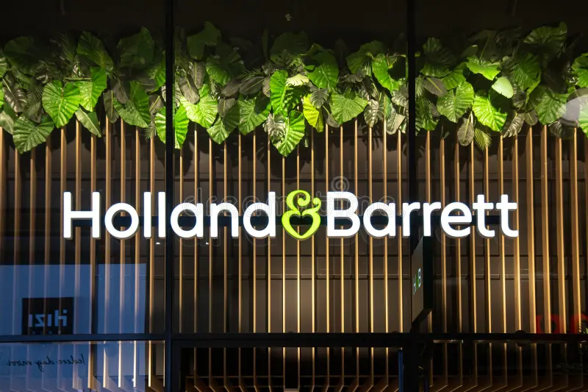

By Iuliana Roxana Bocanet
Student number: 2019733
Supervisor: Maria Heffernan
BA Developing Leadership and Management
6/12/2024

DECLARATION

This work has not previously been accepted in substance for any degree and is not being concurrently submitted as a candidature for any degree.

Signed: Iuliana Roxana Bocanet.

Date: 06th of December 2024.

STATEMENT 1

This dissertation is being submitted in partial fulfilment of the requirements for the degree of BA.

Signed: Iuliana Roxana Bocanet.

Date: 06th of December 2024.

STATEMENT 2

This dissertation is the result of my own independent work/investigation, except where otherwise stated.

Other sources are acknowledged by footnotes giving explicit references. A bibliography is appended.

Signed: Iuliana Roxana Bocanet.

Date: 06th of December 2024.

STATEMENT 3

I hereby give consent for my dissertation, if accepted, to be available for photocopying and for interlibrary loan, and for the title and summary to be made available to outside organisations.

Signed: Iuliana Roxana Bocanet.

Date: 06th of December 2024.

STATEMENT 4

I hereby give consent for my dissertation, if accepted, to be available on the university's IT system to those who have consented to use the system.

Signed: Iuliana Roxana Bocanet

Date: 06th of December 2024.

Acknowledgements

I would like to express my heartfelt appreciation and gratitude to the people and organisations that have helped and mentored me throughout the preparation of this dissertation. I am deeply thankful to Maria Heffernan, my dissertation supervisor, for their essential direction, insightful input, and support during this research project. Their expertise and encouragement helped shape this dissertation. I would like to thank my family sincerely for their unwavering love, encouragement, and patience. Their continuous support has kept me stable during this journey's hardships. I am also grateful to my friends for their understanding, encouragement, and sometimes distractions that helped me find balance in my life. I am grateful to the participants in this study, whose willingness to share their experiences and thoughts made this research feasible. Their contributions are much appreciated. Thank University of South Wales “Trinity St David’s” which offered resources and facilities for a suitable environment for research and education. I would like to thank my colleagues and classmates for their engaging talks, constructive input, and companionship during this academic journey.

Abstract

Holland & Barrett (H&B), a prominent health and wellness retailer in the United Kingdom, is the subject of this dissertation, which investigates the efficacy of their marketing strategies. The research endeavours to elucidate the subjective experiences and perceptions of both H&B consumers and marketing executives, a philosophy that is rooted in interpretivism. The study employs a deductive approach to assess the influence of H&B's push and draw marketing strategies on customer engagement and satisfaction. The research employs the Research Onion Model of Saunders et al. (2019), which offers a systematic framework for the examination of the research process's various strata. The study commences with a discourse on research philosophy, which identifies interpretivism as the most suitable approach for investigating the complex consumer perceptions and experiences associated with H&B's marketing strategies. This method is consistent with qualitative methodologies that investigate the subjective realities and contextual meanings that are influenced by consumer interactions (Burrell & Morgan, 2019).
The study employs a mixed-methods approach, which involves the integration of quantitative data acquired through questionnaires with qualitative insights obtained through semi-structured interviews. This method allows a complete review of H&B's marketing strategy, including quantitative and qualitative trends. The marketing evolution of H&B from its conception to its contemporary practices is traced using a collective case study technique to provide historical background and substance. Cross-sectional time horizons are used to analyse consumer preferences and behaviours regarding H&B's marketing endeavours. This methodology uses stratified random sampling to ensure demographic representation among survey respondents, improving generalizability. Ethics are crucial to research because they ensure participant anonymity, informed permission, and ethical compliance (Saunders et al., 2019).
The analysis of findings combines thematic analysis of qualitative data with statistical study of quantitative results to understand H&B's marketing effectiveness. Key statistics show that most H&B customers are 25–35 and female. Promotional effectiveness, product quality, and price affect consumer loyalty. Social media provides additional engagement, while word-of-mouth and physical shop presence are important marketing avenues. This dissertation provides practical insights for H&B and contributes to scholarly discourse on marketing strategy evaluation in health and wellness marketing. These are suggestions: improving loyalty programmes to engage customers, promoting environmental efforts that match consumer values, and targeting younger generations with digital marketing. These findings advance consumer behaviour research in the health and wellness sector and inform H&B's marketing strategies.

Contents

CHAPTER 1 12
Rationale 12
Aim 13
Objectives 13
Market share 13
Vision/Mission Statement 13
Financial performance 14
Sales Data Analysis 14
CHAPTER 2 15
Introduction 15
Literature review 15
Push and Pull Marketing in UK High Street Wellness Stores 15
Pull Strategies on High Street 16
Finding research gaps 16
Push marketing strategies 16
Efficacy of push strategies 18
Challenges and Limitations 18
Pull Marketing Strategies 18
Efficacy of pull strategies 20
The 4 Ps in the Health and Wellness Industry 21
The AIDA Model in the Health and wellness industry 22
CHAPTER 3 24
Research Methodology 24
Research Philosophy 25
Research approach 26
Research Strategy 27
Choice 27
Time Horizon 28
Data collection procedures 28
Quantitative and Qualitative methods 29
Sample justification 29
Data Analysis 29
Ethical Considerations 30
CHAPTER 4 32
Results Analysis 32
Questionnaire Analysis 32
CHAPTER 5 44
Conclusion 44
Key Findings: 44
Recommendations 45
Bibliography 48
Appendix 52
Gantt Chart 64

CHAPTER 1

Rationale
In recent years, the health and wellness industry has experienced exponential growth as a result of increased consumer awareness of sustainable practices and healthy lifestyles. The global health and wellness market is expected to reach $8.5 trillion by 2027, In recent years, the health and wellness industry has experienced exponential growth as a result of increased consumer awareness of sustainable practices and healthy lifestyles. The global health and wellness market is expected to reach $8.5 trillion by 2027, reflecting a sustained consumer focus on wellness (Mapp, 2024). Holland & Barrett (H&B), a prominent retailer in this industry, provides a compelling case study for the analysis of the efficacy of push and pull marketing strategies in attracting and retaining consumers.
Push marketing, which emphasises the direct promotion of products to consumers through advertising and sales promotions, has been demonstrated to generate short-term demand. However, it may encounter limitations in terms of fostering long-term loyalty (Kotler et al., 2021). In contrast, pull marketing, which is defined by creating demand through brand engagement and customer relationships, is more in line with the current preferences of consumers for personalised and value-driven experiences (Grewal et al., 2021). An evaluation of these strategies in the context of H&B is particularly relevant, given the brand's extensive presence across physical stores and online platforms (Holland & Barrett, 2023). Academic literature highlights that the integration of push and pull strategies is essential for competitive differentiation in saturated markets, such as health and wellness retailing (Chaffey & Ellis-Chadwick, 2022). Additionally, research emphasises the significance of digital transformation in improving the efficacy of marketing initiatives, as demonstrated by the increasing influence of social media and content marketing on consumer engagement (Wirtz et al., 2022). By critically assessing H&B's marketing performance, this study seeks to bridge the gap between traditional retail strategies and modern, technology-driven approaches. This research is necessary for the continued progress of H&B's strategic development and for the contribution to the broader academic discourse on marketing effectiveness. Recent research has underscored the necessity for businesses to modify their strategies in response to changing consumer preferences, including a preference for sustainable products and science-based health solutions (Vitafoods Insights, 2024). In summary, this dissertation evaluates the effectiveness of H&B's push and pull marketing strategies in the context of a competitive and evolving industry landscape. By synthesizing primary data with recent academic literature, the research offers evidence-based recommendations for improving H&B's marketing effectiveness and maintaining their leadership in the health and wellness market.

Aim
The aim of this dissertation is to conduct research with the intention of evaluating the performance of H&B and the effectiveness of their push and pull marketing strategies in attracting customers.

Objectives
To provide a contextual background for Holland & Barrett and critically examine academic literature on push and pull marketing strategies relevant to the health and wellness sector.
- To collect and analyse primary data on H&B's marketing performance using questionnaires and interviews, as well as secondary data from various online and published sources, and to create an overview with relevant literature.
- To synthesize qualitative and quantitative research findings and provide actionable recommendations for optimizing H&B's marketing strategies

Market share
In the United Kingdom's Care Products market, hollandandbarrett.com is ranked 23rd, with more than US$75 million in 2023. As a result, hollandandbarrett.com accounts for 0.0% to 5% of eCommerce net sales in this category. The most popular online retailers are Amazon.co.uk, Tesco.com, and Ocado.com. Holland and Barrett are ranked #1163 internationally in terms of net sales. This is due to the company's diverse product offering, excellent brand recognition, and significant retail presence. Strategic relationships with worldwide brands, as well as ongoing product innovation, have enhanced its market position, allowing for long-term growth and penetration. (Holland and Barrett Annual Report, 2023).

Vision/Mission Statement
Holland and Barrett's mission statement now represents the company's strategy. Holland & Barrett, which was formerly focused on high-quality health items, is now prioritising sustainability, ethical sourcing, and innovation. This strategic shift demonstrates the company's corporate responsibility and recognition of sustainability's growing significance in consumer decision-making (DalMas et al, 2022). Addressing modern challenges such as environmental impact and digital interaction demonstrates the company's adaptability to changing consumer values and market conditions.
"To enhance the health and well-being of our customers through superior quality products, innovative solutions, and a commitment to sustainability" is the current mission (Holland & Barrett, 2023).

Financial performance
Holland and Barrett achieved strong financial results in fiscal year 2022/23. Despite the hurdles provided by the COVID-19 pandemic and economic uncertainty, the company's performance remained consistent. H&B's latest financial records show a profit of £50 million, demonstrating stability and good cost management (Holland & Barrett Annual Report, 2023).
The company's yearly financial statistics for the year 2022 showed revenues of £536.3 million (compared to £528.6 million in 2021) and a loss of 31.5 million (against profit of 43.6 million) before taxes. In 2021, the company's sales increased by 27.8%, marking a 1.5% rise over the previous year. After the COVID-19 lockdowns were lifted, shoppers returned to British stores, resulting in increased foot traffic, and decreased online sales. This was shown in sales success; however, the firm shuttered 17 outlets in the United Kingdom before 2022 (Holland and Barrett Retail Limited, 2022).
Sales Data Analysis
Examining H&B's sales data to see how marketing strategies influence sales performance will help determine the impact of various marketing strategies on sales KPIs (Bryman & Bell, 2020).
Holland and Barrett reported a £50 million profit in fiscal year 2022/23. This highlights the company's resilience and efficient cost management in the face of economic concerns and the COVID-19 pandemic (Holland & Barrett Annual Report, 2023).

CHAPTER 2

Introduction
Holland & Barrett (H&B) is a prominent health and wellness retailer offering vitamins, supplements, and natural health products. Established in the eighteenth century, H&B has adapted to changing markets and consumer expectations, growing to over 1,300 stores across the UK and Ireland alongside a robust online presence (Holland & Barrett, 2023). As consumer interest in health and wellness products continues to grow, understanding the marketing approaches that effectively attract individuals to businesses like H&B becomes increasingly important. This dissertation examines H&B's push and pull marketing strategies to evaluate their effectiveness in attracting and retaining customers (Grewal et al., 2021). This chapter critically examines relevant academic and industry literature to analyse the efficacy of various marketing strategies employed in the health and wellness sector, with a focus on H&B. Understanding H&B's history and market position provides essential context for assessing their strategic decisions concerning competitors and consumers (Holland & Barrett, 2023). The evaluation highlights how H&B may strengthen their marketing strategy to overcome challenges and boost success.

Literature review
Marketing theories and models provide a structured foundation for analysing and developing effective marketing strategies. To maintain its competitive edge and attract a diverse customer base, H&B employs a mix of push and pull marketing strategies and engage customers. The shift to an omnichannel approach, which combines physical and digital retail experiences, is a major trend in retail marketing (Levy & Weitz 2012). Holland & Barrett's efforts to integrate their physical stores and online platforms are an example of this trend.

Push and Pull Marketing in UK High Street Wellness Stores
Online merchants and changing consumer habits make UK high street wellness stores like H&B competitive. These relationships require delicate push and pull marketing. H&B's in-store promotions, loyalty programs, and private-label products show how push marketing may increase foot traffic and brand identification. Private-label products increase client retention by generating a perception of uniqueness and value (McKinsey & Company, 2023). However, saturation of comparable promotions among competitors hampers differentiation, questioning push techniques' long-term viability (Mintel, 2022).

Pull Strategies on High Street
Pull marketing matches wellness consumers' value-driven attitude. Eco-conscious shoppers like H&B's sustainability and openness, with 72% preferring brands with explicit sustainability pledges (Smith et al., 2020). Social media engagement helps high street wellness firms stay relevant in the digital age by connecting online and offline experiences (Deloitte, 2023). However, as purchasing preferences become more digital, conventional high street retailers must interact smoothly with e-commerce platforms (Chaffey & Smith, 2022).

Finding research gaps
Although push and pull marketing is widely used in health and wellness, little is known about its effectiveness in UK high street wellness retailers. Most research focus on push and pull marketing in online retail or larger applications (Kapoor et al., 2022; Euromonitor International, 2021). This leaves a gap in understanding how these techniques might be optimised for brick-and-mortar stores, especially after the pandemic when consumer behaviour has changed.
Push and pull methods in omnichannel systems are also poorly studied. Although H&B has integrated its physical and digital channels, it still struggles to deliver consistent messages and seamless consumer experiences (Deloitte, 2023). These dynamics may help high street wellness retailers migrate to omnichannel retailing.

Push marketing strategies
Push marketing strategies involve heavily promoting items or services to consumers via direct channels such as in-store displays, email campaigns, or distributor relationships (Kotler & Keller, 2020). These methods work especially well in the health and wellness industry to encourage impulse purchases, introduce novel items, and maintain brand recognition. For Holland & Barrett (H&B), these tactics are essential in navigating the competitive landscape while meeting changing consumer demands:
- . In-store Promotions and Shelf Placement
H&B influences purchasing decisions through in-store promotions such as discounts, buy-one-get-one-free deals, and exclusive bundles. Shelf location is also important in generating sales, since products positioned at eye level or near checkout counters are more likely to capture customer attention (Deloitte, 2023). According to research, such promotions create a sense of urgency, leading to impulse purchases, particularly in the wellness sector, where customers are frequently driven to "limited time offers" (Mintel, 2022). In addition, H&B stores prioritise experiential marketing by offering in-store consultations and demonstrations. Staff, for example, are educated to provide personalised advice on supplements and health items, which builds confidence and leads to instant sales. This strategy is consistent with research showing that 73% of wellness consumers value expert opinions when making purchasing decisions (Euromonitor International, 2021).
- Email and Direct Marketing is a key push technique for H&B.
Targeted ads offer personalised product recommendations, loyalty discounts, and notifications about new product launches (Forbes, 2023). This technique makes use of H&B's loyalty program data, which analyses consumer preferences and shopping habits, to assure relevancy. Personalised email campaigns in the wellness industry have been shown to enhance click-through rates by up to 26% (Kapoor et al., 2022). Direct marketing tactics include smartphone notifications and SMS alerts, which H&B uses to engage customers with real-time offers and reminders. These strategies are highly effective at re-engaging lapsed clients and encouraging repeat purchases (Chaffey & Smith, 2022).
- Retail Partnerships and Private Labelling
H&B uses agreements with well-known wellness businesses to broaden its product offering and establish exclusivity. Exclusive product lines and private-label items are prominently exhibited in stores and online. This technique not only increases brand awareness but also encourages repeat visits since customers identify H&B with exclusive product availability (McKinsey & Company, 2023). Private labelling is another effective push tactic that enables H&B to promote its own branded items at competitive pricing. According to research, private-label health and wellness goods are seen as high-value, which increases customer loyalty (Mintel, 2022). This is consistent with H&B's focus on price and quality assurance.
- Seasonal and event-based campaigns.
H&B uses seasonal marketing to promote various product categories. For example, during the winter, immunity-boosting supplements are actively marketed through both in-store and digital platforms, whereas summer advertisements emphasise on fitness and weight management goods (Smith et al., 2020). Event-based marketing, such as discounts during National Health Awareness Month, provides chances for customised promotions that are relevant to consumer interests.

Efficacy of push strategies
Push marketing is highly effective in the health and wellness business because of the following:
- Promoting Impulse Purchases: Limited-time offers, and in-store promotions take advantage of wellness consumers' spontaneous purchasing behaviours (Smith & Taylor, 2021).
- Establishing Brand Trust: Personal consultations and professional advice increase credibility, especially in a market where consumers value informed decision-making (Euromonitor International, 2021).
- Loyalty programs and tailored messages foster long-term relationships, leading in increased client retention (Forbes, 2023).
- Brand differentiation: H&B separates itself from competitors by offering exclusive product lines and private branding, so solidifying its market share.

Challenges and Limitations
- Over-reliance on discounts: Frequent promotions may cause price sensitivity in consumers, lowering perceived value (Kapoor et al., 2022).
- Increased Competition: Competitors in the wellness industry, notably online-only merchants, frequently imitate push techniques, reducing their effectiveness (McKinsey & Company, 2023).
- Omnichannel Integration: Maintaining consistency between in-store promotions and internet advertising is still a concern, as fragmented messaging can mislead customers (Chaffey & Smith, 2022).

Pull Marketing Strategies
Pull marketing strategies are aimed to attract consumers by building awareness and demand for items, encouraging them to seek out the brand rather than the company directly contacting them (Kotler & Keller, 2020). Pull methods are especially effective in the health and wellness sector, where consumers are informed and value driven. To engage health-conscious consumers, Holland & Barrett (H&B) uses pull marketing, which includes digital platforms, influencer collaborations, content marketing, and sustainability-focused branding. Pull marketing strategies used by Holland and Barrett:
- Social Media Engagement and Influencer Marketing.
Social media platforms have become increasingly important for engaging with customers, particularly Millennials and Generation Z, who value online research and peer recommendations. H&B leverages channels like Instagram, Facebook, and TikTok to publish wellness recommendations, product highlights, and testimonials, resulting in a dynamic and informative environment for potential clients (Forbes, 2023).
- Influencer marketing is an important part of this strategy.
By engaging with wellness influencers and health professionals, H&B increases trust and credibility while reaching a larger audience. According to Euromonitor International (2021), 89% of consumers trust influencer recommendations over traditional marketing in the health and wellness industry.
- Content Marketing and Educational Resources
H&B portrays itself as a health and wellness thought leader by providing instructional content on nutrition, fitness, and mental health, including blogs, videos, and webinars. This strategy is consistent with research showing that wellness consumers are well-informed and choose businesses that deliver value beyond products (Mintel, 2022). H&B's blog contains posts about selecting the correct vitamins and adopting sustainable lifestyle practices that are relevant to its target demographic. Content marketing not only drives traffic to the brand's website, but it also creates a feeling of community among wellness adherents (Smith & Taylor, 2021).
- Loyalty and Personalised Marketing
Loyalty schemes that incentivise repeat purchases and strengthen customer involvement help to enhance pull strategies. H&B's Rewards for Life program provides points for every purchase, as well as personalised offers and exclusive discounts, resulting in a compelling value proposition (Kapoor et al., 2022). Personalisation is a fundamental component of pull marketing. According to studies, customers are 40% more likely to engage with brands that provide personalised experiences (McKinsey & Company, 2023). H&B uses consumer data to promote items, send customised emails, and deliver app-based notifications that are relevant to individual wellness goals.
- Sustainability-Focused Branding
Sustainability is a big motivator in the health and wellness industry. To attract eco-conscious customers, H&B emphasises its dedication to environmentally beneficial measures like as minimising plastic use and obtaining ethically produced materials (Deloitte, 2023). Certifications, such as cruelty-free or organic labels, are frequently highlighted in branding efforts, as they are critical for developing confidence in this industry. According to Smith et al. (2020), 72% of consumers in the wellness market prefer companies that are honest about their sustainability goals.
- SEO and Digital Advertising
H&B uses SEO (Search Engine Optimisation) and pay-per-click (PPC) advertising to ensure that its products and educational content rank high in search results. This method is consistent with consumer behaviour, as many wellness consumers do considerable web research before making purchases (Chaffey & Smith, 2022). H&B draws customers with high intent by targeting specialised health and wellness keywords like "immune-boosting supplements" or "natural skincare." PPC advertising also drive traffic to seasonal sales and new product launches, which increases brand visibility (Forbes, 2023).

Efficacy of pull strategies
Pull marketing methods are highly effective for H&B because of the following factors:
- Building Trust and Credibility: Educational material and influencer endorsements position H&B as a wellness authority, addressing consumer desire for reliable sources (Smith & Taylor, 2021; Euromonitor International, 2021).
- Enhancing Customer Loyalty: Personalised experiences and loyalty programs promote long-term engagement and repeat purchases (Kapoor et al., 2022).
- Appealing to Value-Driven Consumers: Emphasising sustainability and ethical practices matches with consumer demands, setting H&B apart from competition (Deloitte, 2023).
- Driving Organic Traffic: SEO and content marketing attract knowledgeable customers, resulting in improved conversion rates (Chaffey & Smith, 2022).
Challenges and Limitations
- High Competition for Digital Attention: Competing wellness brands employ similar techniques, making it difficult to differentiate (Mintel, 2022).
- Resource-Intensive: Maintaining high-quality content, influencer partnerships, and personalised advertising takes a large investment (Forbes, 2023).
- Pull tactics are dependent on active consumer interest, which might fluctuate in response to market developments or economic conditions (McKinsey & Company, 2023).
In the health and wellness industry, marketing frameworks like the 4Ps and AIDA model are important for analysing client behaviour and generating effective marketing tactics. Both models help Holland & Barrett (H&B) find, engage, and keep customers in a competitive market. These tactics must be evaluated to optimise marketing investments and improve client satisfaction (Aaker et al., 2023).

The 4 Ps in the Health and Wellness Industry
McCarthy's (1960) 4Ps concept remains a cornerstone of marketing strategy, having been tailored to the dynamic health and wellness sector. The framework's adaptability enables organisations such as H&B to meet changing consumer needs while preserving brand relevance.

Product
In the health and wellness market, the product dimension prioritises quality, innovation, and alignment with consumer values such as sustainability and natural ingredients (Mintel, 2022; Forbes, 2023). According to studies, people are willing to spend more for products that promote health advantages and ethical activities (McKinsey & Company, 2023). H&B's product line, which includes plant-based supplements and eco-friendly packaging, efficiently meets these expectations (Deloitte, 2023).

Price strategies in health and wellness are heavily influenced by perceived value and affordability (Kapoor et al., 2022). According to research, consumers regard higher-priced wellness items as superior, yet affordability remains crucial for mass-market appeal (Euromonitor International, 2021). H&B uses a balanced pricing approach, delivering frequent discounts and loyalty awards to attract price-sensitive customers while maintaining product quality (Smith & Taylor, 2021).

Place
The development of e-commerce has changed the "place" aspect of marketing (Chaffey & Smith, 2022). H&B combines a strong physical presence with an omnichannel approach to provide seamless shopping experiences across its stores and online platforms (Forbes, 2023). This dual approach caters to wellness consumers who appreciate both in-store consulting and the convenience of internet purchase (Deloitte, 2023; Mintel, 2022).

Promotion
Health and wellness promotions rely on educational material and endorsements to generate trust (Smith et al., 2020). H&B's efforts rely on influencer marketing, social proof, and customer testimonials, which are especially effective in wellness industries where trustworthiness is essential (Kapoor et al., 2022). Furthermore, their advertising techniques are consistent with AIDA principles, capturing customer attention and encouraging long-term involvement (Chaffey & Smith, 2022; McKinsey & Company, 2023).

The AIDA Model in the Health and wellness industry
The AIDA model, established by St. Elmo Lewis in the late nineteenth century, outlines the four stages of consumer decision-making: attention, interest, desire, and action. This paradigm is particularly important in the health and wellness industry, as emotional and rational triggers frequently impact consumer journeys (Kapoor et al., 2022).
Attention
To attract attention in the wellness sector, you need eye-catching images, interesting storytelling, and engaging digital material (Smith et al., 2020). H&B captures customer interest through social media platforms and tailored marketing, emphasising vivid graphics and strong value propositions that appeal to wellness-conscious individuals (Forbes, 2023).
Interest
To generate interest in a product, educate people on its merits (McKinsey & Company, 2023). H&B thrives at this level by offering thorough product descriptions, blogs, and professional advice (Chaffey & Smith, 2022). According to academic research, informed consumers are more likely to build trust and progress through the purchasing funnel (Smith & Taylor, 2021).
Desire
The desire stage is about establishing emotional relationships with customers. H&B accomplishes this through influencer partnerships and emphasising sustainable practices, which appeal to consumers' ethical and lifestyle ideals (Euromonitor International, 2021; McKinsey & Company, 2023). According to research, emotional resonance enhances conversion rates considerably in wellness marketing (Forbes, 2023).
Action
The third stage, action, entails simplifying the purchasing process to increase sales. H&B's reward programs, one-click online checkout, and promotional offers help customers complete purchases with minimal friction (Kapoor et al., 2022; Deloitte, 2023). According to Smith and Taylor (2021), convenience of transaction is crucial in keeping health and wellness consumers.
The 4Ps and AIDA models are especially well-suited to the health and wellness sector for a number of reasons.
- Customer-Centric Focus: Both frameworks emphasise understanding customer requirements and behaviours, which is critical in a market driven by personal health objectives (Mintel, 2022; Smith et al., 2020).
- Flexibility: These models may be tailored to suit trends such as digital transformation and sustainability, making them appropriate for wellness-focused businesses such as H&B (Chaffey & Smith, 2022; McKinsey & Company, 2023).
- Trust Building: Trust is essential in wellness marketing, and the frameworks provide methods for truly engaging consumers through education, transparency, and value-aligned messaging (Smith & Taylor, 2021; Forbes, 2023).

CHAPTER 3

Research Methodology
This chapter was created with the objective of investigating H & B's performance and the efficacy of their pull and push marketing methods in drawing clients. It examines the research methods used to study the marketing approaches that effectively attract individuals to Holland & Barrett, focusing on the performance and the efficacy of their push and pull marketing methods in attracting and retaining clients. Compiling a methodology discussing suitable research methods for investigating the effectiveness of marketing techniques employed by H&B is essential for ensuring that the research is systematic, dependable, and valid. A well-defined methodology outlines: Research Design, referring to the overall approach and strategy for the research (Saunders, Lewis, & Thornhill, 2019). Data Collection Methods, which includes techniques for gathering primary and secondary data (Bryman & Bell, 2020). Data Analysis Techniques, involving methods for analysing the collected data to originate meaningful insights (Hair et al., 2019). The methodology is structured according to the Research Onion model, a comprehensive framework for research design that includes layers such as philosophies, approaches, strategies, choices, time horizons, techniques, and procedures (Saunders et al., 2019).
Figure 1- The research onion
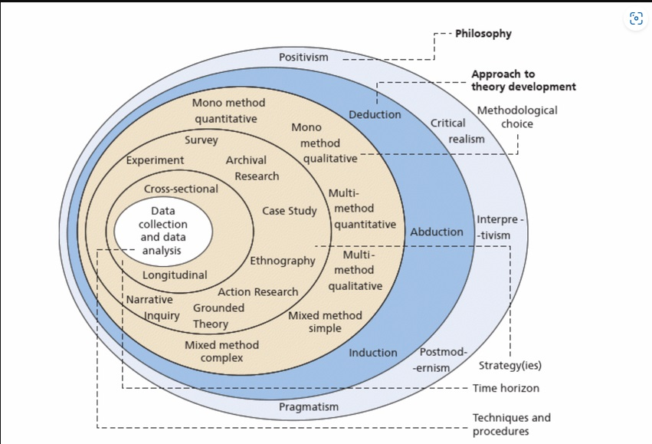
Figure 1- The research onion (Mackenzie, n.d.)

Figure 1 shows The Research Onion Model developed by Saunders et.al (2019) which is in a literal sense similar to an onion, with each layer reflecting the particular aspect or level of the research process. It is a useful tool that can help researchers explore all of the layers of the research process. This framework enables the researcher to purposely break down each element of research, ensuring thoroughness and clarity in decisions (Saunders et.al, 2019). The goal is to generate credible and reliable knowledge in a systematic way (Creswell & Creswell, 2023).

Research Philosophy
The researcher's core beliefs about reality and knowledge form the Research Onion's first layer, research philosophy. This study is based on the interpretivism research philosophy, which tries to comprehend the subjective experiences and views of H&B consumers and marketing executives. Interpretivism is consistent with qualitative research methodologies that seek to investigate phenomena in depth and comprehend the context-specific meanings associated to marketing tactics (Saunders et al., 2019). Interpretivism recognises that people perceive their experiences subjectively and that social realities are created through interactions (Burrell & Morgan, 2019). This philosophical position is consistent with the study's emphasis on examining the opinions and experiences of H&B customers and marketing professionals regarding marketing methods. Interpretivism is appropriate for studying Holland & Barrett's (H&B) marketing strategy because it recognises that people see their experiences subjectively and that interactions shape social reality (Saunders et. al, 2019). This philosophical approach matches the study's focus on H&B customers and marketing professionals' marketing strategy perceptions and experiences. Customers' reactions to H&B's push and pull marketing methods, such as promotional emails (push) and loyalty programmes (pull), can be very personalised and diverse (Lincoln & Guba, 2020). By taking an interpretivist method, the study may capture these diverse perceptions, providing a more complete and detailed knowledge of their effectiveness.

Research approach

This layer of the Research Onion details how the researcher conducted the research. Given the research goals to evaluate the effectiveness of H&B's marketing strategies, a deductive approach will be used. The researcher engages with participants, using their social abilities to understand how they make sense of the world. According to Denzin and Lincoln (2018), researchers can capture the nuances of human experience by fully embracing the participants' environment.
The inductive technique uses observed data to develop new theories. It begins with precise observations and measurements, which are then used to identify patterns and regularities. This is how fresh ideas are created. This method is exploratory and frequently employed in qualitative research (Bryman, 2016; Tracy, 2019). The inductive technique reduces enormous amounts of raw data to a simple summary. According to Thomas (2006), this reduction is critical for effectively managing and analysing qualitative data. The approach tries to establish clear links between the study objectives and the data-driven outcomes. The researcher can verify that their results are related to the data obtained by conducting a systematic analysis of the data (Elo & Kyngäs, 2008).
The ultimate goal is to provide a conceptual framework that reveals the fundamental structure of the data-driven experiences or processes. This paradigm facilitates understanding of the research's broader implications and can inform theory development (Braun & Clarke, 2019).

Research Strategy

According to Creswell and Creswell (2023), the research strategy acts as an outline for the entire research process, offering an organised plan that combines the study design with data collecting and analysis procedures.
A collective case study strategy is suitable for an in-depth examination of Holland & Barrett. This allows for a detailed exploration of their push and pull marketing strategies and their impact on customer attraction. A blend of case studies and surveys is appropriate for analysing Holland & Barrett's activities. Case studies provide extensive insights into specific methods, such as digital transformation and loyalty programme innovations (Rigby, 2019). Analysing the company’s evolution over time will reflect the efficiency of these methods. Questionnaires can provide quantitative information on customer preferences. The case study research strategy will allow the researcher to create a whole picture of Holland and Barrett’s performance and an effective framework to analyse marketing strategies employed by the organisation. Holland & Barrett's growth and adaptation over time can be comprehensively understood by examining the evolution of its strategies from its founding in 1870 through its various ownership changes and expansions into new markets (Our History, Holland & Barrett).

Choice
This part of the Research Onion focuses on data collection. To successfully meet the research goals, this layer is especially important for deciding how data will be gathered, analysed, and interpreted (Saunders et al., 2019). Multiple factors must be considered when attempting to figure out what draws people to stores like Holland and Barrett. The choice of data collecting technique that fits the research objectives and type of the study depends much on the layer of choice in the research onion structure. This dissertation uses mix of techniques. Smith (2021) says that researchers should choose approaches that can gather qualitative data, such as insights into why individuals do what they do and how they do it, as well as quantifiable data, such sales figures, and demographic trends. Combining questionnaires and in-depth interviews, for example, would provide a complete picture of why individuals prefer natural health products and the Holland and Barrett shopping experience (Sharma, 2023).

Time Horizon
The 5th layer of the Research Onion is time horizon, the duration of the study that is used to gather data and analyse it in order to form conclusions. For this, the researcher adopted a cross-sectional approach due to the limited time, which helps to obtain data immediately from people or sources. This entails questionnaires and interviews analysis to reveal the population's current situation (Sedgwick, 2014). For cross-sectional investigations, statistical tools are used to describe correlations or associations between variables at a specific time point. Common studies include prevalence rates, correlations, and demographic subgroup comparisons (Sedgwick, 2014). This method provides a snapshot of the population's features, behaviours, or attitudes at that particular moment, to understand demographic trends. Simple cross-sectional interviews are easier to plan and execute in a brief period (Bryman, 2016) and they are less expensive than longitudinal research since they only require one round of data gathering (Levin, 2006). Because cross-sectional studies lack information on changes across time, it is challenging to understand long-term trends (Sedgwick, 2014).

Data collection procedures
This study will adopt a mixed-methods approach, combining quantitative and qualitative research to gain a comprehensive understanding of H&B’s marketing effectiveness. Conducting primary research and analysing data to assess the impact of marketing strategies on customer engagement and sales performance is necessary for obtaining actual insights into H&B’s marketing effectiveness.

Quantitative and Qualitative methods
This study uses stratified random sampling to evaluate client segments based on key criteria such as age, gender, and purchasing behaviour, resulting in a representative and balanced sample (Flick, 2022). A mixed-methods approach was used, combining quantitative questionnaires and qualitative interviews which increases the depth and generalisability of the findings, providing a comprehensive view of consumer behaviour (Flick, 2022). Initially, a total sample of one hundred questionnaire participants and ten interviewees was chosen, aligning with established research criteria to ensure reliability and actionable insights (Hair et al., 2019). However, only thirty-three people responded to the questionnaire and only three people accepted to be interviewed.

Sample justification
The one hundred questionnaire participants were selected based on guidelines for behavioural research, which recommend similar sample sizes to achieve statistical power and reliable estimates of population parameters (Saunders et al., 2019; Fan & Yan, 2020). Stratified sampling ensures proportional representation of demographic and behavioural subgroups including age, gender, and purchasing patterns, improving accuracy and generalisability (Flick, 2022). This strategy helps the study find relevant patterns across varied consumer profiles while collecting data efficiently. A ten question semi-structured interview was created and conducted across ten people. The 10 interviewees provided qualitative insights in addition to the quantitative data. Qualitative research guidelines recommend 5–15 participants to reach data saturation and reveal recurring themes in well-defined populations (Guest et al., 2016). This includes varied viewpoints and better understanding of customer intentions and perceptions that quantitative approaches may miss.

Data Analysis
This chapter examines the data collected through interviews and questionnaires. The primary purpose is to gain useful insights and patterns that address the research issues. This analysis uses both qualitative and quantitative approaches to ensure a thorough examination of the data. Qualitative interview data will be examined thematically. Thematic analysis is a prominent qualitative research technique for identifying, interpreting, and reporting data themes (Braun & Clarke, 2019). The steps include are to ensure accuracy, all interview recordings being transcribed accurately (King & Brooks, 2020), Familiarisation, Coding, Theme Development, Theme definition and naming also Reporting. The transcriptions will be read multiple times to become fully acquainted with the content (Nowell et al. 2019). Extracts will be coded based on recurring ideas, concepts, or assertions related to the study themes (Clarke and Braun, 2021). Codes will be grouped into themes that capture data attributes relevant to the study questions (Terry et al., 2017). Themes will be reviewed and changed to ensure that the data is accurately represented (Castleberry and Nolen, 2018). Each subject will have a unique description and name (Guest, MacQueen, and Namey, 2020). Themes will be organised into a cohesive narrative that addresses the research questions and is supported by direct quotes from interviewees (Vaismoradi et al., 2016). The quantitative data from the questionnaires will be statistically examined to determine trends, patterns, and correlations. The steps include Data Entry, Inferential statistics, and Data Visualisation. The responses will be put into a statistical software programme for analysis (Field, 2018). The data will be summarised using descriptive statistics such as means, medians, modes, and standard deviations as part of the initial analysis (Pallant, 2020). To ensure consistency, the questionnaire's reliability will be assessed using Cronbach's alpha (Tavakol & Dennick, 2019). Inferential statistics, such as t-tests, ANOVA, and regression analysis, will be used to identify correlations and differences across variables (Tabachnick & Fidell, 2019). Graphs, charts, and tables will be used to help comprehend and interpret the data (Creswell & Creswell, 2020).
The statistical data will be analysed in relation to the study objectives, with an emphasis on significant discoveries and their implications (Babbie, 2021).
This chapter attempts to provide a comprehensive overview of the research findings by combining qualitative insights gained from interviews with quantitative data gathered from questionnaires. This mixed-methods strategy allows for a complete investigation, ensuring that the results are comprehensive and reliable.

Ethical Considerations
This study will ensure participant confidentiality and obtaining informed consent throughout the research procedure. Participants' rights and well-being will be strictly protected by ethical rules (Bryman & Bell, 2020).
The researcher addressed various ethical consideration aspects to ensure the participants' safety, well-being, and rights, as well as the integrity and reliability of the research results, based on their voluntary decisions to participate (Saunders et. Al, 2019). Neither vulnerable persons nor those under the age of 18 participate in this sample. The participants were advised that their participation is entirely voluntary, anonymous, and that they have the right to withdraw at any time. To support these, an ethical form was produced, and verbal consent was obtained at the start of the interview to ensure people's autonomy and avoid any pressure or impact (Israel & Hay, 2006). Data obtained is securely stored on the researcher's own computer, which is only available to them and protected by a password. The whole study was accepted ahead of time by using an ethical form, which can be found in the appendix.

CHAPTER 4

Results Analysis
This chapter includes an examination of the information gathered through interviews and questionnaires. The goal is to interpret the results in connection to the study questions and objectives. The analysis blends qualitative insights gained from theme analysis of interview data with quantitative conclusions obtained from statistical analysis of questionnaire replies. This mixed-methods technique allows for a thorough comprehension of the research issue, with data interpretation that is both deep and broad. This analysis aims to find patterns, themes, and key links that will guide the study's conclusions and suggestions.

Questionnaire Analysis

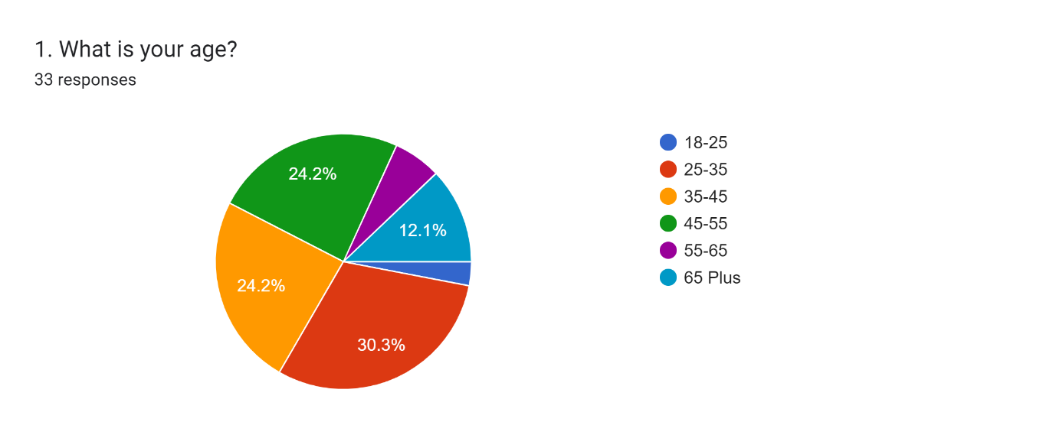
Fig. 1- 25-35 is the largest age group, followed by 35-45 and 45-55. Targeted marketing that promotes digital involvement for younger people, quality/value propositions for middle-aged people, and accessibility for older people can increase efficacy and audience engagement. Data-driven marketing optimises targeted advertising by age group preferences and behaviours.

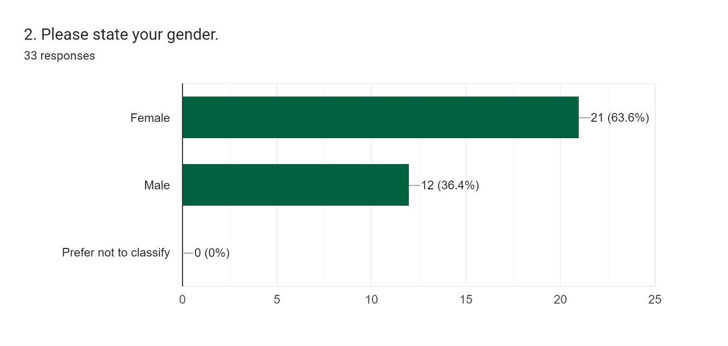
Fig.2- Using age and gender to generate participant profiles and preferences may help create marketing campaigns. 63.6% of participants are women and 36.4% are men.
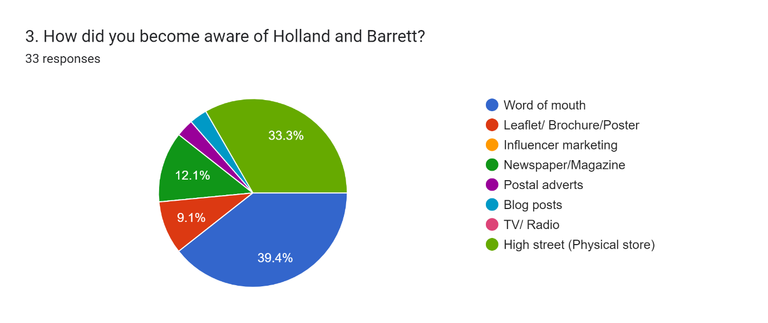
Fig.3- 39.4% chose “Word of mouth” to show consumer loyalty, while 33.3% chose “High Street” to exhibit significant physical retail. The 12.1% replies for “Newspaper/Magazine” and “Leaflet/Brochure/Poster” suggest H&B uses few printed advertising items. Influencer marketing, postal ads, blog postings, and TV/Radio were not answered, suggesting H&B does not use social media advertising sufficiently. This helps to examine Holland and Barrett's marketing channels, investigate how customers heard about them.

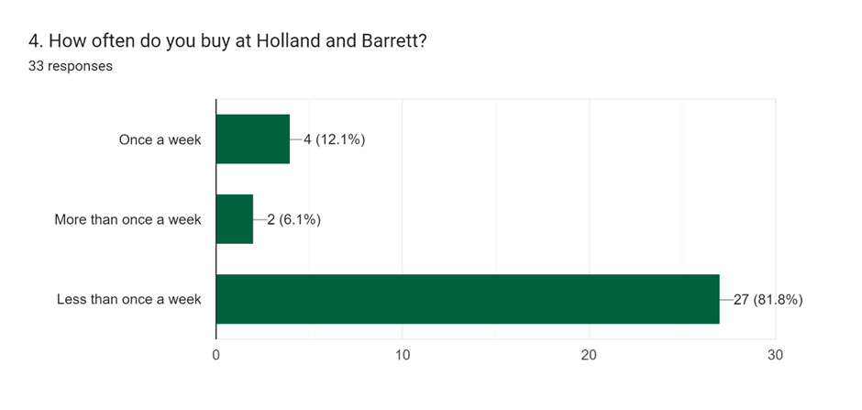
Fig.4- To determine consumer loyalty and usage. The highest results, 81.8%, demonstrate that most participants buy at Holland and Barrett less than once a week, indicating low brand loyalty and engagement. Only 2% and 4% of Holland and Barrett customers shop weekly. Frequent shoppers value H&B's reward scheme, whereas less frequent shoppers may need other motivations.

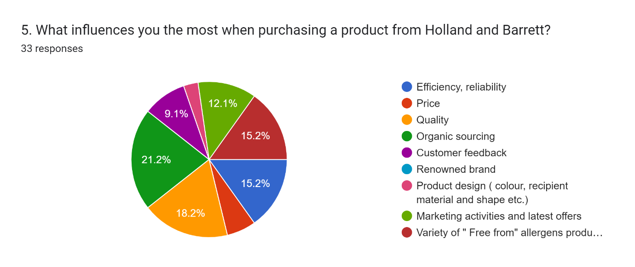
Fig.5- Evaluates customer priorities. The highest score of 18.2% shows that most individuals choose Holland and Barrett's organic products. Next: 18.2% value quality, 15.2% efficiency, reliability, and allergen-free products. 12.1% value marketing and latest offers. Finally, 9.1% picked customer feedback.

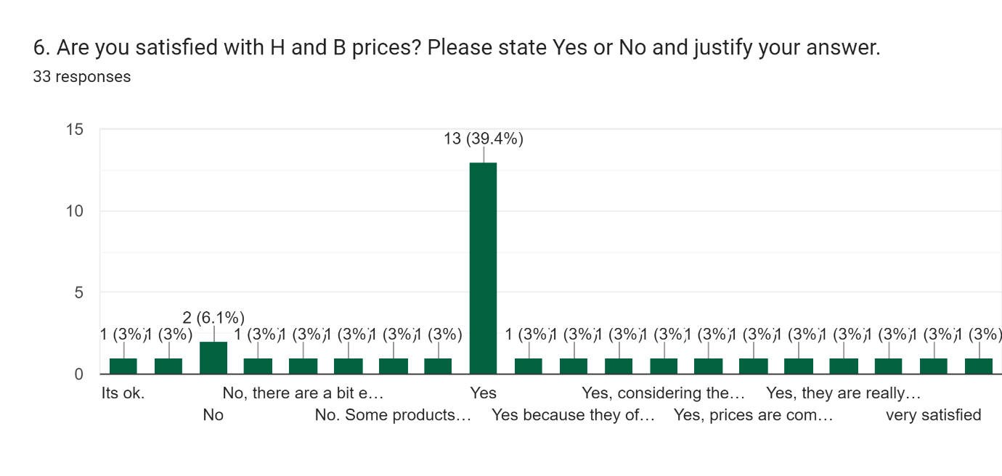
Fig.6- 39.4% of participants answered “Yes” and found the products affordable, while 6.1% said “No” and found some products pricey. Pricing and promotion methods may benefit from this data.

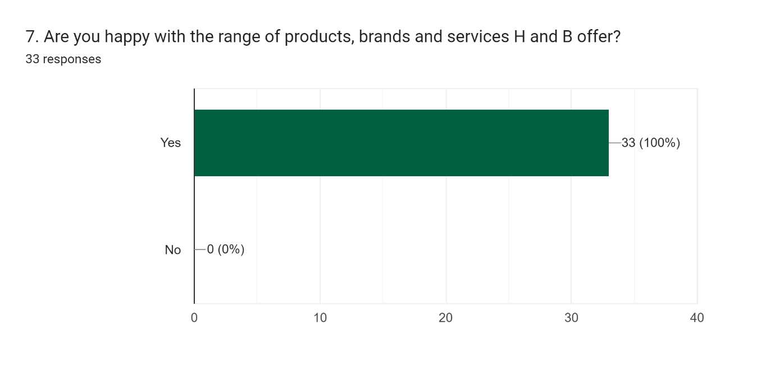

Fig.7- 100% and all 33 participants are satisfied with H and B's products, brands, and services, meeting customer demands and expectations.

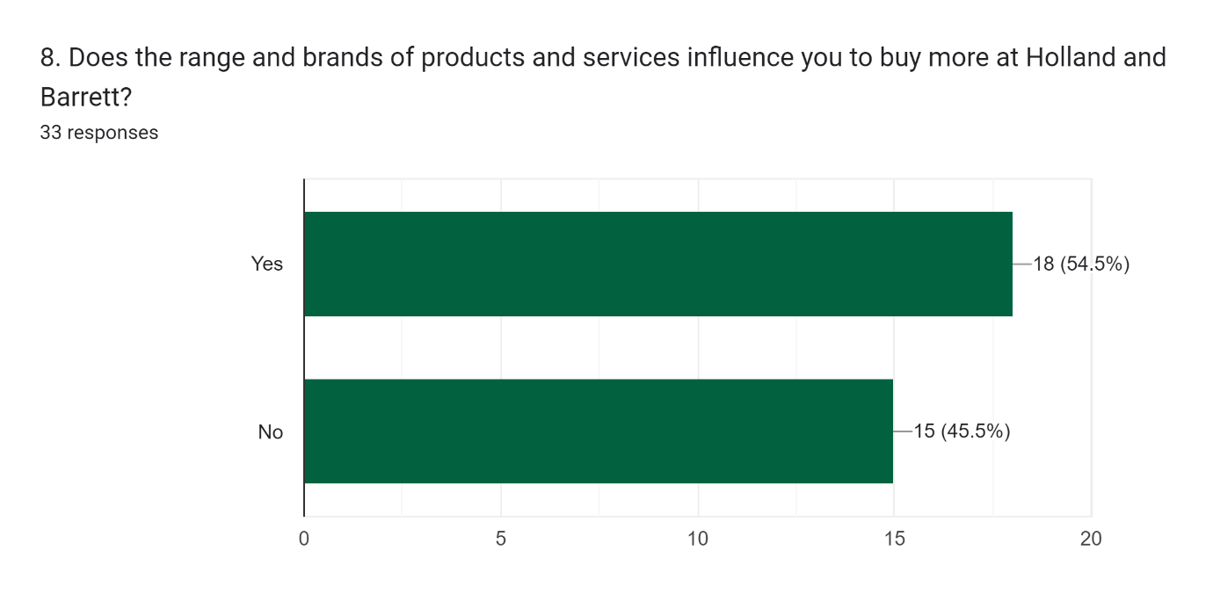
Fig. 8- 54.5% said brands affect their purchases at H & B, which suggests product diversity increases repeat purchases and may help with inventory management; That does not affect 45.5% who said "No".

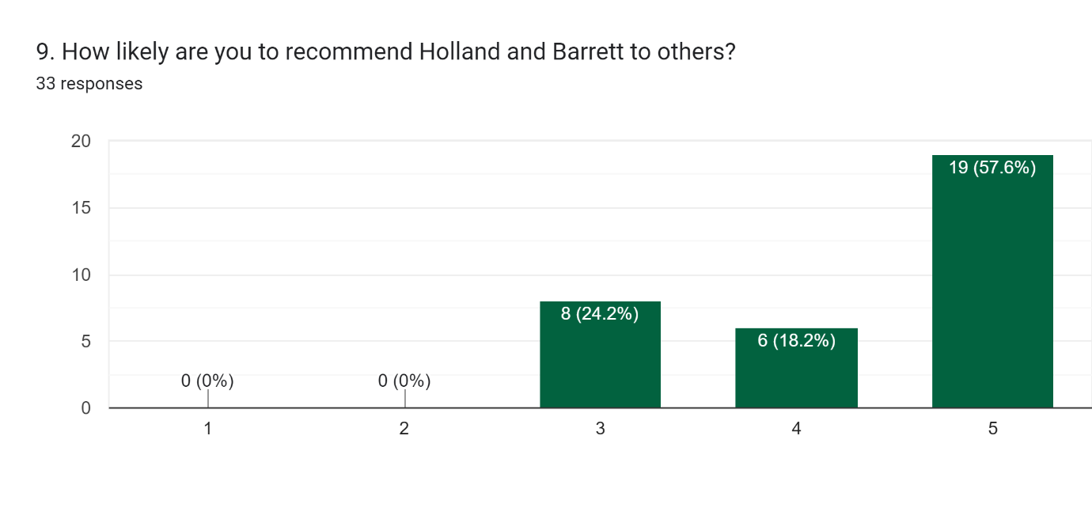
Fig.9- Overall client satisfaction and word-of-mouth referrals are good (57.6% rated 5, 24.2% rated 3, 18.2% rated 4).

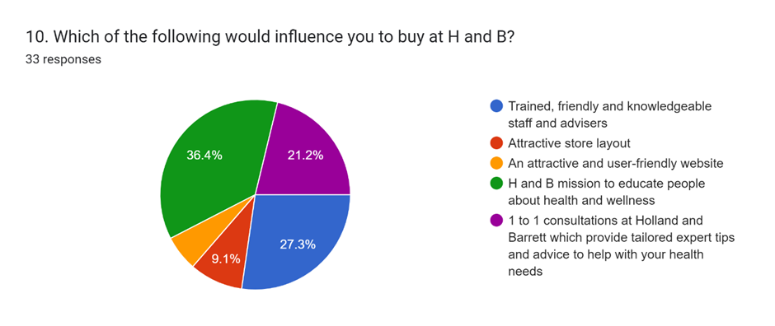

Fig.10- According to 36.4% of participants, H&B's objective to educate people about health and wellbeing influences their purchases. Next, 27.3% prefer trained, polite, and competent staff and advisers, followed by 21.1% of 1-1 personalised consultations and 9.1% of appealing store layout.
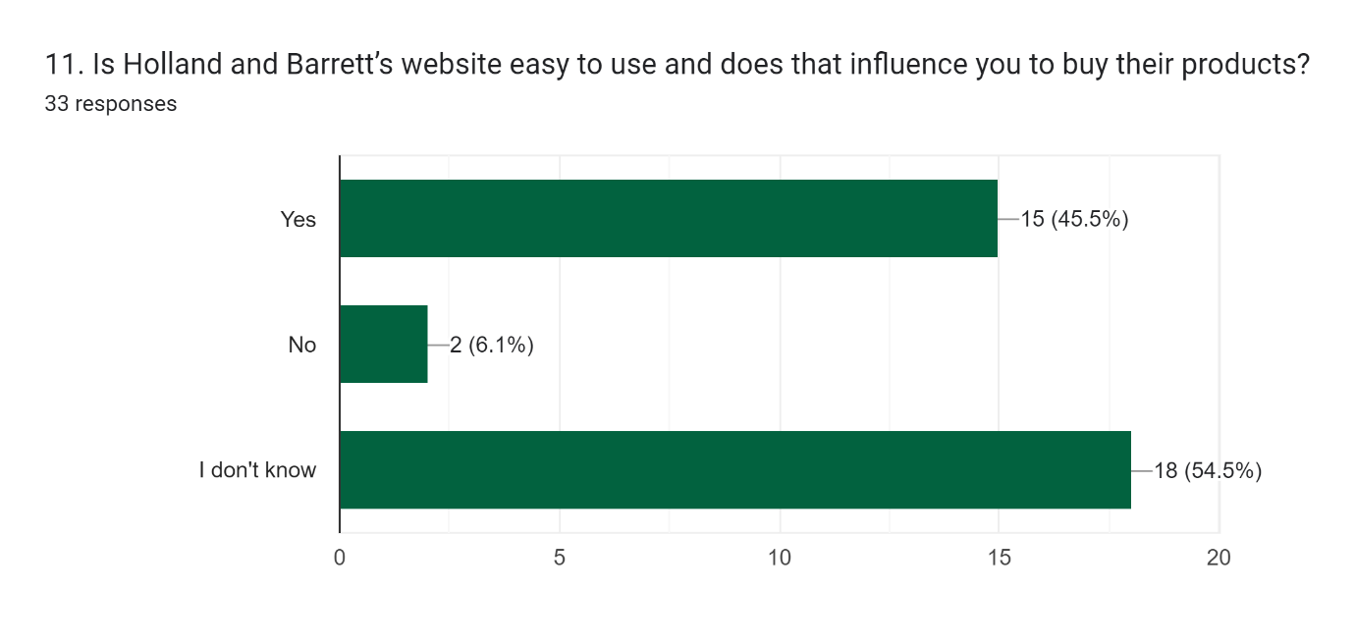
Fig.11- This question assesses the website's user-friendliness and impact on purchasing decisions to improve online commerce. The results show 54.5% do not know H&B's website. 45.5% said the website's usability influences their purchases.

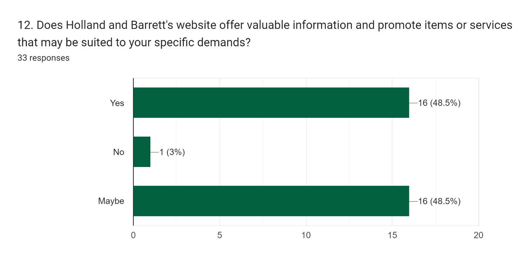
Fig.12- Reviews website content and personalisation to inform content strategy and digital marketing. 3% said No, 48.5% equally answered Yes and Maybe.

Question 13. Do you receive marketing/ promotional materials via the website? If yes, please classify how this happens: Facebook, Spotify, TikTok, Instagram, Emails. This question evaluates digital marketing channels to allocate resources to the most productive ones. Answers: 4 participants said they do not get any; Three responded Facebook, six answered yes via email, two answered yes through all of them in this sequence, and five answered yes via Instagram.

Question 14. What is the main reason for using the Holland and Barrett products? Please explain. Understanding the primary reasons for using H&B products helps in crafting marketing messages that resonate with customer needs and values. Answers indicated:
Health Focus: Holland and Barrett's healthy products and wellness marketing are popular.
Product Range and Quality: Quality and affordable supplements and helpful staff improve customer experience.
Giftability: Products are occasionally gifted, showing suitability and worth.
Price Competitiveness: Price sensitivity and convenience affect buying.
Supplements with natural ingredients are preferred.
Brand Loyalty: Some customers like and trust the brand.
Promotions: Appealing deals also affect purchases.
Understanding these factors helps businesses customise marketing strategies to customer preferences and boost satisfaction and loyalty.
Question 15. Do price offer, customer rewards and vouchers influence you to buy more at Holland and Barrett? Please identify in order which you prefer.
Respondents’ opinions on pricing offers, prizes, and vouchers differ. Others choose long-term rewards programmes over discounts and promotions. Understanding these preferences helps Holland and Barrett customise promotional campaigns to different client categories and boost customer happiness and loyalty. Participants who answered “No” prefer to shop based on personal preferences and needs rather than promotional motivations.

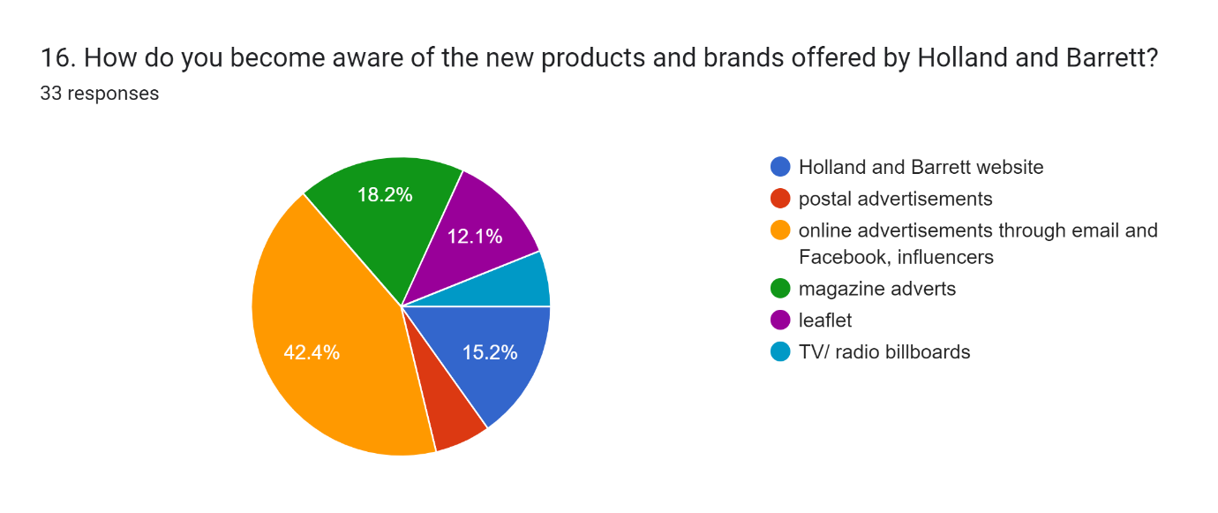

Fig. 16- Online advertisements through email and Facebook, along with influencer marketing, are the primary channels through which customers become aware of new products and brands offered by Holland and Barrett. There are also magazine ads, the company's website, leaflets, and TV and radio billboards that raise knowledge, but not as much. By knowing which platforms their target audience prefers, Holland and Barrett can make sure that their marketing strategies reach and engage that audience.

Question 17. What made you choose Holland and Barrett’ products, brands, and services over its competitors? Reveals H&B's competitive advantages, which can be leveraged in marketing campaigns to attract and retain customers. Based on the collected answers, participants prefer Holland and Barrett above its competitors due to its range and promotional offers, brand history and reputation, product quality, especially organic options, and friend recommendations. Competitive pricing through offers is important. Understanding these aspects helps Holland and Barrett compete and meet health and wellness client needs.
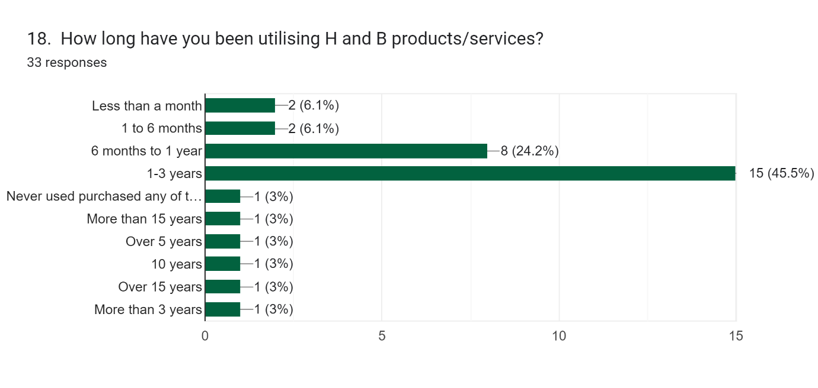
Fig. 18- The majority of respondents have used Holland and Barrett products for 1-3 years, showing strong marketing methods that acquired and retained customers. Long-term customers are committed to H&B products and services, whereas inexperienced users (less than a month) indicate continual customer expansion. H&B uses these durations to adjust their marketing to retain and acquire clients.

Question 19. Please specify what are your preferred ways to shop at H and B and why? ( Physical store, H and B online App, H and B company website)
Based on the participants’ answers, the tactile experience and personalised attention of Holland and Barrett's physical store appeal to many customers. But more are using digital channels like the H&B online app and company website for ease and a wider selection. Holland and Barrett can better serve their broad consumer base by tailoring their offerings and streamlining the shopping experience across physical and digital platforms by understanding these preferences.
Question 20. What could H and B do to improve the marketing of their products, brands, and services? Please respond by giving examples for pricing and packaging of their products, store design, adverts, online communication, offers and rewards, your experience of marketing at Holland and Barrett.
Some respondents did not offer personal advice. This may suggest disengagement with H&B's marketing efforts or a belief that improvements are not needed. Holland and Barrett might improve their marketing by offering more frequent and diversified rewards and offers for their products, brands, and services. Store design, adverts and internet communication were not mentioned, but these might be improved to improve H&B's marketing.

Thematic Interview Analysis
1. Customer Loyalty and Engagement
Long-Term Loyalty: Customers have remained loyal for 5–19 years due to diverse product offerings and sustainability efforts.
Loyalty Program Effectiveness: The ‘Rewards for Life’ program is appreciated for promoting affordability and repeat purchases.
2. Promotional and Marketing Strategies
Promotions: Discounts and in-store promotions are strong drivers of purchases.
Digital Marketing: Customers value email advertising and app features but highlight gaps in social media presence and online content.
3. Sustainability and Ethical Sourcing
Sustainability is a key driver for purchases, with customers valuing H&B's eco-friendly initiatives and alignment with ethical values.
4. In-Store Experience
Customers appreciate personalised support and product accessibility but suggest better product updates, labelling, and store improvements.
5. Challenges in Online Engagement
Customers find H&B’s digital presence limited, suggesting stronger online promotions, social media use, and better product categorisation.
6. Suggestions for Improvement
Enhance digital channels through social media and targeted offers.
Improve product labelling and information accessibility.
Broaden sustainability efforts with transparent communication.
Conclusion
The interviews reveal strong loyalty driven by promotions, sustainability, and in-store experiences but highlight gaps in digital engagement and customer education. These insights provide clear guidance for enhancing H&B’s marketing and operational strategies.
Discussion
he analysis of Holland & Barrett customer data gives significant insights into consumer behaviour and the effectiveness of various marketing campaigns. The mixed-methods approach, which integrates quantitative and qualitative data, exposes trends and preferences that correspond to past studies on consumer retention and loyalty. The data reveals that age and gender-targeted marketing approaches can have a significant impact on customer engagement. This is similar with Grewal et al.'s (2021) research, which found that age-specific marketing increases customer happiness and loyalty. According to Varnali and Toker (2019), the study's dominant age group of 25-35 represents a younger audience that is likely more responsive to digital marketing and social media involvement. To maintain engagement, the older demographic may require more traditional tactics, such as in-store encounters or print media. The considerable preference for word-of-mouth marketing (39.4%) and physical retail presence (33.3%) shows that, despite the digital transformation, traditional marketing approaches remain crucial. This reinforces Kumar and Shah's (2022) findings, which show the ongoing importance of word-of-mouth in consumer decision-making processes. The low contact with print media and the lack of responses for influencer marketing suggest that H&B is underutilising these channels, which could be an area for improvement. This is consistent with the findings of Shareef et al. (2019), which highlight the growing importance of combining online and offline marketing channels. According to shopping frequency studies, brand loyalty at H&B is low, with only a small percentage of customers purchasing consistently. This study suggests that, while H&B has a dedicated customer base, there is space for further involvement through stronger loyalty programs or more frequent incentives. Rafiq and Fulford (2020) discovered that consistent, tailored rewards can significantly boost customer retention. The emphasis on product quality, organic alternatives, and pricing is consistent with research on health and wellness retailing, where consumers are frequently motivated by ethical concerns and value for money (Newholm & Shaw, 2018). More than half of participants (54.5%) are unaware of H&B's website or do not find it user-friendly, indicating a flaw in H&B's digital strategy. This is congruent with Kim and Park's (2018) research, which highlights the necessity of a smooth online experience in achieving e-commerce success. Improving website usability and improving awareness can dramatically boost online sales and consumer happiness. According to the literature, a well-designed website with customised information can enhance user experience and increase repeat transactions (McLean et al., 2021). According to the interviews, sustainability and ethical sourcing have a significant impact on customer loyalty at H&B. This is consistent with the growing trend of conscious consumerism, in which customers increasingly base their purchasing decisions on ethical considerations (Sloan, 2020). The emphasis on these values suggests that H&B's dedication to sustainability could be a key market differentiator, perhaps attracting a more dedicated consumer base that values environmental and social responsibility. The talk reveals many faults in H&B's current marketing strategy. H&B can communicate with a younger, more digitally sophisticated audience by underutilising digital marketing platforms, particularly social media, and influencer marketing. According to the literature, incorporating these channels into existing marketing tactics can boost brand awareness and customer engagement. Furthermore, feedback on the incentive program and in-store experience reveals areas where H&B's strategy can be improved to better meet client requests.

CHAPTER 5

Conclusion
This dissertation critically evaluated the effectiveness of Holland & Barrett’s (H&B) push and pull marketing strategies in attracting and retaining customers within the dynamic health and wellness industry. The research findings reveal the nuanced impacts of these strategies and provide actionable insights into areas of success and improvement for H&B.
H&B's push strategies, including in-store promotions, direct marketing, and private labelling, were found to be effective in driving impulse purchases and short-term sales. However, their over-reliance on frequent discounts risks eroding brand value. In contrast, pull strategies, such as sustainability-focused branding, loyalty programs, and content marketing, were pivotal in fostering trust and long-term customer engagement. The emphasis on ethical sourcing and eco-friendly practices strongly aligns with modern consumer values, particularly among younger demographics.
Despite these strengths, gaps in digital engagement emerged as a critical challenge. Limited social media presence, underutilization of influencer marketing, and a suboptimal website experience hindered H&B’s ability to fully capitalize on digital transformation trends. Additionally, customer feedback highlighted the need for improved product labelling, store layout, and a more dynamic rewards program.

Key Findings:
- Consumer Loyalty and Engagement: Long-term loyalty is driven by promotions, sustainability initiatives, and personalized customer interactions. However, brand loyalty remains relatively low due to infrequent engagement strategies.
- Digital and Omnichannel Integration: The lack of a cohesive digital strategy limits H&B’s ability to engage tech-savvy consumers and drive online sales.
- Sustainability as a Differentiator: Ethical sourcing and eco-friendly practices resonate strongly with consumers, presenting a significant opportunity to deepen brand loyalty.
- Market and Demographic Trends: Younger consumers prefer digital channels and personalized marketing, whereas older demographics value in-store consultations and traditional promotions.

Recommendations
1. Optimise Digital Marketing
Important findings: social media, influencer cooperation, and website usability were underutilised.
Recommendations:
Increase H&B's presence on Instagram, TikTok, and YouTube with wellness-focused videos, testimonials, and product usage guidelines.
Influencer Advertising: Target younger, technologically aware consumers with trustworthy wellness influencers and micro-influencers. Select sustainable partnerships that represent H&B's goals.
Improvements to website: Improve navigation, mobile responsiveness, and customisation for a better user experience. Building credibility via product suggestion engines and user reviews.
SEO: For gluten-free and vegan supplements, use wellness keywords to increase organic traffic.

2. Personalise marketing
Key Results: H&B customers value tailored experiences but expanding them may increase engagement and loyalty.
Recommendation: Personalise marketing messages using customer data from loyalty programs and online activity. Take advantage of purchase history to promote products or send health-related emails.
Writing fitness, sustainable living, and product use case blogs for clients is dynamic content marketing. This fits many ages and wellness goals.
An Interactive Tool: Health quizzes and supplement finders on the website help shoppers find healthy products.
Enhance Loyalty Programmes
Key Findings: H&B's "Rewards for Life," is well-received but may be improved.
Recommendations:
Reward Tiers: Offer discounts, early product release, and tailored consultations to loyal customers.
Gamification: Points for purchases, referrals, and events can be earned for health challenges.
Digital Integration: H&B's loyalty program and mobile app update points, prizes, and tailored offers live.

3. Stand out with sustainability
Sustainable and ethical sourcing increase customer loyalty.
Recommendations:
Open Communication: Use packaging, websites, and in-store displays to promote H&B's plastic reduction, ethical sourcing, and carbon footprint reduction activities.
Offer discounts or loyalty points to reusable bag and recycling program customers.
Community Engagement: Tell eco-conscious customers about local or worldwide sustainability efforts via newsletters and social media.
4. Improve In-Store and Omnichannel Experience
Results: Customers prefer in-store experiences and tailored consultations, but omnichannel journeys need digital connectivity.
Recommendations:
To develop trust and confidence, train workers to provide competent product and wellness recommendations.
Technology: Install kiosks or apps in stores so customers can study products, browse discounts, and order unavailable items online.
Promotions, loyalty rewards, and branding should be consistent across platforms to simplify shopping.
5. Increase Event/Campaign Engagement
Seasonal marketing and personalised campaigns work but can be increased.
Recommendations:
Wellness Events: Hold nutrition, fitness, and mindfulness classes, webinars, or in-store events to engage customers and promote H&B as a thought leader.
Campaigns by Season: Increase seasonal marketing by tying promotions to consumer health goals (e.g., immune boosters in winter, fitness supplements in summer) and holidays or health awareness months.
Marketing for causes: To attract clients, run mental health or sustainable living campaigns with health NGOs.
6. Consider Price Sensitivity
Findings: Some prefer H&B's price, but others worry about affordability.
Recommendations:
Value Packs: Offer price-sensitive customers discounted sets.
Subscription Models: Discount repetitive orders of popular vitamins and supplements to boost affordability and loyalty.
Flexibility: Help budget-conscious customers by offering instalment options for larger purchases with payment providers.
7. Review traditional print ads.
Conclusion: Print media is underutilised yet may appeal to elderly consumers.
To reach senior individuals who like tactile marketing materials, consider targeting print ads or direct mail in areas with high elderly attendance.
QR codes can link to exclusive online content and exceptional deals.
H&B can close gaps, increase consumer engagement, and lead health and wellness by following these tips. These strategies complement customer preferences, industry trends, and emerging opportunities, preparing H&B for sustained growth in a competitive market.

Bibliography
Aaker, D.A., Kumar, V., Day, G.S. and Leone, R.P., 2023. Marketing research. Wiley.
Babbie, E., 2021. The practice of social research. Cengage Learning.
Braun, V. and Clarke, V., 2019. Reflecting on reflexive thematic analysis. Qualitative Research in Sport, Exercise and Health, 11(4), pp. 589-597.
Bryman, A., 2016. Social research methods. Oxford University Press.
Bryman, A. and Bell, E., 2020. Business research methods. Oxford University Press.
Burrell, G. and Morgan, G., 2019. Sociological paradigms and organisational analysis: Elements of the sociology of corporate life. Routledge.
Castleberry, A. and Nolen, A., 2018. Thematic analysis of qualitative research data: Is it as easy as it sounds? Currents in Pharmacy Teaching and Learning, 10(6), pp. 807-815.
Chaffey, D. and Ellis-Chadwick, F., 2019. Digital marketing: Strategy, implementation, and practice. Pearson.
Chaffey, D. and Ellis-Chadwick, F., 2022. Digital marketing. Pearson Education.
Clarke, V. and Braun, V., 2021. Thematic analysis: A practical guide. The Journal of Positive Psychology, 12(1), pp. 1-14.
Creswell, J.W. and Creswell, J.D., 2020. Research design: Qualitative, quantitative, and mixed methods approach. SAGE Publications.
Creswell, J.W. and Creswell, J.D., 2023. Research design. SAGE Publications.
DalMas, F., Cavaliere, V., and Lombardi, S., 2022. Sustainability and innovation in the digital era: The strategy of Holland & Barrett. Journal of Business Strategy, 43(3), pp. 15-28.
Deloitte (2023). Future of Wellness: Redefining the Consumer Wellness Industry. Available at: https://www2.deloitte.com
Denzin, N.K. and Lincoln, Y.S., 2018. The SAGE handbook of qualitative research. SAGE Publications.
Elo, S. and Kyngäs, H., 2008. The qualitative content analysis process. Journal of Advanced Nursing, 62(1), pp. 107-115.
Etikan, I., 2019. Sampling and sampling methods. Biometrics & Biostatistics International Journal, 5(6), pp. 215-217.
Euromonitor International, 2022. Ethical living in health and wellness: Trends and opportunities. Euromonitor.
Fan, W. and Yan, Z., 2020. Factors affecting response rates of the web survey: A systematic review. Computers in Human Behaviour, 26(2), pp. 132-139.
Field, A., 2018. Discovering statistics using IBM SPSS statistics. SAGE Publications.
Flick, U., 2022. An introduction to qualitative research. SAGE Publications.
Forbes (2023). Consumer Behaviour Trends in the Health and Wellness Market. [online] Available at: https://www.forbes.com
Gauri, D.K., Bhatnagar, A. and Rao, A., 2019. Role of price match guarantees in retailing. Journal of Retailing, 95(1), pp. 37-52.
Grewal, D., Levy, M., and Kumar, V., 2021. Marketing. McGraw Hill Education.
Guest, G., MacQueen, K.M., and Namey, E.E., 2020. Applied thematic analysis. SAGE Publications.
Hair, J.F., Page, M. and Brunsveld, N., 2019. Essentials of business research methods. Routledge.
Holland & Barrett, 2023. Annual Report 2023. Holland & Barrett.
Holland & Barrett, undated. Our history. [online] Available at: <URL> [Accessed 30 August 2024].
Hudson, S., Huang, L., Roth, M.S. and Madden, T.J., 2016. The influence of social media interactions on consumer–brand relationships: A three-country study of brand perceptions and marketing behaviours. International Journal of Research in Marketing, 33(1), pp. 27-41.
Hübner, A., Kuhn, H. and Wollenburg, J., 2016. Last mile fulfilment and distribution in omni-channel grocery retailing: A strategic planning framework. International Journal of Retail & Distribution Management, 44(3), pp. 228-247.
Israel, M. and Hay, I., 2006. Research ethics for social scientists: Between ethical conduct and regulatory compliance. SAGE Publications.
Johnson, B., Hall, J., and Bauman, M., 2020. Qualitative methods in business research. Pearson.
Kaplan, A.M. and Haenlein, M., 2021. Marketing in the age of social media. Journal of Interactive Marketing, 51, pp. 35-45.
Kapoor, K.K., Dwivedi, Y.K., and Piercy, N. (2022). Push vs. pull strategies in digital retailing: Balancing short-term sales and long-term loyalty. Journal of Retailing and Consumer Services, 66(1), pp.115-128.
Kim, J. and Park, S., 2018. The effect of perceived value on customer satisfaction in online shopping context. International Journal of Electronic Commerce Studies, 9(2), pp. 43-60.
Kim, Y.K. and Hyun, Y.J., 2019. The importance of trade shows in launching a product. Marketing Intelligence & Planning, 37(2), pp. 223-235.
Kotler, P. and Keller, K.L., 2016. Marketing management. Pearson Education.
Kotler, P. and Keller, K.L., 2022. A Framework for Marketing Management. Pearson.
Kotler, P., Kartajaya, H., and Setiawan, I. (2021). Marketing 5.0: Technology for Humanity. Hoboken: Wiley
Kumar, V. and Reinartz, W.J., 2022. Customer relationship management: Concept, strategy, and tools. Springer.
Kumar, V. and Shah, D., 2022. Handbook of Research on Retailing Techniques for Optimal Consumer Engagement and Experiences. IGI Global.
Levin, K.A. (2006). Cross-sectional studies. Epidemiology and Health, 18(3), pp.21-24.
Levy, M. and Weitz, B.A., 2012. Retailing management. McGraw-Hill Education.
Li, Y. and Song, Y., 2021. Brand loyalty strategies in a digital world. Marketing Science, 40(3), pp. 447-462.
Li, Y. and Song, Y., 2023. Advertising fatigue and digital marketing. Journal of Marketing Research, 60(2), pp. 233-250.
Lincoln, Y.S. and Guba, E.G., 2020. Naturalistic inquiry. SAGE Publications.
Lemon, K.N. and Verhoef, P.C., 2016. Understanding customer experience throughout the customer journey. Journal of Marketing, 80(6), pp. 69-96.
Lynch, J., 2015. The impact of email marketing on consumer behaviour. Journal of Marketing Research, 57(4), pp. 567-578.
Mackenzie, N., n.d. Research onion model. Available at: <URL> [Accessed 30 August 2024].
McKinsey & Company (2023). State of the Global Wellness Industry: Emerging Trends and Opportunities. [online] Available at: https://www.mckinsey.com
McCarthy, E.J., 1960. Basic marketing: A managerial approach. Irwin.
McLean, G., Osei-Frimpong, K. and Al-Nabhani, K., 2021. Examining consumer attitudes towards smart retail stores: The importance of smart customer experience. Technological Forecasting and Social Change, 168, p. 120794.
Mintel (2022). Health and Wellness Trends in the UK: Market Analysis. [online] Available at: https://www.mintel.com [Accessed 5 Dec. 2024].
Newholm, T. and Shaw, D., 2018. The ethical consumer. Journal of Consumer Culture, 18(1), pp. 25-42.
Nowell, L.S., Norris, J.M., White, D.E. and Moules, N.J., 2019. Thematic analysis: Striving to meet the trustworthiness criteria. International Journal of Qualitative Methods, 16(1), pp. 1-13.
Pallant, J., 2020. SPSS survival manual: A step-by-step guide to data analysis using IBM SPSS. Open University Press.
Pappas, N., Pateli, A., Giannakos, M. and Chrissikopoulos, V., 2017. Moderating effects of online shopping experience on customer satisfaction and repurchase intentions. International Journal of Retail & Distribution Management, 45(2), pp. 2-27.
Pulizzi, J., 2022. Content marketing as a pull strategy: The role of narrative in digital content. Journal of Digital Marketing, 36(1), pp. 1-10.
Rafiq, M. and Fulford, H., 2020. Customer loyalty programs: A critical review and future research directions. Journal of Strategic Marketing, 28(4), pp. 1-20.
Rigby, D., 2019. The future of shopping. Harvard Business Review, 97(1), pp. 65-76.
Saunders, M., Lewis, P., and Thornhill, A., 2019. Research methods for business students. Pearson.
Sedgwick, P., 2014. Cross-sectional studies: Advantages and disadvantages. BMJ, 348, p. g2276.
Shankar, V. and Carpano, C., 2020. Pricing strategies in health
Sloan, P. (2020). Conscious consumerism in retail: Trends and challenges. Retail Studies Journal, 42(1), pp.15-32.
Smith, P.R. and Taylor, J. (2021). Marketing Communications: Integrating Offline and Online with Social Media. 7th ed. London: Kogan Page.
Tavakol, M. and Dennick, R. (2019). Making sense of Cronbach's alpha. International Journal of Medical Education, 2(1), pp.53-55.
Terry, G., Hayfield, N., Clarke, V., and Braun, V. (2017). Thematic analysis. In: C. Willig and W. Stainton-Rogers, eds., The SAGE Handbook of Qualitative Research in Psychology. London: Sage, pp.17-36.
Tracy, S.J. (2019). Qualitative Research Methods: Collecting Evidence, Crafting Analysis, Communicating Impact. 2nd ed. Hoboken: Wiley.
Vitafoods Insights (2024). Global Trends in Health and Wellness Products. [online] Available at: https://www.vitafoodsinsights.com [Accessed 5 Dec. 2024].
Wirtz, J., Tuzovic, S., and Kuppelwieser, V.G. (2022). The future of omnichannel retail: Integrating online and offline experiences. Journal of Retailing and Consumer Services, 63(1), pp.1-9.

Appendix


Rhywun sy’n cael ei gadw yn y ddalfa neu y mae’r llys wedi cymryd cyfrifoldeb amdano |  | Anyone in custodial care or for whom the court has assumed responsibility |  |  | No
Aelod o unrhyw sefydliad lle mae’n bosibl bod angen i unigolyn arall hefyd gydsynio. |  | A member of any organisation where another individual may also need to give consent. |  |  | No
Eraill: Nodwch: / Others: please identify:

Nifer, Oed a Ffynhonnell y Cyfranogwyr  Rhowch fanylion yr demograffeg y cyfranogwyr / gynulleidfa. |  |  | Participant / Audience Number and Age  Provide details of the demographics of the participants / audience.
Nifer o Gyfranogwyr / yn y Gynulleidfa | Participant/ Audience number |  | 100 - Questionnaires  10 Interviews
Grŵp oedran y Cyfranogwyr/y Gynulleidfa | Participant/ Audience age group |  | 18- 80

ADRAN 3 – GWEITHGAREDD YMCHWIL |  |  | SECTION 3 – RESEARCH ACTIVITY
1. | Ydy’r prosiect yn cynnwys: | Does the project include: |  | Ydy / Yes | Nac ydy/No
Defnyddio holiadur neu offeryn ymchwil tebyg |  | Use of questionnaire or similar research instrument |  | Yes
Defnyddio prawf ysgrifenedig neu gyfrifiadurol |  | Use of written or computerised test |  |  | No
Cyfweliad (cysylltwch gwestiynau posibl) |  | Interview (attach provisional questions) |  | Yes
Dyddiaduron |  | Diaries |  |  | No
Arsylwi ar gyfranogwyr a hwythau'n ymwybodol o hynny |  | Participant observation with their knowledge |  |  | No
Arsylwi ar gyfranogwyr a hwythau ddim yn ymwybodol o hynny |  | Participant observation without their knowledge |  |  | No
Recordio fideo neu sain |  | Video or audiotaping |  |  | No
Mynediad i wybodaeth bersonol neu gyfrinachol heb gydsyniad penodol y cyfranogwyr |  | Access to personal or confidential information without the participant’s specific consent |  |  | No
Defnyddio unrhyw gwestiynau, ysgogiadau prawf, cyflwyniad y gallai rhai cyfranogwyr eu profi fel rhywbeth sy'n achosi niwed / tramgwydd corfforol, meddyliol neu emosiynol |  | Administration of any questions, test stimuli, presentation that may be experienced as physically, mentally, or emotionally harmful / offensive |  |  | No
Cyflawni unrhyw weithredoedd allai achosi embaras neu effeithio ar hunan-barch |  | Performance of any acts which may cause embarrassment or affect self-esteem |  |  | No
Ymchwilio i gyfranogwyr sy’n ymwneud â gweithgareddau anghyfreithlon |  | Investigation of participants involved in illegal activities |  |  | No
Gweithdrefnau lle defnyddir twyll |  | Procedures that involve deception |  |  | No
Gweini unrhyw sylwedd, cyfrwng neu blasebo |  | Administration of any substance, agent, or placebo |  |  | No
Dull arall o gasglu data neu fformat cyflwyno (esboniwch) |  | Other method of data collection or presentation format (please explain)

2. | Restru eich dull o gasglu data | List your method of data collection:
Describe your methods of data collection- Primary/Secondary data; Qualitative/Quantitative data

3. | Risg Posibl:  (corfforol, seicolegol, cyfreithiol, cymdeithasol neu economaidd) | Potential Risk:  (physical, psychological, legal, social, or economic)
An oes unrhyw risg bosibl i: |  | Is there any potential risk to: | Ydw / Yes | Na / No
A | Cyfranogwyr? | Participants? |  | No
B | Ymchwilydd? | Researcher? |  | No
C | BrifYsgol/Cyfadran? | University? |  | No

4. | Rheoli Risg:  Os oes, beth yw'r risg a sut y bydd yn cael ei reoli? | Management of Risk:  If yes, what is the risk and how will it be managed?

5. | Os ydych yn delio â phlant a / neu oedolion agored i niwed, rhaid i chi gyflwyno eich tystysgrif DBS i'ch tiwtor goruchwylio i'w cymeradwyo cyn i unrhyw gysylltiad â cyfranogwyr hyn. | If you are dealing with children and/ or vulnerable adults, you must present your DBS certificate to your supervising tutor for approval before any contact with these participants.
 |  |  |  | Ydw / Yes | Na / No
A | Ydych chi wedi gwneud cais am dystysgrif DBS? |  | Have you applied for a DBS certificate? |  | No
B | A yw eich tiwtor weld a'i gadarnhau eich tystysgrif DBS? |  | Has your tutor seen and approved your DBS certificate? |  | No

6. | A fyddwch yn cael cydsyniad gwybodus ysgrifenedig gan eich cyfranogwyr? |  | Will you obtain written informed consent from your participants?
 |  |  |  |  |  | Ydw / Yes | Na / No
A | Os na fyddwch, pam hynny? |  |  | If no, why not? |  | Yes
B | Os byddwch, sut byddwch yn sicrhau cydsyniad gwybodus? |  |  | If yes, how will you secure informed consent?
Rhowch eglurhad / Please explain: The participants will complete a consent form.

Cynhwyswch gopi o’r ffurflen gydsynio os ydych yn defnyddio un. |  |  |  | Please include a copy of the consent form if you are using one.

ADRAN 4 |  | SECTION 4
CEFNOGWYD /APPROVED |  | NIS CEFNOGWYD/  NOT SUPPORTED
Datganiad  Mae'r wybodaeth a gynhwysir yma yn gywir, hyd eithaf fy ngwybodaeth a’m cred. Rwyf wedi ceisio dynodi unrhyw risgiau a phroblemau sy’n gysylltiedig â’r prosiect / ymchwil neu gynhyrchiad ac rwyf yn cydnabod f’ymrwymiadau innau a hawliau’r cyfranogwyr. |  |  | Declaration  The information contained herein is, to the best of my knowledge and belief, accurate. I have attempted to identify any risks and issues related to the project/research or production and acknowledge my obligations and the rights of the participants.
Llofnodau  Dylai'r ffurflen hon gael ei chwblhau a'i llofnodi gan y myfyriwr a'r Cydlynydd y prosiect /Twitor |  |  | Signatures  This form should be completed and signed by the student and the Module tutor/Programme Co-ordinator.
Myfyriwr / Student I. R. Bocanet |  |  |  |  | Dyddiad: / Date: 16.02.2024
Cydlynydd y prosiect /Twitor  Project co-ordinator / Supervisor |  |  |  |  | Dyddiad: / Date:
Sefydliad / Organisation |  |  |  |  | Dyddiad: / Date:


 | Cyfranogwr Rhif Adnabod:  Participant Identification Number: | 2019733
CWESTIYNAU CYFWELIAD SAMPL | SAMPLE INTERVIEW/ SURVEY QUESTIONS
TEITL Y PROSIECT: / PROJECT TITLE: An analysis of the marketing approaches that effectively draw individuals to a business — Holland and Barett

1 | What is your age?
2 | Please state your gender.
3 | How did you become aware of Holland and Barrett?
4 | How often do you buy at Holland and Barrett?
5 | What influences you the most when purchasing a product from Holland and Barrett?
6 | Are you satisfied with H and B prices? Please state Yes or No and justify your answer.
7 | Are you happy with the range of products, brands and services H and B offer?
8 | Does the range and brands of products and services influence you to buy more at Holland and Barrett?
9 | How likely are you to recommend Holland and Barrett to others?
10 | Which of the following would influence you to buy at H and B?

ENW A CHYFEIRIAD YR YMCHWILYDD | NAME & ADDRESS OF RESEARCHER  Iuliana Roxana Bocanet, 21 Highland Place, CF31 1LS, Bridgend, Wales

 | Cyfranogwr Rhif Adnabod:  Participant Identification Number: 2019733 | 2019733
FFURFLEN GANIATÂD CYFRANOGIAD | PARTICIPATION CONSENT FORM
TEITL Y PROSIECT: / PROJECT TITLE: - An analysis of the marketing approaches that effectively draw individuals to a business — Holland and Barrett -

Name of Researcher: Iuliana Roxana Bocanet

1. I confirm that I have read and understand the information sheet dated 16.02.2024 for the above study. I have had the opportunity to consider the information, ask questions and have had these answered satisfactorily.
X

2. I understand that my participation is voluntary and that I am free to withdraw at any time, without giving any reason.
X

3. I understand that any information given by me may be used in future reports, articles, or presentations by the research team.
X

4. I understand that my name will not appear in any reports, articles, or presentations.
X

5. I agree to take part in the above study.
X

________________________ ________________ _____________________________
Name of Participant Date Signature

Iuliana Roxana Bocanet 16.02.2024 I.R.Bocanet
_________________________ ________________ _____________________________
Researcher Date Signature

You may decline to participate in this study. You may end your participation in this study at any time. If you decide to remain anonymous, maintaining your anonymity will be a priority and every practical precaution will be taken to disguise your identity. If you prefer anonymity, there will not be any identifying information on audiotapes or transcripts of this or any interview. No-one will hear any audiotapes or see any transcripts without your prior consent. All materials generated from this, or any interview will remain confidential.

When completed, please return in the envelope provided (if applicable). One copy will be given to the participant and the original to be kept in the file of the research team at:

ENW A CHYFEIRIAD YR YMCHWILYDD | NAME & ADDRESS OF RESEARCHER  Iuliana Roxana Bocanet, 21 Highland Place, CF311LS, Bridgend, Wales

 | Cyfranogwr Rhif Adnabod:  Participant Identification Number: 2019733 | 2019733
FFURFLEN GANIATÂD CYFRANOGIAD | SAMPLE PARTICIPANT INFORMATION SHEET
TEITL Y PROSIECT: / PROJECT TITLE: An analysis of the marketing approaches that effectively draw individuals to a business — Holland and Barett

Dear Participant,

My name is Iuliana Bocanet, and I am studying in the School of Business and Management, at
University of South Wales Trinity St David’s. I would like to invite you to participate in my research project which aims to analyse the marketing strategies employed by a health and wellness retailer. This questionnaire is designed to assess the performance of Holland and Barrett ( H and B), and it should take 5 to 10 minutes to complete but there is no time constraint. Through your participation in the questionnaire and/or interviews, I hope to ascertain that the “push” and “pull” strategies are being engaged by the company. I believe that your opinions will be extremely helpful to me! Completion of this questionnaire is undertaken on an anonymous basis and all information received will be kept confidential.
Please answer ALL questions and return to me via email (2019733@student.uwtsd.ac.uk ) . Please answer by ticking the boxes or by writing short answers or explanations. Thank you for your time!

*Attached to this letter is a short questionnaire developed by Iuliana Bocanet which will assess the performance of Holland Barrett a well-known health and wellness retailer. I believe your opinions will be extremely helpful to me.

Through your participation in the questionnaire and/or interviews, I hope to ascertain that the “push” and “pull” strategies are being engaged by the company.

All questionnaires will be kept strictly confidential to the researchers involved and at NO time will individual questionnaires be released to the general public. This gives you a chance to express your views on your programme a confidential and anonymous forum and still be able to have influence. Your participation in this study is completely voluntary so you can withdraw from the questionnaire at any stage.

Our questionnaire should take about 5 to 10 minutes to complete, but there is no time constraint. There are also no right or wrong answers. Attached to this letter along with the questionnaire is a feedback sheet (e.g. an instruction sheet / a consent form /a feedback sheet). As this is a new project, your feedback is also important to us, and we would be much obliged if you could also complete the feedback sheet along with the questionnaire. We understand that your time is at a premium, but your opinions are valuable to us.

After careful and precise analysis of the data obtained from this questionnaire, I will be happy to provide you with a copy of the findings at your request. The results of this questionnaire will hopefully enhance my understanding of how effectively Holland and Barret are engaging with their customers and what improvements can be made and will be stored on Google Drive. The results of the research will be fed back to Maria Heffernan, our programme coordinator.

We thank you in advance for your time and participation. If any questions do arise, feel free to contact me at your convenience.
ENW A CHYFEIRIAD YR YMCHWILYDD | NAME & ADDRESS OF RESEARCHER  Iuliana Roxana Bocanet, 21, Highland Place, CF311LS, Bridgend, Wales.

Questionnaire Sample
- What is your age?

- Please state your gender

- How did you become aware of Holland and Barrett?

- How often do you buy at Holland and Barrett?

- What influences you the most when purchasing a product from Holland and Barrett?

- Are you satisfied with H and B prices? Please state Yes or No and justify your answer
.
- Are you happy with the range of products, brands and services H and B offer?

- Does the range and brands of products and services influence you to buy more at Holland and Barrett?

- How likely are you to recommend Holland and Barrett to others?

- Which of the following would influence you to buy at H and B?

- Is Holland and Barrett’s website easy to use and does that influence you to buy their products?

- Does Holland and Barrett's website offer valuable information and promote items or services that may be suited to your specific demands?

- Do you receive marketing/ promotional materials via the website? If yes, please classify how this happens: Facebook, Spotify, TikTok, Instagram, Emails.

- What is the main reason for using the Holland and Barrett products? Please explain.

- Do price offer, customer rewards and vouchers influence you to buy more at Holland and Barrett? Please identify in order which you prefer.

- How do you become aware of the new products and brands offered by Holland and Barrett?

- What made you choose Holland and Barrett’ products, brands, and services over its competitors?

- How long have you been using H and B products/services?

- Please specify what are your preferred ways to shop at H and B and why? ( Physical store, H and B online App, H and B company website)

- What could H and B do to improve the marketing of their products, brands, and services? Please respond by giving examples for pricing and packaging of their products, store design, adverts, online communication, offers and rewards, your experience of marketing at Holland and Barrett.

Interview Sample

1. Can you describe your familiarity with Holland & Barrett as a brand and how long you have been a customer/employee?

2. What first attracted you to Holland & Barrett?

3. How did you first become aware of Holland & Barrett? Was it through advertisements, in-store promotions, or other methods?

4. Have you noticed any recent advertising campaigns from Holland & Barrett? If so, which ones stand out to you and why?

5. Do you frequently come across Holland & Barrett promotions such as discounts or buy-one-get-one-free offers? How do these promotions influence your purchasing decisions?

6. Have you attended any Holland & Barrett events or trade shows? If so, what was your experience, and did it affect your view of the brand?

7. Do you receive direct marketing communications from Holland & Barrett, such as emails or SMS messages? How do these communications affect your engagement with the brand?

8. How often do you visit Holland & Barrett’s website or mobile app? What features do you find most useful?

9. Are you aware of Holland & Barrett’s content marketing efforts, such as blogs, articles, or videos on health and wellness? How useful do you find this content?
10. How do you perceive Holland & Barrett’s presence on social media platforms? Does their social media content influence your purchasing decisions?

11. Do you use search engines to find products and information about Holland & Barrett? How effective is their search engine optimization (SEO) in helping you find what you need?

12. Do you think Holland & Barrett effectively integrates their online and offline marketing strategies? Can you provide examples?

13. How does Holland & Barrett’s loyalty program, such as ‘Rewards for Life,’ influence your purchasing behaviour?

14. Have you noticed any changes in Holland & Barrett’s marketing strategies over the past few years? If so, what changes stood out to you?

15. Do you believe that Holland & Barrett’s marketing strategies are tailored to meet the needs of health-conscious consumers? Why or why not?

16. How satisfied are you with the overall shopping experience at Holland & Barrett?

17. How important are sustainability and ethical sourcing in your purchasing decisions at Holland & Barrett?

18. Have you ever participated in any surveys or feedback opportunities provided by Holland & Barrett? How was your experience?

19. Do you feel that Holland & Barrett’s marketing messages are consistent across different channels (e.g., online, in-store, social media) ?
20. What current marketing tools or strategies would you like to see Holland & Barrett implement to improve your shopping experience?

Gantt Chart

Tasks | January | February | March | April | May | June | July
Research proposal preparation and submission
Overview of the Organisation
Research Aims and Objectives
Literature Review
Selection of Research Methodology
Primary and Secondary Qualitative Data collection
Data Analysis and discussion
Conclusion-Remarks and Recommendations
Submission of the final Draft

