Unit 5 homework sheet
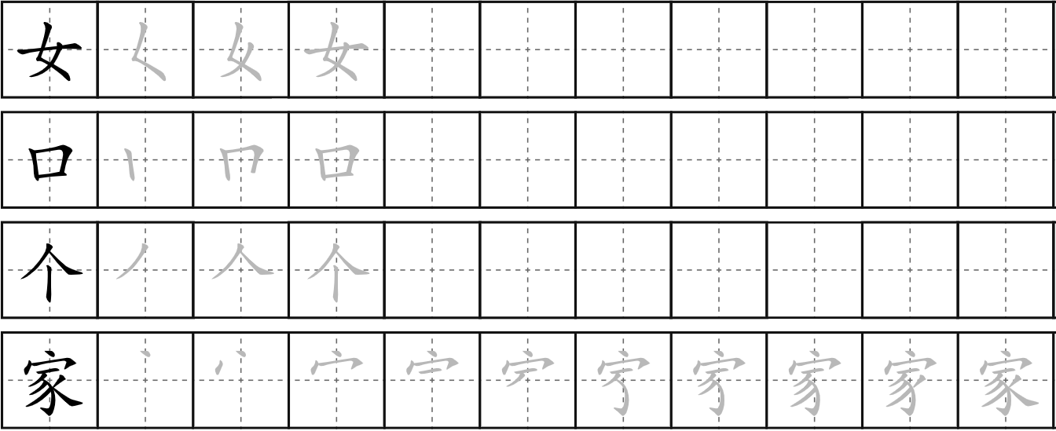
1. Practise writing the character and the radical
jiā
family/home
teulu/cartref
gè
measure word
kǒu
measure word
Female radical

2. Translate the following sentences into English or Welsh.
nǐ jiā yǒu jǐ kǒu rén

- 你家 有几口人？
____________________________
wǒ jiā yǒu wǔ kǒu rén
- 我家 有 五 口 人。
____________________________
tā yǒu yí ge gēge
- 他有一个哥哥。
____________________________
tā yǒu sān ge dìdi
- 她有 三个弟弟。
____________________________

wǒ yǒu liǎng ge jiějie
- 我 有 两 个 姐姐。
____________________________
wǒ yǒu liǎng ge gēge hé sān ge dìdi
- 他 有 两 个 哥哥和三个弟弟。
____________________________
tā méi yǒu mèimei
- 他 没有 妹妹。
____________________________

3. Answer the following questions in pinyin or in Chinese character. Then recording yourself reading it afterwards.
- 你叫什么名字？
- 你是哪国人？
- 你多大？
- 你的生日是几月几号？
- 你家有几口人？
____________________________________________________________________________________________________________________________________________________________
____________________________________________________________________________________________________________________________________________________________
4. Cultural study
https://youtu.be/raQWpGGeWOA
Research questions:
1. Why is Confucius still relevant in today's world?
2. What influences did Confucius or Confucianism post upon Chinese Family Culture?
3. Is Chinese culture Confucian Culture?
4. Is Confucius a good educator?
5. Why did lots of Chinese emperors love Confucianism?

