

The Feasibility of Using Cockle Shell Powder and Reclaimed Brick Powder as a Partial Replacement for Cement in Concrete
Nikhil Rai
Student number: 2511003
A dissertation submitted in partial fulfilment of the requirements for the degree of
MSc Sustainable Construction
Civil Engineering
University of Wales Trinity Saint David (UWTSD)
Supervisor: Dr. Shaker Bitar
September 2026
Copyright Statement
The copyright of this dissertation rests with the author. No part of it may be reproduced or published without the author's prior written consent, and any information derived from it should be properly acknowledged.
Author Declaration
I declare that this dissertation is my own work, except where otherwise acknowledged, and that it has not been submitted in whole or in part for any other degree or qualification. All sources of information have been acknowledged and are listed in the reference list.

Signed: .......Nikhil Rai ................
Date: ............11-09-2026..............
Contents
Acknowledgements viii
Abstract ix
List of Abbreviations and Symbols x
Chapter 1: Introduction 1
1.1 Background and context 1
1.2 Choice of topic 2
1.3 Research problem 3
1.4 Aim and research question 3
1.5 Objectives 4
1.6 Hypothesis 4
1.7 Scope and limitations 5
1.8 Structure of the dissertation 5
Chapter 2: Literature Review 6
2.1 Introduction 6
2.2 Reasons for alternative cementitious materials 6
2.3 Cockle shell powder 7
2.3.1 Properties and preparation 7
2.3.2 Cockle shell as a cement replacement 7
2.3.3 Cockle shell as an aggregate replacement 8
2.4 Reclaimed clay brick powder 9
2.4.1 Behaviour as a pozzolan 9
2.4.2 Replacement levels and strength 9
2.4.3 Durability and material variability 10
2.5 Comparison between the two materials 11
2.5.1 Filler versus pozzolan 11
2.5.2 Workability 13
2.5.3 Strength and optimum dose 13
2.5.4 Water absorption and durability 14
2.6 Summary and research gap 15
Chapter 3: Methodology 16
3.1 Introduction 16
3.2 Research approach 16
3.3 Materials 16
3.3.1 Cement 16
3.3.2 Fine aggregate 17
3.3.3 Coarse aggregate 17
3.3.4 Cockle shell powder 18
3.3.5 Reclaimed brick powder 20
3.3.6 Admixture 21
3.3.7 Water 22
3.4 Mix design 22
3.4.1 Basis of the design 22
3.4.2 Batch quantities 23
3.4.3 Verification against the BRE method 24
3.5 Specimen preparation and curing 25
3.6 Test programme 26
3.6.1 Workability 27
3.6.2 Compressive strength 27
3.6.3 Choice of test ages 28
3.7 Data analysis 29
3.8 Health, safety and ethical considerations 30
3.9 Summary 30
Chapter 4: Results and Discussion 31
4.1 Introduction 31
4.2 Workability 31
4.3 Data treatment and corrections 33
4.3.1 Excluded specimen 33
4.3.2 Note on the 7-day CSP result 33
4.4 Compressive strength results 34
4.4.1 Results at 7 days 34
4.4.2 Results at 14 days 34
4.4.3 Strength development 35
4.5 Discussion 37
4.5.1 The control mix 37
4.5.2 Cockle shell powder alone 38
4.5.3 Reclaimed brick powder alone 38
4.5.4 The blended mixes 39
4.5.5 Workability and strength considered together 40
4.5.6 Comparison across the programme 40
4.6 Limitations of the results 41
4.7 Summary 41
Chapter 5: Conclusions and Recommendations 43
5.1 Introduction 43
5.2 Conclusions against the objectives 43
5.3 Answering the research question 44
5.4 The hypothesis revisited 45
5.5 Contribution of the study 46
5.6 Limitations of the conclusions 46
5.7 Recommendations for further research 47
5.7.1 Immediate priorities 47
5.7.2 Characterisation of the powders 47
5.7.3 Narrowing the replacement range 48
5.7.4 Isolating the effect of the binder 48
5.7.5 Durability and wider assessment 48
5.8 Concluding remarks 48
References 50

List of Figures
Figure 1.1: Process-related industrial CO₂ emissions by source, 2010 (data source: Mohamad, Muthusamy and Ruslan, 2022) 1
Figure 3.1: Heidelberg Materials Multicem cement as supplied 16
Figure 3.2: Oven-dried fine aggregate being weighed 16
Figure 3.3: Oven-dried coarse aggregate being weighed 17
Figure 3.4: Fine and coarse aggregate drying in the laboratory oven 17
Figure 3.5: Waste cockle shells stockpiled at the collection site in Penclawdd 18
Figure 3.6: Washed and crushed cockle shell prior to milling 18
Figure 3.7: Impact Test Equipment Fast Mill used to grind the cockle shell and the reclaimed brick 19
Figure 3.8: Cockle shell powder after milling 19
Figure 3.9: Crushed reclaimed clay brick prior to milling 20
Figure 3.10: Reclaimed brick powder after milling 20
Figure 3.11: SikaMix 3 in 1 admixture 21
Figure 3.12: Belle Minimix tilting-drum mixer used for batching 24
Figure 3.13: Cube specimens under water curing 25
Figure 3.14: Measurement of slump 26
Figure 3.15: Cube specimen in the compression testing machine 27
Figure 4.1: Slump test on the control mix M0, 25 mm 31
Figure 4.2: Slump test on the 10% RBP mix M2, 127 mm 31
Figure 4.3: Slump test on the 4% CSP with 10% RBP mix M4, 89 mm. The reddish colour of the fresh concrete reflects the higher brick powder content 31
Figure 4.4: Compressive strength of all five mixes at 7 and 14 days 34
Figure 4.5: Compressive strength expressed as a percentage of the control at each age 35
List of Tables
Table 3.1: Mix matrix and replacement levels 22
Table 3.2: Batch quantities per 13.34 litre batch 22
Table 3.3: Equivalent mix proportions per cubic metre (kg/m3) 22
Table 3.4: Adopted proportions compared with a BRE derivation 23
Table 3.5: Test programme 25
Table 4.1: Slump results 30
Table 4.2: Compressive strength at 7 days 33
Table 4.3: Compressive strength at 14 days 33
Table 4.4: Strength development between 7 and 14 days, with projection to 28 days 34
Table 5.1: Summary of results at 14 days 41

Acknowledgements
I would like to thank my father Pramod Rai and my supervisor, Shaker Bitar, for their guidance and support throughout this project, and the technical staff at UWTSD for their help with milling, casting and testing in the laboratory. Finally, I would like to thank my family and friends for their encouragement during my studies.

Abstract
Cement production is responsible for roughly 5 to 8% of global CO₂ emissions, and reducing the clinker content of concrete remains the most direct way to cut its embodied carbon. This study examined whether two locally available UK waste materials, cockle shell powder (CSP) from the Penclawdd fishery and reclaimed clay brick powder (RBP) from demolition waste, could partially replace cement in concrete, both separately and as a blend. Each powder has been studied as a cement replacement before, but no published work was found that combines them. Five mixes were cast with a constant binder content of 350 kg/m³ and a free water to binder ratio of 0.50, using a Portland limestone cement: a control, 4% CSP, 10% RBP, and two blends of 4% CSP with 5% and 10% RBP. Workability was measured by the slump test, and compressive strength was measured on 100 mm cubes at 7 and 14 days. The two powders affected workability in opposite directions. CSP reduced slump from 25 mm to 13 mm, whereas RBP increased it to 127 mm. The blend of 4% CSP and 5% RBP matched the control slump and reached 23.27 MPa at 14 days, against 22.89 MPa for the control, outperforming both single-powder mixes (78% and 82% of the control). Raising RBP to 10% in the blend reduced strength to 54% of the control. This showed that the 14% blend was much less successful than the 9% blend, although intermediate replacement levels would need to be tested before any specific threshold could be identified. The results support a feasibility judgement rather than a design recommendation: a low-level CSP and RBP blend appears worth investigating in a larger study that includes later-age and durability testing.

List of Abbreviations and Symbols
Abbreviations
BRE Building Research Establishment
BS British Standard
CEM I Portland cement (BS EN 197-1 designation)
CEM II/A-LL Portland limestone cement (BS EN 197-1 designation)
CSP Cockle shell powder
EN European Standard (Europäische Norm)
M0 to M4 Mix designations (see Table 3.1)
n Number of specimens
OPC Ordinary Portland cement
RBP Reclaimed brick powder
SCM Supplementary cementitious material
XRF X-ray fluorescence
Chemical formulae
Al₂O₃ Aluminium oxide (alumina)
C₃S Tricalcium silicate
CaCO₃ Calcium carbonate
CaO Calcium oxide
CO₂ Carbon dioxide
Fe₂O₃ Iron(III) oxide
MnO Manganese(II) oxide
P₂O₅ Phosphorus pentoxide
SiO₂ Silicon dioxide (silica)
TiO₂ Titanium dioxide
Symbols
f_{cm} Mean compressive strength at 28 days (MPa)
f_{cm}(t) Mean compressive strength at an age of t days (MPa)
β_{cc}(t) Coefficient describing strength development with age
s Coefficient depending on cement class (BS EN 1992-1-1)
t Age of concrete (days)
Units
°C Degree Celsius
d Days (in table headings)
GPa Gigapascal
in Inch
kg Kilogram
kg/m³ Kilogram per cubic metre
kN Kilonewton
L Litre
mm Millimetre
MPa Megapascal (equivalent to N/mm²)
s Second
µm Micrometre

Chapter 1: Introduction
This study investigates whether cockle shell powder and reclaimed brick powder can be used, separately or together, as a partial replacement for cement in concrete.
This chapter sets out the background to the research, the research problem, the aim, objectives and hypothesis, and the scope of the work. It ends with an outline of how the dissertation is structured.

1.1 Background and context
Concrete is used in greater quantities than any other building material, and most of its carbon footprint comes from the cement that binds it. Mohamad, Muthusamy and Ruslan (2022) put the cement industry's share of global CO₂ emissions at between 5 and 8%, with around four billion tonnes of Portland cement used in 2018 and production still rising in China, India, the Middle East and North Africa. Hasan et al. (2024) report roughly one tonne of CO₂ for every tonne of cement produced, while Małek et al. (2025) give a slightly lower range of 0.85 to 0.95 tonnes per tonne of Portland cement. Whichever figure is used, the conclusion is the same: lower-carbon concrete needs less clinker.
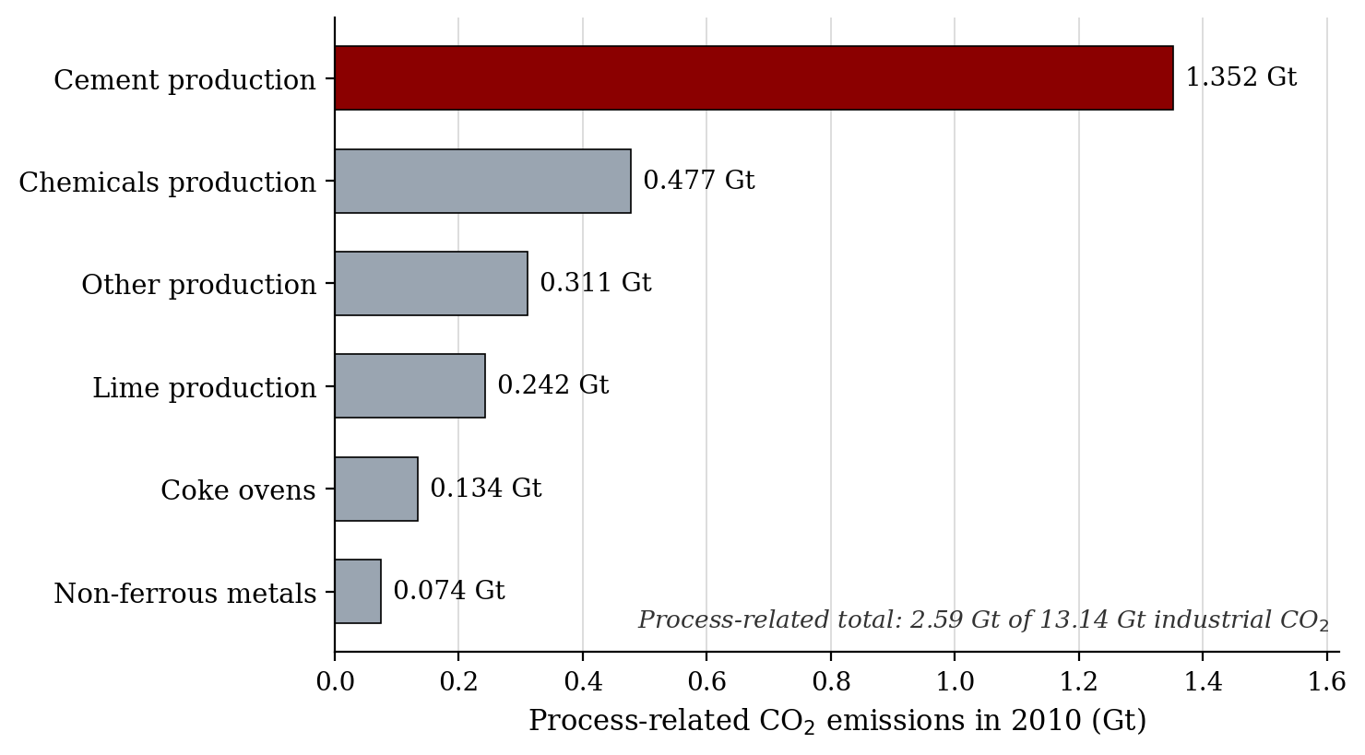
Figure 1.1: Process-related industrial CO₂ emissions by source, 2010 (data source: Mohamad, Muthusamy and Ruslan, 2022)
The usual way to reduce clinker is to replace part of the Ordinary Portland Cement (OPC) with supplementary cementitious materials (SCMs), and much recent research has looked for suitable SCMs in waste streams. Two waste materials are relevant to this study. The first is clay brick, which makes up a large share of construction and demolition waste. Once finely ground, it behaves as a pozzolan because of its silica and alumina content (Liu et al., 2020; Yang et al., 2020; Wu et al., 2022; Tahwia et al., 2025). The second is cockle shell. Most of the shell discarded by the shellfish industry is dumped on open sites, where the remaining meat decomposes and smells, and only a small fraction is recycled (Mohamad, Muthusamy and Ruslan, 2022).
The quantities involved are not trivial. Malaysia exported 538 tonnes of clams, cockles and ark shells in 2019 and 947 tonnes in 2020 (Mohamad, Muthusamy and Ruslan, 2022). The shell is almost pure calcium carbonate (Mat Aris et al., 2018; Hasan et al., 2024; Othman et al., 2024), so dumping it wastes a potentially useful mineral as well as creating a nuisance.
Interest in cockle shell as a concrete ingredient continues. In a recent study, Pitriyani, Devi and Febryandi (2024) replaced fine aggregate with cockle shell powder at up to 15% and found that 28-day compressive strength increased at each step in shell content. Results like this keep the material of interest, but they also show how much depends on the role the shell plays in the mix. As an aggregate replacement it can be used at percentages that would weaken the concrete if the same powder were taken out of the cement instead. Chapter 2 looks at this distinction in more detail.
Nearly all of this evidence comes from outside the UK. The cockle shell studies are mostly from Malaysia, Indonesia and elsewhere in South-East Asia, and the brick powder studies come mainly from China, Poland, Iraq and Egypt. No published study was found that tests these findings with UK materials in a UK laboratory, and this project is a first step towards doing so.

1.2 Choice of topic
Two factors shaped the choice of topic. The first was the MSc Sustainable Construction programme itself, which encourages work on circular-economy materials. The second was location. Swansea is close to the cockle beds of the Loughor estuary at Penclawdd, where there is a long-established commercial cockle fishery, so waste shell could be collected locally. Reclaimed brick, meanwhile, can be obtained from demolition and recycling yards almost anywhere. The literature search for the research proposal that preceded this dissertation showed that both powders had been tested as cement replacements on their own, but never in combination. A clear gap in the literature, together with two locally available materials, settled the topic.

1.3 Research problem
No published study has combined cockle shell powder (CSP) and reclaimed brick powder (RBP). The case for pairing them is simple. CSP acts mainly as a calcium carbonate filler: it packs between the cement grains and gives the hydration products extra nucleation sites. RBP contributes later, reacting with the calcium hydroxide released as the cement hydrates (Yang et al., 2020; Wu et al., 2022). Whether the pairing works in practice is less certain, largely because the two materials perform best at different levels. Shell-based cement replacements tend to perform best at around 5%, and reviews advise against going much beyond 10% (Wan Mohammad et al., 2017; Tayeh et al., 2019; Mohamad, Muthusamy and Ruslan, 2022; Hasan et al., 2023; Othman et al., 2024). Finely ground brick powder performs best at nearer 10 to 15% (Yang et al., 2020; Arif et al., 2021; Małek et al., 2025). Higher shell contents only appear to be tolerated when the shell replaces aggregate rather than binder (Mat Aris et al., 2018; Ruslan et al., 2022; Pitriyani, Devi and Febryandi, 2024; Ruslan et al., 2024).
The research problem can therefore be stated as follows: can a limited CSP and RBP blend replace part of the cement while keeping workability and 7-day and 14-day compressive strength close to those of a control mix without replacement? A study of this size cannot answer that with a design recommendation, and it does not try to. What it can offer is a judgement on feasibility. Even a negative answer would be useful, because it would save future researchers from committing a larger budget to an approach that does not work.

1.4 Aim and research question
The aim of the research was to assess the feasibility of using cockle shell powder and reclaimed brick powder, on their own or blended, as a partial replacement for cement in concrete.
The research question was: to what extent can CSP and RBP, separately and in combination, replace a limited proportion of cement while keeping workability and compressive strength close to those of a control mix?

1.5 Objectives
The aim was broken down into five objectives:
1. To prepare CSP and RBP powder using practical procedures.
2. To describe the basic physical properties of both powders.
3. To cast a limited set of concrete mixes containing CSP, RBP and a CSP and RBP blend as partial cement replacements, alongside a control mix with no replacement.
4. To measure the workability of the fresh mixes and their compressive strength at 7 and 14 days.
5. To compare the fresh and hardened performance of the replacement mixes with that of the control under identical laboratory conditions.

1.6 Hypothesis
The hypothesis was that low replacement levels, around 4% CSP combined with 5 to 10% RBP, would give workability and 14-day strength close to those of the control. The 4% figure comes from Olivia, Oktaviani and Ismeddiyanto (2017), who tested cement replacement at exactly that level using ground marsh clam and ground blood cockle. The 5 to 10% range for RBP draws on Arif et al. (2021), who identified 10% as the practical optimum for waste brick powder on both performance and cost grounds, and on Małek et al. (2025), who also found 10% ground brick powder to be optimal for mechanical performance and reported up to a 54% gain in compressive strength over their reference mix. For shell, Ruslan et al. (2024) obtained their highest 28-day strength at 10% crushed cockle shell, although as a fine aggregate replacement rather than a cement replacement. Above these levels, strength was expected to fall, because removing too much cement dilutes the binder faster than the filler and pozzolanic effects can compensate. Ruslan et al. (2024) observed this above 10% shell, and Ge et al. (2012) recorded flexural strength losses of 9.1%, 12.5% and 15.7% as brick powder content rose from 10% to 20%, 25% and 30%.

1.7 Scope and limitations
The work is laboratory-based and short-term. Compressive strength was measured at 7 and 14 days only. There was no testing at 28 or 90 days, no durability testing (such as water absorption, accelerated carbonation or chloride resistance), no structural testing and no attempt to demonstrate compliance with design codes. None of these could be fitted into a dissertation lasting three to four months.
Two consequences of this were accepted from the outset, and both are discussed further in section 3.6.3. First, because 28 days is the reference age for conformity assessment, no result reported here can be taken as evidence that a mix meets a particular strength class. The programme instead provides a like-for-like comparison between the replacement mixes and the control, which is what a feasibility judgement needs. Second, the pozzolanic reaction of RBP develops over weeks rather than days, so the 14-day results are likely to understate its contribution. The findings therefore support a judgement on feasibility and nothing more. Any positive result is a reason for a longer study, not a design value.

1.8 Structure of the dissertation
Four chapters follow. Chapter 2 reviews the literature on both powders in cementitious systems, organised by theme rather than by author, and identifies the gap this study addresses. Chapter 3 describes and justifies the methodology, covering the sourcing and preparation of materials, the mix design, the test programme, data analysis, and health, safety and ethical considerations. Chapter 4 presents the results and discusses them against the literature reviewed in Chapter 2. Chapter 5 draws conclusions from the project as a whole and makes recommendations for further research. The reference list follows Chapter 5.
The Harvard referencing system is used throughout, and every source cited in the text appears in the reference list. Abbreviations are written out in full at first use, with the abbreviation in brackets, and a full list is given in the front matter. Figures and tables are numbered by chapter (for example, Figure 3.1 and Table 3.1) and are listed after the contents page.

Chapter 2: Literature Review

2.1 Introduction
This chapter reviews published work on the use of cockle shell powder and reclaimed brick powder as cementitious materials in concrete. The two materials are first considered separately and then compared. The comparison is intended to do more than restate earlier findings: it looks at where the two materials might complement each other, where they might not, and whether there is good reason to expect them to work well together in a single mix. The review is organised by theme rather than paper by paper, and it considers how much weight each finding can bear. It ends by identifying the gap that this dissertation sets out to address. The wider carbon problem was covered in Chapter 1 and is referred to here only where it helps to frame the materials.

2.2 Reasons for alternative cementitious materials
The most direct way to lower the carbon cost of concrete is to use less clinker, and supplementary cementitious materials (SCMs) are the usual means of doing so. The best-known SCMs are fly ash, silica fume and ground granulated blast-furnace slag. They reduce embodied carbon and often improve durability, but supply is becoming a problem. Fly ash and slag, which are used in the largest quantities, come from coal-fired power generation and blast-furnace steelmaking, and both industries are in decline. As a result, researchers have started looking for SCMs that can be recovered from waste, in line with the wider move towards a circular economy (Scrivener, John and Gartner, 2018; Liu et al., 2020; Wu et al., 2022; Tahwia et al., 2025).
A waste powder is only useful as an SCM if it meets a few basic requirements. There must be enough of it, its quality must be reasonably consistent, it must be safe to handle, and the concrete containing it must still perform acceptably when fresh, as it gains strength, and over the long term. Cockle shell powder and reclaimed brick powder are assessed against these requirements in the sections below. The question is not whether either powder can replace cement wholesale, but how much can be substituted before the concrete starts to suffer, and why.

2.3 Cockle shell powder

2.3.1 Properties and preparation
The process of making powdered cockle shell is different from study to study. A common way to make powdered cockle shell was described by Othman et al. (2024), in which the shells were washed, dried at approximately 110°C for 24 hours, and then ground. Washing and drying are more important than they seem. Residual meat and salt from the cockles create odour when shells are discarded, and this can affect the performance of the powder in a mix. Grounded cockle shell has particle diameters ranging from 36- 75 µm that fall into the same size range as Portland cement and are therefore an appropriate substitute (Othman et al., 2024).
The cockle shells contain calcite and aragonite. These two materials have been shown to produce higher strength and density than normal limestone powder (Othman et al., 2024). Raw shell usually consists of approximately 95-97% CaCO₃ with very low percentages of trace mineral content and remaining organic material. When raw shell is heated to temperatures above approximately 550°C, the CaCO₃ will start to release CO² gas and transform into CaO. The percentage of CaO in terms of oxides ranges from 52-57% depending upon the type of shell (Othman et al., 2024). Heating raw shell with 95-97% CaCO₃ yields approximately 52-57% CaO; similarly, calcined shell with greater than 90% CaO. The approximate value therefore relates to the raw shell rather than the calcined form.

2.3.2 Cockle shell as a cement replacement
When it comes to dosage, the studies were extremely consistent; when using cockle shell, the smaller dosages had better performance than larger dosages.
Othman et al. (2024) interpreted previous works as indicating that approximately 5% cement substitution by weight would result in the 7-day and 28-day strengths being lower than controls, yet still sufficient for building. Wan Mohammad et al. (2017) came to a similar conclusion based upon their analysis and indicated that 5% substitutions produced flexural strengths of 4.5-6.75 MPa that continued to increase at both 28 and 91 days. They attributed these increases to calcium-rich bond formation between the shell and the paste.
As the dosages become greater, the data become less clear. Nor Hisham, Razali and Razali (2017) utilized calcined shell powder as a binder replacement at dosages of 10%, 20%, 30% and 40%.
Carbonation was enhanced; however, compressive strength decreased as the dosages increased. This is thought to have been caused in part by the slow development of the aragonite found within the shell. Both the species and origin of the shell have an equal amount of influence relative to the dosage. Olivia, Oktaviani and Ismeddiyanto (2017) investigated the use of ground marsh clam versus ground blood cockle to substitute for 4% cement. At this level, the marsh clam mix developed significantly quicker than the control and exceeded the control in terms of density, compressive strength and tensile strength. However, at the same 4% level the blood cockle mix performed poorly and did not reach levels near the control until after 91 days. Two shells with nearly identical levels of carbonates exhibited dramatically different performances.

2.3.3 Cockle shell as an aggregate replacement
When using crushed shells instead of cement, greater amounts are able to be utilized. Ruslan et al. (2024) studied 100% crushed shells as sand replacements within mortar at 0-40% by volume and reported compressive strengths of 17.52-22.21 MPa after 28 days; however, they noted that a mix utilizing 10% crushed shell resulted in the greatest overall performance. Strengths and fire resistance decreased when crushed shell was added above 10%. Mass losses were measured at 800°C and ranged from 9.18% (control) to 11.09%. Mat Aris et al. (2018) continued this line of study by demonstrating that 20% pulverized shell as a sand replacement within a palm oil fuel ash cement-sand brick provided the greatest values of 28-day compressive and flexural strengths and the least amount of water absorption among all mixes examined. The results from Pitriyani, Devi & Febryandi (2024) are the most dramatic to date. They reported that adding 5%, 10%, and 15% of fine aggregate with a superplasticizer dosing rate of 0.8% to replace fine aggregate resulted in increased 28-day compressive strengths of the mixes from 25.39 MPa for the control mix to 35.45 MPa for the 15% addition, while resulting in little to no loss of slump. A notable difference exists between these studies and those involving cement replacement. It has been demonstrated that the same powder that will require approximately 5% as a binder replacement may be used at levels up to or exceeding 15% as an aggregate due to the fact that the powder does not replace reactive cement. Hasan et al. (2024) and Jun et al. (2025) have also observed good results when shell powder is incorporated alongside additional waste materials such as palm oil clinker powder and palm oil fuel ash.

2.4 Reclaimed clay brick powder

2.4.1 Behaviour as a pozzolan
Reclaimed clay brick powder belongs to the wider group of ceramic waste powders. Because brick is fired clay, it contains reactive aluminosilicate phases that can react with the calcium hydroxide released during cement hydration. This reaction forms additional calcium silicate hydrate or calcium aluminosilicate hydrate, which is genuine pozzolanic behaviour rather than simple filling (Yang et al., 2020; Likes et al., 2022; Wu et al., 2022; Tanash et al., 2023; Tahwia et al., 2025). The extent of the reaction depends on fineness and mineral composition. Yang et al. (2020) measured a pozzolanic activity index of about 89.6% for finely ground clay brick powder, confirming that it has the basic characteristics of an SCM. Wu et al. (2022) found waste brick powder to be more pozzolanically active than waste concrete powder, and noted that it also acts as a useful filler and refines the pore structure of the paste.

2.4.2 Replacement levels and strength
The optimal amount of brick powder to be replaced in the cement can range from five percent (5%) to fifteen percent (15%). A research study carried out by Arif et al. in 2021 studied brick powder at two different percentages: 5 percent (5%) and ten percent (10%), and the results showed improvement in workability. They claimed that the rounded, smooth shape of the brick powder acted similarly to small ball bearings, which resulted in better flowability. Additionally, Arif et al. concluded that 10 percent (10%) was the most economically viable percentage because it provided the maximum benefits with respect to performance and costs. Małek et al. conducted a study where they utilized crushed brick powder as a substitute for 5%, 10%, and 15% of the cement used in concrete production. Results indicated that when using crushed brick powder as a substitute for 10% of the cement used in concrete production, there were improvements in mechanical properties such as compressive strength. When comparing the results of the study conducted by Małek et al. with the reference mixture, results showed that there were increases in compressive strength ranging from twenty-four percent (24%) to fifty-four percent (54%), depending on the type of crushed brick powder used. On the other hand, when utilizing crushed brick powder as a substitute for 15% of the cement used in concrete production, results indicated that the thermal insulation improved. Another study conducted by Salman and Yousif in 2018, investigated the use of yellow clay brick powder as a substitute for cement. In the study, Salman and Yousif utilized a range of percentages of yellow clay brick powder including 5%, 10%, and 50%. The findings of the study revealed that replacing up to ten percent (10%) of the cement with yellow clay brick powder only slightly reduced its physical properties. Additionally, the chemical composition of the yellow clay brick powder included 21.61% SiO₂, 64.23% CaO, 4.97% Al₂O₃ and 3.30% Fe₂O₃. These results indicate that the chemical makeup of the yellow clay brick powder is comparable to that of Portland cement instead of fired clay bricks, which typically have higher concentrations of SiO₂ and lower concentrations of CaO.

2.4.3 Durability and material variability
The available durability data on the use of brick powder are promising for the use of brick powder up to low dosages. For example, Sinkhonde et al. (2022) demonstrated that replacement levels of up to 5% of the aggregate by volume of brick powder in a rubberised concrete mixture resulted in a lower water absorption capacity compared to the control and also showed superior resistance to deterioration due to exposure to seawater and sulphuric acid after testing for 90 days. Similarly, Tahwia et al. (2025) reported an increase in compressive strength of approximately 21.12% at 25% by mass of brick powder in a geopolymer matrix, whilst significant decreases were observed at 50% and 75%. Furthermore, they concluded that the use of brick powder resulted in superior resistance to degradation caused by exposure to sulphate attack of the three alternative powdered aggregates tested. On the other hand, Liu et al. (2020) demonstrated improvements in mortar strength when using 10% of the cement content to be replaced by powders produced from construction and demolition waste. However, the authors noted that increasing the fineness of aerated concrete blocks through grinding requires significantly more energy than grinding fired bricks.
A clear trend evident throughout these studies is the high degree of variability associated with the production and properties of each type of brick powder. Yellow clay brick (Salman and Yousif, 2018), twentieth century red brick (Małek et al., 2025), mixed demolition waste (Liu et al., 2020; Wu et al., 2022), and aged housing rubble (Arif et al., 2021) have all been used in previous research studies but yielded very different results. Therefore, based upon the above information, it can be deduced that brick powder should be viewed as a family of materials rather than a single material. Consequently, any investigation which utilises brick powder should include details regarding its origin and preparation method to enable comparisons to be made between different studies, rather than assuming that brick powder will exhibit identical characteristics irrespective of source or preparation. Chapter Three will follow this approach.

2.5 Comparison between the two materials
Viewed side by side, the two powders do different jobs in the mix, and that difference is the main reason for combining them. This section compares them on the properties most relevant to the experimental work.

2.5.1 Filler versus pozzolan
Chemically, cockle shell powder is essentially calcium carbonate, created by an active biological entity. Therefore, the bulk of research regarding limestone powder within cement can be applied to how the cockle shell powder will act. Wang et al. (2018) conducted a review of the previous research and determined that there are four ways in which a finely ground carbonate powder can affect a concrete mix. A filler effect exists. The addition of fine particles, such as those present in a finely ground carbonate powder, provides density to the microstructural voids that exist in all concrete. In essence, they fill space. By filling space within a given volume, the concrete's porosity decreases. There is also a nucleation effect. When a finely ground carbonate powder is added to fresh cement paste, the powder's surface area allows earlier formation of hydrating products.
As mentioned previously, hydration products are formed when water reacts chemically with the oxides present in the cement paste. These hydrating products form a matrix around the aggregate particles (sand & gravel) and hold the structure together. Accelerated hydration results in faster early strength gain. Dilution occurs. The use of a finely ground carbonate powder as a partial replacement for cement effectively replaces reactive material (clinker) with non-reactive material (the carbonate powder). Therefore, some of the potential for the hydrated paste to react with aggregate particles is diminished. Finally, although likely negligible compared to the other three effects, there is a chemical effect. Carbonate may react with certain phases of the aluminum oxide present in the cement paste to produce carboaluminate compounds. The positive effects (strength & reduced porosity) attributed to the filler & nucleation effects are counteracted by negative effects (reduced ability to develop strength due to dilution). The degree to which one effect predominates over another depends upon both the amount of finely ground carbonate powder that is used, and how finely it is ground.
Wang et al. (2018) suggest using no more than 10% of the total binder weight as fine limestone when the goal is to reduce porosity and increase durability. Briki et al. (2021) demonstrate how important particle fineness is to achieving this equilibrium. The authors state that both the chemical and physical effects of limestone generally compensate for clinker lost due to substitution up to approximately 15%. Beyond this point, properties begin to decrease. Within their study, at levels of substitution of up to 20%, a finely ground limestone (<2 µm median particle diameter) resulted in compressive strengths comparable to those of plain Portland cement up to seven days after placement. In contrast, a coarse limestone (>130 µm) primarily served to contribute a dilution effect. Li and Cao (2024) quantify this boundary. The authors found through their review of existing literature that a finely ground limestone powder (<20 µm) increases hydration rates through both nucleation and chemical reactions, while larger/larger grain sized powders result in slower hydration rates due to dilution effects. Collectively, the three studies discussed above describe why small amounts of finely ground materials were effective and large/coarse amounts were ineffective in improving mechanical performance. Additionally, they provide justification for considering CSP as being similar to a finely ground limestone type filler having a narrow range of usability depending on its grind quality. This is especially relevant here since the cement utilized in the experimental work was Portland Limestone Cement, as described in Chapter 3.
The contribution made by Reclaimed Brick Powder (RBP) differs significantly from that made by CSP. The primary contributions made by RBP are chemical and time-dependent. Specifically, during the hydration process (hydration occurs when water comes into contact with cement), the aluminosilicate phases present in the reclaimed brick react chemically with the calcium hydroxide produced during hydration to create additional binding products. RBP also possesses a secondary filler effect (Wu et al., 2022; Yang et al., 2020). Due to the time required for these reactions to occur (weeks vs. hours), RBP typically benefits later-age strength development more than early-age strength development. Evaluating the differences between these two types of contributions is what provides a basis for evaluating whether a blend would be beneficial. CSP could serve to enhance early-age strength and particle packing, while RBP could provide later-age strength. If both components are complementary (i.e., each serves to make up for weaknesses in the other component), then blending CSP & RBP could potentially provide improved mechanical performance relative to either individual component alone. However, this is simply a hypothetical concept based upon our current understanding of these materials, and there are no studies reported in the literature that have evaluated this concept.

2.5.2 Workability
Two of these materials have different impacts on the workability of concrete. When using brick powder, for example, the workability is improved, and this is due to the rounded and smooth surface of the brick powder, which acts like small ball bearings. On the other hand, cockle shell reduces workability in addition to the fact that it increases internal friction among the shells with its sharp angles and rough surfaces when it is crushed into an aggregate. When finely grinding cockle shell to be used as a filling material, it produces less of an impact compared to crushed shell, and Ruslan et al. (2024) found that by adding superplasticizer to a mixture containing 15% finely ground shell, they were able to keep slumps relatively consistent. A blend of both will produce an interaction between the lubrication provided by the brick powder and the stiffness provided by the cockle shell, resulting in some cancellation of each other's effects. As well as fresh properties, such as those related to workability, many of the experimental methods described above are also capable of providing direct answers to this question.

2.5.3 Strength and optimum dose
Both materials show the same broad pattern: strength rises to a peak and then falls. The peaks occur at different levels, however, and where they occur depends on the role of the material (Zhang et al., 2024). As a cement replacement, cockle shell peaks at a low level, around 5% (Wan Mohammad et al., 2017; Othman et al., 2024), while brick powder peaks higher, at around 10 to 15% (Yang et al., 2020; Arif et al., 2021; Lam, Le and Nguyen, 2023; Sallı Bideci, Bideci and Ashour, 2024; Małek et al., 2025). The limestone research explains why. Shell behaves essentially as an inert filler, so its dilution effect takes hold early, whereas brick powder continues to add strength at higher doses because its pozzolanic reaction is still contributing. This difference in optimum dose is the reason a blend has to be tested rather than predicted: the best combined dose cannot simply be read from the two single-material curves.
The reviewed studies also give some indication of when strength develops, not just how much develops. Nor Hisham, Razali and Razali (2017) tested at 7, 14, 28 and 56 days and found that their shell mixes gained strength rapidly over the first 14 days. The best of these mixes reached its peak at 14 days, and none showed meaningful strength development after 28 days. Jun et al. (2025) reported a strong linear relationship between 7-day and 28-day strength in cockle shell mixes, with a coefficient of determination of 0.9115, and treated the early result as a reliable predictor of the later one. Together, these findings suggest that the behaviour of a carbonate filler is largely established within the first two weeks, which is relevant to the test programme adopted in Chapter 3.

2.5.4 Water absorption and durability
At low doses, both materials can reduce water absorption, but for different reasons. With brick powder, the cause is pore refinement through the pozzolanic reaction: Sinkhonde et al. (2022) found that 5% burnt brick powder lowered absorption and improved resistance to acid and sea water. With shell, the cause is improved particle packing, and Mat Aris et al. (2018) recorded the lowest absorption at 20% shell used as fine aggregate. Ge et al. (2012) add an important caution, since water absorption almost doubled between their two brick powder grades, which shows that any benefit depends on the powder being ground to a suitable fineness. Durability was not tested in this study, for the time reasons given in Chapter 1, so the evidence in this section is treated as context for interpreting the strength results rather than something the experimental work sets out to confirm.

2.6 Summary and research gap
Each material has been studied in some depth on its own. Cockle shell has been investigated as a cement replacement (Nor Hisham, Razali and Razali, 2017; Olivia, Oktaviani and Ismeddiyanto, 2017; Wan Mohammad et al., 2017; Hasan et al., 2024; Othman et al., 2024) and as an aggregate replacement (Mat Aris et al., 2018; Pitriyani, Devi and Febryandi, 2024; Ruslan et al., 2024; Jun et al., 2025). Brick powder has been investigated as a cement replacement (Ge et al., 2012; Salman and Yousif, 2018; Yang et al., 2020; Arif et al., 2021; Tahwia et al., 2025), as an aggregate replacement (Małek et al., 2025) , and as part of recycled demolition powder blends (Liu et al., 2020; Wu et al., 2022; Sinkhonde et al., 2022). The mechanisms behind both are also reasonably well understood: the carbonate filler behaviour of shell through the limestone literature (Wang et al., 2018; Briki et al., 2021; Li and Cao, 2024), and the pozzolanic behaviour of brick powder through the literature on ceramic waste.
What is missing is any study that combines the two. None of the papers reviewed tests cockle shell powder and reclaimed brick powder together as a cement replacement in concrete, even though their mechanisms appear complementary and their different optimum doses suggest that a blend might outperform either material alone. There is also a geographical gap. Almost all of the evidence comes from Asia, Eastern Europe and the Middle East, and none of it involves UK materials or a UK source of cockle shell. This dissertation addresses the first gap directly and makes a start on the second, by comparing single and combined replacement mixes with a control under the same laboratory conditions, at a feasibility level.

Chapter 3: Methodology

3.1 Introduction
This chapter explains how the experimental work was carried out and why. It describes where each material came from and how it was prepared, explains the mix design and the reasoning behind the chosen replacement levels, and gives the batch quantities and the procedures used for casting, curing and testing. It ends with the approach to data analysis and the health, safety and ethical arrangements that applied in the laboratory.

3.2 Research approach
The study used a quantitative experimental approach carried out entirely in the laboratory. Five concrete mixes were prepared, one control and four with partial cement replacement, and all five were mixed, cast, cured and tested under the same conditions. Because everything except the composition of the binder was held constant, any difference in workability or compressive strength between the mixes can reasonably be attributed to the replacement material rather than to some other variable. This comparative design is standard in the literature reviewed in Chapter 2.
The approach is comparative rather than predictive. The purpose is not to derive a design value for a CSP and RBP concrete, which would require a much larger programme, but to establish whether such a concrete performs acceptably relative to a control given identical treatment.

3.3 Materials

3.3.1 Cement
The binder used throughout was Heidelberg Materials Multicem, a bagged cement conforming to BS EN 197-1. Multicem is not a CEM I Portland cement. The manufacturer describes it as a Portland limestone cement (CEM II/A-LL), supplied in strength class 32,5R or 42,5N depending on the works that produce it (Heidelberg Materials, 2025). This matters for the study and is stated here for that reason. A CEM II/A-LL cement already contains interground limestone, so the control mix is not a plain Portland cement concrete, and the CSP added to mixes M1, M3 and M4 goes into a binder that already contains a calcium carbonate addition. The implications for interpreting the results are discussed in Chapter 4.
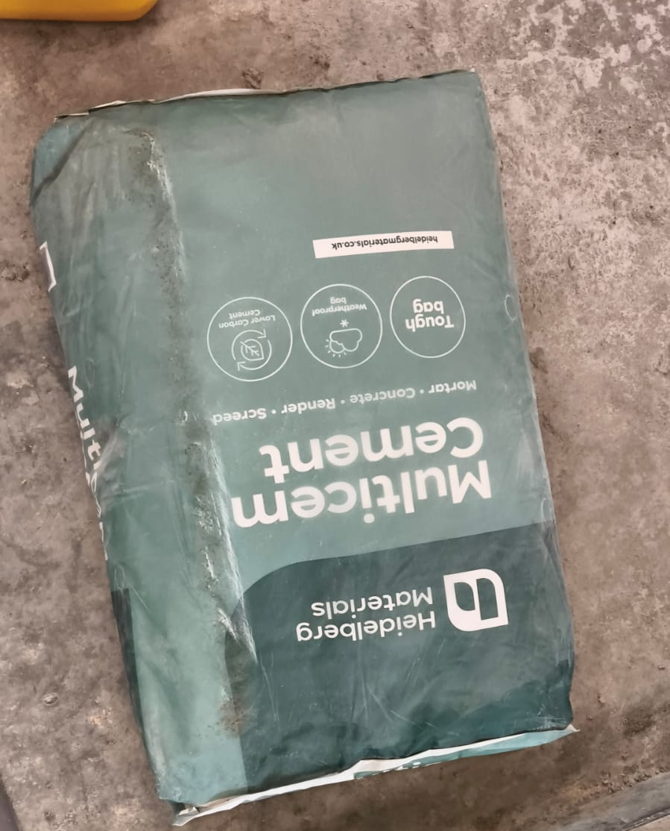
Figure 3.1: Heidelberg Materials Multicem cement as supplied

3.3.2 Fine aggregate
Natural sand was used as the fine aggregate. It was oven dried before batching so that all quantities were weighed in the same dry condition and no uncontrolled moisture was carried into the mix. Oven-dry aggregate does absorb some of the mixing water, so the effective free water content will have been slightly lower than the nominal value. Because the same aggregates and quantities were used in every mix, this does not affect the comparison between them.
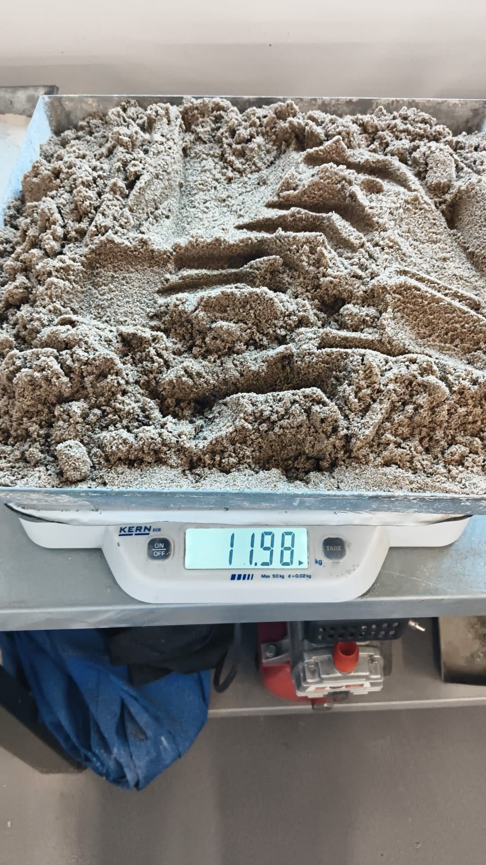
Figure 3.2: Oven-dried fine aggregate being weighed

3.3.3 Coarse aggregate
Crushed limestone with a maximum size of 20 mm was used as the coarse aggregate. It was also oven dried before batching.
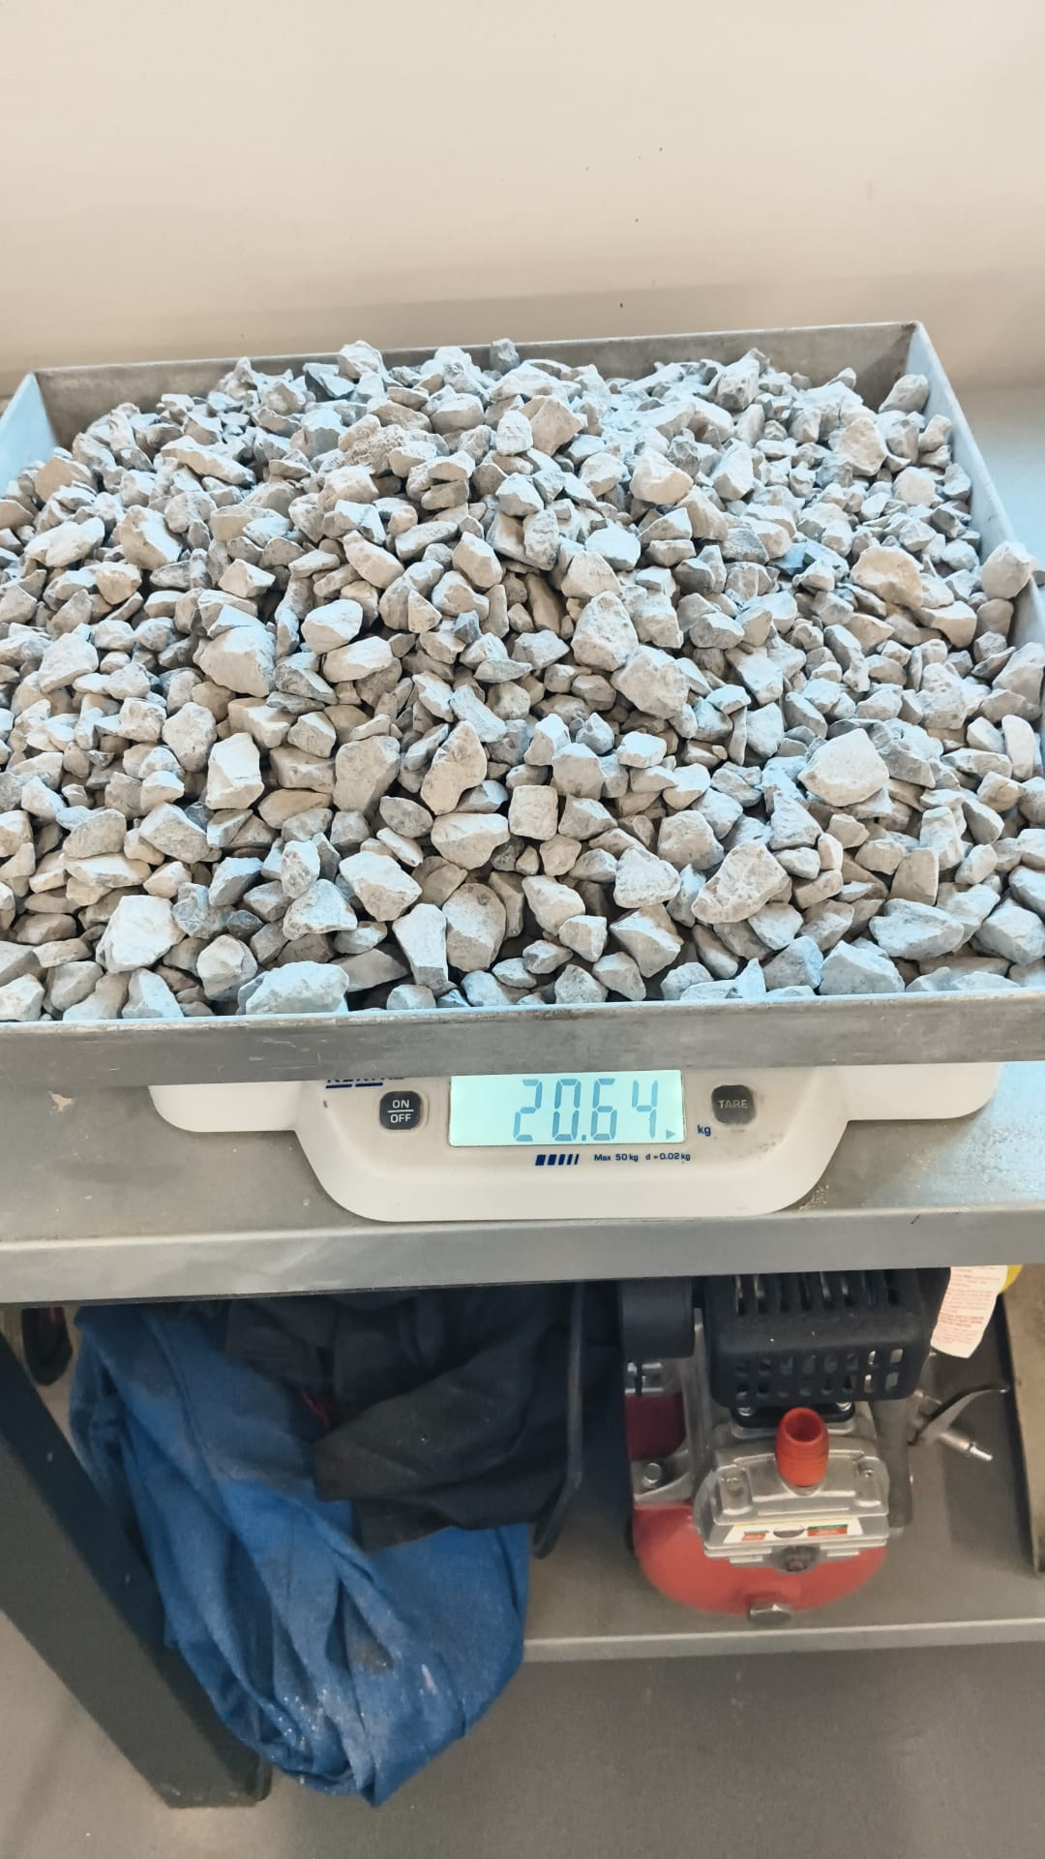
Figure 3.3: Oven-dried coarse aggregate being weighed
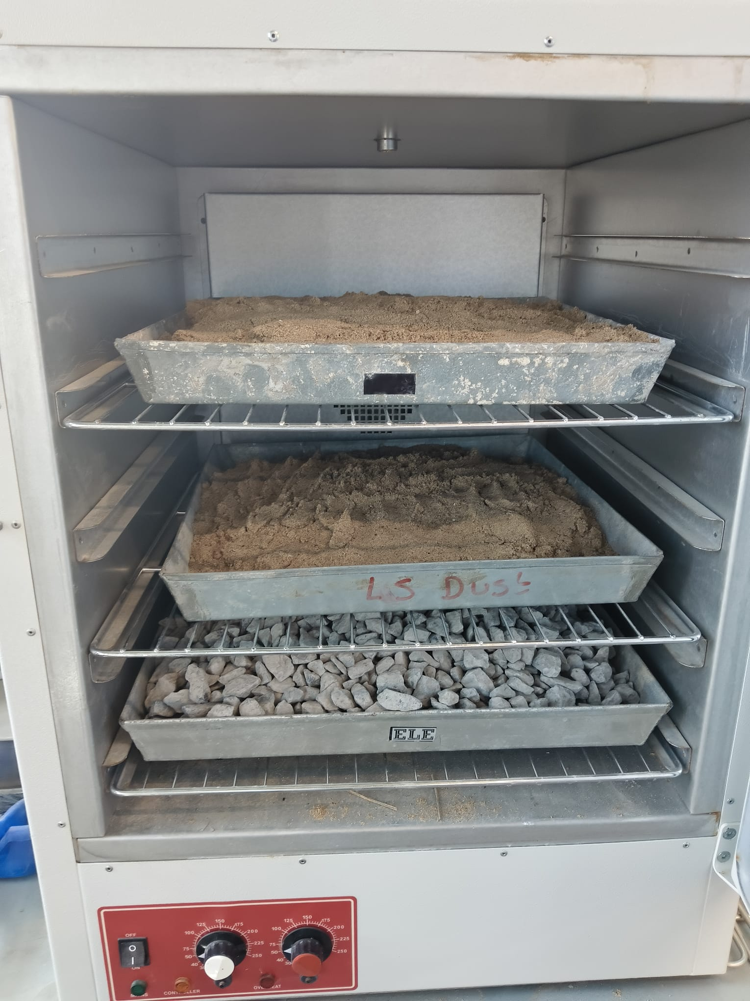
Figure 3.4: Fine and coarse aggregate drying in the laboratory oven

3.3.4 Cockle shell powder
Cockle shells were obtained as a waste product from a commercial cockle fishery at Penclawdd. They were collected from an open storage area at the site, where shells are stockpiled after the meat has been removed, and they belong to the same waste stream described in Chapter 1.
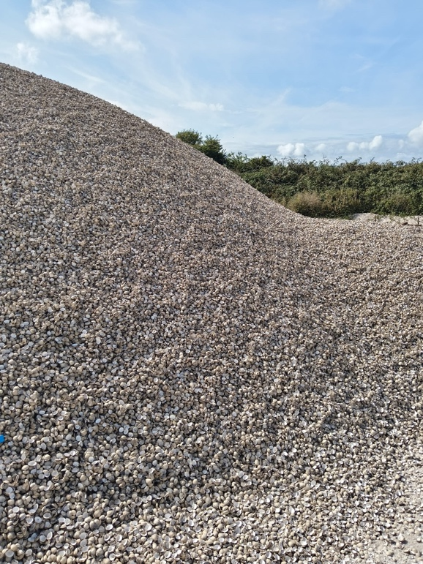
Figure 3.5: Waste cockle shells stockpiled at the collection site in Penclawdd
Preparation followed the route reported by Othman et al. (2024). The shells were washed to remove sand, grit and remaining organic matter, and then oven dried. As noted in section 2.3.1, this step is more important than it may appear, because residual meat and salt cause the odour associated with dumped shell and can affect how the powder behaves in the mix. The dried shells were then crushed into coarse fragments before milling.
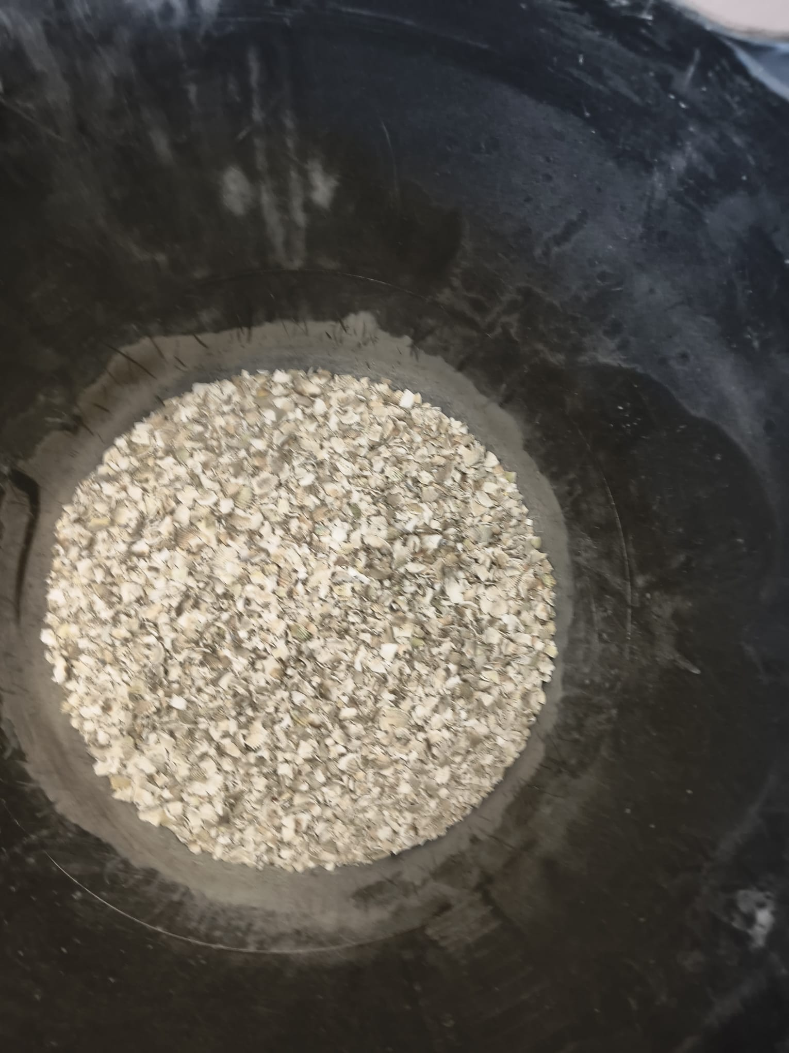
Figure 3.6: Washed and crushed cockle shell prior to milling
Final grinding was carried out in a bench-top laboratory mill (an Impact Test Equipment Fast Mill), in which the crushed shell was ground for ten minutes. The milled powder was then sieved to remove oversize material, giving a fine off-white powder that appeared similar in fineness to cement, although its particle size was not measured. For comparison, Othman et al. (2024) report ground cockle shell in the range of about 36 to 75 µm, which is close to the range for Portland cement.
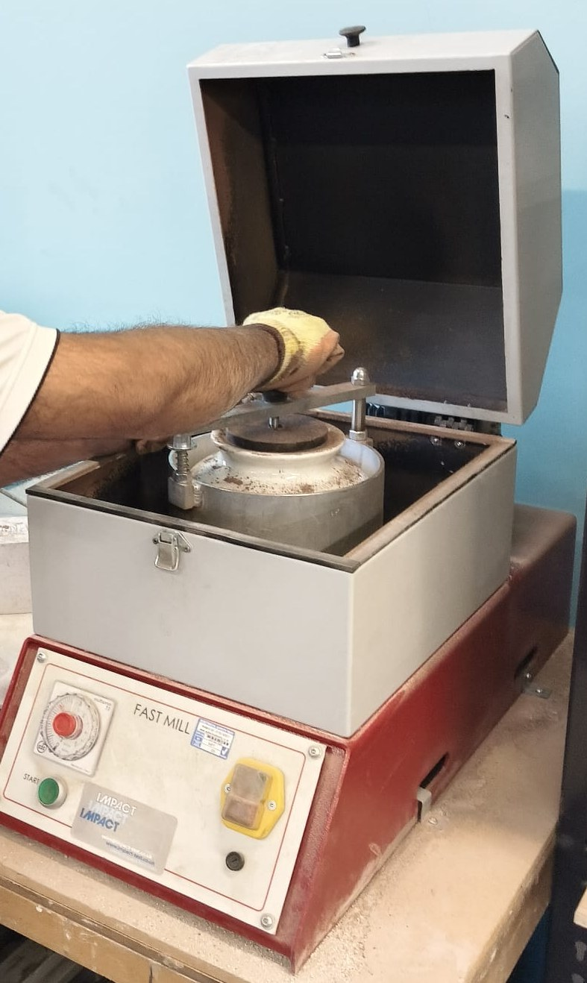
Figure 3.7: Impact Test Equipment Fast Mill used to grind the cockle shell and the reclaimed brick
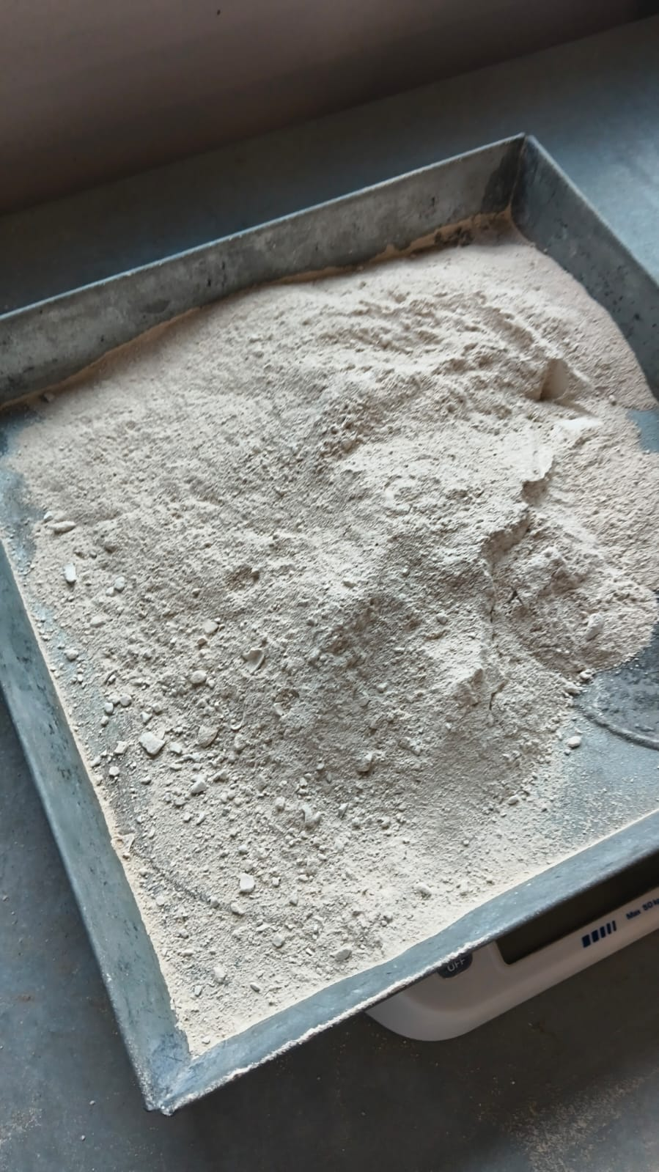
Figure 3.8: Cockle shell powder after milling

3.3.5 Reclaimed brick powder
Reclaimed clay brick was obtained from demolition waste and broken into coarse fragments before milling. As Chapter 2 showed, brick powder is a family of materials rather than a single material, and the results reported in the literature vary widely with the source and firing of the brick. The original manufacture and firing history of the brick used here are not known, so its preparation is recorded as it was carried out, rather than assumed to be equivalent to the material used in published work. This is taken into account when the results are compared with the literature in Chapter 4.
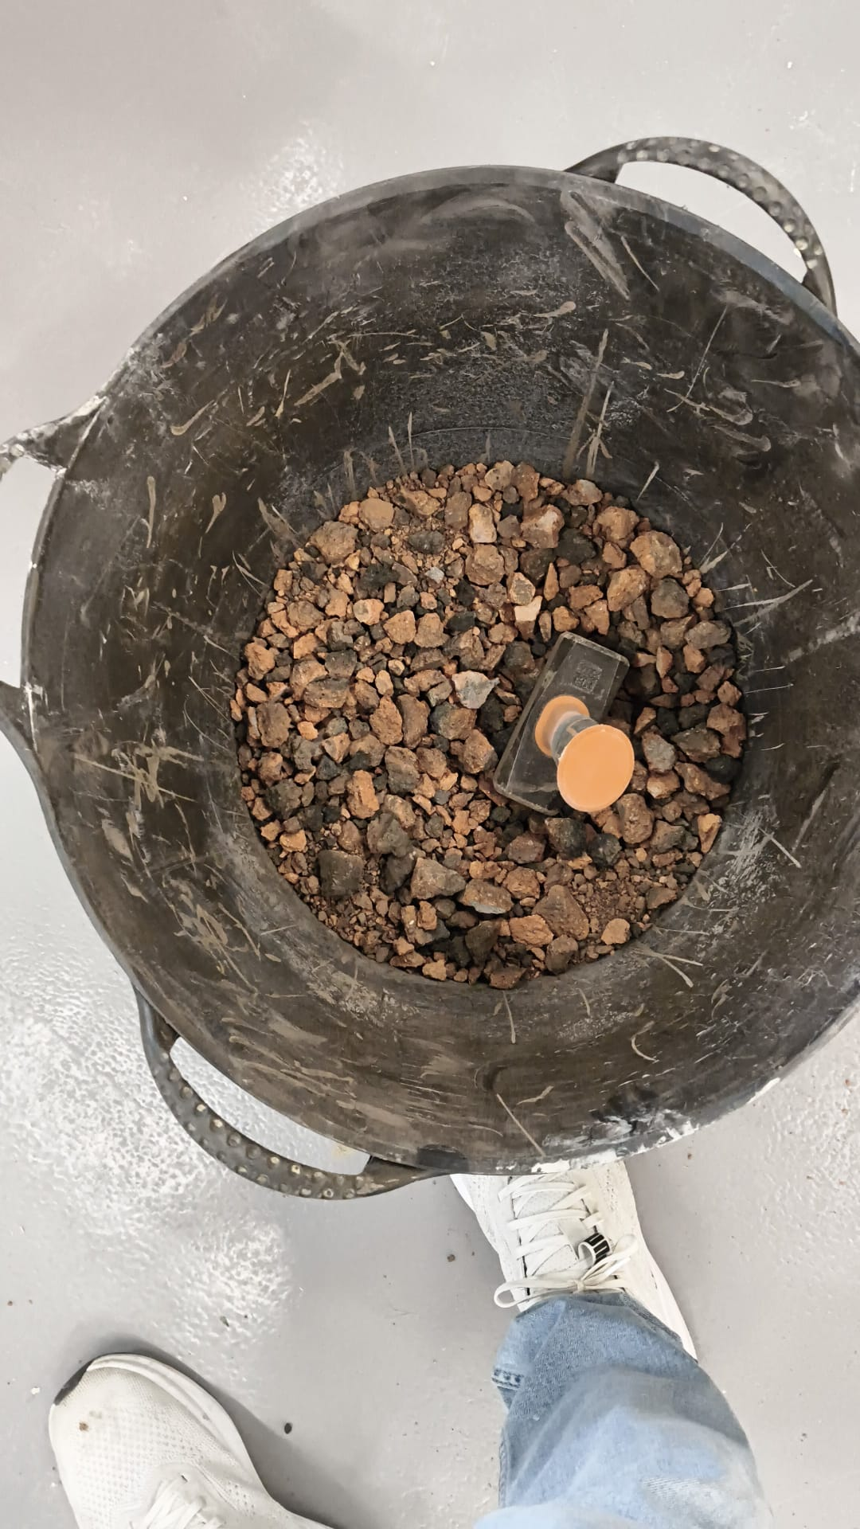
Figure 3.9: Crushed reclaimed clay brick prior to milling
The crushed brick was milled in the same Fast Mill and sieved, producing a fine reddish-brown powder. The brick was ground for thirteen minutes, compared with ten minutes for the shell, because fired clay is harder than shell and takes longer to reach a similar fineness.
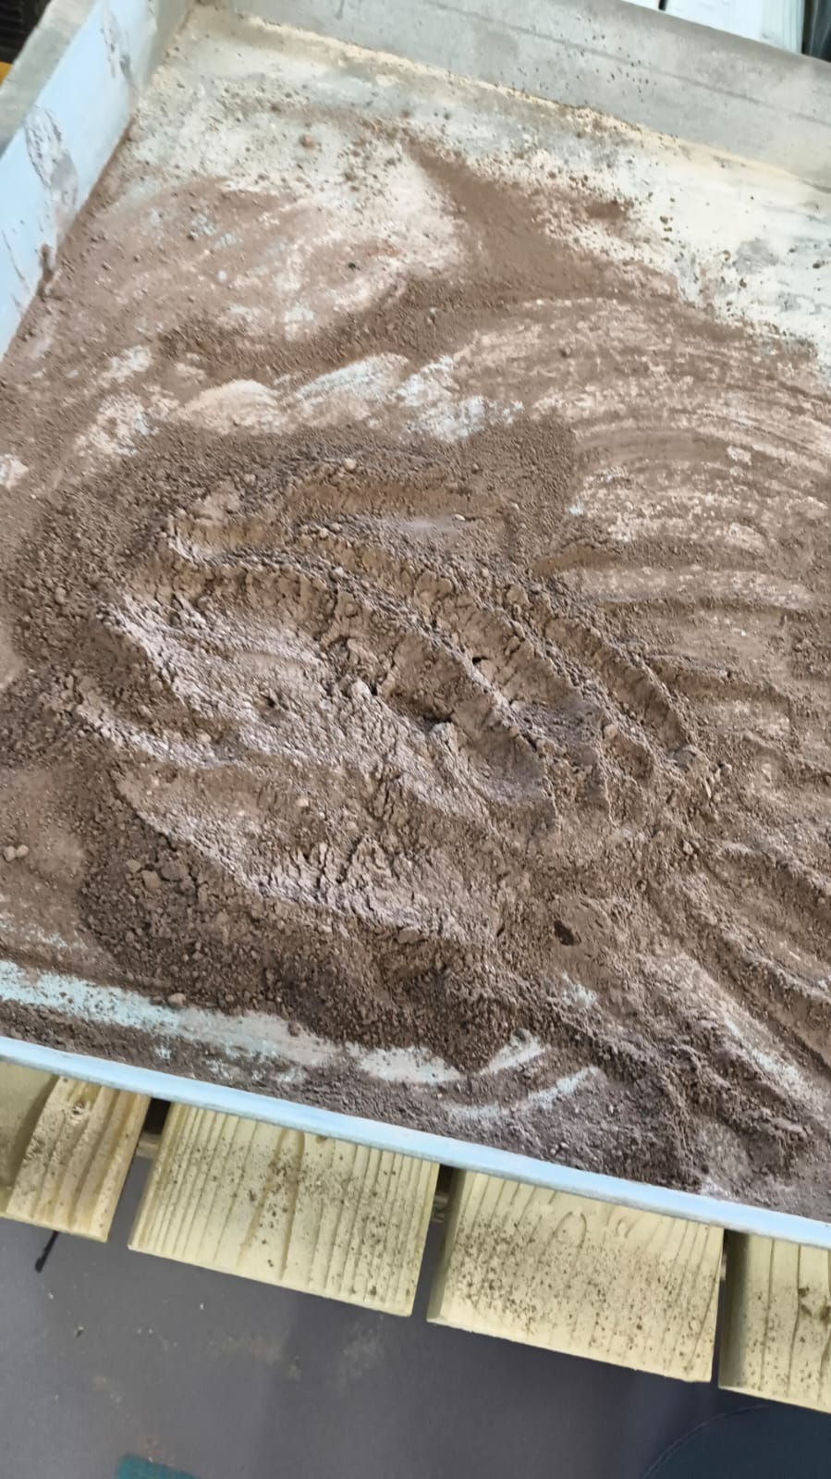
Figure 3.10: Reclaimed brick powder after milling

3.3.6 Admixture
A liquid admixture, SikaMix 3 in 1, was used in all five mixes at a constant dose. The manufacturer describes it as a combined plasticiser, retarder and waterproofer intended for renders and screeds. It is named here because it is not a conventional concrete superplasticiser of the kind used in most of the studies reviewed in Chapter 2, and its retarding action may suppress early strength development. Because the dose was identical in every mix, this effect applies equally to the control and the replacement mixes and does not distort the comparison between them. It does, however, need to be kept in mind when the results are compared with published values in Chapter 4.
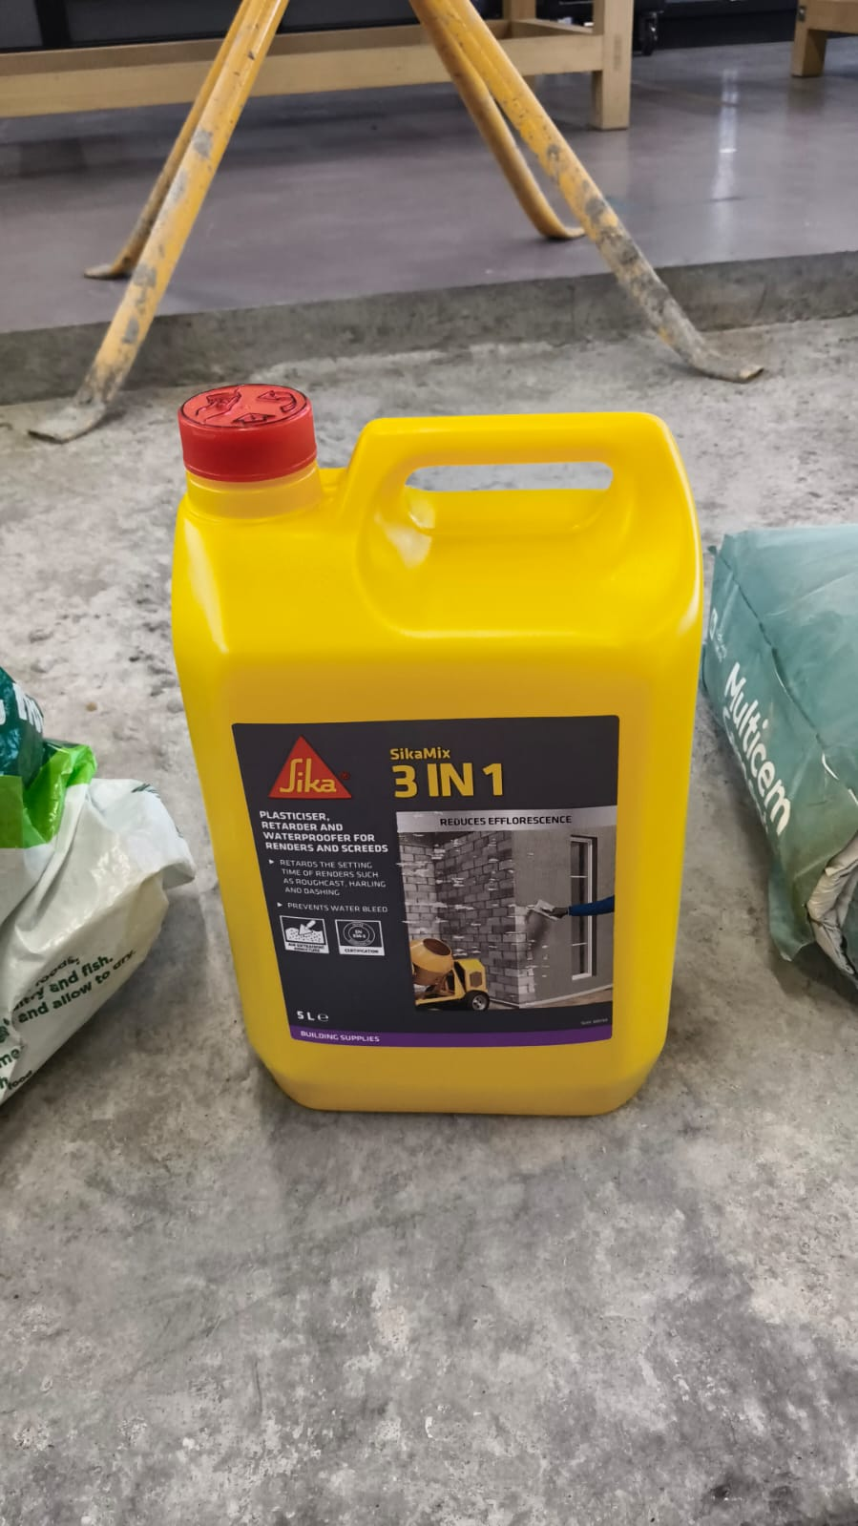
Figure 3.11: SikaMix 3 in 1 admixture

3.3.7 Water
Potable mains water was used for both mixing and curing.

3.4 Mix design

3.4.1 Basis of the design
The mix design was based on one controlling principle: the total binder content and the free water content were kept the same in all five mixes, so that the only variable was the composition of the binder. The free water to binder ratio was fixed at 0.50 throughout. In an orthogonal experiment that varied the water to cementitious materials ratio, sand ratio, replacement level and particle size together, Ge et al. (2012) found the water to cementitious materials ratio to be the dominant factor controlling strength. Holding it constant therefore isolates the effect of replacement, which is what the research question requires.
Replacement was by mass of binder. The levels follow directly from the hypothesis in Chapter 1: 4% CSP, based on Olivia, Oktaviani and Ismeddiyanto (2017), who tested cement replacement at exactly that level with ground shell, and 5% and 10% RBP, the range identified as optimal by Arif et al. (2021) and Małek et al. (2025).
Table 3.1: Mix matrix and replacement levels
Mix | Description | CSP (%) | RBP (%) | Total replacement (%)
M0 | Control, no replacement | 0 | 0 | 0
M1 | CSP only | 4 | 0 | 4
M2 | RBP only | 0 | 10 | 10
M3 | CSP and RBP blend | 4 | 5 | 9
M4 | CSP and RBP blend | 4 | 10 | 14

3.4.2 Batch quantities
Each mix was batched at a volume of 13.34 litres, enough for the cube specimens and the slump test with an allowance for waste. The quantities weighed out for each mix are given in Table 3.2. The admixture was dosed at 0.037 kg per batch in every mix, equivalent to 0.79% by mass of binder.
Table 3.2: Batch quantities per 13.34 litre batch
Mix | Cement (kg) | CSP (kg) | RBP (kg) | Fine agg. (kg) | Coarse agg. (kg) | Water (L)
M0 | 4.67 | 0.00 | 0.00 | 9.33 | 16.00 | 2.33
M1 | 4.48 | 0.19 | 0.00 | 9.33 | 16.00 | 2.33
M2 | 4.20 | 0.00 | 0.47 | 9.33 | 16.00 | 2.33
M3 | 4.25 | 0.19 | 0.23 | 9.33 | 16.00 | 2.33
M4 | 4.01 | 0.19 | 0.47 | 9.33 | 16.00 | 2.33

The total binder content is 4.67 kg in every mix, and the free water to binder ratio is 0.499 throughout. The replacement levels actually achieved were 4.07% CSP in M1, 10.06% RBP in M2, 4.07% CSP with 4.93% RBP in M3, and 4.07% CSP with 10.06% RBP in M4, all close to the nominal levels in Table 3.1.
Expressed per cubic metre for comparison with published mix designs, the same quantities give the proportions shown in Table 3.3.
Table 3.3: Equivalent mix proportions per cubic metre (kg/m³)
Mix | Cement | CSP | RBP | Fine agg. | Coarse agg. | Water
M0 | 350.0 | 0.0 | 0.0 | 700 | 1200 | 175
M1 | 335.8 | 14.2 | 0.0 | 700 | 1200 | 175
M2 | 314.8 | 0.0 | 35.2 | 700 | 1200 | 175
M3 | 318.5 | 14.2 | 17.2 | 700 | 1200 | 175
M4 | 300.5 | 14.2 | 35.2 | 700 | 1200 | 175

3.4.3 Verification against the BRE method
The adopted proportions were obtained by direct proportioning at a fixed water to binder ratio, rather than by following the successive steps of the BRE method (Teychenné, Franklin and Erntroy, 1997). To check that the resulting mix was nevertheless reasonable, the BRE procedure was worked through independently for the same water to binder ratio and aggregate type, and the two sets of proportions are compared in Table 3.4.
Table 3.4: Adopted proportions compared with a BRE derivation
Constituent | Adopted (kg/m³) | BRE derivation (kg/m³) | Difference
Cement or binder | 350 | 360 | -2.8%
Free water | 175 | 180 | -2.8%
Fine aggregate | 700 | 630 | +11.1%
Coarse aggregate | 1200 | 1170 | +2.6%
Free water/binder ratio | 0.50 | 0.50 | none
Fresh density | 2425 | 2340 | +3.6%

The binder, water and coarse aggregate contents of the adopted mix are all within about 3% of the BRE values, and the water to binder ratio is identical. The only notable difference is in the fine aggregate, where the adopted mix contains about 11% more sand than the BRE derivation. An absolute volume check on the adopted proportions gives a yield of 13.35 litres against the 13.34 litres batched, which confirms that the mix is internally consistent and that the fresh density of about 2,425 kg/m³ is realistic. The adopted mix is therefore reported as used, with the BRE derivation kept as a check rather than as the source of the quantities.
Two points about the derivation should be made clear. First, the BRE method normally starts from a target mean strength and works towards a water to cement ratio. Here, the free water to binder ratio was fixed at 0.50 from the outset, for the reason given in section 3.4.1, so the derivation in Table 3.4 was carried out at that ratio and for the same 20 mm crushed coarse aggregate. It therefore checks the proportioning, not the choice of ratio. The strength the mix actually achieves is taken from the control itself: mix M0 reached 21.3 MPa at 7 days, and the control results are the benchmark against which the four replacement mixes are judged in Chapter 4. Second, the relative densities of the aggregates were not measured in the laboratory, so the standard BRE values for uncrushed fine aggregate and crushed coarse aggregate were used in the derivation.

3.5 Specimen preparation and curing
Mixing was carried out in a Belle Minimix, a portable tilting-drum mixer of the type used on site.
The mixing sequence followed the procedure in BS 1881-125 for mixing concrete in the laboratory and was the same for all five batches. The dry materials were loaded and mixed first, so that the replacement powders were evenly distributed through the binder before any water was added. The water, with the admixture already stirred in, was then added, and mixing continued until the concrete was uniform in colour and consistency and no dry material remained in the drum.
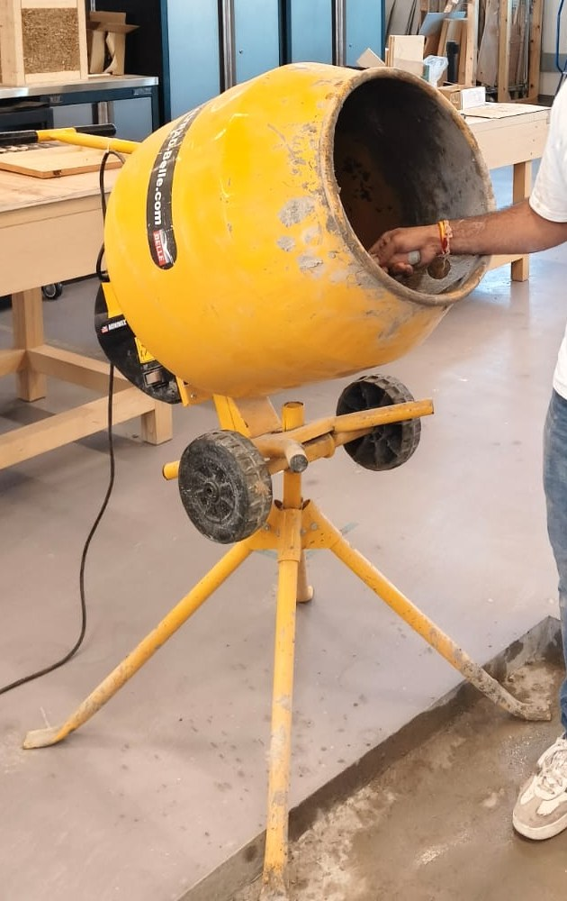
Figure 3.12: Belle Minimix tilting-drum mixer used for batching
Slump was measured immediately after mixing. The concrete was then placed in 100 mm steel cube moulds and compacted by hand in three roughly equal layers, with each layer receiving 25 evenly distributed blows from a standard steel compacting bar. Hand compaction was chosen over a vibrating table because applying the same number of blows to every layer of every cube gives a compactive effort that can be closely repeated from one mix to the next. Two cubes were planned for each mix at each test age. The number actually tested ranged from one to three per mix and age, and the number behind each mean is reported with the results in Tables 4.2 and 4.3. The specimens were left covered in their moulds for the first 24 hours, then demoulded and transferred to a water curing tank, where they stayed until the day of testing.
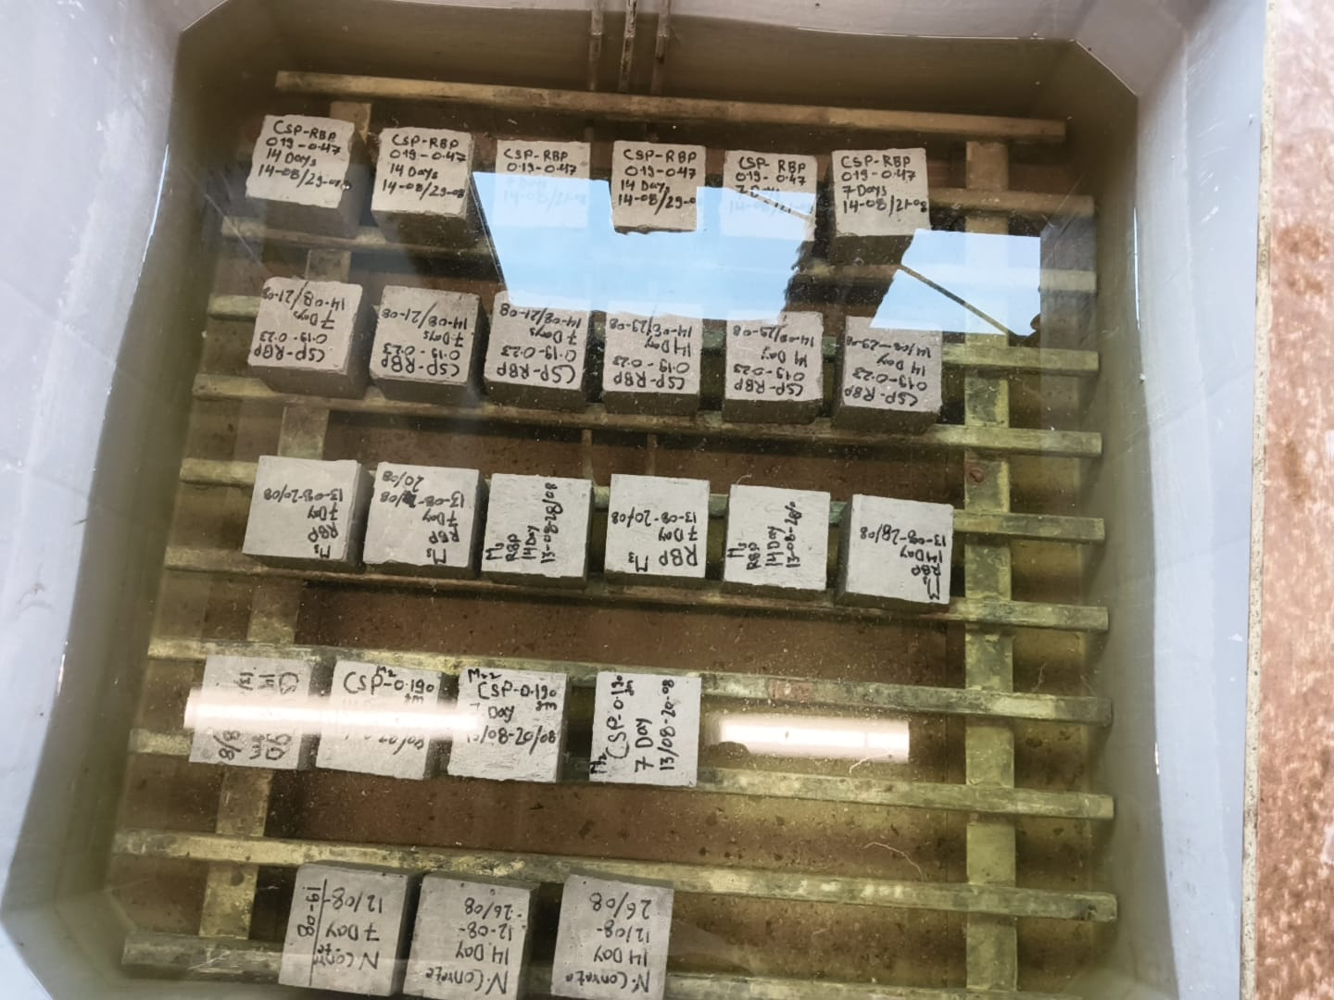
Figure 3.13: Cube specimens under water curing
Each specimen was labelled with its mix and intended test age at demoulding, so that the results could be correctly attributed once the cubes were taken out of the tank.

3.6 Test programme
Two properties were measured: the workability of the fresh concrete and the compressive strength of the hardened concrete at two ages. The test programme is summarised in Table 3.5.
Table 3.5: Test programme
Test | Standard | Age (days) | Specimens tested per mix | Total specimens
Slump | BS EN 12350-2 | fresh | 1 per batch | 5
Compressive strength | BS EN 12390-3 | 7 | 1 to 3 | 11
Compressive strength | BS EN 12390-3 | 14 | 1 to 3 | 13

3.6.1 Workability
Slump was measured on each batch immediately after mixing, using a standard slump cone. Workability was included because the two powders were expected to affect it in opposite directions. Arif et al. (2021) attributed improved workability with brick powder to its rounded, smooth particles, while Ruslan et al. (2024) recorded reduced workability with crushed cockle shell because the angular fragments increase internal friction. Whether these effects offset each other in a blended mix is one of the questions the experiment can answer directly.
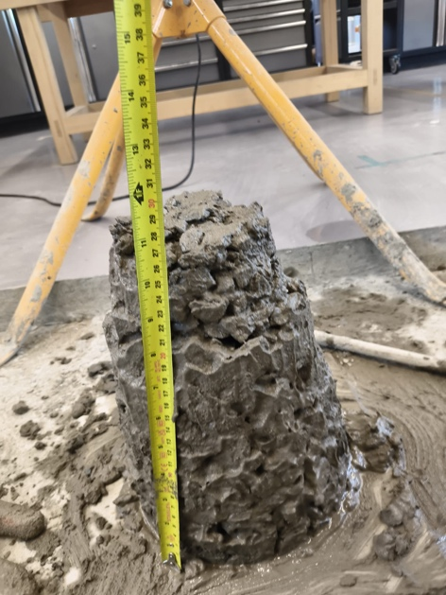
Figure 3.14: Measurement of slump

3.6.2 Compressive strength
Compressive strength was measured on 100 mm cubes using a Controls compression testing machine with a capacity of 3000 kN and a Cyber-Plus Evolution control unit. Each cube was centred on the platen and loaded to failure at a constant rate of 6.0 kN/s. On the 10,000 mm² loaded face of a 100 mm cube, this corresponds to a stress rate of 0.6 MPa/s, which is in the middle of the range permitted by BS EN 12390-3. The machine recorded the failure load and compressive strength of each specimen, and the mean of the specimens tested at each age was taken as the compressive strength for that mix and age.
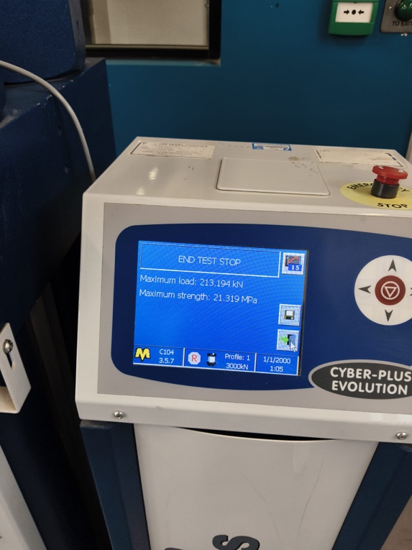
Figure 3.15: Cube specimen in the compression testing machine

3.6.3 Choice of test ages
Compressive strength was measured at 7 and 14 days rather than at the more usual 7 and 28 days. The main reason was the length of the project. Casting, curing and testing all had to fit within the laboratory time available for an MSc dissertation, and a 28-day cycle across five mixes would have left no time to repeat a batch if a mix failed or a set of cubes was lost. Testing at 14 days kept the full set of mixes and preserved that margin.
The choice is also supported by the literature. Salman and Yousif (2018) tested concrete containing waste yellow clay brick powder at 7, 14 and 28 days and reported both compressive and splitting tensile strength at each age, so 14 days is an established reporting age in brick powder research. Nor Hisham, Razali and Razali (2017) went further with the other material studied here, testing concrete containing calcined cockle shell powder at 7, 14, 28 and 56 days. All of their modified mixes gained strength rapidly over the first 14 days, and the best-performing mix, at 10% binder replacement, reached its highest compressive strength of about 25 MPa at 14 days before falling back. They recorded no meaningful strength gain after 28 days in any of the shell mixes. For a calcium carbonate filler of the kind used here, 14 days is therefore at or close to the point at which the material has made most of its contribution.
Published data also show that a 14-day result captures a large share of the 28-day strength. In the concretes tested by Salman and Yousif (2018), the control reached 24.26 MPa at 14 days and 30.11 MPa at 28 days, so the 14-day value was 81% of the 28-day value, and their 5% brick powder mix gave a very similar proportion. Jun et al. (2025) add a related point: they found a strong linear relationship between 7-day and 28-day compressive strength in cockle shell mixes, with a coefficient of determination of 0.9115, and treated the early result as a reliable predictor of the later one. Early-age results are therefore informative about later behaviour, not merely preliminary.
Two limitations follow from this choice and are accepted. First, 28 days is the reference age for conformity assessment in BS EN 206, so no result reported here can be taken as evidence that a mix meets a particular strength class. What the programme provides is a comparison between four replacement mixes and a control tested under identical conditions, which is what a feasibility judgement requires. Second, the pozzolanic reaction of reclaimed brick powder develops over weeks rather than days, so a 14-day result understates its contribution more than a 28-day result would. The error runs in one direction. A mix containing RBP that performs acceptably at 14 days would be expected to improve with age rather than decline, so a favourable result is a conservative one, whereas an unfavourable result is harder to interpret.
The test methods themselves do not restrict the age at which strength is measured. BS EN 12390-3 sets out the procedure for determining the compressive strength of hardened concrete specimens and is not tied to any particular age, while BS EN 12390-2 covers the making and curing of specimens and the permitted tolerance on age at testing.

3.7 Data analysis
For each mix and test age, the individual cube strengths were recorded and the mean was taken as the representative value, with the range across specimens noted as an indication of consistency. Results are presented as strength against replacement level and strength against age, and each replacement mix is also expressed as a percentage of the corresponding control strength so that the mixes can be compared directly. Slump results are reported alongside the strength data so that any trade-off between workability and strength can be seen. Given the small number of specimens per mix, the analysis is descriptive and comparative rather than statistical, and no significance testing is claimed.

3.8 Health, safety and ethical considerations
All laboratory work was carried out under the university workshop's supervision arrangements and risk assessment procedures. Cement and the two waste powders are respiratory and skin irritants, so dust masks, gloves and eye protection were worn during weighing, milling and mixing, and the powders were handled in a way that kept airborne dust to a minimum. The mill, mixer and compression testing machine were operated in line with the laboratory instructions for each machine, and safety footwear and protective clothing were worn throughout.
The cockle shells were a waste product already discarded by the fishery and were collected with permission, so no live organisms were involved and no shellfish were harvested for this research. The reclaimed brick came from demolition waste. The study involved no human participants and no personal data, so no ethical approval was needed beyond the standard laboratory risk assessment.

3.9 Summary
This chapter has described the materials and their preparation, the mix design and the test programme. Five mixes were prepared with a constant binder content of 4.67 kg per batch and a constant free water to binder ratio of 0.50: a control, a 4% CSP mix, a 10% RBP mix, and two blends of 4% CSP with 5% and 10% RBP. Workability was measured on the fresh concrete, and compressive strength was measured on 100 mm cubes at 7 and 14 days, with between one and three cubes tested for each mix at each age. Chapter 4 presents the results and discusses them in the light of the literature reviewed in Chapter 2.

Chapter 4: Results and Discussion

4.1 Introduction
This chapter presents the results of the programme described in Chapter 3 and compares them with the literature reviewed in Chapter 2. Workability is covered first, followed by compressive strength at 7 and 14 days, and then by what the two sets of results together indicate about using cockle shell powder and reclaimed brick powder in combination. Section 4.3, which comes between the workability and strength results, records one excluded specimen and one unreliable result. The strength figures cannot be interpreted properly without it.

4.2 Workability
Slump was measured on each batch immediately after mixing. Because the free water content and admixture dose were the same in every mix, the differences shown in Table 4.1 are due to the replacement powders rather than to the amount of water available.
Table 4.1: Slump results
Mix | Slump (in) | Slump (mm) | Consistency class | Vs control
M0 control | 1 | 25 | S1 | -
M1 4% CSP | 0.5 | 13 | S1 | -48%
M2 10% RBP | 5 | 127 | S3 | +408%
M3 4% CSP + 5% RBP | 1 | 25 | S1 | no change
M4 4% CSP + 10% RBP | 3.5 | 89 | S2 | +256%

The results vary widely. The control gave a slump of 25 mm. Replacing 4% of the binder with CSP reduced this to 13 mm, whereas replacing 10% with RBP increased it to 127 mm, about five times the control value. The two powders clearly work against each other, and by a large margin.
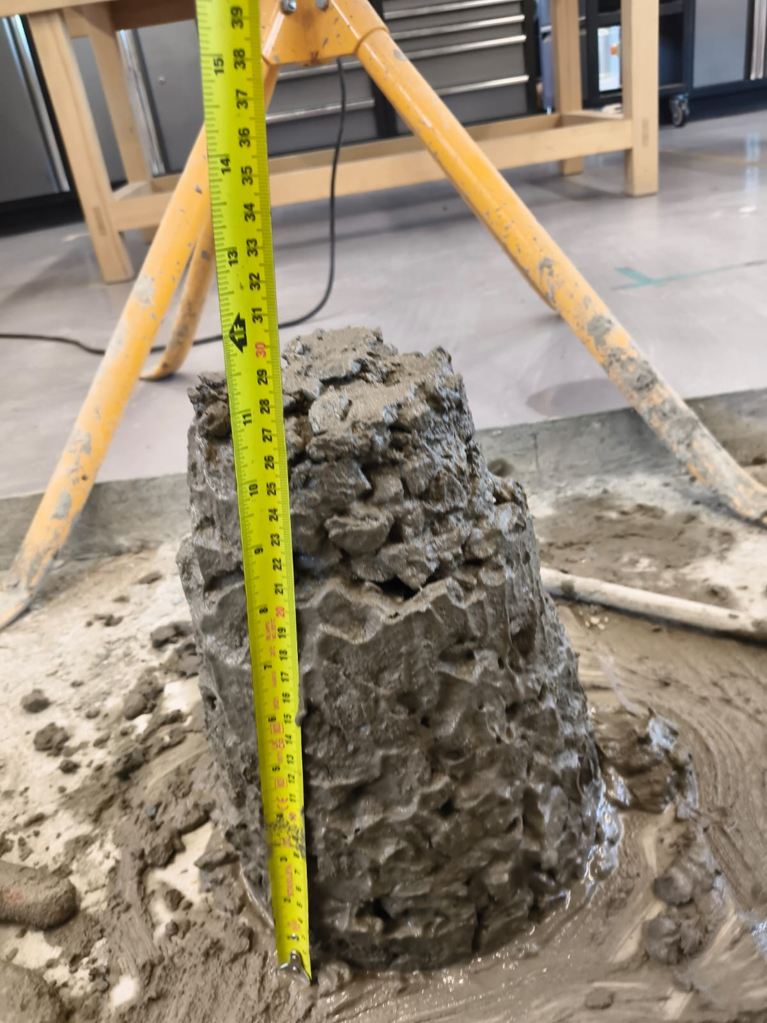
Figure 4.1: Slump test on the control mix M0, 25 mm
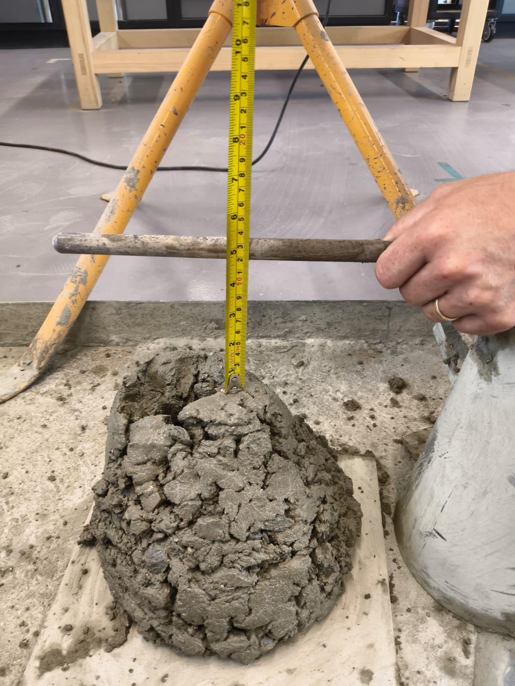
Figure 4.2: Slump test on the 10% RBP mix M2, 127 mm
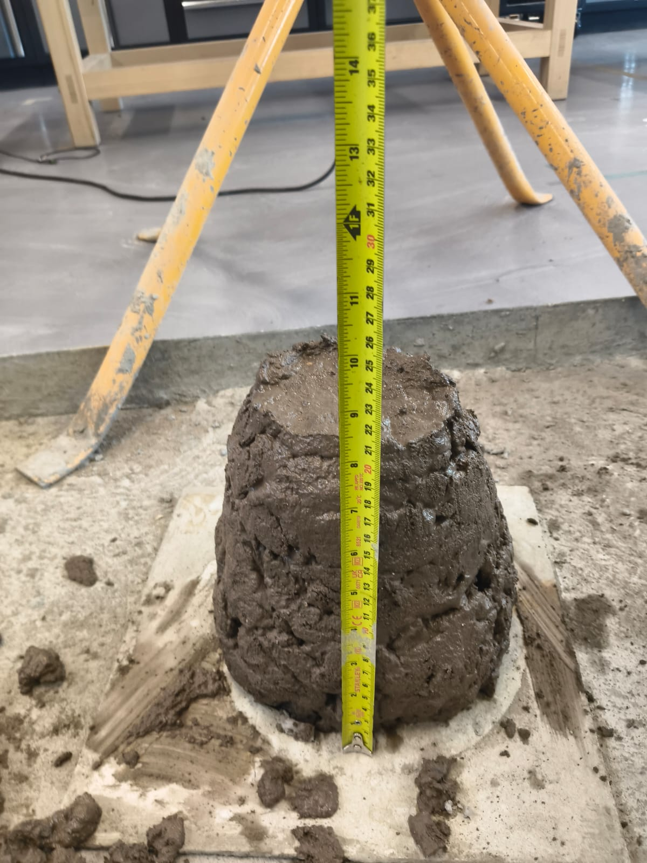
Figure 4.3: Slump test on the 4% CSP with 10% RBP mix M4, 89 mm. The reddish colour of the fresh concrete reflects the higher brick powder content
Both directions were anticipated in Chapter 2. Arif et al. (2021) attributed a workability gain with brick powder to its rounded, smooth particles acting like small ball bearings. The direction of the effect here matches their finding, although its size is much larger. Ruslan et al. (2024) found that cockle shell made mixes stiffer because the angular fragments increase friction, and the drop from 25 mm to 13 mm at only 4% replacement is consistent with that.
The blends are more interesting. At 4% CSP with 5% RBP (M3, referred to below as the light blend), the slump returned to 25 mm, the same as the control. This is consistent with the two powders having opposing effects on workability at this proportion, although one batch is not enough to show that they will always balance in the same way. When RBP was increased to 10% (M4, the heavy blend), slump rose to 89 mm. The result therefore suggests that the proportion of the two powders matters, not simply the fact that both are present.
Under BS EN 206, the control, the CSP mix and the light blend all fall into consistency class S1, the heavy blend into S2 and the RBP mix into S3. At 13 mm, the CSP mix is close to the 10 mm lower limit below which BS EN 12350-2 considers the slump test unsuitable, which gives an indication of how stiff it was to place.

4.3 Data treatment and corrections

4.3.1 Excluded specimen
One 7-day cube from the 10% RBP mix failed at 77.45 kN (7.75 MPa), compared with 174.04 kN (17.40 MPa) for the other cube from the same batch. This specimen contained an internal void, caused by a mould that had not been closed properly during casting, and the defect was visible as soon as the cube was demoulded. Because the cube was defective as made, rather than giving a poor result for the mix, it has been excluded. The decision is based on the recorded defect, not on the low value, and the load record supports it: the cube failed after 8.4 seconds, whereas every other valid test in the programme lasted between 22 and 58 seconds, which is consistent with a specimen breaking around a flaw. This leaves one valid 7-day cube for this mix, and the mean is reported with the reduced sample size stated.

4.3.2 Note on the 7-day CSP result
The 4% CSP mix averaged 12.21 MPa at 7 days and 17.86 MPa at 14 days, a gain of 46%. Over the same period, the control gained 7.4% and the RBP mix 7.2%. This increase is unusually large compared with the other mixes and is difficult to explain from the expected behaviour of CSP alone. No physical defect was recorded for the 7-day specimens, so the result is retained rather than rejected. However, because only two cubes were tested at each age, the apparent rate of strength development should be interpreted cautiously. Section 4.5.5 considers whether compaction may have contributed.

4.4 Compressive strength results

4.4.1 Results at 7 days
Table 4.2: Compressive strength at 7 days
Mix | Individual cube results (MPa) | Mean | n | % of control
M0 control | 21.32 | 21.32 | 1 | 100.0
M1 4% CSP | 12.12, 12.30 | 12.21 | 2 | 57.3
M2 10% RBP | 17.40 (7.75 excluded) | 17.40 | 1 | 81.6
M3 4% CSP + 5% RBP | 19.72, 21.03, 20.23 | 20.32 | 3 | 95.3
M4 4% CSP + 10% RBP | 10.99, 11.45, 11.37 | 11.27 | 3 | 52.9

At 7 days, the control reached 21.32 MPa. The closest mix was the light blend, at 20.32 MPa (95% of the control), followed by the 10% RBP mix at 17.40 MPa (82%). The 4% CSP mix and the heavy blend both reached only just over half the control strength, at 57% and 53% respectively.

4.4.2 Results at 14 days
Table 4.3: Compressive strength at 14 days
Mix | Individual cube results (MPa) | Mean | n | % of control
M0 control | 23.05, 22.73 | 22.89 | 2 | 100.0
M1 4% CSP | 17.65, 18.07 | 17.86 | 2 | 78.0
M2 10% RBP | 18.80, 18.73, 18.44 | 18.66 | 3 | 81.5
M3 4% CSP + 5% RBP | 23.91, 20.73, 25.19 | 23.27 | 3 | 101.7
M4 4% CSP + 10% RBP | 12.62, 12.32, 11.80 | 12.25 | 3 | 53.5

At 14 days, the control reached 22.89 MPa and the light blend 23.27 MPa, just above it. The RBP and CSP mixes followed at 82% and 78% of the control, and the heavy blend remained at much the same level as at 7 days, at 54%.
Repeatability at 14 days was generally good. The cube results for the control, CSP and RBP mixes all fell within 0.42 MPa of each other, and those for the heavy blend within 0.82 MPa. The light blend was the exception. Its three specimens ranged from 20.73 to 25.19 MPa, a spread of 4.46 MPa, or 19% of the mean. This matters because it is the best result in the programme, and section 4.6 returns to it.

4.4.3 Strength development
Table 4.4: Strength development between 7 and 14 days, with projection to 28 days
Mix | 7 d (MPa) | 14 d (MPa) | Gain (%) | Range at 14 d (MPa) | Projected 28 d (MPa)
M0 control | 21.32 | 22.89 | +7.4 | 0.32 | 25.4
M1 4% CSP | 12.21 | 17.86 | +46.2 | 0.42 | 19.8
M2 10% RBP | 17.40 | 18.66 | +7.2 | 0.36 | 20.7
M3 4% CSP + 5% RBP | 20.32 | 23.27 | +14.5 | 4.46 | 25.8
M4 4% CSP + 10% RBP | 11.27 | 12.25 | +8.7 | 0.82 | 13.6

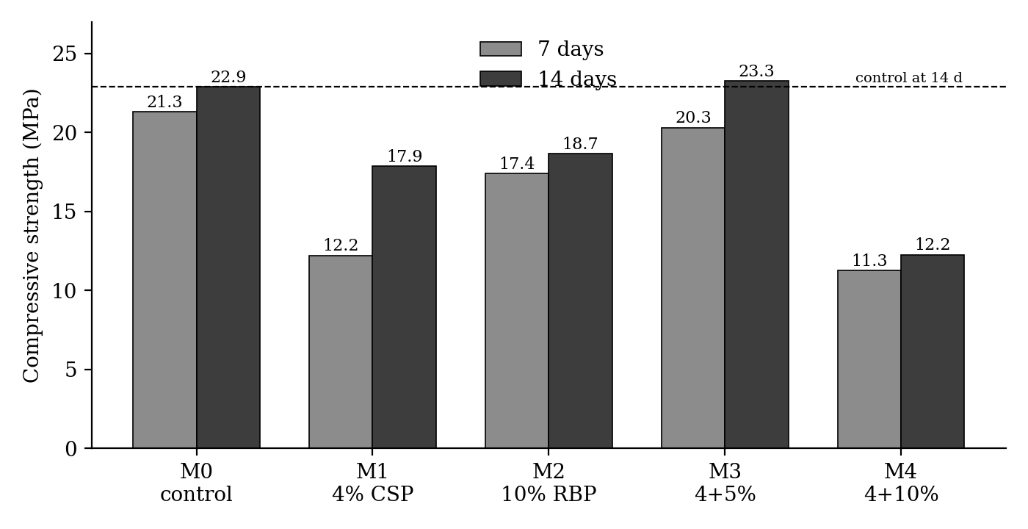
Figure 4.4: Compressive strength of all five mixes at 7 and 14 days
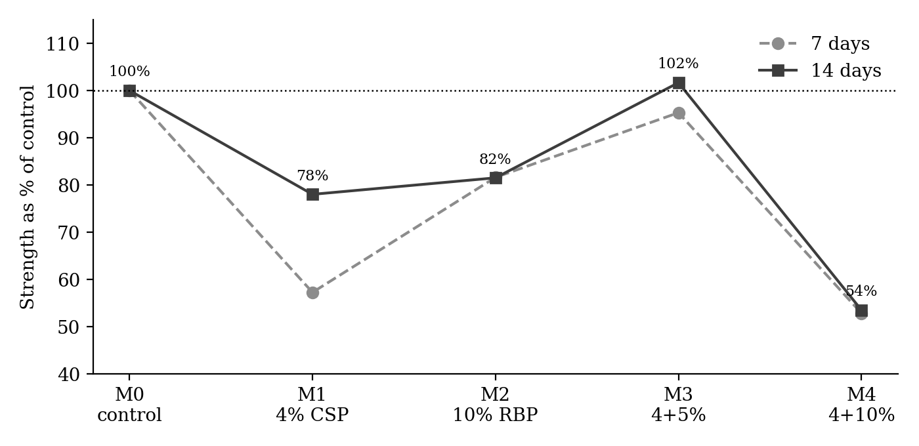
Figure 4.5: Compressive strength expressed as a percentage of the control at each age
The projected 28-day compressive strengths in Table 4.4 were estimated using the strength development relationship given in BS EN 1992-1-1. In this relationship, the mean compressive strength at an age of $t$ days, $f_{cm}\left(t\right)$, is related to the mean compressive strength at 28 days, $f_{cm}$, through the coefficient $β_{cc}\left(t\right)$, as expressed by
$$f_{cm}\left(t\right)=β_{cc}\left(t\right)f_{cm}$$
where
$$β_{cc}\left(t\right)=\exp\left\{s\left[1-{\left(\frac{28}{t}\right)}^{1/2}\right]\right\}.$$
Here, $f_{cm}\left(t\right)$ is the mean compressive strength at an age of $t$ days, $f_{cm}$ is the mean compressive strength at 28 days, $t$ is the age of the concrete in days, and $s$ is a coefficient that depends on the cement class. BS EN 1992-1-1 gives $s=0.20$ for cement strength classes CEM 42.5R, CEM 52.5N and CEM 52.5R (Class R), $s=0.25$ for CEM 32.5R and CEM 42.5N (Class N), and $s=0.38$ for CEM 32.5N (Class S). The Multicem cement used here is supplied as either 32,5R or 42,5N (Heidelberg Materials, 2025). Both are Class N, so a value of $s=0.25$ was adopted. For $t=14$ days, this gives
$$β_{cc}\left(14\right)=\exp\left\{0.25\left[1-{\left(\frac{28}{14}\right)}^{1/2}\right]\right\}≈0.902,$$
which means that the 14-day strength is approximately $90.2\%$ of the 28-day mean strength, so the projected 28-day strength can be estimated from the measured 14-day strength as
$$f_{cm}=\frac{f_{cm}\left(14\right)}{0.902}.$$
The 28-day values in Table 4.4 are therefore estimates based on the Eurocode relationship, not measured strengths, and they are kept separate from the measured results. The relationship was developed for ordinary concretes and may not reflect the rate of strength gain of mixes containing a retarding admixture or a slowly reacting pozzolan, so the projections should be treated with caution.

4.5 Discussion

4.5.1 The control mix
The control reached 21.32 MPa at 7 days and 22.89 MPa at 14 days, which projects to roughly 25 MPa at 28 days. For a binder content of 350 kg/m³ at a water to binder ratio of 0.50, using a CEM II cement with reduced clinker, this is a reasonable if unremarkable result. What stands out is how little strength was gained between the two ages. At 7.4%, the gain is well below the 16% that the Eurocode relationship predicts for a Class N cement. The retarding admixture is unlikely to be the cause, because a retarder would lower the 7-day strength and so make the later gain look larger, not smaller. Two other explanations are more plausible. First, the 7-day control value is based on a single cube, so it may simply be on the high side. Second, a Portland limestone cement develops a large share of its strength early, helped by the nucleation effect of the limestone described in section 2.5.1, and its reduced clinker content leaves less material to react later. Neither explanation affects the comparison between mixes at a given age, because all five used the same cement and the same admixture dose.

4.5.2 Cockle shell powder alone
At 14 days, the 4% CSP mix reached 78% of the control, which is lower than the literature would suggest. Wan Mohammad et al. (2017) and Othman et al. (2024) both interpret earlier studies as showing that strength stays close to the control at around 5% replacement, and Olivia, Oktaviani and Ismeddiyanto (2017), testing at exactly 4%, found that their marsh clam mix outperformed the control. Two factors may explain the shortfall.
The first is the shell itself. In the same study, Olivia, Oktaviani and Ismeddiyanto (2017) used ground marsh clam and ground blood cockle at the same 4% replacement, with almost identical carbonate contents, and obtained opposite results. The clam mix outperformed the control, while the cockle mix fell well below it and stayed there up to 91 days. They concluded that carbonate content does not predict how a shell will behave. Compared with their cockle result rather than their clam result, the finding here is not really in conflict with the seashell literature.
The second is the binder. The cement used here is a Portland limestone cement that already contains interground limestone (BS EN 197-1 permits 6 to 20% in a CEM II/A-LL cement), so adding 4% CSP takes the total carbonate content of the binder well above 4%. Wang et al. (2018) advise keeping fine limestone below 10% of the binder where the aim is to reduce porosity. In a limestone cement, the dilution effect described by Wang et al. (2018) and Briki et al. (2021) is therefore likely to take hold sooner than it would in the CEM I cement used in most of the studies reviewed. The low workability of this mix may also have played a part, as discussed in section 4.5.5.

4.5.3 Reclaimed brick powder alone
The 10% RBP mix reached 82% of the control at 14 days, the same proportion as at 7 days. In other words, it kept pace with the control over that week, neither closing the gap nor falling further behind.
An 18% reduction at 10% replacement is larger than Arif et al. (2021) or Małek et al. (2025) found. Both identified 10% as the practical optimum, and Małek et al. (2025) recorded strength gains over their reference mix. The results of Salman and Yousif (2018), who saw only a slight reduction up to 10%, are closer to those found here. Test age may be one reason for the difference. As Chapter 2 showed, the pozzolanic reaction of brick powder develops over weeks, and all three of those studies reported results at 28 days or later. At 14 days the reaction may still be developing, so the RBP mix could gain further strength by 28 days. Whether it would close the gap to the control cannot be established from the present results and requires direct later-age testing.

4.5.4 The blended mixes
The blends produced both the most important result in the programme and the largest difference between two mixes. Replacing 4% of the binder with CSP and 5% with RBP gave 23.27 MPa at 14 days, against 22.89 MPa for the control. With 9% of the cement replaced by waste material, this mix matched the control and slightly exceeded it. It also outperformed both single-material mixes, which reached 78% (CSP) and 82% (RBP) of the control.
The light blend result is consistent with the complementary behaviour proposed in Chapter 2, although the present tests cannot confirm the mechanism. CSP may have contributed through particle filling and nucleation, while RBP may have provided a later pozzolanic contribution. The light blend gained 14.5% in strength between 7 and 14 days, compared with 7.4% for the control and 7.2% for the RBP-only mix. This is consistent with continued binder development, but particle size, chemical composition and hydration products were not measured. The result should therefore be treated as evidence that the blend performed well at this proportion, rather than proof of a particular reaction mechanism.
The heavy blend behaved very differently. Keeping CSP at 4% and increasing RBP from 5% to 10% raised total replacement from 9% to 14%, and strength fell to 53 to 54% of the control at both ages. This is a much steeper fall than either powder produced alone, given that 10% RBP by itself retained 82% of the control strength. The direction of this change is broadly consistent with the dilution effects discussed by Briki et al. (2021) and with the increasing losses reported by Ge et al. (2012) as brick powder content rose. However, both the total replacement and the CSP:RBP proportion changed between the two blends. The present programme therefore shows that the 14% blend was less successful than the 9% blend, but it cannot identify a specific replacement threshold or separate the effect of total replacement from the effect of blend ratio.

4.5.5 Workability and strength considered together
Looking at slump and strength together suggests a link between them. The control and the light blend had the same slump, 25 mm, and also recorded the highest 14-day strengths, 22.89 and 23.27 MPa. The mixes whose slump differed more from that of the control generally had lower strengths.
The CSP mix, with a slump of only 13 mm, was the stiffest mix tested. Concrete this stiff is harder to place and compact, particularly in 100 mm cube moulds, and incomplete compaction leaves air voids that reduce the measured compressive strength. This may partly explain why the CSP mix was weaker than the values reported by Wan Mohammad et al. (2017), Othman et al. (2024) and Olivia, Oktaviani and Ismeddiyanto (2017). It could also be connected with the doubtful 7-day result noted in section 4.3.2, if the cubes tested at 7 days were compacted less effectively than those tested at 14 days. The two cubes at each age gave very similar results, however, so this cannot be confirmed. Because hardened density was not measured, the role of compaction remains uncertain and should be investigated in further work.
The heavy blend does not fit this pattern. Its slump of 89 mm shows that it was workable enough to place and compact properly, yet it recorded the lowest strength of all the mixes, so poor compaction is unlikely to be the main cause. The more likely explanation is the higher total replacement of 14%, which would have diluted the cement and reduced its contribution to strength development, as discussed in section 4.5.4.

4.5.6 Comparison across the programme
Taken together, the five mixes show that performance depended on both the amount of cement replaced and the composition of the replacement. The 9% blended mix reached 102% of the control strength, the 10% RBP-only mix reached 82%, and the 14% blended mix reached 54%. These values should not be read as a simple dose-response relationship because the replacement composition changed as well as the total percentage. The clearest finding is that the 4% CSP + 5% RBP blend outperformed either material used alone at the tested proportions, which is the question Chapter 2 identified as untested.

4.6 Limitations of the results
Several limitations apply to these findings.
Specimen numbers are small. Between one and three cubes were tested for each mix at each age, so no mean carries statistical weight. This matters most for the light blend. Its 14-day mean of 23.27 MPa is the best result in the programme, but it rests on three cubes that ranged from 20.73 to 25.19 MPa. Taken on its own, the lowest of those cubes would place the mix at about 91% of the control rather than 102%. The finding that the light blend matched the control should therefore be treated as provisional until it has been confirmed with more specimens.
The test ages also limit what can be concluded. As section 3.6.3 explains, 28 days is the conventional reference age for concrete strength assessment, so nothing here demonstrates that any mix meets a strength class. RBP may continue to contribute at later ages, but the present results cannot show whether the RBP-containing mixes would improve relative to the control. Direct 28-day testing is therefore needed before any conclusion is drawn about their later-age performance.
Finally, the powders were not characterised. Their particle size, specific surface area and chemical composition were not measured, so the results cannot be linked directly to fineness or composition, which Chapter 2 identified as major influences on performance. Each mix was also cast from a single batch, so batch-to-batch variation could not be assessed.

4.7 Summary
Slump ranged from 13 mm for the 4% CSP mix to 127 mm for the 10% RBP mix, against 25 mm for the control, with the two powders affecting workability in opposite directions. The light blend of 4% CSP and 5% RBP gave the same slump as the control, which is consistent with the opposing effects balancing at the tested proportion. At 14 days, the control reached 22.89 MPa and the light blend 23.27 MPa, so the blend matched the control and outperformed both single-material mixes. Increasing RBP to 10% in the blend, which raised total replacement to 14%, reduced strength to 54% of the control. On their own, 4% cockle shell powder and 10% reclaimed brick powder reached 78% and 82% of the control respectively. Chapter 5 draws conclusions from these findings and sets out recommendations for further research.

Chapter 5: Conclusions and Recommendations

5.1 Introduction
This chapter brings together what the study set out to do and what it found. It reviews the five objectives set in Chapter 1, answers the research question, compares the hypothesis with the results, sets out the contribution and limitations of the work, and ends with recommendations for further research.

5.2 Conclusions against the objectives
The first objective, preparing the two powders, was achieved without difficulty. Waste cockle shell from a commercial fishery was washed, dried, crushed and milled in an Impact Test Equipment Fast Mill, following the route described by Othman et al. (2024). Reclaimed clay brick from demolition waste was processed in the same mill. Neither route needs equipment that would be difficult to scale up, which matters for a material intended for practical use rather than laboratory study.
The second objective, describing the basic physical properties of both powders, was only partly met. The powders were described in terms of their preparation, colour and milling time, but their particle size distribution, specific gravity and chemical composition were not measured. Section 5.7.2 recommends that this is done in future work.
The third objective, casting the mixes, was completed as planned. Five mixes were batched with a constant binder content of 4.67 kg and a constant water to binder ratio of 0.50, so that the composition of the binder was the only variable across the programme.
The fourth objective, measuring workability and compressive strength, was completed for all five mixes at both ages, subject to the two qualifications recorded in section 4.3: one defective specimen was excluded, and the unusually large increase shown by the 7-day CSP result was retained but interpreted cautiously.
The fifth objective was the comparison itself, which is summarised in Table 5.1.
Table 5.1: Summary of results at 14 days
Mix | Slump (mm) | 14 d strength (MPa) | % of control | Verdict
M0 control | 25 | 22.89 | 100.0 | benchmark
M1 4% CSP | 13 | 17.86 | 78.0 | below control
M2 10% RBP | 127 | 18.66 | 81.5 | below control
M3 4% CSP + 5% RBP | 25 | 23.27 | 101.7 | Comparable to control
M4 4% CSP + 10% RBP | 89 | 12.25 | 53.5 | Well below control

5.3 Answering the research question
The research question asked to what extent CSP and RBP, separately and in combination, can replace part of the cement while keeping workability and compressive strength close to those of a control. The answer is clearly different in each of the three cases.
Cockle shell powder alone, at 4% replacement, kept neither property close to the control. Strength fell to 78% of the control at 14 days, and slump fell from 25 mm to 13 mm. The fresh mix was therefore considerably stiffer than the control and would be more difficult to place and compact. This may also have contributed to the lower measured strength through incomplete compaction, although hardened density was not measured and the effect cannot be confirmed.
Reclaimed brick powder alone, at 10%, kept strength reasonably close to the control, at 82%, but changed the fresh concrete considerably, increasing slump from 25 mm to 127 mm. Because the pozzolanic contribution of brick powder can continue to develop beyond 14 days, the mix may gain further strength at later ages. Whether it would move closer to the control cannot be established from this programme, so direct 28-day testing is needed before drawing a firm conclusion about its later-age performance.
When the two powders were used together, the outcome depended on their proportions. At 4% CSP with 5% RBP (9% total replacement), both properties stayed at control level: slump matched the control exactly at 25 mm, and 14-day strength reached 23.27 MPa against 22.89 MPa for the control. At 4% CSP with 10% RBP (14% total replacement), the blend failed on both counts, with slump rising to 89 mm and strength falling to 54% of the control.
The overall judgement is therefore positive but narrow. The 9% combined replacement performed comparably to the control, whereas the 14% blend did not. Because no intermediate levels were tested, the present programme cannot identify a specific replacement threshold. It only shows that the higher blend was less successful under the conditions tested.

5.4 The hypothesis revisited
The hypothesis was that a low combined replacement, around 4% CSP with 5 to 10% RBP, would keep workability and 14-day strength close to the control. The results partly support that prediction. The 4% CSP + 5% RBP mix matched the control slump and reached 101.7% of the control strength at 14 days, whereas the 4% CSP + 10% RBP mix did not. This means the lower blend performed as expected, but the higher blend did not. The light blend also outperformed the two single-powder mixes at the tested proportions. That outcome is consistent with the idea that CSP and RBP may provide complementary physical and chemical contributions, but the present study did not measure particle size, chemical composition or hydration products, so it cannot prove why the blend performed better. The 14.5% strength increase of the light blend between 7 and 14 days, compared with 7.2% for RBP alone, is consistent with continued binder development rather than evidence of a specific mechanism. The workability results point in the same direction: CSP reduced slump, RBP increased it, and the light blend happened to match the control at 25 mm. When RBP was increased from 5% to 10% while CSP remained at 4%, performance fell sharply. Because both total replacement and blend proportion changed at the same time, the study cannot say which of those factors was mainly responsible.

5.5 Contribution of the study
Chapter 2 identified two gaps. The first was that cockle shell powder and reclaimed brick powder had not been tested together as a combined cement replacement, even though their mechanisms appear complementary. This study tested that combination. At 9% total replacement, the blend matched the control on both workability and strength and outperformed either powder used alone. It is a modest result from a small programme, and section 5.6 sets out how far it can be relied on, but it answers a question that had not previously been asked. The second gap was geographical, and the study makes a first contribution here too, using UK materials, including shell from the Penclawdd fishery, tested in a UK laboratory.
A further contribution is the observation that the two powders affected workability in opposite directions. At the tested 4% CSP + 5% RBP proportion, the measured slump matched the control at 25 mm. This is consistent with the stiffening effect associated with CSP being partly offset by the greater fluidity observed with RBP, although further batches would be needed to confirm whether this behaviour is reproducible. Chapter 2 anticipated these opposing tendencies from the work of Arif et al. (2021) and Ruslan et al. (2024), but no study reviewed had combined the two materials in one mix.

5.6 Limitations of the conclusions
Specimen numbers were small: two or three cubes per mix and age in most cases, and only one in two cases. As a result, no mean carries statistical weight, and no significance testing is claimed. More importantly, the mix on which the positive conclusion depends showed the widest scatter in the programme. The light blend's cubes ranged from 20.73 to 25.19 MPa at 14 days, a spread of 19% of the mean, whereas the spread for every other 14-day group was 0.82 MPa or less (under 7% of the mean). Its mean of 23.27 MPa is therefore indicative rather than reliable, and the finding that it matched the control needs to be confirmed before it is built on.
Testing stopped at 14 days. Because 28 days is the conventional reference age for concrete strength assessment, nothing here demonstrates that any mix meets a strength class. RBP-containing mixes may continue to develop strength beyond 14 days, but the extent of any improvement relative to the control is unknown. Later-age testing is therefore necessary before drawing conclusions about their 28-day performance.
The powders were not characterised, and both the cement (a Portland limestone cement) and the admixture (a render product with a retarding action) differ from those used in most published studies. Together, these limit how directly the results can be compared with the literature.

5.7 Recommendations for further research

5.7.1 Immediate priorities
The first priority is to repeat the light blend with more specimens, because the study's one positive finding rests on three cubes with a 19% spread. Six or nine cubes at each age would give a much more reliable mean.
Testing should also be extended to 28 and 90 days. The 28-day results would provide a direct comparison at the conventional reference age used for concrete strength assessment, while 90-day testing would show whether the RBP-containing mixes continue to develop strength at later ages. These results would provide a much stronger basis for evaluating the mixes, although formal conformity or strength-class assessment would require a larger testing programme carried out in accordance with the relevant standards.
Every cube should be weighed and measured before testing. Hardened density is quick and cheap to obtain and would have settled the question of compaction. It should be routine in any repeat of this work.

5.7.2 Characterisation of the powders
The particle size distribution, specific surface area and chemical composition of both powders should be measured. Chapter 2 showed that fineness determines whether a carbonate powder helps or simply dilutes the cement, and whether a brick powder reacts to any significant extent. Without this information, the results here cannot be properly compared with other studies. Milling the shell more finely and repeating the CSP mix would also show directly whether particle size and shape were responsible for its low slump and strength.

5.7.3 Narrowing the replacement range
Replacement levels between the 9% blend that performed well and the 14% blend that did not should be tested more closely. Mixes with 4% CSP and 6%, 7% and 8% RBP would show whether performance changes gradually or over a narrower range. A second series, keeping total replacement at 9% while varying the CSP:RBP ratio, would help separate the effect of blend proportion from the effect of total replacement. The present programme cannot distinguish between these two factors.

5.7.4 Isolating the effect of the binder
The programme should be repeated using a CEM I cement alongside the CEM II/A-LL cement used here. This would separate the contribution of the cockle shell powder from that of the limestone already in the cement, which this study could not do. Replacing the render admixture with a concrete superplasticiser would also make the results directly comparable with the studies reviewed in Chapter 2.

5.7.5 Durability and wider assessment
Durability should be assessed. Water absorption, sulfate resistance and carbonation were outside the scope of this study, yet they ultimately decide whether a waste-based binder is usable. Chapter 2 found that both materials reduced absorption at low doses, brick powder through pozzolanic pore refinement and shell through improved packing. A blend that matches the control on strength should also be compared with it on durability.
Finally, a carbon and cost assessment should be carried out. The purpose of replacing cement is to reduce embodied carbon, and the case for these materials is incomplete until it has been shown that the energy used in milling does not cancel out the savings. Liu et al. (2020) noted that grinding some construction wastes to a fine powder is energy intensive, and the same question applies to shell and brick.

5.8 Concluding remarks
The carbon problem in concrete is essentially a clinker problem, and the conventional supplementary materials are becoming scarcer just as demand for lower-carbon concrete is growing. Waste materials that currently go to landfill or open dumps are one of the few remaining places to look. Cockle shell and reclaimed brick are both wastes, both are available in the UK, and until now they had not been tested together.
In this study, a blend replacing 9% of the binder with these two powders matched an equivalent control on workability and on compressive strength at 14 days, and performed better than either powder alone. The margin is narrow. A further 5% of replacement removed the benefit entirely, and the result rests on three specimens that varied more than any other set in the programme. What the findings support is a larger and better-instrumented study, not a design recommendation. The research question was framed at that level, and at that level the answer is that the combination is worth pursuing.

References
Arif, R., Khitab, A., Kırgız, M.S., Khan, R.B.N., Tayyab, S., Khan, R.A., Anwar, W. and Arshad, M.T. (2021) ‘Experimental analysis on partial replacement of cement with brick powder in concrete’, Case Studies in Construction Materials, 15, e00749. doi: 10.1016/j.cscm.2021.e00749.
Briki, Y., Zajac, M., Ben Haha, M. and Scrivener, K. (2021) ‘Impact of limestone fineness on cement hydration at early age’, Cement and Concrete Research, 147, 106515. doi: 10.1016/j.cemconres.2021.106515.
Ge, Z., Gao, Z., Sun, R. and Zheng, L. (2012) ‘Mix design of concrete with recycled clay-brick-powder using the orthogonal design method’, Construction and Building Materials, 31, pp. 289–293. doi: 10.1016/j.conbuildmat.2012.01.002.
Hasan, K., Karim, A., Islam, M.T., Ali, M.B., Rahman, M.T., Rahman, M.M. and Mat Yahaya, F. (2023) ‘A review of the mechanical properties and durability of concrete containing recycled seashells as a partial cement replacement’, Journal of Material Cycles and Waste Management, 25(6), pp. 3192–3216. doi: 10.1007/s10163-023-01795-5.
Hasan, K., Islam, M.T., Ferdaus, R. and Mat Yahaya, F. (2024) ‘Experimental study on environment-friendly concrete production incorporating palm oil clinker and cockle shell powder as cement partial replacement’, Materials Today: Proceedings, 107, pp. 254–262. doi: 10.1016/j.matpr.2023.11.150.
Heidelberg Materials (2025) Multicem cement: technical data sheet. Available at: https://www.heidelbergmaterials.co.uk/system/files/2025-06/technical-data-sheet-multicem%20june%202025.pdf (Accessed: 11 September 2026).
Jun, C.K.H., Mohd Yassin, N.I., Burhanudin, M.K. and Adnan, S.H. (2025) ‘Sustainable cement sand bricks: Utilizing palm oil fuel ash (POFA) and cockle shells as cement and sand replacements for enhanced performance and eco-efficiency’, IOP Conference Series: Earth and Environmental Science, 1453, 012009. doi: 10.1088/1755-1315/1453/1/012009.
Lam, M.N.-T., Le, D.-H. and Nguyen, D.-L. (2023) ‘Reuse of clay brick and ceramic waste in concrete: A study on compressive strength and durability using the Taguchi and Box–Behnken design method’, Construction and Building Materials, 373, 130801. doi: 10.1016/j.conbuildmat.2023.130801.
Li, X. and Cao, M. (2024) ‘Recent developments on the effects of micro- and nano-limestone on the hydration process, products, and kinetics of cement’, Materials, 17(9), 2133. doi: 10.3390/ma17092133.
Likes, L., Markandeya, A., Haider, M.M., Bollinger, D., McCloy, J.S. and Nassiri, S. (2022) ‘Recycled concrete and brick powders as supplements to Portland cement for more sustainable concrete’, Journal of Cleaner Production, 364, 132651. doi: 10.1016/j.jclepro.2022.132651.
Liu, Q., Li, B., Xiao, J. and Singh, A. (2020) ‘Utilization potential of aerated concrete block powder and clay brick powder from C&D waste’, Construction and Building Materials, 238, 117721. doi: 10.1016/j.conbuildmat.2019.117721.
Małek, M., Smarzewski, P., Kunikowski, M. and Kluczyński, J. (2025) ‘Utilization of brick powder as a sustainable additive in concrete: Optimization of mechanical and thermal performance’, Construction and Building Materials, 492, 143092. doi: 10.1016/j.conbuildmat.2025.143092.
Mat Aris, S., Muthusamy, K., Uzer, A. and Wan Ahmad, S. (2018) ‘Properties of palm oil fuel ash cement sand brick containing pulverized cockle shell as partial sand replacement’, IOP Conference Series: Earth and Environmental Science, 140, 012145. doi: 10.1088/1755-1315/140/1/012145.
Mohamad, N., Muthusamy, K. and Ruslan, H.N. (2022) ‘A review on fresh concrete, thermal conductivity, and permeability properties of concrete containing cockle shell’, International Journal of Sustainable Building Technology and Urban Development, 13(1), pp. 11–22. doi: 10.22712/susb.20220003.
Nor Hisham, N.F., Razali, N. and Razali, N. (2017) ‘Utilization of cockle shells as partial binder replacement in concrete’, Journal of Engineering and Technology, 8(2), pp. 81–100.
Olivia, M., Oktaviani, R. and Ismeddiyanto (2017) ‘Properties of concrete containing ground waste cockle and clam seashells’, Procedia Engineering, 171, pp. 658–663. doi: 10.1016/j.proeng.2017.01.404.
Othman, R., Muthusamy, K., Sulaiman, M.A., Duraisamy, Y., Putrajaya, R. and Parsuraman, J. (2024) ‘Feasibility study of cockle shell powder as a partial cement replacement in mortar’, Research Square [Preprint]. doi: 10.21203/rs.3.rs-5292462/v1.
Pitriyani, Devi, D.S. and Febryandi (2024) ‘Effect of cockle shell powder on the compressive strength of concrete with Viscocrete 3115 N additive’, Fondasi: Jurnal Teknik Sipil, 13(1), pp. 22–33. doi: 10.36055/fondasi.v13i1.21995.
Ruslan, H.N., Muthusamy, K., Ariffin, N.F., Abdul Wahab, M.M. and Mohamad, N. (2022) ‘Effect of crushed cockle shell as partial fine aggregate replacement on workability and strength of lightweight concrete’, Materials Today: Proceedings, 48(6), pp. 1826–1830. doi: 10.1016/j.matpr.2021.09.140.
Ruslan, H.N., Muthusamy, K., Md Jaafar, M.F., Mohamad, N. and Jamaludin, N.F.A. (2024) ‘Compressive strength and fire resistance of mortar containing crushed cockle shell as fine aggregate replacement’, Materials Today: Proceedings, 109, pp. 48–52. doi: 10.1016/j.matpr.2023.06.320.
Sallı Bideci, Ö., Bideci, A. and Ashour, A. (2024) ‘Utilization of recycled brick powder as supplementary cementitious materials—A comprehensive review’, Materials, 17(3), 637. doi: 10.3390/ma17030637.
Salman, M.M. and Yousif, M.Z. (2018) ‘The effect of waste brick powder as cement weight replacement on properties of sustainable concrete’, Journal of Engineering and Sustainable Development, 22(2, Part 6), pp. 116–130. doi: 10.31272/jeasd.2018.2.88.
Scrivener, K.L., John, V.M. and Gartner, E.M. (2018) ‘Eco-efficient cements: Potential economically viable solutions for a low-CO₂ cement-based materials industry’, Cement and Concrete Research, 114, pp. 2–26. doi: 10.1016/j.cemconres.2018.03.015.
Sinkhonde, D., Onchiri, R.O., Oyawa, W.O. and Mwero, J.N. (2022) ‘Durability and water absorption behaviour of rubberised concrete incorporating burnt clay brick powder’, Cleaner Materials, 4, 100084. doi: 10.1016/j.clema.2022.100084.
Tahwia, A.M., Abdellatief, M., Salah, A. and Youssf, O. (2025) ‘Valorization of recycled concrete powder, clay brick powder, and volcanic pumice powder in sustainable geopolymer concrete’, Scientific Reports, 15, 11049. doi: 10.1038/s41598-025-93598-x.
Tanash, A.O., Muthusamy, K., Mat Yahaya, F. and Ismail, M.A. (2023) ‘Potential of recycled powder from clay brick, sanitary ware, and concrete waste as a cement substitute for concrete: An overview’, Construction and Building Materials, 401, 132760. doi: 10.1016/j.conbuildmat.2023.132760.
Tayeh, B.A., Hasaniyah, M.W., Zeyad, A.M. and Yusuf, M.O. (2019) ‘Properties of concrete containing recycled seashells as cement partial replacement: A review’, Journal of Cleaner Production, 237, 117723. doi: 10.1016/j.jclepro.2019.117723.
Teychenné, D.C., Franklin, R.E. and Erntroy, H.C. (1997) Design of normal concrete mixes. 2nd edn. Amended by B.K. Marsh. Watford: Building Research Establishment (BRE Report BR 331).
Wan Mohammad, W.A.S.B., Othman, N.H., Wan Ibrahim, M.H., Rahim, M.A., Shahidan, S. and Abd Rahman, R. (2017) ‘A review on seashells ash as partial cement replacement’, IOP Conference Series: Materials Science and Engineering, 271, 012059. doi: 10.1088/1757-899X/271/1/012059.
Wang, D., Shi, C., Farzadnia, N., Shi, Z., Jia, H. and Ou, Z. (2018) ‘A review on use of limestone powder in cement-based materials: Mechanism, hydration and microstructures’, Construction and Building Materials, 181, pp. 659–672. doi: 10.1016/j.conbuildmat.2018.06.075.
Wu, H., Liang, C., Wang, C. and Ma, Z. (2022) ‘Properties of green mortar blended with waste concrete-brick powder at various components, replacement ratios and particle sizes’, Construction and Building Materials, 342, 128050. doi: 10.1016/j.conbuildmat.2022.128050.
Yang, D., Liu, M. and Ma, Z. (2020) ‘Properties of the foam concrete containing waste brick powder derived from construction and demolition waste’, Journal of Building Engineering, 32, 101509. doi: 10.1016/j.jobe.2020.101509.
Zhang, H., Ma, J., Chen, Z. and Wu, B. (2024) ‘Effect and mechanism of recycled clay brick powder on compressive strength of different types of concretes’, Journal of Building Engineering, 94, 109983. doi: 10.1016/j.jobe.2024.109983.
British Standards
British Standards Institution (2011) BS EN 197-1:2011: Cement. Composition, specifications and conformity criteria for common cements. London: BSI.
British Standards Institution (2021) BS EN 206:2013+A2:2021: Concrete. Specification, performance, production and conformity. London: BSI.
British Standards Institution (2013) BS 1881-125:2013: Testing concrete. Methods for mixing and sampling fresh concrete in the laboratory. London: BSI.
British Standards Institution (2019) BS EN 12350-2:2019: Testing fresh concrete. Slump test. London: BSI.
British Standards Institution (2019) BS EN 12390-2:2019: Testing hardened concrete. Making and curing specimens for strength tests. London: BSI.
British Standards Institution (2019) BS EN 12390-3:2019: Testing hardened concrete. Compressive strength of test specimens. London: BSI.
British Standards Institution (2014) BS EN 1992-1-1:2004+A1:2014: Eurocode 2. Design of concrete structures. General rules and rules for buildings. London: BSI.

