

Student Name: Marzana Hasan Mita

Student ID: 2504068

Module Name: Marketing Management

Module Code: LCMB7024

Lecturer’s Name: Dr Tushara Bakendranndran

Table of Contents
1. Introduction 3
2. STDP Analysis 3
2.1 Company Overview 3
2.2 Concept Behind the New Brand 3
2.3 Segmentation Analysis 4
2.4 Targeting Strategy 4
2.5 Differentiating Strategy 5
2.6 Positioning Strategy 5
3. Marketing Mix for Nike Pulse 5
3.1 Product 5
3.2 Price 6
3.3 Place 6
3.4 Promotion 6
3.5 People 6
3.6 Process 7
3.7 Physical Evidence 7
4. Marketing Strategy Pitch 7
5. Reflection 9
5.1 Reflection on Developing the Brand Concept 9
5.2 Reflection on Creating and Delivering the Pitch 10
5.3 Reflection on Skills Gained and Future Development 10
Reference 12

1. Introduction
Brand development refers to the process of building a new brand or modifying an old one in such a way that it becomes distinct and can convey a solid meaning to customers. It assists an enterprise to build a level of trust, stand among the competition, and provide value that is easily understood by the people. The contemporary markets are highly competitive and dynamic and thus brand development has emerged as a significant component of success in business.
The purpose of this report is to create a new brand of an already existing company. The company that I will adopt is Nike, which is a reputable and well-known international company specializing in sports and lifestyle products. The new brand name and new product category introduced in this report will correspond with the existing customer needs. It will consist of an analysis of the market, a marketing mix, the short presentation pitch and an overview of what was learnt during it.

2. STDP Analysis

2.1 Company Overview
Nike is a sports global enterprise, which sells clothes, footwear, and other products related to fitness. Its market presence in most countries both through stores and online platforms is very high. A well-developed brand identity generated customer trust and contributed to the expansion of a company in new markets (Iglesias et al., 2020). Nike has a reputation of inventiveness, athletics, innovation, and emotive narration. The values assist the company in accessing a large variety of customer groups. Nike already incorporates recent technology and lifestyle trends in its products, so it is already suitable to develop a new brand in a new product category that specializes in wellness and digital support.

2.2 Concept Behind the New Brand
This new brand will be named Nike Pulse. It will be a simple digital wellness product that can assist customers to cope with stress, breathing, and movement, as well as short wellness exercises. In contemporary life, most individuals experience stress and they seek it easy to boost their well-being. According to research, customers currently seek more responsible and healthy lifestyle options (White et al., 2019). Nike Pulse applies digital functionality to direct users through brief workouts that align with a hectic routine, a trend in response to the embrace of digital decision-making in physical activities (Lamberton and Stephen, 2020). The concept is also correlated with an increasing trend of wellness practices in most countries (Pop et al., 2020).

2.3 Segmentation Analysis
Segmentation also aids Nike to know what groups will have the greatest interest in Nike pulse.
- Demographic segmentation would consist of the young adults aged between eighteen and thirty-five years who can afford the trends in technology and wellness. It is also comprised of professionals aged thirty to forty-five years who usually experience stress at the workplace.
- Psychographic segmentation deals with individuals who appreciate health, balance, personal development, and straightforward routines. It is argued in the research that the customer experience is based on what is considered meaningful and useful by each category (Kumar and Reinartz, 2019).
- Geographic segmentation involves urban territories where the customers have hectic and strenuous schedules. Digital wellness products are usually of great interest in large cities.
- Behavioural segmentation encompasses individuals that already have fitness applications, sleep trackers, or meditation devices. These clients usually would prefer a straightforward and fast working customer care since they are time constrained and cannot afford to take long wellness programs.
Studies on online consumer behaviour reveal that a range of customers like to use short and convenient tools that can be integrated into their lives (Gensler et al., 2021). These categories of segmentation are important as they indicate obvious needs, great purchasing power, and desire to obtain digital wellness support.

2.4 Targeting Strategy
The audience that Nike Pulse aims is young urban adults whose age is between twenty and thirty-five and use digital applications every day. They experience study, work and busy stress. Research justifies that specific and direct targeting assists companies to fit services to the appropriate customer needs and enhance the performance (Awan et al., 2021). This segment is appropriate as they prefer straightforward wellness products and can be willing to experiment with new online services.
The second target market consists of busy workplaces of people aged between thirty and forty-five years who feel the strain of their work schedules. These customers are seeking fast wellness services that can be performed within a short break. It has been found that professionals are even ready to pay to make their lives less stressful and consume less time (Kapoor et al., 2021).

2.5 Differentiating Strategy
Nike pulse will do differentiated targeting. This implies that Nike will address the two groups but target their various needs. The young adults desire better arrangements and personal development, whereas professionals desire the relaxed atmosphere and time-saving services. According to studies of digital markets, the accurate targeting assists brands to utilize their resources more efficiently and contact the correct target market (Gensler et al., 2021).
This would enable Nike Pulse to capture two good market segments that have a high level of interest and profitability.

2.6 Positioning Strategy
Nike Pulse will be positioned as an easy digital wellness companion of our active customers who desire calmness and balance in their everyday lives. The positioning statement is: Nike Pulse is a digital wellness service that can provide simple everyday wellness support to young adults and busy professionals by simplifying their routine, providing clear guidance, short routines, and personal tips as it is built with modern technology and relied upon Nike design values.
The functional aspect emphasizes user-friendliness, guided tours and smart technology that adapts to users’ requirements, which reinforces evidence that digital properties influence customer choices (Gensler et al., 2021). The emotional front is concentrated on the sense of calmness and confidence, which is backed by studies indicating that emotional support develops loyalty (Pop et al., 2020). This direct and very coherent message aligns with contemporary positioning concepts (Iglesias et al., 2020).

3. Marketing Mix for Nike Pulse

3.1 Product
Nike Pulse is a digital wellness platform that aids with daily health based on the basic functions of breathing sessions, stretching, and mood check-ins. The service can be used in two levels; free basic and premium level. It is stated that customers enjoy straightforward digital technology that enhances everyday habits (Kumar and Reinartz, 2019). Nike Pulse relies on personal information to provide advice that fits the routine of each individual. Soft colours and clear instructions are used in the design to provide a relaxing experience. It aligns with the values of Nike by encouraging balance, motivation, and healthy living in a straightforward and approachable manner.

3.2 Price
Nike pulse has a freemium pricing structure in which the basic version is free. This eliminates the risk and allows a high number of users to experiment with the service. The high-end version is a subscription based on a fee. It provides individual wellness scheduling, sleep assistance and tracking. The studies indicate that freemiums model enhances the adoption of customers and establish durable relationships within digital markets (Lamberton and Stephen, 2020). The price of Nike is comparable to other wellness services, which remains competitive and fair. Customers will be ready to pay when a service helps their everyday health and alleviates stress in a clear way (Kapoor et al., 2021).

3.3 Place
Nike Pulse is provided through digital platforms and hence easy to use. The service will be offered in Apple App Store, Google Play Store and at the Nike web site. It has been found that online channels enhance convenience and general experience (Awan et al., 2021). The service will be also compatible with wearable devices like smart watches. This allows the users to get reminders during the day. Nike even has the option of advertising the service in the apps it already has. QR codes are available in-store and allow the customer to download the app fast.

3.4 Promotion
Promotion of Nike Pulse will focus on relaxed everyday assistance and routine. The campaign will be based on brief social-media content videos of real people, engaging in breathing and stretching at work or in the morning. Studies have revealed that customers like straightforward, significant messages during digital promotion (Kapoor et al., 2021). Nike will also partner with well-being influencers, who will show how the service makes them feel balanced. This service will be advertised within the existing apps of Nike, in which people are already interested in health. This combination of promotion develops interest and trust in new and existing customers.

3.5 People
Nike Pulse relies on the people to deliver its services. The team consists of wellness coaches, app designers and customer support employees. The study demonstrates that cordial interaction by employees enhances satisfaction in customers (Iglesias et al., 2020). Nike Pulse will provide online chat services to all users and live wellness advice to premium users. Training will be conducted to the team on basic wellness coaching and effective communication. This will make customers feel secure and valued when providing the service. Courteous, competent employees will facilitate the process and assist in creating long-term relationships with Nike Pulse.

3.6 Process
Nike Pulse is meant to be easy to use. Upon opening the application, users provide answers to several questions regarding stress and everyday habits. It is then followed by individual recommendations by the service. Using simple digital processes leads to a rise in satisfaction and long-term use, according to research (Gensler et al., 2021). The app reminds of breathing or stretching consistently each day. The users will have options of short sessions according to their schedule. These are weekly plans and progress updates to premium users. The service updates content on a monthly basis. This is a smooth process which makes Nike Pulse easy to follow day-to-day.

3.7 Physical Evidence
Physical evidence of Nike Pulse incorporates visible components that demonstrate the quality of the service. The key fact is the application design in soft colors, clear icons, and serene views. Studies indicate that visual design has a strong impact on trust and emotional convenience in online wellness services (Pop et al., 2020). Nike Pulse will also show wellness progress reports and summaries of personal routine to make users see the actual improvement. Screens and QR codes will be displayed in Nike shops and allow downloading the service quickly. These graphics make the service seem authentic, credible and aligned to the Nike brand.

4. Marketing Strategy Pitch
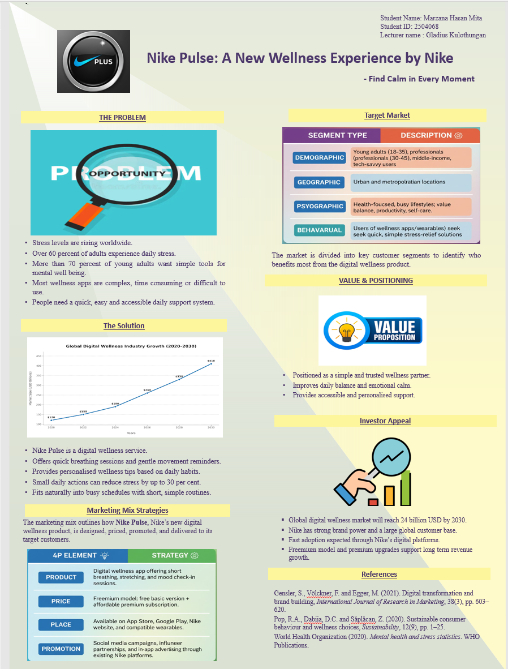
The Problem
The stress rates are increasing all over the world. According to the World Health Organization, six out of ten adults are exposed to daily stress, and according to digital lifestyle survey, they found that over 70 percent of young adults are seeking basic tools to maintain a healthy mental life. It does not give people time to maintain very long wellness routines, and most wellness apps demand excessive effort. Customers require concise and convenient daily support system.
The Solution
Nike Pulse is a digital fitness service which offers short breathing exercises, light exercises reminders and personalised wellness suggestions. Studies indicate that daily wellness behavior with the help of small exercises can decrease stress by a significant margin of up to 30 percent. Nike Pulse relies on the digital expertise to lead the user with easy steps into a busy routine.
Target Customers
The service targets two categories of people:
- The young adults are the most significant consumers of digital wellness tools, as more than 65 percent of them are using mobile apps to improve their health.
- Busy professionals, another group where 58 percent have reported stress due to work pressure and would desire short-time help during the day.
Value and Positioning
Nike Pulse is posed as an easy and reliable wellness companion that enhances the balance and helps to maintain emotional well-being on a daily basis.
Investor Appeal
The digital wellness sector in the global economy is increasing rapidly and is projected to have USD 24 billion market by the year 2030. Nike already enjoys brand power and size of global customer base which facilitates Nike Pulse fast adoption. Premium upgrades and freemium model provide investors with long term financial stability.

5. Reflection

5.1 Reflection on Developing the Brand Concept
The development of the Nike Pulse brand showed me how essential it is to examine the actual customer demands when developing a marketing plan. At the beginning of the task, I found that most individuals are stressed and are interested in having simple, wellness-supporting resources. The study on wellness behavior development (Pop et al., 2020) confirmed the rationale behind a digital wellness service. I also learnt that development of a brand should be developed around clear ideas that relate customer needs, company values, and market trends. Nike already enjoys a robust presence in the fields of fitness and lifestyle, and the idea of creating a wellness service was logical.
The other skill that I acquired was the application of the STDP method. I needed to look at various customer segments and what they desire in their lives. In the course of developing segmentation, I also realized that such segments as young adults and busy professionals have different needs but also common issues. Targeting phase also enabled me to select the particular groups that the service ought to target initially. This move made the strategy more realistic and stronger.
The differentiation process also allowed me to learn how a brand should demonstrate what makes it special. I understood that simplicity and calmness were some of the strong selling points of Nike Pulse. It demonstrated how a small idea can be powerful when related positively to the needs of customers.

5.2 Reflection on Creating and Delivering the Pitch
The pitch preparation assisted me in enhancing my communication abilities. I needed to consider how I would describe the concept of Nike Pulse in a straightforward means. The time constraint helped me to consider the kind of information that really mattered. I also found out that pitching should be supplemented with emotional and practical things. Emotional points assist the customers in feeling connected, whereas practical points demonstrate why the service is helpful. I also got to understand the importance of plain language. Since I am not a native speaker, it often occurs to me that I use the wrong words, although I feel more confident after writing this pitch. I learned to structure the pitch with the help of the research on digital promotion which demonstrates that customers prefer to see such short and clear messages (Lamberton and Stephen, 2020). Another lesson that I learned in creating the poster was the use of design to facilitate the message. These tasks assisted me to be confident when presenting ideas.

5.3 Reflection on Skills Gained and Future Development
I gained a few valuable aspects in this project. I got to know how to relate theory to actual brand decisions. To design Nike Pulse features, I used an example of how customer experience varies and depends on what they consider important (Kumar and Reinartz, 2019). I also was able to enhance my capability to research the market trends and how consumer behaviour evolves with time. I also enhanced my ability to plan. The experience in working on each section provided me with understanding of how a complete marketing strategy should be planned step by step. I needed to consider segmentation, targeting, the seven P elements and the final pitch. This taught me how marketing decisions relate to one another. My future goals are to become better at writing in English and to be more analytical. I would also like to know more about digital marketing since it is gaining relevance in most sectors. The project has helped me recognize that marketing is not just about sales but also about people and adding value to them.

Reference
Audretsch, D.B., Belitski, M. and Chernih, A. (2020). Entrepreneurial ecosystems and digital transformation. Small Business Economics, 55, pp.1–17.
Awan, U., Shamim, A. and Khan, Z. (2021). Customer experience and loyalty in competitive markets. Journal of Retailing and Consumer Services, 61, pp.1–10.
Gensler, S., Völckner, F. and Egger, M. (2021). Digital transformation and brand building. International Journal of Research in Marketing, 38(3), pp.603–620.
Iglesias, O., Landgraf, P. and Ind, N. (2020). Corporate brand identity co-creation. California Management Review, 63(1), pp.18–36.
Kapoor, H., Dwivedi, Y.K. and Piercy, N. (2021). Brand meaning and customer engagement. Journal of Business Research, 123, pp.310–321.
Kotler, P., Keller, K. and Chernev, A. (2024). Marketing Management. Pearson.
Kumar, V. and Reinartz, W. (2019). Integrating customer experience and brand strategy. Journal of Marketing, 83(6), pp.1–17.
Lamberton, C. and Stephen, A. (2020). A research agenda for digital marketing. Journal of Marketing, 84(1), pp.18–36.
Pop, R.A., Dabija, D.C. and Săplăcan, Z. (2020). Sustainable consumer behaviour and brand choice. Sustainability, 12(9), pp.1–25.
Purnomo, B.R. (2023). Customer retention strategies in digital service environments. Journal of Service Management Research, 5(2), pp.45–59.
Trautwein, C. (2021). Digital stress in modern work environments. Journal of Workplace Behavioral Health, 36(3), pp.215–230.
White, K., Habib, R. and Hardisty, D. (2019). Shifting consumer behaviour toward healthier and sustainable choices. Journal of Marketing, 83(3), pp.22–49.

