Organisational Change Case Study

8th July 2022

Jade Emery
2022574

Acknowledgements

This report and the research would not have been possible without the support of my company director, Emma Elias, who provided insight and experience that aided my study.
I appreciate having had the opportunity to study alongside all of my MBA peers throughout this and previous modules. Each student in my course has given me in-depth professional advice and taught me a lot about their personal experiences within their organisations. I would especially like to thank Dr Roisin Mullins my tutor, for supporting me through the change and stability management module and providing excellent learning content. Finally, my family has been most significant in my pursuit of an MBA. I want to thank my spouse, who supports me in all that I do with his love and wisdom.

Executive summary

Park Vet's ethos and objectives are being re-evaluated due to the recent change in leadership. Historically a lack of strategic planning has been identified. As a result, Park Vets has experienced significant change with an emergent change approach. Based upon internal research, planned and unplanned change has caused the team a great deal of stress and uncertainty due to the lack of planning and guidance throughout the process. In addition, leadership are required to develop the ability to plan and carry out well-managed change projects whilst identifying and involving key stakeholders. A comprehensive and long-term plan is therefore crucial for the practice's future. The practice's goal is to provide the local community's pets with high-quality care while making money and successfully competing with local competition.
The practice requires a strong team of veterinary professionals and support staff to achieve this. The main objective is to create a positive, inclusive culture through fostering trustworthy connections, making sure that each team member feels appreciated and essential, and fostering good communication across the practice.
The practice leaders will introduce change management framework models using a methodical approach to change management, preventing many issues immediately. It also provides a strategy for handling and lessening the effects of developing issues. Following change management frameworks increases the likelihood of change becoming successful and meeting objectives.

Contents

- Introduction…………………………………………………………………... 5
- Research………………………………………….…….…….………………… 6
  - Primary research…………………………………………………………… 6
2.2 Secondary research…………………………………………………………. 9
- Discussion & analysis …………………………………………….…………. 10
- Forcefield analysis……………..………………………………….…………… 11
- Stakeholder analysis………..……………………………………………………14
- Stakeholder GI grid………..……………………………………….…………….15
- Kubler-Ross Change Curve………………………………………………………16
- RASCI………….……………………………………………………..………… 17
- Resistance……………………………………………………….…………………17
- Conclusion ……………………………………….………………………….……18
- Recommendations……………………..…………………………………………....19
- Appendices……………………….………………………………..……………..…22
- References…………………………………………………………………..………26

Introduction

The Park Veterinary Group is a well-established small animal hospital that provides first-opinion vet care based in South Wales. A corporate company named VetPartners LDT acquired the practice in 2018. The practice currently has four Clinical Directors, seventeen full-time veterinarians, twelve registered vet nurses and seventeen admin employees.
Since VetPartners acquired Park Vets, there has been a significant restructure of the leadership team. The original partners/directors of the practice retired in 2020. However, within a short time of their retirements, two out of the remaining three managers resigned. Therefore, creating a large wave of unplanned emergent change within the practice to its employees. As a result, the practice experienced a sudden, unanticipated crisis leading to a demotivated team and a high turnover of staff. The leaders lacked the time necessary to engage in careful planning and consensus-building. During this significant organisational change, the new leadership team attempted to undertake crisis management. “The process for mitigating, responding to, recovering from, and learning from emergency incidents (Shaw, 2018)”.
The previous senior management team at Park Vets has lacked the implantation of change models. This report will discuss the approaches that were taken, the inefficiencies of the prior strategies, and explore a new direction that might aid in the organisation’s sustainability and development for the future by utilising change management framework models.
As a result, from the recent leadership changes and the major disruption caused this report will focus on a change project within Park Vets focusing on achieving an improved organisational culture. “Organisational culture is outlined at the highest level of an organisation and then communicated, supported, and enforced throughout every level.” (SHRM, u.d)

The Research Process
Primary research
- Observation / Participant Observation.
- Surveys.
- Interviews.

Methods

Interview

A semi-structured interview was conducted with Emma Elias, the current clinical director at Park Vets. Questions were asked to help understand the changes that have occurred over the last two years predominately focusing on the leadership transition. In addition, questions asked the leader their level of awareness of the changes imposed on the broader team during and following the change.

Key findings:
“Previously change was not strategically planned, change happened by reaction to pressures and circumstances invoking changes which often came as a surprise to the team and therefore, often change was turbulent and feared by the team”
“Change was imposed on the team rather than encouraged and empowered to improve working environments for all.”
“Changes often did not work as the team would revert back to habits and did not understand or fully embrace the need for the change. Therefore, never actioned fully.”

Transition from previous leadership team to current
“I feel the team were aware of the changes intended, as retirement was approaching for the old leadership, however the changeover was not communicated well, roles and responsibilities were not clear, our cooperate owners did not support the new leaders or the team in what to expect.”

Analysis of current leadership
“I feel that the new leadership team now openly asks for team input, considers requests and ideas and delivers of what is achievable.”

“Involving the team in how they would like to be managed promotes physiological safety, empowers individuals and develops leadership across the team, not just focusing change lead through management direction.”

“Promoting a healthy culture will always be a challenge and culture is something that need continuous attention.”

“Culture is a challenge especially in the face of a recruitment crisis, potentially loosing key employees due to more attractive a salary packages, cost of living changes means culture momentum can be lost very quickly.”

Employee survey

This survey was offered out to all employees

Survey results based on a 33% participation
Findings:
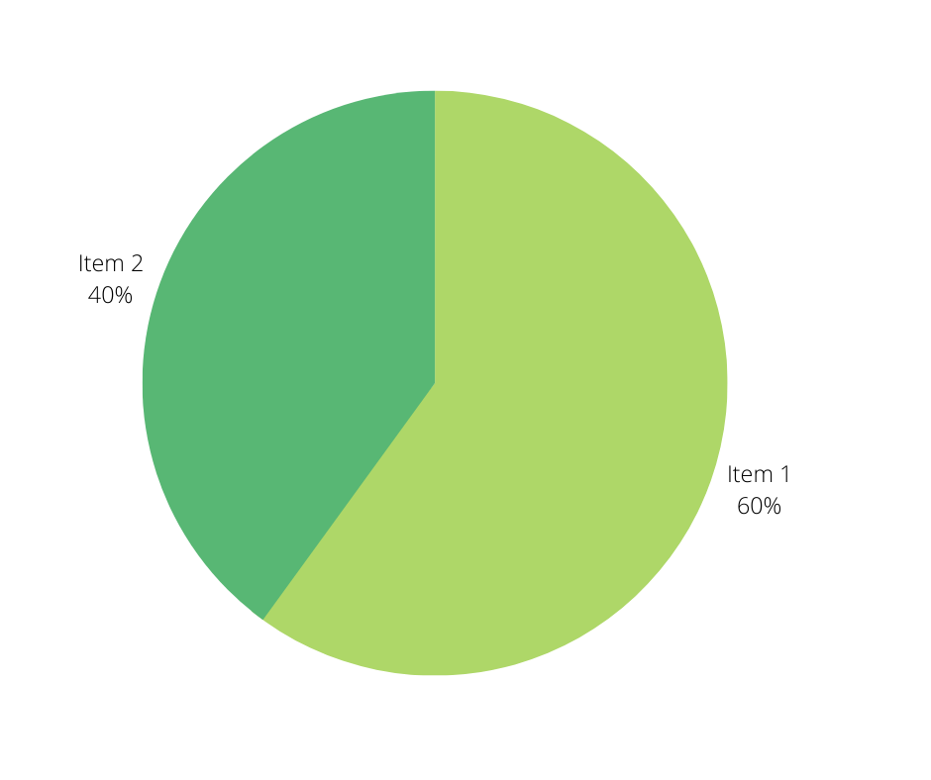
Some team members indicated trepidation about future progress and had unfavourable expectations for the handling of organisational transformation. Some concerns around the fear of new processes, and not feeling safe in their role. Current experiences of feeling uninformed of the transition, as well as sentiments of being burnt out and understaffed in the continuously demanding clinical setting, added to these concerns.

60% of the team believe the culture needs to be improved within the organisation
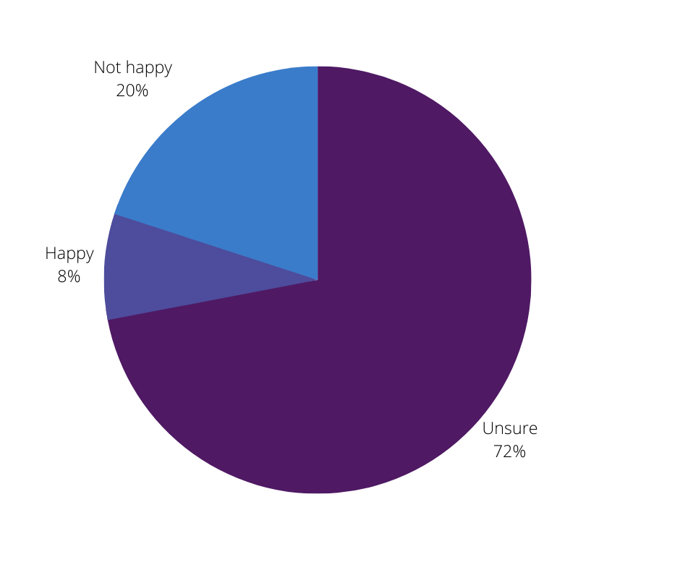

The team were asked if they were happy with change in the workplace. 72% answered unsure, 20% answered they were not happy with change and 8% answered that they were open to change.

The survey identified two sub-components:
- The emotional hangover: According to NY university (2016) In a change hangover, “current team members are burdened by the events of earlier changes”. This is because change frequently triggers negative emotional memories due to the way our brains are formed. Leaders will be required to take some time to think about previous organisational change and how this may have an influence on how employees feel about potential changes going forward. This insight will make it easier to control how individuals react.
- Employee expectations based on past experiences: It’s natural that when confronting a struggle, which change frequently seems like, people will think back to their most recent or most comparable experience. Leaders should assess the assumptions that their team must prevent the spread of negative expectations. This presents a chance to disprove any harmful assumptions (Brearley, 2016).

Secondary research
Data analysis
Employee turnover figures provided by VetPartners HR department and have been configured into a graph to identify the number of employee turnover figures during the period of significant change.
Findings:
Employee turnover across 2018-2022
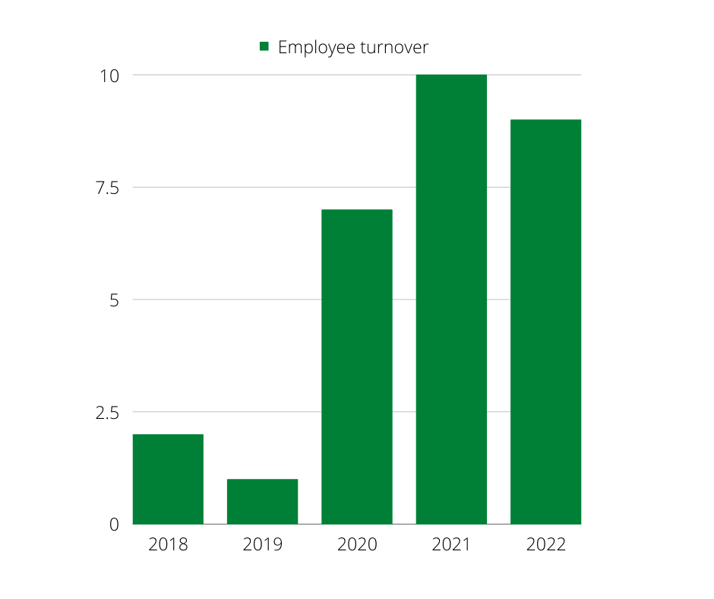
Limitations

The turnover results may have also been affected by the recruitment crisis that has impacted the veterinary industry over the last few years. The political effects of Brexit and the major pressure from the covid-19 pandemic could have also affected the figures (BVA, 2022).

Discussion & analysis
Any planned change always starts with a procedure, like the force-field analysis. For the transition process, there are several models.; Egan (1988) suggested the following is a basic, straightforward model. He outlines these three actions:
• The evaluation of the existing situation.
• The development of a desired situation.
• Creating a strategy that shifts the system from the desirable situation to the present one.
Egan’s focus on planning and assessment shows that Kurt Lewin’s model (unfreezing, changing, and refreezing) has influenced him. However, Egan also contends that action must follow planning to achieve results or outcomes that are valuable to the organisation. Consequently, a particular objective must be the focus of both planning and transformation.
The objective for Park Vets is to reset and reinstate a positive culture within the company whilst improving the utilised change processes. Combining the improvement of change management within Park Vets with the objective of better culture will enable a more trusting and engaged team. According to Boyarsky (2021), “85% of employees worldwide are not engaged or actively engaged in their work”. Nevertheless, Boyarsky (2021) suggests that when engagement is heightened through a better working culture, there has been a 21% increase in profitability. Therefore, a lack of engagement with the team can negatively affect the team’s morale and impact the bottom line.

A forcefield analysis was produced by collating all the data from the primary and secondary research.
The data has produced the following forces for change:
- Demographic
- Political
- Technology
- Declining team morale
- Employee turnover

The forces resisting change:
- Mistrust
- Fear
- Poor communication
- Existing organisational structures
- Disruption
- Cost
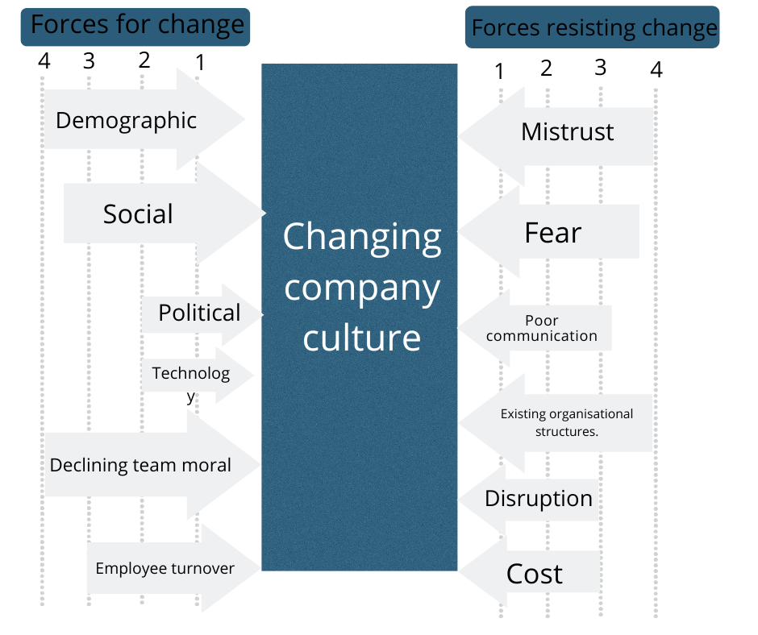

Figure (1)

Force field Analysis - Kurt Lewin’s Model
The "force field analysis," developed by Kurt Lewin, describes any present level of performance or existence as a balance between the forces pushing upward movement and the restrictions on it. (Cheishvili, Zarnadze and Zarnadze, 2017). This means that the forces opposing change balance the forces favouring it, creating the existing equilibrium.
Usually, there are good, sensible, logical, conscious, and economic forces at work.
The restraints are typically negative, emotional, irrational, unconscious, and social/psychological (Tahir, 2019).
When dealing with change, managing, or responding to change, the leadership team must consider both sets of forces produced and very significant. (Figure 1)
Many of the forces resisting change directly result from the historical poorly managed change. Implementing a change project to improve company culture will reduce the levels of resisting change and increase the forces for change.
This analysis openly discussed with organisational leaders will raise awareness of the issues currently being dealt with by the company. Discussions can then switch to how best to deal with the stakeholders involved in the forces supporting and opposing the planned changes. The staffing, timeline, budget, and communications plan for the project will be defined with the support of the responses from each anticipated stakeholder or group (Rittenhouse, 2015).

Stakeholder analysis
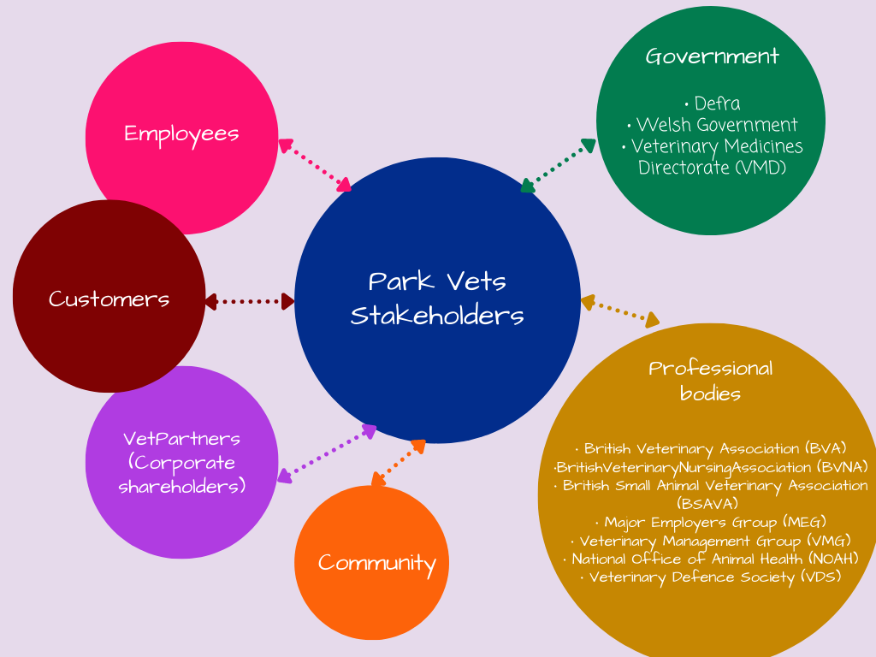

Figure (2)

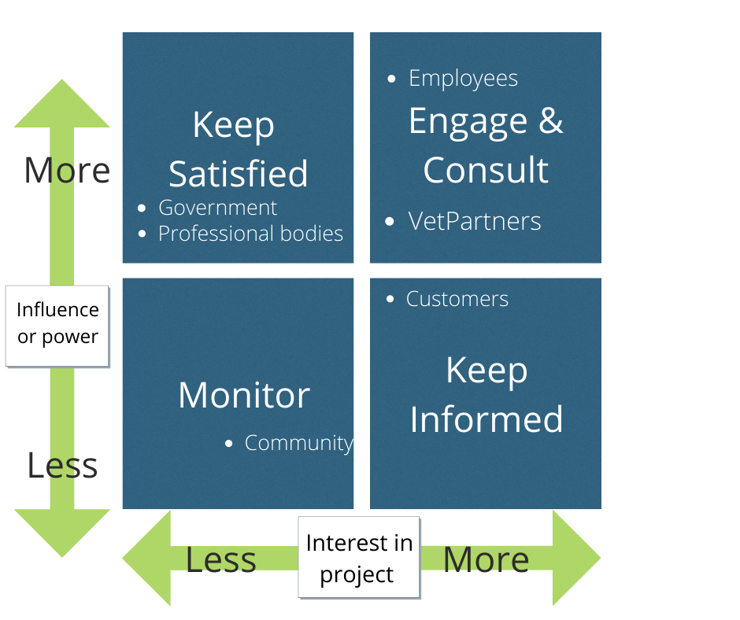

Figure (3)

The team is arguably the most significant set of stakeholders within this project hence it is crucial to invest in team building, consulting, and engagement. Figure (3).
After the team has documented the anticipated problems from the stakeholders in the force, the six techniques to managing change identified by Kotter and Schlesinger can help the team deal with change resistance. -field chart (Rittenhouse 2015).

Kotters model
According to the needs of the stakeholders and the situation, Kotter and Schlesinger (1979) presented an initial list to structure the management of stakeholders. For each "driving" and "restraining" force observed during the force-field chart exercise, the list can be used to assign objectives. Kotter’s 8 step process for leading change was later introduced in 1996 which “focuses less on process and more on the people behind the change (Juneja, 2015)”.

Finding engagement opportunities will encourage people to promote change by creating a sense of urgency. According to Tuck (2014)
“It is important to highlight successful outcomes, and that consequences of failure are communicated openly and effectively. For mental health settings, it is paramount to encompass service user involvement and other stakeholders when identifying opportunities”.
This will encourage employees and direct their efforts. Lastly, Kotter highlights that “75% of the organisation’s management needs to be on board with implementing change (Kotter, 1996)”.
Prior to performing the subsequent steps, it is crucial to devote a lot of effort to the stage of developing a sense of urgency (Pollack, 2015).
The focus of veterinary hospitals is on the patients, the team, owners, and other stakeholders. The company's core beliefs are centred on its veterinarians and patients. The results imply that Kotter's (1996) method may be suitable for organisational change and may enhance company culture.
Kubler-Ross Change Curve
As stated by Atktas, (2021) “Business leaders can effectively use the Kubler-Ross Change Curve to help their workforce adapt to change and move towards success”.
By investing in Kotter's 8-step change model using the employee's experience to aid in the resistance to change, Kubler-Ross's change curve will transition the team through the "5 stages of grief" (Belyh, 2022). It has been identified within the analysis that there is fear, mistrust, and poor communication. The change curve will create a change management process using the Kotters model.
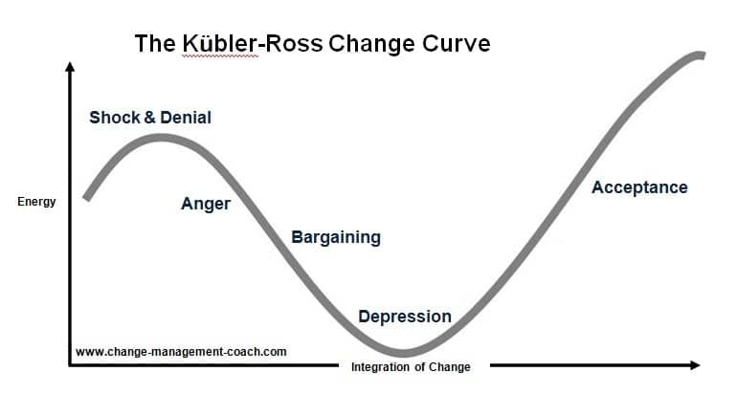

(Connelly, 2020)
RASCI
Due to the findings from historical failings within the company and the identification of a lack of accountability within the leadership team, using RASCI will enable the project to hold those involved accountable. In addition, assigning each project level to a team member will clarify and define roles and responsibilities across departments (Reeves, 2019).

Resistance

Resistance is inevitable in almost all cases when implementing change within an organisation (Spring, 2021). The primary research has identified much uncertainty and fear surrounding organisational change within Park Vets.
According to Conway and Monks (2011), poor employee communication is the root of resistance to change. They claim further that varied levels of worry that result in resistance are experienced by workers who perceive the imposition of change initiatives. A 2012 study by Michela and Vena examined the psychological effects of significant change on staff members' mental stability. They discovered that workers who perceive a threat to their jobs from change frequently go into a self-protective mode, which hinders their openness for change.
People's social and emotional well-being is influenced by their capacity to adapt to their social and cultural circumstances. Therefore, an organisation's leadership must always seek the best approaches to involving its staff in its mission. Additionally, they must include opportunities for self-realisation, self-efficacy, and personal growth in their role. (Cooper, 2013).

Conclusions
By examining various change models, this study thoroughly investigated the elements influencing the success of change management within the Park Veterinary Group. The appropriate elements for a culture change initiative's effective change management are investigated using an action research methodology within the veterinary practice. According to a survey and interview with the employees and leaders, the most critical factors for successful change management when implementing a change plan are the approach, effectiveness and continuous communication during change, engagement of stakeholders, and motivation of employees.
In contrast, the top reasons for previous change management failure include a lack of a clear vision, inadequate leadership, limited stakeholder engagement, and poor communication. The analysis also showed that some factors could affect other factors. This was illustrated in the data produced from the employee turnover 2018-2022.
The report’s recommendations may help enhance the actions and choices required to implement organisational change projects effectively. Additionally, the results can make it possible for managers to focus their time and energy on the crucial issues needed to ensure organisational change management success. As a result, leaders may improve the performance of organisational change initiatives. Furthermore, they can utilise the study's findings to craft more definite plans for raising their companies' change management competence.
Veterinary practices must continuously adapt to meet the needs of their employees, clients and patients whilst remaining profitable. All adjustments ultimately come down to the team adopting new behaviours. Many change projects will fail unless they are governed by a clearly defined process of creating a feeling of urgency, recruiting a strong team of change agents, involving the workforce, and removing obstacles to change because it is argued that it is in our human nature to resistant to change (Kanter, 2012)
.
Recommendations
Forming a key coalition
The leader of each department to meet to create a consultation session. During the meeting, the results from this analysis will be discussed, showing the importance and urgency of intervention. Resource packs should be created for the leaders to share amongst their teams. This information will include the plans on how the organisation would like to proceed with change management and the importance of redefining the company culture.
Each team leader will recruit department volunteers to act as advocates and champion the project. Support must be provided to employees who struggle to understand and initially resist.
Development of a strategic vision
A solid vision can inspire and encourage workers to take appropriate action. It is crucial to consider the fundamental principles that, at this point, motivate change and should be compatible with the organisation. According to Tanner, (2021) “To illustrate the necessity and motivation for change, it is crucial to consider the past, present, and future when developing a strategic vision”. Strategic initiatives can be developed from the vision and should comprise focused, coordinated actions that can be successfully carried out.
A vision statement really should be succinct, clear, and applicable to all organisational levels of staff:
“Improving Company Culture”
Providing the team, a review of ‘where the organisation is now' and ‘where we want to be’ may aid in setting objectives and goals.
Getting everyone to participate
The leadership and change agent team at Park Vets will need to work together to develop a communication plan while working within the company. Suggested communication:
• Weekly/Monthly updates.
• Channels for staff communication, such as newsletters, socials, and email; •Channels for service users, such as service engagement sessions, social media, and local networks
• Convey the vision and goal-related information.
• Identify who oversees implementing the strategy.
They will put this approach into action as soon as it has been decided, evaluating the plan every six months to ensure it is still working.
Removing obstacles and reducing resistance
The weekly newsletter features an anonymous poll that the Park Vets leadership team have created, allowing employees to share their thoughts on the change process. Through communication, Park Vet’s leaders and the change agents can learn about the organisation’s successes and any organisational obstacles and hurdles. It also allows employees to describe what might assist them to overcome these obstacles.
The Park Vet’s leaders will analyse the feedback at organised progress meetings. Solutions are found, a report is written, and it is distributed via communication lines. Additionally, line managers could convey this knowledge to their department.
Additionally, considering the local context and lessons learned from prior initiatives.
Sustaining progress
HR and managers have been requested to incorporate a component of company culture goal into job descriptions. When hiring new staff, they know the ethos and visions of the practice upon employment.
Ongoing team bonding exercises to be regularly scheduled. To become part of the practice’s professional development plan.
Setting the changes in stone.
The leadership team shows the entire organisation their enthusiasm and drive to maintain a positive and inclusive culture. They appreciate the employees for their engagement and convey the beneficial behaviour and the effects this change has had on the company.

Appendices

Emma Elia Interview questions and answers, interview conducted 1.7.22, Park Vets, Cardiff.

Do you feel the previous leaders (Simon, Suzanne, Mary) led change within the organisation strategically and actioned efficiently? If not, why not?
Previously change was not strategically planned, changed happened by reaction to pressures and circumstances invoking changes which often came as a surprise to the team and therefore, often change was turbulent and feared by the team. Strategy planning was not prioritised by the old management style adopted by the previous leaders.
Change was imposed on the team rather than encouraged and empowered to improve working environments for all. Doctorial management styles often create this culture.

Do you think the previous leaders used change models to support changes within the practice (e.g Lewin's change management model, The McKinsey 7-S model, Kotter's change management theory, ADKAR change management model)?
No, as above change was not planned it happened by reaction.
Changes often did not work as the team would revert back to habits and did not understand or fully embrace the need for the change. Therefore, never actioned fully.

Do you feel the transition of leadership was well-planned and considered the team when changes were made?
I feel the team were aware of the changes intended, as retirement was approaching for the old leadership, however the changeover was not communicated well, roles and responsibilities were not clear, our cooperate owners did not support the new leaders or the team in what to expect.
I feel the team were considered in as far as the need for leadership team members, interviews were conducted and appointments made, but again no follow up support given to provide clear expectations and goal setting.

How is the approach to change different now than it was with previous leadership?
I feel that the new leadership team now openly asks for team input, considers requests and ideas and delivers of what is achievable.
The team has been involved in budgeting ideas, expansion plans and how they view our working culture, this has given the leadership team insights into how the team would like to function and therefore should create more achievable goals. Involving the team in how they would like to be managed promotes physiological safety, empowers individuals, and develops leadership across the team, not just focusing change lead through management direction.

Do you agree that organisational culture is the biggest challenge within the practice at this present time?
Promoting a healthy culture will always be a challenge and culture is something that need continuous attention. The culture of the practice should be outlined from grassroots, discussed in interviews, outline expectations and behaviours, reiterated in practice meetings, PDRs etc. The practices’ vision and values also needs to be flexible and adaptable to industry changes.
Culture is a challenge especially in the face of a recruitment crisis, potentially loosing key employees due to more attractive a salary packages, cost of living changes means culture momentum can be lost very quickly. Sometimes being a nice place to work is not enough.
If not, what do you believe to be the biggest challenge?
Answered in previous question
Survey questions and results (Park Vets newsletter, 2022)
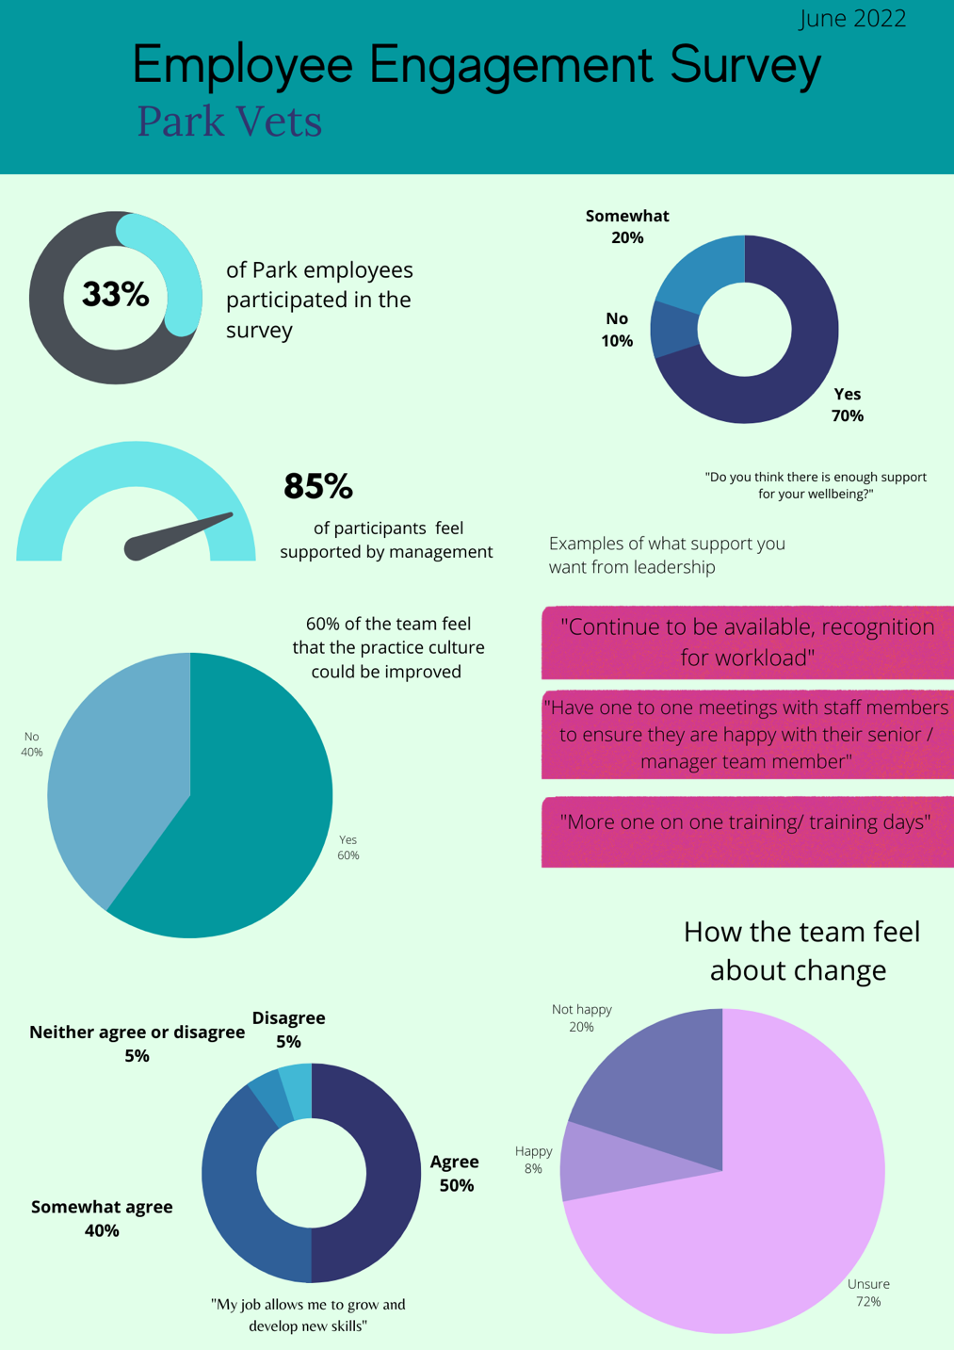

Park Vets turnover figures 2018-2022

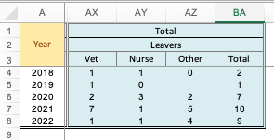

(VetPartners database, 2022)

References

Adin, C., 2021. Leading and Influencing Culture Change. Veterinary Clinics of North America: Small Animal Practice, 51(5), pp.1071-1078.

Atktas, M., 2021. Kübler-Ross’ Five Stage Change Curve Model – all you need to know. [online] UserGuiding. Available at: <https://userguiding.com/blog/kubler-ross-change-curve-model/>

Belyh, A., 2022. Understanding the Kubler-Ross Change Curve. [online] Cleverism. Available at: <https://www.cleverism.com/understanding-kubler-ross-change-curve/>

Boyarsky, K., 2021. Engaged Employees are Happy Employees. [online] Resources.owllabs.com. Available at: <https://resources.owllabs.com/blog/engaged-employees>

Brearley, B., 2016. 3 Ways That Making Assumptions Damages Your Team - Thoughtful Leader. [online] Thoughtful Leader. Available at: <https://www.thoughtfulleader.com/stop-making-assumptions/>

BVA, 2022. UK’s veterinary workforce crisis deepens as EU registrant numbers drop by over two-thirds since Brexit | British Veterinary Association. [online] British Veterinary Association. Available at: <https://www.bva.co.uk/news-and-blog/news-article/uk-s-veterinary-workforce-crisis-deepens-as-eu-registrant-numbers-drop-by-over-two-thirds-since-brexit/>
Cheishvili, J., Zarnadze, I. and Zarnadze, S., 2017. Management of Change Delivery Decision Making Through the Force Field Analysis in Georgia.

Connelly, M., 2020. [online] Change-management-coach.com. Available at: <https://www.change-management-coach.com/kubler-ross.html>

Conway, E. & Monks, K. (2011). Change from below: The role of middle managers in mediating paradoxical change. Human Resource Management Journal, 21: 2, 190-203.
Cooper, M. (2013). The intrinsic foundations of extrinsic motivations and goals: Toward a unified humanistic theory of well-being and change. Journal Of Humanistic Psychology, 53(2), 153-171. doi:10.1177/0022167812453768

Ferrance, E. (2000). Page 9. Themes in education: Action research. Providence, RI: Northeast and Islands Regional Educational Laboratory.

Hussain, S., Lei, S., Akram, T., Haider, M., Hussain, S. and Ali, M., 2018. Kurt Lewin's change model: A critical review of the role of leadership and employee involvement in organizational change. Journal of Innovation &amp; Knowledge, 3(3), pp.123-127.

Juneja, P., 2015. Contingency Model of Change Management: Dunphy and Stace's Model of Change. [online] Managementstudyguide.com. Available at: <https://www.managementstudyguide.com/contingency-model-of-change-management.htm>

Kanter, R., 2012. Ten Reasons People Resist Change. [online] Harvard Business Review. Available at: <https://hbr.org/2012/09/ten-reasons-people-resist-chang>
KOTTER, J. P. (1996). Leading change. Boston, Mass, Harvard Business School Press.
Pollack, J. and Pollack, R., 2014. Using Kotter’s Eight Stage Process to Manage an Organisational Change Program: Presentation and Practice. Systemic Practice and Action Research, 28(1), pp.51-66.

Michela, J. L., & Vena, J. (2012). A Dependence-Regulation Account of Psychological Distancing in Response to Major Organisational Change. Journal Of Change Management, 12(1), 77-94. doi:10.1080/14697017.2011.652376.

New York University. (2016, December 26). Is there such a thing as an emotional hangover? Researchers find that there is. ScienceDaily. Retrieved July 5, 2022 from www.sciencedaily.com/releases/2016/12/161226211238.htm

Reeves, S., 2019. A Comprehensive Guide to the RASCI/RACI Model. [online] GoodCore. Available at: <https://www.goodcore.co.uk/blog/a-guide-to-the-raci-rasci-model/>

Rittenhouse, J. (2015). Improving stakeholder management using change management tools. Paper presented at PMI® Global Congress 2015—North America, Orlando, FL. Newtown Square, PA: Project Management Institute.

Shaw, M. (2018). Unplanned Change and Crisis Management. In: Farazmand, A. (eds) Global Encyclopedia of Public Administration, Public Policy, and Governance. Springer, Cham. https://doi.org/10.1007/978-3-319-20928-9_748

SHRM, n.d. Understanding and Developing Organizational Culture. [online] SHRM. Available at: <https://www.shrm.org/resourcesandtools/tools-and-samples/toolkits/pages/understandinganddevelopingorganizationalculture.aspx>

Spring, K., 2021. Overcoming Resistance to Change within Your Organization. [online] Betterup.com. Available at: <https://www.betterup.com/blog/resistance-to-change>

Tahir, U., 2019. Lewin’s Force Field Analysis (Change Management) | CMI. [online] CMI. Available at: <https://changemanagementinsight.com/lewins-force-field-analysis-change-management/>

Tanner, R., 2021. Leading Change (Step 3) – Develop a Change Vision and Strategy. [online] Managementisajourney.com. Available at: <https://managementisajourney.com/leading-change-step-3-develop-a-change-vision-and-strategy

Tuck, P., 2014. A failure to communicate. [online] Training Journal. Available at: <https://www.trainingjournal.com/articles/feature/failure-communicate>

Young, J., 2020. Organisational Culture and Cultural Change | Factsheets | CIPD. [online] CIPD. Available at: <https://www.cipd.co.uk/knowledge/culture/working-environment/organisation-culture-change-factsheet#gref>

