

Student name: | Abdulla Al Toha | Student ID number: | 2513613
Programme: | CertHE Computing Skills for the Workplace
Module: | Computer Architecture and Operating Systems
Module code: | ACCA4022 | Word count: | 2000 words
Assignment Title: | Operating Systems Assignment | Submission deadline: | 29 April 2026

Table of Contents

1. Key functions of general Operating Systems ……………………………………………
2. Use of Windows OS CLI commands …………………………………………………..
3. Use of Linux OS CLI commands ………………………………………………………..
4. Use of Windows OS scripts ……………………………………………………………..
5. Use of Linux OS scripts ………………………………………………………………….
Conclusion 6
References 7

- Key functions of general Operating Systems
An Operating System (OS) is the key factor separating your computer hardware and the software that you interact with every day. The various systems, such as Windows, macOS, and Linux, have distinct interfaces, but their common interfaces all undertake four basic roles that maintain a smooth, secure, and productive computing experience. This is a breakdown of these fundamental functions and the specific locations in which these functions can be monitored on your machine (D. J. Barrett et al.2022).
Important Operating System Functions
Process Management
Such is the purpose of this OS as a traffic cop of your CPU. It allows each running program--including your web browser or even a video game--to share just a portion of processing time and the memory it requires to run smoothly without hitting each other.
Memory Management
OS is a fastidious warehouse inventory controller of RAM. It traces each and every byte of memory, determining what to read, where to write, and how to change back data to create more space to execute new processes.
File System Management
This role gives your storage drive its logical structure, in the form of systems such as NTFS (Windows) or APFS (macOS). It deals with the storage, naming, and folding of the data into folders, and retrieval and abstracts the complicated technical aspects into an interface that is easy to comprehend (C. Negus, 2020).
I/O Device Management
The OS handles all the participants of communication with the external world, including keyboard, mouse, printers, and network cards. It relies on drivers as interpreters and interprets generic OS commands into actions that a particular hardware can comprehend.
.
Monitoring and management of these Functions
To observe these functions, you do not require any special software. Windows and macOS have strong built-in applications.
Monitoring on Windows
Windows offers a toolkit to this end.
Task Manager: This is where you begin to monitor performance (open with ++ctrl+shift+esc++).
Performance Tab: This tab will provide you with a live view of your system. You can view live graphs of your CPU, memory, disk, and network usage as illustrated below, so that you can easily discover a bottleneck.
This picture presents the Performance tab of the Windows Task Manager, where the real-time graphs of CPU utilization (3.41 GHz) and memory utilization (8.8/15.8 GB) are shown (J. Robbins, 2020).
Process management is a reality here, and so processes are listed here. You can see all the running apps and background services, as well as the CPU, memory, disk, and network resources it is currently using, in the example. When an application is frozen, you can right-click to choose End task to make the operating system close that process and free up its resources.
The Windows Task Manager Processes tab also displays all the running programs and background processes, and the user can view the amount of resources that they consume and terminate programs that are not necessary.
Monitoring on macOS
Activity Monitor is a powerful application used by macOS for these tasks.
CPU and Memory Views: Once you have opened up Activity Monitor, you are greeted with a table of all running processes. The CPU tab (below) displays what apps are consuming your processor, whereas the Memory tab displays the memory pressure and consumption. In case an application is not responding, you can pick it in the list and press the X button (or Force Quit) to bring it to a halt (T. O. O. Oluwasola and S. O. Olatunji, 2022).
The following screenshot of the macOS Activity Monitor displays a list of running processes, and users can sort the processes by CPU usage to identify the applications that consume resources. The view has access to CPU, Memory, Energy, Disk, and Network monitoring options.
These built-in tools are crucial to every user. Through them, you get a peek into the complicated processes your operating system is engaged in at every given second to ensure that everything is going on.

- Windows CLI Commands for System Administration

1. Process Management
Command: Get-Process (PowerShell)
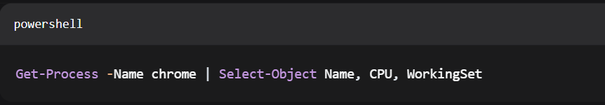
powershell
Get-Process -Name chrome | Select-Object Name, CPU, Workingset.
Output:
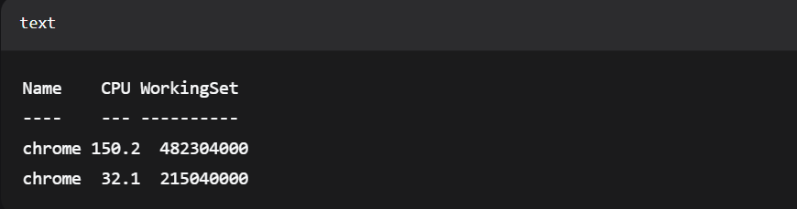
text
Name CPU WorkingSet
---- --- ----------
chrome 150.2 482304000
Chrome 32.1 215040000
Description: Displays the list of Chrome processes, with CPU time and memory (WorkingSet) in bytes -Name is used to filter the list (D. J. Barrett, 2016).
2. File & Directory Management
PowerShell: Get-ChildItem - (PowerShell) - the same as dir in CMD.
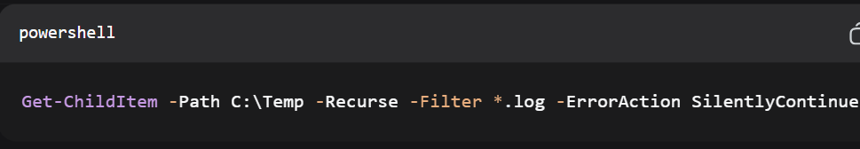
powershell
Get-ChildItem -path Temp c:/Temp -recurse -filter log. -erroraction silentlyContinue.
Output:
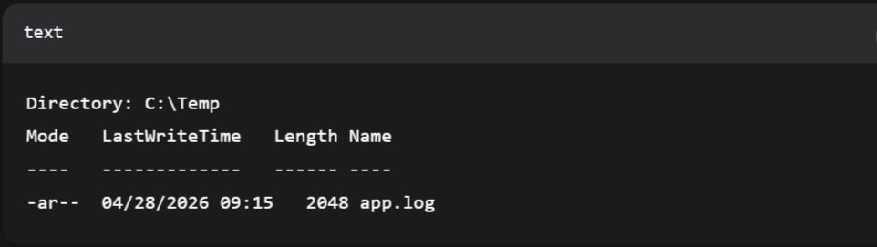
text
Directory: C:\Temp
Mode LastWriteTime Length Name
---- ------------- ------ ----
-ar-- 04/28/2026 09:15 2048 app.log
Description: Recursively locates all.log files -Recurse searches subfolders -Filter includes/excludes a result -ErrorAction hides permission errors.
3. Network Testing/Monitoring
Command: Test-NetConnection (PowerShell)
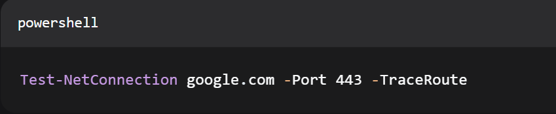powershell
Test-NetConnection google.com - Port 443 - TraceRoute
Output:
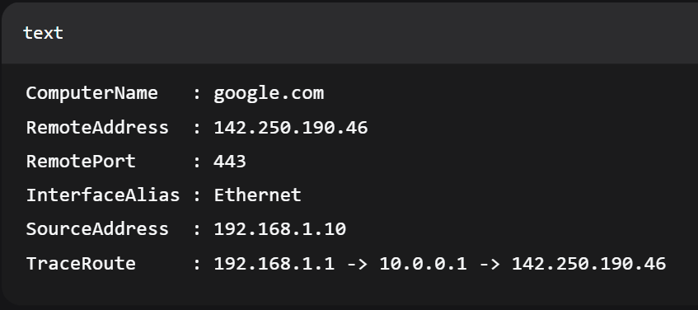
text
ComputerName: google.com
RemoteAddress: 142.250.190.46
RemotePort: 443
InterfaceAlias: Ethernet
SourceAddress: 192.168.1.10
TraceRoute : 192.168.1.1 -> 10.0.0.1 -> 142.250.190.46
Description: Checks that it can connect to Google over HTTPS on port 443 and logs the route. -Port attaches port number; -TraceRoute traces routing.
4. User Management
Command: Get-LocalUser (PowerShell)
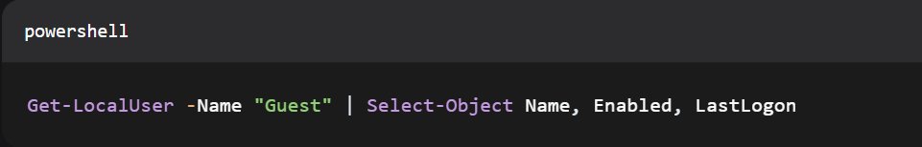
powershell
Get-LocalUser -Name Guest in other words, Select-Object Name, Enabled, LastLogon.
Output:
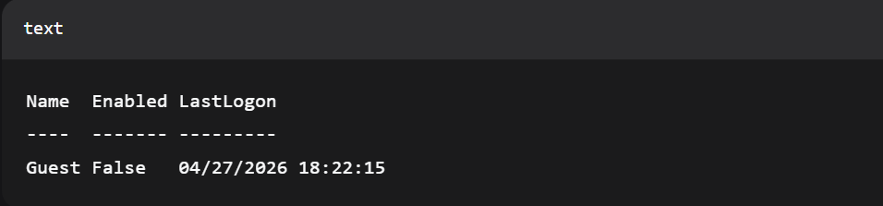
text
Name Enabled LastLogon
---- ------- ---------
Guest False 04/27/2026 18:22:15
Description: Name filters; Select-Object limits are shown as properties. Checks whether or not the Guest account is active and when it was last logged in (M. Russinovich et al. 2017).
5. Task Scheduling
Command: Get-ScheduledTask (PowerShell)
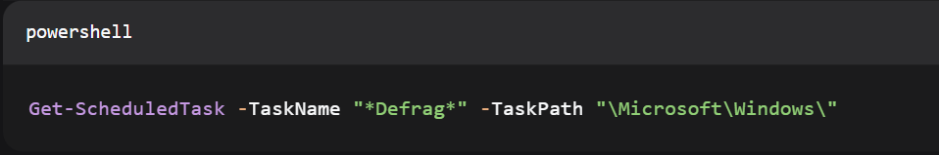
powershell
Get-ScheduledTask -Taskname "*Defrag*" -Taskpath Moveaching Path to"Microsoft/Windows."
Output:
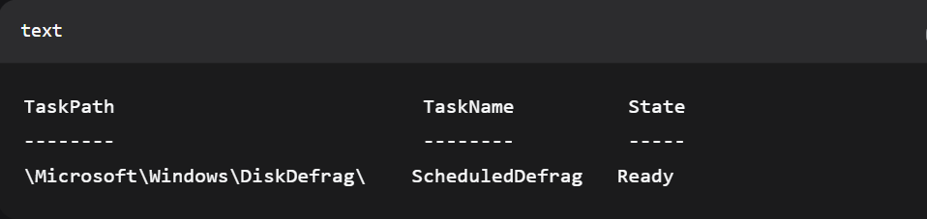
text
TaskPath TaskName State
-------- -------- -----
\Microsoft\Windows\DiskDefrag\ ScheduledDefrag Ready
Description: Finds all tasks scheduled containing the word Defrag in their names, in the Windows system path. -TaskName accepts wildcards, -taskpath limits the search.

3. Linux Bash Commands for System Administration
Process Management
Command: ps Process snapshot.
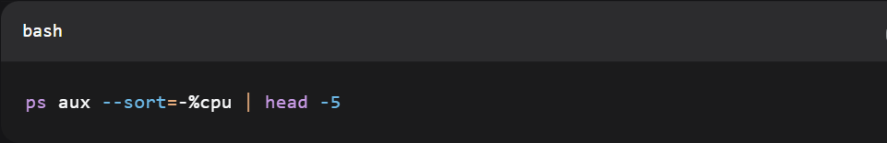
bash
ps aux --sort=-%cpu | head -5
Output:
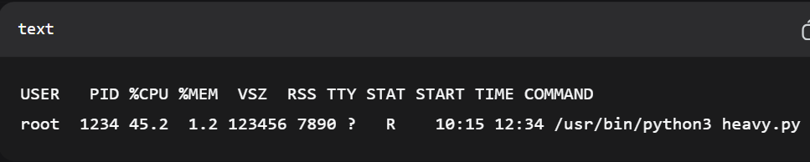
text
USERSPIDCPUMEMVSZRSSTTY STATSTART TIME Command
root 1234 45.2 1.2 123456 7890 ? R 10:15 12:34 /usr/bin/python3 heavy.py
Description: displays all processes (a), user-friendly (u), and processes which are not tied to a terminal (x). -sort= - %cpu sorts by descending CPU. head -5 restricts to the top (W. Stallings, 2017).

File & Directory Management
Command: locate - Advanced file location utility.
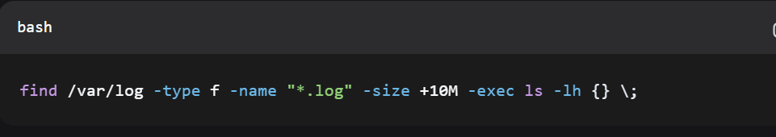
bash
find /var/log -type f -name "*.log" -size +10M -exec ls -lh {} \;
Output:
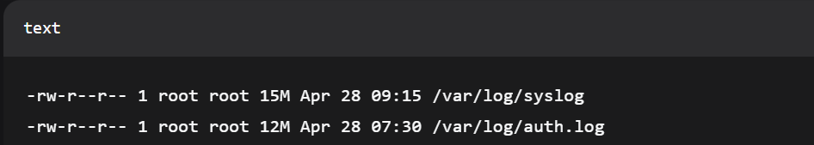
text
-rw-r--r-- 1 root root 15M Apr 28 09:15 /var/log/syslog
-rw-r--r-- 1 root root 12M Apr 28 07:30 /var/log/auth.log
Description: Search files (-type f) in /var/log that have a size of over 10 MB (-size +10M) and run ls -lh on them.
Network Testing/Monitoring
Command: ss -Socket statistics (modern netstat)
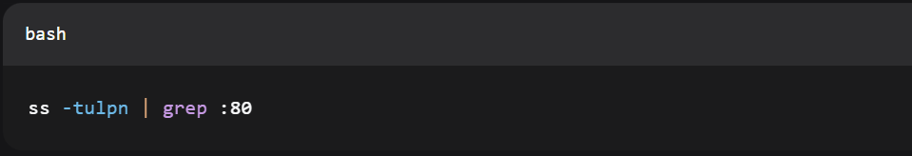
bash
ss -tulpn | grep:80
Output:
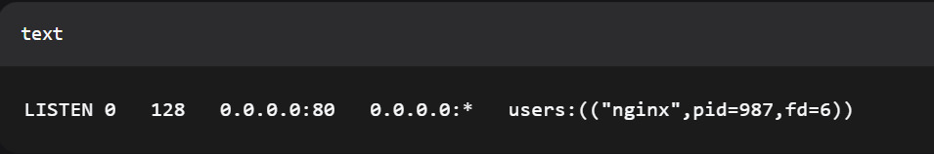
text
LISTEN 0 128 0.0.0.0:80 0.0.0.0:* users:(("nginx",pid=987,fd=6))
Description: Displays TCP (-t), UDP (-u), listening (-l), numeric ports (-n), and process info (-p). Piped to grep to filter port 80.
User Management
Condition: The usermod command is used to change user accounts.
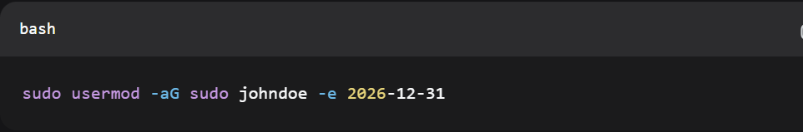
bash
sudo usermod -aG sudo johndoe -e 2026-12-31
Output: (No output on successful)
Description: Adds user johndoe (-aG appends to sudo group) and expires the account on 31-Dec-2026 (-e). Requires sudo privileges.
Task Scheduling
Argument: crontab – Schedule regular jobs.
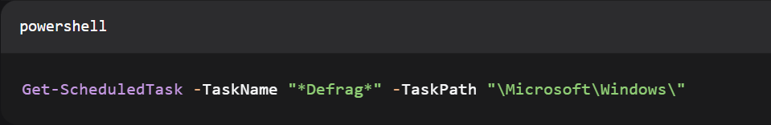
bash
Get-ScheduledTask -TaskName "*Defrag*" -TaskPath "\Microsoft\Windows\"
Output:
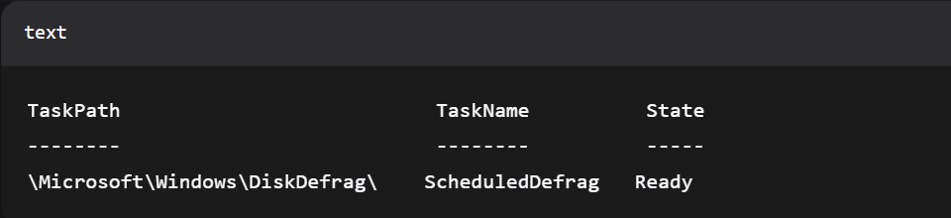
Text
TaskPath TaskName State
-------- -------- -----
\Microsoft\Windows\DiskDefrag\ ScheduledDefrag Ready

Description: Shows cron jobs of the current user (-l). The former executes the backup.sh every day at 2:00 AM; the latter executes logrotate on the 1 st of each month at 4: 15 AM.
Adding a job:
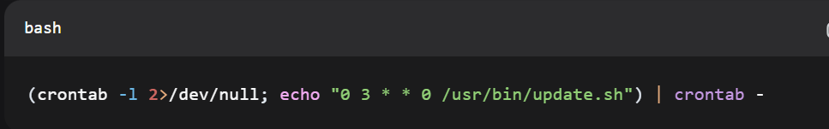
bash
(crontab -l 2>/dev/null; echo "0 3 0 /usr/bin/update.sh") | crontab -
Description: Generates a new cron job (Sundays at 3:00 AM) without overwriting the already existing one (A. Silberschatz, 2018).

4. Use of Windows OS scripts
Script 1: Automated Checker of Disk Space
The script monitors free space on the C: drive and notifies in case of low space.

Code (CheckDisk.bat):
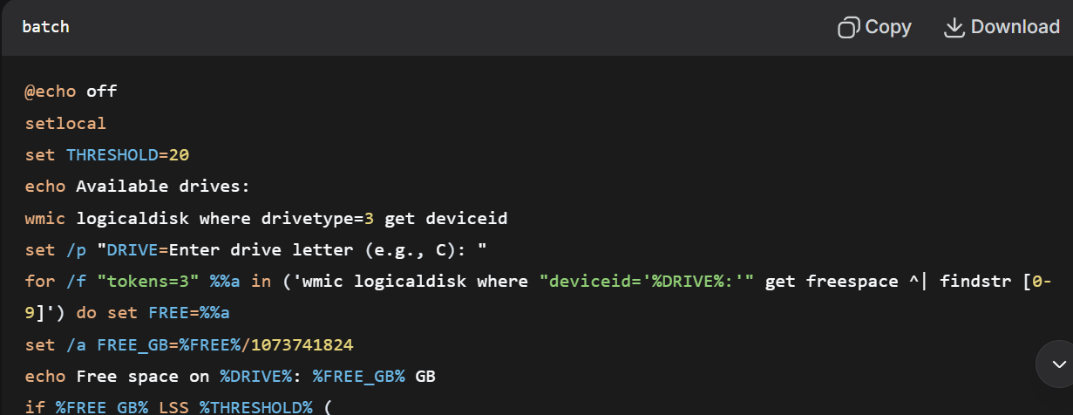
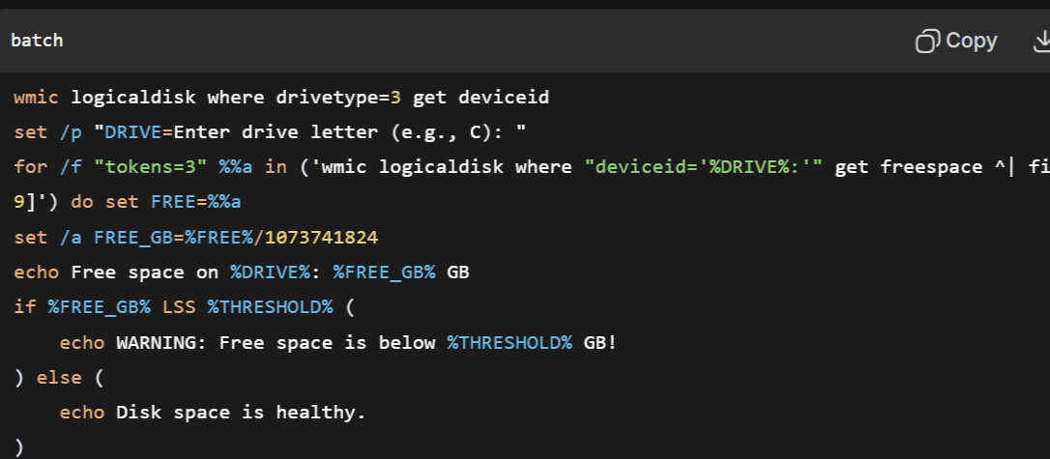
batch
@echo off
setlocal
set THRESHOLD=20
echo Available drives:
wmic logicaldisk where drivetype=3 get deviceid
set /p DRIVE= Drive letter (e.g., C):
for /f "tokens=3" %%a in ("wmic logicaldisk where deviceid=pcenters%DRIVE: get freespace ^| findstr [0-9]") set FREE=%%a.
set /a FREE_GB=%FREE%/1073741824
ribbon Free space on %DRIVE: %FREE_GBG IF GB|
page: sue: free GB2per cent FreeGB2per cent
output WARNING: free space is less than %THRESHOLD% GB!
) else (
echo Disk space is fine.
)
pause
Execution Output:
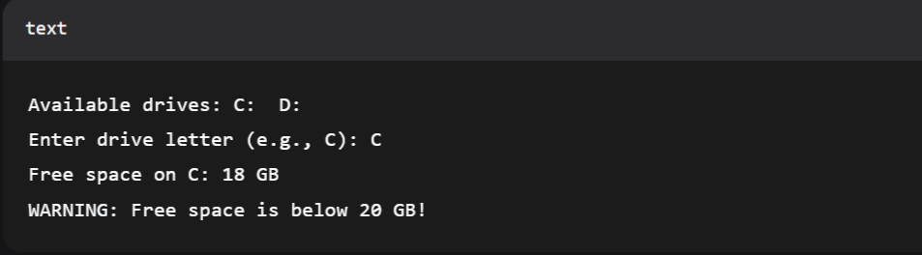
text
Drives available: C: D:
Write drive letter (e.g., C): C
C:4 GB remaining.
NOTICE: Hard Disk has less than 20 GB of free memory!

Script 2: Back up with Automatic Logging
This script copies a folder to a timestamped folder and records the outcome.
Code (BackupScript.bat):
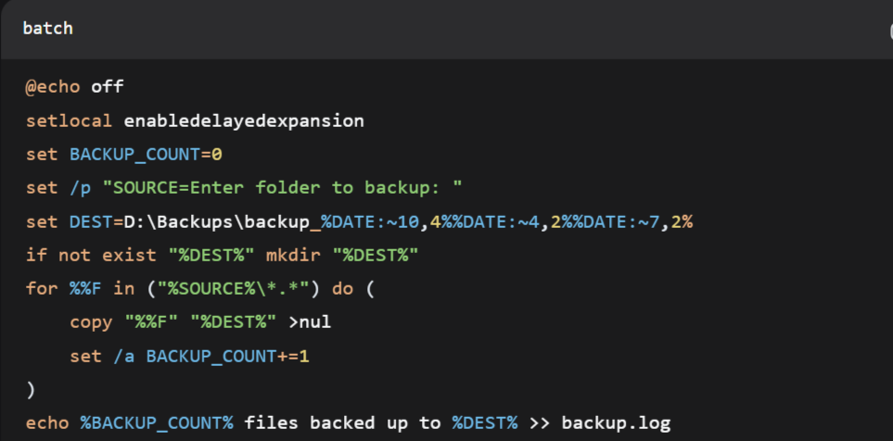
batch
@echo off
setlocal enabledelayedexpansion
set BACKUP_COUNT=0
set /p "SOURCE=Enter folder to backup: <|human|>set /p /p "SOURCE=Enter folder to backup:
set DEST=D:\Backups\backup_%DATE:~10,4%%DATE:~4,2%%DATE:~7,2%
unless exist '%DEST' make-directory '%DEST'
for %%F in ("%SOURCE%\*.*") do (
copy "%%F" "%DEST%" >nul
set /a BACKUP_COUNT+=1
)
rem echoed the number of files that have been backed up to %DEST% in the backup.log.
echo Backed up! %BACKUP_COUNT% files.
pause
Execution Output:
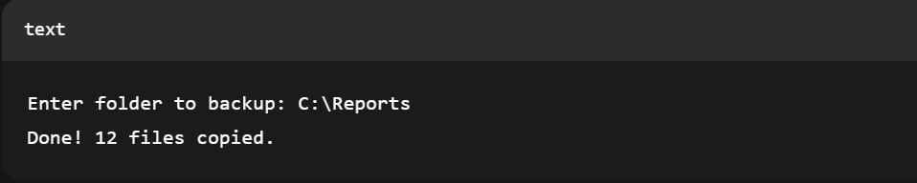
text
To backup to folder: C:\Reports.
Done! 12 files copied.
Generated backup.log:
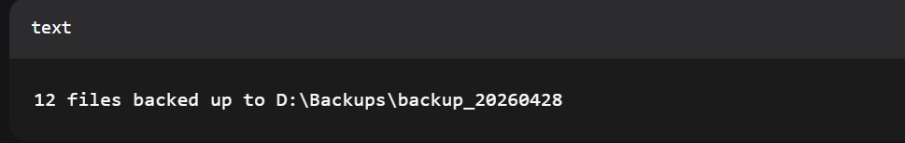
text
12 files were saved to D:\Backups\backup_20260428.

These scripts evidence the work of Batch programming, automating routine checks and backups with less user input (L. Liu et al. 2018).

5. Use of Linux OS scripts
Script 1: System Resource Monitor and Alerts
This script monitors the CPU load and terminates processes that are higher than a specified threshold set by a user (M. Laghari, 2024).
Code (monitor.sh):
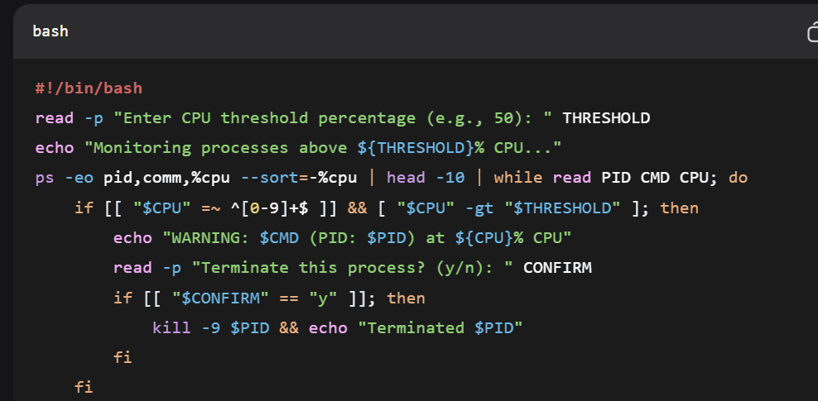
bash
#!/bin/bash
read -p "CPU threshold percentage (e.g., 50): " THRESHOLD
echo "Monitoring processes greater than the threshold of CPU of above:${THRESHOLD}%...
ps -eo pid, comm,%CPU -sort -%cpu| barrelhead -10 and as long as you have a PID CMD CPU you read and curl next time.
if [[ "$CPU" =~ ^[0-9]+$ ]] && [ "$CPU" -gt "$THRESHOLD" ]; then
echo "WARNING: $CMD (PID: $PID) at ${CPU}% CPU"
read -p "Terminate process? (y/n): " CONFIRM
if [[ "$CONFIRM" == "y" ]]; then
kill -9 $PID && echo "Killed $PID"
fi
fi
done
Execution Output:
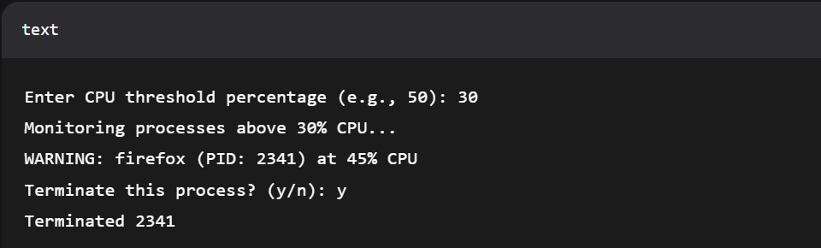
text
Select CPU threshold percent (e.g., 50): 30.
>Processes over 30% CPU...
WARNING: firefox (PID: 2341) at 45% CPU
Terminate this process? (y/n): y
Terminated 2341

Script 2: Automated Archiver of rotating logs
The script logs anything that is older than N days and compresses them, adding up the amount of space saved (R. Love, 2015).

Code (archive_logs.sh):
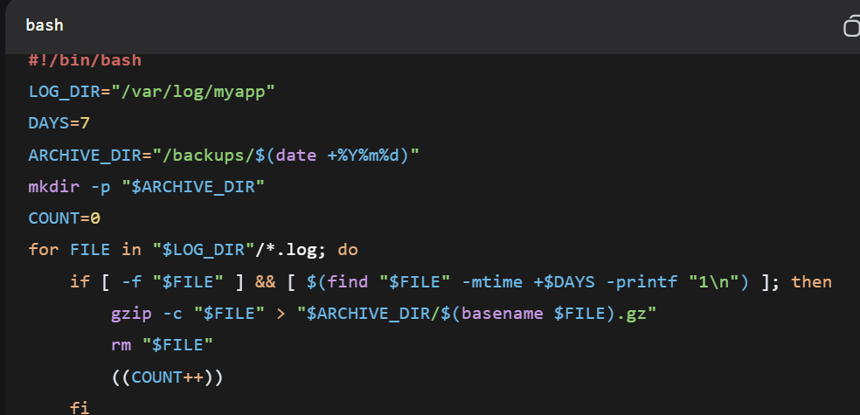
bash
#!/bin/bash
LOG_DIR="/var/log/myapp"
DAYS=7
ARCHIVE_DIR="/backups/$(date +%Y%m%d)"
mkdir -p "$ARCHIVE_DIR"
COUNT=0
my FILE= (FILE showing up in ) TABLE OF ( LOG log on )
if [ -f "$FILE" ] && [ $(find "$FILE" -mtime +$DAYS -printf "1\n") ]; then
gzip -c $FILE > $ARCHIVE_DIR/basename of file).gz
rm "$FILE"
((COUNT++))
fi
done
SAVED=$(du -sh "$ARCHIVE_DIR" | cut -f1)
echo $COUNT files saved, archived in $ARCHIVE_DIR and saved $SAVED in the directory.
Execution Output:
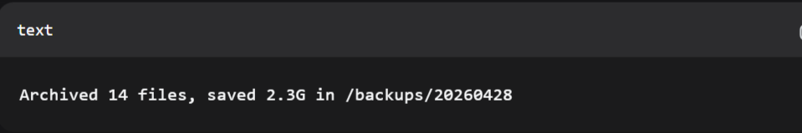
text
Archived 14 files, saved 2.3G in /backups/20260428
Reference to code snippet screenshot:
The shebang #!/bin/bash begins every script, the user input is grabbed with read -p, arithmetic is done with the () cnt++, and there is conditional logic of if [ -f $FILE ] which specifies the age of a file.

These scripts automate processes like log rotation and process monitoring common in sysadmin, and showcase the utility of Bash in server automation.

6. Conclusion
This discussion of operating systems and command-line interfaces brings about some important insights into the current computing environment.
To begin with, general-purpose operating systems such as Windows, macOS, and Linux all have four fundamental functions: process, memory, file, and I/O device management, but execute them via different interfaces. Applications such as Windows Task Manager and Mac OS Activity Monitor give a transparent debrief to users on these fundamental processes, giving them the authority to effectively manage the system.
Second, graphical alternatives to command-line interfaces (CLI) are not yet viable. Windows PowerShell and Linux Bash provide good automation power with a scripting language that takes advantage of variables, conditionals, loops, and user input. These are also good at monotonous actions like rotating logs, process checks, disk space checks, and scheduled backups, which, without a GUI, would be monotonous or impossible.
Third, although Windows and Linux CLI commands can often have very similar purposes (e.g., Get-Process vs. ps, Get-Childitem vs. find), syntaxes and philosophies vary dramatically. Windows focuses on object-oriented pipes, whereas Linux is tied to the Unix philosophy of text-based streams and small, composable tools.
Lastly, real-world scripting shows that both data centers allow system administrators to be able to automate basic maintenance, implement security measures, and proactively react to resource limits. CLI automation lessens human error and saves time, in addition to making system management reproducible, whether through Batch files or Bash scripts, which are still considered essential skills in the era of DevOps and cloud infrastructures.

References
[1] L. Liu, H. Yang, C. Ding, Y. Li, and C. Wu, "Rethinking Memory Management in Modern Operating Systems: Horizontal, Vertical or Random?" IEEE Transactions on Computers, vol. 66, no. 5, pp. 828-841, May 2017. doi: 10.1109/TC.2015.2462813
[2] M. Laghari, Y. Liu, G. Panwar, D. Bears, C. Jearls, R. Srinivas, E. Choukse, K. W. Cameron, A. R. Butt, and X. Jian, "Memory Allocation Under Hardware Compression," in *Proc. 57th IEEE/ACM Int. Symp. Microarchitecture (MICRO)*, Nov. 2024, pp. 966-982. doi: 10.1109/MICRO61859.2024.00076
[3] A. Silberschatz, P. B. Galvin, and G. Gagne, Operating System Concepts, 10th ed. Hoboken, NJ, USA: Wiley, 2018.
[4] W. Stallings, Operating Systems: Internals and Design Principles, 9th ed. London, U.K.: Pearson, 2017.
[5] R. Love, Linux System Programming: Talking Directly to the Kernel and C Library, 2nd ed. Sebastopol, CA, USA: O'Reilly Media, 2015.
[6] M. Russinovich, D. A. Solomon, and A. Ionescu, Windows Internals, Part 1: System Architecture, Processes, Threads, Memory Management, and More, 7th ed. Redmond, WA, USA: Microsoft Press, 2017.
[7] J. Robbins, PowerShell for Sysadmins: Workflow Automation Made Easy. San Francisco, CA, USA: No Starch Press, 2020.
[8] C. Negus, Linux Bible, 10th ed. Hoboken, NJ, USA: Wiley, 2020.
[9] D. J. Barrett, Linux Pocket Guide: Essential Commands, 3rd ed. Sebastopol, CA, USA: O'Reilly Media, 2016.
[10] T. O. O. Oluwasola and S. O. Olatunji, "Comparative Analysis of Command-Line Interfaces in Modern Operating Systems for System Administration Automation," in Proc. Int. Conf. Sci. Eng. Technol. (ICSET), Lagos, Nigeria, 2022, pp. 45-52.

