The Digital Transformation of The Daily Mail and the birth of The Mail Online

Assignment 1B, Assessment of a digital media organization
Marius Cicau, MBA Student
University of Wales Trinity St David

Index

- Introduction
- Historic context
- Market position (refer to part A presentation video of the assessment) (link to YouTube “unlisted” upload and the reference set for this part are on the last page)
- Changing Business Models, Strategy and Supply Chains
- Privacy, Credibility and Journalistic Advocacy
- References
- Part A sheet with references

Abstract
The aim of this paper is to provide insights into the effects of Digital Transformation on news consumption and some of the main challenges faced by the mass media in the digital age. The focus will be on systematically analysing the biggest success story, The Mail Online which was created in 2003 and then made into a separately managed site in 2006.
Keywords
Digital Transformation, Business models; Business strategy

- Introduction
  - It’s no secret that newspapers in their traditional printed form have been under threat from Digital Transformation over the last two decades. As news consumption moves to digital, the challenges are immense, this poses a risk to traditional media and opportunities for new players. There has been a dramatic decline in Newspaper advertising expenditure from from 4.6bn in 2007 to 1.4bn in 2017 in the UK. ¹(Mediatique, 2017)
  - The primary analysis is of The Daily Mail, a traditional tabloid newspaper, from a historical prospective into the digital age and the creation of The Mail Online. The model changes in strategy and approach to marketing gave birth to The Mail Online which is now the largest online news outlet with over 26.8 monthly unique visitors. (Source: Mail Metro Media https://www.mailmetromedia.co.uk/brand/mailonline/)
  - The challenges posed by Digital Transformation in a market with a low degree of commoditisation extend beyond revenue, although monetisation of online news is notoriously difficult, how are newspapers to survive in the digital age when so much information is available for free on the internet.
  - This paper also aims to take a brief look at “Fake News” and the increasing threat to journalistic advocacy, credibility, integrity and reliability of information within the largely unregulated domain of online media.

- Historic context
  - The Daily Mail was founded in 1896 at the height of the Victorian era, it enjoyed success as one of the top circulating daily newspapers for over a hundred years, putting aside its criticisms it has been a highly successful outlet with a large readership.
  - In 2003 The Daily Mail created its website counterpart, The Mail Online which was to be managed separately from 2007, this was a bold strategic move capitalizing on the brand name “The Mail” as it is known in the UK.
  - With the advent of the internet age in the late nineties and early 2000s, the company created what was to become the most visited English-language newspaper website in the world. ²(Fothergill J, 2014)
  - Fast forward to 2007 and the digital disruption is firmly taking hold, the newspaper advertising expenditure in the following decade was to drop dramatically ³(Fig.1)
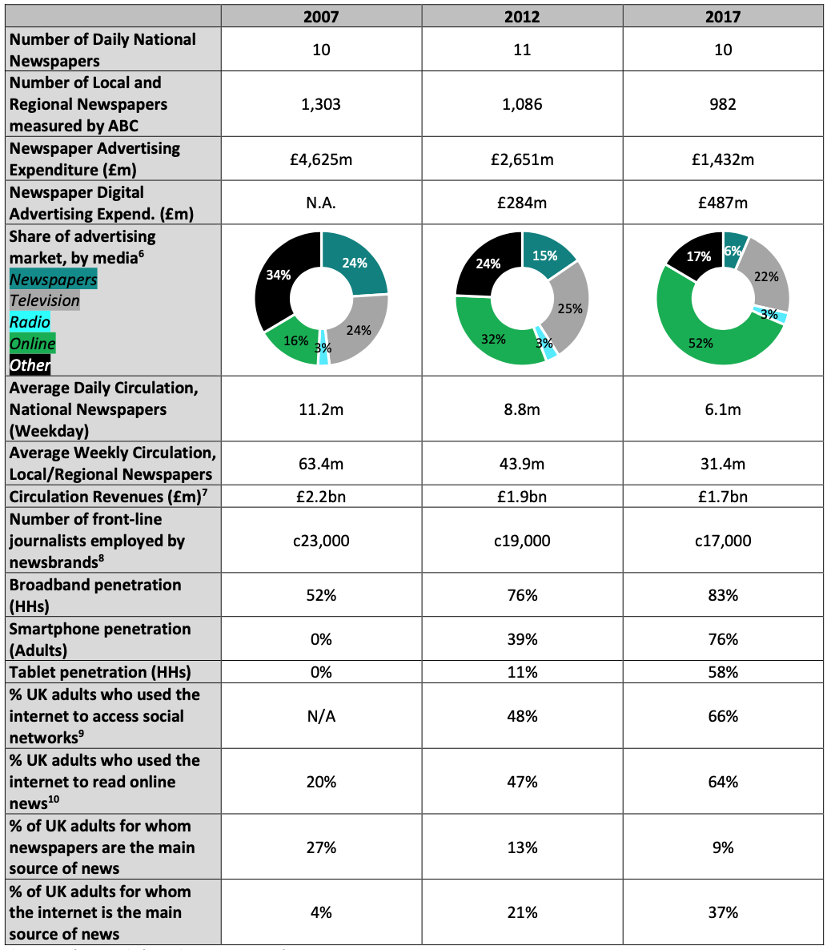
³ Fig 1, The Press Industry in 2007, 2012 and 2017
3.1 Source: AA / WARC; newspapers excluding digital advertising and TV excluding AVOD revenue. Gross of sales commission.
3.2 Mediatique estimates; see Annex 2 for details on our methodology for the estimation of circulation revenues.
3.4 Mediatique, updated from calculations established for Ofcom, in its submission to the Leveson Inquiry (see: https://www.ofcom.org.uk/__data/assets/pdf_file/0030/54597/annex6.pdf.pdf); see Annex 2 for details on our methodology for the estimation of the number of front-line journalists employed by newsbrands.
3.5 Source: ONS, Home internet and social media usage: 2017.
3.6 Source: ONS, Internet access – households and individuals: 2017.

  - By 2017, the forces of Digital Transformation are felt deeply by newspapers and because it was a relatively early entrant into the online news arena, The Mail Online has seen significant growth as its printed counterpart suffered a dramatic drop in readership and therefore circulation. ⁴(Sweeney, M, The Guardian 2019)

- The organisation’s marketplace
- Refer to part A presentation video of the assessment. (link to YouTube “unlisted” upload and the reference set for this part are on the last page).

- Changing Business Models
  - Rapidly changing markets require new business models and strategies, often, trying to adapt existing models can be a slow process fraught with difficulty. As shown by the big market disruptors or tech “Unicorns” in the last two decades, coming to market with a completely new model rather than trying to adapt an existing one can be an advantage. But it is possible to adapt businesses like newspapers that have established long before digitalisation.
  - In Digital Transformation: A multidisciplinary reflection and research agenda, a 2018 paper published in the Journal of Business Research, Peter C. Verhoef et al.⁵ identify three stages of Digital Transformation:
- Digitisation
- Digitalisation
- Digital Transformation
  - Digitisation is the process of converting physical content into digital, traditional newspapers have used digital editing tools since the eighties, this alone isn’t enough to move onto delivering online content, for this, Digitalisation is needed:
  - Digitalisation is the use of Digitisation to improve business processes, in the news industry it’s a very complex task due to the nature of the product, high volume written content released daily, even hourly. By the time the internet started to become mass-adopted in the early 2000s, news production and editing were already Digitised this meant that already established digital processes had to be leveraged to create an all-online ecosystem.
  - Digital Transformation is a result of Digitalisation which in itself is dependent on Digitisation.
  - In a seminal book by David L Rogers published in 2016 with Columbia Business School, the author emphasises the importance of new ways of thinking: “Digital Transformation is not about technology--it is about strategy and new ways of thinking. Transforming for the digital age requires your business to upgrade its strategic mindset much more than its IT infrastructure”
⁶ Rogers, D.L. 2016. The Digital Transformation Playbook: Rethink Your Business for the Digital Age, Columbia Business School
In the same book, the author analyses the five domains of Digital Transformation. (Fig 2)

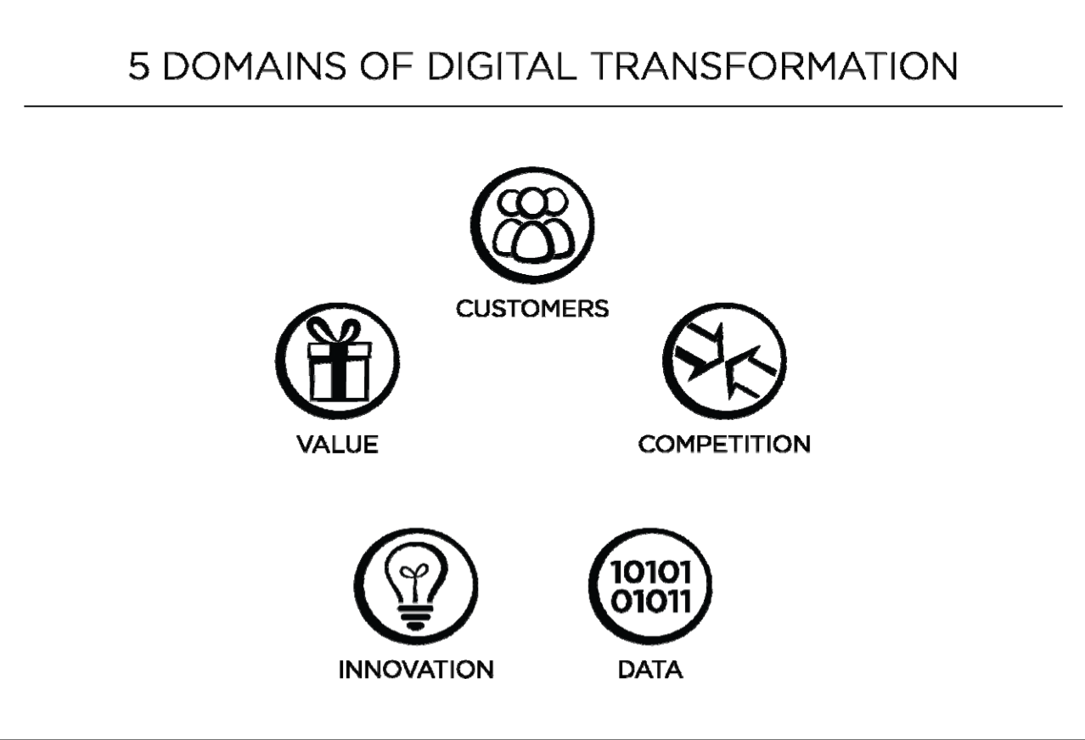

⁶ Fig 2, The five domains of Digital Transformation.

  - Digital Disruption –
“Digital Disruption – “Digital disruption is generally perceived from the perspective of firms that are heavily invested in old conditions and whose typical or planned course of development is interrupted. As the proliferation of certain digital processes or artefacts leads to change in established industry structures, established firms face severe pressure to respond.” ⁷(Skog, D.A., Wimelius, H. & Sandberg, J. Bus Inf Syst Eng (2018) 60: 431. https://doi.org/10.1007/s12599-018-0550-4)

In the case of The Daily Mail, a firm heavily invested in old conditions, creating their online entity, The Mail Online was a response to Digital Disruption in the sector, a crucial move that paved the way for the transition into the digital age.

  - In the same way that the production of goods is organised through supply chains, The Digital Media Supply Chain is the process used to create, manage and deliver digital media from the point of origin to destination. The supply chain gets even more complicated as digital media flows to multiple devices and regions, this presents a new opportunity for employing the use of digital tracking tools to understand the audience and in the case of The Mail Online whose income model is based on advertising sales, optimise and target the advertising based on individual users.
⁸(OpenText White Paper, Digital Disruption & the Digital Media Supply Chain, 2015, Online, https://www.opentext.com/file_source/OpenText/en_US/PDF/Digital%20Disruption%20and%20the%20Digital%20Media%20Supply%20Chain%20WP.pdf)

5 Privacy, Credibility and Journalistic Advocacy

5.1 User Tracking – is a divisive topic, on one hand it allows online content creators like The Mail Online to optimise content and advertising based on user data tracked on the site and cross-site and on the other hand it presents new privacy challenges and a risk of keeping users enclosed within their own personalised information bubbles complete with targeted advertising. The Digital Transformation is a transformation because it changes the way businesses operate fundamentally, among many others, offering tools such as user tracking to harness new data about the users behaviour and preferences. Who owns and manages this highly diffused dataset about our behaviours online continues to be a hotly debated issue.
⁹(Bashir, Ahmad & Wilson, Christo. (2018). Diffusion of User Tracking Data in the Online Advertising Ecosystem. Proceedings on Privacy Enhancing Technologies. 2018. 85-103. 10.1515/popets-2018-0033. )

5.2 Journalistic Advocacy and Credibility are under threat in the domain of digital consumption of news. In the UK, newspapers have long been bound by press regulations but online news are still largely unregulated and have given rise to the serious threat of “Fake News”, this risks continuing the erosion of credibility in news organisations.
¹⁰(European Commission, JRC Digital Economy Working Paper 2018-02, The digital transformation of news media and the rise of disinformation and fake news, https://ec.europa.eu/jrc/communities/sites/jrccties/files/dewp_201802_digital_transformation_of_news_media_and_the_rise_of_fake_news_final_180418.pdf )

- References

¹ Mediatique. 2017. Https://assetspublishingservicegovuk/. [Online]. [11 December 2019]. Available from: https://assets.publishing.service.gov.uk/government/uploads/system/uploads/attachment_data/file/720400/180621_Mediatique_-_Overview_of_recent_dynamics_in_the_UK_press_market_-_Report_for_DCMS.pdf
² Fothergill, J. 2014. CampaignLivecouk. [Online]. [11 December 2019]. Available from: https://www.campaignlive.co.uk/article/newspaper-abcs-digital-figures-august-2014/1313132?src_site=mediaweek
³ Figure 1, The Press Industry in 2007, 2012 and 2017, extract from Mediatique 2017 ¹
3.1 Source: AA / WARC; newspapers excluding digital advertising and TV excluding AVOD revenue. Gross of sales commission.
3.2 Mediatique estimates; see Annex 2 for details on our methodology for the estimation of circulation revenues.
3.4 Mediatique, updated from calculations established for Ofcom, in its submission to the Leveson Inquiry (see: https://www.ofcom.org.uk/__data/assets/pdf_file/0030/54597/annex6.pdf.pdf); see Annex 2 for details on our methodology for the estimation of the number of front-line journalists employed by newsbrands.
3.5 Source: ONS, Home internet and social media usage: 2017.
3.6 Source: ONS, Internet access – households and individuals: 2017.

⁴ Sweeney, M. 2019. The Guardian. [Online]. [22 November 2019]. Available from: https://www.theguardian.com/business/2019/may/30/mail-online-advertising-revenue-growth-daily-mail-general-trust

⁵ Verhoef, P.C. et.al. 2018. Digital Transformation: A multidisciplinary reflection and research agenda, The Journal Of Business Research. [Online].[29 November 2019]. Available from: https://www.sciencedirect.com/science/article/pii/S0148296319305478
⁶ Rogers, D.L. 2016. The Digital Transformation Playbook: Rethink Your Business for the Digital Age, Columbia Business School (Fig 2)
⁷ Skog, D.A., Wimelius, H. & Sandberg, J. Bus Inf Syst Eng (2018) 60: 431. https://doi.org/10.1007/s12599-018-0550-4

⁸ OpenText, Digital Disruption & the Digital Media Supply Chain (2015) Online, https://www.opentext.com/file_source/OpenText/en_US/PDF/Digital%20Disruption%20and%20the%20Digital%20Media%20Supply%20Chain%20WP.pdf

⁹ Bashir, Ahmad & Wilson, Christo. (2018). Diffusion of User Tracking Data in the Online Advertising Ecosystem. Proceedings on Privacy Enhancing Technologies. 2018. 85-103. 10.1515/popets-2018-0033.

¹⁰ European Commission, JRC Digital Economy Working Paper 2018-02, The digital transformation of news media and the rise of disinformation and fake news, https://ec.europa.eu/jrc/communities/sites/jrccties/files/dewp_201802_digital_transformation_of_news_media_and_the_rise_of_fake_news_final_180418.pdf

- Part A sheet with References

Market analysis for The Mail Online
– PowerPoint Presentation with VoiceOver –

YouTube unlisted link: https://youtu.be/jode8qfFgQw
References Specific to Part A:
¹ Newsworks, Readership Statistics & Reach 2019, available from https://www.newsworks.org.uk/resources/readership
² Mediatique. 2017. Https://assetspublishingservicegovuk/. [Online]. [11 December 2019]. Available from: https://assets.publishing.service.gov.uk/government/uploads/system/uploads/attachment_data/file/720400/180621_Mediatique_-_Overview_of_recent_dynamics_in_the_UK_press_market_-_Report_for_DCMS.pdf

³ Statistics source: Statista, 2019, available from: https://www.statista.com/statistics/283009/digital-advertising-spending-in-the-united-kingdom-uk/
⁴ Data from TouchPoints, 2017, available from: https://www.ofcom.org.uk/__data/assets/pdf_file/0024/116529/news-consumption-2018.pdf
⁵ News in the internet age, OECD 2010, extracted from: https://read.oecd-ilibrary.org/science-and-technology/news-in-the-internet-age/the-value-chain-and-economics-of-the-traditional-newspaper-industry_9789264088702-5-en#page5
⁶ Open Text, Digital Media Supply Chain 2015, available from: https://www.opentext.com/file_source/OpenText/en_US/PDF/Digital%20Disruption%20and%20the%20Digital%20Media%20Supply%20Chain%20WP.pdf
⁷ Verhoef, P.C. et.al. 2018. Digital Transformation: A multidisciplinary reflection and research agenda, The Journal Of Business Research. [Online].[29 November 2019]. Available from: https://www.sciencedirect.com/science/article/pii/S0148296319305478
⁸ Source: Internet Statistics, UWTSD. 2019

⁹ Ofcom Survey, News Consumption in the UK, 2018 Available From: https://www.ofcom.org.uk/__data/assets/pdf_file/0024/116529/news-consumption-2018.pdf
¹⁰ Forecasts Source: Statista, available from: https://www.statista.com/statistics/553530/predicted-number-of-social-network-users-in-the-united-kingdom-uk/

