Landscape Characteristics: Medieval Llanllyr
Evan Davies

Into the field HPAR4001
Dr Ros Coard, Quentin Drew
University of Wales Trinity Saint David
May 12, 2024

Introduction:
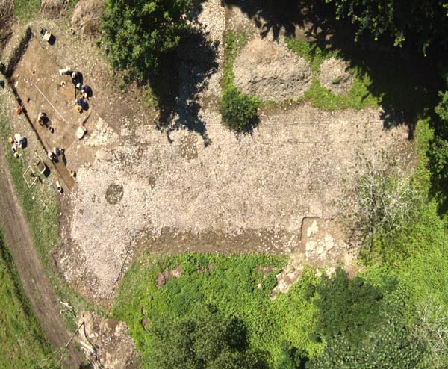
In this essay the landscape of Llanllyr Nunnery will be looked at. The political and religious, agricultural and social. There are many ways in looking at the landscape, and one must consider the pasts way of viewing it, as it will differentiate from our modern way of perceiving and viewing the landscape (Turner, 2013). The landscapes of Europe have almost all been modified by people (Turner, 2013). A technique that will be used to analyse the landscape of Llanllyr Nunnery is called Historic Landscape Characterisation, which will help greatly in appreciating and understanding the landscape of this area (Turner, 2013).

Figure 1, Aerial photograph of the cobbled surface and 2015 excavation
(Dyfed Archaeological Trust, 2015).

The first account of Llanllyr Nunnery was by Gerald of Wales (Giraldus Cambriae) a benedictine monk. In “The Journey Through Wales (Itinerarium Cambriae)” in the year 1188 A.D. Gerald of Wales called Llanllyr Nunnery “a small and poor house” (see fig 1), this could be due many different factors (Murphy, 2014). Gerald of Wales could have said this statement due to the nuns themselves and their acts or appearance, or it could be due to the economic situation of Llanllyr Nunnery at the time. Firstly, where is Llanllyr Nunnery. Today it may be situated under the Manor house of the farm, the foundations of the nunnery that is.
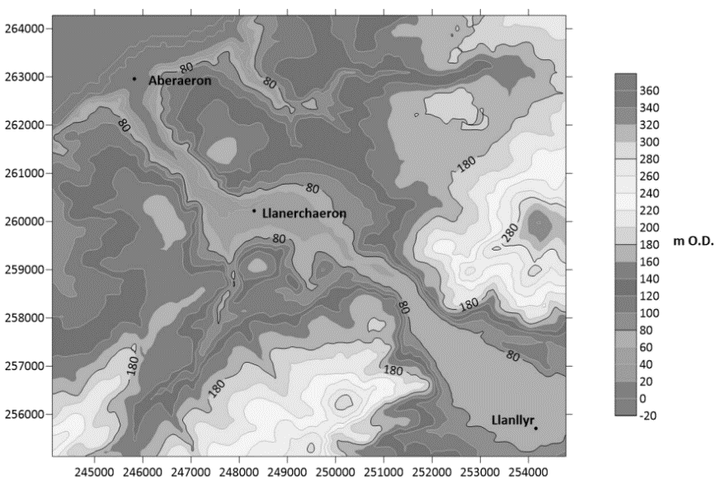
The land of Llanllyr lies in a low-lying but fertile and marshy area of the Aeron Valley (see fig 2) (Burton & Stöber, 2015). The Nunnery worked closely with Strata Florida Abbey (see fig 3) (Burton & Stöber, 2015). Using Gerald of Wales’ interpretation of Llanllyr Nunnery, he said that they were
Figure 2, Map of the Aeron Valley.
(no name, no date)
exploited by Strata Florida, and
viewed it as oppression
(Burton & Stöber, 2015). However, this could be due to Gerald of Wales’ relationship with Strata Florida (see fig 3). The Cistercian nuns and monks would have endowments of long-cultivated lands, rather than forestry areas (Berman, 2018). This suggest that the Nunnery in Llanllyr may have cultivated the fertile land and marshes surrounding the valley. There is evidence of the stream being moved. However, whether this is because of the Nuns of Llanllyr is up to interpretation. If the Nuns die cultivate the fertile land, this could suggest that economically they may be prosperous or comfortable in their area. Gerald of Wales’ does suggest that they were exploited, which may be a bias. However, this may also be true, and the Abbey of Strata Florida (see fig 3) could have been taking advantage of their progress in the Aeron Valley. Although, the Nuns of Llanllyr would have been self-sufficient, allowing themselves to remain hermits and keep contact with the rest of the Medieval societies at a minimum (Berman, 2018). The Nuns were also not exempt from taxation (Berman, 2018).
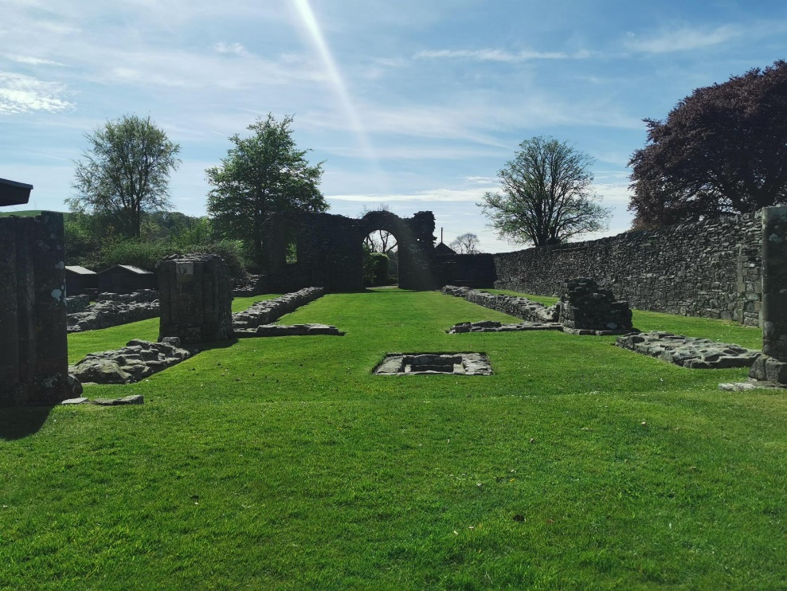
If Llanllyr Nunnery had episcopal foundations then they would have been visited by the bishops in the region (Berman, 2018). In 1249 the Pope Innocent IV and Abbots came to an agreement to only allowing the Nuns to be visited by Abbots rather than Bishops
Figure 3, Strata Florida Abbey ruins.
(Davies, 2024)
(Berman, 2018). Therefore, the Abbots of Strata Florida Abbey (see fig 3) may have visited the Nunnery from time to time, either to “exploit” as Gerald of Wales implies, or to aid them. However, there is no written or archaeological evidence currently to confirm this suggestion on the site. Most Cistercian Abbots were concerned on the Nuns potentially becoming financially independent (Berman, 2018). Due to the size of their communities and the progress of their works (Berman, 2018). As the Abbots were concerned of this, Abbot Stephen had set a maximum for Nunnery’s, only allowing so many nuns which varied from place to place (Berman, 2018). However, if their assets increased there may be exemptions to this law set by the Cistercian Order (Berman 2018). The building and architecture of Llanllyr Nunnery would not have been grandeur, mostly because of the economic situation Wales has been in throughout the Medieval Era, this is mostly due to the environment of Wales and lack of resources. However, there might be a remnant of the Nunnery found by archaeological teams. Archaeologists of Dyfed Archaeological Trust has found a fragment of a 16th century floor tile, that may have come from the Nunnery (see fig 4).
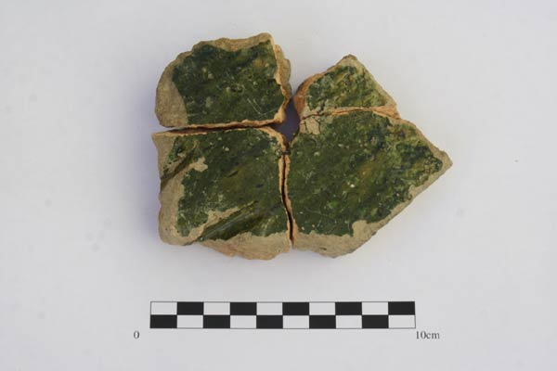

Figure 4, A fragment of a 16th century floor tile (Dyfed Archaeological Trust, 2014).
The mansion (see fig 5) would eventually be built on-top of Llanllyr Nunnery after its dissolution in 1535 A.D (Murphy & Wilson, 2015). There was a geological survey done on the site and there is inconclusive evidence of buried features that might be buried under the ground due to dumping (Murphy & Wilson, 2015). The excavators had found a medieval tile (see fig 4) in trench 3a (Murphy & Wilson, 2015). Due to the mansion being built on the site after the dissolution of the Nunnery, which may have used materials left behind from the Nunnery, shows us that it may have had some significance to the population. Showing archaeologist that the land was an intelligent area to choose for such a place. This may have been why the Nunnery had lasted before the dissolution and this may also be the reason why Strata Florida (see fig 3) may have “exploited” the area, according to Gerald of Wales.
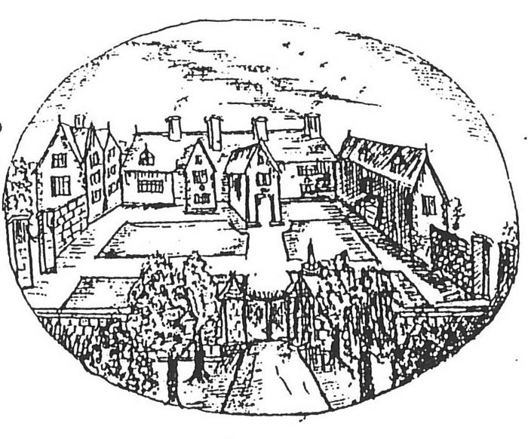
Figure 5, Thomas Dinley’s drawing of 1684 possibly showing Llanllyr Manor (Dinley, 1684)

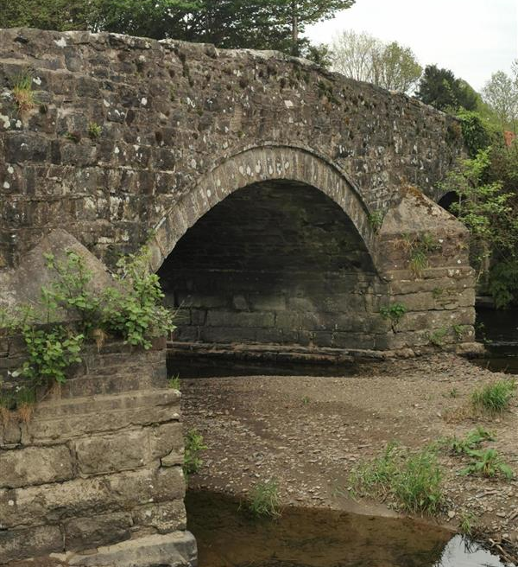

Figure 6, Photograph of Pont Talsarn in Ceredigion
(Davies, 2024)

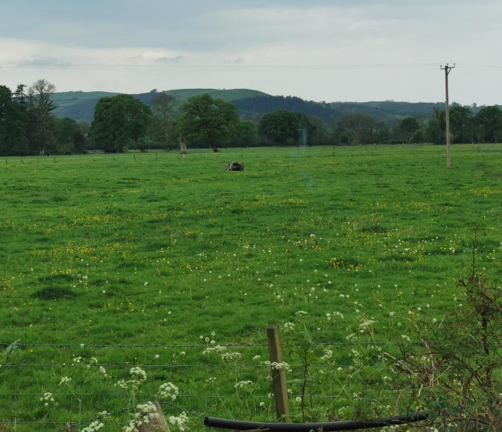
In the photograph above is the bridge Pont Talsarn (see fig 6). This bridge is built with three segmental arches, it includes recessed arches and squared voussoirs (Coflein, no date). The elevations are familiar to low triple-stepped cutwater with cemented coping (Cofelin, no date). The reason this bridge has grabbed this essays attention is due to it possibly being made from the stones and rubble of Llanllyr Nunnery after its dissolution. This possibility is due to the bridge’s proximity to the possibly original location of the Nunnery, and because it is a Post Medieval bridge (Coflein, no date). However, there is no hard evidence that this is the case, this possibility is merely a speculation due to the location of the bridge.
Figure 7, Field near Llanllyr (Davies, 2024)
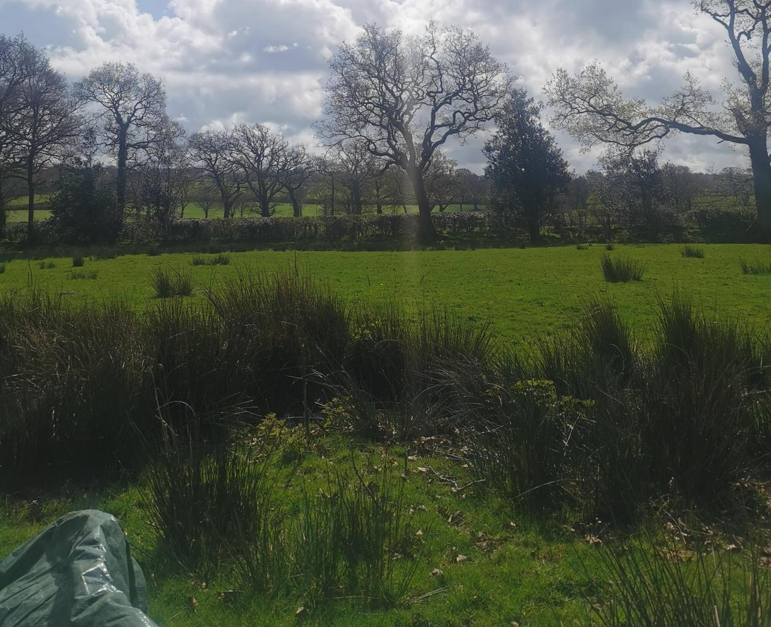
The field above (see fig 7) could possibly be a landscape for agriculture of some kind that the Nuns of the Nunnery participated in. This field most probably was not used by the Nunnery. However, it could show what the landscape of their agriculture may have looked like. As there is a large possibility that the Nuns did participate in agriculture to remain somewhat self-efficient (Berman, 2018). This is also a common trend in the Monasteries of the Cistercian Order as they would encourage this (Berman, 2018). Cistercians would rely on themselves to provide (Berman, 2018).

Figure 8, Photograph of field 2 during 2024 Llanllyr excavations UWTSD (Davies, 2024)

Currently near the area of where Llanllyr Nunnery may have been, are the marshes (see fig 8). These marshes (see fig 8) could show archaeologists that the Nuns would have controlled them to their liking. The marshes would be able to provide a water source for the Nuns to continue their agricultural industry. This is not confirmed. However, it is a possibility that the Nuns of the Nunnery used every possible industry in the area to maximise their self-sufficiency.
In conclusion, Llanllyr Nunnery has a huge and diverse landscape. Filled with politics and industry. The importance of the location allowed the Nuns to use the fertile land of Aeron Valley and create self-sufficient agriculture, which may have also aided other Monasteries nearby or even locals if close enough. The political aspect of the Nunnery in Llanllyr was more complicated. As there is no knowing on the truth of certain sources. Using Gerald of Wales shows historians and archaeologists that they were “exploited”. However, is this source trustworthy? Overall, the Nunnery had gone through many different centuries and was long lasting. The only artifact left from the Nunnery that is known to archaeologists of today is the tile (see fig 4), and possibly the Manors and bridge near the potential location of the Nunnery.

Reference List:
Berman, H. (2018). The White Nuns: Cistercian Abbeys for Women in Medieval France. [online] University of Pennsylvania Press . Available at: https://www-jstor- org.ezproxy.uwtsd.ac.uk/stable/j.ctv16t6gx6 [Accessed 12 May 2024].
Burton, J. (2019). Authority and Conflict at The Cistercian Abbey of Strata Florida. The Welsh History Review / Cylchgrawn Hanes Cymru, [online] 29(3), pp.377–407. doi:https://doi.org/10.16922/whr.29.3.2.
Burton, J. and Stöber, K. (2015). Abbeys and Priories: Abbeys and Priories of Medieval Wales. 1st ed. [online] JSTOR. University of Wales Press. Available at: https://www.jstor.org/stable/j.ctt9qhdvn.41 [Accessed 12 May 2024].
Davies, E. (2024). Figure 3, Strata Florida Abbey ruins. [photograph].
Davies, E. (2024). Figure 6, Photograph of Pont Talsarn in Ceredigion. [photograph].
Davies, E. (2024). Figure 7, Field in Llanllyr. [photograph].
Davies, E. (2024). Figure 8, Photograph of field 2 during 2024 Llanllyr excavations UWTSD. [photograph].
Dyfed Archaeological Trust. (2015). Figure 1, Aerial photograph of the cobbled surface and 2015 excavation. [photograph].
Dyfed Archaeological Trust. (2015). Figure 4, A fragment of a 16th century floor tile. [photograph].
Dyfed Archaeological Trust. (n.d.). Llanllyr Nunnery, Talsarn – Dyfed Archaeological Trust. [online] Available at: https://www.dyfedarchaeology.org.uk/wp/discovery/projects/llanllyr-nunnery- talsarn/.
Dinley, T. (1684). Figure 5, Thomas Dinley’s drawing of 1684 possibly showing Llanllyr Manor. [drawing].
Murphy, F. (2017). SURVEY AND EXCAVATION AT LLANLLYR MEDIEVAL NUNNERY AND POST-MEDIEVAL MANSION, CEREDIGION, 2014-2015. [online] Available at: https://www.dyfedarchaeology.org.uk/wp/wp-content/uploads/llanllyrreport2017.pdf.
Murphy, F. and Wilson, H. (2015). LLANLLYR, CEREDIGION, ARCHAEOLOGICAL EVALUATION 2014: INTERIM REPORT. [online] Available at: https://www.dyfedarchaeology.org.uk/wp/wp-content/uploads/llanllyrinterim.pdf.
No name. (no date). Figure 2, Map of the Aeron Valley. [map].

