Breaking Barriers: Enhancing Accessibility in the Hospitality Industry

Student Name: Ciprian Anghel
Student Number: 2223637
Module Title: International Meetings Management BMIH6007
Lecturer’s Name: Kathryn Flynn
Word count: 2754 words

I confirm that I have not used any AI tools in the research and creation of this assignment. I confirm that I have not presented any AI generated materials as my own work. I confirm I have copies of my drafts, notes, and other resources I used, which I may be asked to provide in evidence.
Executive Summary
The event "Breaking Barriers: Enhancing Accessibility in the Hospitality Industry" aims to address the ongoing challenges faced by individuals with disabilities in the hospitality sector. Despite regulations like the Equality Act 2010 and the Americans with Disabilities Act (ADA), many hospitality businesses still fall short of meeting accessibility standards. Held at the Manchester Central Convention Complex, the event will adopt a hybrid format to ensure inclusivity for both in-person and virtual attendees. Structured around the Event Management Body of Knowledge (EMBOK) framework (Kumar, Islam, & Ragavan, 2025), the event will cover essential topics such as accessible hotel design, inclusive customer service, assistive technologies, and global compliance standards. The primary objectives include training 200 attendees on accessibility requirements, showcasing 10 innovative assistive technologies, and fostering at least 15 new collaborations among stakeholders (Kruse et al., 2024). A comprehensive management plan will be executed by a skilled team, ensuring that logistical, technical, and accessibility needs are met. With a budget of £22,000, supported by ticket sales and sponsorships, the event is financially sustainable and aims to reinvest any surplus into future accessibility initiatives. This event seeks to inspire meaningful industry change by promoting inclusivity, encouraging collaboration, and highlighting the importance of accessibility as both a legal obligation and a moral responsibility.

Table of contents:
Introduction………………………………………………………………..4
The Event Cycle…………………………………………………………...5
Event Concept……………………………………………………………..7
Aim and Objectives………………………………………………………..8
Event Management………………………………………………………..9
Event Budget……………………………………………………………..11
Industry trends, Issues and Impacts………………………………………12
Situational and Cultural Considerations………………………………….14
PESTEL Analysis…………………………………………………………14
Conclusion………………………………………………………………...15
Reference List…………………………………………………………….16

Introduction
The event “Breaking Barriers: Enhancing Accessibility in the Hospitality Industry,” lies at the very foundation of the report to handle the crisis of accessibility of the disabled into the hospitality industry. Accessibility remains a pressing global issue, with over one billion people worldwide living with disabilities. Despite legal mandates such as the Equality Act 2010 and the Americans with Disabilities Act (ADA), many venues and services in the hospitality industry fail to meet accessibility standards. It is a collaborative event aimed at bringing in multiple professionals, human resources, the advocacy groups all to raise the need to have the said group included in the workforce in the hospitality industry. The Manchester Central Convention Complex has been chosen as the venue due to its excellent accessibility features, including ramps, elevators, and sensory-friendly spaces (Rodrigues, Dias, & Teixeira, 2024). Conveniently located in the heart of Manchester, the venue offers seamless public transport connection, ensuring convenience for attendees from diverse locations. The hybrid format will maximize participation by accommodating both in-person and virtual attendees, thereby ensuring the event’s inclusivity and broad reach (Tourism, 2025). By addressing the unique challenges faced by the hospitality industry, the event aims to set new standards for inclusiveness. Key topics to be covered include accessible hotel design, inclusive customer service practices, assistive technology innovations, and compliance with global accessibility standards. The event is intended to prepare the participants to create an inclusive environment that would be able to accommodate the special class with disabilities of diverse nature and the entire event acts as networking and connection forum (Li, Xu, Liu, & Cao, 2024).
There will be a special time together where both the business experts and the attendees will interact in a manner to promote diversity and inclusivity and the best practices to do so. The hybrid nature of the event ensures that stakeholders unable to attend in person can still actively engage with the sessions through live streaming and virtual networking opportunities. By bringing together a diverse group of stakeholders, the conference will promote the exchange of ideas and best practices. The event seeks to inspire a cultural shift within the hospitality industry, emphasizing the importance of accessibility not only as a legal obligation but also as a moral imperative and a significant driver of business success. If an organization cares and caters to any visitor with his or her conditions, that same organization is likely to experience a surge in revenue as the customers increase and more referrals mean high productivity returns. Therefore, the conference aims to ensure that the attendees garner enough necessary skills that help them discharge their standards professionally and bring a decisive change in the hospitality industry (Rogers & Wynn-Moylan, 2022).
The Event Cycle
We adopted EMBOK as an approach that would be key in running the event from the beginning, implementation stage up and until the post-event review and guide the personnel to be aware of the standards and expectations. It comprises five essential stages: initiation, planning, implementation, execution, and closure, ensuring a comprehensive approach to managing the diverse and often complex aspects of event management. This framework not only aligns the event with its core objectives but also integrates strategic insights to optimize outcomes (Onwuzulike, Uzondu, & Joseph, 2024). At the very beginning based on this model, accessibility in the hospitality industry is prioritized as the key matter to pursue through the event. It is at this moment that the important elements are scheduled to be implemented while evaluating the value of the entire meeting. It is important to do diligent market research which points to the specific issues and needs the audience may have. This ensures the event's relevance and its ability to resonate with stakeholders. Before taking the event off, if there are investigations especially from those deemed to attend, the necessary precautionary measures can be taken to allow the disabled to feel free and comfortable when attending. The next important step is the planning which includes the logistics and the general preparation for the entire process. Accessibility was achieved by adopting a hybrid format which accommodated both the virtual and physical audience, hence broadening the attendance base. The venue was chosen based on its suitability for individuals with varied needs, including wheelchair access and assistive technologies. The decision to settle on experts in their lines made the event so natural, powerful, and credible and valuable to the attendees. Resource allocation plans, budgets, and detailed timelines were meticulously crafted to maintain operational efficiency and accountability. To ensure the event’s success and prepare for any unprecedented event, risk assessment, and mitigation strategies are crafted with the necessary mechanisms to cater to any anomaly (Basri & Ayu, 2024). In the implementation stage, efforts focused on targeted marketing campaigns tailored to the audience, highlighting the event’s unique accessibility features. To ensure the needed inclusivity tips were home as expected, a collaborative effort with Scope and RNIB, institutions that have long-standing experience with inclusivity was a priority for enriching the audience. Strategic partnerships enabled wider outreach and credibility, while promotional strategies were employed to build anticipation and engagement. On the event day, the execution stage involves seamless delivery of planned activities (Getz & Page, 2019), such as workshops, panel discussions, exhibitions, and networking sessions. Testing of the technical appliances and systems is compulsory to ensure they do not fail in the hour of the greatest need. An experienced team will coordinate operations, monitor attendee engagement, and address real-time challenges effectively. Finally, the closure stage emphasizes evaluation and reflection. As a means of follow-up, the administration of the surveys and interviews will give details of the successes and failures of the event from the attendees which will form part of the progress report for future management. These insights will inform future improvements, reinforcing the commitment to accessibility and quality. By adhering to the EMBOK framework, the event cycle facilitates a systematic, goal-driven, and efficient approach to event management, ensuring both immediate success and long-term value creation.
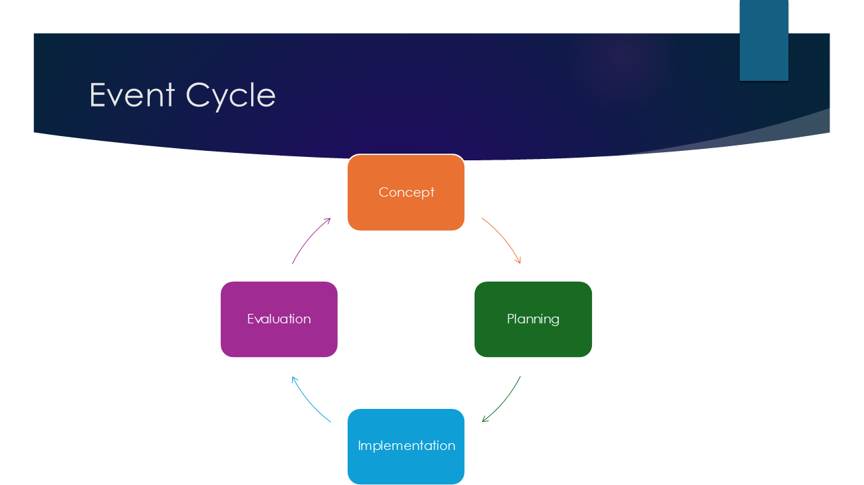
Event Concept
The event concept is designed to provide a meaningful and impactful experience for all attendees. There will be a close connection between the sessions to keep the participants positively engaged throughout. The experts from the industry level will speak more on accessibility issues, especially in the hospitality industry, which will be followed by later workout sessions for more interaction. These workshops will focus on practical topics, such as legal compliance and best practices for creating inclusive environments. In the afternoon, panel discussions will bring together experts, advocates, and innovators to discuss cutting-edge accessibility solutions, including assistive technologies like braille programs, sensory-friendly tools, and captioning services. There will be a display of the tools and technologies that spark the need for adoption of the accessibility options in industry and organizations . The day will conclude with networking sessions to facilitate meaningful collaborations; and a fundraising event aimed at supporting future initiatives in accessibility. The event’s hybrid format will also allow virtual attendees to participate fully, ensuring inclusivity for individuals who cannot attend in person.
Aim and Objectives
Main Goal:
Create awareness in the hospitality industry to embrace accessibility and inclusivity, focusing on the disabled community.
Objective 1:
Conduct three workshops to train 200 attendees on legal and practical accessibility requirements.
- Empower participants with knowledge to implement accessibility changes within their organizations.
Objective 2:
Showcase 10 innovative assistive technologies during the exhibition to highlight practical accessibility solutions.
- Examples include virtual reality-based accessibility simulations and mobile applications for inclusive navigation (Veronese, Crowther, Lee, & Boyle, 2025).
Objective 3:
Facilitate networking opportunities, leading to at least 15 new collaborations among stakeholders.
Aim: Drive transformation in the hospitality industry and foster collaborations among stakeholders for a more inclusive sector.
Event Management
Efficient management for this event it is essential. Diverse staff will coordinate the different levels of engagement to ensure success. A skilled and diverse team, including an event manager, an accessibility coordinator, a technical team, and volunteers, will be critical in delivering a seamless experience. The event manager will oversee all logistical components, from venue selection to scheduling, ensuring that all operational activities are cohesive. To ensure that the neurodivergent members feel comfortable and accommodated, personnel in charge of coordinating the accessibility facilities, the coordinator will be tasked with the responsibility of ensuring that all that they may need is available. There is a need to have special washrooms, wheelchair sets, and other technologies that may assist them to be active and normal in the event. Operational activities will include vendor coordination for catering, audio-visual services, and assistive technology suppliers. Comprehensive risk management plans will be implemented to address potential challenges, such as technical failures, adverse weather conditions, or speaker cancellations. Marketing efforts will focus on engaging the target audience through a multi-channel approach, including digital campaigns, email outreach, and partnerships with disability organizations. Collaborating with industry leaders and influencers on platforms like LinkedIn and Twitter will amplify the event’s reach and visibility among hospitality professionals.
To publish the event, there are reputable means that will be used such as blogging, twitter, and Facebook and Feedback mechanisms, such as surveys and live Q&A sessions, will be integrated to enhance attendee engagement and refine future events (Fox et al., 2014). When the essential components include strategic planning, inclusive strategies, and the so-called groundwork preparations the event will be effectively managed. The EMBOK Model provides a structured framework for event management, covering domains such as administration, marketing, operations, and risk. Integrating this model ensures a comprehensive approach to managing international meetings and events (Robson, 2018). A model by the name of Event Management Body of Knowledge (EMBOK) framework, guides the preparation of the event from scratch to the successful end that helps in the ultimate delivery of the required services. Strategic planning follows Mintzberg’s Strategic Management Theory (1994), balancing deliberate organization with adaptability, particularly through the event’s hybrid format that accommodates both in-person and virtual attendees. Risk management is aligned with ISO 31000 Risk Management Standards alternatives that ensure that the technical and operational hitches have been fixed in the required times. Financial sustainability follows Bowdin et al.’s Event Management Framework (2011) (Al-Filali, Abdulaal, Alawi, & Makki, 2024), incorporating diversified revenue streams such as sponsorships, ticket sales, and grants. Post-event evaluation leverages Kirkpatrick’s Four-Level Training Evaluation Model (2006) which is key in evaluating the event’s progress and providing insights that would furnish the management with the required standards. These models integrated prepare the international hospitality events to be of such a high caliber to attract as many visitors as possible.

Event Budget
The financial feasibility of the event is supported by a detailed budget that outlines income and expenditures (O’Toole, 2011). The whole event was estimated to consume £22,000, allocated as follows: £8,000 for venue rental, £4,000 for marketing, £5,000 for catering, and £5,000 for technology and accessibility features. The budget was judiciously crafted to ensure that the highest quality and provisional inclusivity expectations were met. Income generation will rely on ticket sales and sponsorships. With an expected attendance of 200 participants at £120 per ticket, ticket sales will generate £24,000. Sponsorship packages, available in gold, silver, and bronze tiers, are projected to bring in an additional £12,000. After covering expenses, the event is expected to yield a surplus of £12,000, which will be reinvested into future accessibility initiatives. The financial choice in place ensured that the event will successfully be completed, furthermore, the decision to consider donors and grants from the international partners would be pursued (Meredith, 2022).

Funding Source | Estimated Amount ($) | Notes
Ticket Sales | 50,000 | Based on projected attendance
Sponsorships | 30,000 | Corporate sponsors
Grants & Government Aid | 15,000 | Event tourism funding
Merchandise Sales | 10,000 | Branded event merchandise
Total Funding | 105,000 | Projected Budget
Table 1: Funding table for the project
Industry Trends, Issues and Impacts
There is undeniable evidence of ever-changing landscapes when it comes to events and conferences, which is a factor to consider in line with the theme of the discussion. With a great quest for inclusivity, the hospitality and tourism sectors have experienced a great change in the adoption of accessibility tools as a current trend in the market (Stankov, Vujičić, Orero, & Gretzel, 2024). The current industry trend is key in ensuring that accessibility options are adopted when demonstrating the innovative tools designed. However, the industry faces challenges, including non-compliance with global accessibility standards and insufficient staff training. These issues can result in legal liabilities and reputational risks for organizations. The problems enumerated become great beacons for success should they be fixed, which will enhance customer loyalty and expand the impact of the inclusive choices made by the industry. Technologies with sensory-friendly tools attached would encourage a suitable environment for accessibility among needy folks. Additionally, the COVID-19 pandemic has accelerated the adoption of hybrid event formats, making accessibility considerations even more critical for virtual and in-person attendees. The growing demand for accessible tourism and hospitality reflects a broader societal shift towards inclusivity and equity. The aforementioned trend is a chance for business organizations to adopt strategies that can increase their customer base and improve their revenue generation and brand credibility (Sinsuepphon & Udomlappaisan, 2025).
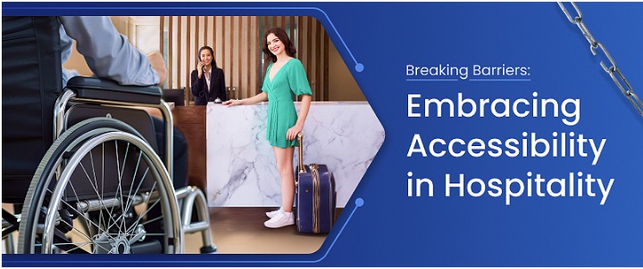
Events like “Breaking Barriers” provide a platform to foster collaboration between industry stakeholders, including event planners, hoteliers, and technology developers, to drive innovation in accessibility solutions (Smith, 2012). A partnership of this nature is imperative in stemming the systematic barriers and preparing the organizations to benefit more from collaborative efforts. One key area of focus is the implementation of Universal Design principles (Osorio Tromp, 2024), which aim to create environments usable by all people, regardless of ability. By incorporating features such as step-free access, captioning for presentations, and customizable seating arrangements, event organizers can ensure a seamless experience for all attendees. It is key to ensure that the staff operating in the hospitality industry have the required knowledge to deal with the cases of the accessibility nature that is achieved through training them. The rise of assistive technologies, such as real-time translation devices and virtual reality tools for navigation, further illustrates the role of innovation in shaping the future of accessible events (Talukder, Kumar, & Das, 2024). For hybrid formats, ensuring compatibility with screen readers and providing multiple communication channels are essential to accommodating virtual attendees. Where many organizations have ignored the power behind embracing accessibility tools, those that have adopted the idea have opened avenues for both competitiveness and success which they would have missed altogether. Marketing strategies, such as the AIDA model, help maximize event reach. Operations management ensures logistical efficiency, while financial planning, including budget forecasting and sponsorship acquisition, secures the event’s sustainability (Kitchen, 2024).
Situational and Cultural Considerations
PESTEL Analysis
Factor | Description
Political | Government regulations, policies on event management, visa requirements for international attendees, and local authority approvals.
Economic | Budget constraints, sponsorship availability, inflation affecting costs, and the impact of economic downturns on event funding.
Social | Changing consumer preferences, cultural influences on event participation, and the rise of sustainable and inclusive events.
Technological | Integration of virtual/hybrid event technologies, ticketing and registration software, and data analytics for attendee engagement.
Environmental | Sustainability concerns, eco-friendly event planning, carbon footprint reduction, and waste management strategies.
Legal | Compliance with health and safety regulations, data protection laws (e.g., GDPR for attendee information), and contractual obligations with sponsors and vendors .

By addressing these factors, the event will create a culturally sensitive and impactful experience for all participants. With an event of such magnitude, the coordinator must ensure that the accessibility standards meet the international cultural criteria to accommodate the people therein (Nelson et al., 2018).
Conclusion
To have a successful event of international standards, there is a need to have a well-prepared financial structure, and strategy, and employ the models that can propel the intended goals. The Breaking Barriers: Enhancing Accessibility in the Hospitality Industry event demonstrates how applying theoretical frameworks such as EMBOK ensures a systematic approach to event planning, risk mitigation, and stakeholder engagement. By complying with the inclusive and diverse calls, the event spans beyond the legal boundaries to be culturally oriented and accommodates the class of all people. Future considerations for similar events include leveraging emerging digital event technologies to enhance accessibility for a global audience, expanding partnerships with advocacy organizations to promote inclusivity, and implementing long-term impact assessment strategies. Working with the required terms in the inclusive calls in the hospitality industry provides sustainable practices that can ensure success and progress. By continuing to evolve and refine its approach, the hospitality sector can set new benchmarks for inclusivity, ensuring that accessibility is not just an obligation but a fundamental business strategy.

Reference list:
Al-Filali, I.Y., Abdulaal, R.M., Alawi, S.M. and Makki, A.A., 2024. Modification of strategic planning tools for planning financial sustainability in‎ higher education institutions. Journal of Engineering Research, 12(1), pp.192-203.
Basri, W.S. and Ayu, A.L., 2024. Risk Management in Information Systems: Applying ISO 31000: 2018 and ISO/IEC 27001: 2022 Controls at PMI's Central Clinic. International Journal For Applied Information Management, 4(1), pp.1-13.
Fox, D. et al.(2014) Doing events research: from theory to practice. Routledge: Oxford.
Getz, D. and Page, S. (2019) Event studies: theory, research and policy for planned events. 3rd Edition. Routledge: Oxford
Kitchen, E., 2024. Building event management skills through authentic assessment. Educational Studies, pp.1-17.
Kruse, D., Schur, L., Johnson-Marcus, H.A., Gilbert, L., Di Lallo, A., Gao, W. and Su, H., 2024. Assistive technology’s potential to improve employment of people with disabilities. Journal of occupational rehabilitation, 34(2), pp.299-315.
Kumar, J., Islam, T. and Ragavan, N.A., 2025. Consumer Behaviour Research in the Event Management Journal: Past Insights and Future Research Directions. Event Management.
Li, M., Xu, W., Liu, W. and Cao, H.,2024. Networking for innovation dynamics: a design-driven approach in the hospitality industry. International Journal of Contemporary Hospitality Management, 36(2), pp.632-660
Meredith, J. (2022) Project management: a managerial approach.
Nelson, M.C., et al. (2018). Emerging Adulthood and College-aged Youth. Obesity, 16(10), pp.2205–2211. https://doi.org/10.1038/oby.2008.365.
O’Toole, W.(2011) Events feasibility and development: from strategy to operations. Elsevier: Oxford.
Onwuzulike, O.C., Uzondu, N.C. and Joseph, O.B., 2024. Impact of strategic management education on professional development: A longitudinal study.
Osorio Tromp, J.M., 2024. Optimizing hospitality service'value propositions through design principles: A case study of strategic software implementation (Doctoral dissertation, FH Vorarlberg (Fachhochschule Vorarlberg)).
Rodrigues, S.S., Dias, L.G. and Teixeira, A., 2024. Emerging methods for the evaluation of sensory quality of food: Technology at service. Current Food Science and Technology Reports, 2(1), pp.77-90.
Rogers, T. Wynn-Moylan, P(2022) Conferences and conventions: a global industry. 4th Edition. Routledge: Oxford.
Sinsuepphon, N. and Udomlappaisan, C., 2025, February. DIGITAL BRANDING TOOLS AND STRATEGIES IN THE TOURISM AND HOSPITALITY INDUSTRIES. In International Conference" Actual economy: local solutions for global challenges" (pp. 195-204).
Smith, A.(2012) Events and urban regeneration: the strategic use of events to revitalise cities. Routledge: Oxford.
Stankov, U., Vujičić, M.D., Orero, P. and Gretzel, U., 2024. Accessibility of tourism 4.0—designing more meaningful and inclusive tourist experiences. Universal Access in the Information Society, 23(4), pp.1503-1506.
Talukder, M.B., Kumar, S. and Das, I.R., 2024. Implications of blockchain technology-based cryptocurrency in the cloud for the hospitality industry. In Emerging trends in cloud computing analytics, scalability, and service models (pp. 340-358). IGI Global Scientific Publishing.
TOURISM, S., 2025. PRACTICES IN THE MICE INDUSTRY. Routledge Handbook of Tourism and Hospitality Development in Vietnam, p.212.
Veronese, J.P., Crowther, G., Lee, P. and Boyle, M., 2025. The impact of simulation with debriefing on developing clinical competence and performance in paramedicine students.
Appendix

Funding Source | Estimated Amount ($) | Notes
Ticket Sales | 50,000 | Based on projected attendance
Sponsorships | 30,000 | Corporate sponsors
Grants & Government Aid | 15,000 | Event tourism funding
Merchandise Sales | 10,000 | Branded event merchandise
Total Funding | 105,000 | Projected Budget
Table 1: Funding table for the project
PESTEL Analysis
Factor | Description
Political | Government regulations, policies on event management, visa requirements for international attendees, and local authority approvals.
Economic | Budget constraints, sponsorship availability, inflation affecting costs, and the impact of economic downturns on event funding (Tomás López Guzmán et al., 2016).
Social | Changing consumer preferences, cultural influences on event participation, and the rise of sustainable and inclusive events.
Technological | Integration of virtual/hybrid event technologies, ticketing and registration software, and data analytics for attendee engagement (O’Brien et al., 2018).
Environmental | Sustainability concerns, eco-friendly event planning, carbon footprint reduction, and waste management strategies.
Legal | Compliance with health and safety regulations, data protection laws (e.g., GDPR for attendee information), and contractual obligations with sponsors and vendors (Nelson et al., 2018).

