Effective Team Working and Communication
Mominur Rahman
Student ID: 1705768
Lecturer: Jhon Paul
Module Code: BMSK4002

Table of Contents
Introduction 1
Task: How well employers perform at communicating? 2
Task: Improvement of workplace communication and performance of employers 6
Conclusion 8
References 9

Table of figures

Figure 1 – Percentage of those who have taken steps to improve employee voice) 5
Figure 2 - Managers level ineffectiveness in different managerial skills 5
Figure 3 - Employee cited qualities and competences of great managers (2016) 6

Introduction
The assessment is mainly divided into two section. One section covers the competence of employers in different industries over communication skill in teamwork. For this purpose, various comes and feedbacks from my friends working in different organisations are being used. The opinions from my friends indicate that there is a mix of skill competency among the employers from different sectors. Varied opinions also indicate that the employers possess different communication skills in terms of organisational work-related context. The other section is about the different ways and strategies to improve the communication skills of the managers. For this purposive, findings from different scholarly and online articles were being used.

Task: How well employers perform at communicating?
Communication skill in team development
One of the key aspects of communication is how employers perform in team communication. For instance, in terms of Tuckman’s team development framework, how well an employer perform with his communication skill. There are mainly four stages of team development in the team dynamics model, and based on the friends’ opinions, employers’ skill of communication can be assessed under this model.
At the forming stage of team, most of team members feel passionate about the team’s objective. Gilley et al (2010) found that the role of the employer is to provide the strategic guidance to the employees about the purpose and objective of team. One of my friend, while working in Tesco Plc said that his employer made several appearances and advised about the team’s objective. My friend was in a marketing/branding team and he mentioned that the general manager of his area often visited their offices, made some speeches to motivate employees, also made several points on dealing with the competitors. This indicates that the employer of that particular organisation has excellent competency over the verbal communication.
Another stage of the team development is the storming stage where the employees try to push the boundary of team formation and start to work on the team’s objective. My friend from Tesco said that they faced several conflicts with each other over solving a problem. Each member wanted to establish their opinion and solution as the best option. However, it was necessary to bring the employer to decide on which is the best solution while satisfying other members. The Tesco employer apparently selected the best solution and provided an explanation for this. My friend argued that the employers spent two hours with them that day while giving additional guidelines.
According to Gilley et al (2010), the situation in the norming stage is very different from that preliminary stage because team member usually resolves their conflicts in this stage and start to work on the given team objective. Mostly, the effective teams reach this stage. Actually, by this stage, team member become able to make an effective plan for working on the team’s goals. My friend from Tesco mentioned that after some time the employer did not make many physical appearances but he established a written communication system which included regular reporting of the daily and weekly objectives. Anyway, from that point, the employer most made contact with e-mail, notices but his message was produced in a clear format. This indicates that the employer had a good command of his written communication skills too.
The last stage of team development model is the performing stage where most of the team member develop a proper understanding about the team’s objectives, teammates’ mentality, and also envelop cohesion which is very important for better performance. My friend mentioned that they worked on several marketing campaigns in the last year throughout the UK and they were being very successful in those campaigns. However, in terms of the employer’s communication skill, my friend mentioned that the employer's ability to inspire the employees, strategic vision, media skills were important communication skills which helped them in different situations.
Employers’ competency in verbal, non-verbal and written communication skills
These three types of communications are mostly used and applied in the business world. Based on the opinions and answers of my friend’s working in different organisations, the following discussion is developed.
Verbal communication skills: It is very important communication skill in terms of facing a person or a group while addressing important issues. While conducting a feedback survey on my friends’ experience about their employers, they mentioned that good or bad, most of the employers have good verbal communication skills. One of my friends, while working in Virgin Money, mentioned that his branch manager possessed some excellent verbal communication skill he had ever experienced. During the interviews and meetings, he used excellent word, entertaining sentences, popular phrases and easy explanation of every complex procedure. That particular branch was one of the best-performing branches of Virgin Money.
Non-verbal communication skills: Brandler and Roman, (2015) found that non-verbal communications are mostly related to facial expressions, simile and other body movements that can help to make a good verbal communication. From my experience, I witnessed that, President Donald Trump of USA possess a different body language, especially he has a different facial expression from other leaders. Apparently, he smiles a lot in conversations and informal meetings especially when he makes public appearances. One of my friend working GSK talked about his employer while mentioning that his employer speaks very slowly. Sometimes, he remains silent after finishing one or two sentences in organisational meetings. Though his words aren’t always a written speech he talks differently.
Written communication skills: Many employers from different industries have a different level of competence in written communication skills (Whetten and Cameron, 2014). For instance, the experience from my friend in banking sector mentioned that their employers have very good written communication skill. Their choice of formal words and formation of reports can beat any other industries’ employers. However, some of my friends working in retail industries mentioned that their employers really have good voices but less written communication skills. For instance, one friend who is working in a London and Manchester based retail chain mentioned that his employer may not know to write a report at all. Copy pasting, spelling mistake, improper formations are very common in his e-mails, notices or letters.
HR surveys on employers competence in different aspect of communication skills
CIPD regularly conducts survey on the top employers of UK to provide an outlook into the HR activities. In the HR OUTLOOK (Winter 2016–17) report, they have found some insightful result which can be used to assess the competence of communication skill. The following figure indicates that organisation-wide communication will very important in next few years and how different organisations have improved their communication skills.
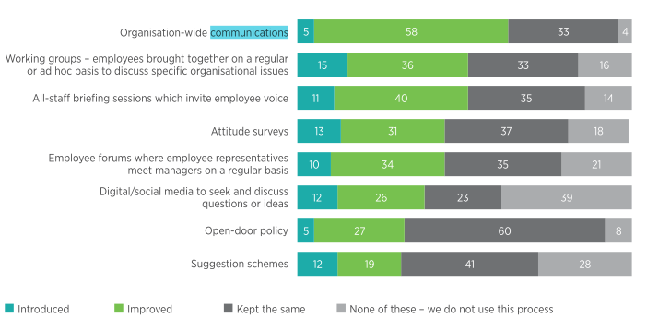
Figure 1 – Percentage of those who have taken steps to improve employee voice)

In other findings on the survey, CIPD mentioned that majority of the employers have good competence in their technical skills but do not have other managerial skills to become fully effective leaders. The following survey result mainly shows the level of ineffectiveness of different managerial skills including the communication skill.
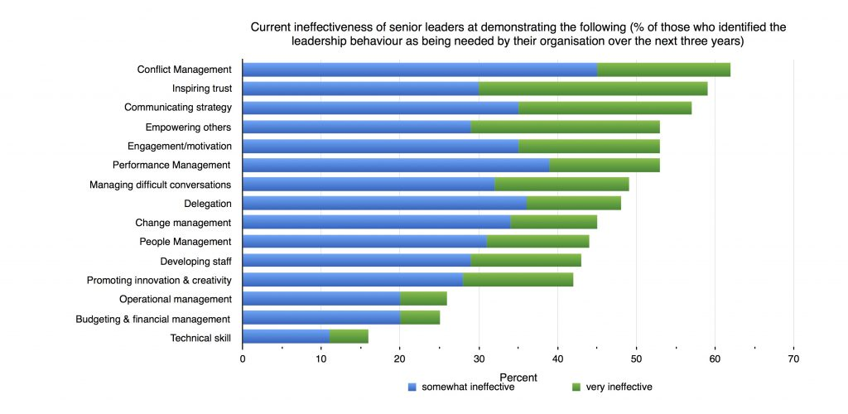
Figure 2 - Managers level ineffectiveness in different managerial skills
Here’s another survey on employees opinion about the necessary skills of great managers (Wright, 2016). Here, different skills and abilities of the managers are being listed which are usually seems important for performing managerial skills. A lot of important communications skills are being provided here which are important for managers of employers.
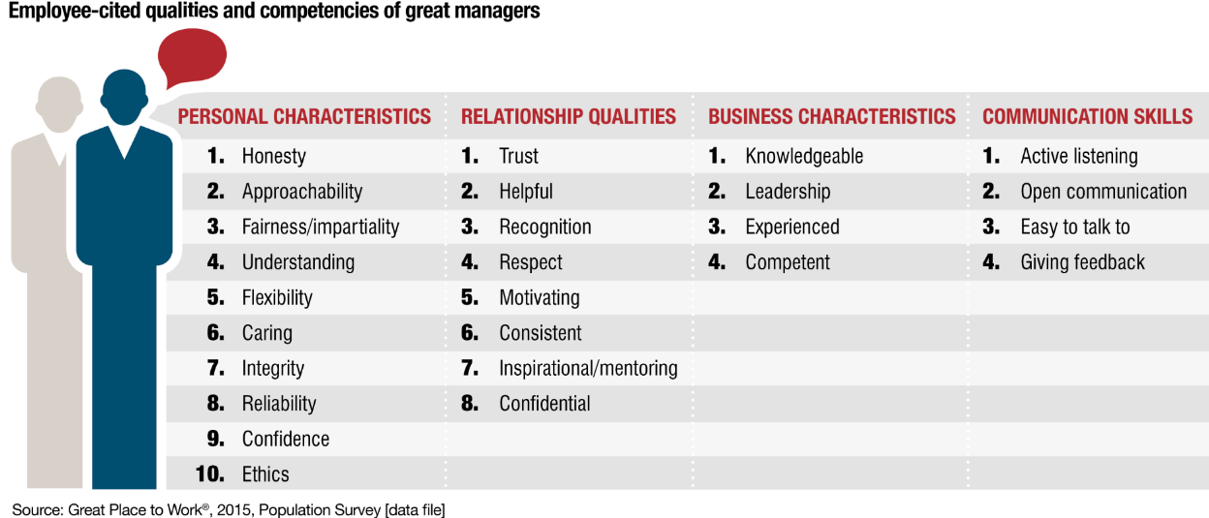
Figure 3 - Employee cited qualities and competencies of great managers (2016)

Task: Improvement of workplace communication and performance of employers
There are lots of ways and strategies that managers or employers can use to improve their communication skills so that an effective communication network can be established with the employees. These ways and strategies can help managers from different industries to apply in their workplace
Listening to the audience: Most of the studies recommend that to be a pro in communication skills, manager should develop good listening skills at first. Sometimes, manager might confuse listening with the hearing which shouldn’t be practised. To develop good listening skills, managers need to concentrate on the speaker’s speech, key points, non-verbal messages, emphasis on keyword etc. issues. To raise questions or to comment or to answer the questions of the audience, good listening skills can help managers to support their audiences. Olenski (2016) suggested that one of improving the listening skill is to apply ‘empathetic’ listening which involves listening to the audience with a feeling of what they are saying. Good listening skills can also help to improve other ways of boosting communication skill.
Being timely in meetings: Bergener et al (2012 mentioned that being regular and timely in meeting and seminars are an indication of a good manager having a good communication skill. They mainly emphasised on the psychological aspect of the communication skills because listeners or audience might look into the times taken for a speech, the delay time of starting the speech etc. different aspect. The persistence of listeners, the waiting time are important in meetings because whatever good talks a manager can bring in the conversation, his lengthy times might vex the audience.
Being brief and specific: It is another important side of the communication skill which makes a manager have a good communication skill. Gray (2010) mentioned that adding critical information might increase the values of the manager’s speech but many managers fail to provide information effectively because they are too complex in verbal form of communication. In written commutation, providing detailed information might also annoy the readers. It is important that, in term of providing information, it should be brief yet understandable to the audience can help the audience to easily catch the message. Here, the skill of putting numerical data in messages is very important because many managers put too much of such numerical data while making the message less understandable.
Getting Feedback: According to Reh (2017), to develop a good communications skill, feedback from the listeners is important. Many experts pointed out that reading the feedback of the audience might help the speaker to understand his level of communication skill. As a strategy, manager can practice speech session and send that to trusted colleagues to analyse the level of competency. So after every speech or feedback, manager can ask his trusted colleagues or secretaries to assess the message or speech. Additionally, manager can use different grammatical software to improve the writing skills. Grammarly is a very good application which can be added to the document writing application as an extension to find out the errors in wiring almost instantly.
Answering questions smartly: Reh (2017) also mentioned that, as a part of improving the communication skill, it is necessary for the manager to give rights answer to different questions. It is common that to avoid embarrassing situation in meetings and seminars or interviews, managers often avoid answering the right question. Additionally, to avoid the unwanted questions, manager also provides information from another perspective. From the communication skills perspective, such practice of manager might indicate very well command over communication skill. Sometimes, answering popular questions differently might also increase the manager’s popularity among audience. Such practices in answering question smartly should definitely improve the communication skill.
Being careful in body language: Non-verbal communication is also important to having a good communication skill. Koprowska (2014) emphasised the importance of knowing which body language is appropriate for which situation. Giving a wrong expression might create embarrassing situation for the whole audience. However, having a good command over non-verbal communication skill can make the audience more attentive to the message. In terms of giving a feeling about the message to the audience, body language might help the manager to progress the overall communication skill.
Sense of humour: According to DuBrin (2013), having a good sense of humour increase the value of message to the audience. It is also important to understand the situation before applying a good sense of humour. For instance, in formal meetings or formal letter, manager should avoid sense of humour as much as possible because this might reduce the seriousness of formal sessions. DuBrin also mentioned that a limited and constructive use of humour might impress the audience better and make the message clear.

Developing good writing skills: According to Cottrell (2011), written communication skill might increase the value of the manager among the colleagues and fellow employees. Knowing the use of phrases and popular words and adding them to the written document usually increase the quality of the document. Sometimes, employees might find the source of words if they are being copied from other sources which will eventually reduce the value of document despite its strong and clear message. Formatting is another aspect of written commutation because readable font, use of heading and sub-heading are very important to make a document better.

Conclusion

In conclusion, it could be said that by culturing different habits, practices, and adopting different strategies, manager can develop their communication skill. In business, managers or employers often need to communicate with different stakeholders to inform about various situations and decisions. By developing a good communication skill employers can easily build a good acceptance among the employees.

References
Bergener, K., vom Brocke, J., Hofmann, S., Stein, A. and vom Brocke, C., 2012. On the importance of agile communication skills in BPM education: Design principles for international seminars. Knowledge Management & E-Learning, 4(4), p.415.
Brandler, S. and Roman, C.P., 2015. Group work: Skills and strategies for effective interventions. Routledge.
Cottrell, S., 2011. Critical thinking skills: Developing effective analysis and argument. Palgrave Macmillan.
DuBrin, A.J., 2013. Human relations for career and personal success: Concepts, Applications, and Skills. Pearson Higher Ed.
Gilley, J.W., Morris, M.L., Waite, A.M., Coates, T. and Veliquette, A., 2010. Integrated theoretical model for building effective teams. Advances in Developing Human Resources, 12(1), pp.7-28.
Gray, F.E., 2010. Specific oral communication skills desired in new accountancy graduates. Business communication quarterly, 73(1), pp.40-67.
Koprowska, J., 2014. Communication and interpersonal skills in social work. Learning Matters.
Olenski, S. (2016). Forbes Welcome. [online] Forbes.com. Available at: https://www.forbes.com/sites/steveolenski/2016/03/29/five-communication-skills-that-make-good-leaders-great/#540a45b17ae9 [Accessed 3 Jan. 2018].
Reh, F. (2017). Here Are Some Ways to Improve Your Communication Skills at Work. [online] The Balance. Available at: https://www.thebalance.com/improving-your-communication-skills-at-work-2275766 [Accessed 3 Jan. 2018].
Whetten, D. and Cameron, K., 2014. Developing Management Skills: Global Edition. Pearson Higher Ed.
Wright, H. (2016). What makes a great manager? Key skills and characteristics - Great Place to Work® UK - Building and recognising successful workplaces. [online] Greatplacetowork.co.uk. Available at: http://www.greatplacetowork.co.uk/publications-and-events/insights/1029-what-makes-a-great-manager-key-skills-and-characteristics [Accessed 3 Jan. 2018].

