Callum Evans (2116012)

Introduction to web and database concepts
(ACCA4023)

Context Diagram
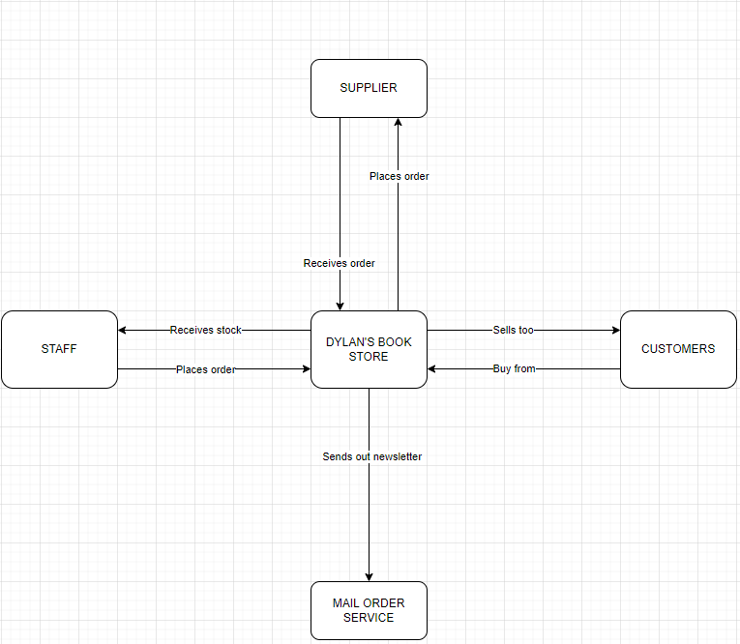
The diagram above is the Context Diagram, this shows what the main areas in the database should be and what each of the entities are and what their actions need to be to continue getting the things done within the Book store. So, looking at the Diagram you can see that Dylan’s bookstore needs to place orders to the supplier then the supplier would send back the required order to the bookstore. Dylan’s bookstore then sells too the customers, and the customers buy from the store. Dylan’s Book Store also sends out newsletters to the customers that have applied for the newsletters. So, Dylan’s Book Store sends the newsletters to the Mail Order Service. Dylan’s Book Store would then give the stock to the Staff so the staff can stock the books in the store. The Staff would let the store know what needs to be ordered.

Level 0 DFD
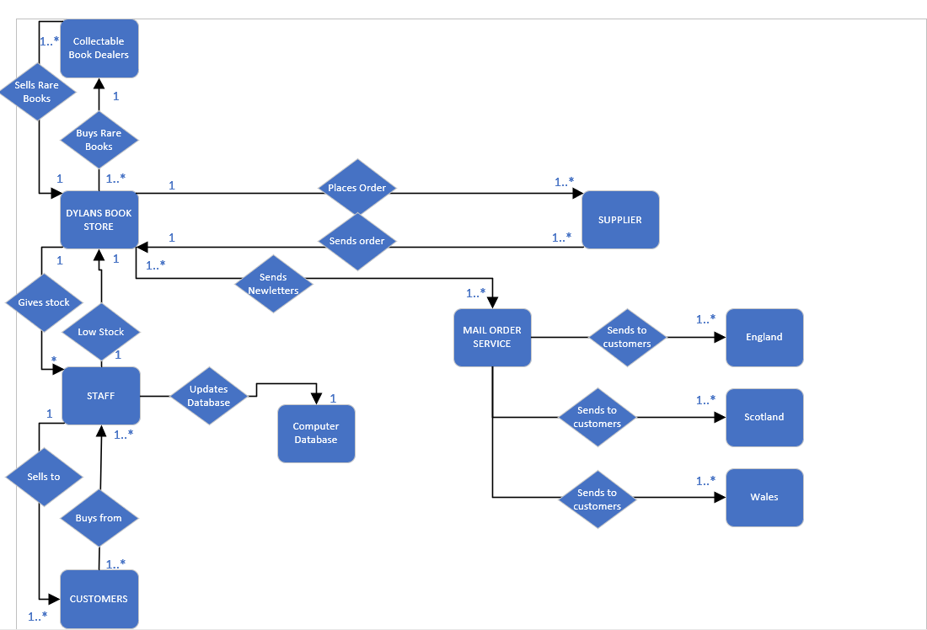
This is the Level 0 DFD, this shows all the tables and what happens when they are going to another tables. This also shows all the relationships that are going to be within the database, as you can see this is a little more complex compared to context diagram, this is an extension of the context diagram you can see that this has added other tables do extend the database as its needed and it also added a flow to the diagram. I’ve added arrows do someone that is viewing this can see which arrow goes where and what each are doing an example of this is that 1 staff sells to 1 or many customers and 1 or many customers buys from 1 or many staff members.

Entity Relationship Diagram
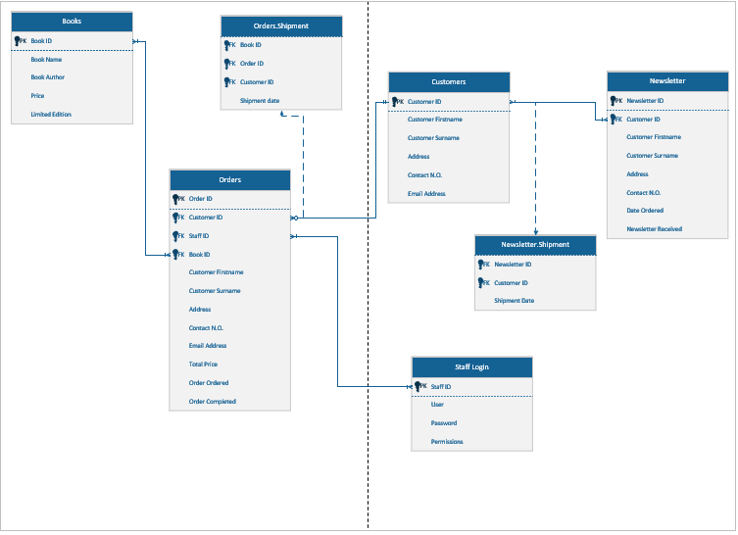

This is the ERD diagram. This shows all the tables and the link tables. Link tables are needed when there is a Many to many relationships. So, in this example there are many orders that to many customers, so that would mean that I needed a link table in between them, which is the Orders.Shipment table. Like the last many to many relationships, I had to make customers and newsletter table a many to many, because many customers can order many newsletters to for that I created a link table called newsletter shipment. Books table is a 1 or more to 1 or more, this is because 1 book can be for many orders or many books can be for one order, so that is a 1 or many to a 1 or many relationships. Next is the Orders table and the Staff Login table. So, the relationship between these tables is 1 or many staff members can take 1 or many orders within the bookstore. This also shows all the categories for what the data needs to go into and all the primary keys and foreign keys. A primary key is a piece of information that is unique, so an example of this is a customers ID. Customer ID is linked to one customer and one customer only, 2 different customers can’t have the same ID. Then the foreign key is where you need to use the primary key for more than 1 entry, so you still have the unique information but can use it more than once within a table. The dotted line in my ERD is to show that they are link tables for the other tables that the link is connected to.

Relationships in Access database
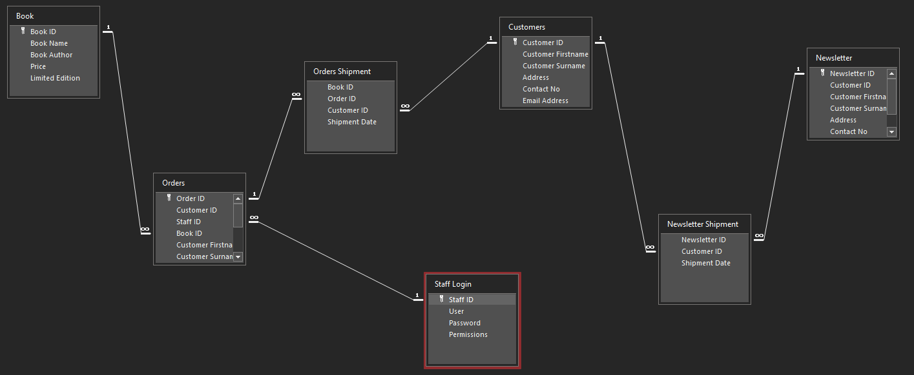
This is how my relationships look within access. As you can see if looks very similar to the ERD diagram if not very identical. Each relationship shows the primary key and all shows if it’s a 1 to 1, many to many, 1 to many, or many to 1 relationship. It also shows the 2 link tables and how they link to their retrospective tables. Both link tables don’t have primary keys and only foreign keys.

Report Outcomes
I did 10 different Reports all ranging from books in the shop through to completed orders all the way to orders before 2022.
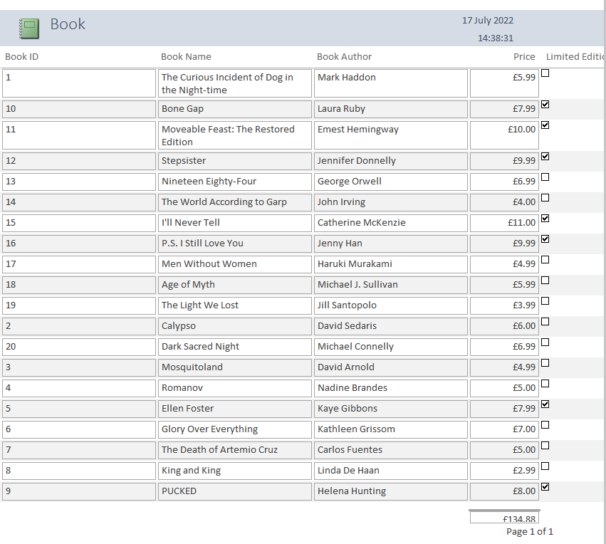

This report shows all the books within the bookstore, it shows the book ID, Book name, Book Author, Price and lastly if the book is Limited Edition. Then at the bottom of the report it shows the price of the books if they were all bought.

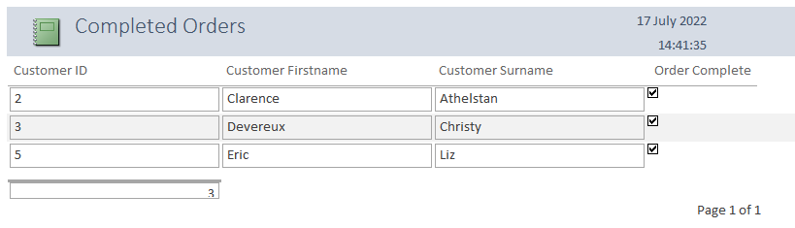
This is the Completed orders report, this shows all the orders that have been received and complete. As seen on the image you can see that only 3 of the customers have received their orders. It shows the customers ID, first name, Surname and if the order is complete. 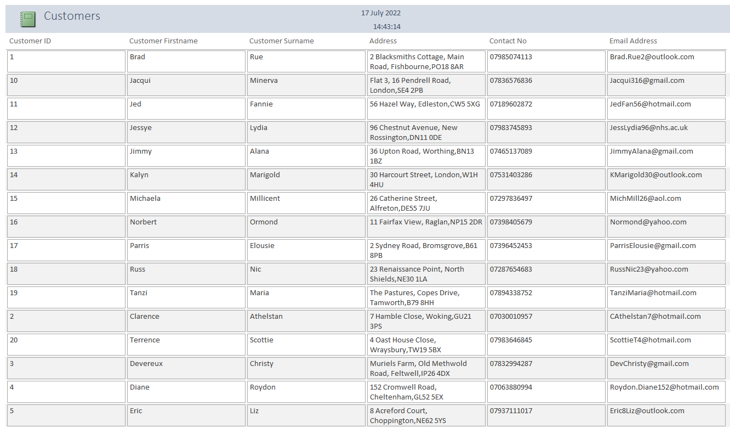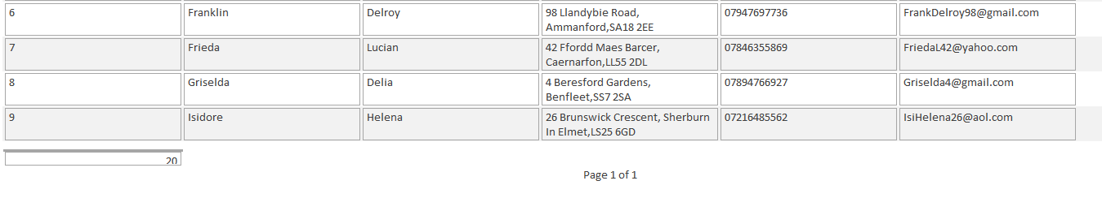
This is the customers report, this shows all the customers and their details. This is Customer ID, Customer first name, Customer Surname, Address, Contact No, and Email Address. This outputs all the customers so its easily readable.
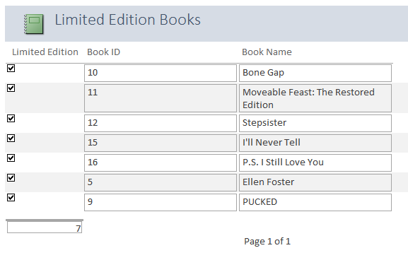
This report shows all the Limited-Edition Books that the store has. It has a check to shows that these are the limited books, shows the book ID, and the Book name. So, if a customer asked what limited books are in stock this would show you what is in stock.
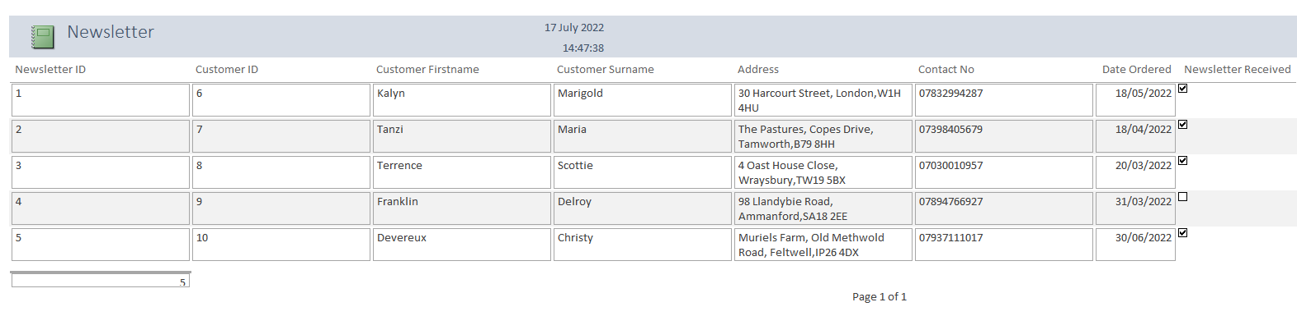
Like the customer order report this is the newsletter report, this shows all the customers that have asked to receive a newsletter. It shows what newsletter the customers have through newsletter ID, the customer ID to show what customer has ordered it, Customer first name and Surname, So, you can Identify if the customer ID is correct, then address, contact No, date ordered and if they have received the newsletter.
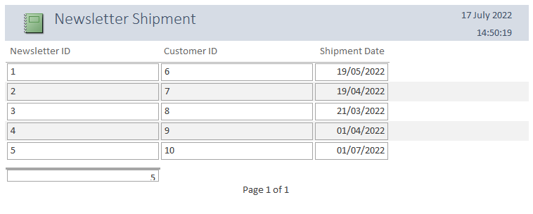This is the newsletter shipment, this is very similar to the newsletter report, but this looks more at the main points, So, its newsletter ID, Customer ID and the date it shipped rather than the date it was ordered, this is to confirm if the order they have done has been sent out or not.
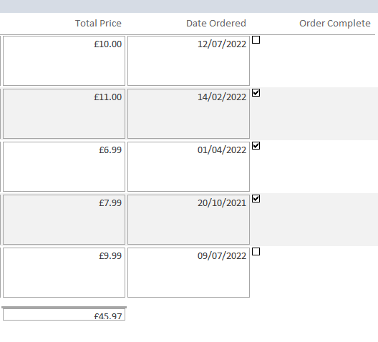
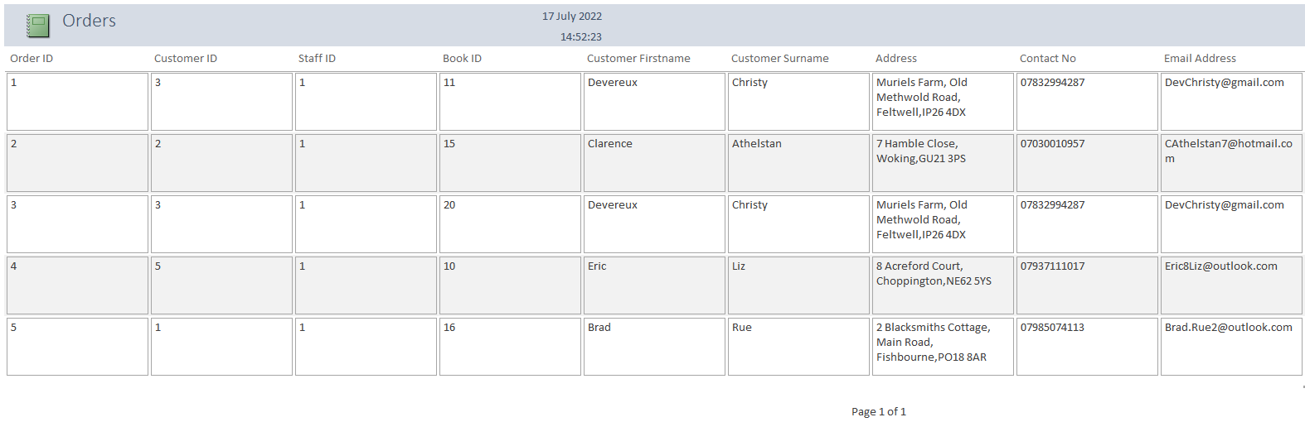
This is the orders report. This shows all the customers that have ordered in the bookstore. It has all the information about the customer like their customers ID, Firstname, Surname, address, contact No, and Email address. It also has other information more for the store to see which is, Order ID, Staff ID, Book ID, Total price, Date Ordered and Order complete. It also shows the total of all orders to be able to work out profits of the store.

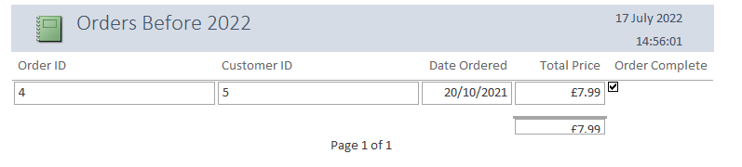
This report shows what customers have ordered before the year 2022. As you can see at this moment, only 1 customer has ordered before the year 2022. The report shows the user, Order ID, Customer ID, Date ordered, Total Price, and Order Complete. It also shows the total of how much the bookstore would have collected in 2022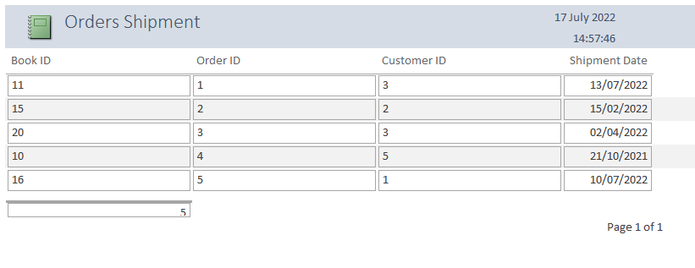
Now this Report is the orders that have been shipped. This shows what Order has been shipped and when it was shipped. So, it shows Book ID, Order ID, Customer ID, and Shipment Date.
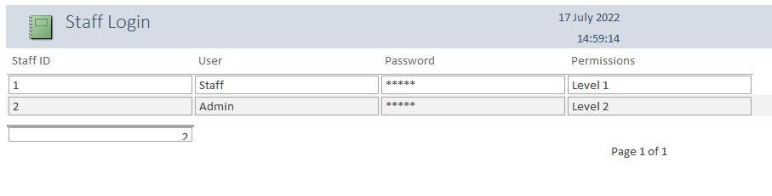
This is the last report, and this is the Staff login report. This shows all the information about how to log into the system if needed. But it doesn’t show the passwords, as if someone was able to get onto the reports they still couldn’t see the passwords as they are hidden. This also shows what level of permission does each role get within the system.

\

Forms being used
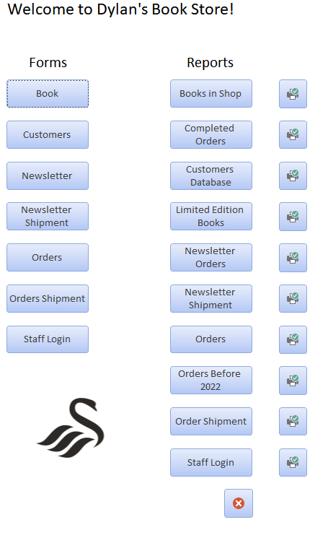
This is the main menu. This automatically opens when the access database is open as I have put a macro that launches this right away. It has all the forms and the reports to click and view and as seen all the print options for the reports as a quick print. At the bottom right there is also a quit application button that closes the form down when it’s done being used.

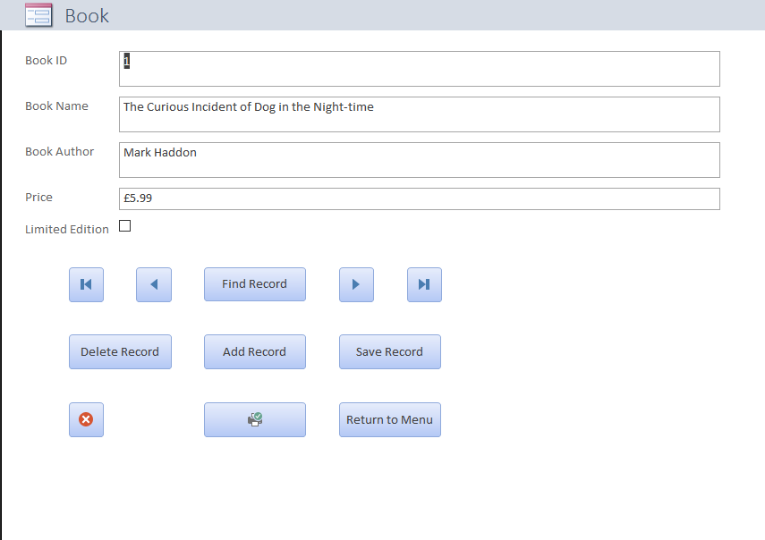
This is the books form. This allows you to see the books in the store one by one. It shows you all the information needed and has buttons. Each button has a different use. You see that there is a skip to last and skip to first buttons. There is a left and right button that goes either back or forward by 1 entry and then the “Find record”, this pops up a prompt that allows you to search for a specific entry. Then the button underneath the top ones is “delete record”, “add record”, and “save record”. All these button sort of talk for themselves, delete record, deletes a selected record. Add record also the user to add their own record and save record, saves the records that you’ve input. Then underneath those 3 buttons there are 3 more buttons, which are as listed, Quit application (Far left), Print (Bottom Middle), and Return to menu (Bottom Right). All the button are identical on every form. As seen below on the other forms.
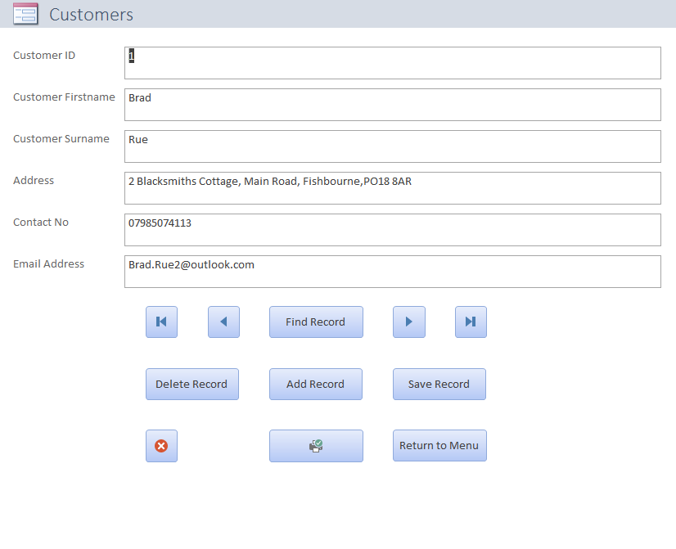
This is the customers forms; it shows all the information needed to identify what customer is who. It has identical buttons and placement as the books forms, and this is the case all throughout the database forms.
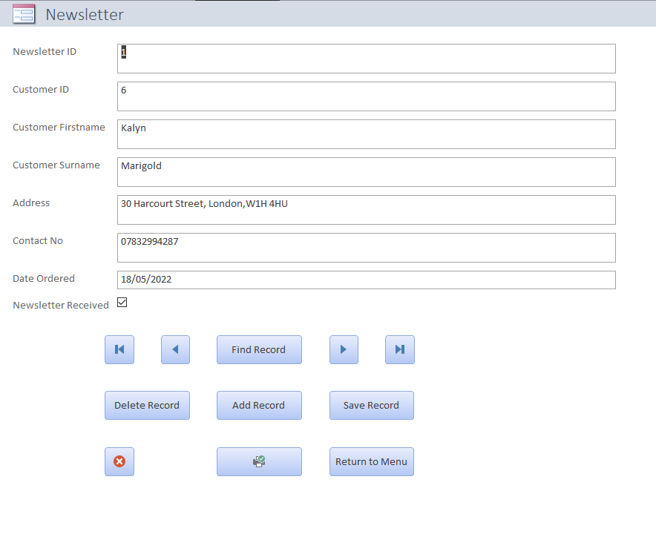This is the newsletter form, with Identical buttons and placement with all the necessary information on the newletters.
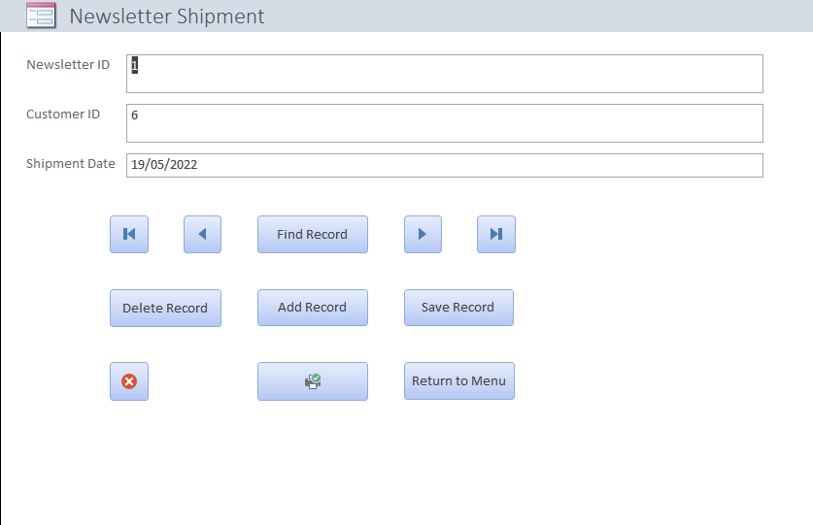This is the newsletter shipment form.
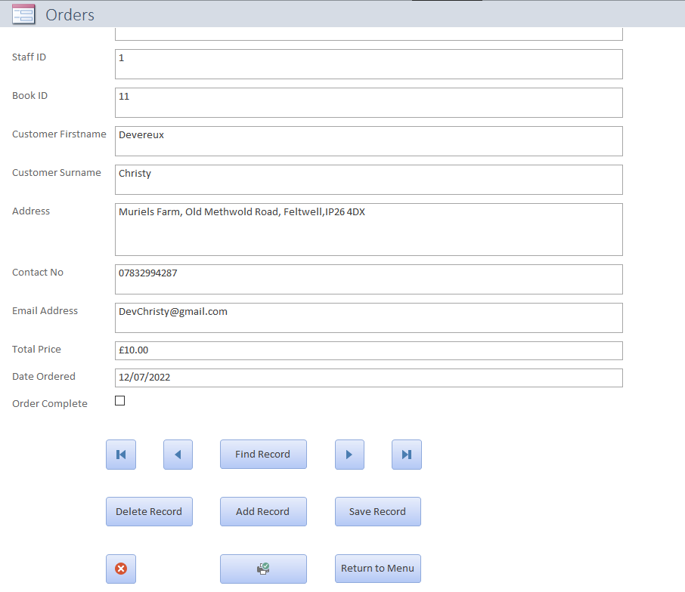This is the Orders form.
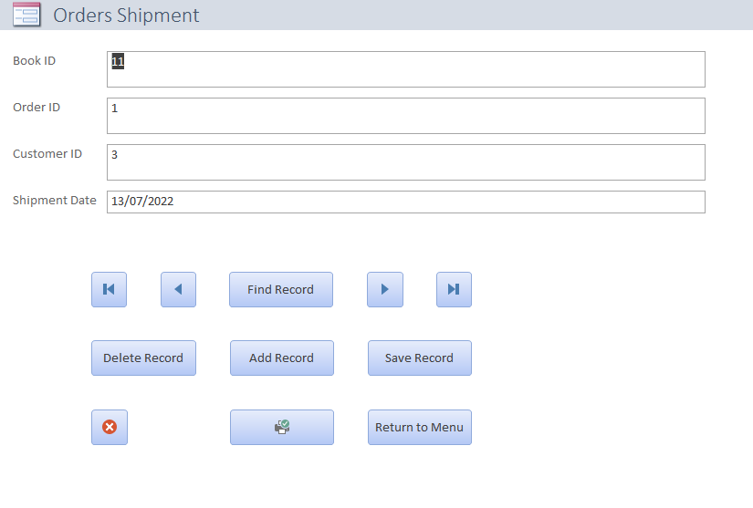This is the Orders Shipment form.
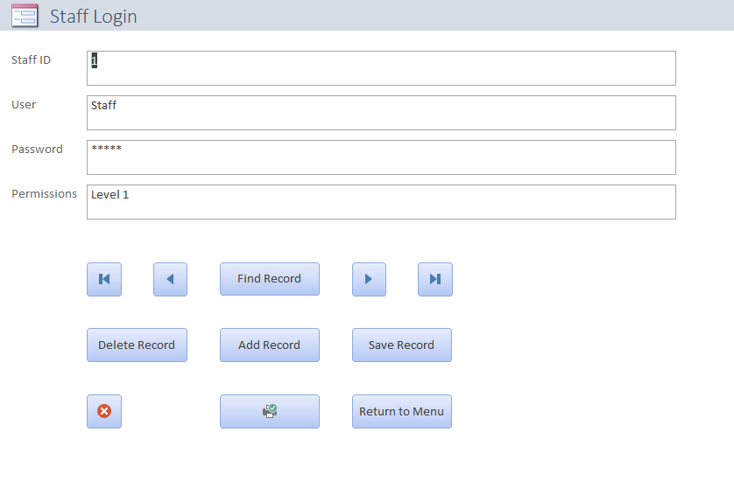
Lastly this is the Staff Login form.

