ALINA PRECUP
STUDENT NUMBER :1816777
MODULE TITLE : MARKETING FUNDAMENTALS
ASSIGMENT TITLE : ANALYSIS AND EVALUATION NESTLE INDIVIDUAL REPORT MODULE LECTURES NAME : REXON NITING



Contents
Introduction: 1
TASK 1A 2
Processes and stages of marketing including the role of the marketing mix. 2
The role of marketing in creating value for customers. 5
Stakeholder engagement and their impact on the marketing activities of an organization 8
TASK 1B 11
Conclusion: 12
References 13

Introduction:
Nestlé is one of the leading food processing companies in the world both in terms of profitability and product differentiation. The current goal is to attain a mid-single-digit organic growth from 2022 and has seen 3.5% organic growth last year(BBC News, 2020). The reason behind this success was innovation and proper marketing strategy. The total revenue in 2018 was increased by 1.2% to CHF 92.6 billion. The continuing product placement and creating brands had been the key reasons behind this accelerated growth. It is important to know how mega-companies are dealing with complex marketing strategies these days.

TASK 1A

Processes and stages of marketing including the role of the marketing mix.
The general concept of people of marketing being just selling and advertising has long been changed with a more complex process. The core understanding of marketing has emerged as satisfying customer needs and develop marketing strategies according to it(Baker, M.J., 2014). There is a simple four-step marketing step model which includes mainly understanding the needs of customers and reaping the rewards of creating superior customer value.

Figure 1: The Marketing Process
Source:(Smith, 2017)
Designing and implementing an integrated marketing strategy comes straight after the innovation process. For example, a man in the UK will go after to sought out brand product than a local or foreign brand. This is all because of positioning perfectly with a customer base with an established brand. So the process of marketing involves market segmentation, targeting, differentiation, and lastly positioning(Bradley, 2009).

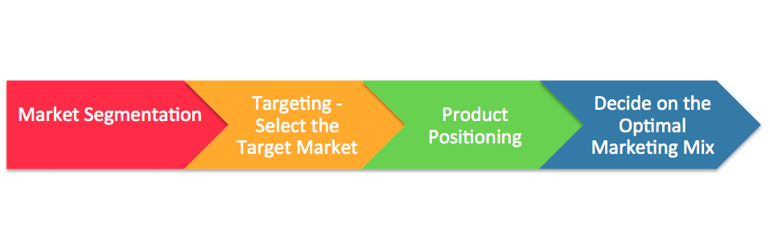
Figure 2: Stages of Marketing
Source:(Baker, M.J., 2014)
Market Segmentation:
The marketing process starts with market segmentation where people with similar viewpoints and needs toward a particular brand are being identified. Nestlé does market segmentation by using demographics such as age, income, sex, and geography such as cultures, countries, norms, etc. Singapore Nestlé has successfully segmented the growing market for Nescafe ice based on the weather of that region where the demographic analysis is often used in every country.
Market Targeting:
The market segmentation helps to determine the customer niche and what kind of products will maximize customer satisfaction(Bradley, 2009). As the segmentation will result in different patterns of what customers want, it is wise to determine the customers the company would like to serve with its products. The strength of the company might be utilized according to the needs of the customers of particular or multiple segments. Two of the major marketing decisions that are dependent on positioning are to go for standardized products or product differentiation.
Market positioning:
Market positioning involves all the marketing mix elements. For example, Unilever is an organization withmore diverse product range with different brand names, unlike Nestlé. Nestlé positioned itself as a company for food products and indirectly engages in nonfood products. Still, it goes for product differentiation for the food products as they produce around 25 varieties of Nido products for the Children worldwide(Lane and Devin, 2017). Chanel and image differentiation are also crucial these days for sustaining in the competitive market. The logo of Nestlé is easily identifiable by the customers in most countries and it helps them to gain the confidence of the customers while choosing products.
Marketing mix
The marketing mix starts with product planning including qualities and design. Then there is the question of where and how to sell them to the desired customers. McCarthy’s dominant design of 4P formula is regarded as the market mix which has four classes: Product, price, Place, Promotion. Product development refers to offering products or services which will create value for the customers and the product life cycle can be extended over the period. The second marketing mix is pricing which involves gauging the value offered through the product and selecting a price according to it. For example, Mercedes –Benz is known to be a luxury car producer and so can command a high price for its products. Price premium or discount depends on the company’s brand and even the market. The place refers to the channel of distribution of the products to the end customers. The final marketing mix element is a promotion which is a process to communicate and influence the customers. The major tools for promotion are sales representatives, advertising, sales promotion, etc.
Figure 3: Products of Nestlé
Source:(Nestlé, 2019)
New product policy, research development program, pricing policy, branding, or selecting a trademark, channels of distribution, packaging, etc are the core elements of Nestlé’s marking mix in general. Kitkat, Polo, and Munch are some of the most famous chocolate brands of Nestlé. The pricing strategy of this company is to maintain the cost and profit per unit of the product as it tries to deliver a quality product(Lane and Devin, 2017). For example, the price of Maggie is a bit higher than some of the local Asian noodles, but by giving the price it is also ensuring quality products to everyone. Bulk products from the factory go to the company warehouse and then it is sold to the local distributors. Lastly, promotional activities always have been unique to keep up the interest of the customers worldwide. Customer responsiveness is dealt with regional marketing and promotional activities. After the Nescafe tunes which Nescafe brought, it became quite popular among the customers.

The role of marketing in creating value for customers.
Creating value for the customers is the key building block for managing the customer relationship as it creates loyalty among the customers. In this age of social media, active sales instruments are not enough to stand out for the customers or stopping them to switch to competitors(Sakas and Konstantopoulos, 2010). The marketing strategy of a global company like Nestlé defines the company’s overall mission and objectives. A business should devise procedures that actually fit the resources and look for greater opportunities continuously. The global strategy is aligned with nutrition based on demographics which generally vary from time to time area wise. The close near competitor,“Unilever”, also follows somewhat same global expansion strategies but positioning into a new community demands few changes. But Unlike Unilever, the company tries to focus on its corporate wellness instead of focusing on customer preferences. Time and effort are given to product differentiation and customer satisfaction. But the common factor among them is to create profitable customer value through various marketing mixes. But to elaborate on the value creation process, it refers to identifying, building, and delivering something that can satisfy the needs of the targeted customer segments(Smith, 2017). Getting a complete market insight is afirst and foremost step to start the value creation process. The information gathered by research should be used to design a customer-driven integrated marketing strategy. This stage involves to segment and target desired market. This also involves doinga SWOT analysis, PEST analysis, and industry analysis to understand the internal and external forces that might impact the overall value creation process. The goal should be offering something that exceeds customers' expectations.
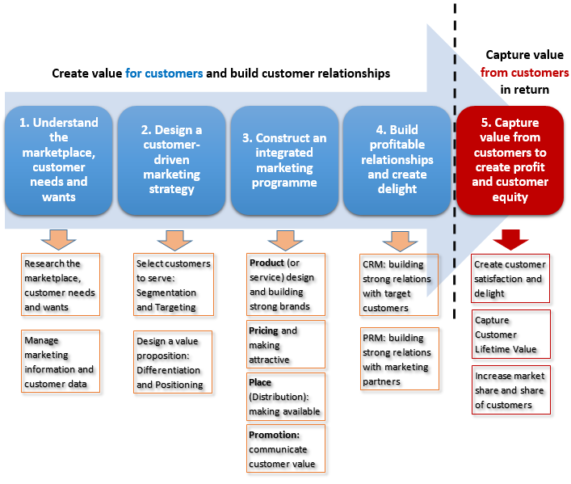
Figure 4: Value creation process
Source:(Abdullah Saif, 2015)
Capturing the value is equally important as the profit growth will indicate if the marketing mix and the strategies are effective or not. As the ultimate aim of customer relationship management is to create customer equity. The total combined customer lifetime value of customers involving in repeat purchases is called Customer Equity(Mazurek, 2014). But at the same time, the value creation process includes the partners or suppliers too as they impact the profitability and smooth supply to the end customers. So creating a strong relationship with the marketing partners indirectly helps to increase customer value.

The fundamental changes in the research process of Nestlé have been important for the company to create value for its global customers. This led to anticipate the changes in consumer trends and launching products efficiently aligning with customer needs. As the customers are being more environmentally cautious and even eager to pay more if it helps the companies to go green. Sometimes it is necessary to take action to capture customer lifetime value as it is a challenge to balance the brand value proposition in this changing economy. Nestlé in 2018 did a divestment of Nestlé Skin Health for CF 10.2 billion as it didn’t match with its core business strategy(The Guardian, 2020). Even if a segment has potential, the company tries to shift its portfolio which will guarantee to maximize growth to its targeted market. Other companies are also formulating strategies that might help them to create customer value in the long run.
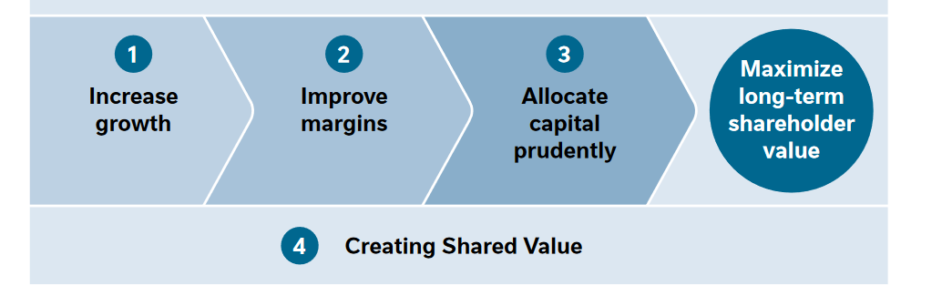
Figure 5: Shared value creation strategy
Source:(Smith, 2017)
For example, Intel has started a program that focuses on improving student achievement by increasing sales of classroom technology. The results show that technology has a great positive impact on the students but only 5% of the 1 billion students get access to technology. However, Nestlé focuses on the development of its suppliers in the villages so that they will be able to supply more and better raw material for the business. It employs more than 1,100 staff to educate the small farmers in the local communities(The Guardian, 2020). As they source materials from thousands of farmers, the company needs to encourage sustainable production. The impressive part is that Nestlé has interconnected all these aspects to trust their brand and create a long term customer relationship. It creates customer value through many of its activities including helping 50 million children to lead healthier lives.

Stakeholder engagement and their impact on the marketing activities of an organization
Communication with the customers before designing a product is necessary. This is now the difference between previous practices when engineers would design based on their preferences and techniques(Mazurek, 2014). But now the production and selling products depends on the demand and need of the customers. Holistically all the stakeholders of Nestlé play a significant role in designing and implementing their marketing strategies.
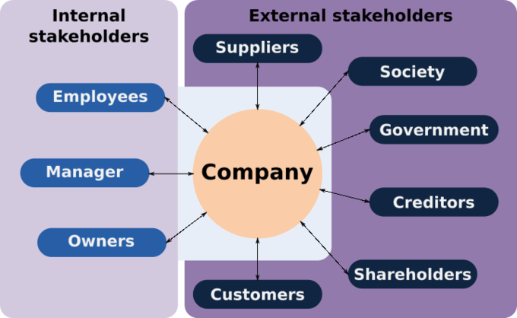
Figure 6: Internal and external stakeholders
Source:(Mazurek, 2014)
Stakeholder theory refers to an inclusive approach to consider the wellbeing of all the stakeholders of the business in the strategic decision-making process. The interest of the customers, employees, investors, suppliers, community, government,etc. should be discussed through dialogue between the company and these stakeholders(Rossi, Allenby and McCulloch, 2012). It has become important for global companies like Unilever and Nestlé to take an inclusive approach for stakeholder engagement governance. The theoretical perspectives regarding stakeholder engagement are discussed below:

Reflective paradigm
The triple bottom line which refers to people, planet and profit,etc. is associated with symmetrical communication on an ethical account. Basically, it is beyond the basic dynamic for a business to think about only the economic aspect and incorporating a broader perspective for all the stakeholders.
Excellence theory
The integrated theory deals with the success of an organization and public relations. It has been proved that organizational effectiveness depends on when the goals of the organization’s objective have been reconciled according to the expectation of the public relation inputs(Belloc, 1967).
Structuration theory
The structure of the organization is an important factor to communicate with its stakeholders. The structure of the society and the organization both are interlinked in terms of public relation creation(Lane and Devin, 2017). The shared experience created by the stakeholders is the base for the organization’s public relations or stakeholder engagements.
The new age stakeholder engagement is quite crucial for multinational companies like Nestlé as the brand image and success depend on it greatly in today’s business world. Nestlé has been accused of child labor and manipulating farmers in Brazil once. The place of the marketing mix is often jeopardizing the overall business performance. The ethical standpoint is very crucial as a big organization they should show more responsible business practices. They have designed a Compliance Program for its business operations and protect Nestlé’s brand image worldwide. Also, another interesting aspect of the marketing mix of Nestlé is that most of the sales and revenues come from European countries and its 90% of the total sales(The Guardian, 2020).
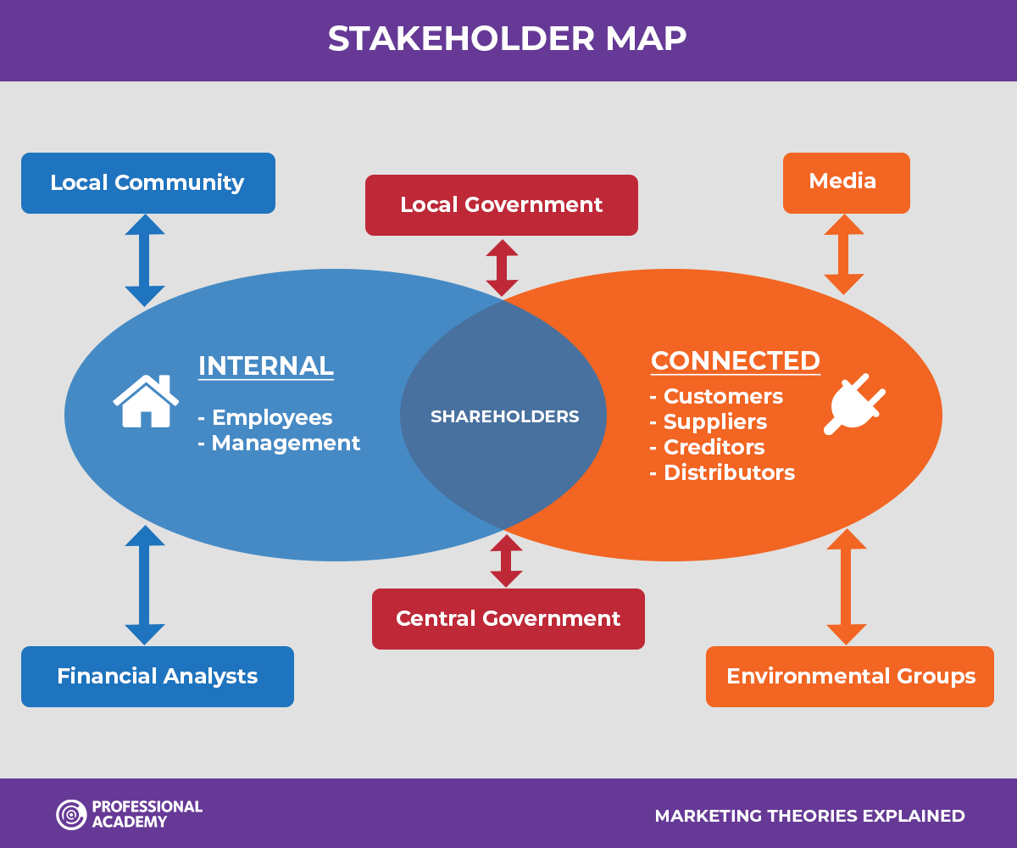
Figure 7: Stakeholder Map of Nestlé
Source:(Nestlé, 2019)
These European countries are becoming more cautious about Human Rights and environmental compliances. So the global stakeholders consist of consumers, customers, investors, suppliers, governments, local communities, NGOs,etc.should be engaged with the actives that are done by the company(Rossi, Allenby and McCulloch, 2012). The most recent stakeholder convening of Nestlé was organized in London 2019 where almost seventy stakeholder representatives were present. Other than that the employees are also an important stakeholder as more than 291,000 people work in 150 different nations as they are the ones that run the business operation. A healthy, effective, and diverse workforce is necessary to run all its marketing activities. The climate change initiatives are recently impacting the marketing strategies more as in 2019;Nestlé ensured 87% of its packaging to be recyclable(BBC News, 2020). For better stakeholder engagement, the marketing strategy needs far more research and data these days to incentivize in the markets. Nescafe marketing mix should be planned in a way where the product is socially and economically viable and rebranding is done to highlight the shared value creation. To sum it up, all the marketing plans are decided and designed based on the objective of enhanced stakeholder engagement.

TASK 1B
The changing dynamic of global marketing strategies has become important to the global business organization. The companies are trying to reach their target market through different effective communication channels. My project deals with the current structure of Nestlé and its marketing mix along with superior value creation. Customer lifetime value creation is now essential for every kind of businesses starting from a tech start-up to multinational companies. Public relations are marketing communication which is part of the marketing mix or “4P’s of marketing”(Sakas and Konstantopoulos, 2010). My project of the marketing strategy of Nestlé’s can be an overview of how the society and business environment is changing for the business entities. The communication tools for this project truly depend on several factors such as experience offerings, industry, budget, target audience. Generally, this kind of project paper can be communicated better with blogs or designated websites that provide project paper to registered users. An editorial in the newspaper on this topic might attract an organization but its costly and publishing the total analysis is quite impossible.
Blogs are now one of the popular mediums to give opinions and recommendations to any topic. As a student, I prefer my marketing insights to share via a blog or report based website. The information in this project has been integrated via thorough research of the changing marketing scenario for the big leaders in the FMCG industry. The internet infrastructure around the world has also enabled writers like me to know and share the topic that we are interested in. For example, “LiveJournal” is one of the websites that enable writers to put up projects like this. But the promotional activities are also necessary to increase the interest of the targeted audience. Promotional material on Facebook or LinkedIn can take the audience straight to the destination website for the blog on the marketing strategies of Nestlé in the changing business world. The success of these communication tools depends on the timing, budget, planning, and execution.

Conclusion:
The marketing strategic process actually involves creating value for the customers to ensure value from customers in return for the long term time frame. People’s view of the large organization varies from smaller firms as there is more visibility of the actions. Recently there has been a sharp decrease in confidence for the multinational companies like Nestlé. So now the marketing strategy needs to have more defined marketing mix in order to create customer lifetime value creation. More inclusive approaches are being taken by the companies but the profitability should also be measured from these stakeholder engagement activities.

References
Abdullah Saif, N., 2015. How does Marketing Strategy Influence Firm Performance? Implementation of Marketing Strategy for Firm Success. International Journal Of Innovation And Economic Development, 1(3), pp.7-15.
Baker, M.J., 2014. Marketing strategy and management. Macmillan International Higher Education.
BBC News. 2020. Home - BBC News. [online] Available at: <https://www.bbc.com/news> [Accessed 6 May 2020].
Belloc, H., 1967. On. Freeport, N.Y.: Books for Libraries Press.
Bradley, F., 2009. International Marketing Strategy. Harlow: Financial Times Prentice Hall.
Lane, A. and Devin, B., 2017. Operationalizing Stakeholder Engagement in CSR: A Process Approach. Corporate Social Responsibility and Environmental Management, 25(3), pp.267-280.
Mazurek, G., 2014. Network Value Creation through Marketing. Management and Business Administration. Central Europe, 22(4), pp.70-77.
Nestlé Global. 2020. Nestlé Reports Full-Year Results For 2019. [online] Available at: <https://www.Nestlé.com/media/pressreleases/allpressreleases/full-year-results-2019> [Accessed 6 May 2020].
Rossi, P., Allenby, G. and McCulloch, R., 2012. Bayesian Statistics And Marketing. Hoboken: John Wiley & Sons.
Sakas, D. and Konstantopoulos, K., 2010. Marketing And Management Sciences. London: Imperial College Press.
Smith, P., 2017. Stakeholder Engagement Framework. Information & Security: An International Journal, 38, pp.35-45.
the Guardian. 2020. Latest UK News | The Guardian. [online] Available at: <https://www.theguardian.com/uk-news> [Accessed 6 May 2020].

