NAMES: SARAH. EVANS. KOKUNDA.
STUDENT NUMBER: 1711420.
MODULE TITLE: (BMSW 5106)
ASSIGNMENT TITLE: KNOWLEDGE AND INFORMATION MANAGEMENT SKILLS FOR WORKPLACE
LECTURER: MR KALIM. MUHAMED.

Table of Content
Introduction……………………………………………………………………3
Company’s Overview………………………………………………………….3
Relationship between data, information and knowledge……………………3
Data.…………………………………………………………………………….3
Information…………………………………………………………………….4
Knowledge……………………………………………………………………...4
Relationship between individual’s knowledge and organizational knowledge…...5
Analysis and modelling techniques to identify knowledge assets…………...6
Knowledge assets……………………………………………………………....6
Modelling assets..................................................................................................6
Technique to identify knowledge assets............................................................7
Evaluation to actual and potential assets..........................................................7
Requirement to create, store, apply, and integrate knowledge............................8
Importance of intellectual property rights............................................................9
Contribution of knowledge assets on an organization........................................10
Knowledge requirements for the organization....................................................11
Organizations framework knowledge sharing.....................................................12
Recommendation for improvements in the current framework........................14
Conclusion...............................................................................................................14
References................................................................................................................16

Introduction

In knowledge management, the relation between data, information, and knowledge has been an essential part of it. However, the report will highlight the significance of data, information and knowledge in an organization. The data, and information are important assets for any organization. The organization can only grow if the employees working there are highly-skilled, knowledgeable and passionate. The report comprises of the following pattern: The detailed analysis of the relationship between data, information and knowledge, the relationship between individual knowledge and organizational knowledge, modelling techniques to identify the knowledge assets, the evaluation of the actual and potential knowledge assets, the importance of intellectual property rights, knowledge assets and requirements for the organization, framework for enabling knowledge sharing and recommendation for the improvement of current frameworks.

Company’s Overview
Zenos Cars is a British automotive company that manufactures high performance, lightweight sports cars which were found in Norfolk in 2012 by Ansar Ali and Mark Edwards (Zenos Cars, 2020). They found a gap in the market, and launched a lightweight sports car that is affordable and provide high-quality performance. The first product that was launched by the company was E10 series. The vision of the company is to produce cars that provide high-level performance, comfort and excitement to their customers. Additionally, they provide services that can benefit their customers and are evolving with the time to serve better in the future.

The Relationship between Data, Information and Knowledge
To understand the relationship between data, information, and knowledge, it is important to define each Sseparately.

Data
Data is a set of values, usually are in numerical form that can be collected through observations (Sanders, 2020). Generally, data is based on information, facts and figures that are collected in the form of numeric but none of the results could be generated from that.

Information
It is a form of a processed data or message which implicit meaning and derives a conclusion as per the need of the users (Stenmark, 2020).

Knowledge
Knowledge is the understanding of facts, information and skills that are obtained through the experience or learning (Omotayo, 2015).

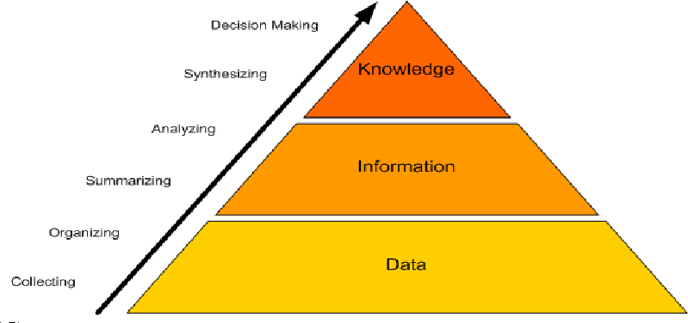
Figure 1: DIK Model

Data, information and knowledge are interlinked with each other and these cannot be defined in absolute terms. The differentiation between the terms relies on the potential user of the data, information and knowledge. The hierarchy of the model shows that every step is equally important for adding value to the upper stages (Sanders, 2020). The connection between data, information and knowledge is an essential part of every organization but it varies from company to company. Zenos Cars effectively implement this model on their company to ensure the efficacy in the workplace structure and its cultural environment. The organization gather data through their observation, organize the data and process the data to achieve the results. Further, the data is analyzed based on the experiences which, therefore, lead the company towards decision making. The model helped the company to make decisions to make the organization progressive.

Relationship between individual knowledge and organizational knowledge
According to Ahmed and Ahsan (2014), organizations do not have the learning abilities whereas individuals are working in an organization who can learn. Additionally, in the author’s point of view, the evolution of the organizations is due to the learning capabilities. The organizational knowledge is acquired through their past experiences which could be found through organizational histories.

Organizational knowledge is actionable knowledge whilst individual knowledge is internal knowledge. Knowledge is an essential organizational driver that helps in the development of the organizational culture through organizational learning. There are a variety of sources and practices through which the knowledge and information can be passed on in an organization (Ahmed, and Ahsan, 2014).

However, individuals play an important role in knowledge creation, as the knowledge that is generated, is due to the interactions between the individuals or their environments. Besides that, even some individuals use technology and are also recognized as the source of knowledge creation and creativity (Lee, Yoo, and Yun, 2015). The individual’s knowledge is required to create organizational knowledge. The knowledge is gathered by the individuals who provide relevant opinions, giving better insights, planning innovative strategies and other new ideas that can enable the individual to gather more tacit knowledge. All the employees working in Zenos Cars are motivated and encouraged to contribute their knowledgeable skills individually with others in order to increase the organization’s overall knowledge. Every individual gets their chance to interpret their thoughts and recall past events which can be helpful for the organization and can lead to a productive result.

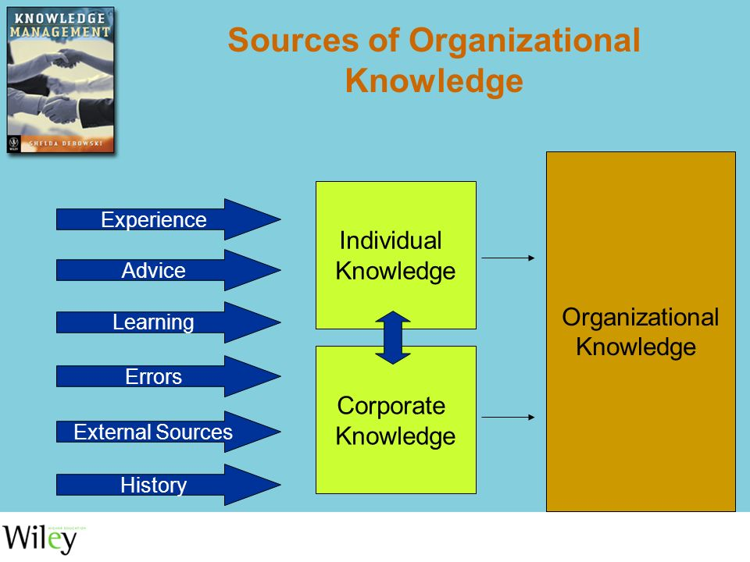
Figure 2: Sources of Organizational Knowledge

The figure demonstrates the contribution of the individual knowledge and corporate knowledge to establish a company that can integrate the process of data, information and knowledge to make better organizational decisions. This shows how the experience, advice and learning of an individual whereas, the errors that are made, external resources and the history of the company matter to the organization to progress effectively and efficiently.

Analysis and modelling techniques to identify knowledge assets

Knowledge Assets
It is a term that refers to gather intellectual resources of the organization (Mackintosh, Kingston, and Filby, 2020). It is a knowledge which is gathered concerning the markets, products, technologies and organizations that a company owns or wants to own which, therefore, enables the process to add value or generate profits for the business. A knowledge management system manages both explicit and tacit knowledge (Naik, Com, and Chandran, 2016).

Modelling Techniques
Models can be used to capture the essential structures of real systems by dividing them into manageable parts that can help in easy understanding and handling. A model is a simplification of reality. As Zenos Cars is a large entity that consists of a real system which works in a complex manner, however, the model helps that complexity to be resolved and showcase it in a simple manner which can help in understanding it easily.
The modelling process builds conceptual models of knowledge concentrated activities. During the information obtaining stage, a large portion of the knowledge is unstructured and frequently in tacit structure (Raisinghani, et al., 2020). This process of discussion will stimulate ideas and insights from the individuals to how the knowledge can be used, how it may help in decision-making and the factors that can motivate the employees to produce further ideas. The importance of knowledge modelling is that it helps in understanding the working mechanisms among the knowledge-based systems.

Techniques to Identify Knowledge Asset
To attract knowledge for the clear view of the organization, initially, the company needs to recognize the knowledge assets. Usually, the official heads of the department do not find it their responsibility to share the amount of knowledge or experience with their employees as they think that by sharing the knowledge with other individuals in the organization will lose the hold of that knowledge (Dalkir, 2017). Although in Zenos Cars, the upper management, if identifies such issues in the organization, they find ways to solve the problem. Identifying the individual who owns the knowledge and does not wants to share it with other employees, in that case, the manager starts implementing new ways through which the knowledge can be passed on for instance, by training sessions, informative gatherings which then benefit the individual by receiving appraisals, rewards and other ways of appreciation. Therefore, it aids in carrying forward the legacy of passing the knowledge to whoever it seems to be and can be beneficial for the Zenos Cars in future.

Evaluation of actual and potential knowledge asset
The actual knowledge asset is the knowledge that is already the part of the organization and the employees work accordingly whereas, the potential knowledge assets are the expected investments that can be earned by the organization (Natalicchio et al., 2017). Although, Zenos Cars have been implementing and evaluating their actual knowledge assets and keep on challenging themselves to enhance their knowledge and expect various knowledge assets. The employees working there, keep on pitching new ideas to improve the company’s service and their designs. The company try to enhance the performance of the cars and maintains the price range that is affordable for the customers. In spite, they gather their employees and try to take insights from them which can help them to serve better for their customers.
The company evaluate their actual and potential knowledge assets which enable them to establish new strategies or generate new ideas for their upcoming cars or the maintenance of it. The data is collected based on the research through markets or the competitors which led them to be the pioneer of the industry. This may help them in sustaining the culture and environment of the company. This knowledge asset helps the managers to hire employees who are capable of generating new ideas, know the technicalities, have diversified mindsets and knows how to deliver or attain new knowledge. The people with such skills will help in developing the company’s knowledge asset as well as in the effectiveness of the company.
Requirement to create, store, apply and integrate knowledge
Creating, storing and integrating the knowledge is an essential way of any Knowledge Management System which can identify that wherein the organization the knowledge is located. It determines the knowledge that is already the part of the organization. The identification of the weaknesses and opportunities of the knowledge could be recognized through the process. This process is also known as the knowledge map and is based on recognizing the knowledge needs and sharing.
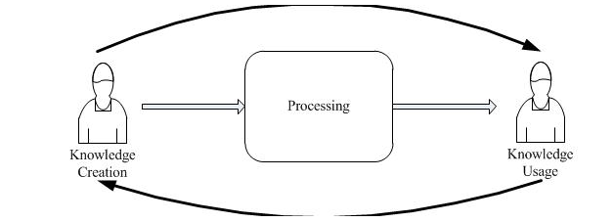
Figure 3: The process of Knowledge Creation and Usage
The diagram provides you with a clear vision of how the knowledge is developed, created by the individual which then processed via different stages and after the process how the knowledge will be used in the organization to make further embellishments to improvise the procedure of the workplace (Ahmed, and Ahsan, 2014).
Creating knowledge is to gather information or data from the relevant markets, competitive organizations, and the products that can identify key knowledge workers in the organization. It involves the documentation of the workflows and decision-making processes (SciELO, 2020). This may include the collection of the ideas to determine the suitable individual who is capable of meeting the knowledge needs of the company. It entails a process of selecting the individuals, generating new knowledge and y the adaptation of the idea to the organizational environment.

Storing the knowledge is a process that involves the identification, storage, evaluation, preservation of knowledge, updating the workflow or map design and enhancement or change in the knowledge (Mohajan, 2017). It further preserves the knowledge and waits for the right time on which the knowledge can be utilized by the managers to add value to the organization.

Applying the knowledge is a process in which after the collection of the data, information and knowledge the person having immense knowledge will be implemented on the organization which can then help in productive results (Knowledge-management-tools.net. 2020). The application of the knowledge includes the decision that when, where and how the knowledge can be implemented which can improve the company results or could be fruitful for the company.

Integrating knowledge is mainly regarding knowledge socialization operations (Mohajan, 2017). The knowledge sharing entails various activities which involve the exchange of the teamwork, possibility of internships and creating the knowledge cafes among themselves. It entails the process of synthesizing multiple knowledge models into a common model which establish that the multiple representations will, therefore, lead to end up together in a single representation.

Importance of intellectual property rights
Intellectual property is the concept that refers to the preservation and protection of the nontangible assets of a company. Usually, the term is used to define the ideas and innovative ways that a company has developed themself, and does not want anyone to copy them. The intellectual property is usually the trademark of that company (Hu and Png, 2013). The IP is used by the company both internally and externally. Internally it can be used to enhance the working conditions and overall business process of the company. Externally the company could sell the IP to another company and allow its patented use or to use it by providing royalty to the parent company. There are many advantages to protect the intellectual property, one is to stop other companies to gain a competitive advantage over the parent company (Acemoglu, and Akcigit, 2012). For example, if a company has a trade secret of a specific model of doing business, then they have to protect it by intellectual property laws to prevent others from copying their work.

For some corporation’s their intellectual property is their main way of generating revenue, and if others start to copy their ways then that could lead to competition and loss if revenue (Hudson, and Minea, 2013). Usually when companies create something that falls under the intellectual property category, such as new product design, it a new formula or even a working framework, then they protect it by copyright laws so no one else can copy their work (Hu, and Png, 2013). This makes the company only one in the market to make that particular thing and gives it a competitive advantage over other companies. Securing the IP through laws also means that the prevention of unauthorized use of the company’s IP by other companies, as that could then come under the category of theft.

LO3

Contribution of knowledge assets on an organization
Knowledge assets refer to all the information and knowledge, that contributes to the success of the company (Denicolai et al., 2014). Knowledge assets can include simple tactics that a company use to do business, along with raw information that is related to the company’s business strategy. This also includes confidential knowledge that is codified to protect it from theft. Usually, knowledge assets are stored in a structured manner, as that makes o the use of that knowledge easier in the future. In most cases the knowledge assets of a company are kept confidential and are not for the use of public or even for everyone in the company (Swart, and Kinnie, 2013). They are used only by people that work in the specific domain of which the information is about.

The knowledge assets, are very the very core of a company, they represent the capacity of a company to perform and are a testament of what the company is capable of achieving. They are also used to determine the worth of a company (Barney, J.B., 2017). The more knowledge assets a company will have the more it will gain acknowledgement in the market. Knowledge assets are also productive in maintaining a productive working environment. As the rules and regulations that are unique to productivity also come under the category of knowledge assets, this means that knowledge is considered the most important and crucial resource available in the arsenal of any company (Leonard, 2011). The knowledge assets if a company varies upon the overall goals and strategic objectives of a company. The knowledge assets can be used to broaden the sphere of influence for a company and also will open doors for future partnerships with other companies, for example a company can give royalty rights of its knowledge assets to other companies in exchange for long term partnerships (Leonard, 2011).

Knowledge requirements for the organization
As stated before knowledge assets are essential for the success of any company. There is no company in the world that does not have knowledge assets, no matter how small every company has them. The knowledge assets are a result of innovative and creative thinking in the company, and the company must do extensive knowledge management to remain successful (Delgado‐Verde, et al.2011). In this section all the information that can be considered knowledge assets for Zenos Cars shall be discussed in detail. The first thing that can be counted as knowledge assets for the company are its experimental car and other design that ate associated with the finished product. These designs are the most basic designs that company has based all its products on. Such items come under the category of experimental knowledge assets (Erickson, and Rothberg, 2012).
The next thing that is essential in the knowledge department for Zenos in the conceptual knowledge assets. There are a number of things that can come under this category, such as the data graph of the products, the design and symbolic languages, such as the company logos and other things such as images. Normally the things that are in this category, are those that are required for the production of the product. The third aspect are the systematic knowledge assets. This type usually includes information that is related to the running of operation in the company, such as the patents of company, and other patents that the company has purchased for use. This also include all the documents and data associated with the suppliers and customers of the company. In the case of Zenos cars, the systematic knowledge assets of the company includes, information of all the suppliers and their customers, most of the data in systematic assets is considered confidential, and as such has to be guarded closely.

Organisation’s Framework knowledge sharing
In the precious sections the importance of knowledge management was highlighted and also the main knowledge assets for the company Zenos cars were also discussed. In this section a suitable framework that is acceptable in the Zenos cars company that is designed for knowledge asset management shall be discussed. For designing the framework the knowledge management cycle shall be used, with respect to the practices of the company (Stenholm, and Landahl, 2014). The knowledge management cycle covers all the steps that are involved in all the operations of the company from start to finish. The complete cycle is given below.

Figure: Knowledge management process
Source: Hislop et al., (2018)

The first part of the framework is to first acquire the information that is required for the functioning of the company (Hislop, et al. 2018). The best way is to encourage the staff to work innovatively and come with new ideas. In case of Zenos the company was founded with the ideas of light weight sports cars. There many ways of acquiring knowledge like employees both new and existing bringing knowledge from external parties of the company. Other sources include partnership contracts, training sessions, and purchasing new material and equipment for the factory.
Zenos cars is a company that is built upon innovation and believes, in change, this will speed up the overall process of knowledge gathering in the company.

The next step in the retention and safety of the data that what acquired by the company. It is very crucial that the data is secured and is not available for public use. If the data is not secured properly and gets under the hands of the competitor companies, then Zenos Cars could lose all its advantages in the industry. The first method that is used in the database management systems. In this system data of various nature such as documents, pictures and other sensitive material is stored all together. Another way is choose the valuable information form useless information, it falls under the category of business intelligence to secure the most confidential data such as information of clients and suppliers. All the data is secured in data warehouses on a weekly basis in the company, while the most relevant is then selected and further divided on a departmental level (Evans, and Ali, 2013).

The third step is the transfer of data, like every company, Zenos also shared, relevant data that is needed to be shared with the public, such as share value prices. The company also offers the use of its knowledge assets such as its patents. Knowledge movement is generally done among partners or suppliers. The company does not share all the knowledge, only that which is agreed upon through partnership. There are many ways to transfer data, the Zenos Cars usually transfers data using the following methods, electronic mail, text messages through mobile, video conferencing. Social media platforms such as Facebook, Twitter, also the original company website. One thing that has to be made clear before any type of knowledge transfer is that all the parties with whom the data is shared must make sure that this data is not used in any way to harm the Zenos cars company and that the data has to be used in such a manner that would be beneficial for both parties. To make sure to keep everything professional Zenos Cars has strict rules about information sharing, they also have a shareholder trust agreement.

The last part is the knowledge application, in this part, all the acquired knowledge is used in the real world cases. In the real-time scenarios where the company is facing challenges, the knowledge is mostly used in the instances if decision making, and also when updating the overall process of doing work, as the information is also gathered from work experience of employees, that becomes crucial at this stage. There are many ways to use the application such as using human consultation services to effectively use the information to succeed. There is also the DSS system which contains all the charts and data, it predicts the future scenarios based on the information present. Fault diagnostic systems are a perfect way, to detect problems and solve them with the information available in the company.

Recommendation for improvements in the current framework
There are considerable changes that can be made in the existing framework. The biggest of the said change will be to make sure that the information shared is first reviewed by a separate board for clearance, all the internal and external factors are considered and monitored. The effects that the information will have on the company will have to be also evaluated in the economic and the current situation of the market if any contract is made with anyone that there has to be a time limit set of at least 5 years to ensure a long-lasting partnership. The company has to minimize the risks, and must first do a thorough background on anyone that they are doing their dealings with, whether they be a future business partner or current stakeholders. The company must have a digital backup of all the data stored in a separate server, to avoid any form of theft of data.

Conclusion
The main purpose of this report is to provide awareness about the knowledge and data and the distinction among them, also this report covers the crucial relationship among them. The report then highlights the relationship between organizational knowledge and individual knowledge among the employees working in the company. The results that information sharing have among the employees in an organization., the key concept of knowledge assets for a company were discussed, as well as the framework and techniques that are required to recognize knowledge assets of a company. For this report the company of Zenos Cars was chosen, it is a UK based sports company that manufactures lightweight cars. In the report, the key elements that are required to create and store knowledge were discussed briefly as well as the distinction between current and future knowledge assets for a company. The importance of protecting intellectual property through copyright was also discussed. The typical knowledge assets of an organization, as well as the advantages that having the said assets on the organization, were also discussed. At the end of the report, a framework for knowledge management was given for Zenos Cars, as well as recommendations of how to improve it.

B, B. J., 2017. Resource, core comptence , iinvisibleassets and knowledge assets. The SMS Blackwell handbook of organisational capabilties, pp. 422-426.
cars, Z., n.d. [Online]
Available at: https://www.zenoscars.com/our-story/
[Accessed 18th May 2020].
D., S., 2001. The relationship between information and knowledge. Proceedings of IRIS 24 Ulvik, Norway, August 11-14, s.n.
D., S. J. L. a. B., 2014. Knowledge management life cycle: An individual's perspective. s.l., Proceedings of the design 2014 13th international design conference.
Funmilola, O. O., 2015. Knowledge management as an important tool in organizational management: A review of literature. Library philosophy and practice, Issue 1, pp. 1-23.
Hussain, D. .. a. H. K. .. M. .., 1992. Information Management:Organisation, Management , andControlof Computer Processing., Newyork: Prentice Hall.
J., S. a. K. N., 2013. Managing multi-dimensional knowledge assets: HR configurations in professional service firms. Human resource management journal, 23(2), pp. 160-179.
John, D. S., 2016. Defining terms: Data, information and knowledge. SAI conference at Excel centre, London, s.n.
Kimiz, D., 2017. Knowledge management in theory and practice. s.l.:MIT Press.
Kumar, H. M., 2017. The role of knowledge management for the development of organisations. Journal of scientific achievements, 2(2), pp. 1-27.
M. max Evans, D. K. a. B. C., 2015. A holisitic view of the knkowledge life cycle. The Electronic journal of knowledge, 12(1), p. 47.
O'Dell, C. .. ,. H. ,. C. .. ,., 2011. The new Edge in Knowledge:, New Jersey: John Wiley,.
R, S., 2003. Knowledge management and organisational competence. (Online). https://www.oxfordscholarship.com/view/10.1093/acprof:oso/9780199259281.001.0001/acprof-9780199259281 ed. s.l.:s.n.
SC, A.-R., 2014. Cross Country Comparisons and Two Case. US HRM Principles , 5(3), pp. 75-78.
Strange, R. D. S. a. Z. A., 2014. Knowledge assets and firm international performance. international Business Review, 23(1), pp. 55-62.

Bibliography
Anon., n.d. [Interview] n.d.
B, B. J., 2017. Resource, core comptence , iinvisibleassets and knowledge assets. The SMS Blackwell handbook of organisational capabilties, pp. 422-426.
cars, Z., n.d. [Online]
Available at: https://www.zenoscars.com/our-story/
[Accessed 18th May 2020].
D., S., 2001. The relationship between information and knowledge. Proceedings of IRIS 24 Ulvik, Norway, August 11-14, s.n.
D., S. J. L. a. B., 2014. Knowledge management life cycle: An individual's perspective. s.l., Proceedings of the design 2014 13th international design conference.
Funmilola, O. O., 2015. Knowledge management as an important tool in organizational management: A review of literature. Library philosophy and practice, Issue 1, pp. 1-23.
Hussain, D. .. a. H. K. .. M. .., 1992. Information Management:Organisation, Management , andControlof Computer Processing., Newyork: Prentice Hall.
J., S. a. K. N., 2013. Managing multi-dimensional knowledge assets: HR configurations in professional service firms. Human resource management journal, 23(2), pp. 160-179.
John, D. S., 2016. Defining terms: Data, information and knowledge. SAI conference at Excel centre, London, s.n.
Kimiz, D., 2017. Knowledge management in theory and practice. s.l.:MIT Press.
Kumar, H. M., 2017. The role of knowledge management for the development of organisations. Journal of scientific achievements, 2(2), pp. 1-27.
M. max Evans, D. K. a. B. C., 2015. A holisitic view of the knkowledge life cycle. The Electronic journal of knowledge, 12(1), p. 47.
O'Dell, C. .. ,. H. ,. C. .. ,., 2011. The new Edge in Knowledge:, New Jersey: John Wiley,.
R, S., 2003. Knowledge management and organisational competence. (Online). https://www.oxfordscholarship.com/view/10.1093/acprof:oso/9780199259281.001.0001/acprof-9780199259281 ed. s.l.:s.n.
SC, A.-R., 2014. Cross Country Comparisons and Two Case. US HRM Principles , 5(3), pp. 75-78.
Strange, R. D. S. a. Z. A., 2014. Knowledge assets and firm international performance. international Business Review, 23(1), pp. 55-62.

