BA (Hons) International Hotel Management
Student name: Mohammad Abul Kalam Ali
Student ID: 2234300
Programme: International Hotel Management
Module: Marketing Essentials
Module code: BMIH4005 Resit

Table of Contents

INTRODUCTION 3
SITUATION ANALYSIS 3
MARKETING MIX 4
OBJECTIVES 5
STRATEGY 5
CHANGES TO THE MARKETING MIX 6
TACTICS 6
ACTION PLAN 7
CONTROL 8
CONCLUSION 8
REFERENCES 8
APPENDIX 10

INTRODUCTION
Ritz Carlton hotel brand is a very reputed hotel chain. They operate their business in different countries of the world. These countries arrange different types of marketing based on their own culture. In addition to conducting business in countries, they conduct various types of analysis to develop their marketing projects. In this article we will discuss how these hotel companies can further develop their marketing. As a result, they can reach more people and become more popular.

SITUATION ANALYSIS
Customers:
The organization can construct consumer profiles and conduct targeted marketing efforts by analyzing demographic, psychographic, and behavioral characteristics (Champagne, 2016). Potential clients include affluent vacationers, professionals, event organizers, and those just looking for a once-in-a-lifetime adventure. The organization can better cater to each demographic by catering to their specific wants, requirements, and desires via in-depth research.
Company:
The SWOT analysis will reveal the possibilities and dangers facing the Ritz-Carlton hotel chain, as well as its own internal strengths and weaknesses. This study will highlight the company's strong points, such as its well-known premium brand image, first-rate service, and loyal customer base. It will also attract attention to faults that must be addressed, such as potential operational inefficiencies or a lack of technology adoption. The company can capitalize on opportunities by finding them, such as emerging markets or new customer groups (Khazaeli, 2012). The company can lower risks by anticipating potential threats such as increased competition or economic downturns.
Collaborators:
To benefit on synergies and increase its market reach, the Ritz-Carlton must demonstrate understanding of B2B linkages, partnerships, and franchises. Collaboration with other high-end firms, such as airlines, tour operators, and event planners, can increase revenue and attract important clientele (Boucher, 2018). Franchise agreements with reputable hotel operators in other regions or countries can also help to extend the market while preserving brand standards. By developing strong relationships with partners, The Ritz-Carlton will boost its visibility and clients.
Climate:
The PESTLE analysis of the macroenvironment will provide light on the relevant aspects impacting the Ritz-Carlton. Political factors can include laws affecting the hospitality sector, economic factors can include changes in consumer spending patterns or travel trends, social factors can include shifting consumer preferences or changes in travel trends, technological factors can include developments in digital marketing or improvements to the guest experience, legal factors can include labor laws or data privacy laws, and environmental factors can include sustainability initiatives and initiatives to reduce carbon footprints. With an awareness of these characteristics, The Ritz-Carlton will be able to modify its strategy and operations to the changing business climate.
Competitors:
The building of a perceptual positioning map and the usage of Bowmans' Strategy Clock will assist in assessing the competitive landscape and identifying opportunities for differentiation for the Ritz-Carlton. By mapping out its primary competitors based on characteristics such as price, luxury, and service quality, the business can discover its unique position and potential market gaps.

MARKETING MIX
The current aspects of the Ritz-Carlton hotel chain's marketing mix are:
Pricing:
Since The Ritz-Carlton markets itself as a premium label, its products are more expensive than those of its competitors. The price strategy is based on the degree of facilities, extras, and specialized services provided to visitors. Many different bundles, promotions, and seasonal rates are available under the hotel chain's umbrella to appeal to a diverse spectrum of guests.
Distribution Channels:
The Ritz-Carlton uses a multi-channel approach to distribution to reach its customers. It has a website where customers can make direct reservations. To further its online presence, it collaborates with global distribution systems (GDS) and online travel agencies (OTA) (Kelly, 2016). The company has strong ties with corporate customers and event planners, and its products are widely sold via conventional travel agencies.
Value Proposition:
The Ritz-Carlton is known for its superior service and opulent amenities. Service excellence, specificity, and individualization are emphasized. The value proposition is on creating one-of-a-kind experiences for guests and delivering an unprecedented level of luxury to visitors.
Promotions and Communications Strategies:
The Ritz-Carlton promotes its brand through both traditional and digital marketing methods. It employs content marketing, public relations, print and online advertising, social media platforms, and public relations to communicate with customers and develop brand awareness (Boucher, 2018). The hotel brand emphasizes its excellent service and unique guest experiences via tales and testimonials. Additionally, it connects with premium travel partners and offers incentive programs to promote customer retention and attract repeat business.

OBJECTIVES
The marketing strategy's SMART goal for the next six months is to increase social media followers by 20% and website traffic by 10%. Key performance indicators (KPIs) like website analytics, social media engagement metrics, and conversion rates will all be utilized to assess the plan's efficacy.

STRATEGY
The Ritz-Carlton will expand its present offers into other regions using Ansoff's Matrix's market growth strategy. The firm recognizes the opportunity to get new customers by relying on its excellent service offerings and strong brand awareness (Hurst, 2017). The approach's key objective will be to provide a fantastic and secure luxury experience that meets the needs and preferences of the target market.
New Value Proposition: The Ritz-Carlton's new value proposition will emphasize the company's commitment to providing great and safe premium experiences. This includes delivering personalized services, paying attention to the details, and making guests feel importance (Khazaeli, 2012). To reassure guests about their safety during their stay, tight hygiene requirements, contactless services, and better sanitary measures will be implemented.

CHANGES TO THE MARKETING MIX
Pricing Strategies:
To service the new markets, better pricing strategies will be adopted (Khazaeli, 2012). This might involve offering inexpensive pricing, innovative packages, and promotions suited to the target demographic's likes and budget restrictions. The pricing techniques will strive to deliver value while maintaining the feeling of elegance and exclusivity associated with the Ritz-Carlton brand.
Optimized Online Processes:
To enhance the customer experience, The Ritz-Carlton will invest in simplifying and upgrading its online booking operations. There is a user-friendly website, straightforward navigation, and a secure and effective online reservation system (Champagne, 2016). To attract and engage potential customers, the brand will employ technology to personalize online interactions, provide virtual tours, and showcase unique products.
Expanded Distribution Channels:
To effectively penetrate new areas, The Ritz-Carlton will extend its distribution networks. Collaborations with well-known and prominent regional travel agencies, tour firms, and luxury travel advisors in the target markets might fall into this category. The firm will also leverage global distribution systems (GDS) and online travel agents (OTA) to expand its reach and attract customers from other nations.

TACTICS
The RACE framework (Reach, Act, Convert, Engage) will guide the communication efforts. The Ritz-Carlton will use new communication channels and methods in response to the findings of the situational study. This includes redesigning social media presence, improving website user experience, implementing targeted email marketing, and using influencer partnerships (Robinson, 2018). Other aspects of the marketing mix, such as price and distribution, will be altered to accommodate the new strategy.

ACTION PLAN
A Gantt chart will be used to describe the timeframe for the Ritz-Carlton hotel brand's many marketing channels and initiatives. The selection of marketing channels is guided by an evaluation of the hotel's current communication channels, social media performance, and website statistics (Lorenc, 2018). The goal is to fortify weak places and capitalize on opportunities for enhanced brand exposure, customer interaction, and financial benefit. Some of the marketing initiatives are:
Email Marketing:
- Make specialized email campaigns for different types of customers.
- Send emails to customers with information and offers tailored to their interests and past purchases.
Social Media Marketing:
- Create a plan for sharing interesting and relevant material on social media.
- Keep an eye on metrics like social media reach, engagement, and follower growth.
Collaborations with Influencers:
- Work together with key opinion formers to spread the word about their luxurious Ritz-Carlton stays.
- Use key performance indicators like social media mentions, engagement, and website traffic to track the results of your interactions with influencers.
Website Updates:
- Improving a website's usability, design, and navigation can all lead to a more satisfying experience for visitors.
- Page views, bounce rates, and conversion rates are just a few of the metrics that should be tracked for a website.
Gannt Chart
Month/  Plan | Month 1 | Month 2 | Month 3 | Month 4
Social Media Marketing
Email Marketing
Website Updates
Collaborations with Influencers

CONTROL
Success will be determined by indicators such as an increase in website visits, activity on social media, positive customer satisfaction surveys, and sales (Kelly, 2016). We can evaluate the efficacy of your marketing strategy by keeping track of these metrics and adjusting as necessary.

CONCLUSION
Both the intended audience and the existing market conditions are focal points of this marketing strategy for the Ritz-Carlton hotel chain. The ability to adjust will be provided via constant monitoring and review. The strategy involves applying new communication strategies, altering the marketing mix, and addressing safety issues to promote brand awareness, attract more consumers, and boost revenue growth. Other ideas include looking at individualized interactions, using advanced programs, and promoting customer loyalty through reward programs.

REFERENCES
Almquist, E., Senior, J. and Bloch, N., 2016. Sales and Marketing. [online] Harvard Business Review. Available at: <http://The Elements of Value Eric AlmquistJohn SeniorNicolas Bloch>
Boucher, C., 2018. High Alert: How Hotels Protect Themselves After a Terrorism Event.
Champagne, J., 2016. EU Referendum: How Brexit Complicates the Hotel Industry - Capterra Blog.
Dobai, M., 2016. The Expansion of The Ritz Carlton on Foreign Markets. 1st ed. [ebook] Rumania: Revista Romana De Geografia Politica, pp.76,77,78.
Frangos, N., 2016. Corporate Social Responsibility: Environmental Management and Sustainability Strategies for Hospitality Organisations.
Hurst, A., 2017. European visitor numbers down after UK terror attacks.
Kelly, J., 2016. The Evolution of Wellness Tourism - August 2016.
Kelly, J., 2017. The Role of Travel Technology in Tourism - International - October 2017. [online] Academic.mintel.com.ezproxy.cardiffmet.ac.uk.
Khazaeli, B., 2012. Corporate Social Responsibility and Impact on Hotel Industries. [online] Eposters.net.
Kotler, P. and Keller, K., 2012. Marketing Management. 14th ed. Boston, Mass.: Prentice Hall/Pearson, pp.424-425.
Lovelock, C. and Wright, L., 2017. Principles of service marketing and management. [online] 202.74.245.22.
Morritt, R., 2014. Segmentation Strategies for Hospitality Managers. New York: Routledge, pp.34-37.
Robinson, J., 2018. Technology in the hospitality industry – exploring the very latest trends. [online] Aurecongroup.com.
Wilson, A., 2012. Services marketing. Maidenhead: McGraw-Hill Higher Education.
Zeithaml, V. and Bitner, M., 2020. Services marketing: Integrating customer focus across the firm. 2nd ed. New York: McGraw-Hill Publishing Company.

APPENDIX
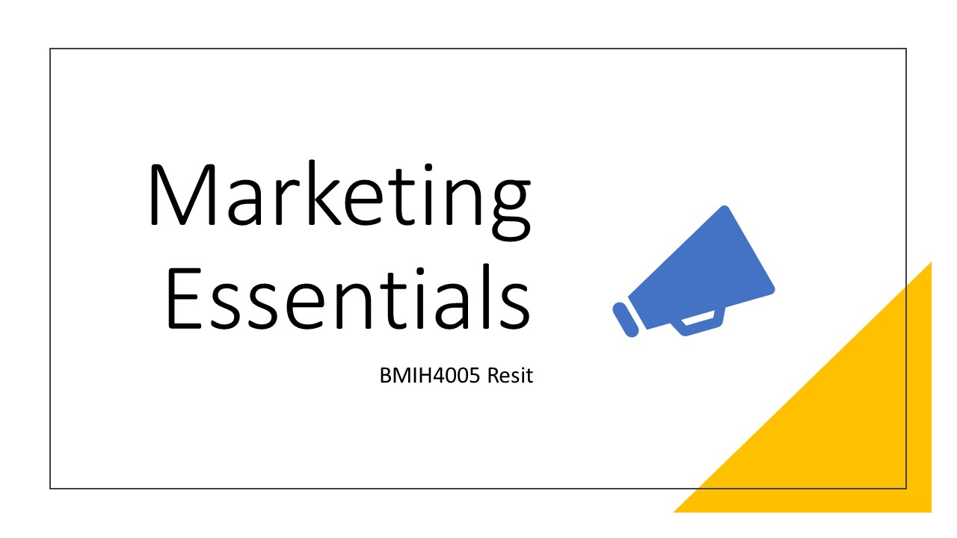
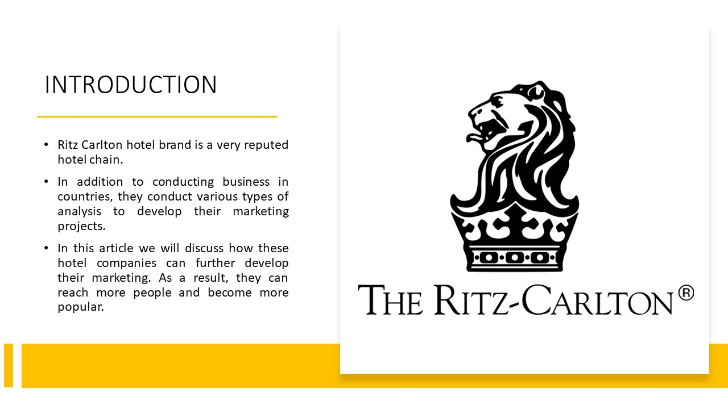
Ritz Carlton hotel brand is a very reputed hotel chain. They operate their business in different countries of the world. These countries arrange different types of marketing based on their own culture. In addition to conducting business in countries, they conduct various types of analysis to develop their marketing projects. In this article we will discuss how these hotel companies can further develop their marketing. As a result, they can reach more people and become more popular.
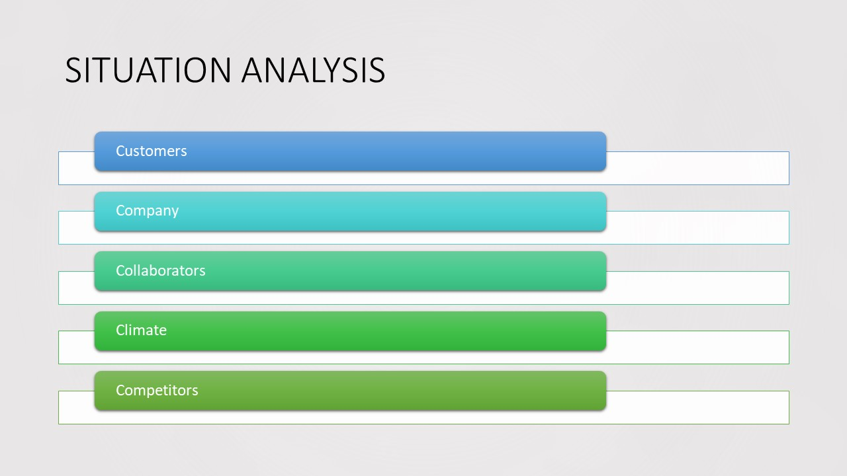
SITUATION ANALYSIS
Customers:
The organization can construct consumer profiles and conduct targeted marketing efforts by analyzing demographic, psychographic, and behavioral characteristics (Champagne, 2016). Potential clients include affluent vacationers, professionals, event organizers, and those just looking for a once-in-a-lifetime adventure. The organization can better cater to each demographic by catering to their specific wants, requirements, and desires via in-depth research.
Company:
The SWOT analysis will reveal the possibilities and dangers facing the Ritz-Carlton hotel chain, as well as its own internal strengths and weaknesses. This study will highlight the company's strong points, such as its well-known premium brand image, first-rate service, and loyal customer base. It will also attract attention to faults that must be addressed, such as potential operational inefficiencies or a lack of technology adoption. The company can capitalize on opportunities by finding them, such as emerging markets or new customer groups (Khazaeli, 2012). The company can lower risks by anticipating potential threats such as increased competition or economic downturns.
Collaborators:
To benefit on synergies and increase its market reach, the Ritz-Carlton must demonstrate understanding of B2B linkages, partnerships, and franchises. Collaboration with other high-end firms, such as airlines, tour operators, and event planners, can increase revenue and attract important clientele (Boucher, 2018).
Climate:
The PESTLE analysis of the macroenvironment will provide light on the relevant aspects impacting the Ritz-Carlton. With an awareness of these characteristics, The Ritz-Carlton will be able to modify its strategy and operations to the changing business climate.
Competitors:
The building of a perceptual positioning map and the usage of Bowmans' Strategy Clock will assist in assessing the competitive landscape and identifying opportunities for differentiation for the Ritz-Carlton. By mapping out its primary competitors based on characteristics such as price, luxury, and service quality, the business can discover its unique position and potential market gaps.
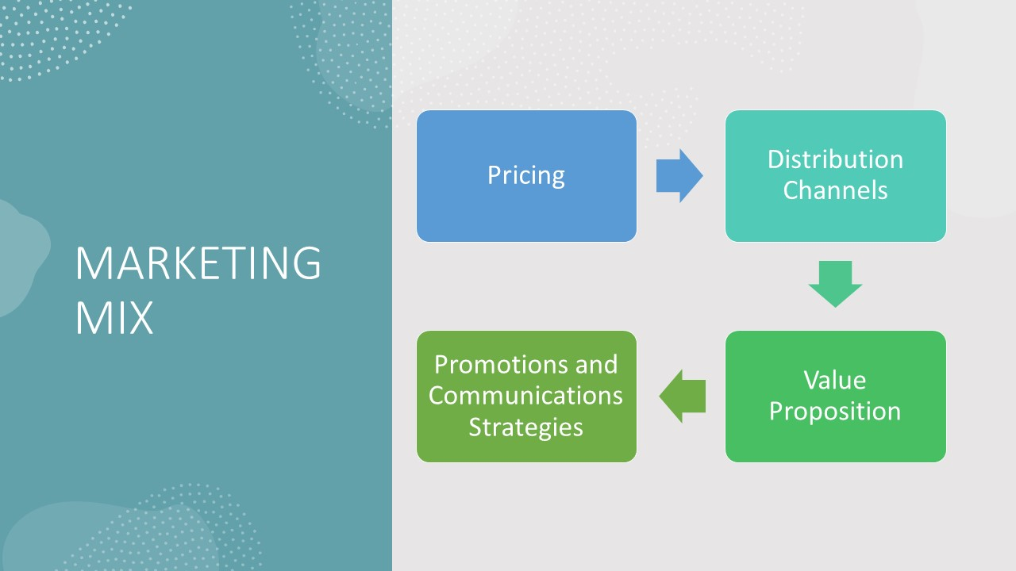
The current aspects of the Ritz-Carlton hotel chain's marketing mix are:
Pricing:
Since The Ritz-Carlton markets itself as a premium label, its products are more expensive than those of its competitors. The price strategy is based on the degree of facilities, extras, and specialized services provided to visitors.
Distribution Channels:
The Ritz-Carlton uses a multi-channel approach to distribution to reach its customers. It has a website where customers can make direct reservations. To further its online presence, it collaborates with global distribution systems and online travel agencies.
Value Proposition:
The Ritz-Carlton is known for its superior service and opulent amenities. Service excellence, specificity, and individualization are emphasized.
Promotions and Communications Strategies:
The Ritz-Carlton promotes its brand through both traditional and digital marketing methods. The hotel brand emphasizes its excellent service and unique guest experiences via tales and testimonials. Additionally, it connects with premium travel partners and offers incentive programs to promote customer retention and attract repeat business.
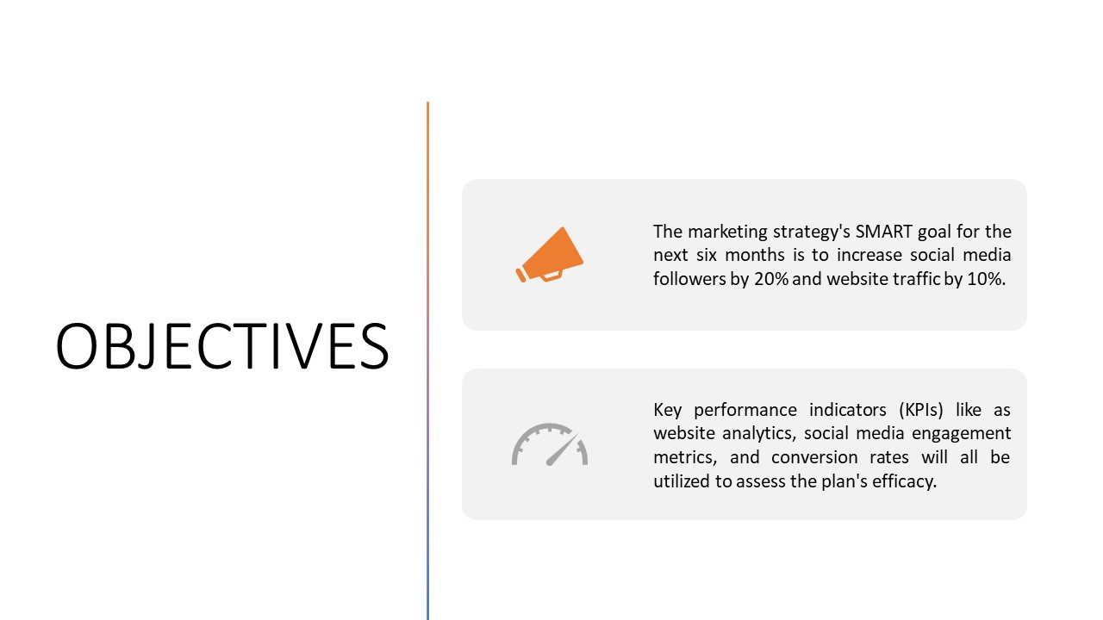
OBJECTIVES
The marketing strategy's SMART goal for the next six months is to increase social media followers by 20% and website traffic by 10%. Key performance indicators (KPIs) like website analytics, social media engagement metrics, and conversion rates will all be utilized to assess the plan's efficacy.
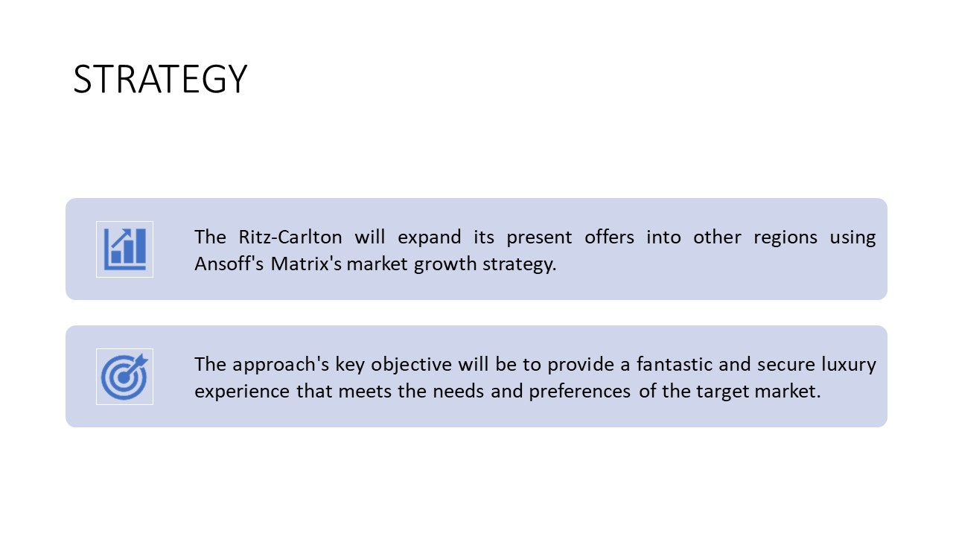
STRATEGY
The Ritz-Carlton will expand its present offers into other regions using Ansoff's Matrix's market growth strategy.
The Ritz-Carlton's new value proposition will emphasize the company's commitment to providing great and safe premium experiences. To reassure guests about their safety during their stay, tight hygiene requirements, contactless services, and better sanitary measures will be implemented.
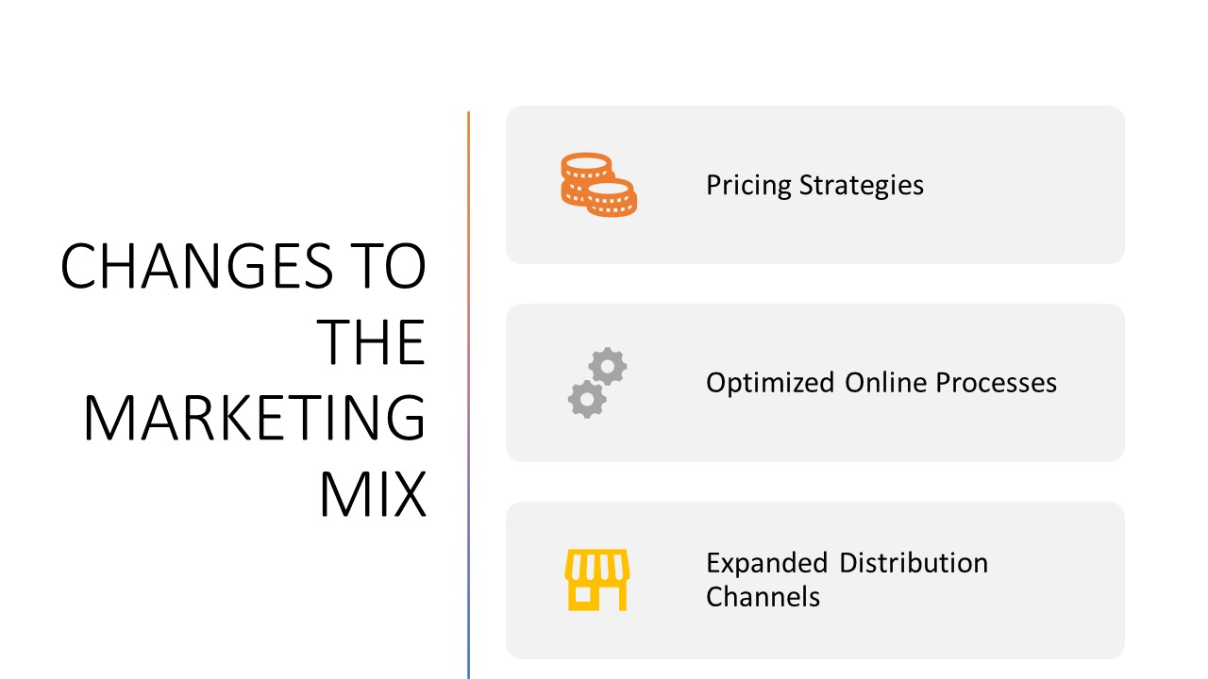
CHANGES TO THE MARKETING MIX
Pricing Strategies:
The pricing techniques will strive to deliver value while maintaining the feeling of elegance and exclusivity associated with the Ritz-Carlton brand.
Optimized Online Processes:
To attract and engage potential customers, the brand will employ technology to personalize online interactions, provide virtual tours, and showcase unique products.
Expanded Distribution Channels:
The firm will also leverage global distribution systems (GDS) and online travel agents (OTA) to expand its reach and attract customers from other nations.
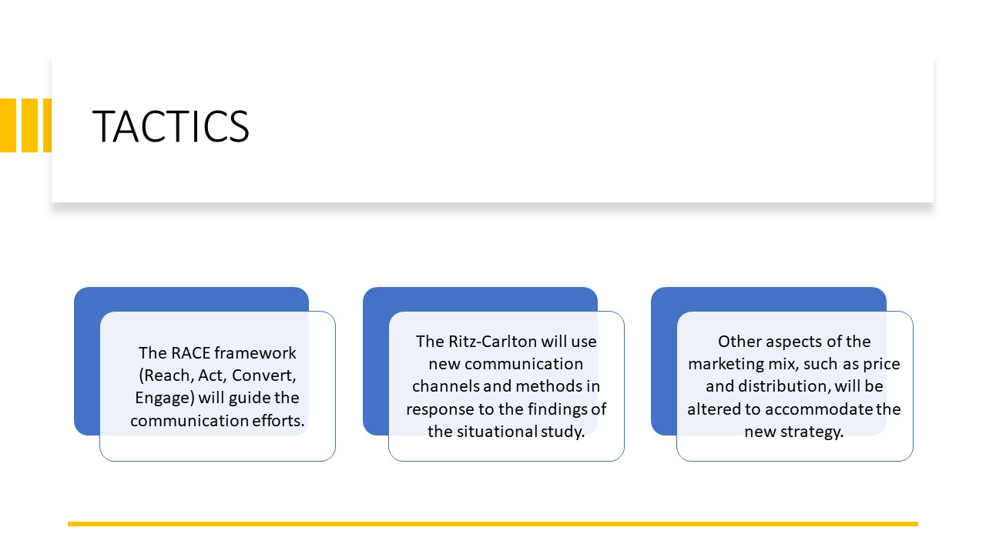
TACTICS
The RACE framework will guide communication efforts. The Ritz-Carlton will use new communication channels and methods in response to the findings of the situational study. This includes redesigning social media presence, improving website user experience, implementing targeted email marketing, and using influencer partnerships. Other aspects of the marketing mix, such as price and distribution, will be altered to accommodate the new strategy.
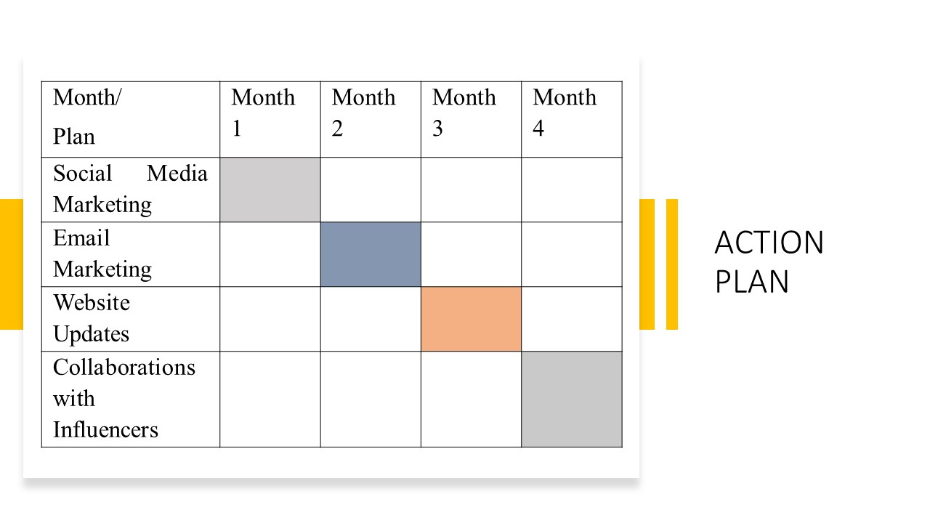
ACTION PLAN
A Gantt chart will be used to describe the timeframe for the Ritz-Carlton hotel brand's many marketing channels and initiatives. Some of the marketing initiatives are:
Email Marketing:
1. Make specialized email campaigns for different types of customers.
2. Send emails to customers with information and offers tailored to their interests and past purchases.
Social Media Marketing:
1. Create a plan for sharing interesting and relevant material on social media.
2. Keep an eye on metrics like social media reach, engagement, and follower growth.
Collaborations with Influencers:
1. Work together with key opinion formers to spread the word about their luxurious Ritz-Carlton stays.
2. Use key performance indicators like social media mentions, engagement, and website traffic to track the results of your interactions with influencers.
Website Updates:
1. Improving a website's usability, design, and navigation can all lead to a more satisfying experience for visitors.
2. Page views, bounce rates, and conversion rates are just a few of the metrics that should be tracked for a website.
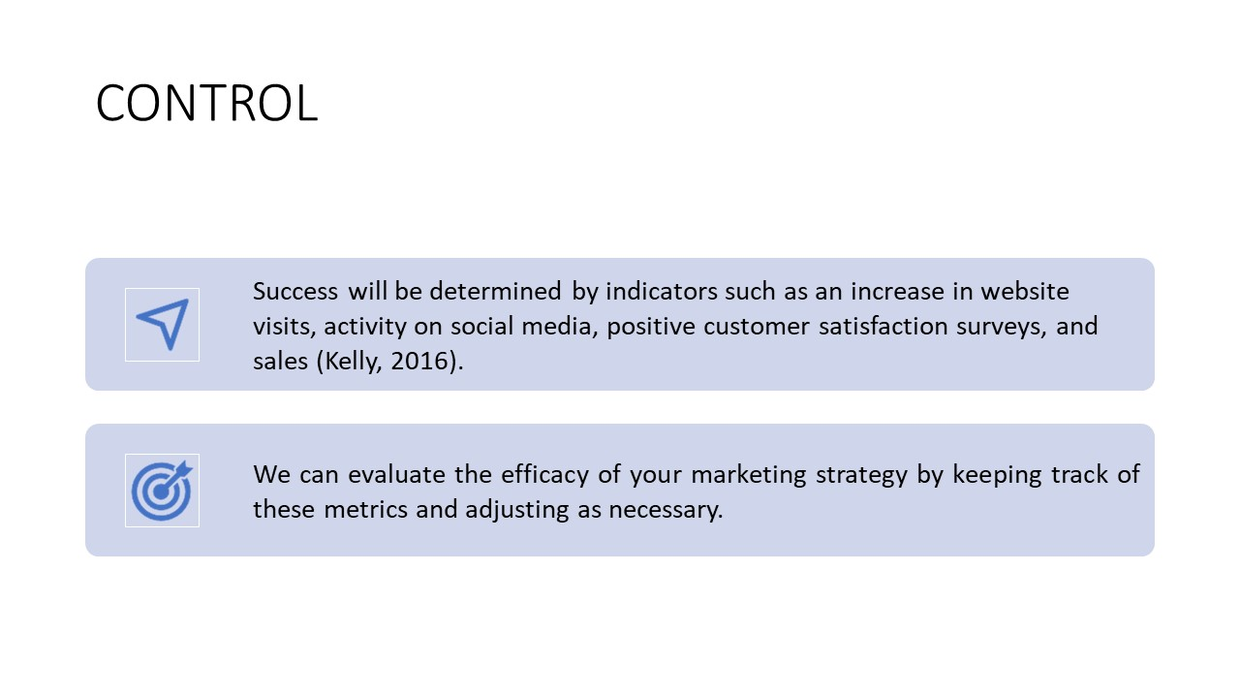
Success will be determined by indicators such as an increase in website visits, activity on social media, positive customer satisfaction surveys, and sales (Kelly, 2016). We can evaluate the efficacy of your marketing strategy by keeping track of these metrics and adjusting as necessary.
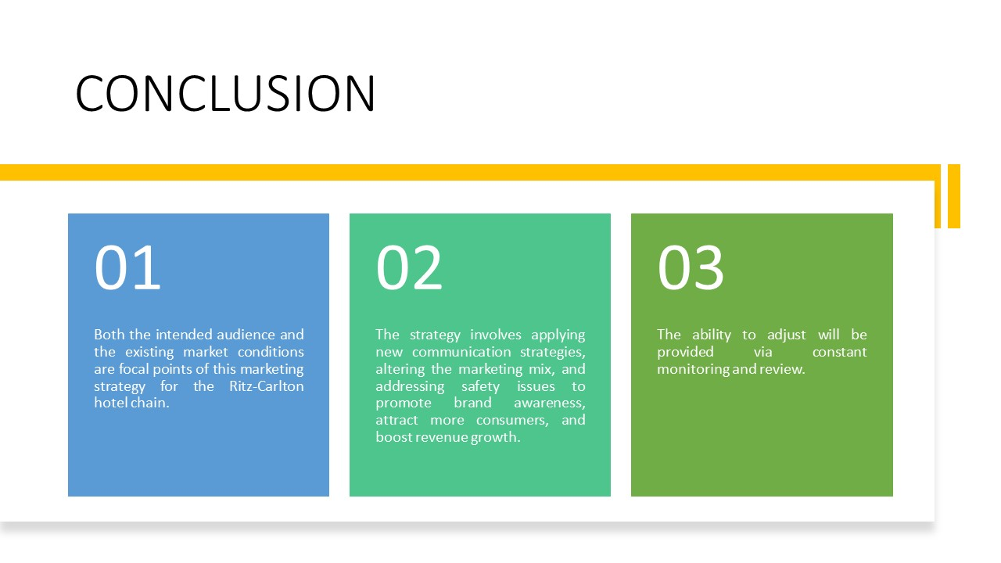
CONCLUSION
Both the intended audience and the existing market conditions are focal points of this marketing strategy for the Ritz-Carlton hotel chain. The ability to adjust will be provided via constant monitoring and review. The strategy involves applying new communication strategies, altering the marketing mix, and addressing safety issues to promote brand awareness, attract more consumers, and boost revenue growth. Other ideas include looking at individualized interactions, using advanced programs, and promoting customer loyalty through reward programs.


