Analysis of Results – 1000 words

Introduction
The aim in this section of work is so analyse the results of a survey that I created and sent out to members of staff and officers employed by Gwent Police along with some members of partner agencies. This survey was created on Microsoft Office and a link was created and sent out to members of the force via a link, this link was sent out via secure email directly to some members of the force and partner agencies and sent out also across a secure teams channel. The reason for creating the survey in this manner is due to the results are collected on a secure password protected account and will give me instant results. I also gathered information and data from a secure crime manage system which is used by Gwent Police called Qlikview. This system details crimes year on year and can be back dated and you can also apply filters to narrow down your search and incident you are looking to evidence.
The research was targeted to understand the powers that are currently in place for community support officers and training that are currently in place for Neighbourhood teams across the section of Gwent police, and how improvements can be made to assist with missing young people and prevent these individuals from becoming missing children. The research was also targeted to establish if Neighbourhood teams are confident in assisting with missing people and if they are confident in identifying and dealing with individuals who are exposed to or have characteristics of adverse childhood experiences. The research conducted by the detailing results from the system called Qlikview, is to show the demand on the force currently with missing people and the cost this is having on the force and the volume of calls that the force deal with, in relation to missing people in general across the whole force. The aims that were laid out in the form of a questionnaire were to show the knowledge and understanding from those officers and staff members that are currently on the ground and dealing first hand with missing people and how and why these children are going missing and the prevention techniques that are currently in place and if they are having the desired impact in protecting and preventing further episodes of missing events.
The results that were gathered from the questionnaire may pose a hinderance to the data that the dissertation was aiming to detail. This is due to the fact that the majority of the completed questionnaires were completed by officers and staff members that are currently employed by Gwent Police, this meaning that there is a lack of detail from other forces and how they manage missing people that are reported to them. The results will be isolated to Gwent Police and no other force across the South Wales are. The data gathered from the online tool within Gwent Police is solely detailing incidents for that force, there will be no data from other police forces software and data due to not having access to this data, the software that has been access is readily available to assist this dissertation due to being employed as a Gwent Police, police constable.

The results are displayed within the graphs below with a brief description of the concept of the question asked. I have selected 10 questions from the 19 question survey I sent out which highlight the most detail in relation to the topic within this project.

Q.1 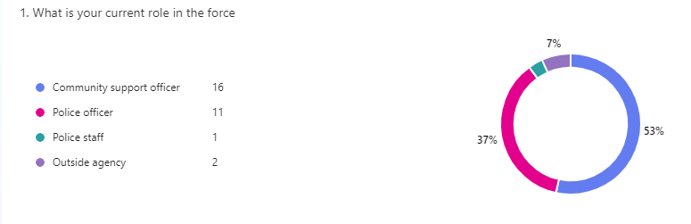
The results in the above graph, detail the responses from 30 individuals that are employed by the force and some that are external.

Q.2
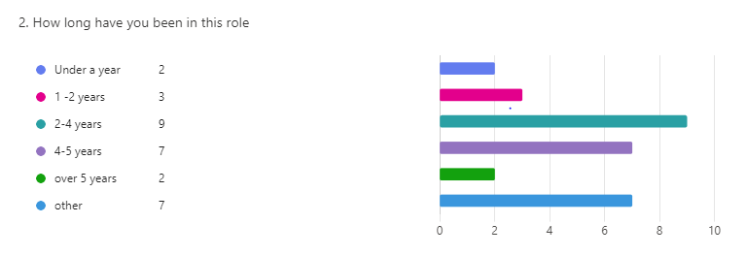
The above graph details how long each person has been employed by the force or in their current post. This details a variant of experience.

Q.3
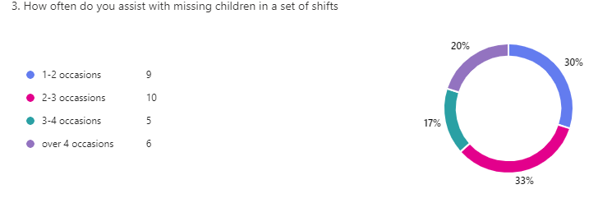
The above graph highlight show many times officers or staff assist with missing children within a set of six shifts. As you ca see between two and three occasions being the most with 33% but there is a result of 30% who deal with missing people between 1-2 occasions.

Q.8
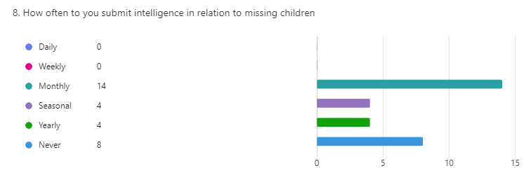
This graph details how often officers and staff are submitting information regarding missing children into the police systems for others to see. 14 people stated that they submit intelligence once a month. Its unknown what detail this information would entail.

Q.9
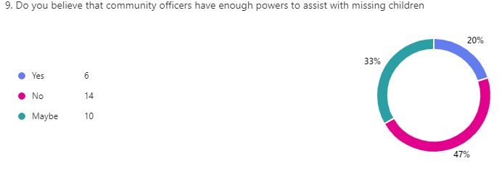
This question is of opinion and not fact but it shows that 47% of people who have completed the survey believe that community support officers do not have enough powers to assist with missing children.
Q.10
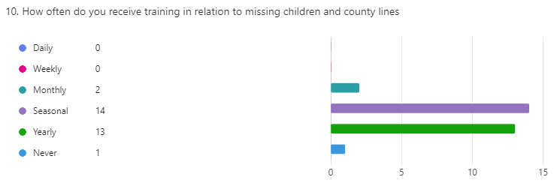
This question asked about training surrounding missing children and its highlighted that training is conducted every four months.

Q.12
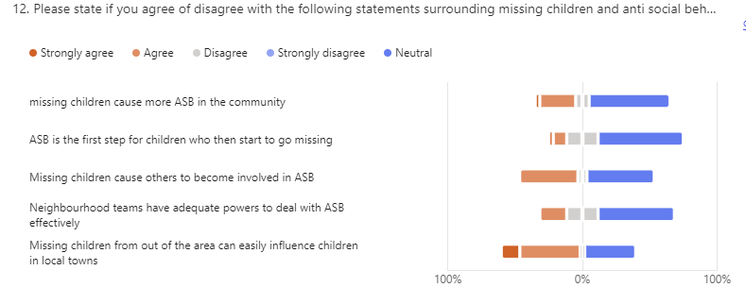
The first statement came back with 3.3% who strongly agree, 26.7% agree, 10% disagree, 60% Neutral.
The second statement came back with 3.3% who strongly agreed, 10% agree, 23.3% Disagree, 63.3% Neutral.
The third statement came back with 43.3% agree, 6.7% disagree, 50% neutral.
The fourth statement came back with 20% agree, 23.3% disagree, 56.7 neutral
The fifth statement came back with 13.8% strongly agree, 44.8% agree, 3.4% disagree , 37.9% neutral

Q.13
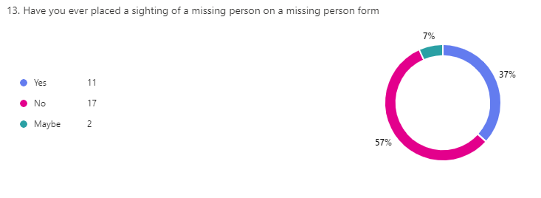
This question relates to information that can be placed on a missing persons form if an officer on foot patrols sees a missing person.

Q.16
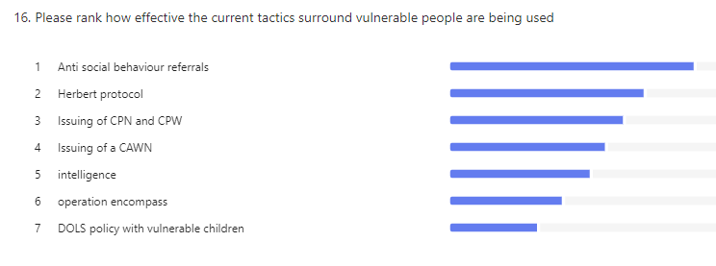

Q.18
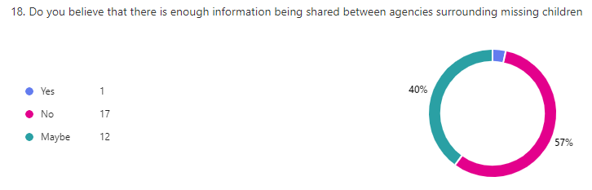

Below are some statistics gathered from the in-force crime data on a system called Qlikview. These graphs detail the missing person reports for the West of the force. Gwent police is split into two sections, the west and the East of the force. I have mainly focused on the West of the force as this is where the majority of police officers and staff are based who have responded to the surveys that have been sent out.
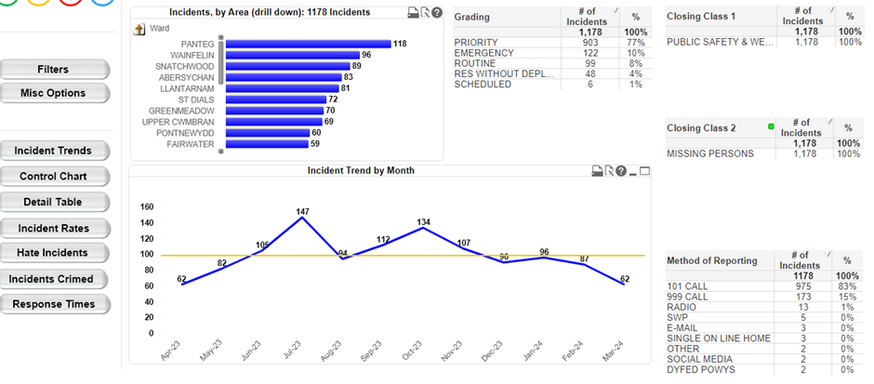
The above graph details the statistics for the last 12 months for the West of the force, in relation to reports that have been made to the police regarding missing people. From Aug 2024 to Aug 2024, there have been a total of 1,178 reports made. Its also details how the force have received these reports and the average being 100.

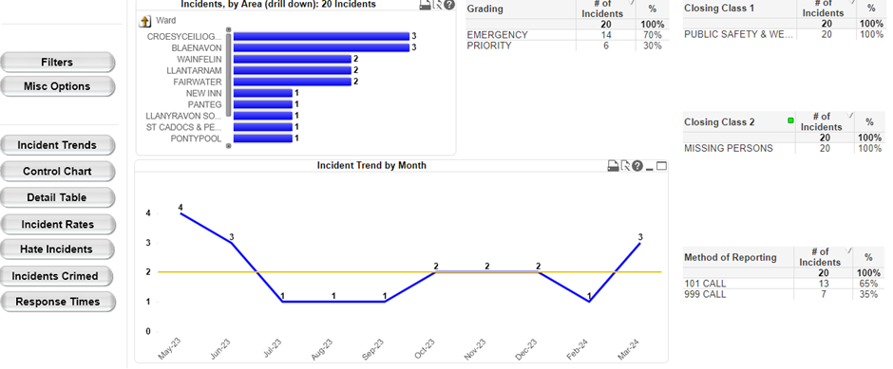
The above graph details how many incidents during the last year that the police helicopter has been deployed in the West of the force to assist with missing people. This highlights that this tactic was used a total of 20 times.

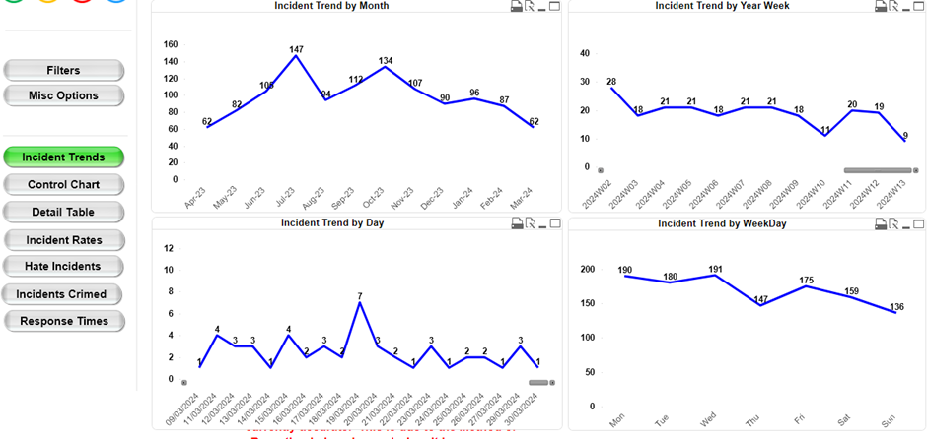
The above graph narrows down what times of the year the police receive the most reports for missing people and the dates and the days of the week when these calls are made and when the vulnerable people go missing.

Conclusion
Within the results there is a clear lack of information that could be vital with knowing where the missing children have been sighted. This is information that could be shared with all officers who are looking for them. This survey has also highlighted that lack of powers that community officers and neighbourhood teams have surrounding missing children. It also details that the information that all agencies have surrounding missing children and vulnerable people needs to be shared more often to prevent any further missing episodes.

