Developing Professional Practice
The Human Resource Professional Assignment 1
Lucy Crocker
1701540
M5X00869
15th of March 2019

Contents
Introduction: 2
What it means to be an HR Professional? 2
Activity 2: 3
Activity 3: 4
Activity 4: 6
References 9

Figure 1: McLagan’s Wheel (HRinIndia, 2010) 2
Figure 2: CIPD Profession Map 2018 (CIPD, 2019) 2
Figure 3 Core Elements of Profesionalism: (CIPD, 2017) 3
Figure 4: Tuckman's Theory Model (Business Balls , 2018) 3
Figure 5: The Eisenhower Matrix (Eisenhower, 2017) 5
Figure 6: The Cynefin Model (MindTools, 2019) 5

Introduction:
The aim of this assignment is to demonstrate a professional development assessment. The origins of the Human Resource profession can be located within the larger organisations that were in operation in the late nineteenth and early twentieth century. The terminology of human resource management was firstly introduced in the USA in the 1960’s, but by 1980 the term was being used widely all over the world (Taylor & Woodhams, 2016).
Human resource management has been defined by Torrington, (1931) as “the basis of all management activity, but it is not the basis of all business activity”. However, it has also been defined by Armstrong (2008), as a “strategic and coherent approach to the management of an organizations most valued assets – the people working there, who individually and collectively contribute to the achievement of its objectives”. Both of these definitions have been defined by credible sources and they are suitable for the purposes fof this assignment.
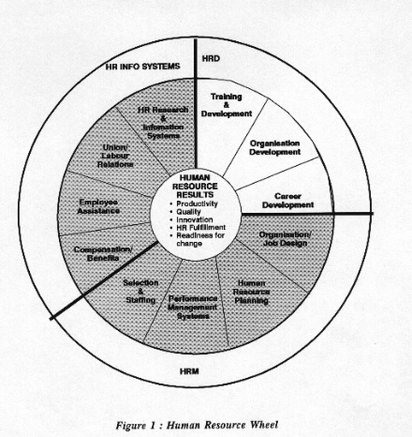
Human Resource managers have a variety of roles and functions to complete, for example, staffing, compensation and benefits, career development, motivation, training and development and maintenance within an organisation as demonstrated in figure 1.
Figure 1: McLagan’s Wheel (HRinIndia, 2010)

What it means to be an HR Professional?
Taylor & Woodhams (2016), have attempted to define a professional as “someone who carries out their job – whatever it is – to a high standard”. Another definition of a professional provided by Taylor & Woodhams (2016), has stated that a professional should be based upon the individuals professional qualifications, for example, a CIPD qualification. However, defining a professional is not a “straight forward question to answer” as a variety of people have different opinions on how a professional should be defined.
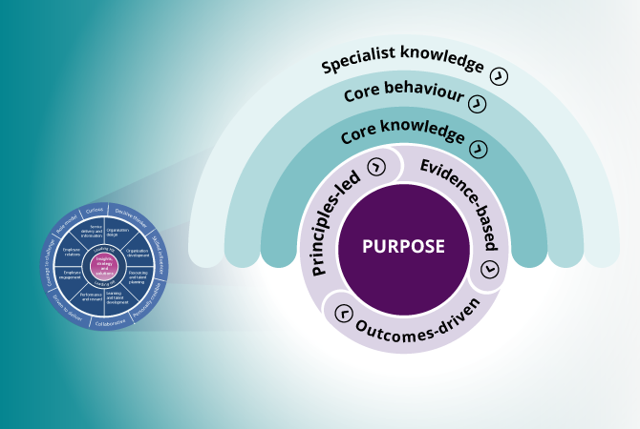
CIPD are a not for profit organisation who are incorporated under The Royal Charter, and are also the “only professional body in the world” that are able to “confer individual chartered status” in relation to Human Resources and Learning and Development professionals (CIPD , 2019). The CIPD have a specific framework which is known as the profession map, on setting professional standards which proves their commitment to providing the highest level of standard of practice to human resource professionals and learning and development (CIPD , 2019). The CIPD professional map is an extensive and a highly beneficial tool that has a use for a variety of purposes, which includes the competencies human resource professionals will need in the future, the competencies are organised into three detailed core elements known as specialist knowledge, core behaviour and core knowledge (See Evidence 1).The professional framework will “provide a greater clarity” for what can be expected for the chartered members in all aspects of being a professional, for example, behaviours, social responsibility, knowledge, skills and commitment to professional development (CIPD , 2019).
Figure 2: CIPD Profession Map 2018 (CIPD, 2019)
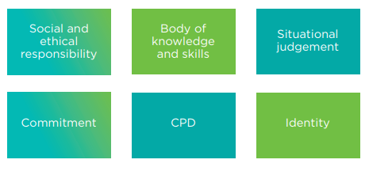
There are various core elements of professionalism, which include social and ethical responsibility, situational judgement, identity, CPD, commitment and body of knowledge and skills. These elements are crucial for an individual’s professional profile. The first core element of professionalism is social and ethical responsibility. Ethical values are an important element for an individual’s approach to professionalism as members can be trusted to apply their personal expertise. The second element of professionalism is Continuing Professional Development (CPD), which is the “intentional maintenance and development of knowledge and skills” that are needed to develop and perform within a professional context (The CPD Standards Office, 2019), professionals can develop their performance by developing their current skills to a higher level, or extend their skills variety to include newer skill sets which can allow a potential promotion or a job role expansion to an employee.
Figure 3 Core Elements of Profesionalism: (CIPD, 2017)
The third element of professionalism is body of knowledge and skills, this element has been based upon specialised education or training (Gilmore & Williams, 2007). The fourth element is situational judgement, which has been highlighted as an important skill to professional behaviour, as it means that a professional can apply their own practical insight to certain circumstances, for example, resolving conflicts of interest between numerous stakeholders (CIPD, 2015).
The fifth element is commitment. This element is important within the workplace as it can show a professional’s dedication to a certain organisation. The final element is identity, which is an important core element for a human resource professional, as a professional identity is a cognitive mechanism that can have an effect on employees’ attitudes and behaviour within their working environment (Ashforth, et al., 2008).

Activity 2:
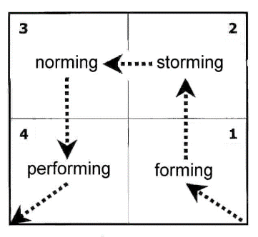
According to Mullins (2010), group dynamics “is the study of interactions and forces within small face-to-face groups” and is also ,”concerned with what happens when groups of people meet.” Groups are known as a social community, that consist of two people or more who have similar interests, in comparison to a team who’s commonality is specifically a shared goal (Team Technology, 2013). There are a variety of strategies available to develop a highly productive group, an example of this is through the use of Tuckman’s team development model. This model consists of 4 elements known as, forming, storming, norming and performing .
Figure 4: Tuckman's Theory Model (Business Balls , 2018)

Conflict has been defined as a “incompatibility of goals arising from opposing behaviours at the individual, group or organisational level (Mullins & Christy, 2016)”. Conflicts are a common occurrence within the workplace, a survey conducted by CIPD (2015) has concluded that in the last year nearly four in ten UK employees had reported some form of interpersonal conflict within the workplace.
There are numerous reasons for why conflict can happen within an organisation, these examples include, differences in perception, the nature of work activities, environmental and limited resources. In order to manage conflict, there are a variety of strategies that can be of use for an organisation, for example, adjusting HR policies and procedures, acknowledge the situation and introducing the development of interpersonal/group process skills (Mullins & Christy, 2016). The use of HR policies and procedures can be a solution to managing conflict , as the introduction of equitable HR policies which can include systems of reward and punishment for employees, but also training negotiation skills to managers, can reduce conflict within the workplace (Mullins & Christy, 2016). Acknowledging the situation can be effective when managing and resolving conflict within an organisation, as many viewpoints can be considered and a compromise can be reached by communicating and considering the viewpoints of those involved (Mullins & Christy, 2016). The development of interpersonal and group processing skills can reduce conflict as it can assist professionals understanding of another’s behaviour, point of view, problem solving and communication processes, this can also include focusing on an individuals body language which can motivate and assist others to resolve any conflict on a one to one basis (Mullins & Christy, 2016).
Leadership conflict is an example of current conflict within the workplace. In numerous organisations leadership conflict can occur regularly, one of the reasons being under the influence of more than one leader which can cause an employee to follow numerous different leadership styles which in turn cause confusion (YFS Magazine, 2014).

Activity 3:

Project management is a crucial skill for Human Resource professionals, as professionals will be able to develop their effectiveness within their position through the practice of time management and project management. The project management skills are important for human resource professionals, as practice of efficient project and time management is crucial for human resource professionals. The activities involved for efficient project and time management include classifying and ordering priorities, the prevention and control of stress and the elements of project planning, scheduling, milestone monitoring and control.
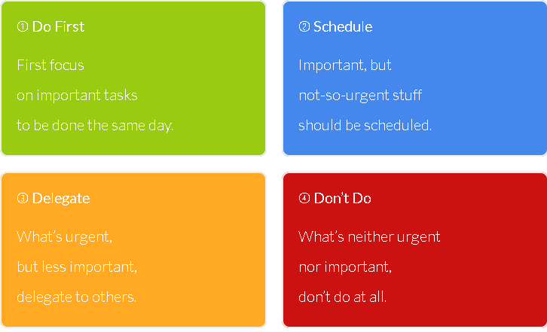
There are various factors that a human resource professional should consider when making the decision on which tasks must be prioritised, for example, the level of importance that the task itself has, what would the consequences be if the task was not completed or completion had been delayed, and what impact would the task at hand have on an organisation’s aims and objectives. The Eisenhower matrix is a useful model for prioritising tasks, as the model consists of four sections known as do first, schedule, delegate and don’t do, where an individual can prioritise their tasks based on the level of urgency and importance within the four categories (Eisenhower, 2017).
Figure 5: The Eisenhower Matrix (Eisenhower, 2017)
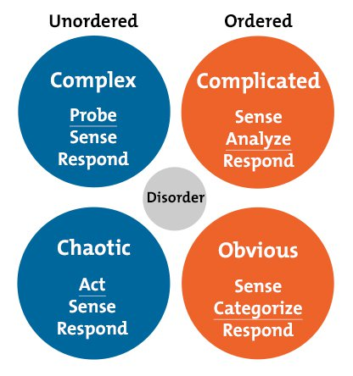
The Cynefin Model is known as a sense- making model that is divided into four sections which are known as, complex, complicated, chaotic and simple (Cognitive Edge, 2010). The Cynefin framework is used within a variety of situations in order to categorise a specific decision or a problem and to be able to respond accordingly. An example of this model put into action, was the task that was based on Lupo World – Space Adventure, where the group were given three cards which were labelled “soap world”, “fitness obsessed penguins” and “cute” and the team later was given the task to create a world that revolved around the topics on the cards within a certain time period, and the team had to design modern life for humans in this world. The activity was complicated in the sense that the group had received three cards in total, with the first card at the start of the activity and the remaining cards given at random intervals during the task, but also as we had to analyse what topics were given and we had to make numerous decisions on what items were related to the topics on the cards.
Figure 6: The Cynefin Model (MindTools, 2019)
A recent group project that we had encountered was to work in collaboration with a not for profit organisation called Down To Earth, on a project in relation to the use of electric cars on their site. Due to unforeseen circumstances the project objective had changed to raising awareness of their current projects, where they developed sustainable structures sponsored by a variety of causes including the post code lottery. The task that the group were originally presented with was to research the possibilities of introducing electronic vehicles into the organisation, the task was later changed to raise awareness on Down to Earth’s current projects (see evidence 2). The change in task was due to misunderstanding and miscommunication between the group and the organisation involved. A variety of project management techniques were used to ensure the task was completed to the highest standard possible, for example, setting SMART objectives (Decision Skills , 2014) .This technique was used in regard to the group developing a series of blog posts based upon sustainable living. The objective was reached by the group, as a deadline for the completion of the blog was given and the group had taken the date into consideration, and in turn planned the order of the blog posts around the deadline (See evidence 3) . Another technique that was used within our project was monitoring, the group had used this problem-solving technique in order to keep track on who had certain tasks that needed to be completed. During the course of the project, there were numerous occasions in which we had to negotiate with certain members of the team, whether it was due to lack of progress or lack of effort with participating in the task that was set. The group had encountered issues with a certain member in particular but had negotiated with him and the compromise of a different task was reached whilst another member of the group had taken over the task with which our team member had experienced difficulty initially.
If the group had the opportunity to do the project again, we would apply the design thinking process (See Evidence 4). The design thinking process is made up of five stages. The first stage of the process is empathise, where the group would gain an understanding of the problem that needed to be solved. Our group had originally gained an understanding of the task that was set, which was to research ways for Down To Earth to hire out electric vehicles, but we later negotiated a different task to raise awareness on their current projects and collaboration. The group had consulted with the manager of Down To Earth in order to visit the site, but in the future the group could have discussed the outcomes of the project in greater detail. The second stage of the process is to define the problem. This stage would be beneficial for the group if the task could be redone, as we would adapt our approach to the situation a lot differently, if we had a clearer understanding of the type of person we were working in collaboration with. The third stage of this process is ideate, where a team would have started to generate ideas on how to solve the task at hand. In relation to our group project, the team had identified that the main problem within the task was that a news article had already been published on the task that was assigned, after identifying this as a potential problem the group had later decided to pursue raising awareness for the organisation as an alternative task. If the group had the opportunity to change the outcome of the project, the team would have explored and identified new solutions to the problem and increase brainstorming activity to find an acceptable solution. The fourth stage in the design thinking process is prototype, which is the experimental phrase of the process, where the team would identify the most appropriate solution for the problems that had been identified in the first stages. In relation to our group project, in the future we would consider better management of the solution building process, where if the group had broken the task down into smaller pieces, it may have introduced the group to a wider range of solutions. The fifth and final element in the design thinking process is test, where the final tests are conducted on the final product. In relation to the groups project, the result of our task was presented at the showcase which was organised by our University, where our group had presented a range of photographs taken at Down To Earth’s site and any newspaper articles that were related to both current and previous projects.

Activity 4:
After evaluating the CIPD professional map I have identified that situational decision making is a personal weakness (see evidence 5) . Situational decision making consists of making effective and pragmatic decisions or choices based on a certain situation, it also involves the process of identifying different options along with any benefits and risks that can be associated with them, but also their alignment for professional values and principles (CIPD, 2019) .Any decisions made based upon the situation will need to be flexible in order for it to be adapted to new changes and circumstances, it should also be considered how present decisions will impact in future practice.
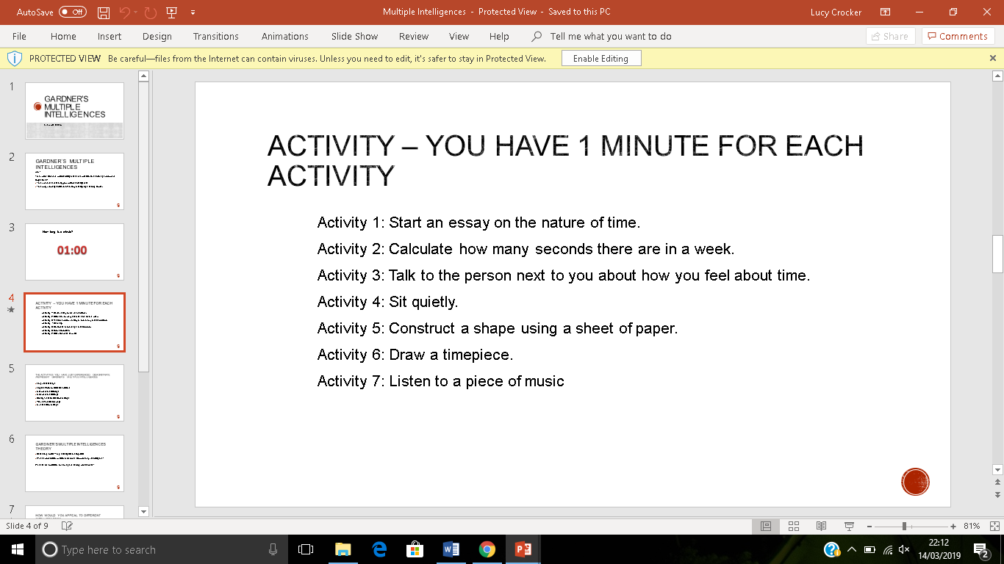
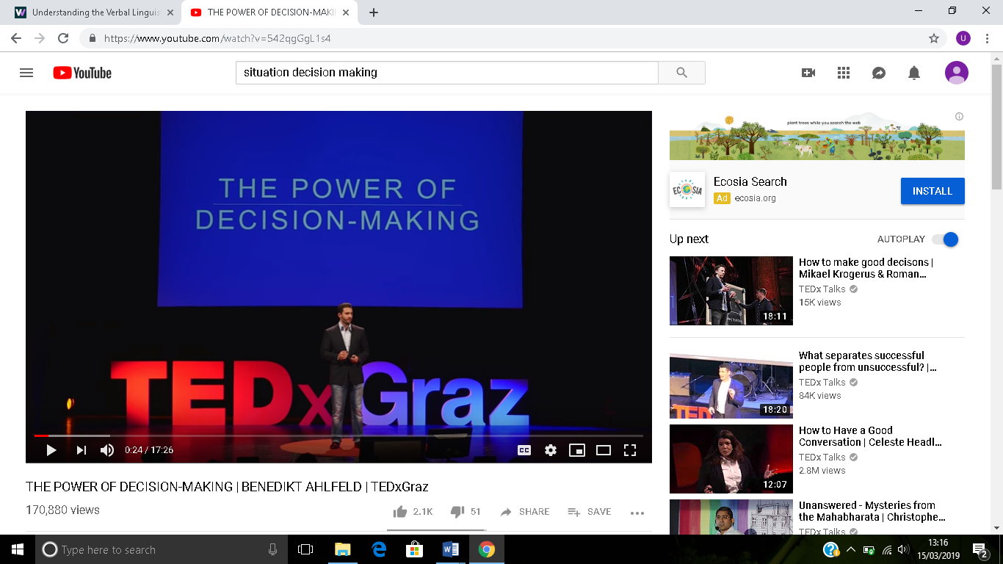
Developing confidence as a situational decision maker would personally make me better within the human resource profession, as it will allow me to be able to assess the situations more thoroughly and to take the situation into consideration whilst making a final decision. In order for myself to determine my specific intelligence, I had to complete a specific task which was made up of six individual activities in order to determine my preferred intelligence. In relation to participating with the activity, it was revealed that my preferential intelligence was linguistic. The linguistic intelligence approach consists of the ability to understand both written and spoken language and an individual can achieve their goals by the use of language both in a verbal and written sense. I am going to learn more using the linguistic approach by learning how to cope with making decisions based in situations that can be considered challenging, I plan to learn this by watching videos such as the TED Talk on the power of decision making, and develop my decision making by using revision techniques such as revision cards.

Personal Development Plan:
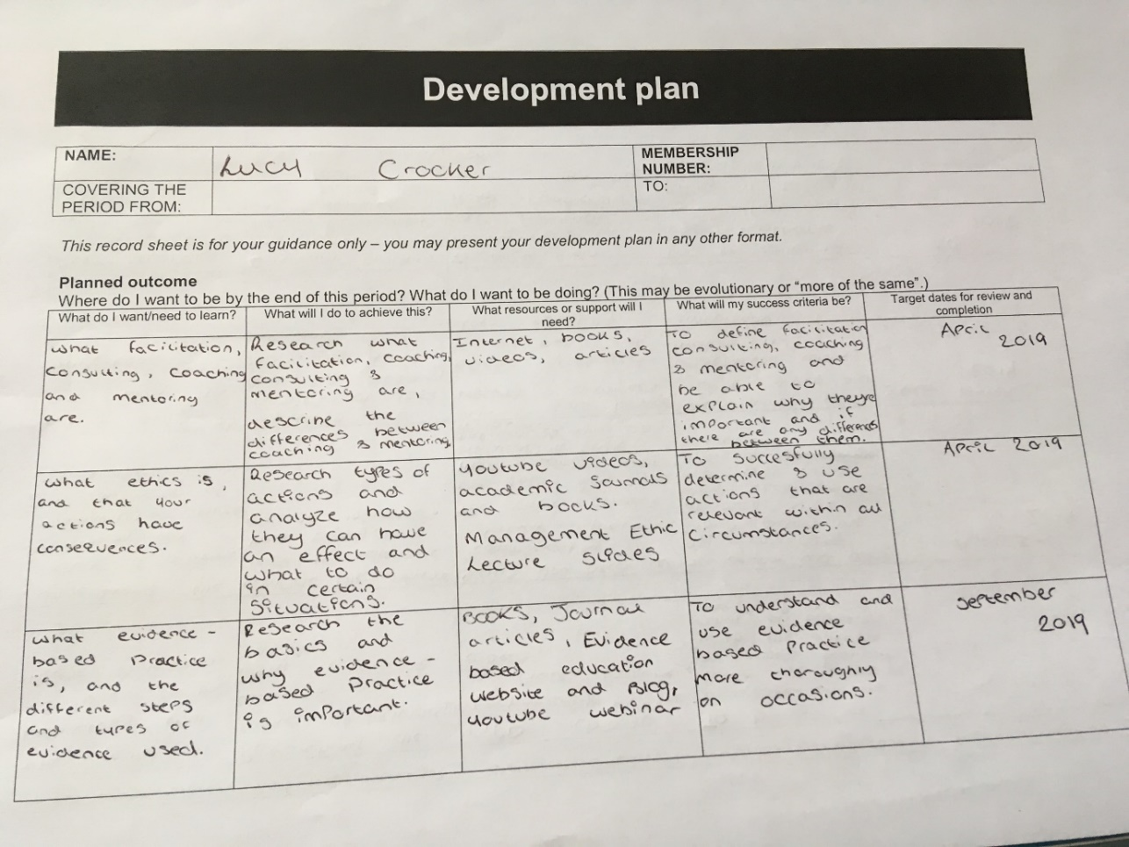
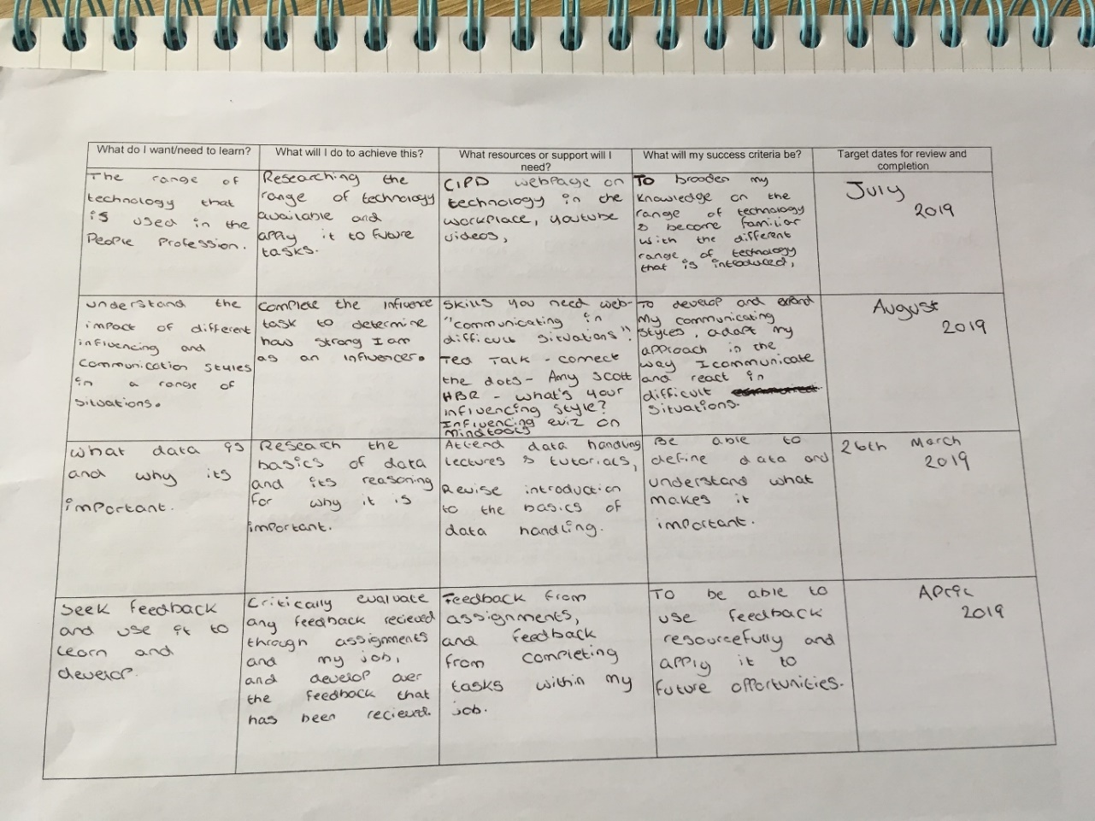
The personal development plan is a crucial tool in ensuring that development progress is made and ensuring that all goals and deadlines are met. There are numerous topics that I want to learn and develop on, for example, to learn what evidence based practice is and what types of styles and types of evidence there are, I plan to develop this by researching the basics of evidence based practice and why is important through the use of YouTube webinars, the evidence based education website and through books and journal articles.

References
Armstrong , M., 2008. Strategic Human Resource Management. 4th ed. London: Kogan Page .
Ashforth, B. E., Harrison, S. H. & Corley, K. G., 2008. Identification in organizations: An examination of four fundamental questions. Journal Of Management, 34(3), pp. 149-174.
Business Balls , 2018. Tuckman: Forming, Storming, Norming, Performing Model. [Online]
Available at: https://www.businessballs.com/team-management/tuckman-forming-storming-norming-performing-model/
[Accessed 13 03 2019].
CIPD , 2015. Getting Under The Skin Of Workplace Conflict: Tracing The Experiences Of Employees, London: CIPD.
CIPD , 2019. https://www.cipd.co.uk/about/what-we-do/professional-standards. [Online]
Available at: https://www.cipd.co.uk/about/what-we-do/professional-standards
[Accessed 21 02 2019].
CIPD , 2019. Our Royal Charter. [Online]
Available at: https://www.cipd.co.uk/about/who-we-are/royal-charter
[Accessed 06 02 2019].
CIPD, 2015. The CIPD Profession Map - Our Professional Standards, London: CIPD.
CIPD, 2017. Research Report, London: CIPD.
CIPD, 2019. Profession for the Future. [Online]
Available at: https://peopleprofession.cipd.org/
[Accessed 03 03 2019].
Cognitive Edge, 2010. Cynefin Framework Introduction. [Online]
Available at: https://cognitive-edge.com/videos/cynefin-framework-introduction/
[Accessed 13 03 2019].
Decision Skills , 2014. SMART Goals - Quick Overview. [Online]
Available at: https://www.youtube.com/watch?v=1-SvuFIQjK8
[Accessed 13 03 2019].
Eisenhower, 2017. Introducing the Eisenhower Matrix. [Online]
Available at: https://www.eisenhower.me/eisenhower-matrix/
[Accessed 13 03 2019].
Gilmore, S. & Williams, S., 2007. Conceptualising the "personnel professional". A critical analysis of the Chartered Institute of Personnel and Development's professional qualification scheme", , 36(3), pp. 398 - 414.
HRinIndia, 2010. McLaglan's HR Wheel. [Online]
Available at: http://hrinindia.blogspot.com/2010/12/hr-wheel.html
[Accessed 13 03 2019].
MindTools, 2019. The Cynefin Framework. [Online]
Available at: https://www.mindtools.com/pages/article/cynefin-framework.htm
[Accessed 10 03 2019].
Mullins, L. J., 2010. Management and Organisational behaviour. 9th ed. Harlow: Pearson Education Limited.
Mullins, L. J. & Christy, G., 2016. Management & Organisational Behaviour. 11th ed. Harlow: Pearson.
Taylor, S. & Woodhams, C., 2016. Studying Human Resource Management. 2nd ed. London: Chartered Institute of Personnel and Development.
Team Technology, 2013. The Difference Between Team And Group Dynamics. [Online]
Available at: https://www.teamtechnology.co.uk/team/dynamics/vs-group-dynamics/
[Accessed 09 03 2019].
The CPD Standards Office, 2019. What is CPD?. [Online]
Available at: https://www.cpdstandards.com/what-is-cpd/
[Accessed 22 02 2019].
Torrington, D., 1931. Human Resource Management. 10th ed. Harlow: Pearson.
YFS Magazine, 2014. 5 Workplace Conflicts Every Small Business Will Encounter. [Online]
Available at: https://yfsmagazine.com/2014/02/06/5-common-workplace-conflicts-every-small-business-will-encounter/
[Accessed 13 03 2019].

