

Certificate of Higher Education in
Employability Skills
LEVEL 4
Digital Skills for Personal Development and Business Growth (BMSW4008_CARD)
Lecturer: Philippa Fitzgerald
Student: Sulafa Yousif
S/No: 2233898
Task: 1-4
Date: 27/03/2025



Table of content
Task 2 Website & Marketing Materials
Task 3 Microsoft Excel
Task 1 Questionnaire Design

References
Task 4 Story telling

Task1: Questionnaire Analysis

Canvas & Cords has done an exceptional job in designing a comprehensive market research questionnaire to gather insights from potential visitors. The thoughtful inclusion of diverse questions reveals a deep commitment to understanding the preferences and expectations of the target audience. Here is an extended analysis based on the feedback:
Note: due to the lack of response in the appropriate time, I have chosen
The following 5 questionnaires to base my findings on.

1. Age Category: The segmentation by age groups is a smart approach, as it allows Canvas & Cords to tailor their offerings to the preferences and interests of different demographics. By understanding the age distribution of potential visitors, the art gallery and jazz café can create experiences that resonate with each age category.

2. Frequency of Art Gallery Visits: By inquiring about the frequency of art gallery visits, Canvas & Cords aims to gauge the level of interest in cultural activities among respondents. This will help in planning the scheduling of art exhibitions and jazz performances to attract regular visitors and potentially increase foot traffic.

3. Interest in Live Jazz Performances: The question about interest in attending live jazz performances is crucial for determining the demand for this offering. Positive responses can guide Canvas & Cords in curating engaging jazz sessions that appeal to the preferences of their target audience.

4. Inclination Towards Art Displays and Jazz Music: The rating scale question on the inclination to visit spaces with art displays and live jazz music provides quantitative data on the appeal of such a combined concept. Higher ratings indicate a strong preference for the unique blend of visual arts and live music, which can be leveraged in marketing strategies.

5. Factors Influencing Café Visits: Understanding the critical factors influencing café selection reveals valuable insights into customer decision-making processes. By prioritizing factors such as quality of food and beverage, service quality, and ambience, Canvas & Cords can focus on delivering a holistic and satisfying customer experience.



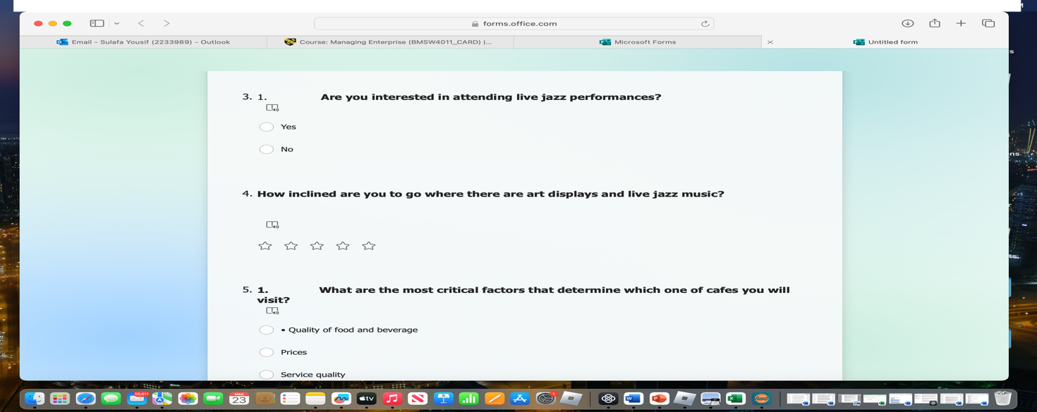
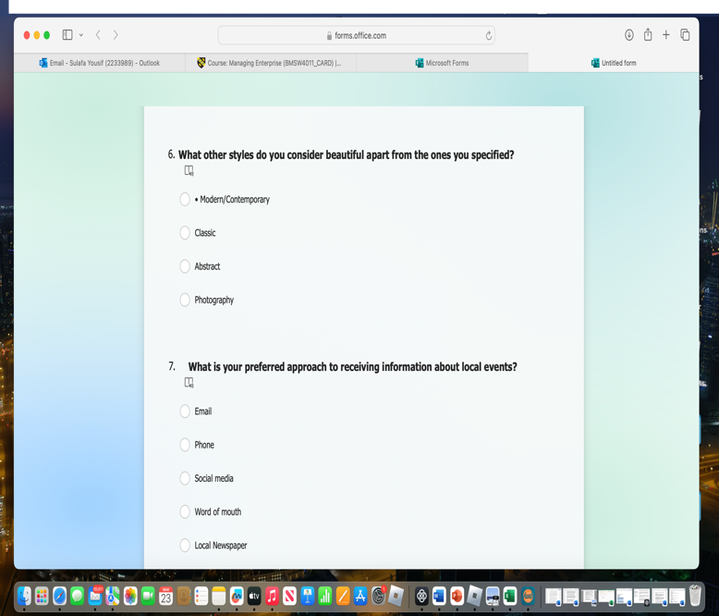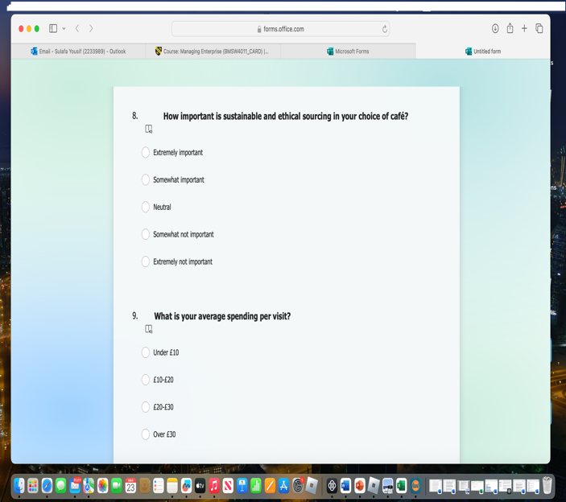
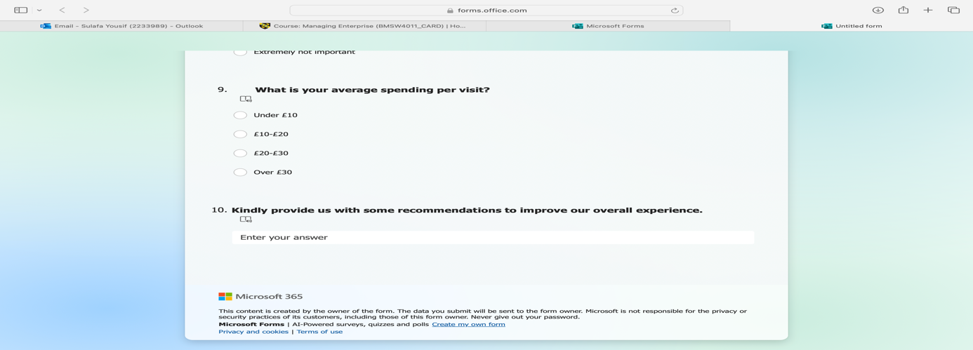

In conclusion, Canvas & Cords has crafted a well-rounded market research questionnaire that delves deep into the preferences, expectations, and behaviours of potential visitors, also serves as a roadmap for elevating the customer experience, fostering community engagement, and solidifying the art gallery and jazz café's position as a distinctive cultural destination that resonates with its audience.

The detailed questionnaire also delves into respondents' preferences for art styles, preferred communication channels for local events, views on sustainable sourcing, average spending habits, and recommendations for improvement. Each question is strategically formulated to provide an understanding of visitor preferences, expectations, and values, allowing Canvas & Cords to tailor its offerings and experiences to meet and exceed customer expectations.

The holistic approach taken in crafting the questionnaire reflects Canvas & Cords' commitment to creating a culturally stimulating and customer-centric destination in Cardiff. By soliciting feedback on a wide range of topics related to art, music, café services, and overall customer experience, Canvas & Cords shows a dedication to continuous improvement and meeting the evolving needs of its audience.

The data gathered from this comprehensive survey has the potential to inform strategic decision-making, marketing campaigns, event planning, menu development, and customer service enhancements at Canvas & Cords. By listening attentively to the feedback provided by respondents and implementing suggested improvements, Canvas & Cords can further establish itself as a vibrant and engaging hub for art and music.

Task2: The design of the website

Canvas & Cords" is a one-of-a-kind fusion of artistry and rhythm that transcends the boundaries of traditional galleries and cafes. Picture these vibrant canvases adorning the walls, each telling a unique story, setting the stage for eclectic live jazz performances that ignite the soul.

In the dynamic landscape of modern business, the success of a new venture heavily depends on understanding and engaging with its target audience effectively. Canvas & Cords, a vibrant fusion of an art gallery and jazz cafe, stands at the intersection of cultural immersion and artistic expression. To propel this unique establishment into the spotlight, a comprehensive analysis of customer data is essential for shaping its online presence, marketing initiatives, and audience engagement strategies. By harnessing insights gleaned from a detailed questionnaire, for Canvas & Cords I tailored the website, marketing materials, segmentation approaches, and SEO optimization tactics to resonate with the diverse clientele. This paper delves into how I leveraged questionnaire data to craft a compelling narrative, engage the audience thoughtfully, and boost the online visibility through strategic digital marketing practices for Canvas & Cords.

Website and Marketing Material Development:
- I’ve Design a visually appealing website that integrates elements of art styles and jazz music, such as vibrant colours, artistic layouts, and music-themed graphics, based on the feedback from the questionnaire. This will create an engaging online presence for Canvas & Cords that resonates with the tastes of the target audience.
- Incorporating the customer testimonials and reviews from the survey responses into the marketing materials to build trust and credibility among potential visitors to the art gallery/jazz cafe. Highlighting positive experiences shared by past customers can attract new patrons to the establishment.
- Emphasizing the unique value propositions identified in the questionnaire, such as the cozy ambiance of the cafe, exclusive art collections, or special jazz events, and unique food and beverages offering in the website content and marketing materials. This will differentiate Canvas & Cords from competitors and attract customers seeking these specific offerings.

Segmentation and Targeting:
Identify distinct customer segments within the audience based on the demographic and psychographic data collected through the questionnaire, such as age groups, art preferences, and spending habits. Develop personalized marketing strategies for each segment to enhance engagement and conversion rates.
- Tailor promotional offers, events, and communications to appeal to the specific interests and needs of each segment identified in the survey results. For example, create targeted promotions for art enthusiasts, jazz music lovers, or residents interested in cultural experiences to drive traffic to the website and encourage visits to the physical location.
- Utilize customer communication channel preferences obtained from the survey to deliver targeted messages via preferred channels, such as email newsletters, social media platforms, or direct mail. This approach ensures that marketing efforts are optimized for reaching and engaging each segment effectively.

SEO Optimization:
- Optimize website content for search engines by integrating relevant keywords and phrases identified in the questionnaire responses related to art styles, jazz music, cafe services, and cultural events. Incorporate these keywords strategically in page titles, descriptions, headings, and image alt texts to improve organic search visibility.
- Develop high-quality, informative content based on the insights from the questionnaire, such as blog posts, articles, or event descriptions, that incorporate targeted keywords and provide value to visitors. Engaging content not only enhances the user experience but also boosts SEO performance by attracting organic traffic.
- Monitor website analytics and keyword performance regularly to track the impact of SEO efforts and make data-driven adjustments based on user behaviour and search trends identified in the survey data. This iterative approach ensures that the website's SEO strategies remain effective and aligned with evolving customer preferences.

These detailed points showcase how Canvas & Cords can leverage insights from the questionnaire to enhance its website, marketing materials, audience segmentation, targeting strategies, and SEO optimization efforts effectively.
In conclusion, the integration of customer insights derived from the questionnaire into the various facets of Canvas & Cords' operations has the power to elevate the establishment's brand presence and customer engagement significantly. By translating feedback into visually captivating website designs, personalized marketing strategies, targeted audience segmentation, and SEO-optimized content, Canvas & Cords can forge stronger connections with its audience and stand out in a competitive market. As Canvas & Cords continues to evolve and innovate, the ongoing utilization of customer data and iterative refinements based on survey responses will be pivotal in sustaining its success and fostering a loyal community of art and jazz enthusiasts. Through a customer-centric approach guided by data-driven decision-making, Canvas & Cords can continue to captivate its audience, foster meaningful connections, and solidify its position as a cultural hub where artistry and music converge harmoniously.

“Canvas & Cords” Website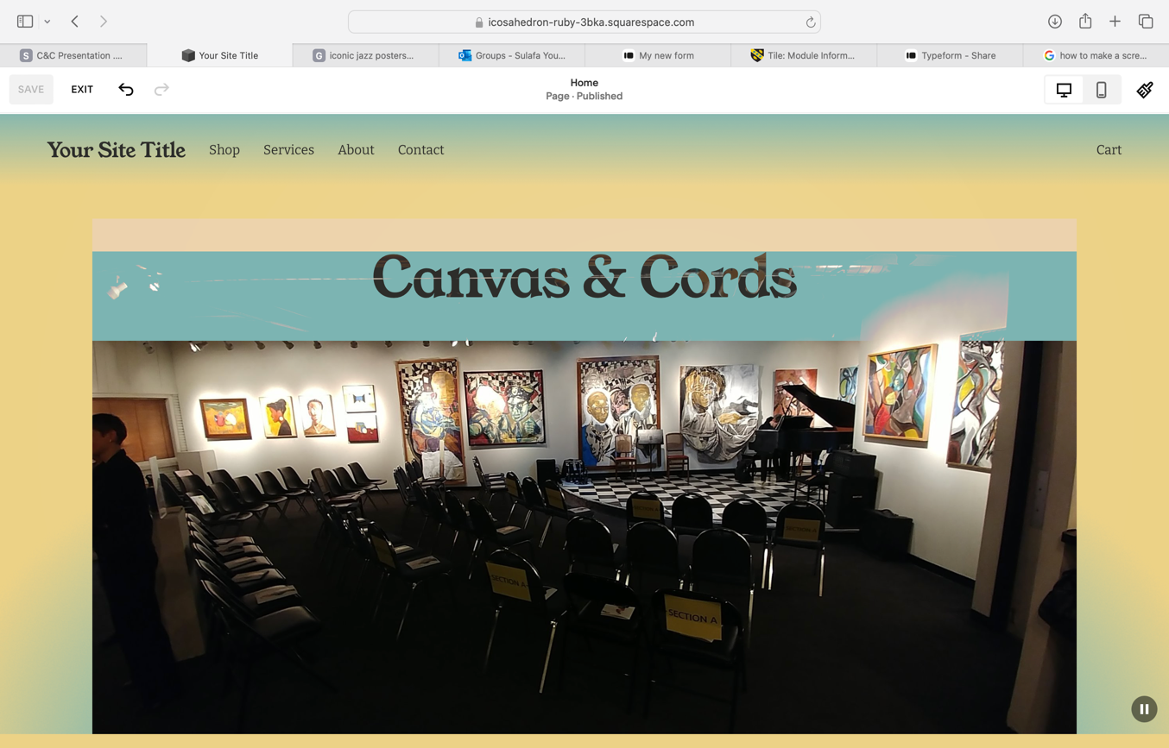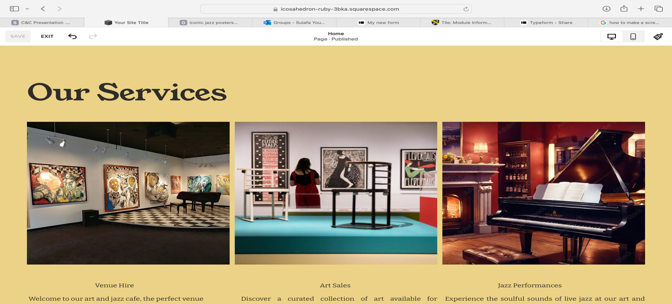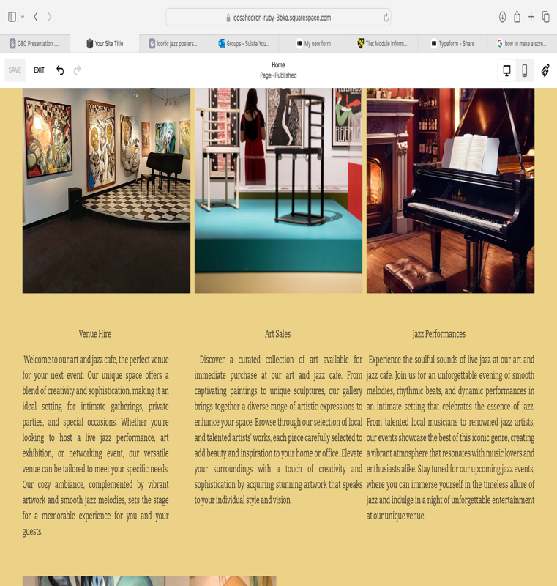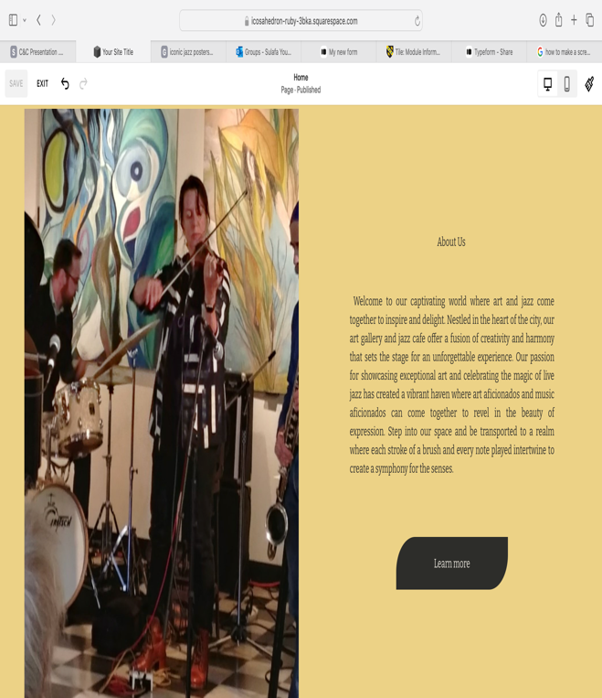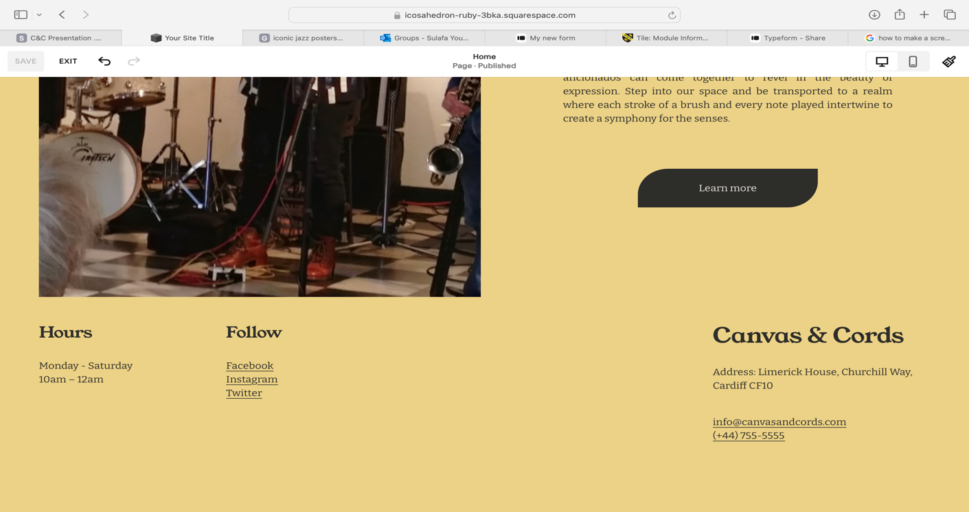
Company logo and branding materials.
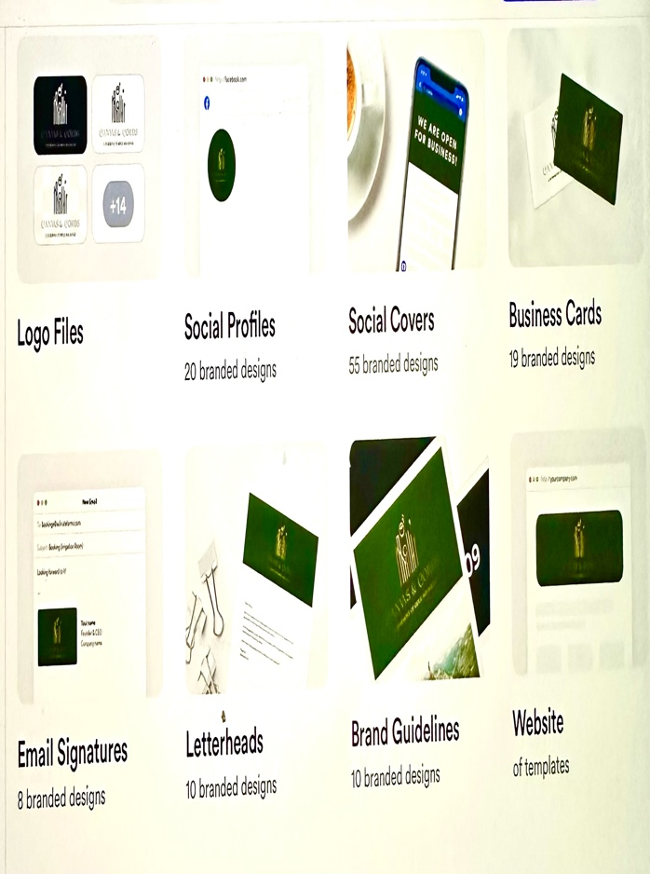
Promotional Materials:
Note: I’ve used my own art portfolio as a promotional poster for featured artist.


Events promotional Videos:


Note: The video below is from a paint session called “Paint The Town” I have hosted in Dubai in 2020.

Task3 (1-2)

1-Microsoft Excel Spreadsheet

2- The Importance Of Excel In The Digital Era

With the speed, in today’s rapid digital world when it comes to business, Microsoft Excel is one of the most powerful tools one can have. It started as a basic spreadsheet application but transformed into a full-fledged platform for creating, visualizing, and communicating data and building financial models. And for Canvas & Cords, a creative art gallery and jazz café, Excel isn’t just a digital tool, but a part of daily operations for this small business. Anyone can operate a business with limited resources, but the most important thing is the ability to handle data effectively. For small businesses, Excel allows them to track their income and expenses, predict their profits, and make business decisions based on the current, dynamic data insights. With digitalization redefining how companies go about their activities, Excel is becoming even more important when it comes to managing small enterprises.

Excel plays a fundamental role in business because it provides a structure for a company’s financial management. The multiple revenue streams that keep small businesses alive like Canvas & Cords art sales from local artists, cafe sales, and the income from jazz performances hosted by the eatery have collapsed (Caves, 2000). Tracking these different sources of income can be a hassle to do manually and is prone to error (McFedries, 2013). This is made easier to do by Excel, as it provides customizable spreadsheets in which businesses can group income and expenses on a monthly or yearly basis (Larson, 1997). It can be used to automatically calculate total income, total expenses and profit or loss with basic formulas such as sum or average.
Additionally, Excel is able to provide flexibility in financial planning and budgeting and scenario analysis. Since Canvas & Cords is a business that might have seasonality in income, diner sales peak in the summer, art sales peak for the holidays, Excel can forecast the cash flows and plan the budget (Azman et al., 2021). Being agile and responsive to market changes undoubtedly takes top priority for small businesses, which makes this a proactive approach.
Along with financial calculations, Excel provides tools that present business performance in a more compelling manner such as graphs and charts (Gulati, 2010). Bar charts and pie charts can be used by Canvas & Cords to compare monthly income and expenses to visually determine which months were profitable and find where expenses are on the rise (Caves, 2000). Not only are these visual representations useful for internal decision making, but also it makes sense to share the financial reports with investors, business partners, and financial advisors easily (Larson, 1997). Excel helps people without a finance background to understand complex data and make informed decisions, through making complicated things simple by converting data into readable visuals.
It contributes to keeping track of data accuracy and reducing human errors. Miscalculations, misplaced decimal points, and forgotten expenses occur due to manual record keeping (McFedries, 2013). This is minimized by Excel as it automates the calculations and provides error checking features (Baker et al., 2009). It prevents using unreliable finances, Excel also support inventory management, staff scheduling and event planning (Gulati, 2010). This means that financial data for critical business decisions (Jannach et al., 2014). And, for a small business like Canvas & Cords, with such tight margins, even one small financial misstep can be catastrophic (Azman et al., 2021). Fortunately, Excel has built in features like conditional formatting, data validation and automatic formula updates to protect against these errors, and thus, is an indispensable tool for the small business owner.
Apart from the Canvas & Cords can keep records on sold art pieces, levels of café stock, or the number of tickets sold for jazz events in the same software (Berinato, 2019). Centralization of data leads to a more efficient way of doing business and business owners get the big picture without needing to juggle multiple tools or software subscriptions (Jannach et al., 2014). The cost saving ability to handle different business operations in the one place is exactly what is required by startups and small enterprises.

In conclusion, Microsoft Excel is a must have digital tools for small businesses in the current world. As such, it can help businesses like Canvas & Cords manage data, automate calculations, manage financials, visualize performance, and support planning. Excel improves efficiency, decreases the chances of errors and offers insight into valuable information that helps in making decisions. Digital tools are becoming more essential to conducting business. Successful use of Excel is essential not only for survival, but also for growth. It democratizes access to Excel’s full potential, allowing small businesses to streamline operations, ensuring good financial health, and creating an environment for sustainable growth in a competitive digital marketplace.

Task 4 – Story Telling

https://youtu.be/sDm3Y-XSL98

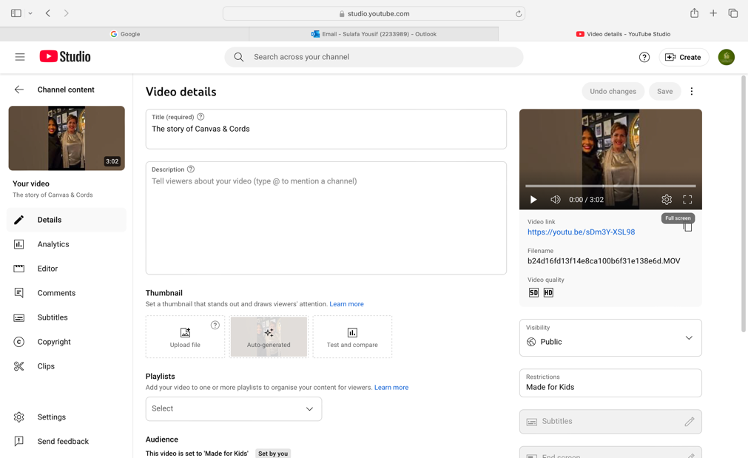

References
- Belzunegui-Eraso, A., & Erro-Garcés, A. (2020). Ethical aspects in market research: The case of online surveys. Journal of Business Research, 116, 19-22. https://doi.org/10.1016/j.jbusres.2020.07.037

- Hair, J. F., Celsi, M. W., Ortinau, D. J., & Bush, R. P. (2016). Essentials of marketing research. McGraw-Hill Education.

- Babin, B., & Zikmund, W. (2015). Essentials of marketing research. Cengage Learning.

- Churchill, G. A., & Iacobucci, D. (2018). Marketing research: Methodological foundations (11th ed.). Cengage Learning.

- Aaker, D. A., & Day, G. S. (2014). Marketing research. John Wiley & Sons.

- Groves, R. M., Fowler, F. J., Couper, M. P., Lepkowski, J. M., Singer, E., & Tourangeau, R. (2009). Survey methodology. John Wiley & Sons.

- Malhotra, N. K. (2017). Basic marketing research. Pearson.

- Kotler, P., & Armstrong, G. (2017). Principles of Marketing. Pearson.

- McCarthy, J., & Perreault, W. D. (2018). Basic Marketing: A Marketing Strategy Planning Approach. McGraw-Hill Education.

- Kotler, P., Keller, K. L., Brady, M., Goodman, M., & Hansen, T. (2016). Marketing Management. Pearson.

- Chaffey, D., Smith, P. R., & Ellis-Chadwick, F. (2019). Digital Marketing Excellence: Planning, Optimizing and Integrating Online Marketing. Routledge.

- Evans, D., & McKee, J. (2010). Social Media Marketing: The Next Generation of Business Engagement. Wiley.

- Smith, P. R., & Zook, Z. (2011). Marketing Communications: Integrating Offline and Online with Social Media. Kogan Page Publishers.

- Kotler, P., & Keller, K. L. (2015). Marketing Management (15th ed.). Pearson Education.

- Azman, N. A., Mohamed, A., & Jamil, A. M. (2021). Artificial intelligence in automated bookkeeping: a value-added function for small and medium enterprises. JOIV: International Journal on Informatics Visualization, 5(3), 224-230.

- Baker, J., Jones, D., & Burkman, J. (2009). Using visual representations of data to enhance sensemaking in data exploration tasks. Journal of the Association for Information Systems, 10(7), 2.
- Berinato, S. (2019). Good charts workbook: Tips, tools, and exercises for making better data visualizations. Harvard Business Press.

- Caves, R. E. (2000). Creative industries: Contracts between art and commerce (No. 20). Harvard university press.

- Gulati, R. (2010). Reorganize for resilience: Putting customers at the center of your business. Harvard Business Press.

- Jannach, D., Schmitz, T., Hofer, B., & Wotawa, F. (2014). Avoiding, finding and fixing spreadsheet errors–A survey of automated approaches for spreadsheet QA. Journal of Systems and Software, 94, 129-150.

- Larson, G. O. (1997). American canvas: An arts legacy for our communities.
- McFedries, P. (2013). Excel 2013 Formulas and Functions. Que Publishing

- Dalrymple, J., & Davies, H. (2018). The Art of Business Storytelling: Harnessing the Power of Words. Harvard Business Review. Retrieved from https://hbr.org/2018/04/the-art-of-business-storytelling-harnessing-the-power-of-words

- Brown, J., & Miller, J. (2017). Bringing Your Brand Story to Life Through Video Marketing. Harvard Business Review. Retrieved from https://hbr.org/2017/11/bringing-your-brand-story-to-life-through-video-marketing

- Watkins, K., & Charity, S. (2019). The Impact of Visual Storytelling on Consumer Engagement. Harvard Business Review. Retrieved from https://hbr.org/2019/06/the-impact-of-visual-storytelling-on-consumer-engagement

