Qualification: CIPD Diploma in Applied Human Resources

Module Name: Developing Professional Practice

Word Count Assignment 2: 952
Word Count Assignment 4: 939

Student Name: Jade Bowen
Student Number: 2014437
CIPD Membership Number: 57385937

By signing below, I confirm that the work/evidence presented is my own, unaided work. I understand the regulations pertaining to candidate malpractice and the action that may be taken as a result.

Signed: J.Bowen
Date: 03/01/2021
Activity 2

How does the CIPD HRPM areas and bands define the HR profession and why the HRPM behaviours are essential to being an effective HR professional

Intro
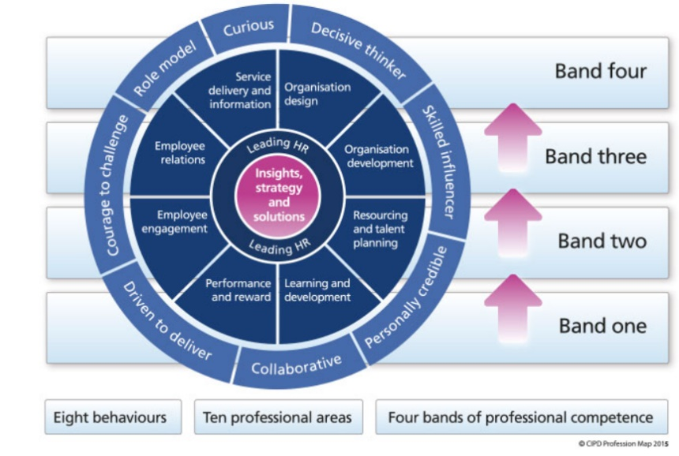
The CIPD Profession Map 2013 is a competency framework detailing the knowledge and behaviours needed to be an effective HR Professional. The Profession Map (below) consists of ten areas, eight behaviours and four bands; all of which together define the HR Profession.

The context of the map focuses on having a good understanding of business priorities to enhance sustainable performance, and the contribution needed from all HR Professionals (CIPD, 2013).
HR Professionals use specialist knowledge and skills to analyse and evaluate, in accordance with a code of conduct set by a governing body, i.e. CIPD (Lester, 2010). A HR Professional is someone who makes valuable and strategic contributions to an organisation (Farndale, 2005, cited in CIPD, 2020, People Profession Survey).
This report details how the areas and bands within the Profession Map define the HR Profession, and why the behaviours are essential to being an effective HR Professional.

For the purposes of this report, I will be referencing the 2013 Profession Map, as opposed to the new 2018 map.

Main: Areas and Bands
The CIPD 2013 Profession Map (PM) defines the HR Profession (HRP) through 10 key areas that all HR Professionals should practice, regardless of their role or level of responsibility.

The Profession Map emphasises on being a HR Leader by role modelling ‘what good looks like’ through own effort and developing and supporting others to add value and drive the business’ performance (CIPD, 2013).

Each area of the CIPD (2013) Profession Map is appropriate to all HR Professionals, but the importance of that area will vary dependent of the role. For example, Resource and Talent Planning will be more suited to someone who is responsible for ensuring there is adequate resourcing and continuous talent development, as oppose to someone who focuses on ensuring there are sufficient recognition and reward schemes available through Performance and Reward. This shows how diverse the HR role can be and the importance of being adaptable to change.

Accompanying each of the 10 areas within the CIPD (2013) Profession Map are 4 ‘bands of competence’. These bands define the level of input and responsibility for each activity such as ‘Organisational Development’ or ‘Employee Relations’. The level of detail provided varies depending on whether they are at the start of their HR career (Band 1) or within the most senior HR position (Band 4).

However, what remains a key focus throughout the Profession Map is having a deep understanding of the business strategies and being able to work with various stakeholders, regardless of level (CIPD, 2013).

The Profession Map also highlights what knowledge and skills are needed to progress to the next level. Madden and Mitchell (1993) states Continual Professional Development (CPD) is a lifelong journey and is key to being an effective HR Professional. Focusing on building skills, keeping knowledge up-to-date and developing behaviours, enhances personal capability as well as benefitting organisational performance. Keeping up to date with the forever-changing needs of the external world, for example, Employment Law changes, is crucial to support the business to help implement, lead and in-bed change. (CIPD, 2015)

Eight behaviours
The CIPD, 2013 Profession Map also includes 8 behaviours that distinguish how HR Professionals (HRP) should conduct themselves, in order to add value and enhance business success.

CIPD, (2012) research shows that having the courage to challenge, expressing curiosity, and gaining a deep understanding of the business to drive performance is key to being a successful ‘business savvy’ HRP.

Skilfully influencing, along with having the courage to challenge can only be effective once a genuine relationship has been made. Understanding concerns and worries of peers enables successful communication to influence effectively, achieving better results. (CIPD, 2018)

CIPD (2013) implies having the courage to challenge is important to being an effective HR Professional as it shows strength and confidence. Remaining calm, using evidence-based knowledge, and carefully selecting battles gives a bigger impact and generates valuable debates. An effective HRP will speak up when it is the right thing to do for customers, colleagues, and the business.

Identifying issues, analysing information, and making ethical decisions is key to being a decisive thinker. When done right adds great value to the business and enhances performance. Understanding business priorities is key to effective decision-making; an effective HR focuses on fixing the cause of the problem and develops structured solutions. (CIPD, 2020a)

Effective HR Professionals are curious to improve ways of working and are focussed on key priorities. They inspire and collaborate with others in and outside of the business to find ‘best practice’ and make ethical decisions (CIPD, 2013). Although, according to 2018 People Profession Survey, 28% of HR Professionals felt pressured from the business which hindered them from making ethical decisions. (CIPD, 2020b)

Collaborating with others in and outside of the business, identifying and supporting talent development, and inspiring others to deliver the business strategy enhances contributions and excels business performance. (CIPD 2013)

Underpinning the HR Profession is the CIPD Code of Conduct (CIPD, 2020d); a set of ethical principles detailing the importance of confidentiality, integrity, equality, and diversity, and CPD, demonstrating ethical practice and making ethical decisions (CIPD, 2020c). The Code of Conduct is essential in protecting the integrity of the profession, failure to do so shows lack of professionalism (CIPD, 2012).

Conclusion
In conclusion, the Professional Map provides a guiding framework of behaviours, skills and knowledge that enable the HR Professional to provide ethical, expert, and dedicated support that adds value to the business. Each area and band facilitate directed learning that supports continuous development, to ensure the effectiveness of HR Professionals.

References/ Bibliography

CIPD, (2012) Business savvy: giving HR the edge. Available at: https://www.cipd.co.uk/Images/business-savvy_2012-giving-hr-the-edge-sop_tcm18-8844.pdf (Accessed: 22/11/2020)

CIPD, (2013) CIPD HR 2013 Profession Map. Available at: https://www.cipd.co.uk/cipd-hr-profession/cipd-hr-profession-map/default.html (Accessed on: 6/11/2020)

CIPD, (2015a) CPD for HR Podcast. Available at: https://www.cipd.co.uk/podcasts/cpd-for-hr (Accessed on: 13/11/2020)

CIPD, (2018) Core behaviours: Professional courage and influence. Available at: https://peopleprofession.cipd.org/profession-map/core-behaviours/professional-courage-influence (Accessed: 20/11/2020)

CIPD, (2020a) People Profession Survey 2020. Available at: https://www.cipd.co.uk/Images/people-profession-uk-ireland-2020-report-1_tcm18-78597.pdf (Accessed on: 20/11/2020)

CIPD, (2020b) Coronavirus and the workforce: doing the right thing in a crisis. Available at:
https://www.cipd.co.uk/news-views/changing-work-views/future-work/thought-pieces/coronavirus-workforce-crisis (Accessed on: 18/11/2020)

CIPD, (2020c) Ethical practice and the role of HR. Available at: https://www.cipd.co.uk/knowledge/culture/ethics/role-hr-factsheet (Accessed on: 12/11/2020)

CIPD, (2020d) CIPD Code of Professional Conduct. Available at: https://www.cipd.co.uk/Images/code-of-professional-conduct-april-2020_tcm18-14510.pdf (Accessed on: 30/11/2020)

Activity 4

The concept of team dynamics and how political behaviour can impact the achievement of organisational objectives
Intro
This report describes the meaning of team dynamics, and what is needed to become an effective and successful team. It will discuss Tuckman and Jensen (1977) five stage model to being an effective team, as well as looking at the different roles’ individuals play from Belbin’s model.
The report also investigates what is meant by ‘political behaviour’, and how individuals displaying these behaviours can have effect team-members as well as the achievement of organisational objectives; both positively and negatively.
Main: Team dynamics
A team is defined as two or more individuals focussed on achieving a shared goal. Team dynamics are the forces that drive the team’s behaviour to achieve the end result (Eckes, 2003).
These forces are influenced by personality, past experiences, knowledge, and skills influencing the team-effectiveness (Watson, 2014) and enhancing business performance (Jackson and Carter, 2000, cited in Watson and Reissner, 2014).
Core to being a successful HR Professional is having the attribute to work collaboratively, communicating effectively, and being adaptable to change, which is especially important in a crisis (CIPD, 2013). These behaviours are crucial when building an effective team under pressure. As well as focussing on the competencies of the individuals; particularly those who will motivate and support one another, as well as setting clear objectives, and continually reviewing progress (West, 2020).
Effective teams work better together once a good relationship has been formed and they feel confident to challenge ideas, ask questions and make mistakes. Using each other’s strengths, understanding their own purpose, and seeing positive results is encouraging for a team to strive forward, producing better results. (Re:work, n.d.)
Diversity of skills, knowledge and culture can contribute to team-effectiveness, as well as being the main cause of unnecessary conflict and disagreements (Watson, 2014). However, Lamb (2014) argues getting the balance of conflict right can be healthy, as too little conflict prevents ‘innovative thinking’, and too much conflict effects team moral and performance (Watson, 2014).
Research conducted by (Re:Work, n.d.) highlights the importance of how a team is formed as opposed to who is on the team. Team size can also be an arguable factor as (Katzenbach and Smith, 1993, cited in Re:work, n.d.) suggests a team less than 10 individuals produces higher quality of work than a larger team. For teams to succeed, individuals and group efforts are needed, with everyone taking responsibility and accountability for the outcome. (Clegg et all, 2005, cited in Watson and Reissner, 2014)
Building an effective team starts with the groundwork; firstly, identifying the key success factors of the project enables a team to be formed around what is needed (Jones, 2014).
Tuckman and Jensen (1977) suggest teams develop through five stages: forming, storming, norming, performing and adjourning. The model highlights how teams start off unsure and confused. They set roles and responsibilities, causing conflict and disagreements. As the team progress, they start to become more independent and settled, having a clear understanding of the objectives, and collectively achieving the end goal (Tuckman, 1965, cited in Watson and Reissner, 2014).
Belbin’s model identifies nine roles needed for an effective team. Research shows effective teams are made up of a range of diverse behaviours; coordinator, implementer, shaper, plant, resource-investigator, monitor/evaluator, team-worker, completer and specialist (Belbin, 2019). This model encourages teams to become high performing, avoiding being stuck at the earlier stages of Tuckman model (Miller, 2014).
However, as a team grows, so does their knowledge and performance, eventually outgrowing each other and can lead to lack of exertion (Clegg et al, 2005, cited in Watson and Reissner, 2014).
Political Behaviour
Political behaviour can be described as influencing others to your own beliefs when there is an unreliable authority (Kakabadse, 1983, cited in Armstrong 2009), to enhance personal and organisational objectives (Jarrett, 2017).
Organisational politicians believe by applying manipulative behaviours such as ‘wire-pulling’, ‘exerting pressure’, and using a ‘Machiavellian approach’ achieves the end goal and justifies their behaviour (Armstrong p.149, 2009). Although, such behaviours can stem from lack of resourcing, pressure to deliver and own motivations (Jarrett, 2017).
Individuals displaying these behaviours tend to be highly driven by their own opinions. They believe using political behaviour is the only way to get things done (Armstrong, 2009) but, when used appropriately; politics can be useful and effective to achieving own and organisational objectives (Jarrett, 2017).
However, some people will act unethically by withholding important information from their teammates, go behind their back, and target weaker members with the belief that knowledge is power (Armstrong, 2020). This over-controlling behaviour can affect the effectiveness and contribution from the team and become a barrier to achieving the objectives (Horn, 2009).
When dealing with organisational politics, managers need to be aware of them but avoid being part of them, as they can have an impact on the success of the end goal (Horn, 2009). Managers should ensure that any issues are discussed in full, differences in opinions are dealt with quickly, and ensure any disagreements do not become personal (Armstrong, 2009).

Conclusion
To summarise, the contribution of individuals’ knowledge, skills and experience plays a significant role in driving organisational objections.
The roles people play are pivotal in developing an inclusive culture, enabling team cohesion and confidence to challenge through the toing and froing of sharing ideas.
However, in spite of the fact that political behaviour can push forward the achievement of business goals, power tactics and manipulation can disrupt the integrity of team dynamics, undermine the inclusivity, and disengage team members.
Therefore, utilising the full potential of team dynamics is essential for achievement and sustainability of business objectives.

References
CIPD. (2013) The CIPD Profession Map. Available at: https://www.cipd.co.uk/learn/career/profession-map (Accessed: 3rd December 2020)
Re:work, n.d. Identify dynamics of effective teams. Available at: https://rework.withgoogle.com/guides/understanding-team-effectiveness/steps/introduction/ (Accessed: 5th December 2020)
Lamb, P. (2014) Building the best team. Available at: https://www.cipd.co.uk/podcasts/building-best-team (Accessed: 5th December 2020)
Jones, G. (2014) Building the best team. Available at: https://www.cipd.co.uk/podcasts/building-best-team (Accessed: 5th December 2020)
Eckes, G. (2003) Six Sigma Team Dynamics. Hudson, New Jersey, USA. John Wiley & Sons
Tuckman, B.W. & Jensen, M.A.C. (1977) Stages of Small-Group Development Revisited. Available at: http://faculty.wiu.edu/P-Schlag/articles/Stages_of_Small_Group_Development.pdf
(Accessed: 5th December 2020)
Belbin, M. (2019) Belbin team roles. Available at: https://www.belbin.com/about/belbin-team-roles/ (Accessed: 5th December 2020)
Watson, G. and Reissner, S. (2014) Developing skills for business leadership. 2nd ed. London: Chartered Institute of Personnel and Development.
Miller, T. (2014) When four worlds collide. Available at: https://www.belbin.com/media/1397/when-4-worlds-collide-tj-2014.pdf (Accessed: 6th December 2020)
West, M. (2020) The key components of effective teamworking during the covid-19 crisis. Available at: https://people.nhs.uk/teamworking/the-key-components-of-effective-teamworking-during-the-covid-19-crisis/ (Accessed: 4th December 2020)
Armstrong, M. (2009) Armstrong’s Handbook of Management and Leadership. 2nd Edition. London: Kogan Page
Armstrong, M. (2020) Armstrong's Handbook of Human Resource Management Practice. 15th Edn London: Kogan Page
Jarrett, M. (2017) The 4 types of organisational politics. Available at: https://hbr.org/2017/04/the-4-types-of-organizational-politics (Accessed: 6th December 2020).
Horn, R. (2009) The Business Skills Handbook. London: Chartered Institute of Personnel and Development.

