Michael Cunniffe (P148021)

Abstract
An examination and Analysis of two engine control systems with practical examination incorporated into the analysis of both engines.
Engine control systems
Electronic ignition and fuel injection systems


Electronic Ignition & Fuel Injection Systems

Student name: Michael Cunniffe (P148021)

Programme: HND/BSc Motorsport

Module: Engine control systems

Module Code: M4X2197

Lecturer: Andrew Gibson

Contents

1) Introduction = Page 3

2) Background research = Page 4

3) Health and safety and equipment = Page 8

4) Methodology = Page 10

5) Data analysis = Page 13

6) Waveforms = Page 23

7) Modifications and improvements = Page 26

8) Evaluation = Page 27

9) References = Page 28

10) Appendix = Page 29

1) Introduction
In the field of motorsport and automotive industries, processes have become much more technical in all aspects of vehicle performance, fuel economy and emissions. Each of these outputs of an internal combustion engine have been going through constant evolution in recent years. Whether it is the power output of a race car that has to fit the requirements of the FIA or an everyday economy road car that has to fit the legislation set by governments, in today’s world these engines have control systems. This means there is a growing need for multi skilled engineers and technician level workers with engine control systems experience and knowledge to keep improving this old cycle of how an engine burns its fuel.
This assignment is an analysis and evaluation of the operation of different types of electronic ignition and electronic fuel Injection systems using standard and dedicated test equipment, measuring voltage, resistance and how these systems correlate with fuelling. The two ignition and fuelling systems are used in vehicles today and will look at the progress made from the older Bosch LE 3 Jetronic system to the more recent Bosch Motronic system. As a student studying motorsport this assignment requires research by means of a practical sessions testing both engines in the university workshop and present the results in a technical report. The report requires graphs to back up our explanations and discussions.

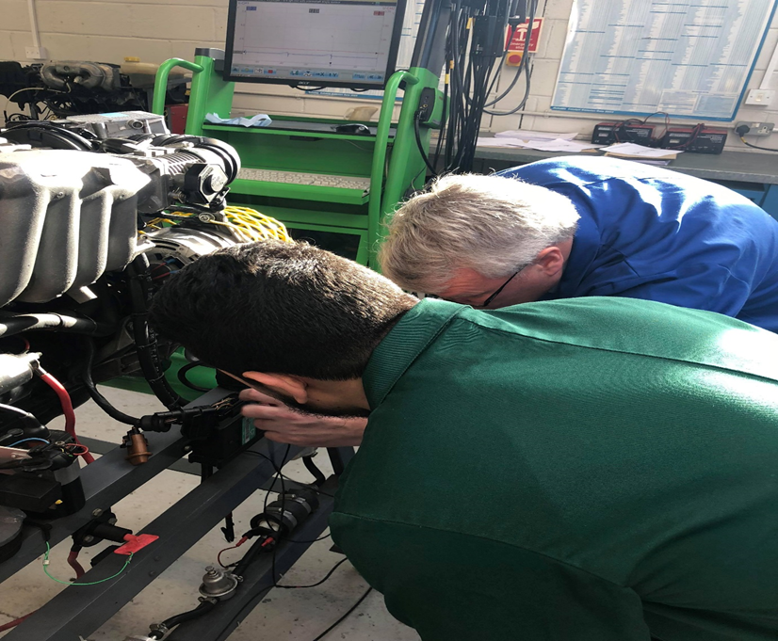

2) Background Research
Engine Control Unit (ECU)
In the 80s emmisions regulations were clamped down on so there was a change in government proposals which led to vehicle manufacturers to produce new engine designs with cleaner burning of fuel. Because of the fuel crisis there was an increased demand for engines with increased fuel economy which set in motion the changed of fuel delivery of carburettors to an electronically controlled system.
Engine management generally used to describe an electronically controlled engine which represents the modern era of motoring from the early days of distribution timing and ignition these systems were developed to evolve the way we burn fuel as means of propulsion, therefore enhancing an old design of an internal combustion engine (Hilliers 6th edition, 2014). Confusing to people in the 80s and 90s to understand how electronically a little box in a car can control so much and generate lower emisions, smoother running and better fuel economy of lesser capacity engine sizes. Before that time the internal combustion hadn’t really change in controlling the fuel or ignition other than improved carburettors, distributors, mechanically fuel injection driven off the engine etc. since the 80s the introduction of the engine management system has shaped our automotive industry and culture to this day and currently there is a movement to the next innovative idea which many are being invested into.
As regards to the complexity of these systems depends on the makes and models of vehicles, the once complex systems are now seen as extremely simple to what is out on the market today. Basically how they work is several sensors provide computer inputs and there are several actuators that respond to the computers outputs, for the system to operate efficiently all of these sensors and actuators need to correlate with one another. The system needs to be in fully working order but faults can still appear due to faulty spark plugs etc, place where there is a medium mechanical part between the engine and the electronics. Places like this need to be checked before beginning an electrical diagnosis is done. (Bonnick 1998)
Although the engines fitted in vehicles today still maintain the same operation that is the 4 stroke cycle but now the difference is the engines are controlled by engine control units (ECU’s). The early examples of ECU’s was seen in the Bosch LE Jetronic systems which was put in many vehicle such as GM Opel/Vauxhaul engines. The LE Jetronic system managed ignition and fuelling separately which correlate with one another unlike one whole ECU seen in today’s vehicles which controls the fuelling and ignition for the engine another for the gearbox etc. ECUs are the brain to a modern engine as they send and receive information altering what the engine does to inputs.

All ECUs have pins in there plug with each pin allocated to a sensor or switch in the engine to send and receive data to alter the engines characteristics, like a brain the ECU receives input signals, processes them and then sends output signals. For the ECU to carry out its duties the pins allocated to a sensor or switch as stated above, the ECU needs a wiring Loom/harness which has a plug to fit the pins on the ECU. In the modern era vast some of investments into new sensors have been created.
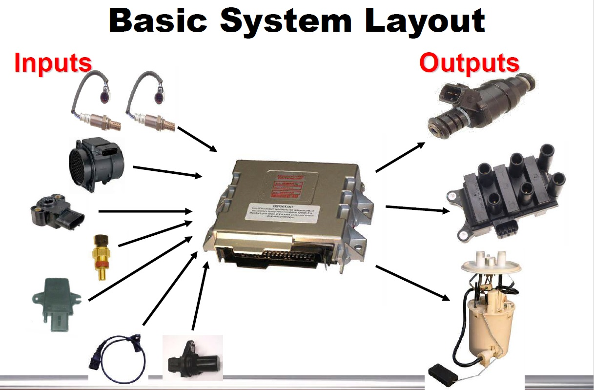

Input signals
The sensors control the electrical signals which send the electrical supply via the wiring loom and connectors over a ‘different interface’ to the pin allocated to that sensor in the ECU. An ‘Analog interface’ to transfer analogue waveforms measured by the sensors such as the engine temperature. A ‘Digital interface’ for digital input signals is seen by two forms of ‘Logic’, ‘High logic = 1 and low logic = 0’. This is evident in the switching signals such as speed signals from the Hall Effect measuring the engine speed. ‘Analog waves are smooth and continuous, digital waves are stepping, square, and discrete’.

Processes
As a result of data from the engine sensors, the ECU will calculate the correct injector pulse duration right across the rpm, load and temperature range. Engine load determines the basic injection pulse value and correction factors are applied for starting, deceleration part/full load operation.

Output signals
The output signal is then used by the microcontroller to activate the output stages to send transfer an adequate amount of supply for a direct connection between the actuator. (Bosch 2014)

Today’s petrol engines
Inputs Outputs
Cam sensor (CKP) Ignition coils
Crank sensor (CMP) Idle speed control valve
Air flow sensors (AMM/MAF) Throttle motor
Engine coolant sensor (ECT) Fuel pump
Throttle position switch (TPS) Exhaust gas recirculation
Heated oxygen sensors (HEGO) Turbo boost controller
Accelerator position (APP) VVT control
Map sensor (MAP) Variable induction control (MAP)
Knock sensor (KS)
Exhaust gas temperature
Fuel temperature sensor
EGR position sensor

Today’s diesel engines
Inputs Outputs
Cam sensor Electronic injectors
Crank sensor EGR valves
Air mass sensor Additive systems
Map sensor Inlet metering valves
Rail pressure sensor Pressure regulator
Throttle position
Fuel temperature Glow plugs
EGT
EGR position
DPF sensor

The two systems tested
The Bosch LE 3 Getronics system is electronically commanded and injects fuel in the intake manifold. This injection system has a function to provide the engine with exactly dosed amounts of fuel necessary to several running conditions. ‘The Le 3 jetronic command unit receives various input signals, from many sensors that send precise information about the instant engine operation conditions’. ‘Then the command unit processes this information received and calculate the appropriate amount of fuel injection time through an electrical signal’. This time taken is known as ‘injection time’. (Br.Bosch-automotive.com, under products drop down, LE 3 Getronics.) In the LE3 Getronics system the injection valve sprays the fuel simultaneously therefore the injectors are all sprayed at the same time. The LE 3 Getronics only controls the fuel system.
The Bosch Motronic system is a multipoint system also, it differentiates from the LE 3 Jetronic for having an injection system and ignition system incorporated into the ECU. ‘A multi-point system will normally inject fuel onto the back of the open intake valves’(Hilliers 6th edition, 2014), although manufacturers are now designing direct-to-head injection. Direct meaning straight into the combustion chamber which can be seen on the Millington diamond series two engine. This system features a lambda sensor that links to the injection system installed in the exhaust manifold pipe. Also in the motronic system, the tank has a ventilation valve (known as a canister valve) which allows the reuse of fuel vapours which are highly toxic therefore contributing for reduction of pollution which is the main advantage of electronic injection.

3) Health and safety and Equipment
Health and safety
For this investigation to be possible to carry out, the class were assigned into groups by the class lecture and given certain time slots for each group to carry out the tasks instructed in the assignment brief. Before undertaking the investigating process and equipment used to test the two engines we had to undergo a health and safety briefing of the workshop test area. This was compulsory before carrying out our examination.
‘Safety is not just a buzzword on a poster in the work area’. ‘Safe work habits can reduce accidents and injuries, ease the workload and keep employees pain free’. (James. 2011). Firstly our university tutor introduced our group to the safety brief when we arrived at the university workshop. The aims of this brief was to inform the students to be aware of potential dangers. The faculty provided us with the correct PPE clothing such as lab coats, gloves, steel toe boots and protective glasses which was compulsory to be worn at all times inside the University’s workshop. Our tutor showed us the start-up procedure before we took part in the examination ourselves this was to show us techniques and tips to accomplish the examination as a professional would. For example there was an extractor built into the workshop for us to use when the engine was running to release the exhaust gasses elsewhere and the workshop door was left open so that any exhaust gasses not extracted didn’t suffocate the University workshop. Also one person starts the engine the others do not touch while thoroughly being aware of the engine for faults leaks overheating etc.

Equipment
Undertaking these tasks we were supplied with correct professional equipment. A Bosch FSA-740 engine diagnostics system was used which is the new dimension in trouble-shooting universal system made up of perfectly matching modules. In other words it is a computer that analyses engines. This system gave us the ability to accurately find faults and see our readings in waveforms dynamically and pause the system in areas to see what is happening at different stages. We also had a person allocated to using a multimeter in which they used to test the voltage and resistance of the engine which was essential in completing this examination.

Tasks
- Using the equipment provided carry out a full systems operation test on the vehicles – working group.
- Explain on the basis of practical measurement and interpretation of data sheets, how injection on-time is addressed to meet the following operating conditions:

A) Ignition on with the engine not running.
B) Engine cranking from cold.
C) Engine warm up.
D) Acceleration.
E) Deceleration.
F) Idle speed while the engine at operating temperature.

- Analysis on the outcomes of the test with reference to:
- Procedure adopted when carrying out the test.
- Actual test readings and signal waveforms recorded as compared to manufacturer’s specifications.
- Reasons for choice of test equipment.
- Safe working practices adopted when carrying out the tests.
- NTC2 Graph (compare values)

- Compare the main system operational differences and define through technical analysis and evaluation the signal waveforms.
- Justify any modifications to the system you feel are necessary.

4) Methodology
Live testing
The investigation could only be possible in small groups so that everybody had a role to play testing the engines in the university workshop is and so every student had a chance to gain some practical experience using the professional measuring equipment. We first met in the workshop with the tutor in charge of overseeing our investigation and he gave us the health and safety brief as stated above and in our groups with the guidance of our university tutor we got a feel for the measuring equipment. Our tutor had booked 4 hours of testing to be carried out on two GM Vauxhall engines one of which had the Bosch LE 3 Jetronic system and the other had the more recent Bosch Motronic system.
In preparing for the examination we were giving many lectures on engine control systems and the evolution of them and were instructed to read a list of books with chapters on this topic. The first session we completed was the Vauxhall engine with the Bosch LE 3 Jetronic which took nearly half the time from the Motronic system as there were much less pins to check. The examination had to be carried out recording the, voltage, resistance, of all the pins, the engine oil temperature and ignition in milliseconds under these working conditions:
A) Ignition on with the engine not running.
B) Engine cranking from cold.
C) Engine warm up.
D) Acceleration.
E) Deceleration.
F) Idle speed while the engine at operating temperature.
One hindrance that came into play was the weather on that day. Since each group were examining the engines on different days the weather change so there was different values for every group so we could not compare data. On engine warm up we couldn’t record our voltage etc. For each pin a at 10°C as the ambient temperature of the workshop was 17.3°C for the LE 3 Jetronic and 17.5°C for the Motronic on the day of testing so we began heating our engine up to 20°C instead and carried on recording in 10°C increments until we reached the engines operating temperature. It would have been ideal for us to record the data with the climate in cold conditions such as -10°C. also another factor that came into play was that of the height above sea level that we recorded the data at. Even though we examined the engines in Swansea by the sea but the university workshop was at a 60m elevation above sea level with would have affected the air/fuel ratio of the engines as the air gets thinner with elevation giving less horsepower of the engine to be created. This was interesting to say the least for a student studying motorsport as this is one of the many problems Formula 1 teams face for circuits like the Mexican GP where the circuit is mostly flat with an elevation change of 2.8m but the height above sea level is 2000m or circuits like Spa-Francorchamps in Belgium where the Elevation change between highest point and lowest point is 102.2m. Also WRC teams face this problem in Mexico with stages climbing altitude which leaves the engine performing less. The route climbs to the season’s highest point at 2737m. Engines struggle to breathe in the thin air and lose 20 per cent power.
The conditions we tested in are therefore said to be an ‘uncontrolled environment’. This data that we calculated as a group is not as accurate as it could even though we used the dedicated test equipment. Engine testing companies carry out these tests in a ‘controlled’ environment consisting of a testing chamber that controls the ambient temperature to fit conditions which racing teams are subject to.
The group we were assigned to were given selected roles for testing the LE 3 Jetronic and Motronic systems. Before our group turned over the engine we checked the ECU with the ignition on but whilst the engine wasn’t running which was to check if there was any faults with the engine. The scribe: was the person that took notes of everything happening throughout the examination and the data received from the test. The scope operator: was the person in control of the Bosch FSA-740 engine diagnostics system. The probe operator: placed the probe into each pin in in the ECU so that the scope operator could receive the readings from the engine. The multimeter operator: was the person that recorded the engine voltage and resistance at each condition via the use of a multimeter. We went on to cold crank the engine at 17.3°C at begin the examination of the LE 3 Jetronic. Since the LE3 Jetronic has two ECU’s, one for fuelling and the other for ignition both units had to be checked separately.
We began with A) (Ignition on with the engine not running) when the multimeter operator verified to see if the system is ground and then measured determined to voltage of the input coming from the ECU to the sensors. Then removed then removed the electrical connector at the coolant temperature sensor. Our tutor provided us also with the Vauxhall handbook therefore we could compare the data we received to that of the factory tested engine when it was new with the values they received in a ‘controlled environment’. For example we recorded the resistance of the Ignition coil, king lead, HT leads, idle speed control valve and the injector valves. Once we seen a correlation of resistance with the Vauxhall handbook which insured us that the engine had no faults and appeared to be in working order and then proceeded onwards.
B) (Engine cranking from cold) for the LE 3 Jetronic (17.3°C) at this point the injectors pulsed at 51ms at first fire up of the engine and for the Motronic (17.5°C) at this point the injectors pulsed at 3.2ms. We measured resistance, voltage and the injector pulse. Engine operating temperature is 60°C because the Vauxhall engine had no cat convertor. For us to reach this temperature correctly this cycle of each of our jobs to be carried out in order had to keep repeating itself for each pin recording. How we collected the ‘injection on time’ for both engines we used the Bosch FSA-740 engine diagnostics system which received the recordings through the probe that was connected to Pin no.3 on the LE 3 Jetronic and Pin no.16 on the Motronic, (These two pins represent the injectors) as expressed above Jetronic is simultaneous and Motronic is multi-point so different waveforms occur. This created a waveform dynamic graph for us to see on the Bosch FSA-740 engine diagnostics system.
C) (Engine warm up) The multimeter operator recorded NTC2 (coolant temperature sensor) at 20°C for the first warm up recording, On the LE3 Jetronic system we been checking the engine-oil temperature to do the testing during the warm up, and the pins being tested for are (Pin no.3(Injectors in ms) and Pin no.8(for Voltage and resistance) in the fueling ECU, NTC2. On the Motronic system we will been checking the engine-coolant temperature to do the testing during the warm up, and the pins being tested are (Pin no.45 resistance and voltage, Pin no.16 injectors, Pin no.4 keying ratio percentage of the (rotary idle valve1), Pin no.5 charcoal solenoid, Pin no.28 lambda sensor, Pin no.44 which is NTC1 (air temperature to monitor density) and NTC2 (coolant water temperature). The same procedure been followed to test the engines, for the LE 3 Jetronic the same procedure been followed to test the engine at different temperature (30deg, 40deg, 50deg, 60deg, 65deg). However, it was impossible to reach 65degree after testing engine on 60degree temperature and that because the fan was off, therefore the fan switched on while the engine was running to rise the temperature to 65 degree so that the data can be collected at that high operating temperature. For the Motronic we recorded the procedure at different temperatures (30deg, 40deg, 50deg, 60deg, 70deg, 80deg) because the Motronic system contains catalytic converter therefore the fan was switched on while the engine was running to rise the temperature to 80 degrees so that the data can be collected at that high operating temperature. How we recorded the oil temperature was by placing a probe from the Bosch FSA-740 engine diagnostics system in to the dipstick slot. For the LE 3 Jetronic we read the voltage and resistance with the engine turned off because it reached 20°C and the resistance of the NTC2 been recorded using multimeter. In regards the Motronic system at ignition, resistance 1442(Ω) and voltage 3(V) of NTC2 was found in Pin no.45, For us to read then injection on time whilst the engine was running we probed Pin no.16 which pulsed at 3.5ms. The Pin we recorded was Pin no.4 keying ratio percentage of the (rotary idle valve1), this was just to monitor it until It turned on. Lastly we recorded Pin no.28 which was the lambda sensor, this was to monitor Lambda until it switches on.

D) (Acceleration), E) (Deceleration), F) Idle speed while the engine at operating temperature. For this next task we just simply our tutor revved up the engine whilst the injectors were connected to the Bosch FSA-740 engine diagnostics system which created dynamic waveforms that we could monitor to see injectors pulsing and interpret what is happening. This was done for both engine control systems and is examined exactly what is happening in the data analysis section below.

5) Data Analysis
The results collected from both Vauxhall engines in the workshop during the live testing period were written down by the scribe for each pin so that we could interpret what is happening. Our tutor explained the waveforms below to help us approach explaining them in this part of the assignment. When examining the wiring components we consulted the wiring diagram for both engines so that we had a clear diagram of both engines.
Throttle switch closed
- Specifications for terminals 2 and 18 = 0(Ω) and testing it with the multimeter confirmed that it was = 0(Ω)
- Specifications for terminals 3 and 18 = infinity

Auxiliary air valve
- Specifications are = 40(Ω) between the 2 terminals and when testing we got a reading of 46.5 ohms

Injector Values
- Specifications are = 15-17(Ω) resistance between terminals and we got a reading of 15.8(Ω)

Kettering coil
- After testing with a multimeter the readings we received were = Primary: 1 (Ω)
= Secondary: 7450(Ω)

HT leads
- After testing the readings we received were = 1) 8560(Ω)
2) 8500(Ω)
3) 7460(Ω)
4) 5070(Ω)
As discussed the resistance is less with the length of the HT leads which made sense for the depleting values for each cylinder.

LE3 Jetronic – Live Test

Ignition ECU
Pin No. | Voltage (Ign off) | Voltage (Ign on)
1 | 0 | 0.07
2 | 0 | 0.17
3 | 0 | 12.24
4 | - | -
5 | 0 | 0.19
6 | 0 | 0.02
7 | 0 | 1.32
8 | 0 | 1.20
9 | - | -
10 | 0 | 0.18
11 | 0 | 0.12
12 | 0 | 0.18
13 | 0 | 0.26
14 | 0 | 5.01
15 | 0 | 0.16

These charts here are representing A) (Ignition on with the engine not running) where we checked each pin of both ECU’s prior to the engine warm up. The readings for both ECU’s of LE 3 Jetronic for the Ignition off are all zero as there is no voltage travelling to any Pin which clarified that there was no faults. When Ignition was turned on verify that voltage (approximately 5 volts) exists and ground (Hilliers green book). The LE3 Jetrionic is simultaneous injection in which fuel is injected all at the same time to all the cylinders. How the ignition ECU gets its timing correct on the LE 3 Jetronic system was from the speed sensor / crank angle sensor which sends an analog signal being digitised which was Pin no.12. From examining all the pins for the resistance and voltage of the LE 3 Jetronic system we came to the conclusion that everything was in spec when comparing our data with the Vauxhall books data but one pin we got a resistance figure that was above spec. this was the auxiliary air valve which should have been within 40ohms but it was 46.5ohms which can be interpreted as the part is broken.

Fueling ECU
Pin No. | Voltage (Ign off) | Voltage (Ign on)
1 | 0 | 0.32
2 | 0 | 12.30
3 | 0 | 0
4 | 0 | 0.02
5 | 0 | 0.03
6 | - | -
7 | - | -
8 | 0 | 0.82
9 | - | -
10 | 0 | 0.15
11 | - | -
12 | 0 | 12.35
13 | - | -
14 | 0 | 5.02
15 | 0 | 0.02

B) (Engine cranking from cold) In fuelling the engine, ‘the injector is a solenoid-operated valve, the injector requires a power supply and an earth connection in order to operate’ (Hilliers 6th edition, 2014). We were unable to see cold start values because of the uncontrolled conditions so we only monitored ‘warm up’ and not ‘Cold starts’. For example during cold starts the relative amount of fuel mixture decreases so the mixture goes LEAN. Which is ‘An inadequate blending of fuel and air in the intake mixture, low fuel vaporization and condensation on the walls of the intake’ and cylinder walls ‘all contribute to this’. To compensate for this extra fuel is supplemented for cold starting. Since we could measure the engine temperature from 20°C (post start up phase) where the injectors pulsed at its greatest value confirmed to us what the Bosch book wrote. ‘After starts at low temperatures, supplementary fuel must be provided to enrich the mixture until the combustion chamber heats up and the mixture formation within the cylinder improves’. Ive also noticed personally that the engine idled well compared to race built engine that cant idle due to high lift cams etc. ‘The RICHER mixture also increases torque to provide a smoother transition to the desired idle speed’ (Bosch, Gasoline Fuel-Injection System L-Jetronic, Edition 1995/96).

Amplifier
Pin No. | Voltage (Ign off) | Voltage (Ign on)
1 | 0 | 12.23
2 | 0 | 0.02
3 | 0 | 12.20
4 | 0 | 0.18

For the LE 3 Jetronic as verified above has 2 ECU’s, one for fuelling and one for ignition. How these both work together hasn’t been discussed yet. The system has an amplifier that has 4 pins. Pin 1 = ‘the primary waveform’, Pin 2 = the earth, Pin 3 = the supply and Pin 4 = signal from the ignition ECU. This acts as a medium so the 2 ECU’s can correlate with one another. For example injection timing and ignition timing.
LE 3 Jetronic – warm up procedure
Coolant temperature (°C) | NTC2 - Ohms (Ω)  Pin no.8 | NTC2 – Volts (V)  Pin no.8 | Injectors – Milliseconds (ms)  Pin no.3
20 | 1822 | 1.5 | 4.7
30 | 1047 | 1.1 | 3.3
40 | 749 | 0.8 | 3.2
50 | 538 | 0.6 | 2.9
60 | 401 | 0.6 | 2.7
65 | 552 | 0.6 | 2.5

C) (Engine warm up) As stated earlier, because of the uncontrolled environment so we let the engines idle until it reached 20°Ccoolant temperature. This graph represents the resistance values and temperature range between 20°C - 65°C. For the LE 3 Jetronic we read the voltage and resistance with the engine turned off because it reached 20°C and the resistance of the NTC2 been recorded using multimeter and read as 1822(Ω) with the voltage being read as 1.5(V) and Injectors on time of 4.7ms. As shown in the above chart of our warm up procedure you can clearly see as the engine oil temperature rises to operating temperature we recorded the resistance Ohms (Ω), Voltage (V) and the pulse of the injectors (ms) all decrease in values. The readings from the engine coolant sensor are fed back to the ECU which uses data to adjust injection timing. As the engine warms up, resistance should change. This verifies that the sensor is changing resistance with coolant temperature but does not yet ensure the system is working (Hilliers,2014). Our result as clearly shown above as Pin no.3 (the injectors) at 20°C pulses its greatest value of 4.7ms and is the greatest value of injection because in the warm up phase the engine still needs extra fuel. Which is proven in the (Bosch, Gasoline Fuel-Injection System L-Jetronic, Edition 1995/96). ‘The cold cranking and post start up phases are followed by the engines warm up phase’. ‘In this phase the engine still requires a richer mixture, as the cylinder walls are still cool’ therefore a portion of the fuel is used to condense them. (Bosch, Gasoline Fuel-Injection System L-Jetronic, Edition 1995/96). So that is why with the greater temperatures less fuel was needed. Such as at 60°C the injection time is much less with a value of 2.7ms as shown above.

Motronic – Live Test

Throttle potentiometer
- Checking resistance between terminals 1 and 2 = 2000(Ω) (Throttle closed)
- Checking resistance between terminals 1 and 2 = 2540(Ω) (Throttle open)

Airflow sensor
- Checking resistance between terminals 4 and 2 = 329(Ω)
- Checking resistance between terminals 4 and 3 = 536(Ω)
- Checking resistance between terminals 4 and 1 = No Pin 1

Air temperature sensor
- Air temperature is an integral part of the air flow sensor
- Checking resistance between teminals 4 and 5 = 2690(Ω) (Cold engine temperature)
= 246(Ω) (80°C engine temperature)

Idle speed control valve
- Checking resistance with the ignition off = 8(Ω)

Injector values
- Checking resistance for injectors specifications are = 15-17(Ω) resistance between terminals and we got a reading of :
1) 16(Ω)
2) 16(Ω)
3) 16(Ω)
4) 16(Ω)

HT leads
- After testing the readings we received were =
1) 1900(Ω)
2) 1750(Ω)
3) 1500(Ω)
4) 2140(Ω)
As discussed the resistance is less with the length of the HT leads which made sense for the depleting values for each cylinder.

Primary and secondary windings
- Primary windings = 0.6(Ω)
- Secondary windings = 7720(Ω)

•The LE 3 Jetronic uses a throttle switch and testing it with the multimeter confirmed that it was = 0(Ω) or infinity whilst the Motronic uses a throttle potentiometer which gave 2000(Ω) (Throttle closed) and 2540(Ω) (Throttle open). This is because the butterfly valve has a potentiometer attached to it with full range of motion.
•The LE 3 Jetronics injectors gave a resistance value between terminals and we got a reading of 15.8(Ω) whilst the Motronic 1) 16(Ω), 2) 16(Ω), 3) 16(Ω), 4) 16(Ω) because it is multipoint injection. The LE3 is simultaneous injection which gave us a single resistance figure for the injectors when the Motronic uses multipoint and to prove this, the schematic our tutor gave us shows that the Motronic has 2 grounding points for the injectors so they pulse into 2 cylinders at a time not all at once.
•For both systems the Kettering coils work the same but gave different resistance for primary and secondary because there simply different engines.

Motronic System
Pin No. | IGN (OFF V) | (IGN ON V)
1 | 0 | 12.31
2 | 0 | 0.03
3 | 0 | 12.2
4 | 0 | 9.85
5 | 0 | 12.18
6 | 0 | 11.48
7 | 0 | 0.31
8 | - | -
9 | - | -
10 | 0 | 0
11 | - | -
12 | 0 | 5.07
13 | 0 | 10.23
14 | 0 | 0.02
15 | - | -
16 | 0 | 12.18
17 | 0 | 12.18
18 | 12.54 | 12.16
19 | 0 | 0.02
20 | - | -
21 | - | -
22 | 0 | 0.91
23 | - | -
24 | 0 | 0.03
25 | - | -
26 | 0 | 0.05
27 | 0 | 12.28
28 | 0 | 0.46
29 | - | -
30 | - | -
31 | - | -
32 | 0 | 11.46
33 | - | -
34 | - | -
35 | - | -
36 | 12.21 | 0.28
37 | 0 | 12.18
38 | - | -
39 | - | -
40 | 0 | 0.05
41 | 0 | 0.05
42 | 0 | 0.03
43 | - | -
44 | 0 | 3.7
45 | 0 | 3.7
46 | 0 | 5.07
47 | - | -
48 | 0 | 0.05
49 | 0 | 0.09
50 | - | -
51 | - | -
52 | - | -
53 | 0 | 0.62
54 | - | -
55 | 0 | 11.15

A) (Ignition on with the engine not running) For the Motronic the same tedious job of testing each of the pins in the ECU prior to the engine warm up. The readings for the ECU of Motronic when we checked the voltage as off were not all zero as there was voltage travelling to Pin no.18 and Pin no.36. Pin no.18 is the direct connection to live and Pin no.36 is the connection to the Fuel relay. These have voltage going to them when the ignition is switched off because normally ECU’s and computers have a memory built in which is there to send voltage to the motherboard. This system is in contrast with the LE 3 Jetronic which it does not have and also the LE 3 Jetronic doesn’t have a system fault lamp so it isn’t able to detect faults.
B) (Engine cranking from cold) Before the warm up testing, the team cold ranked the engine at 17.5 degree cold engine temperature and the injectors pulsed 28.2ms at this first fire-up. Because the engine is cold cranked the voltage is higher revs so the injection time duration is long (Hilliers, 2014).
Motronic – warm up procedure
Coolant temperature °C | Pin 45 NTC2 - Ohms (Ω) | Pin 45 NTC2 – Volts (V) | Pin 16 Ignition - Milliseconds (ms) | Pin 4 (Keying)% | Pin 5  (Charcoal solenoid) | Pin 28 (Lamba)
20 | 1442 | 3 | 3.5 | 45 | OFF | OFF
30 | 1090 | 2.6 | 3.3 | 43 | OFF | OFF
40 | 712 | 2.1 | 3 | 43 | OFF | ON
50 | 472 | 1.7 | 2.8 | 42 | ON | -
60 | 354 | 1.4 | 2.8 | 42 | - | -
70 | 264 | 1.1 | 3 | 44 | - | -
80 | 246 | 0.8 | 2.7 | 45 | - | -

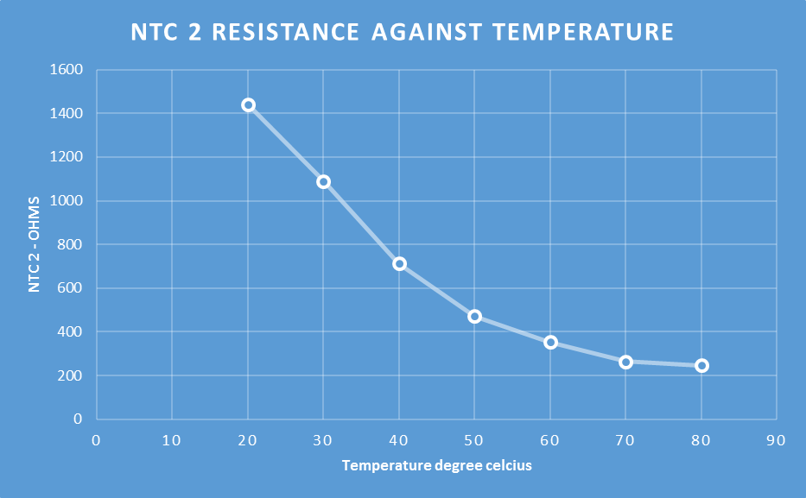

C) (Engine warm up) The same procedure been followed to test the engine at different temperatures (30deg, 40deg, 50deg, 60deg, 70deg, 80deg). We then went on to see the readings from the engine at 80 degrees so the fan was switched on. The Motronic system at ignition, resistance 1442(Ω) and voltage 3(V) of NTC2 was found in Pin no.45, For us to read then injection on time whilst the engine was running we probed Pin no.16 which pulsed at 3.5ms. The Pin we recorded was Pin no.4 keying ratio percentage of the (rotary idle valve1), this was just to monitor it until It turned on which was at 42%. The idle control is achieved by setting a given keying ratio when the engine is warm. Probing again in pin n5 which was the charcoal solenoid from the fuel tank to check at which engine temperature it started to function which wasn’t the case at 20 degrees but we took note that the solenoid started to function between (50deg – 55deg). When fuel evaporates inside the gas tank, the excess vapours are transferred to the charcoal canister. They are stored there until they can safely be transferred back to the engine to be burned with the normal air fuel mixture of the engine. As you can see in the graph above Lambda is on at 40degrees and the valve opens that creates the vacuum for the vapours to be drawn into the engine to be burnt. This cant come on before 50 – 55 degrees because it will mess with Lambda because that comes on at 40 degrees. This would mess up the air fuel mixture. Because the Motronic system contain catalytic converter therefore the fan switched on while the engine was running to rise the temperature to 80 degrees so that the data can be collected at that high operating temperature. The fan being switched on added an electrical load to the engine which gave greater injection timing values (that’s why we noticed a rise in the injection timing after 60 degrees as the fan started at this temperature).

6) Digital Waveforms
• Analogue (AC wave form output)
• Digital (square wave form output)
• Frequency
• Pulse width (Modulated)
• Duty cycle (Modulated)

Motronic Waveforms
Appendix A: This is the waveform from Secondary wave pattern, the high voltage is the spark line and the voltage drops and stays constant for 2ms (spark duration) and then the voltage drops to zero because there was no energy left after the spark duration and which in turn causes an oscillation. The voltage stays constant for 60% (dwell period).

Appendix B: This is the waveform for spark duration which is Pin no.1 which at first clearly shows the battery voltage grounding of the supply. Next the is the ‘Back EMF’ which is the high voltage released to the spark plug before it feed the spark plug the voltage drops abruptly causing the spark duration of 3ms and in turn causes the oscillation’s.

Appendix C: This is Pin no.4 which is the rotary idle valve at engine running temperature of 80degrees Celsius. The high voltage is when the rotary valve is closed and the low voltage is when it is open. It is measured to be opened for 4.8ms and that indicated as 42% open.

Appendix D: This is the waveform for both Pin no.27 (Supply from ignition) and Pin no.2 (Earth return).

Appendix E: This is the waveform for both pin no.16 and Pin no.17 (Multipoint fuel injection). As you can see here the Dual injectors use a simultaneous injection method because both waveforms for Pin 16 and 17 both fire at the same time. So the voltage decreases as the injector is grounded then abruptly increases signalling voltage released to the injectors (2 at the same time) before it feed the spark plug the voltage drops abruptly causing the spark duration of 3ms and in turn causes the oscilliations.

Appendix F: This is the waveform representing lambda which is Pin no.28 as you can see as the voltage gets higher this means that the engine is running rich and when the voltage is low meaning the engine is running lean. Since the system is an older system the motronic dosnt have a wide band sensor so is just signals go lean go rich. This is a lambda closed loop control the air fuel ratio can be maintained as a stoichiometric efficiency = 1. (As the graph indicates dependent upon the result of the comparison so either excessively lean air fuel mix is enriched or excessively enriched mix is leaned. (Livesey,2012)

Appendix G: This is the Speed sensor waveform which is Pin no.49 which in this engine the speed sensor is located in the flywheel for timing. This is an analogue waveform as previously pointed out.The graph signifies the crank angle sensor which shows the missing tooth recording engine rotational speed. What would happen if the engine was accelerated or decelerated? The frequency changes between acceleration and deceleration so the frequency gets closer together and longer in an upwards downwards direction when revved up and the frequency gets further apart and smaller when you lift off the throttle. This graph indicates that the throttle is held midway constantly.

Bosch LE 3 Jetronic Waveforms
Appendix H: This is Pin no.3 (acceleration) and (deceleration) of the Jetronic post warm up phase. This is the waveform for spark duration which is Pin no.1 which at first clearly shows the battery voltage grounding of the supply. Next the is the ‘Back EMF’ which is the high voltage released to the spark plug before it feed the spark plug the voltage drops abruptly causing the spark duration of 4.7ms and in turn causes the oscillation’s. This is because of the enrichment of fuel under warm up and shows that in comparison with the motronic that the LE 3 Jetronic is less efficient under these conditions. With the deceleration the graph shows very short injection duration. This is due to the throttle switch, an outdated unit over the potentiometer that communicates idle for full load throttle positions to the ECU.

Appendix I: This is Pin no.1 (Primary) and (Secondary) Voltage from the amplifier. Pin 1 = ‘the primary waveform’, Pin 2 = the earth, Pin 3 = the supply and Pin 4 = signal from the ignition ECU. This acts as a medium so the 2 ECU’s can correlate with one another. For example injection timing and ignition timing. Once again showing grounding where then the voltage drops to zero because there was no energy left after the spark duration and which in turn causes an oscillation.

Appendix J: This is the Speed reference for the fuel ECU which is Pin no.5. The waveform indicates a digital square waveform (Voltage does not change to frequency increase). Voltage must peak to input voltage and switch to 0(V) for the ECU to acknowledge an on/off signal. The graph shows the engine under high load like other graphs with long duration as indicated earlier. Variable pulse width so as the waveform is up it is off time when I drops closer together it is on time. The gaps between the start of the pulse and the start of the next pulse is total time, one cycle = 100%.

7) Modifications and improvements
For this section of the analysis of both engine control system I am choosing the Bosch LE 3 Jetronic as the example for which I am adding improvements with the intent of improving the engine efficiency and emissions to fit government legislation. I have chose this engine because out of the 2 it is the oldest and most out dated.
Throttle position sensor
Firstly I would take away the throttle switch and replace it with a (TPS) and this is why. The potentiometer has a wire running in and out to the ECU. In the throttle body the butterfly valve opens and closes and it moves a needle up and down and has to pass through a resistive wire element. So the current travels through the wire going and passes through the needle throughout the resistive element to the ECU. So as you change throttle, the needle moves along the resistive path of wire which adds resistance so you will have a voltage change. The ECU will measure voltage change and input them for a series of functions. For example: Cruise control, ABS, Injectors, Traction control. (Hilliers, 2014)

Map Sensor
In this case I would use this in place of a mass airflow sensor. To detect how much air is going into the engine so the ECU can determine how much fuel to put in. how the Map sensor is beneficial is as follows. So there is a tube leading into the intake manifold which has a vacuum of negative pressure. The map sensor has a chamber which has a controlled pressure calibrated for the engine. There is a silicon chip which divides the Map sensor from the manifold vacuum tube. The chip has a current in it running to the ECU. (Livesey, 2012) So when you accelerate you increase the pressure in the intake manifold so there is less of a vacuum. The pressure flexes the chip which alters the resistance. When you take your foot off the throttle you have a move of a vacuum going back out the intake pipe. The ECU receives the resistance change and translates it to a voltage change. This is an incredible improvement as the ECU knows when to inject more or less fuel. (Hillier, 2014)

Hot film air mass meter
With the hot film air mass meter the electrically heated element is in the form of a platinum film (resistance heater). The heaters temperature is registered by a temperature dependant resistor. The voltage across the heater is measured for air mass flow. It is converted by the hot film air mass meters electronic circultry system into voltage which is suitable for the ECU. This improvement ensures pulsation accuracy for precision measurements (with individual optimization measures), The modular system allows the integration of additional sensors (moisture, pressure and temperature) and Adapting the air and fuel mass enables efficient fuel combustion.
8) Evaluation
The assignment analysis and evaluation I believe has been achieved at high level the detail involved a lot of research from credible sources even though at first the two engine control systems seemed very convoluted to me. The LE 3 Jetronic has proven to be less efficient in cold start conditions as pointed out earlier and a lot of its inputs for the electronic control unit are just simply out of date in todays world. One of the problems our group had faced in the examination of these ignition systems was the fact that we were testing in an uncontrolled environment which gave us less data when recording the warm up phase of both engines. The Motronics over run fuel cut off never got to be seen in person even though our tutor explained it to us. The fuel supply of the engine is reduced so consumption is less and emissions drop when driving downhill and braking which we could not see as the engine was set up in a rig and not in a vehicle. Another variable that didn’t help when comparing was that we weren’t comparing 2 Motronic systems or 2 Jetronic systems so the 2 different engines didn’t have the same parts or one had more. Like the Motronic had a lambda sensor and the LE 3 Jetronic didn’t so it impeded our ability to compare figures.

9) References
- (Hillier’s, Fundamentals of motor vehicle technology2014, 6TH edition, Oxford)
- (Hillier’s Fundamentals of automotive electronics.2012, 6TH edition, Oxford)
- Advanced Motorsport Engineering.2012, Level 3, by Andrew Livesey, Routledge)
- Robert Bosch.2014 Automotive handbook,(9th Edition), Sussex, Robert Bosch Gmbh.
- Allan W. M. Bonnick, Automotive computer controlled systems: Diagnostic Tools and Techniques.2000 by Routledge.

10) Appendix
Appendix A
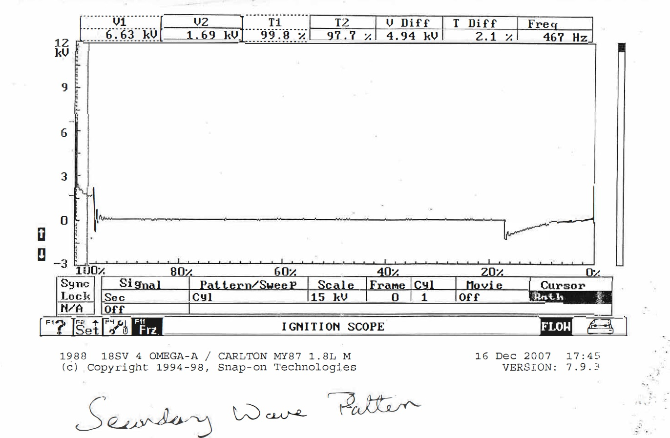

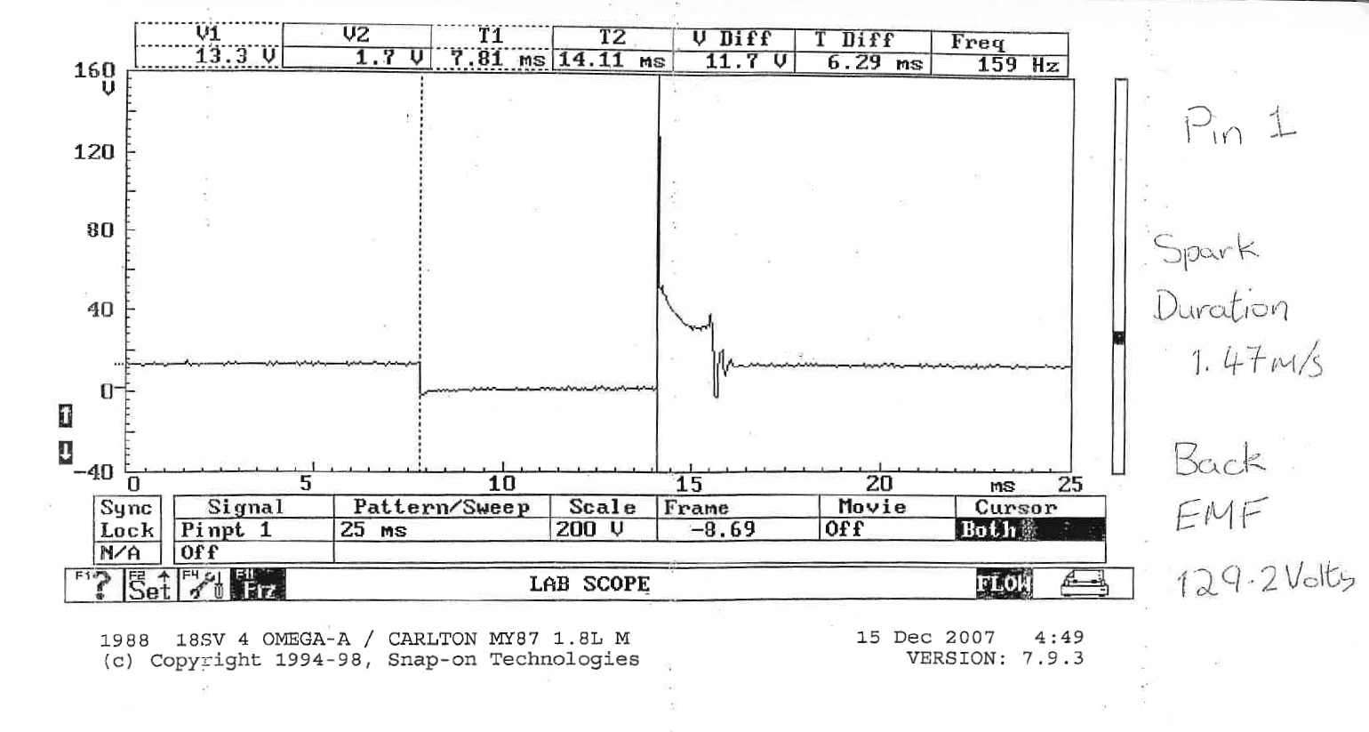
Appendix B

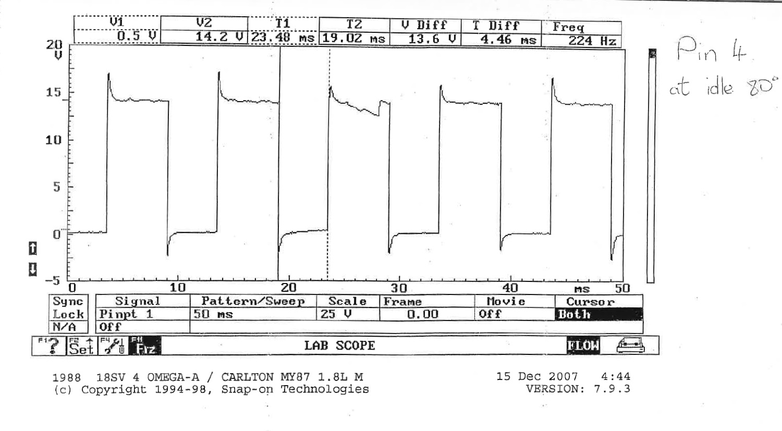
Appendix C

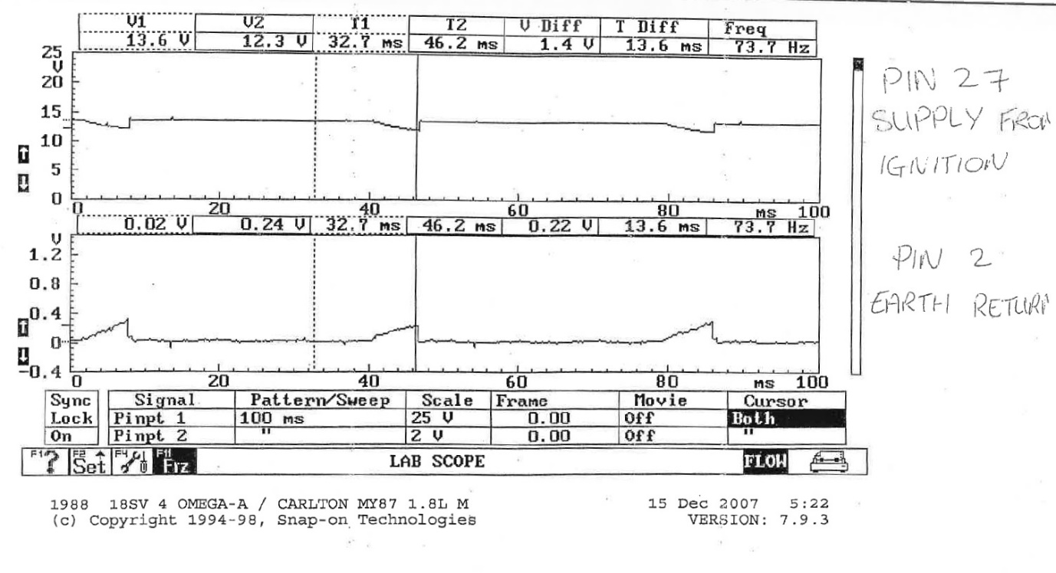
Appendix D

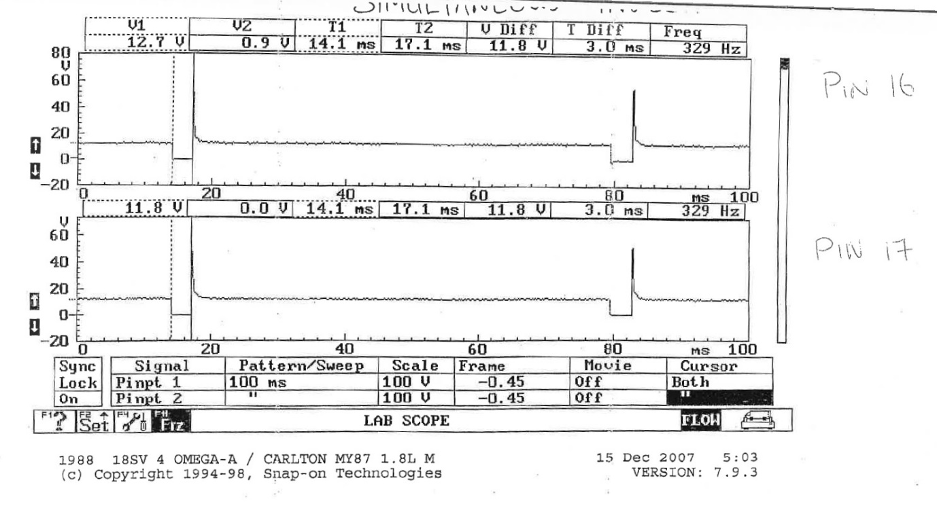
Appendix E

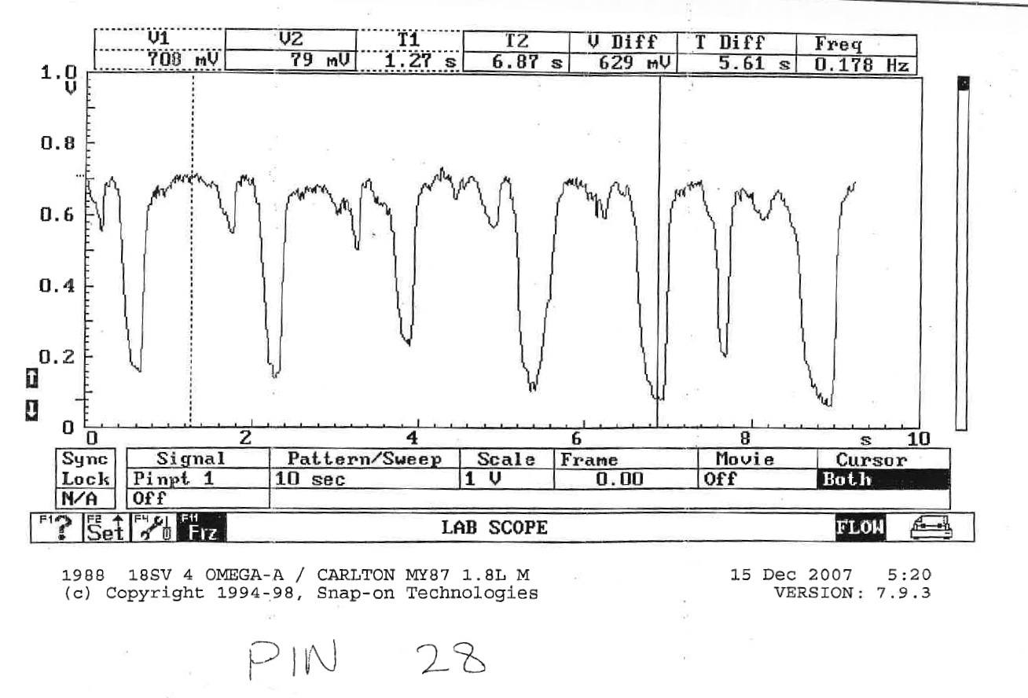
Appendix F

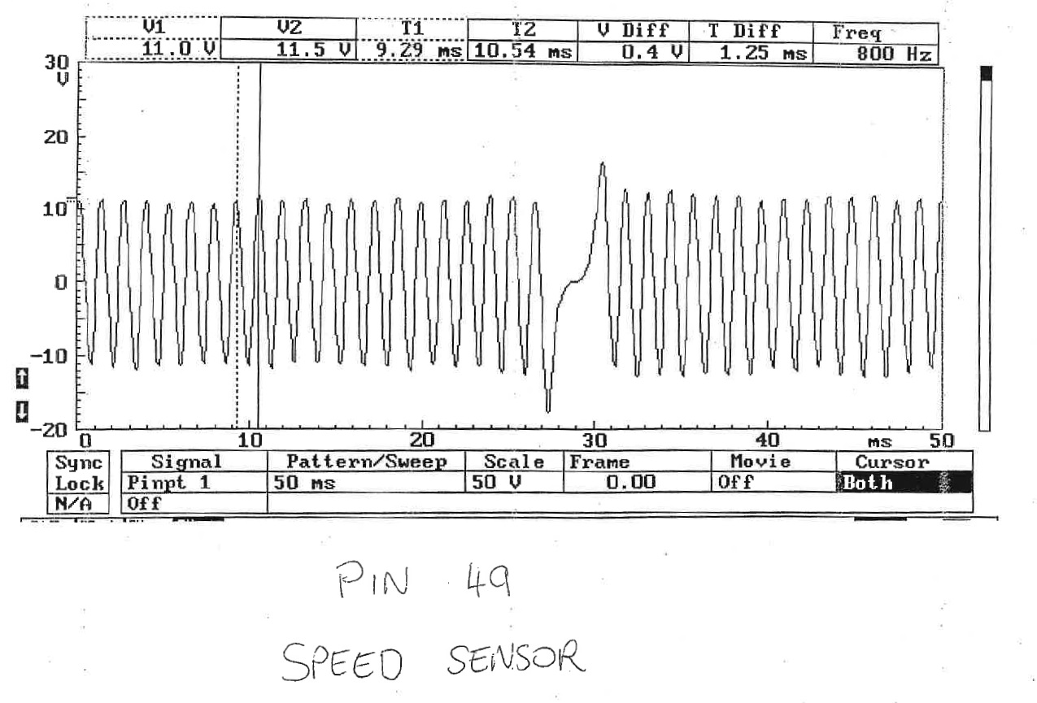
Appendix G

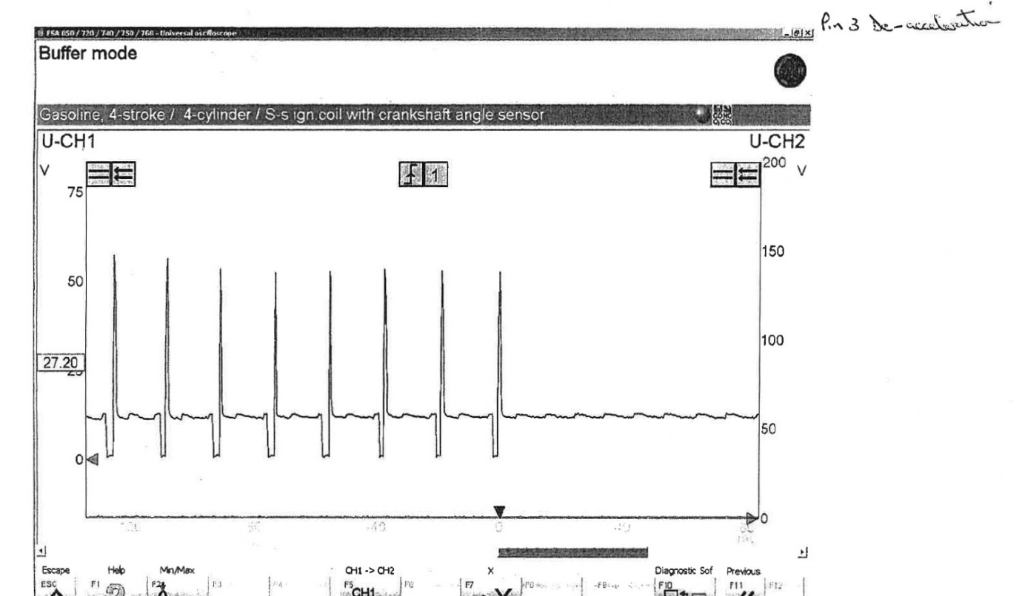
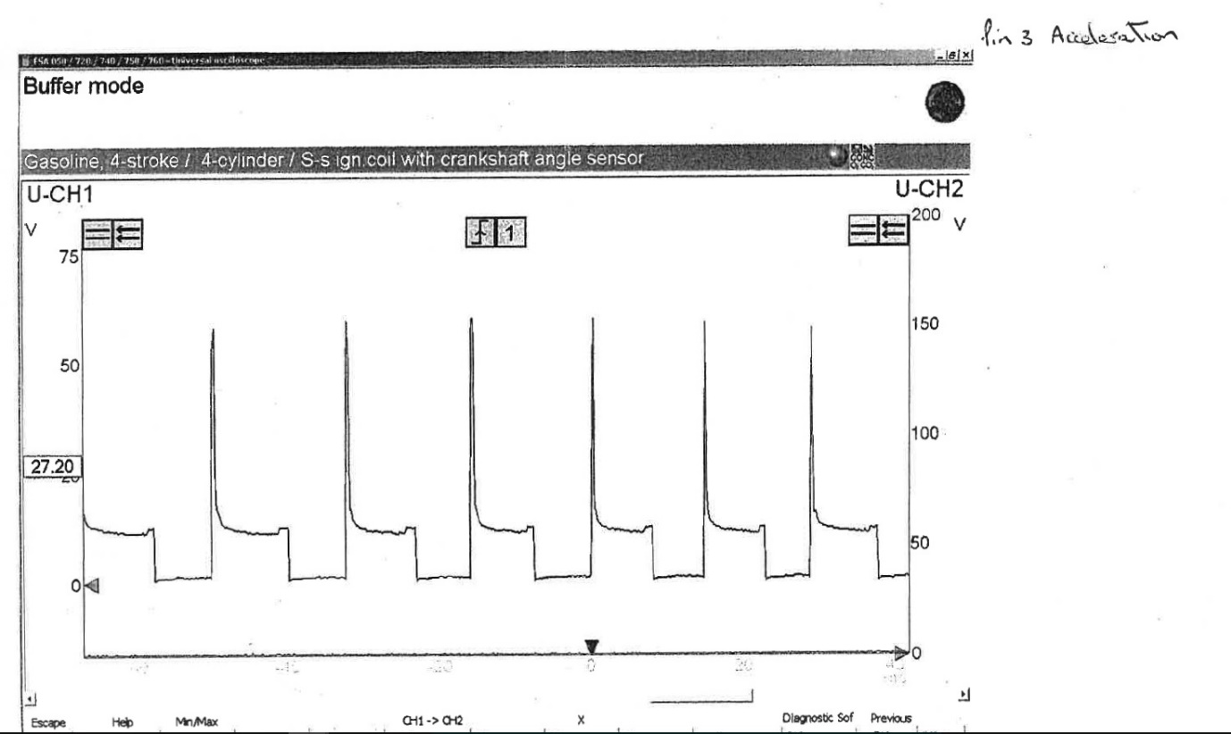
Appendix H

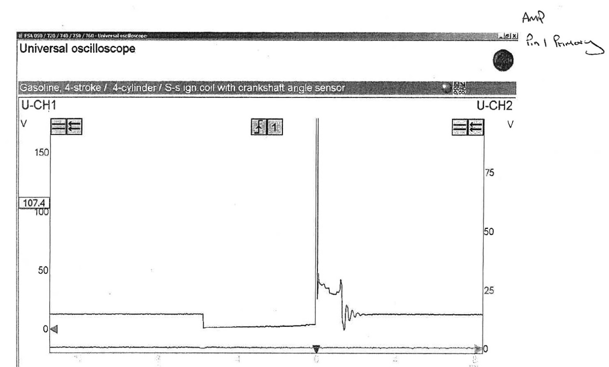
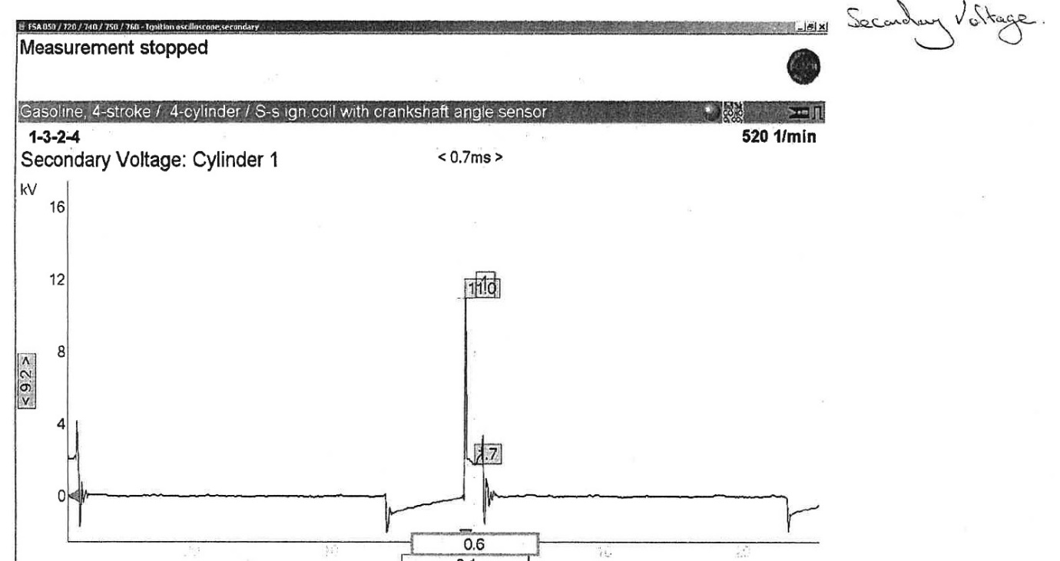
Appendix I

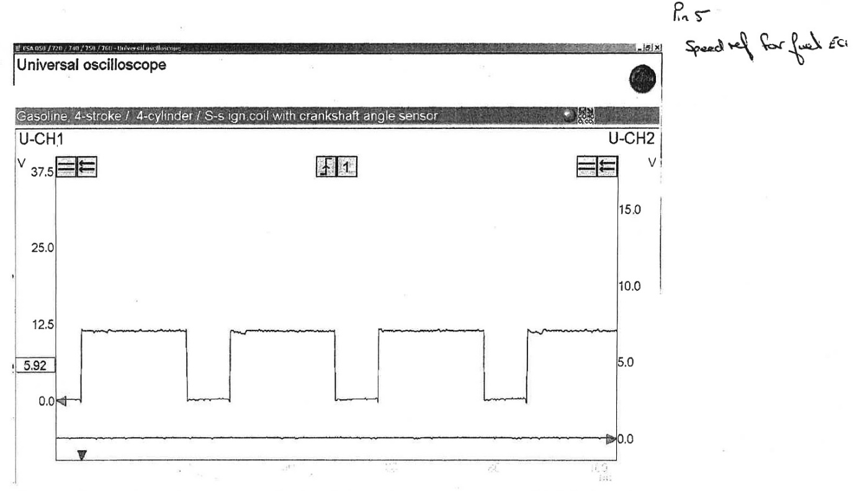
Appendix J

