Ffurflen Cyflwyno Aseiniad / Assignment Submission Form

COPI Swyddfa ACDSaW

Rhif Myfyriwr: 1709373

Enw’r Myfyriwr: Kevin Kelly

Enw’r Tiwtor: Julie Crossman

Teitl yr Aseiniad: Obstetric Bleeding Strategy for Wales (OBS Cymru) – A North Wales Perspective

Cod Modiwl: DSAW7058 (Leading Service Improvement)

Dyddiad cyflwyno: 17th Medi 2018

Ni fydd eich gwaith yn cael ei farcio heb y datganiad hwn.
Cadarnhaf mai fy ngwaith gwreiddiol yw hwn a fy mod wedi cadw at bolisi’r Brifysgol ar lên-ladrad.
Enw’r myfyriwr: Kevin Kelly Llofnod: 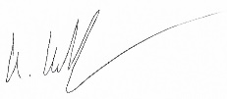

Staff ACDSaW yn unig
Derbyniwyd gan:_____________________Dyddiad cyflwynwyd:____________________

Derbynneb y Myfyriwr

Rhif Myfyriwr: ________________________________________________

Enw’r Myfyriwr: _______________________________________________

Enw’r Tiwtor: _________________________________________________

Teitl yr Aseiniad: ______________________________________________

Cod Modiwl: __________________________________________________

Dyddiad cyflwyno: _____________________________________________

Staff ACDSaW yn unig
Derbyniwyd gan:_____________________Dyddiad cyflwynwyd:____________________

Assignment Submission Form / Ffurflen Cyflwyno Aseiniad

WIWBL Copy
Student Number: 1709373

Student’s Name: Kevin Kelly

Tutor Name: Julie Crossman

Assignment Title: Obstetric Bleeding Strategy for Wales (OBS Cymru) – A North Wales Perspective

Module Code: DSAW7058 (Leading Service Improvement)

Submission Date: 17th of September 2018

Your work will not be marked unless it is accompanied by this statement.
I confirm that this is my original work and that I have adhered to the University’s policy on plagiarism.
Student’s Name: Kevin Kelly Signature:

WIWBL Staff only
Received by:_____________________Date submitted:____________________

Student Receipt
Student Number: ______________________________________________

Student’s Name: _______________________________________________

Tutor Name: _________________________________________________

Assignment Title: ______________________________________________

Module Code: __________________________________________________

Submission Date: _____________________________________________

WIWBL Staff only
Received by:_____________________Date submitted:____________________

Dr Kevin Kelly Welsh Clinical Leadership Training Fellow & Anaesthetic Registrar Student Number: 1709373
University of Wales Trinity Saint David
Module Code: DSAW7058 Leading Service Improvement Obstetric Bleeding Strategy for Wales (OBS Cymru) – A North Wales Perspective
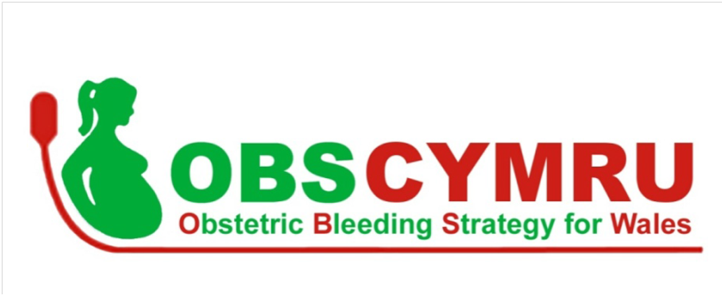
Table of Contents
Project Proposal: Obstetric Bleeding Strategy for Wales 5
(OBS Cymru) – A North Wales Perspective 5
Background 5
Methods 5
Ethics 5
My Leadership Role 6
Stakeholder Engagement 7
Change Management 7
Aims 7
Project Report: Obstetric Bleeding Strategy for Wales 8
(OBS Cymru) – A North Wales Perspective 8
The Scale of the Problem 8
OBS Cymru 8
OBS Cymru: Research into Practice 10
Initial Implementation Phase 10
Ethics 11
Structure and Funding 11
North Wales Perspective 12
Method 13
My Leadership Role 13
Facilitating Change 14
Stakeholder Engagement 16
PROMPT Wales 21
Results and Discussion 22
A Measure of Change 22
Run Charts of Blood Bank Data 23
Awards 28
OBS Cymru Clinical Governance Session 28
Conclusion 28
Acknowlegdments 28
References 29
Appendix 1 32
Appendix 2 35

Project Proposal: Obstetric Bleeding Strategy for Wales

(OBS Cymru) – A North Wales Perspective

Background
Postpartum haemorrhage (PPH) remains a challenging clinical problem to address. The most recent report on maternal deaths and morbidity (Knight et al, 2017) demonstrated an increase in mortality, from 0.5 to 1/100,000 maternities. It remains the second most common direct cause of death in pregnancy second only to venous thromboembolism (Knight et al, 2017). Morbidity is also a significant consideration, with the Scottish Confidential Audit of Severe Maternal Morbidity (SCASMM) noting that 80% of severe maternal morbidity was related to major obstetric haemorrhage (SCASMM, 2014).

Obstetric Bleeding Strategy for Wales (OBS Cymru) is a national quality improvement programme aiming to reduce harm from PPH across Welsh maternity services (OBS Cymru 1000 Lives National Improvement, 2017). The project is funded and supported by the Welsh Government, with support from the all health boards in Wales, 1000 Lives Improvement, Maternity Network Wales and the Wales Deanery.

Methods

Ethics
The Quality Healthcare Improvement Partnership provide guidance on how to assess the level of ethical oversight required for a project (QHIP, 2017). Under this guidance OBS Cymru is a quality improvement programme and not research. As such it does not require formal ethics committee review, but it does require oversight of the project to identify and address any ethical issues. To meet this need, the project was registered with the clinical governance department of each of the hospitals it was being implemented. A national data sharing agreement was signed by a spectrum of representatives from senior clinicians to the Caldicott guardians and facilitated by 1000 Lives Improvement Wales.

The programme was rolled out to all twelve Consultant Led Units (CLU) between February and April 2017 (500 -6000 deliveries/year).
The project involves implementing the four pillars of OBS Cymru;
- Universal risk assessment.
- Early Identification of abnormal bleeding by measurement of blood loss through weighing.
- Multidisciplinary team (MDT) review, at the bedside, early in the PPH and then participation in learning from the case review.
- Patient specific blood product management using blood gas and visco-elastometric point-of-care testing (VE-POCT) in the form of a ROTEM® device (ROTEM Sigma, 2018).

The project is now in its second year with the ongoing challenge of integrating the OBS Cymru quality improvement programme into routine practice across Wales. For my part of the project, I was specifically responsible for the three district general hospitals in North Wales. See Figure 1.

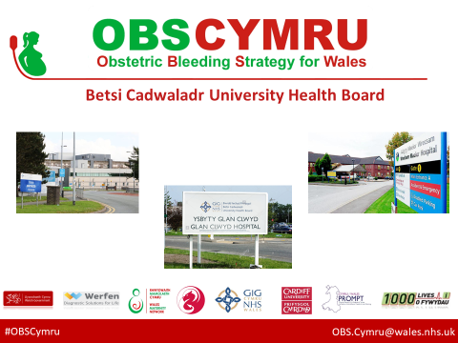
Figure 1. The three acute district general hospital in North Wales; Wrexham Maelor Hospital (Wrexham), Glan Clwyd Hospital (Bodelwyddan) and Ysbyty Gwynedd, (Bangor).

My Leadership Role
I will act as the team manager for the Betsi Cadwaladr University Health Board (BCUHB) supporting a network of multidisciplinary OBS Cymru champions to train and educate the wider delivery suite team. It is likely that due to lack of resources, my role will not be filled in August 18 /19, as such it is essential to focus on embedding the change in practice. I will also be the lead with regards to collating a retrospective database of all the twelve Consultant led delivery units in Wales of PPH related outcomes to act as a comparator and assess any changes that occur as a result of implementing OBS Cymru. This information is essential in order to aid engagement and further establish the OBS Cymru approach into normal practice.

Stakeholder Engagement
The main stakeholders to engage with will be obstetricians, midwives and anaesthetist. In order for the project to make an longlasting impact, it will be necessary to engage with all members of the delivery suite team. In addition, it will be important to work with support staff in haematology and blood transfusion. Of strategic importance will be the engagement of labour ward and hospital management to ensure the project receives the appropriate support at management level.

Change Management
In order to build on the work already carried out I will be utilising the Lewin 3 stage change model (Lewin, 1947), as each of the three sites in North Wales, much like the rest of Wales is still in a transition period of fully implementing the OBS Cymru approach. Other models that may be useful would be Kotter’s 8 stage approach (Kotter,1996) as it would fit a top down approach as directed by the national project team.

Aims
The project goal is to reduce maternal morbidity associated with PPH. A standardised, national approach is aimed at reducing variations in care and specifically targets:
- Halving the number of women requiring ≥ 5 units of red blood cells.
- Reducing the number of women experiencing massive PPH (blood loss >2500ml).
- Halving the number of women requiring level 3 (highest level of support) in critical care, secondary to PPH.
- Halving the number of women receiving hysterectomy secondary to PPH.
- Achieve more than a 50% reduction in the administration of fresh frozen plasma (FFP).
We hope to demonstrate these outcomes in BCUHB by July 2018.
Word Count 805/750

Project Report: Obstetric Bleeding Strategy for Wales

(OBS Cymru) – A North Wales Perspective

The Scale of the Problem
Haemorrhage is the leading cause of maternal death worldwide, representing 27·1% of maternal deaths (Say et al, 2014). More than two thirds of reported haemorrhage deaths occurred after the delivery of the baby and as such were classified as postpartum haemorrhage (PPH). The most recent report looking at maternal deaths and morbidity in the United Kingdom was by Knight et al (2017) and shows an increase in mortality, from 0.5 to 1/100,000 maternities due to haemorrhage. It remains the second most common cause of death in pregnancy directly attributable to the pregnancy, second only to venous thromboembolism. Of concern, this is the only direct cause of maternal mortality which is increasing (Knight et al, 2017). Morbidity is also a significant consideration, with the Scottish Confidential Audit of Severe Maternal Morbidity (SCASMM) noting that 80% of severe maternal morbidity was related to major obstetric haemorrhage (SCASMM, 2014). In a pilot study Mantel et al, (1998), outlined the classification system of describing type of maternal morbidity that can occur. The impact of the morbidity associated with a significant postpartum haemorrhage may include increased length stay in hospital, negative impact on mother baby bonding and anaemia.

OBS Cymru
To address this significant clinical challenge of improving the management of postpartum haemorrhage the Obstetric Bleeding Strategy for Wales (OBS Cymru) was formed. OBS Cymru is a national quality improvement programme aiming to reduce harm from PPH across the Welsh maternity services. (OBS Cymru 1000 Lives National Improvement , 2017). The scheduled timeframe for the OBS Cymru quality improvement programme is three years and encompasses multiple complex interventions on a national scale in order to achieve the goal of ‘reducing harm from post partum haemorrhage’ (OBS Cymru 2017).

The project involves implementing the four pillars of OBS Cymru (OBS Cymru 1000 Lives National Improvement , 2017) See Figure 2 ;
- Universal risk assessment of every woman giving birth in Wales to identify risks specific to that patient for postpartum haemorrhage before labour and as their labour progresses. In this way the appropriate team and skill mix can be planned to mitigate the risks identified.
- Early Identification of abnormal bleeding by the measuring of blood loss through weighing, as opposed to the previous practice of estimation, which is inaccurate. In work by Lilley et al (2015) it was shown that the “mean percentage error of measured blood volume was 4.0 ± 2.7% compared to visually estimated blood volume with a mean percentage error of 34.7 ± 32.1%.”. Not only is estimating blood loss inaccurate it can impact on the team dynamic as there is variation in opinion as to the significance of the blood loss. Invariably, the opinion of the most senior person involved is followed which is not always correct and can also lead to team disharmony. By weighing the blood loss, using scales or measuring using a calibrated suction device it negates these human factor issues as it allows the whole team to share the same reality. In essence, it allows the accurate diagnosis of a postpartum haemorrhage (PPH), this is essential as a PPH cannot be managed appropriately until it has been recognised.
- Prompt intervention and effective team working with multidisciplinary team involvement including a senior midwife, obstetrician and anaesthetist at the bedside of the patient. The goal being that by intervening early in the postpartum haemorrhage event, it can be controlled and managed effectively in order to prevent progression to point where significant morbidity or even loss of life is a potential outcome.
- Patient specific blood product management guided by point of care testing in the form of a ROTEM® device. Previous opinion on the transfusion management of PPH followed similar guidance to trauma patients as outlined in the recent BMJ article (Chandraharan & Archana 2017). This article advocates transfusing patients with four units of packed red cells and also giving 15ml/kg of fresh frozen plasma clotting products in the absence of any coagulation tests. A ROTEM® point of care coagulation testing device is an innovative piece of technology that allows for rapid assessment of the patient’s coagulation state.

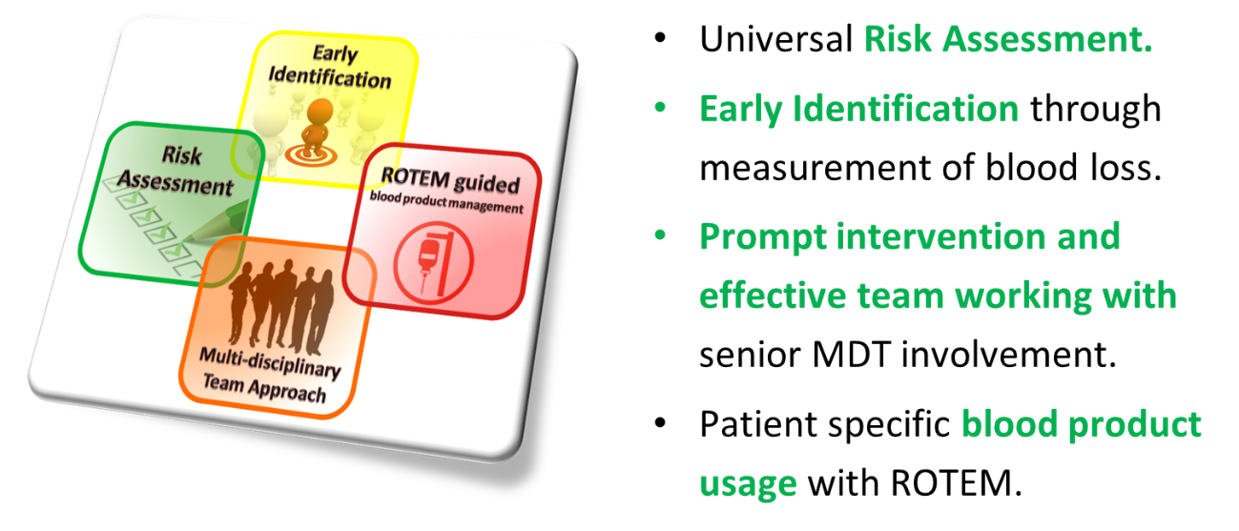
Figure 2. The four pillars of OBS Cymru

OBS Cymru: Research into Practice
The scientific basis for OBS Cymru has a strong foundation in research. As previously mentioned Lilley et al (2015) have highlighted the importance and accuracy of measuring blood loss during a postpartum haemorrhage. Charbit et al (2007) identified low fibrinogen levels as marker in progression to major obstetric haemorrhage. Low fibrinogen can be identified rapidly utilising the ROTEM® point of care testing device, facilitating early intervention and treatment.

Over a four year period of PPH research at University Hospital Wales, Cardiff the number of very large blood transfusions fell by 80% (Collins et al, 2017). In the OBS-2 trial (Collins et al, 2017) further explored the use point of care guided early fibrinogen concentrate infusion to improve outcomes in PPH. Point of care testing provides the facility to obtain rapid information on the clinical state of the patient, by processing the sample in close proximity to the clinical area. Instead of coagulation results being available in sixty minutes, they are available in ten minutes supporting the multidisciplinary team to make informed clinical decision in a more timely fashion. In the case of OBS Cymru this is using a ROTEM® device to gain information on the coagulation status of patient, whether they require blood products and if so it helps guide what that patient specifically needs. An observational study by Collins et al (2017), demonstrated the ability, to safely withhold blood products allowing a more conservative approach to their use, thus avoiding the risks associated with transfusion of clinically unnecessary blood products.

Initial Implementation Phase
The programme was rolled out to all 12 Consultant Led Units (CLU) between February and April 2017 (500 -6000 deliveries/year). See Figure 3.
Figure 3: Location of the twelve Consultant Lead Delivery Units in Wales.
The roll out was supported by an education programme focusing on how to measure blood loss and use of a standardised four stage paperwork tool. The four stage paperwork is a specifically designed universal document standardised across Wales to facilitate clear documentation of the risk assessment, act as an escalation tool and aide memoire to guide PPH management. Werfen the company behind ROTEM®, along with members of the national team provided training on how to technically run a test. An education session on the basis and evidence for OBS Cymru was delivered around the ROTEM® training. This covered the how to interpret the results with the aid of the OBS Cymru ROTEM® Protocol (OBS Cymru ROTEM® Protocol, 2016), and importantly the context behind it so people could understand the drivers to change practice.

Ethics
OBS Cymru is a quality improvement programme and not research, as such it does not require formal ethics committee review. It does however, require ethical oversight in line with the guidance set out in the Quality Healthcare Improvement Partnership (QHIP, 2017). The project was registered with the clinical governance department of each of the hospitals it was being implemented in. A national data sharing agreement was signed by representatives of each of the health boards and facilitated by 1000 Lives Improvement Wales.

Structure and Funding
The project has multiple funding streams with the initial major grant coming from an efficiency through technology fund from Welsh Government. The project has support from the all health boards in Wales, 1000 Lives Improvement, Maternity Network Wales and the Wales Deanery. See Figure 4.

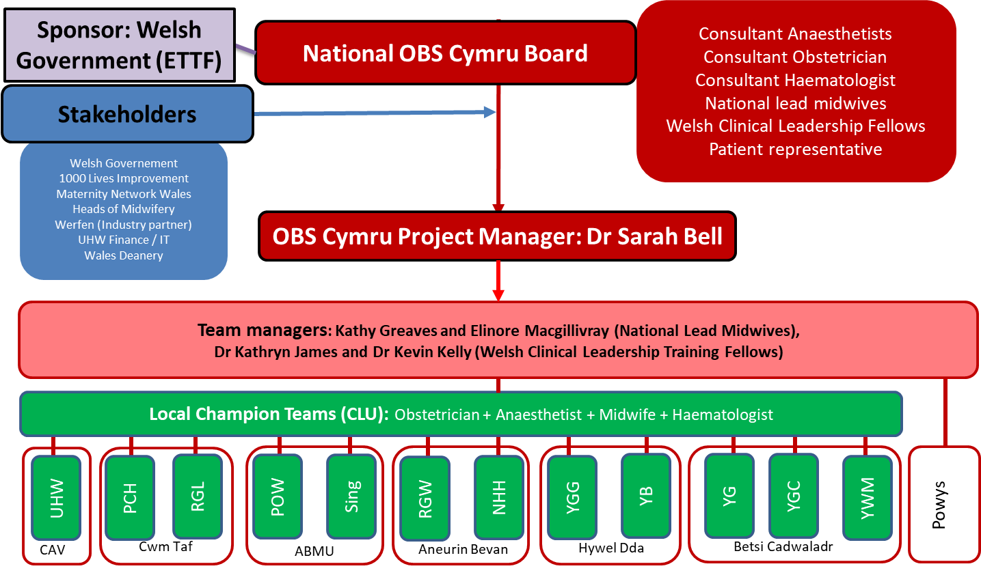
Figure 4. The project management structure of the OBS Cymru project

North Wales Perspective
On commencing the role, it was apparent that there were a number of significant challenges to face in particular sites. Early figures from the national database highlighted that there was potentially an increased rate of postpartum haemorrhage in one of the Consultant led obstetric units in North Wales in comparison to the rest of Wales. In the recent past the fate of the delivery suites on each of the three sites was in doubt as BCUHB considered re-organisation of maternity services (BBC News 2015). This uncertainty and coupled with recruitment challenges in North Wales can impact on how well a team can implement change and sustain it.

Site Visits
A useful tool utilised was the Ishikawa fishbone analysis to assess the progress made from the initial site visits. John M et al, (2017) used this tool (see Figure 5) to assess readiness of the Consultant lead units in Wales to deal with a postpartum haemorrhage. It was modified for the follow up visits, to act as a focus for discussion and to see how the each site was managing their own specific challenges.
Figure 5: An updated version of the Ishikawa analysis tool used for the second wave of site. Original version from ’Evaluating readiness for managing postpartum haemorrhage in consultant led units across Wales’ (John M et al, 2017).

Method

My Leadership Role
Prior to taking up my role with OBS Cymru project I was acutely aware that I was joining a well established team going into its second year of a three year project, which would pose particular challenges and therefore provide invaluable learning opportunities.

My specific role within the project was to act as the project team manager for BCUHB, covering three consultant lead delivery suites. See Figure 4. This would entail supporting the local OBS Cymru multidisciplinary champions on the ground, to implement, embed and consolidate the change in practice required to realise the vision of OBS Cymru.

Additionally I am a member of the national project team who is responsible for the direction and management of operational issues and logistics relating to the project. I am also a member of the OBS Cymru national board, which focuses more on the strategic direction of the programme and includes lay representatives along with members of the Maternity Network Wales (Maternity Network Wales, 2015). From the driver diagram from OBS Cymru (see Figure 6), a significant amount had been achieved by the team already prior to my involvement.

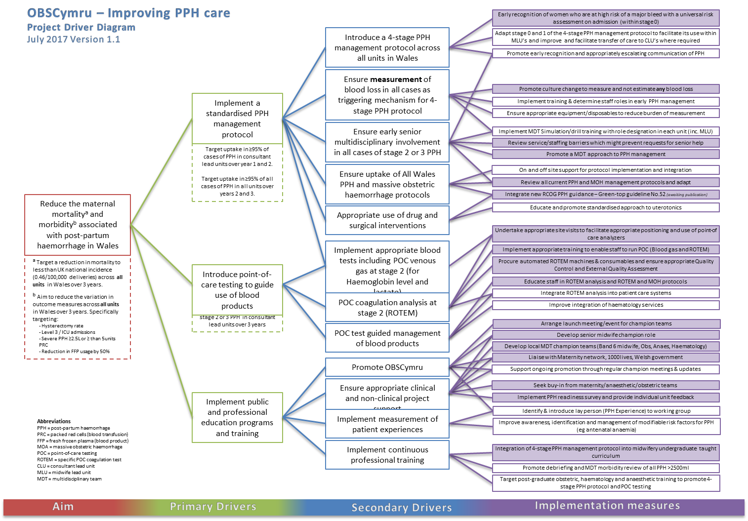
Figure 6: Progress of the OBS Cymru project as of July 2017 (Produced by OBS Cymru Team, July 2017)
I very much view my role as building upon and consolidating the progress that had been made to date and see how the project could mature. Key to this was accumulating evidence and outcome data to demonstrate the impact of the OBS Cymru programme in the twelve CLUs in Wales.

It was a clear priority in order to maintain momentum and preserve credibility that hard outcome data was available and importantly that this could be measured against baseline information prior to the inception and roll out of OBS Cymru. This information is essential in order to aid engagement and further embed the OBS Cymru approach into normal practice.

Facilitating Change
In terms of barriers to getting the project ingrained into the culture at each of the three North Wales Consultant led sites, I was aware that there was variation within each unit depending on staff skill mix. Clinical approaches towards PPH also differ between sites. I choose to take a different strategy with each of the sites depending on the units performance and history.

Ysbyty Gwynedd
In July 2013 there was maternal death due to postpartum haemorrhage (BBC News, 2014). As a result, measuring blood loss was introduced a number of years before the implementation of OBS Cymru. There is a strong cohort of the MDT who are very committed to improving and engaging with OBS Cymru. For this reason , the change management model proposed by Kotter (1996) could be a suitable model, as they were very much operating at the higher level of the 8 stage model with the focus on step 7, which is consolidation of progress.

Glan Clwyd Hospital
Glan Clwyd was an early adopter site, with one of the senior Consultants of the national board present on labour ward. The change management theory potentially used here would be from Lewin (1947). The project has been taken up very well, with the majority of staff buying into the change in practice. The priority now is to ‘refreeze’ and embed the good practice improvements. See Figure 7
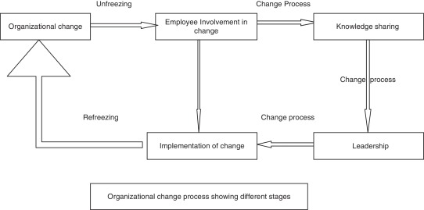
Figure 7: The three step change model of organizational change as described by Lewin (1947).

Wrexham Maelor Hospital
As mentioned previously this hospital was identified as an outlier in Wales due to the rate of significant bleeds occurring. When this was raised with the delivery suit MDT, there was a variation in response, which mirrored every stage of the Kübler-Ross change curve. See Figure 8.
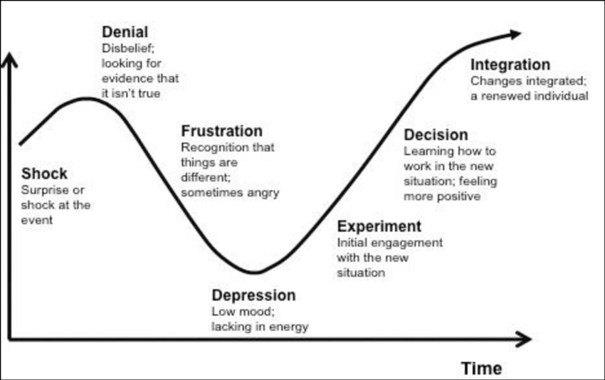
Figure 8: Kübler-Ross change curve (Kübler-Ross E, 1947)
There were repeated challenges made to question the evidence behind the project. This is in keeping with the second stage of the Kübler-Ross change curve (Kübler-Ross E, 1947), especially the trigger point at which the MDT team in contacted to rapidly assess the patient by the bedside. There was frustration (stage 3) as a common feedback was that this trigger of intervention was too early. It was a communications challenge to move people from denial to at least an experimental phase. Handy (2009) provides a template of how to interact with people who may require different approaches to communication comparing different group in terms of Greek Gods each requiring very different communication strategies. Another resource that was useful in planning how to overcome the communication and performance challenge was work done by The Kings Fund on leading across the healthcare system (The Kings Fund, 2017). In this work they outline ‘Five factors that facilitate system leadership’ (see Table 1.
- Develop a shared purpose and vision.
- Have frequent personal contact.
- Surface and resolve conflicts.
- Behave altruistically towards each other.
- Commit to working together for the longer term.
Table 1: The Kings Fund (2017) found that ‘five factors in particular offer a helpful way of framing the challenges system leaders are facing’.
I found this to be a reassuring document, as on reflection, I felt that the key factors identified and the rationale behind them, fitted very closely to my natural personal leadership style. I particularly identified with point two, as I feel that the most productive meetings and networking opportunities arose when I invested time to have face to face meetings with stakeholders. The Kings Fund (2017) state that ‘face-to-face meetings enable leaders to build rapport and understanding and to appreciate and acknowledge each other’s problems and challenges’.

Stakeholder Engagement
The main stakeholders to engage with will be obstetricians, midwives and anaesthetists. For the project to succeed however, and achieve a sustained change in practice, it will be necessary to engage with all members of the delivery suite team. It was essential to be inclusive in the process of changing the management of postpartum haemorrhage, as the approach was innovative and a huge shift from previous clinical practice. Various approaches were used, which will be outlined below, to engage with all the members of the delivery suite team, in order to share the vision of the benefits that OBS Cymru approach represent. Having a clear vision and being inclusive is consistent with step 3 ‘developing a strategic vision’ and step 4 ‘involving everyone in the plan’ of Kotter’s eight step model of change management (Kotter JP, 1996).
Weller et al (2014) proposed seven interventions to address and overcome barriers to effective teamwork in healthcare and breakdown some of the walls between different tribes of the multi-professional team. In their work, they hypothesise that ‘improvement in teamwork in healthcare can lead to significant gains in patient safety, measured against efficiency of care, complication rate and mortality’ (Weller et al, 2014).
Action | Decription | OBS Cymru Action
‘Teach effective communication  Strategies’ | ‘Teaching structured methods of  communication, such as ‘SBAR’ handovers, can improve patient outcomes.’ | Use of the standardised OBS Cymru communication paperwork.
‘Train teams together’ | ‘Teams that work together should train together. Training that includes all members of the team improves outcomes.’ | Incorporation of OBS Cymru into mandatory midwife training and into MDT clinical governance training sessions.
‘Train teams using simulation’ | ‘Using simulation is a safe way to practice new communication techniques, and it increases interdisciplinary understanding.’ | Using simulation to explore and improve communications challenges. Simulation also useful to assess the robustness of emergency procedures in action.
‘Define inclusive teams’ | ‘Redefine the team of healthcare  professionals from a collection of disciplines to a cohesive whole with common goals.’ | Shared agenda and understanding of OBS approach ‘the four pillars of OBS Cymru’.
‘Create democratic teams’ | ‘Each member of the team should feel valued; creating flat hierarchies encourages open team communication.’ | Regular feedback sessions and clinical governance to promote the process and highlight how each team member has a role and is integral to it.
‘Support teamwork with protocols  and procedures’ | ‘Use procedures that encourage information sharing among the whole team, such as checklists, briefings and IT solutions.’ | OBS Cymru Quality and Safety Sub Group of Maternity Network Wales. All Wales Guideline Prevention and Management of Postpartum Haemorrhage (2018)
‘Develop an organisational culture supporting healthcare teams' | ‘Senior champions and department heads must recognise the imperative of interprofessional collaboration for safety.’ | Network of local OBS Cymru champion collaborating across health board boundaries.
Table 2: The seven interventions proposed by Weller et al (2014) to improve teamwork and communication, and how OBS Cymru has addressed these recommendations.

Communication strategy
As well as face to face meetings and Information sessions, other opportunities for engagement and feedback were utilised. Additional information was available via multiple platforms; the OBS Cymru webpage on the 1000 Lives Improvement Wales and social media in the form of Twitter®. The #OBSCymru and #Measuredbloodloss was used to inform and promote any events at which OBS Cymru were presented at. In addition to social media there was bi monthly newsletter and an OBS Cymru email address so that people could get in contact to give feedback or ask questions. The project was also widely publicised in an article in Anaesthesia News (James & Kelly, 2018) which reached an Irish and United Kingdom audience.
A second annual OBS Cymru national project event was organised for the MDT champions (held on 23rd January 2018). This event allowed the national team to feedback some of the initial data, but also have the local champion discuss and share their experiences and challenges of implementing the project. This facilitated a culture of open shared learning and opportunity for participation in planning the future direction of the project.

National Prospective Database
Reliable data collection and subsequent analysis is a key requirement in any quality improvement initiative. Due to the scale and collaborative nature of the OBS Cymru project, working across health board boundaries, it was necessary to create a bespoke database held centrally with the support of 1000 Lives Improvement Wales. The database is only accessible from within NHS Wales, by use of the NADEX/Cymru user login for NHS Wales. Individual access had to be granted by the author of the database, and was requested by an OBS Cymru champion or by one of the team managers.
Key dialogue with the OBS Cymru midwives resulted in multiple changes made to the database in terms of the burden of data required along with making it more user friendly. It has been integral to showing each site retains ownership of their own data, while simultaneously contributing to the all Wales picture. The information gathered from the national database will be essential in shaping how the project moves forward in terms of focus and scope. As the year progressed it became clear that the database not only provided a means of recording data, it was hugely important as an engagement tool, as the run chart options with in the database gave monthly contemporaneous feedback to each Consultant led delivery suite. See Figure 9.
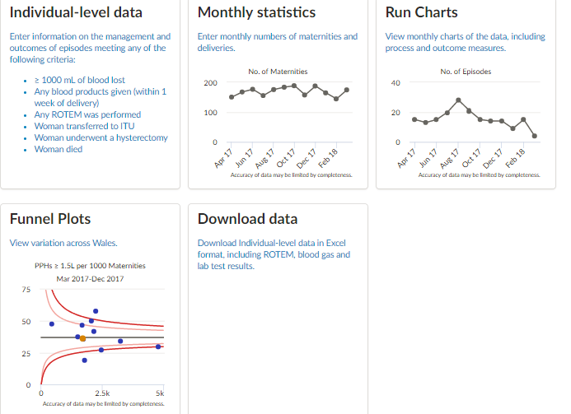
Figure 9: Screen shot of OBS Cymru national prospective database, with options to download all the units data into a spreadsheet for analysis and see how each unit compared with respect to rates of PPH and use of blood products.

Measuring Blood Loss (MBL)
Ongoing measurement of blood loss has been facilitated by a new whiteboard (see Figure 10) in all three delivery suite theatres in BCUHB. Pivotal to this is the agreement by MDT of liquor volume during the case rather than at the end. Everything else is considered blood and calculated from the weighed swabs, by subtracting the dry weight of the swabs. A running total is documented on the board for all to see and has been extremely helpful for recognizing and supporting open communication and escalation.
Healthcare assistants have been integral to the process as they have been empowered to weigh swabs and measure suction routinely. Whilst measuring blood loss has been a cornerstone of the project, it has also proved one of the more challenging aspects of change that required management with investment of time and resources. Regular individual training sessions have been undertaken with members of the MDT focusing on; obstetricians, anaesthetists, scrub nurses and midwives to ensure that MBL is the terminology in Wales not estimated blood loss (EBL). It is too important an issue to guess.

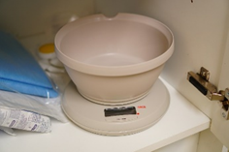 | 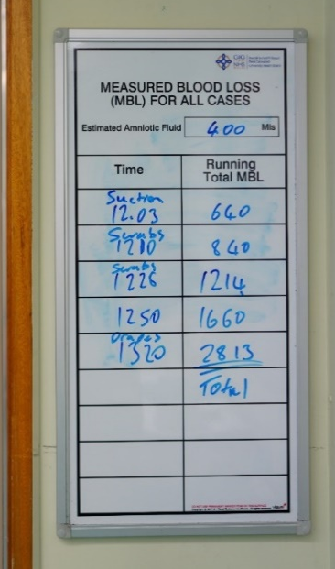
Figure 10: Scales which are in every labour room in Glan Clwyd, with Ysbyty Gwynedd and Wrexham having a defined MBL process with mobile scales. Example of how the measruing blood loss board in Glan Clywd has been used.

Labour Ward Forums
Of strategic importance was engagement with labour ward and hospital management to ensure the project and staff involved are supported in their job planning. To ensure this I attended local labour ward management meetings in each of the three hospitals in addition to bi-monthly health board wide labour ward management meetings. Through involvement as a member of these management groups, I ensured that OBS Cymru remained a standing agenda item. I also was able to network with the people who would be integral to ensuring the logistics and financial infrastructure remained in place after the initial three year quality improvement programme ended.

Awards
One of my responsibilities this year to submit applications for patient safety awards and academic organisations. From a strategic perspective opportunity it would present to raise the profile of the project on and national and international level. Locally it was useful as a motivational tool to improve engagement as Maslow’s hierarchy of needs (see Figure 11) describes that involvement in something deemed worthwhile by your peers and externally meets a psychological need (Maslow AH, 1954). Being award winning was useful to build political favour with 1000 lives, Welsh Government, our industry partner and also the Wales Deanery.

Figure 11: Maslow’s hierarchy of needs. (Maslow A 1954)

PROMPT Wales
PROMPT (PRactical Obstetric Multi-Professional Training) is an evidence based multi-professional training package for obstetric emergencies which has been embraced in multiple countries. The key outcomes are that it is ‘associated with direct improvements in perinatal outcome and has been proven to improve knowledge, clinical skills and team working’ (PROMPT Maternity Foundation, 2008). It is very much in keeping with guidance that ‘teams that work together should also train together, with regular training taking place on the labour ward rather than on ‘away days’ and being seen as a core activity rather than an optional extra’ (The Kings Fund, 2008). The Maternity Network and Welsh risk pool in Wales rolled out a specific PROMPT Wales (2018) programme aiming to achieve the improvements in outcome measures listed above. In light of this, I attended a PROMPT course and successfully progressed to becoming a PROMPT instructor. This served several purposes, the majority of PROMPT instructors were also key stakeholders for OBS Cymru, and being involved I was able to ensure that the PPH simulation station was consistent with the principles of OBS Cymru. Through engagement with the PROMPT team by the national project team, the PROMPT Wales simulation scenarios and teaching sessions have been amended to ensure they cover the four pillars of OBS Cymru as described previously (OBS Cymru 1000 Lives National Improvement NHS Wales, 2017).

Results and Discussion

A Measure of Change
Outcome measure data (see Figure 12) was sought from each maternity units, intensive care units and haematology departments in BCUHB to obtain retrospective data from January 2013 to December 2016 to match up with data from the prospective database. This information was also requested from the rest of the Consultant led units in Wales via the local OBS Cymru network of champions. The potential impact of the new General Data Protection Regulation (European Parliament GDPR, 2018) was discussed as a possible threat to the database. The database and process of data collection was assessed as compliant with the change in legislation by the national project team. Prospective data collection included:
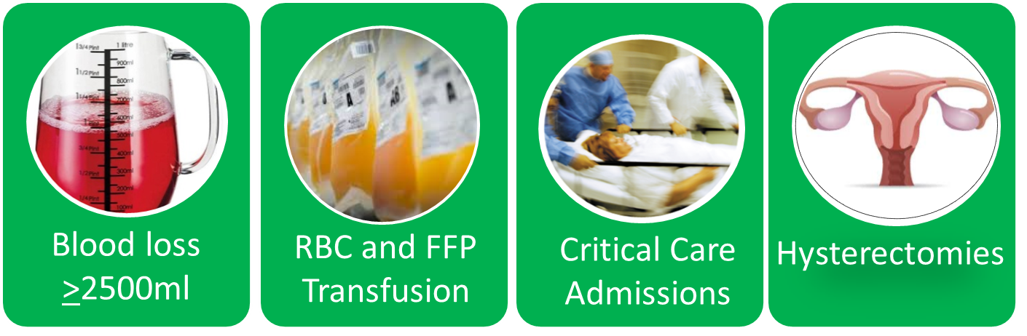

Figure 12: Outcome measure data obtained from retrospective review of labour ward statistics, blood bank and intensive care. Same outcomes assessed via the OBS Cymru national prospective database.
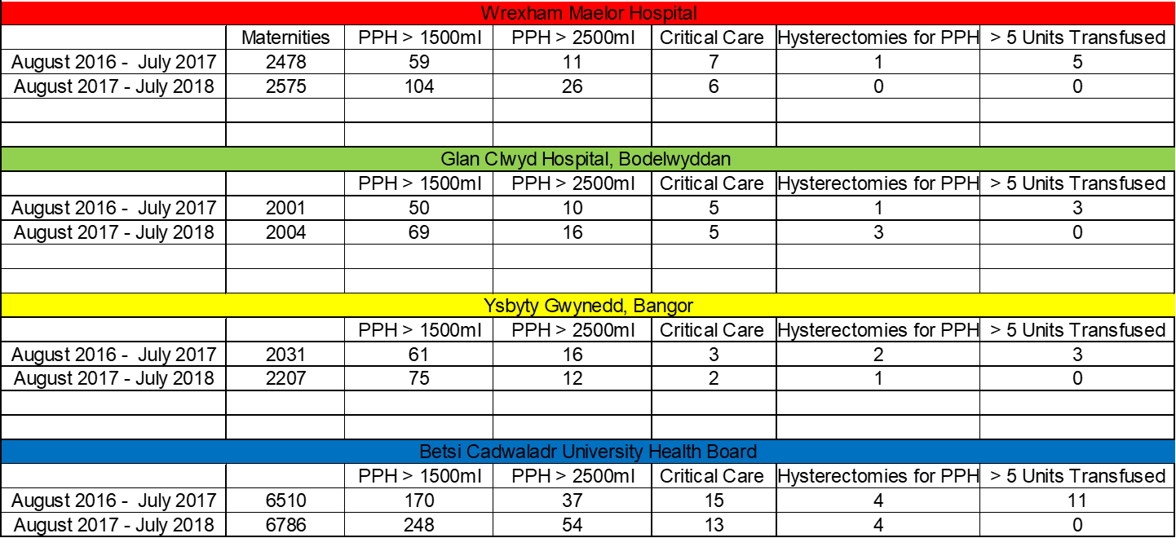
Figure 12: Outcome data from delivery suite comparing data from August 2016 to July 17 with August 2017 to July 2018.
Figure 12 illustrates that the project did not achieve the changes in outcomes targeted. There was an increase in the number of bleeding episodes over 1000ml and also in the category over 2500ml . It is highly likely that this increase in number if related to the change in practice of actually measuring blood loss and represents a true reflection of the clinical picture. Data from the first year of OBS Cymru on a national level was showing a rate of 9.6% for bleeds over 1000mls (James et al, 2018). The rate of PPH is higher than previously published, however previous figures were based on estimated blood loss. Comparing the rate of episodes where the blood loss is greater than 2500ml, it is similar to previously published figures.
There has been a noticeable is the change in transfusion practice with a huge reduction in the number of massive transfusions, that is those women who received over five units. This has reduced from eleven for all the for the health board to zero). This mirrors the outcome seen during the initial period of research in Cardiff as described by Collins et al (2018).

Run Charts of Blood Bank Data
The change in transfusion practice is more noticeable when seen the context of a statistical process control chart. This was based on the retrospective data combined with prospective blood bank data to give a monthly summary of change in transfusion practices. This information was then fed back to the respective labour wards and also to the national team where was used to illustrate the impact of the project at multiple meetings. In this way the local change management techniques employed at a local level in BCUHB had a major impact on the direction of the national project. See Figures 13 to 20.
For each of the graphs the Y– axis is number of units of a particular type of blood product transfused, whether that is pack red cells to improve oxygen delivery or fresh frozen plasma with the aim to improve clotting. The X – axis is time in months. UCL and LCL stand for upper control limit and lower control limit respectively and denotes a point approximately three standard deviations from the mean. What this means is that any data point outside of these lines is highly unlikely to be a result of chance alone.

Whilst having a health board wide picture, it was important to look at each specific unit in isolation, as when reviewing the data on red cell usage for Wrexham it is clear that the same reduction in red cell usage seen in the other two sites is not replicated. This was consistent with how project was in place on each of the units, with Glan Clwyd highlighted as an early adopter site in Wales, while Wrexham was at the other end of the scale. What is important though is to recognise that each site has a different baseline performance and its own challenges. Each unit will make progress at different rate. It takes time to implement a significant change in practice and even longer to see the improvements. It may take months if not years for the full benefits in terms of outcome measures to come to fruition.
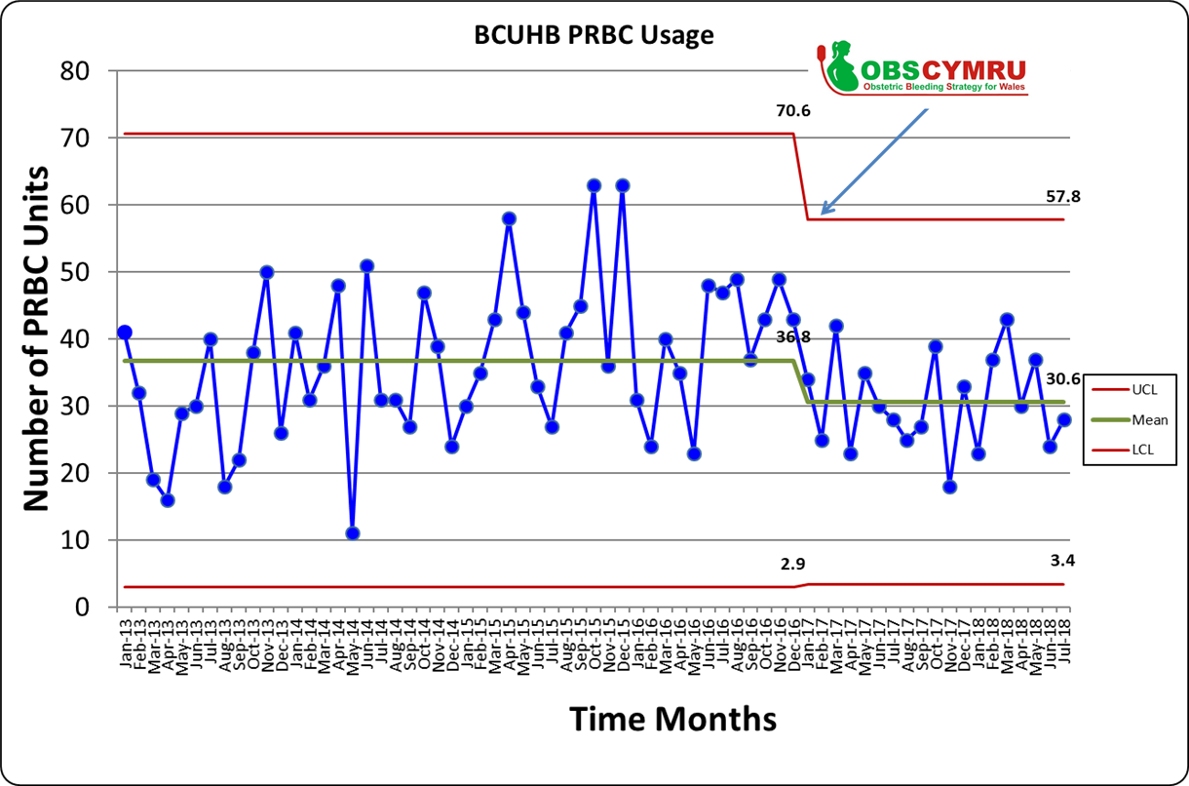
Figure 13: Run chart of red cell usage in BCUHB since in the start of OBS Cymru showing a reduction in variation and average monthly use of blood products.

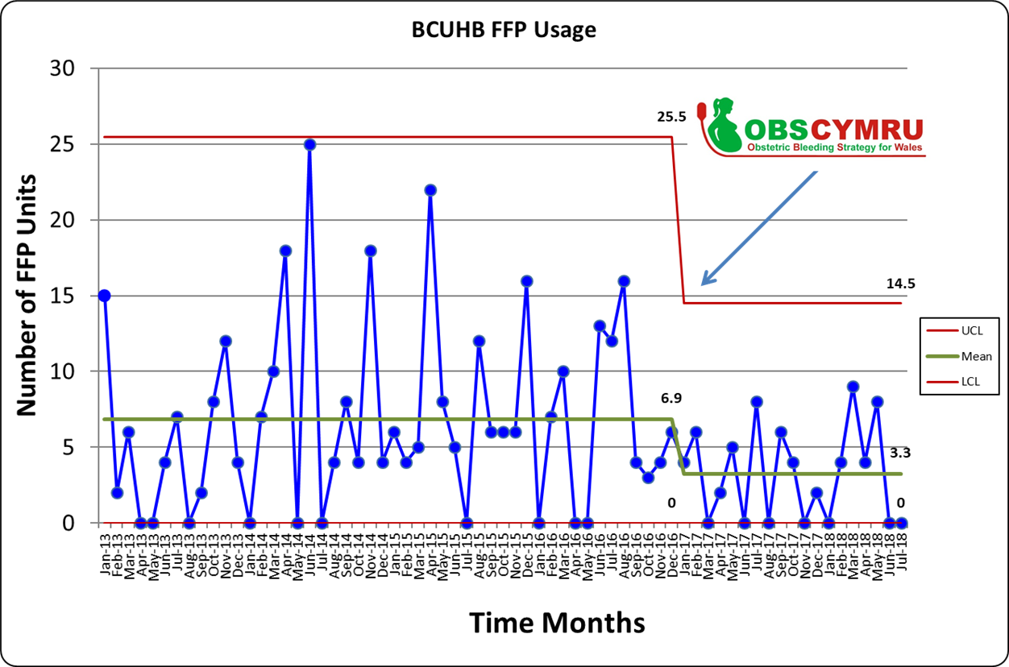
Figure 14: Run chart data plotting the number of units of fresh frozen plasma clotting products transfused to obstetric patients each month in BCUHB. Data Source is historic blood bank data obtained as part of the process of establishing baseline transfusion practice and outcome measures prior to the implementation of OBS Cymru.
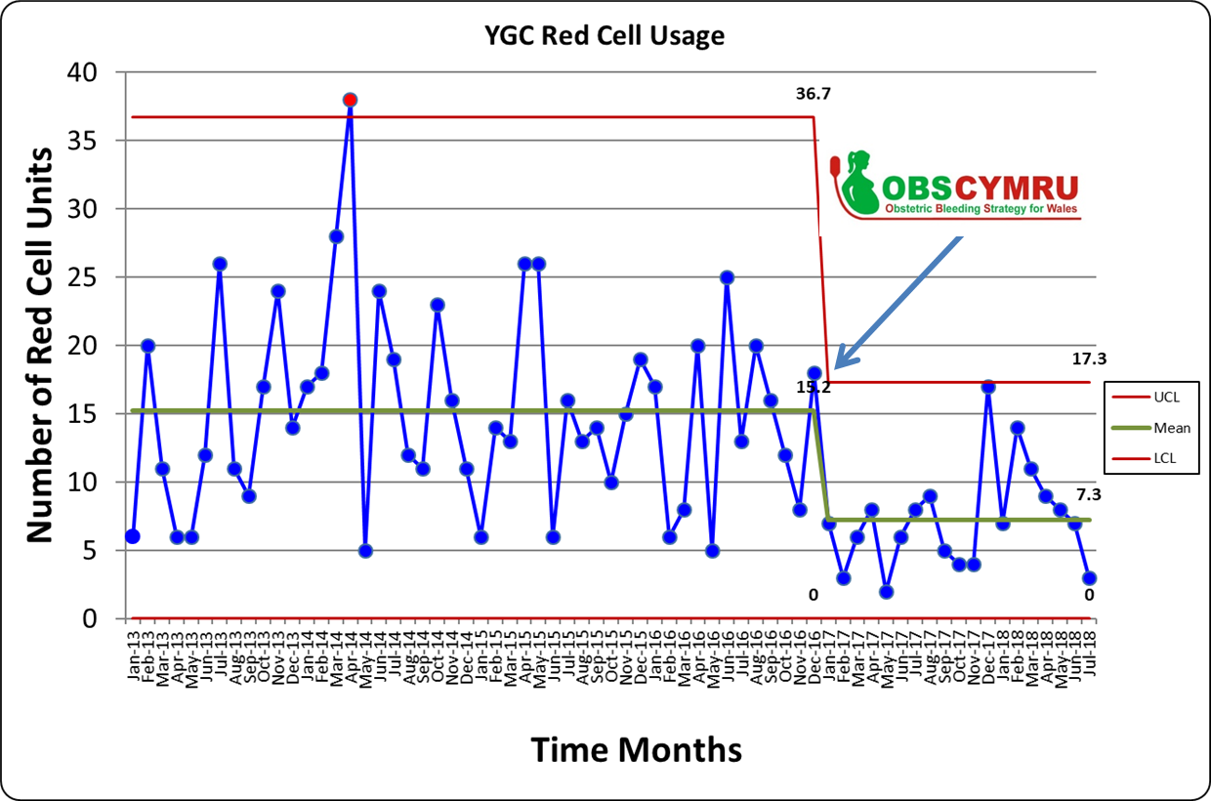
Figure 15: Run chart data plotting the number of red cell transfused for obstetric haemorrhage in Glan Clwyd Hospital since the start of OBS Cymru showing a reduction the average monthly use of red cells as well as reduced variation.
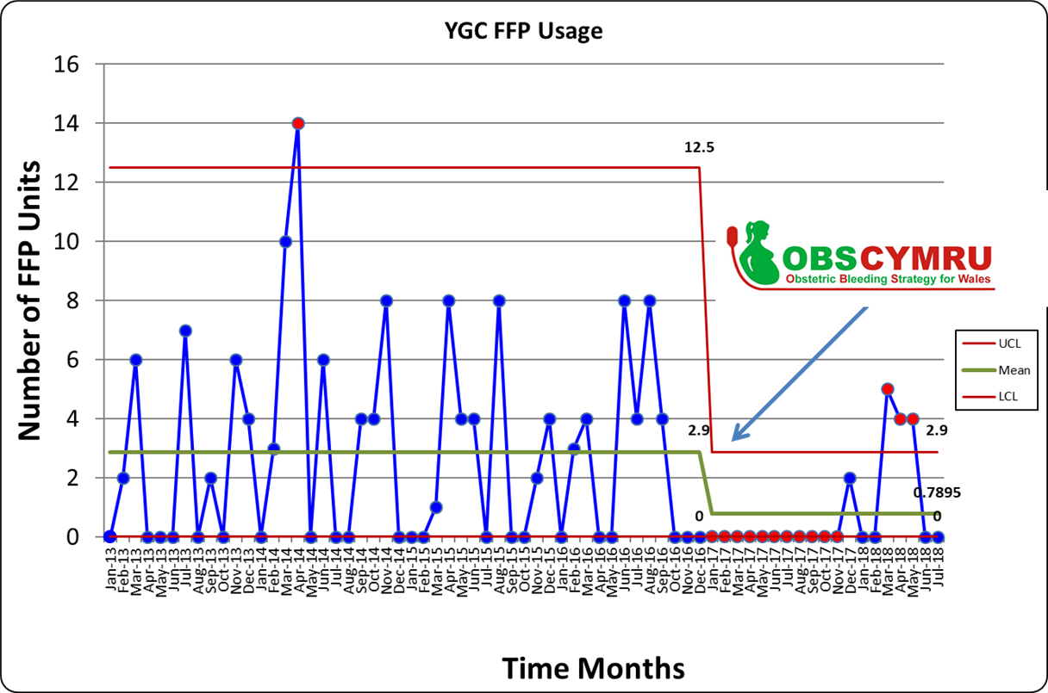Figure 16: Run chart data plotting the number of units of fresh frozen plasma clotting products transfused in Glan Clwyd Hospital for obstetric haemorrhage, since the start of OBS Cymru showing a significant decrease the average monthly use.
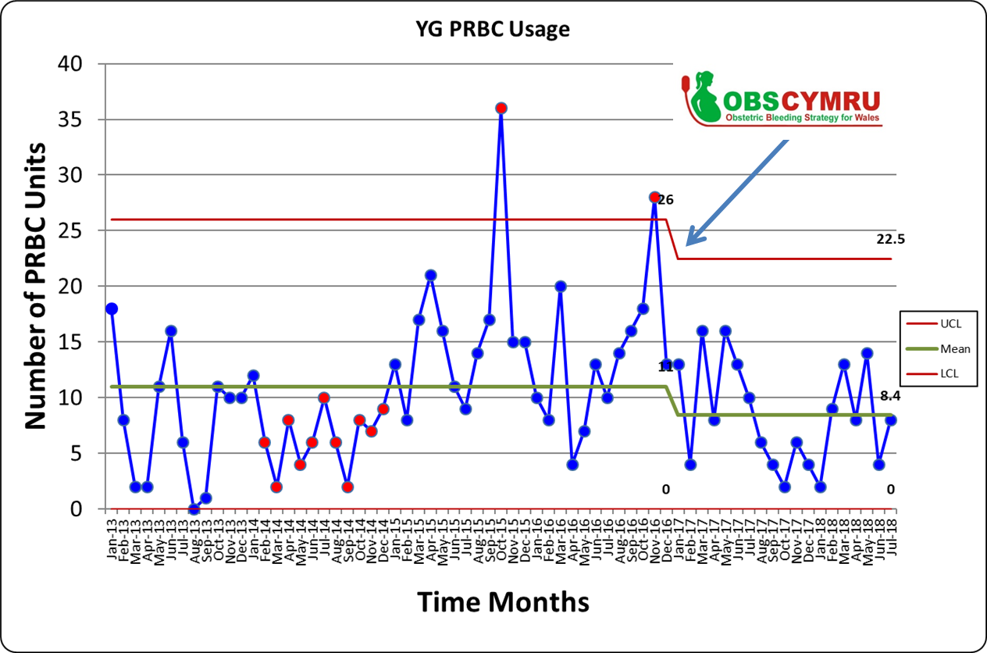
Figure 17: Run chart data plotting the number of red cell transfused for obstetric haemorrhage in Ysbyty Gwynedd, since the start of OBS Cymru showing a reduction the average monthly use of red cells as well as reduced variation.

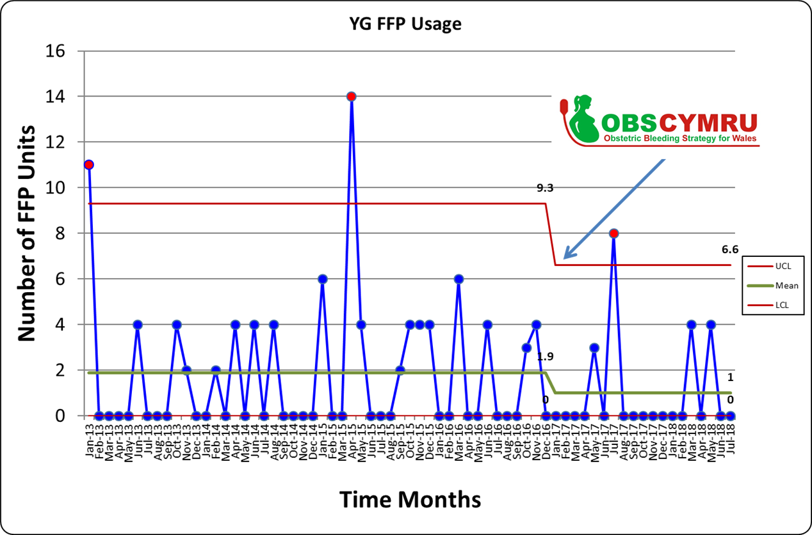
Figure 18: Run chart data plotting the number of units of fresh frozen plasma clotting products transfused in Ysbyty Gwynedd for obstetric haemorrhage, since the start of OBS Cymru showing a decrease the average monthly use.
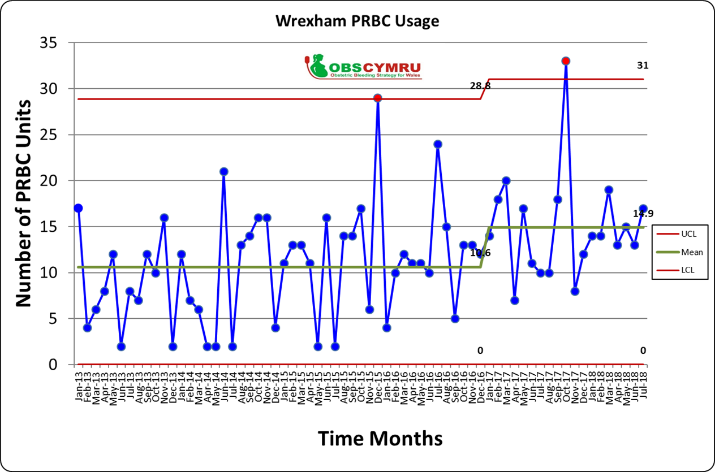
Figure 19: Run chart data plotting the number of red cell usage in Wrexam Maeolor Hospital since the start of OBS Cymru showing an increase the average monthly use of red cells.

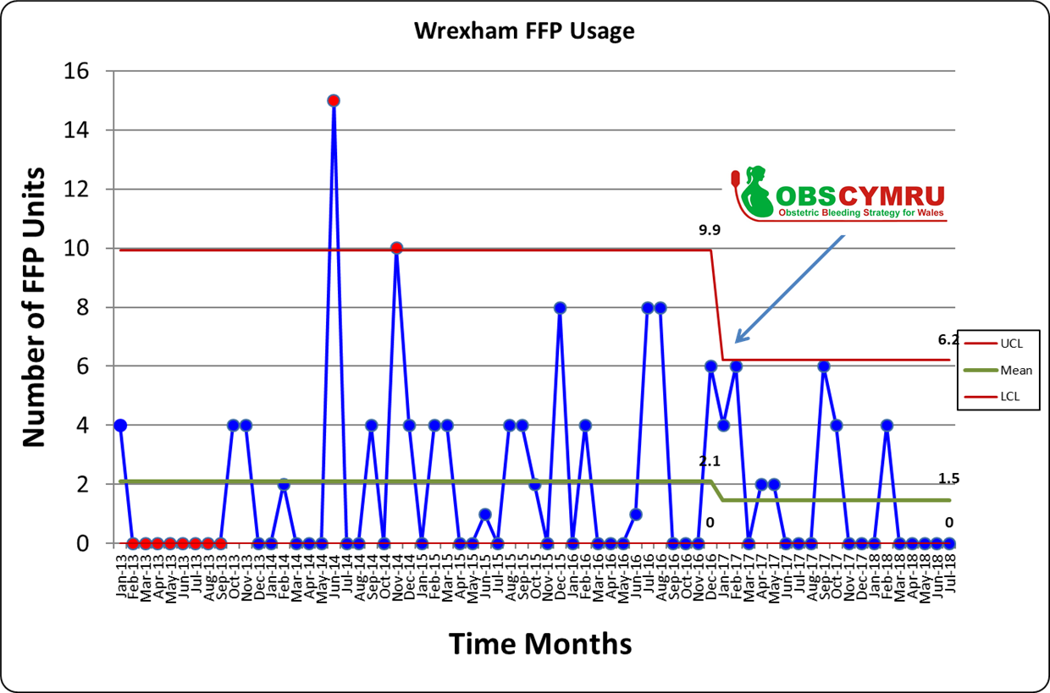
Figure 20: Run chart data plotting the number of units of fresh frozen plasma clotting products transfused in Wrexam Maeolor Hospital since the start of OBS Cymru showing a decrease average monthly use and variation.

Awards
Though only in its second year the OBS Cymru project is already award winning as it won an award at MediWales Innovation Awards (2017) in the efficiency through technology fund (ETTF). This award was highly useful to engage with members of the MDT to reward and share the success achieved. The project was a finalist at the patient safety awards and was also shortlisted for a prize at the Obstetric Association of Anaesthetist annual conference. Central to both presentations was the use of the run charts of blood product usage for early adopter sites such as Glan Clwyd. OBS Cymru is also nominated for an NHS Wales award as an example of ‘integrating research into a quality improvement project to reduce harm from postpartum haemorrhage' (NHS Wales, 2018). Glan Clwyd, an early adoptor site was choosen to represent OBS Cymru.

OBS Cymru Clinical Governance Session
‘Simulation-based training, which assesses clinical, communication and team skills within a single exercise, should be offered to all maternity staff, ideally within their own units.’ (The Kings Fund, 2008). Running a high fidelity simulation OBS Cymru scenario was an aspiration for the year. This was achieved in June 2018 (See Appendix 1 for programme) with a fifty strong multi disciplinary training session, with a highlight being the simulation session with debrief (See Appendix 2).

Conclusion
OBS Cymru is a multidisciplinary national programme achieving change across Welsh maternity services. Successful engagement with a network of local multidisciplinary champions have supported the sharing of best practice to successfully overcome the challenges of project implementation and integration to normal everyday practice.
Measuring blood loss has been a huge shift in culture and instrumental in ensuring a shared language and understanding when objectively assessing the severity of a postpartum haemorrhage. Moving forward into the final year of the quality improvement phase, processes are now in place with blood bank to monitor outcome measures and ensure that the project’s success continues

Acknowlegdments
I am grateful for the experience of working with the national OBS Cymru project team. It been a privilege to be involved. I wish thank Adam Watkins, Information Analyst from 1000 Lives Improvement Wales, who created the national prospective database for OBS Cymru. Lastly and most importantly, I am extremely grateful to all the OBS Cymru Champions in each hospital in Wales and particularly those based in the BCUHB for their hard work and dedication.
Word Count 4590/4500

References
BBC News (2014) Mother dies after caesarean section. Accessed August 28th 2018. Available at https://www.bbc.co.uk/news/uk-wales-north-west-wales-27621337
BBC News (2015) Maternity care shake-up in north Wales goes to consultation. Accessed 28th August 2018. Available at: https://www.bbc.co.uk/news/uk-wales-33962830
Chandraharan E, Krishna A (2017). Diagnosis and management of postpartum haemorrhage BMJ 2017; 358 :j3875
Charbit B, Mandelbrot L, Samain E, Baron G, Haddaoui B, Keita H, Sibony O, Mahieu-Caputo D, Hurtaud-Roux MF, Huisse MG, Denninger MH, de Prost D. (2007) The decrease of fibrinogen is an early predictor of the severity of postpartum hemorrhage. Journal of Thrombosis and Haemostasis 2007;5:266–273.
Collins PW, Cannings-John R, Bruynseels D, Mallaiah S, Dick J, Elton C, Weeks AD, Sanders J, Aawar N, Townson J, Hood K, Hall JE, Collis RE. Visoelastometric-guided early fibrinogen concentrate replacement during postpartum haemorrhage: OBS2, a double-blind randomized controlled trial. British Journal of Anaesthesia. 2017 119(3):411-421
Collins PW, Cannings-John R, Bruynseels D, Mallaiah S, Dick J, Elton C, Weeks A, Sanders J, Aawar N, Townson J, Hood K, Hall J, Harding K, Gauntlett R, Collis R. Viscoelastometric-guided fresh frozen plasma infusion for postpartum haemorrhage: OBS2, an observational study. British Journal of Anaesthesia. 2017 119(3):422–434.
Collins, P., Bell, S., de Lloyd, L., Collis, R. (2018) Management of postpartum haemorrhage: from research into practice, a narrative review of the literature and the Cardiff experience, International Journal of Obstetric Anesthesia (2018), In press. doi: https://doi.org/10.1016/j.ijoa.2018.08.008
European Parliament. The General Data Protection Regulation 2016/679 (May 2018). Accessed 10th May 2018. Available at: https://eugdpr.org/
Handy C (2009) Gods of Management – The Changing Work of Organisations. London: Souvenir Press Ltd.
Healthcare Quality Improvement Partnership (2015). A guide to quality improvement methods. Accessed 3rd September 2017. Available at: https://www.hqip.org.uk/wp-content/uploads/2018/02/guide-to-quality-improvement-methods.pdf
Healthcare Quality Improvement Partnership (2017). Guide to managing ethical issues in quality improvement or clinical audit projects. Accessed 3rd September 2018. Available at: https://www.hqip.org.uk/wp-content/uploads/2017/02/guide-to-managing-ethical-issues-in-quality-improvement-or-clinical-audit-projects.pdf
Instrumentation Laboratory, product information on ROTEM® Sigma. Accessed 2nd September 2018. Available at: http://www.instrumentationlaboratory.com/en/rotem-sigma.
James KE, Kelly K, Kitchen TL, John M, Bailey C, Edey T, Macgillivray E, Tozer J, Bell SF, Volikas I, Collis RE. OBS Cymru (Obstetric Bleeding Strategy for Wales): early lessons and preliminary successes. ” [Abstract]: Abstracts of free papers presented at the annual meeting of the Obstetric Anaesthetists’ Association, Belfast, 24&25th May 2018. International Journal of Obstetric Anaesthesia. 35: S7
James K & Kelly K. Welsh Clinical Leadership Training Fellowship: an out of programme-experience with OBS Cymru. Anaesthesia News 2018, 272: 26-27
John M, Kitchen TL, Bailey CM, Bell SF, Collis RE (2017) “Evaluating readiness for managing postpartum haemorrhage in consultant led units across Wales” [Abstract]: Abstracts of free papers presented at the annual meeting of the Obstetric Anaesthetists’ Association, Brussels, 18 & 19th May 2017. International Journal of Obstetric Anaesthesia. 31: S34
Knight M, Nair M, Tuffnell D, Shakespeare J, Kenyon S, Kurinczuk JJ(Eds.) MBRRACE-UK Saving Lives, Improving Mothers’ Care - Lessons learned to inform maternity care from the UK and Ireland Confidential Enquiries into Maternal Deaths and Morbidity 2013–15. Oxford: National Perinatal Epidemiology Unit, University of Oxford 2017.
Kotter JP (1996). Leading Change. Boston: Harvard Business School Press
Kübler-Ross E (1969). On death and dying. New York: MacMillan
Lewin K (1947) Lewin's change management model: understanding the three stages of change. (Accessed 6th September 2018) Available at: https://www.mindtools.com/pages/article/newPPM_94.htm .
Lilley G, Burkett-St-Laurent D, Precious E, Bruynseels D, Kaye A, Sanders J, Alikhan R, Collins PW, Hall JE, Collis RE. (2015) Measurement of blood loss during postpartum haemorrhage. International Journal of Obstetric Anesthesia (2015) 24, 8–14
Mantel GD, Buchmann E, Rees H, Pattinson RC (1998) Severe acute maternal morbidity: a pilot study of a definition for a near-miss. British Journal of Obstetrics and Gynaecology. 105: 985-990
Maslow AH (1954). Motivation and Personality. New York, NY: Harper & Row Publishers.
Maternity Network Wales 1000 Lives National Improvement NHS Wales (2015). Accessed October 2017. Available at: http://www.1000livesplus.wales.nhs.uk/about-the-network
MediWales Innovation Awards (2017). Accessed December 13th 2017. Available at https://www.mediwales.com/news/photo-gallery-innovation-awards-2017/
NHS Wales (2018). NHS Wales Awards 2018 Accessed 25th May 2018. Available at http://www.nhswalesawards.wales.nhs.uk/nhs-wales-awards-2018-finalists-
OBS Cymru ROTEM Protocol, Public Health Wales 2016. Accessed 2nd August 2017. Available at: http://www.oaa-anaes.ac.uk/assets/_managed/cms/files/Guidelines/ROTEM%20Protocol.pdf
OBS Cymru 1000 Lives National Improvement NHS Wales (2017). Accessed 2nd August 2017. Available at: http://www.1000livesplus.wales.nhs.uk/obs-cymru
OBS Cymru Quality and Safety Sub Group of Maternity Network Wales. All Wales Guideline Prevention and Management of Postpartum Haemorrhage. Accessed Jan 2018. Accessible at http://www.wisdom.wales.nhs.uk/sitesplus/documents/1183/All%20Wales%20Prevention%20of%20Postpartum%20Haemorrhage%20%281.4%29_2018.pdf
Patient Safety Awards 2018: Maternity and Midwifery Services. Health Service Journal Patient Safety Awards 2018. https://www.hsj.co.uk/patient-safety-awards/hsj-patient-safety-awards-2018-maternity-and-midwifery-services/7022744.article
PROMPT Maternity Foundation (2008) PROMPT: Practical Obstetric Multi-Professional Training. Accessed 13th October 2017. Available at http://www.promptmaternity.org/
PROMPT Wales (2018) Implementation: Practical Obstetric Multi-Professional Training. http://www.nwssp.wales.nhs.uk/sitesplus/documents/1178/PROMPT%20Wales%20Implementation%20Support%20Information%20ENGLISH.pdf
Say L, Chou D, Gemmill A, Tunçalp Ö, Moller A, Daniels J, Gülmezoglu A, Temmerman M, Alkema L (2014) Global Causes of Maternal Death : a WHO Systematic Analysis. Lancet Global Health 2014 2 (6): E323–E333
Scottish Confidential Audit of Severe Maternal Morbidity: Reducing Avoidable Harm 10th Annual Report (Data from 2012 and 10-year summary) Healthcare Improvement Scotland. 2014
The Kings Fund (2008) Safe Births - Everybody's business: An independent inquiry into the safety of maternity services in England. Accessed 13th October 2017. Available at https://www.kingsfund.org.uk/sites/default/files/field/field_publication_summary/safe-births-summary-onora-oneill.pdf
The Kings Fund (2008) Leading across the health and care system Accessed 1st November 2017. Available at https://www.kingsfund.org.uk/publications/leading-across-health-and-care-system
Weller J, Boyd M, Cumin D (2014) Teams, tribes and patient safety: overcoming barriers to effective teamwork in healthcare. Postgrad Med J. 2014 Mar; 90 (1061):149-54.

Appendix 1
BCULHB (Central)
Ysbyty Glan Clwyd

Joint Clinical Governance Forum
Division of Anaesthesia, Critical Care & Chronic Pain
Women’s Directorate – Obstetrics and Midwifery

Tuesday 12th of June 2018
North Wales Clinical School Central
Chair – Dr G Mula
 | Session | Facilitators
13.00 – 14.00 | Lunch – Kindly provided by Werfen | Werfen
14.00 – 17.00 | 5 groups to rotate through 6 x 30 mins stations
Station 1 | Rotem – Running a test/troubleshooting and interpretation with OBS Cymru Protocol | Sarah Mellor  Steven Adams  Werfen
Station 2 | Intraosseous access | Resuscitation Department
Station 3 | PPH Simulation Scenario | Mr P Banfield/Mr A Pleming  Dr Ingrid Volikas/ Dr K Kelly
Coffee Break | COFFEE BREAK and Simulation Debrief | Mr P Banfield/Mr A Pleming  Dr Ingrid Volikas/ Dr K Kelly
Station 4 | Obstetric Airway: Use of Nasal High Flow Oxygen and OAA/DAS guidance | Dr Dan Redfern /  Dr James Dougherty
Station 5 | Measuring Blood Loss & Surgical Management of PPH | Jo Kelly – Senior Midwife  Mr Nil Sengupta
 | Resources
Rotem
Intraosseous access | https://lifeinthefastlane.com/ccc/intraosseous-needle-insertion/
OBS Cymru | http://www.1000livesplus.wales.nhs.uk/obs-cymru
Nasal High Flow Oxygen | https://lifeinthefastlane.com/ccc/high-flow-nasal-cannula/  http://www.oaa-anaes.ac.uk/ui/content/content.aspx?id=3447

Reminder to all that attendance is COMPULSORY and is recorded.
Please send your apologies if you are unable to attend.
Please note – timings and order of the timetable could change

Time | Group 1 | Group 2 | Group 3 | Group 4 | Group 5
14.00 – 14.30 | Simulation Scenario  Sim Suite | Airway Station  NHF0₂  Lecture Room | Intraosseous Access  Skills Lab | Measuring blood loss & Surgical Management of PPH  Skills Lab | Rotem  Lecture Room
14.30 – 15.00 | Coffee | Simulation Scenario  Sim Suite | Airway Station  NHF0₂  Lecture Room | Rotem  Lecture Room | Intraosseous Access  Skills Lab
15.00 – 15.30 | Airway Station  NHF0₂  Lecture Room | Coffee | Simulation Scenario  Sim Suite | Intraosseous Access  Skills Lab | Measuring blood loss & Surgical Management of PPH  Skills Lab
15.30 – 16.00 | Measuring blood loss & Surgical Management of PPH  Skills Lab | Rotem  Lecture Room | Coffee | Simulation Scenario  Sim Suite | Airway Station  NHF0₂  Lecture Room
16.00 – 16.30 | Intraosseous Access  Skills Lab | Measuring blood loss & Surgical Management of PPH  Skills Lab | Rotem  Lecture Room | Coffee | Simulation Scenario  Sim Suite
16.30 – 17.00 | Rotem  Lecture Room | Intraosseous Access  Skills Lab | Measuring blood loss & Surgical Management of PPH  Skills Lab | Airway Station  NHF0₂  Lecture Room | Coffee

Appendix 2
Simulation Scenario devised for OBS Cymru Glan Clywd simulation session. Written by Dr Kevin Kelly and Dr Ingrid Volikas (Consultant Anaesthetist) with input from Mr Philip Banfield (Consultant Obstetrician)
PPH Scenario
36 week nulliparous lady bleeding heavily pre hospital with contractions and severe abdominal pain, out of area holiday maker. There is nothing remarkable in her handheld notes Last midwife appointment was 4th June 2018, when she weighed 70kg.

Initial Presentation
Vitals | Progress | Action Expected
- Talking  - RR25 Sats 97% on Room air  - HR 115 BP 100/60  - Alert BM 5.2  - Uterus Rigid | FH Absent – in room USS scan  None found on Doppler  Foetal death  - MBL from pads pre hospital 200ml.  - Concerned Concealed blood loss.  - Consider bloods as per OBS Cymru | - Measure blood loss (MBL)  - 2 x IV access  - Start fluids – crystalloid 1 litre stat.  - Bloods include 2 x samples cross matched  - Think TXA early  - Urinary Catheter  - VBG, Rotem, FBC, Coag, U&E  - Initial Vaginal examination 5-6cm.  - Communicate death to mother in an appropriate manner.
Notes for Patient | - Scared and anxious.  - ‘How is my baby?’  - ‘My tummy really hurts’  - Is my baby ok?
Venous Blood Gas  PO₂ 10  PCO₂ 4.0  Lac 2.5  BE -6,  Hb 110 | Rotem  Fibtem A5 10mm  Normal ≥ 12mm  Extem CT 69 seconds  Normal ≤ 75 seconds |  | - Give 4g fibrinogen concentrate as per OBS Cymru Protocol.
Approximately 10 minutes into scenario
Vitals | Progress | Action Expected
- Talking, anxious  - RR 28 Sats 97% on NRB O₂  - HR 125 BP 90/50  - Alert BM 5.1  - VE - | Vaginal exam  - Fully dilated contracting well, delivers baby quickly vaginally unaided.  - Followed by gush of blood.  - The placenta is delivered, complete and looks intact.  - Updated MBL - 1945ml.  Post Delivery Examination  - Atonic uterus.  - No evidence of trauma | - Activate major obstetric haemorrhage protocol.  - Uterotonics  - Syntocin 10 units IM  - Or syntometrine as first line  - Syntocinon Infusion  - Ergometrine if not had syntometrine.  - Carboprost IM  - Uterine massage including bimanual if needed.
Notes for Patient | - Scared and anxious.  - ‘Delivering baby/pushing sounds’  - What’s happening?  - I don’t feel well?
Venous Blood Gas  PO₂ 10  PCO₂ 3.8  Lac 3.0  BE -8,  Hb 95 | Rotem  Fibtem A5 5mm  Normal ≥ 12mm  Extem CT 73 seconds  Normal ≤ 75 seconds | - Give further 2g Fibrinogen concentrate as per OBS Cymru (assuming 4g not given yet) Protocol to make 6g in total  - Urgent crossmatch communicated to lab.  - Consider giving blood.  Obstetric Interventions  - Consider Bakri/Rusch ballon consider going to theatre to get more control.  - Plan for ongoing care- team decision.  - Swab count in room.
Approximately 25 minutes into scenario
Key points for Debrief | - Emphasis of debrief to be led by the group.  - Could be emotionally challenging – address any concerns.  - Cover any queries regarding the 4 stage protocol and Rotem Protocol.  - Measuring blood loss to guide management and escalation.  - Communication with team in room and across site e.g. blood bank.  - Activation of MOH protocol.  - Allocation of roles and resource (scribe/dilute drugs etc)

