Cloud Based Web Services - Program Documentation
Scott Roberts - 2306895 (Differentiated Deadline Granted)
2024

Table of Contents
1Introduction 2
2Getting Started 3
3Navigating the Application 4
3.1Product Screen 5
3.2Add to Basket Screen 6
3.3Basket Screen 8
3.4Purchase Screen (Order Summary) 9
3.5Order Completion Screen 10
3.6Orders Screen 11
3.7Order Tracking Screen 12
3.8Search 14
3.9Login Screen 16
3.10Sign-up Screen 18
4Docker Documentation 20
5Application Design 20
6Frontend Documentation 20
7Backend Documentation 21
7.1Controllers 22
7.2Drivers 22
7.3Entities 23
7.4Services 23
7.5Utilities 23
7.6Authentication 23
7.7Websockets 23
7.8Route Overview 23
7.9Input Validation 23
7.10Database 23
7.10.1Orders 23
7.10.2Users 23
7.10.3Basket (Link Table) 23
7.10.4Products 23
8Testing 23
9Conclusion: Limitations & Areas for Further Expansion 23
9.1Product Ratings and Reviews 23
9.2User Interface Improvements 23
9.3Better Currency Handling 23
9.4Type Safety 23
9.5Websocket Resilience 23
9.6Convert Backend Services to Static Methods 23
9.7Use of the Factory Pattern 23
9.8Security 23
9.9External Config File and Environmental Variables 23
9.10Refactor Websocket Code 23
9.11Improved Error Handling 23
9.12Consistent ‘Not found’ behaviour 23
9.13Storage Driver Improvements 23
10Contact 23
11Video Link 23

1 Introduction
The purpose of this documentation is to describe clearly the purpose and functionality of the included web application, including instructions on how to set up and run the application locally. The application is a simulated eCommerce website which takes inspiration from large online stores such as eBay and Amazon.
The application has a clear and easy-to-use interface which will be familiar to anyone who has previously used an online shopping website. It utilises a RESTful web API to fetch and modify the necessary data using AJAX requests. The application allows users to view detailed information about specific products by clicking on them. The application allows users to create an account, sign-in and add products to their digital shopping basket. It allows users to modify and remove items from their basket. It allows users to place orders and track their progress, among other features.
The application is built in two parts, the frontend and the backend. The frontend which the user sees and interacts with directly, is written in React. React is a JavaScript framework which allows a web developer to write responsive, dynamic web applications in a syntax which encompasses HTML, CSS and JavaScript all in the same context. The backend is written in NodeJS, which is a JavaScript programming environment which allows developers to write server code in a language that is familiar and common with the frontend code.
The backend code is Object-Oriented and modular, allowing parts to be quickly and easily swapped out if needed. Extensive use of dependency injection, abstraction, encapsulation and loosely-coupled code means that new modules can be quickly and easily written without affecting the rest of the program.

2 Getting Started
In order to get the program set up and running, you will need to satisfy the following prerequisites:
- It is assumed you are running an x86/amd64 Linux system. This program may or may not work on Windows, but you may run into problems/need to set up WSL, which is outside the scope of this documentation.
- You must have docker installed and available on your system
- ONE of these conditions must be true
  - You have sudo, or “superuser” privileges
  - Your user account must be a member of the docker group
  - You have configured rootless docker
- You must have either the docker compose plugin for docker installed OR the legacy docker-compose application available
To get started:
- Clone the git repository: (if applicable)
- git clone git@github.com:[Username]/mike-dacey-web-assignment.git
- Create the file backend in the .env directory (this may be hidden by default, depending on your system configuration). Create the JWT_SECRET environment variable, supplying a valid JWT secret. It is suggested that you use a suitably random string for security purposes.
- JWT_SECRET=<yoursecret>
- Run either docker-compose up or docker compose up
- Open the express-mongo UI on port 8081
- Import the file products-import.json into the products collection, in order to populate the store with products
- To access the application, connect to port 5173

3 Navigating the Application
When opening the application, you will be presented with the screen shown in figure [1]
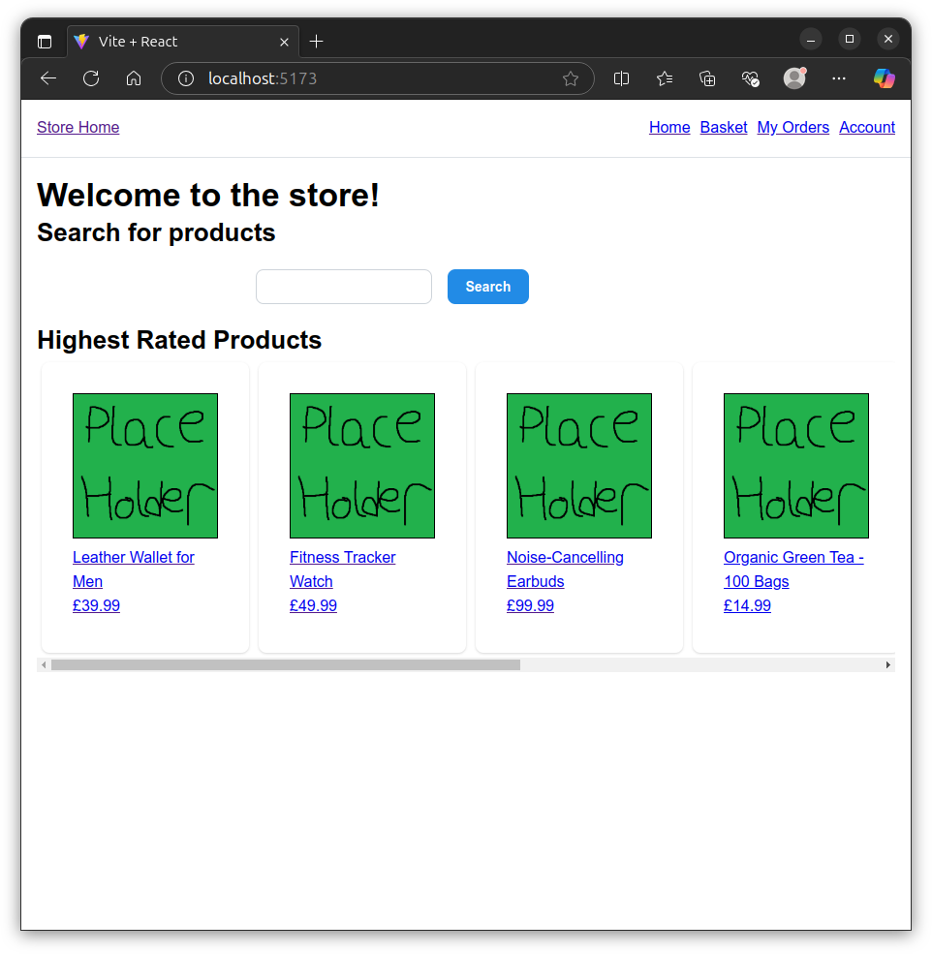
Figure [1]
The application features a collapsible navbar, a search function and a row of featured products which can be scrolled horizontally. On mobile, this makes for a very intuitive experience where a swipe from right-to-left can scroll the products in a carousel-like fashion, similar to other large online stores. Clicking on a product will bring you to the product screen for that particular product.

3.1 Product Screen
The product screen features a large product image, navigation breadcrumbs, a large title and a number of other elements which are synonymous with online stores.
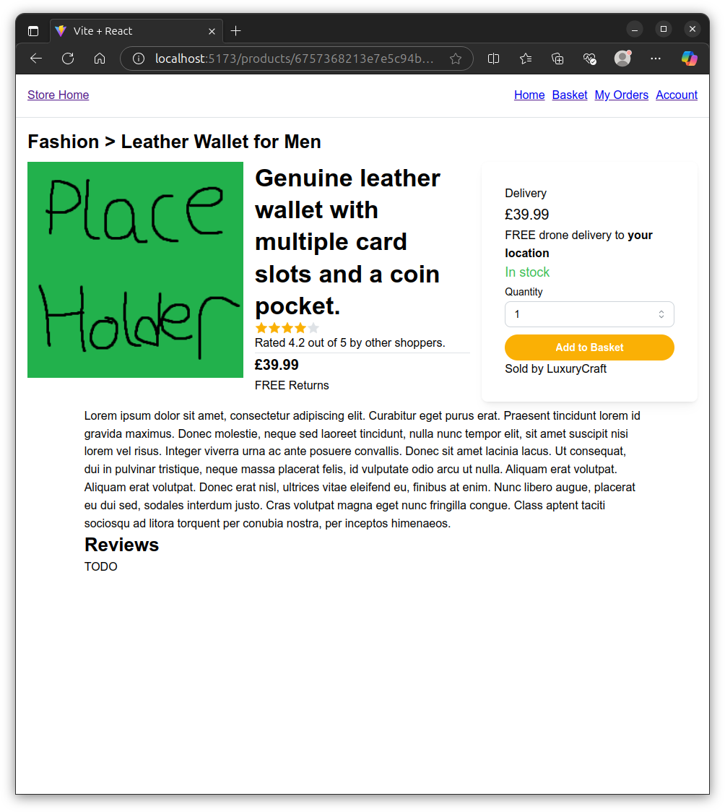
Figure [2]
A dropdown menu allows the user to select the quantity of the item they want, before proceeding to add the product to their basket.

3.2 Add to Basket Screen
Once the user adds a product to their basket, they will be greeted with a success message, telling them that the product was added to their basket.
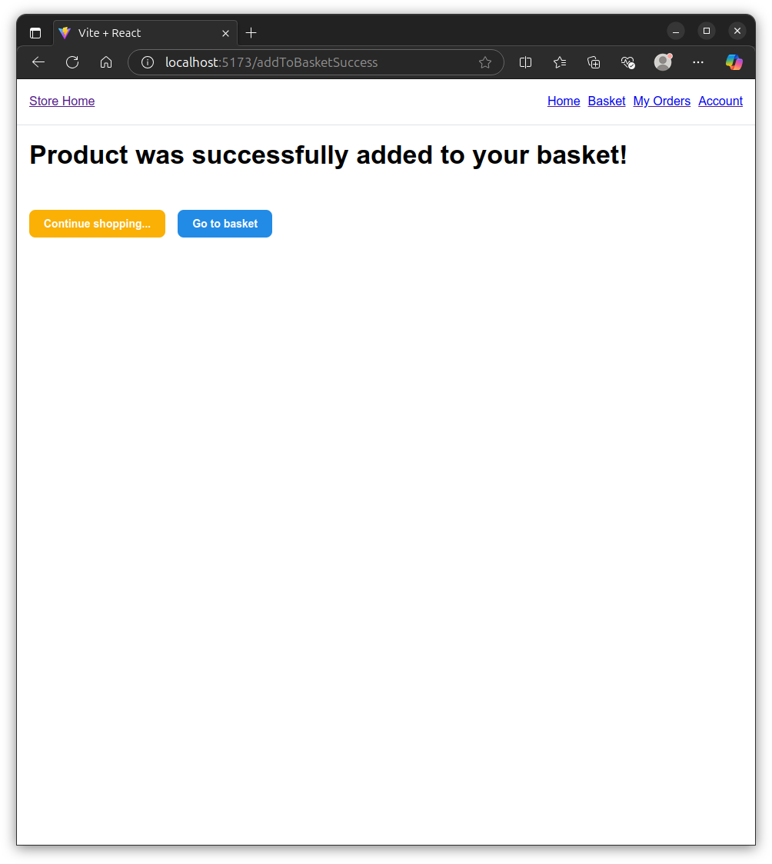
Figure [3]
The application then provides the user with the option to either return to the home page or go to their basket

3.3 Basket Screen
The basket screen shows the user the products that are in their basket, along with quantities and the option to remove products. Clicking up or down on the quantity box will increment and decrement the quantity of items in the user’s basket respectively. Clicking Remove will remove the product from the basket entirely. If the user goes back to the home page and adds another product that they already have in their basket, the quantity of the existing basket item will be increased.
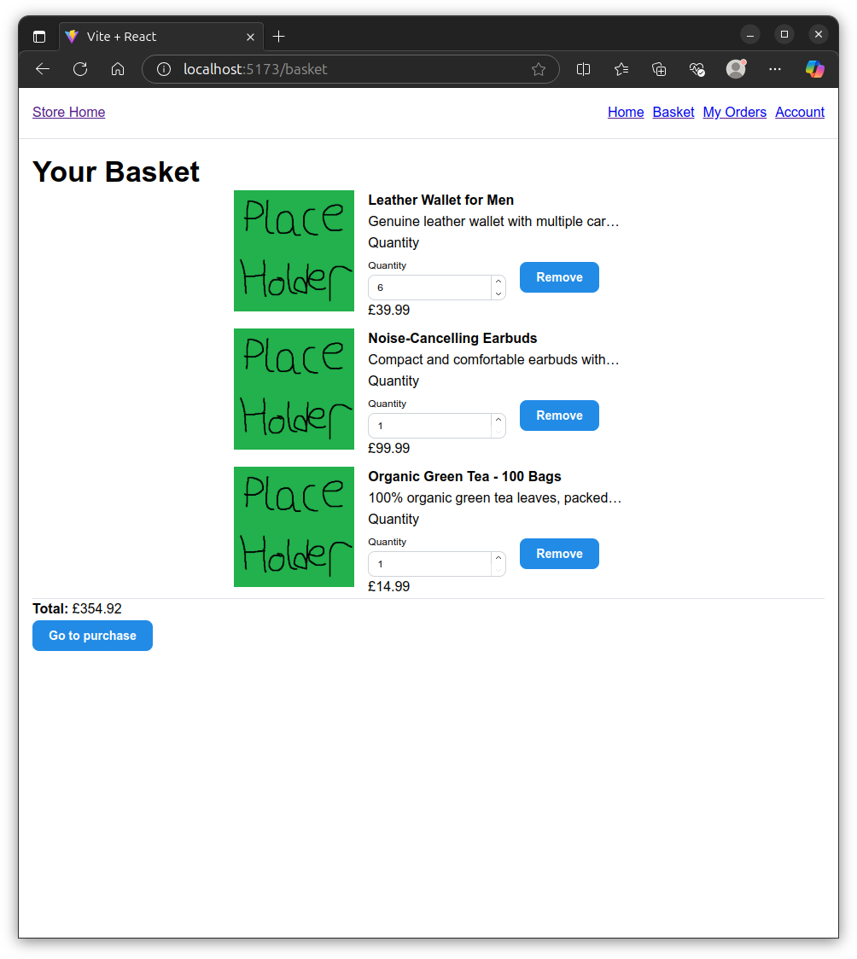
Figure [4]
The user is also provided with an option to proceed with purchasing their chosen products.

3.4 Purchase Screen (Order Summary)
The purchase screen shows the user the list of products that they are about to purchase and the total amount payable.
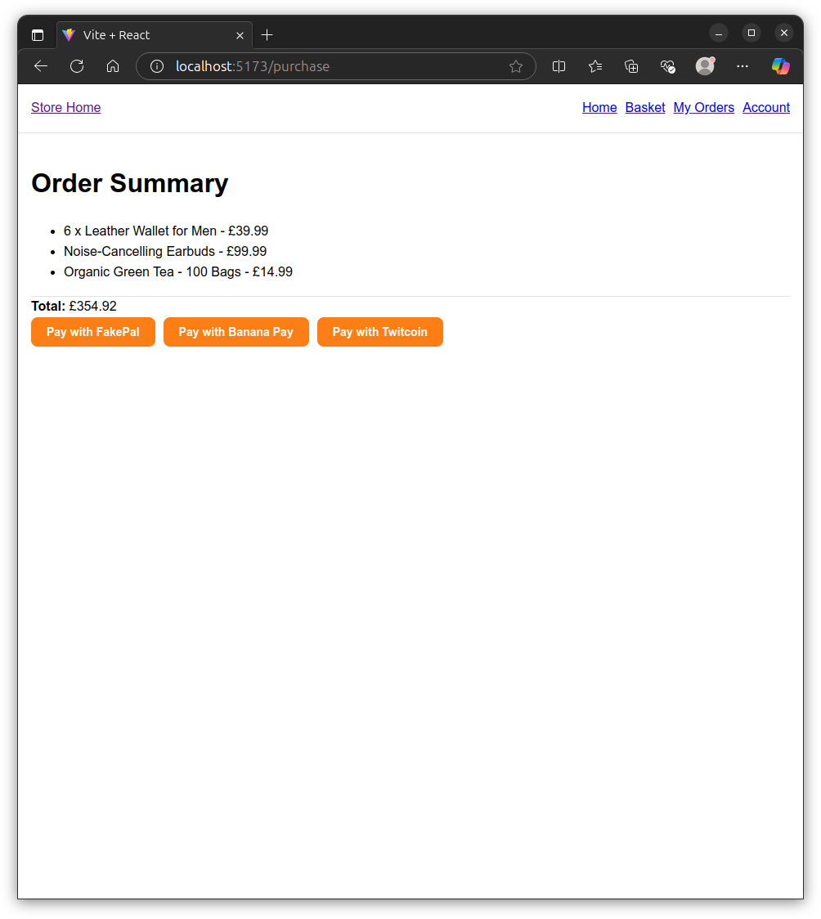
Figure [5]
The user is offered a choice of multiple simulated payment methods.

3.5 Order Completion Screen
Upon the successful completion of a purchase, the user is shown the order success screen.
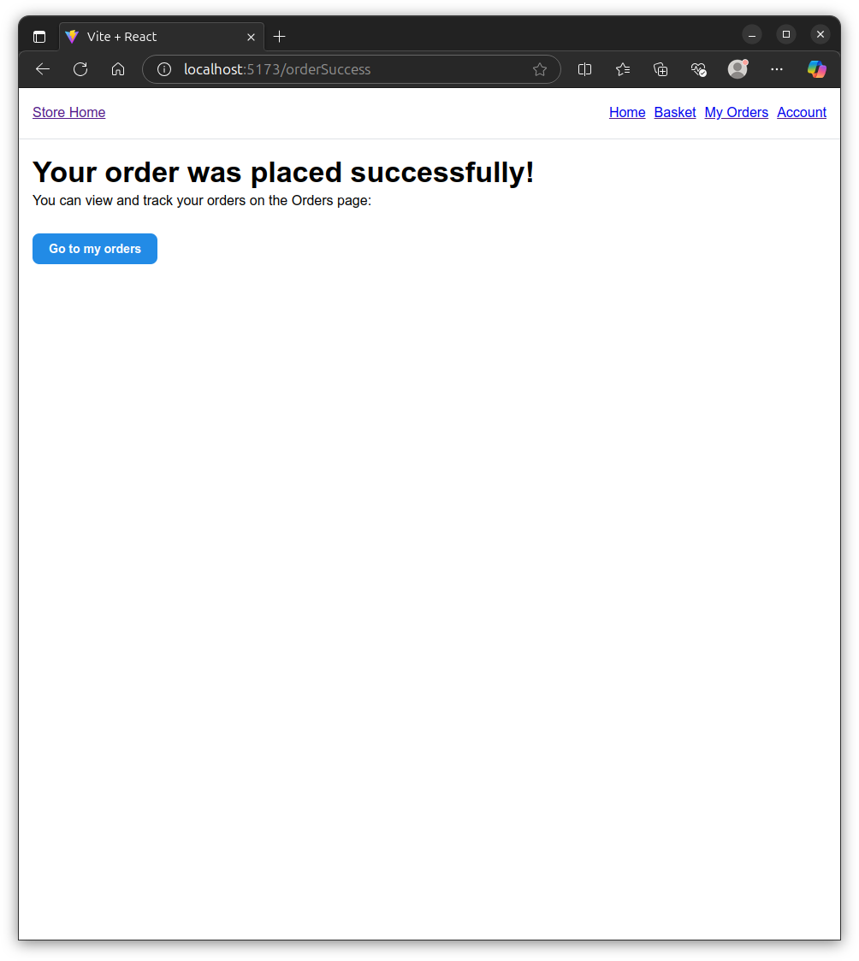
Figure [6]
The user is presented with the option to view their orders

3.6 Orders Screen
The orders screen shows the list of orders that the user has placed.
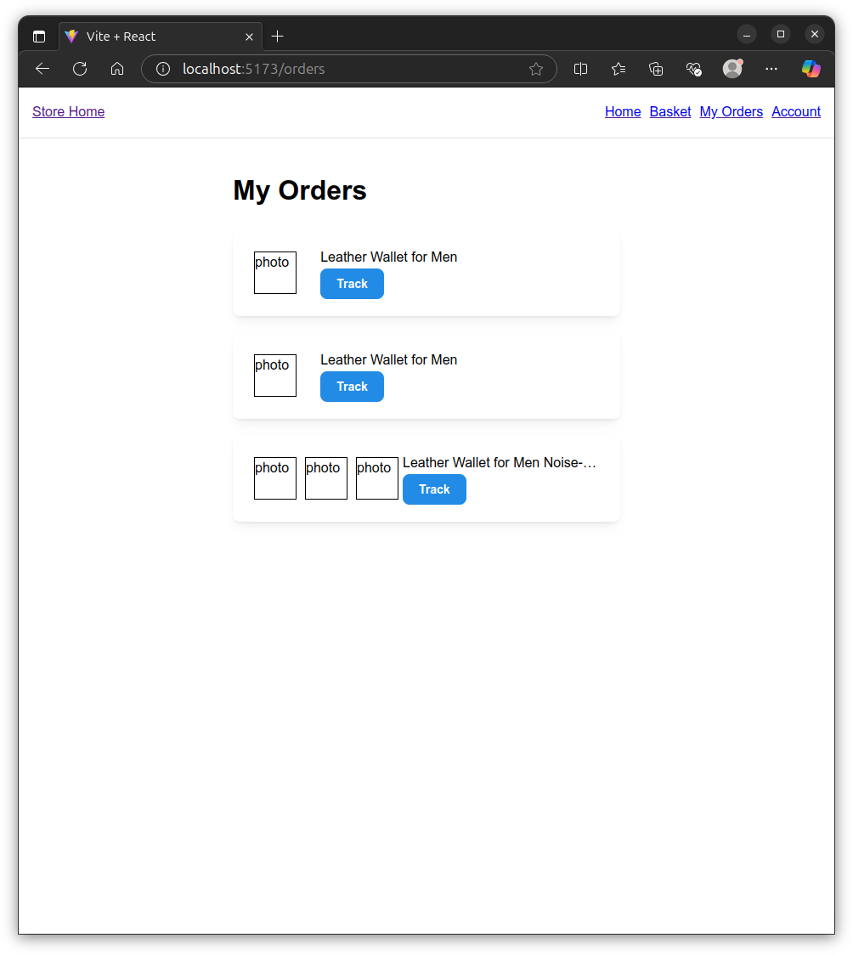
Figure [7]
The user can select the Track button on any of the orders to begin tracking their order progress.

3.7 Order Tracking Screen
The order tracking page shows a summary of the order, including the items ordered and the date that the order was placed. A timeline is displayed which shows the current progress of the order. A number of delivery milestones are displayed, along with the ‘time since’ the milestone occurred. This page is updated in real-time via the use of an efficient & modern Web Socket, meaning that the page does not need to be refreshed, and no polling needs to occur for the screen to be updated.
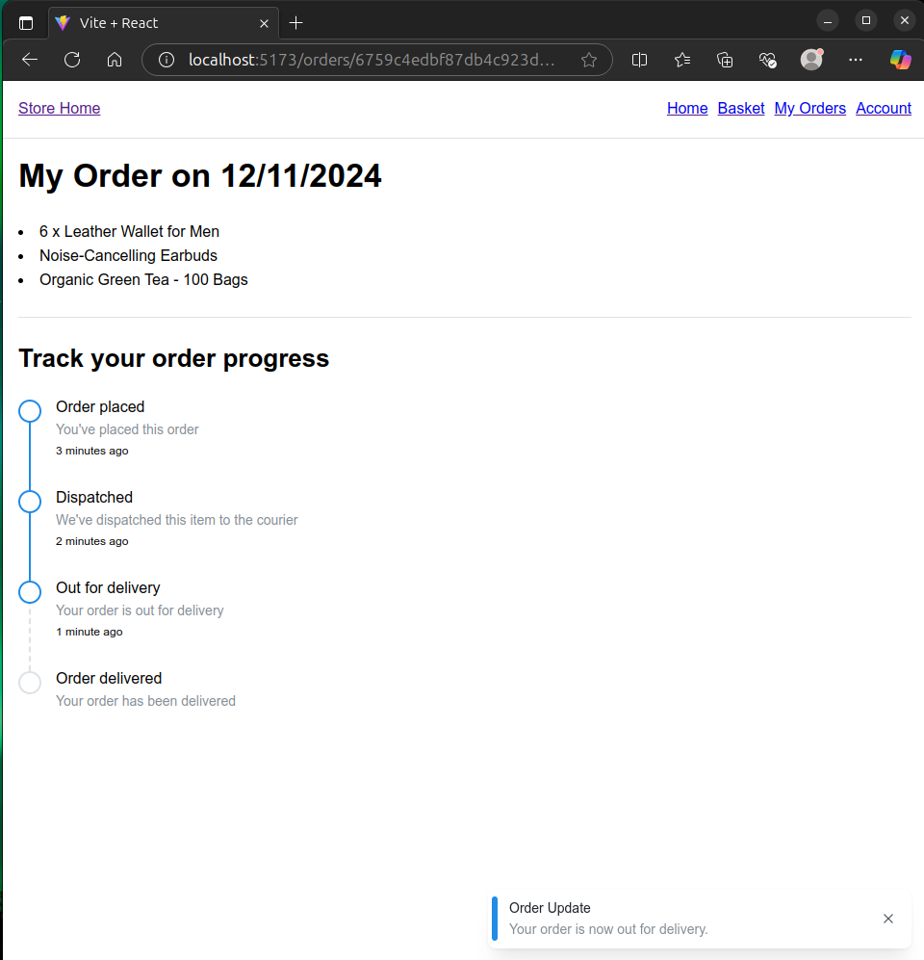
Figure [8]
When the delivery meets a new milestone, a brief notification is displayed on the bottom-right hand corner of the screen.

3.8 Search
The home screen features a search function, where the user can enter a search string and be presented with a list of products related to their query.
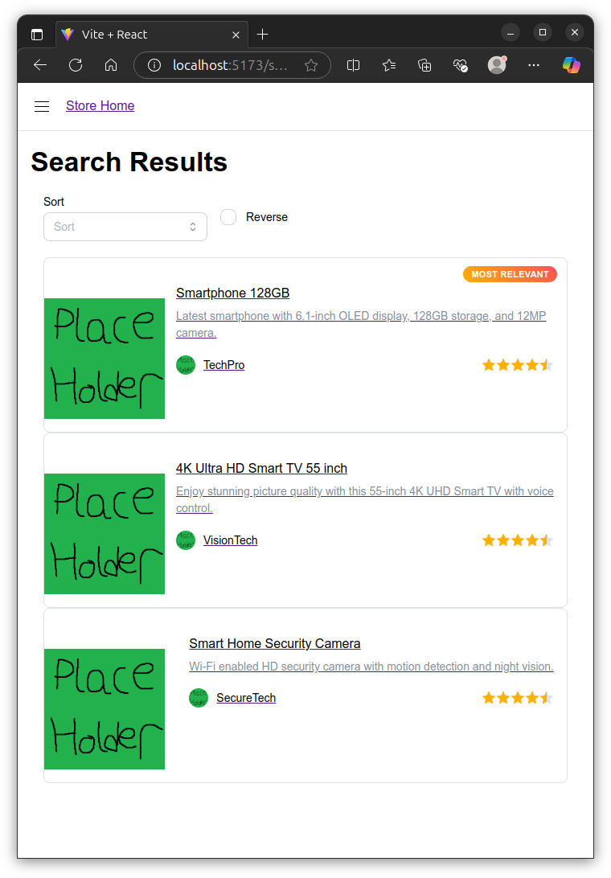
Figure [9]
The user can sort the list of products by rating, price, and available stock level. The user can also select whether to display the results in ascending or descending order using a checkbox.

3.9 Login Screen
If the user tries to perform an operation that requires them to be logged in, they are directed towards the login screen. At this screen, the user can enter their login credentials and be authenticated to the application.
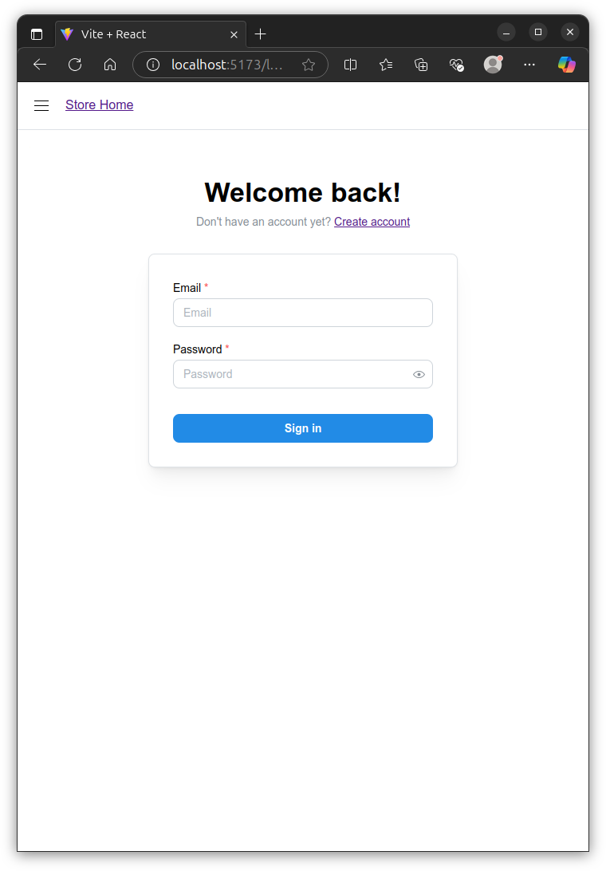
Figure [10]
The user is also provided a link to the sign-up page, so that they can create an account if they do not have one already. Once the user is successfully authenticated, they are redirected to the application home page.

3.10 Sign-up Screen
The application features a sign-up screen for the user to create an account to be used on the site. The sign-up screen consists of a form which asks for the user’s first name, last name, email and preferred password.
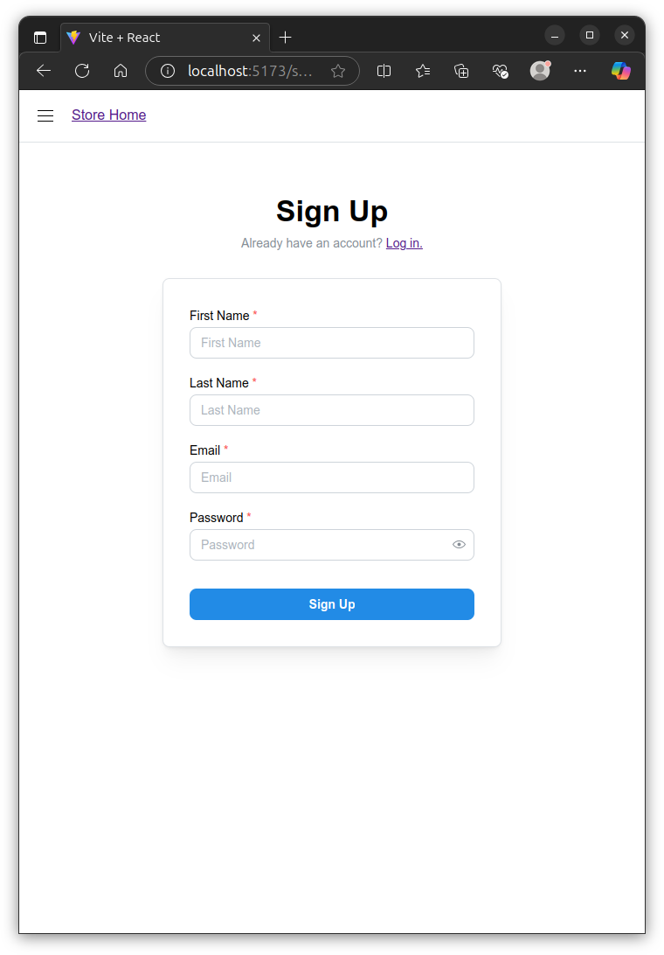
Figure [11]
Once the user has successfully created an account, the application automatically logs them in with the new account.

4 Docker Documentation
The application was packaged using Docker, a technology which allows applications to be containerised. The result of this is that the application can be deployed to any docker-compatible x86/amd64 system without first setting up dependencies. The application does not depend on system packages or libraries being present or being a particular version.
Docker was chosen for this application for a number of reasons. Firstly, the application needed to be portable and run on any system regardless of the system’s existing configuration. Docker proved perfect for this, as Docker-packaged applications will run on any Docker-compatible system with the same processor architecture.
Docker was also chosen as it, along with compose, allows a developer to package multiple applications together, and supply the applications’ configuration in a declarative way. This was important as it allowed for bundling of the frontend and backend together, along with the required database software and administration tools.

5 Application Design
The application was designed iteratively with a few guiding principles. The main principle was that it must be modular, and able to have pieces swapped out without re-engineering parts of the application. This principle guided the decision to use React for the frontend, which is highly modular and composable by nature. This principle also heavily guided the backend design, as it is designed to run on any technology that implements CRUD operations. It is mainly aimed at NoSQL technologies, but could just as easily run on an SQL or KV backend for example. Another principle was that it must be easy for another developer to look at and make changes. For this reason, the code is broken down into smaller, easy-to-understand chunks. Careful management of the codebase and folder structure was used.

6 Frontend Documentation
The React framework was used as the frontend, as it supports the development of modular applications. It encourages code reuse by design, and is extremely flexible. The syntax is logical, and blends together HTML, CSS and JavaScript into the same syntax. It does so with elegance, especially with its new “Functional Components” design pattern. One drawback of React is the steep learning curve, which can make it incredibly difficult for those who haven’t spent a considerable time using it. Another drawback is the flexibility can be quite double-edged, as it does not make any attempt to prevent the developer from making mistakes and poor/inefficient code.
The frontend makes extensive use of React Router, which is a package that enables one to build a multipage application which can be navigated using the URL bar like a standard website. It integrates well with React, and provides ‘loaders’ and ‘actions’ which can be used to manage the data inside the SPA. Loaders are pieces of code that React Router automatically runs when a page is visited, and it will load all the data required to display the page. Actions are pieces of code which perform some kind of data manipulation, typically calling a backend and modifying some state. React Router will automatically call actions and loaders when required, ensuring that page data is always kept up-to-date.
The project is structured into routes, with each folder containing a single route, with all the assets required for a particular route stored in its associated folder. Where a route requires dynamic data loading, its folder will also contain scripts for making fetch calls to the backend.
Routes are defined as follows:
{ path: "/ordersuccess", element: <OrderSuccess /> },
{ path: "/orders", element: <Orders />, loader: ordersLoader },
{ path: "/orders/:orderId", element: <Order />, loader: orderLoader },
{ path: "/search", element: <Search />, loader: searchLoader },
{ path: "/signup", element: <SignUp />, action: signUpAction },
...
When a user visits the page defined in the path attribute, the element referenced in element will be shown on screen. If the page requires dynamic data loading, the loader referenced in loader will be called. If the page requires an action to be invoked (usually to manipulate application state), the action defined in action will be provided to the referenced element. Routes are typically defined in a way that makes logical sense. For instance, to get all orders, the user would go to /orders. If the user wanted to see details about a single order, say the order with the ID 3, they may go to /orders/3.
For styling the application, the Mantine design framework was used. The reason a framework was used was to reduce the development overhead of writing a pretty user interface. In this case, functionality is preferred over form. Therefore, the decision was taken to focus on the technology and the programming techniques rather than hand-crafting a beautiful user interface.
In order to authenticate users to the application, a JavaScript Web Token (JWT) was used. This JWT is provided by the frontend on login or signup, and is sent with each request that requires the user to be authenticated. Further information on the JWT implementation is described further in this document.

7 Backend Documentation
The backend application was developed in pure NodeJS, which is an environment where JavaScript can run outside a web browser. This allows the frontend and backend of an application to share a common language. The backend is structured in a way that is modular, and each piece of distinct functionality is broken down into its own file. The application makes heavy use of the Express web server library, which allows a developer to write simple or complex web applications with minimal boilerplate.
The backend is written using ES6 classes, which is an abstraction layer on top of the JavaScript prototype system. It is not true object-oriented code, but it provides a syntax which closely resembles object-oriented languages. This approach was taken mainly from the point of view of making the code modular and more easy to read and understand. The backend is made up of five distinct kinds of file, namely Controllers, Drivers, Entities, Services, and Utilities.

7.1 Controllers
Controllers are short snippets of code which directly receive requests from the express web server and handle them appropriately. They are designed to be concise and simple, and are designed to handle the high-level business logic of the application. They also provide strict validation of inputs via the Joi library. Joi allows one to define a schema which inputs are tested against. If the inputs do not comply with the given schema, an exception is thrown and the execution is halted, preventing damage to the application.

7.2 Drivers
Drivers are at the opposite end of the spectrum to Controllers, in that they are responsible for handling low-level interactions with systems such as databases and filesystems. They are designed to be invisible to Controllers, and no Controller code should ever directly call a Driver. By adhering to this design pattern, it means that that driver code can be swapped out without having to write code which pertains to the business logic.
Drivers are classes which are built to deal with low-level CRUD operations to backing stores, caches, databases etc. The idea of a driver is that it implements a ‘contract’. Provided a driver fulfils its contract, it can be used in place of another driver of the same type. For example, the below specification describes a contract for the storage driver which the application uses.
### `readMany`
- Purpose: Retrieve multiple items from the data store with optional filters, sorting, and limits.
- Inputs:
- `sort` (string, optional): The property name to sort the data by.
- `reverse` (boolean, default: `false`): Whether to reverse the sorted results.
- `limit` (number, optional): Maximum number of items to return.
- `filters` (array of objects, optional): An array of filters. Each filter is an object with:
- `filterProperty` (string): The property name to filter by.
- `filterValue` (any): The value to match.
- `filterType` (string, default: `"exact"`): Type of filter to apply. Options:
- `"exact"`: Matches items where `item[filterProperty] === filterValue`.
- `"contains"`: Matches items where `item[filterProperty]` contains `filterValue` (case-insensitive for strings).
- Output:
- Returns an array of filtered, sorted, and optionally limited items from the mock data.
### `readOneByPrimaryKey`
- Purpose: Retrieve a single item by its primary key (`id`).
- Inputs:
- `id` (number): The primary key value.
- Output: The matching item, or `undefined` if not found.
### `readOneByValue`
- Purpose: Retrieve the first item where a specified property matches a given value.
- Inputs:
- `key` (string): Property name to match.
- `value` (any): Value to match.
- Output: The first matching item, or `undefined` if not found.
### `updateOneByPrimaryKey`
- Purpose: Update a property of the first item where a specified property matches a given value.
- Inputs:
- `id` (any): ID to match.
- `keyToUpdate` (string): Property name to update.
- `newValue` (any): New value to assign.
- Output: `void`.
### `deleteManyByValue`
- Purpose: Delete all items where a specified property matches a given value.
- Inputs:
- `key` (string): Property name to match.
- `value` (any): Value to match.
- Output: `void`.
### `createOne`
- Purpose: Add a new item to the data store.
- Inputs:
- `data` (object): New item data. Automatically assigns an `id`.
- Output: The `id` of the newly created item (number).
This contract is implemented by two drivers, namely DummyStore and MongoStore. DummyStore loads some initial application state from a file into memory. Calls to DummyStore then make changes to and read from the in-memory version of this state. Changes made when using the DummyStore driver are wiped as soon as the application restarts, making it unsuitable for production and scale-out, however it is useful for testing. DummyStore was used heavily during the application’s development. Only once the application was near completion was the MongoStore driver written, which reads and writes to and from a MongoDB database. Implementing and switching over to MongoStore at such a late stage was quick and painless, and demonstrates the benefits of writing modular code with encapsulation and dependency injection. In order to switch the application from DummyStore to MongoStore and vice versa, only four tiny changes to the code are needed. With further refinement, this could be reduced down to just a single change.

7.3 Entities
Entities are very much what they sound like. These pieces of the code are simple JS classes, each stored in their own file. They represent physical objects identified at an early stage of development through noun analysis. There are three entities represented within the application, Order, Product, and User. Each entity contains methods which make calls to a storage driver, which it references as store. These entities are then used by one or more controllers, which orchestrate business logic. Entities are generally produced using a Service.

7.4 Services
Services are classes which are used to perform ancillary operations pertaining to Entities. They are responsible for operations which are performed about entities rather than on them. For example, the UserService is responsible for creating a new user via the createUser method, and is responsible for finding a user by their email address via the findOneByEmail method. A future refinement could merge entities and services by making each service’s methods a static method of its respective entity. For example, userStore.createOne() could become User.createOne().

7.5 Utilities
Utilities are small, generic helper functions which are not part of the overall business logic, and could be re-used across other applications if required. The only utility used by this application is jwtverifier-middleware, which validates JavaScript Web Tokens (JWTs) on protected routes, which is covered later in this documentation.

7.6 Authentication
Special attention was paid to ensuring that there is a secure authentication mechanism in place. When a user is created via the UserService’s createUser method, the user’s first and last name, email address, and chosen password are gathered. The current date and time are used as a cryptographic salt and concatenated with the password. This is then hashed using the cryptographically strong SHA256 algorithm and stored as a hexadecimal string. The password is hashed to ensure that a data breach would not reveal plaintext passwords to an attacker, and passwords are salted in order to mitigate potential rainbow table attacks if the database is stolen. The resulting user record looks like this:
{
"id": 0,
"firstName": "Scott",
"lastName": "Roberts",
"email": "2306895@student.uwtsd.ac.uk",
"passwordSalt": 1731923998976,
"passwordHash":
"b631a67495ed56700ba0f39b9da336e031dcc42f9cb3b8f07f8991209f501cd1"
}
As can be seen from the above sample, the password is stored in an unreadable format and can only be used along with the password salt to check whether a user has entered the correct password. The following function is used to verify that the entered password matches the one stored.
authenticate(password) {
let hashedPassword = crypto
.createHash("sha256")
.update(password + this.#passwordSalt)
.digest("hex");
if (hashedPassword === this.#passwordHash) {
return true;
}
return false;
}
This code is then called by the /login controller:
// If authentication is unsuccessful, bail out early
if (!user.authenticate(req.body.password)) {
res.status(403).end();
return;
}
// Create a JWT
const token = jwt.sign(
{
userId: user.id,
email: req.body.email,
},
JWT_SECRET,
{ expiresIn: "2h" }
);
res.json({ token });
A signed JavaScript Web Token (JWT) is then returned to the user, who can use it for the next two hours by presenting it within the HTTP Authorization header. The token is checked on protected routes in order to make sure the user is authenticated before they can perform any privileged operations.

7.7 Websockets
Websocket technology was chosen as a means to implement live data refreshing. Websockets facilitate bidirectional communication between a web application and a user interface, and are much more performant and efficient than other approaches such as polling. Websockets allow arbitrary message to be sent back and forth between a client and a server. A typical approach selected is to load the initial data for a page using a simple HTTP request, and then keep it up-to-date after the page loads using a Websocket. An alternative approach is to perform all data loading using the Websocket, but this may not be desirable as some user agents may not support Websockets and will fail to load any data at all. In this case, the former approach was selected.
Websocket technology was used to update the order tracking page in real-time, to show live delivery updates. When the frontend visits the /orders/:orderId route, it opens a Websocket connection and sends sub /orders/[orderId] to the server. The server responds by sending all future tracking updates back to the client who requested them for the lifetime of the Websocket, in JSON format. This could be expanded to allow the client to subscribe to other such updates, such as product availability, new discounts, and price changes. One downside to using Websockets is that, in their raw form, they require a lot of boilerplate code and event handling for things like intermittent connections. Libraries such as socket.io are available which abstract these concerns away, but using raw Websockets is good enough for testing purposes.
- Routing (incl. Overview of all routes)
- Database schema and models

7.8 Route Overview
The backend exposes the following HTTP routes:
- GET /products - Get a list of products from the server. Provides options for sorting, limiting the number of returned results, reversing the results, and text querying.
- GET /products/:productId - Get information about a specific product, by ID.
- POST /login - Authenticate to a user account. Returns a signed JWT
- GET /basket - Returns all the items from the authenticated user’s basket
- POST /basket - Put an item into the authenticated user’s basket
- DELETE /basket/:productId - Remove an item from the authenticated user’s basket
- PATCH /basket/:productId - Adjust the quantity of an item in the authenticated user’s basket
- GET /orders - Get a list of the authenticated user’s orders
- POST /orders - Place an order on behalf of the authenticated user
- GET /orders/:orderId - Get information about a specific order, by ID
- POST /signup - Register a new user account, return a signed JWT

7.9 Input Validation
Controllers provide strict validation of inputs via the Joi library. Joi allows one to define a schema which inputs are tested against. If the inputs do not comply with the given schema, an exception is thrown and the execution is halted, preventing damage to the application. Joi was chosen as manually handling input validation is extremely tedious work, and prone to error. Therefore, it makes sense to use a battle-tested library for input validation. An example of a Joi schema is as follows: (user sign-up)
const schema = Joi.object({
firstName: Joi.string().min(1).max(32).required(),
lastName: Joi.string().min(1).max(32).required(),
email: Joi.string()
.email({
minDomainSegments: 2,
tlds: { allow: ["com", "net", "uk"] },
})
.required(),
password: Joi.string().min(8).max(64).required(),
});
This schema ensures that the first and last name fields are present, are strings, and contain at least one character and at most 32. The schema ensures that there is a valid email string supplied with at least two domain segments, and only allows email addresses ending with .com, .net, or .uk. The schema ensures that the password is present, is a valid string, and contains at least eight characters and at most 64. Fields supplied in addition to the ones listed cause validation to fail.
By performing this strict input validation, the application’s vulnerability and attack surface are reduced, and the likelihood of errors occurring decreases.

7.10 Database
The database contains the following kinds of items:

7.10.1 Orders
{
id: 0,
userId: 0,
products: [
...products
],
orderTimestamp: 1731923998976 || null
dispatchTimestamp: 1731923998976 || null
outForDeliveryTimestamp: 1731923998976 || null
deliveryTimestamp: 1731923998976 || null
}

7.10.2 Users
{
id: 0,
firstName: "Scott",
lastName: "Roberts",
email: "2306895@student.uwtsd.ac.uk",
passwordSalt: 1731923998976,
passwordHash:
"b631a67495ed56700ba0f39b9da336e031dcc42f9cb3b8f07f8991209f501cd1",
}

7.10.3 Basket (Link Table)
{
id: 0,
userId: 0,
productId: 1,
quantity: 1
},

7.10.4 Products
{
id: 1,
title: "Wireless Bluetooth Headphones",
description:
"High-quality over-ear headphones with noise cancellation and 30-hour battery life.",
category: "Electronics",
price: 79.99,
rating: 4.5,
imageUrl: "https://example.com/images/headphones.jpg",
brand: "AudioMax",
stock: 120,
}

8 Testing
- Test: Add Item to Shopping Basket
  - Description: An authenticated user adds an item to their basket by clicking the “Add to Basket button on a product page.
  - Expected Outcome: The item lands successfully in their basket and can be viewed from the /basket page
  - Environment: Test must be performed using the frontend
  - Preconditions
    - The user must be logged in
  - Postconditions
    - The application must not crash or exhibit undefined behaviour, and the application state must not become corrupted
  - Actual Outcome: Matches expected outcome
- Test: Remove Item from Shopping Basket
  - Description: An authenticated user removes an item from their basket by clicking the “Remove” button on the basket page.
  - Expected Outcome: The item is successfully removed from the basket and the basket is updated accordingly.
  - Environment: Test must be performed using the frontend
  - Preconditions:
    - The user must be logged in
    - The basket must contain at least one item
  - Postconditions:
    - The application must not crash or exhibit undefined behaviour, and the application state must not become corrupted
  - Actual Outcome: Matches expected outcome
- Test: View Shopping Basket
  - Description: An authenticated user views their shopping basket by navigating to the /basket page.
  - Expected Outcome: The basket page displays all items currently in the user’s basket along with their quantities and prices.
  - Environment: Test must be performed using the frontend
  - Preconditions:
    - The user must be logged in
    - The basket must contain at least one item
  - Postconditions:
    - The application must not crash or exhibit undefined behaviour, and the application state must not become corrupted
  - Actual Outcome: Matches expected outcome
- Test: Checkout Process
  - Description: An authenticated user completes the checkout process
  - Expected Outcome: The order is successfully placed, and the user can view their order from the /orders page
  - Environment: Test must be performed using the frontend
  - Preconditions:
    - The user must be logged in
    - The basket must contain at least one item
  - Postconditions:
    - The application must not crash or exhibit undefined behaviour, and the application state must not become corrupted
  - Actual Outcome: Matches expected outcome
- Test: View Delivery Timeline for Order
  - Description: An authenticated user views the delivery timeline for a specific order by navigating to /orders/:orderId. The timeline updates in real-time via WebSocket updates from the backend.
  - Expected Outcome: The delivery timeline is displayed and updates in real-time as new status updates are received via WebSocket.
  - Environment: Test must be performed using the frontend
  - Preconditions:
    - The user must be logged in
    - The user must have at least one order with a valid orderId
  - Postconditions:
    - The application must not crash or exhibit undefined behaviour, and the application state must not become corrupted
  - Actual Outcome: Matches expected outcome
- Test: Adjust Item Quantity in Basket
  - Description: An authenticated user adjusts the quantity of an item in their basket by changing the quantity field and clicking the “Update” button on the /basket page.
  - Expected Outcome: The item quantity is successfully updated, and the basket total is recalculated accordingly.
  - Environment: Test must be performed using the frontend
  - Preconditions:
    - The user must be logged in
    - The basket must contain at least one item
  - Postconditions:
    - The application must not crash or exhibit undefined behaviour, and the application state must not become corrupted
  - Actual Outcome: Matches expected outcome
- Test: User Sign-Up
  - Description: A new user signs up by providing their first name, last name, email, and password.
  - Expected Outcome: The user account is successfully created, and the user is redirected to the homepage.
  - Environment: Test must be performed using the frontend
  - Preconditions:
    - The user must not already have an account with the provided email
  - Postconditions:
    - The application must not crash or exhibit undefined behaviour, and the application state must not become corrupted
  - Actual Outcome: Possible to fail the precondition due to lack of checks. Needs refinement.
- Test: User Login
  - Description: An existing user logs in by providing their email and password.
  - Expected Outcome: The user is successfully authenticated and redirected to the homepage.
  - Environment: Test must be performed using the frontend
  - Preconditions:
    - The user must have an existing account with the provided email and password
  - Postconditions:
    - The application must not crash or exhibit undefined behaviour, and the application state must not become corrupted
  - Actual Outcome: Matches expected outcome

9 Conclusion: Limitations & Areas for Further Expansion
It is clear that the application has areas where it could be improved, both from a technical standpoint and a design one. This section of the report documents a list of limitations of the application as it currently stands, as well as areas for potential future expansion. Some features were considered for the application, but were not implemented due to time constraints.

9.1 Product Ratings and Reviews
There was a desire to add product ratings and reviews to the application. This would have been relatively straightforward, but there simply was not enough time. Mantine provides nice UI elements such as clickable star ratings and user avatars, and the schema for implementing reviews would have been relatively simple, needing only a userId, a rating out of five and an optional comment.

9.2 User Interface Improvements
Overall, the User Interface leaves a lot to be desired. Given more time, certainly more time would have been invested into the appearance of the application. A more opinionated framework could have been used for composing the frontend, perhaps one designed specifically for ecommerce sites. There are many placeholders in use across the application, and real images could have been created and used instead.
Similar to other ecommerce sites, it would have been nice to add a badge to the basket link on the navbar. Overall, it would have been beneficial for aesthetics if the navbar links were represented by icons. This was attempted during the application’s development, but importing the required icon pack caused the bundle size to grow significantly, and the application performance suffered.

9.3 Better Currency Handling
At present, the application stores currency as a floating point number. This is the intuitive approach and catches many developers out. Currency amounts should really be represented by their base unit as a whole number, for instance cents for US Dollars or, in this case pence for Pound Sterling. For example, £150.35 would be stored as the integer 15035, with logic in the view code to automatically place the decimal if required. This eliminates floating point precision issues.

9.4 Type Safety
Given more time, the application would have been built with TypeScript in order to ensure type safety and reduce the risk of bugs associated with weak and implicit typing. There were several points during development where guaranteed type safety would have been especially useful, but was unavailable due to the design of JavaScript.

9.5 Websocket Resilience
In its present state, the application’s Websocket performance under poor or unreliable network conditions is untested and unknown. It is unlikely to perform well, as raw Websockets were used without an abstraction library, and no special care was taken to handle edge cases. Testing of the application was performed in a stable network environment and so no issues were found in this regard.
Future iterations of the application could use a library like socket.io which is an abstraction layer on top of Websockets which handles network interruptions and other edge cases. For high-performance applications, low level libraries such as uws could be used instead.

9.6 Convert Backend Services to Static Methods
One avenue to explore would be to take the methods implemented as ‘services’ and implement them as static methods on their respective entity class. For example, userStore.createOne() could become User.createOne(). This would help to consolidate related methods into a single class, but could also lead to larger file sizes. This is something that would have been explored given more time.

9.7 Use of the Factory Pattern
Dependency injection could be improved by using the factory pattern to simplify driver instantiation. Rather than changing the code in multiple places to load a different driver, the factory pattern would allow the correct driver to automatically be selected at runtime based on a configuration option. This would make driver selection user-configurable without needing to have access to the source code.

9.8 Security
There are many areas where the application falls down from a security standpoint, which could be improved. To name a few issues, users can access each other’s baskets so long as they are authenticated as a valid user, and one can create a user account with the same email address as someone else, potentially leading to security problems. These security issues could be down to the development focus being on speed and quick prototyping, and the fact that it is not designed to be used in the real world. Overall, there is plenty of opportunity for the application’s security to be improved.

9.9 External Config File and Environmental Variables
More configurations could be moved from hardcoded values within the source, to an external configuration file or environment variables. This would allow for more flexibility per-deployment, and would allow the engineer responsible for app deployment to make changes without having access to the source code.

9.10 Refactor Websocket Code
At present, the Websocket code is present within the main index.js file without any kind of organisation. Ideally, this code would be refactored and placed into a Websocket service and Entity.

9.11 Improved Error Handling
At present, error handling functionality is not complete. There are many cases where the user can do things that they generally should not be able to do. To mitigate this, the application should have been written against a series of well-defined tests, and a consistent approach should have been taken for error handling.
Given the opportunity to rewrite this application from the start, this would have been done alongside implementing TypeScript.

9.12 Consistent ‘Not found’ behaviour
At present, return behaviour when items are not found is inconsistent. It would be better if a consistent strategy was used across the entire application. For example, returning an empty array on readMany operations, and returning null on readOne operations. This allows developers working on business logic at higher layers of abstraction to detect error conditions and handle them better.

9.13 Storage Driver Improvements
The syntax used for CRUD operations could be improved. For example, it would be good to be able to chain calls together like selectMany().next() and selectOne().update(). Additionally, it would be better if the syntax was written in a way that is more agnostic and not tied so closely to NoSQL technologies.

10 Contact
This concludes the application’s documentation. For further more information, contact Scott Roberts on 2306895@student.uwtsd.ac.uk.

11 Video Link
https://uowtsd-my.sharepoint.com/:v:/r/personal/2306895_student_uwtsd_ac_uk/Documents/Videos/Clipchamp/Video%20Project%202/Exports/CloudWebAssignment.mp4?csf=1&web=1&e=ilmxlP

