Mr Elis Tomos Allsopp

BA Youth and community

2019

The Transition from Full Time Education into Independent Living: How can Youth Work Respond?



1601113

Abstract
This paper will attempt to solve the question proposed by the author, The transition from full time education into independent living- how can youth work respond’?. As youth work strives to support young people into developing adults, it is important to uncover the issues they may be facing. This paper will discuss past research conducted, and will draw comparisons to the finding. The author has found for core themes effecting young people as they transition from full time education, those being financial concerns, lack of life skills, mental health and a sense of being underprepared for independent living. Through the method of focus groups, the author was able to discover these occurring themes in addition to other issues that are affecting young people in today’s society. Through reading this, the paper will inform the current youth service of the issues young people face when preparing for independent living, and of the areas which could be met with additional support from the service to help better prepare young people for life in adulthood.
Acknowledgments

I would like to thank my lecturers Angharad, Alana & Darrell for the education and support they have provided across my studies, each of you saw the best in me and ensured I aimed high.

I would also like to thank my friends, classmates and the participants of my research, for it could not have been achieved without you.

To Ken and Hannah, founding Youtoo and giving youth work a foothold in higher education, and providing aspiring youth workers the opportunity to develop their skills for future practice.

Finally, a thank you to my close friend Julie, I could not ask for anyone more caring and understanding to support me through my studies, to motivate me and be a shoulder to lean on when the going got tough.

Table of Contents
Chapter 1- Introduction 2

Chapter 2 – Literature Review 6

Chapter 3 - Methodology 10

Chapter 4 Presentation of Data 14

Chapter 5 Analysis of collected Data 17

Chapter 6 Summary 20

References 22

Appendix 24

Chapter 1- Introduction
The aims of this applied research project is to explore ‘The transition from full time education into independent living- how can youth work respond’?. The author finds the project interesting as it falls under the category of young people who could benefit from additional support in this stage of education. The proposed notion is well researched for ages under 18, as Chapter two will display the findings of Creed et al (2003) and others. This age group is where most youth services operate, to form a preventative strategy for young people becoming at risk as they grow in maturity. This subject will be discussed further in chapter two. Despite this The Independent (2013) identified many young people from ages 18-25 still suffer with ill mental health or struggle to engage in a social environment, this is could be the result of a lack of services for this age group. It is of upmost importance to begin policies to counter these issues in higher educational institutions.
The third chapter will discuss the proposed methodology of this project. The research will be conducted through focus groups, which reflect the views and aims of the youth worker. This will enable the project can uncover potential support routes that could provide youth work with a foothold to begin assisting young people in higher education. Following these needs, the project will seek to provide an informative probe into the current generation of students and how youth workers can intervene to ensure young people reach their full potential and follow into their professional careers as mature adults. These are clear benefits for young people, as they will be able to build upon their resilience, self-esteem and social development, which will further provide for them as they become adults.
The fourth chapter will present the collected data from the research, and will be structured according to the key themes selected by the author that are considered to be important to young people. Following this, the fifth chapter will be a full interpretation of the gathered information, linking to past research identified in the literature review.
In conclusion, the applied research project will summarise the primary findings, and will then strive to answer the project’s question of ‘the transition from full time education into independent living- how can youth work respond’?.
To close, the sixth chapter will form conclusions, and propose recommendations for those seeking to further this research and devise new methods to support young people.

Chapter 2 Literature review

The Transition from Full Time Education into Independent Living:
How can Youth Work Respond?

This chapter will discuss the aims of the research project, referring to literature and past research to display what is already known about transitions in young people between education and work. The research aims to uncover issues that young people may face when departing education.
As I found, there is little research into transitions from higher education into independent living, however there is substantial research from other bodies regarding transitions from education to independent living, which I will use to compare my data for any patterns or similarities.
The Current response
What current support is there for young people transitioning from full time education into independent living? The aims of this project are to discover the needs of the older spectrum of young people in regards to their general well-being and social needs. The age group of 18-25 has not been well supported in recent years, as only the last decade have the youth service put policies in place to support young people to ‘be better prepared and supported to live independently’ according to GOV(2016). This shows a gap in the knowledge in how to support older youths. As they depart full time education to begin their independent lives, young people will begin to struggle adapting to living with a complete change of routine, where new life skills and living requirements that they did not learn during education become more apparent.
According to Clausen (1991) it is well known that young people who plan and prepare for their aspired work roles will become more successful than those that do not. When discussing his theory of psychosocial moratorium Erikson (1968 pg131) stated that young people in their late adolescence ‘ experience a sense of confusion in regards to work’ among other factors of life. This demonstrates that young people who are soon to depart education will have difficulties transitioning to a world of work, as they may be behind in social development.
The Increase in Higher Education
Accessibility of higher education is improving, and as a result higher numbers of young people are attending, with UCAS (2018) recording a total of 17,650 of first time applicants from Wales alone. Young people leaving school often do not have to decide whether to continue in education or pursue their career, they can simply continue with their education in the form of a degree, therefore these decisions can be postpones until after graduation. Most adolescents expect to attend and graduate before beginning their working life, a process that Reitzle and Vondracek (2000 pg.445-467) call ‘optimizing qualifications’.
Supporting this, a survey conducted by prospects net (2018), consisting of graduates from the UK, graduate and non-graduate earnings were compared, which discovered a direct correlation between attainment levels of higher- education and higher earnings in the work force. With the social normality of attending University increasing and accessibility also improving, the number of students attending University has increased, as a result of individuals attempting to optimise their credentials and improve their potential wages in future.
Leaving Effects on well-being in Young people
A study in Australia conducted by P.A. Creed, J.Muller and W.Patton (2003) discovered that young people with well being issues in a high school setting are held back when transitioning into work, and those who depart school healthy will either grow strong and more confident, or will receive a decrease in their well being. Creed et al.(2003) stated ‘the challenge here is for school-based practitioners to be able to identify these at-risk students and provide interventions’ which would support their well-being and confidence, in addition to their career skills. This research project shares the same motives as Creed, in order to identify risk-groups within the community and show the need and potential suggestions for a youth work response for young people aged 16-25 in higher education.
How Youth work should adapt to resolve the issue
There is a gap between University and the job market, Stringer (2012) states ‘HE careers advisers are something of an anachronism, unable to keep pace with the labour market realities’. This shows that people are being left unattended and will need support, this is the target audience which youth work should engage with. This gap in support is what leaves young people at risk of mental health issues such as stress, depression and anxiety, as a result of the lack of support in finding work and settling into a working life. This displays a clear slot for youth work to engage and develop a system to support the older demographic of young people, increasing their resilience, prospects, and reducing the number of soon-to be adults entering adult services (job centres, clinics for health needs). In addition to this, youth work strategy will become more informed and open opportunities to research the older spectrum of young people, and how to improve the service for their needs.
Rose (2018) surveyed today’s employers in regards to what skills were needed to become employed, with a finding that 80 percent of employers seek literacy, numeracy and Information technology skills over qualifications. These are the skills that youth work should strive harder to educate into young people to better prepare them for the future.
Anna Kewk et al (2013) researched the link between resilience and academic performance, where ‘The results suggest that for both groups, self-esteem and resilience are significant predictors of academic performance’. Although their work focussed upon international students, the identified issue is the same for young people in the UK- self-esteem and resilience will have an effect on academics, which could hold implications for future aspirations of young people. If further researched was conducted, it would allow for youth work to formulate a much more effective response in supporting young people’s resilience in higher education.
Research
The gap between university careers advice service and the youth work service- universities are struggling to provide efficient support for careers/pushing the responsibility on students to find their careers. Supporting this statement, Denham (2013) stated universities are not delivering sufficient support for students, and ‘long waiting lists for universities counselling services dissuade many in need of help’. This shows that young people are falling beneath the scope of university support, and therefore demonstrates a clear audience for youth work to develop a response to ensure this group are not abandoned and are supported to achieve their full potential in higher education, so they can continue to succeed in adulthood within their desired careers.
In order to explore the applied research project question further, the next chapter will consider the methodology, method and design that will be applied to research young people and their youth workers when discussing ‘the transition from full time education into independent living- how can Youth work respond?’.

Chapter 3- Methodology

The objective of this chapter is to discuss the methodological approach to the applied research project, this is to ensure the research question is fulfilled in the most reliable and ethical way. Research methodology is a fundamental component when exploring new fields within youth work, therefore it’s fundamental to consider the approach to research, to ensure it follows ethical guidelines and can limit or if preferred extend the variable outcomes from study. The method selected will provide an outline as to how the author can operate, and the rules and limitations that must be followed when conducting the research.
Background
This section will discuss the reasoning this project has been undertaken by the author. As chapter two has demonstrated, the research for this particular subject is restricted primarily to young people under 18, from high school or college level of study, as determined by Creed et al (2003). This clarifies the demographic the author will investigate has been lightly researched, providing a clear opportunity to uncover unknown data in this area. By revealing new data the youth work sector can become informed of the 18 plus age group, and begin to develop new strategies that could help support their well-being and maturity into adulthood.

The Approach
“The aim of scientific investigation is to understand the behaviour and the culture of humans and their groups “from the point of view of those being studied” Bryman 1988, p. 46

With the above statement in mind, the author has determined a qualitative approach to data collection would be the most appropriate in answering the research question. This research being based on social need, it shares the same ideal as the above statement, to understand and identify the needs and behaviour of a key group, such as young people. When deciding the methodological approach, it is critical to utilise a method that limits the undesirable outcomes and provides the maximum opportunity for valuable data. Mackenzie and Knipe (2006) identified that ‘Creswell (2003), Thomas (2003) and Krathwohl, (1993) now view qualitative and quantitative methods as complementary choosing the most appropriate method/s for the investigation’, showing the application of any methodology or a combination can be effective. Therefore there is no incorrect methodology, but simply the matter of which one is most suitable to be applied to uncover the issues young people face. Hence the author selected a qualitative principal, as it would allow the opportunity for participating young people in focus groups (the selected method) the freedom to expand on their views about the issues they face. When confronted with stimulating questions (see appendix 5 for questions asked during the conduction of research.) to support the researcher in identifying the matters today’s young people face when departing education.
Research Design
This section will cover the selected method the author took upon to gather information for research. As stated in the previous section, the author selected a qualitative methodological approach to conduct this research, in order to allow for detailed findings to be made to answer the research question of ‘the transition from full time education into independent living- how can youth work respond’?. In this case, the author took upon the method of small focus groups, where a group of young people could congregate with the researcher and discuss key issues that could arise when transitioning to independent living. Focus groups allow the autonomy for young people to expand upon one another’s raised facts, allowing for further discussion to take place. This allows for openings to uncover more data from varying subjects and backgrounds, based upon each young person’s individual knowledge and experiences. ‘It is anticipated that through engaging in a case study design, this research will “inductively generate new understandings” (O’Leary, 2010, p. 175) of the transition from full time education into independent living- how can youth work respond’?. Focus groups were deemed essential for their qualitative values, but also given the short time frame to complete this applied research, it was a ideal method as it was not deeply time consuming, which ensured the participation of the young people and their continuous engagement. The focus group was to be held in a small function room, to ensure the privacy of each participant and their security of anonymity for taking part. Furthering this, the next section will discuss ethical conduct when performing research.
Conducting ethical research
This section will discuss the ethical approach undertaken in this applied research project. When working with young people, it is a principal that they are safeguarded from harm, and that any research or activity involving young people is conducted in a routine and well assessed manner. Following the principles of practice of the National Occupational Standards (NOS, 2014,p5) youth work ‘safeguards the welfare of young people, and provides them with a safe environment in which to explore their values, beliefs, ideas and issues’. As a youth work led research project, following youth policy is a core component to ensure the ethical conduct of this research is fulfilled, and that the opportunity for young people to be empowered to voice their concerns and be heard is provided. Furthering this, the author followed procedure by applying for ethical approval (appendix 2) and providing consent forms with informative letters (appendix 3 and 4 for examples) to introduce the aims of the project to its participants prior to any research taking place.
Following this chapter will be the presentation of results, where the findings uncovered from the focus groups will be displayed in a clear format. See Appendix 5 and 6 to see the physical copies of the data collected from the focus groups.

Chapter 4- Presentation of Data

This chapter will present the findings from the focus group conducted for this applied research project. Firstly, the author will provide a background into the demographic of young people that took part within the focus group:
Including the Author, five people were present for the focus group. Four of these were participants aged between 18-25, currently studying at the University of Wales Trinity Saint David (UWTSD). Three participants were male, the other female, studying an array of courses. Each young person was numbered one through four for the research project, to protect their anonymity.
From the research, four themes emerged from all participants, showing a need that has not been met by current services. The first of these themes are the financial concern young people have when their older. This issue was identified by all four participants, discussing issues with living wage, or as participant three states “I know nothing about taxes’ or participant four two exclaiming their concern for ‘not being able to afford rent or bills’. This ties with the second theme, were a lack of life skills has been uncovered. Participants two and four indicated they were quite confident with their life skills, participant four expressing ‘I’m good at looking after myself’. Other themes that were uncovered include concerns over their well-being, mental health, social inclusion, and their readiness for living independently, all declaring current support isn’t sufficient, or they have not learned key life skills as soon as they’d like to better prepare them for seeking their career or functioning well as an independent adult.

Below are two ‘word clouds’, an informal way to display the common themes that emerged from the focus group. Larger words indicate more concerned and commonly discussed issues, whereas smaller words were discussed in less detail.

Figure 1
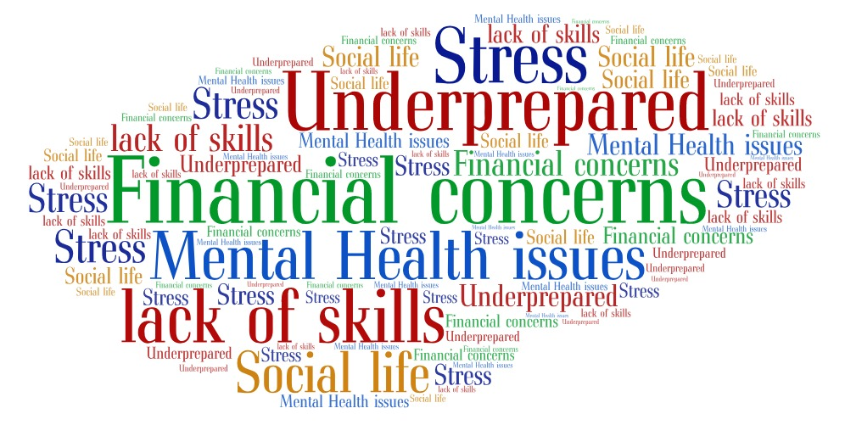
This figure displays the negative themes uncovered in the focus group.

Figure 2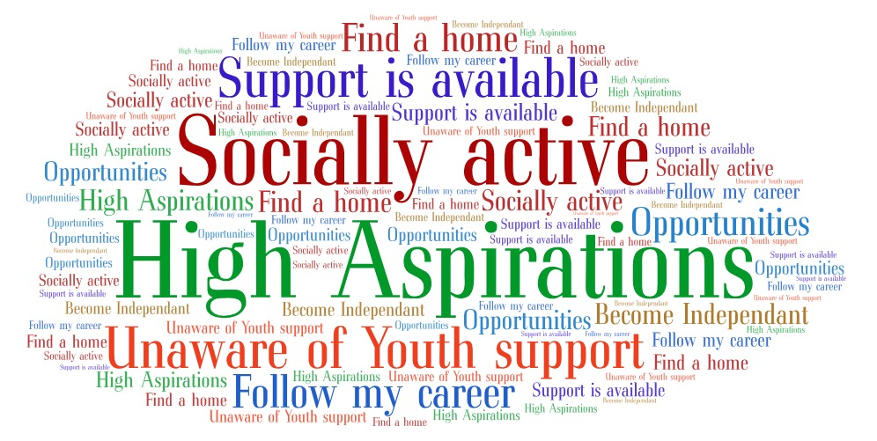
This figure displays the positive themes that emerged from the focus group.

As the above shows, the participants were somewhat unaware of the multitude of services that could be accessed to further their learning and support. In addition, all participants indicated concerns for their social well-being and mental health, and that there was some stigma around living at home with family, as participant one specified they’d be perceived as ‘freeloading’ or being seen as inferior to others in society, whilst participant four argued ‘I can live with my family ‘till i’m 40’ but elaborated they would prefer to be independent, but were stating they were comfortable with living at home and did not see a negative with being with family as an adult.

Chapter 5- Analysis of collected data

The preceding chapter presented the primary findings of the qualitative research carried out by the author with a group of young people studying within university. The core themes identified were ‘Financial Concerns’ ‘Lack of Life Skills’ ‘Mental Health’ and ‘Unprepared for independent living’. This chapter will further analyse the data in order to examine ‘the transition from full time education into independent living- how can Youth work respond’?. The chapter will deduce the core themes that were discovered, and link these findings with those previously found by the theory and policies and other research identified within the literature review (chapter two).
Firstly, the theme of financial concerns was prominent during the focus group, with anxieties of being unable to succeed or struggling to maintain a standard of living. This can be linked to Reitzle and Vondracek (2000) and those attending university are expected to graduate before beginning a professional career, as they are anticipated to succeed in order to be able to achieve higher earnings. Due to the number of young people now attending university as recorded by UCAS (2018), financial issues may not be restricting young people in attending higher education, but if under a state of confusion, may be less certain of what to aim for, and therefore jeopardise their ability to succeed, as Clausen (1991) refers when implying those who aspire for their work role are more likely to succeed in comparison to those who are not as certain of their future. Therefore, the young people have a strong concern about their aspired careers, as they are anxious to fall short of their desired role due to financial difficulties. Participant three explained they were grateful with the opportunities they were able to access, being able to take on a role with ‘Go Wales’ for a period of time to gain valuable experience within their desired sector of work. Taking on experiential breaks like this have boosted their confidence for their aspired work role, and has even continued in providing further learning experiences. Participant two felt confident in their ability to achieve a standard work role, given the competitive nature of their sought role. They stated their field of study prepared them for the competitive market and ensured they had sufficient support. Despite this, they indicated their mental health was low. Participant one also displayed poor mental health, and a lacking of using support which is available, this find supports the second theme of ‘mental health’ being an issue for young people. This are clear indicators which are further supported by Denham (2013) when referring to universities not providing sufficient support for students, allowing for many young people to be missed by support services. This also reinforces the third theme of feeling ‘underprepared’, as the young people have made a clear point that student support is not sufficient and more could be done to support their professional development. When probing which skills the young people lacked, most stated they were confident in their literacy, whereas others were less confident of their numeric skills, with potential underlying learning difficulties that have not been assessed. Referring to Rose (2018) finding employer’s preferred skills for employment- those being literacy, numeracy and information technology skills- it is clear that these young people may be disadvantaged when seeking employment, as they are not being supported to enhance their abilities and have the full potential to succeed in their careers.
With these findings, the suggestion by Creed et al (2003) to ‘identify these at risk students’ grows in importance, as the found research shows that some young people are unobserved by the professionals that could support them, therefore raising awareness of the support groups available to young people becomes increasingly fundamental. Being able to detect, identify and provide support schemes for these young people would be an effective method for encouraging their growth and preparation for independent living.
Through discussion, the careful study and analysis of the issues young people face when transitioning to independent living, this chapter has been able to draw comparison between past research with younger age groups, and discovering that young people still face the same challenges at an older age, but are not aware of the multitude of support groups they could be accessing. This research has therefore uncovered a demographic that requires urgent attention, as there are a large number of concerns affecting young people which could benefit from direct youth support. From finding out the number of services in their community, the group are now informed of potential support outlets that they can utilise to help further their development socially and professionally.
The final chapter of this paper will conclude with a summary of the main findings, and will provide proposals and guidance for further research to help further uncover the issues young people face, and developing strategies that could support them.

Chapter 6- Summary
To close, this chapter will provide an overview of the main findings of this applied research project, and will develop suggestions for future researchers to consider when exploring this field within youth work.
As the previous chapter found, there are four core themes that have emerged to be effecting young people as they depart education. Financial concerns, mental health, feeling underprepared and lack of life skills were found to be the foremost of young people’s concerns for when they depart education, in addition to other issues, which makes a clear statement that young people are in need of further support to progress into independent living, and therefore require an intervention from youth support services to provide a platform in which they can learn the necessary skills to assist them in their adult lives. With these findings, youth work has four primary goals to prepare objectives and strategies to sustain young people’s learning further. These four fields of learning are where they can educate young people on the founding skills which are considered necessary by young people to become successful, which in consideration to Rose’s (2018) survey of employers, would truly benefit their employability thus securing their aspired career roles in the future.
With these findings, the author hopes youth work can evolve to become more efficient when working with young people at higher education and independent living, supporting their transitions more effectively. As stated in chapter two, this transition to independence young people face has been lightly researched to this context, therefore the author aims to open a new avenue of research for aspiring youth workers to explore. As such, the author would recommend extending the range of study, by including a wider scale of young people to uncover if these issues are spread across the United Kingdom, and if there are patterns in this stage of transition. A combination of qualitative and quantitative data would be valuable to display the scale and the needs of young people, which with further information, can youth work fully invest itself to begin supporting those in need of further education to be better prepared for life as an independent adult.

References

Anna Kwek et al (2013) ‘The Impacts of Self-Esteem and Resilience on Academic Performance: An Investigation of Domestic and International Hospitality and Tourism Undergraduate Students’, Journal of Hospitality & Tourism Education Vol.25 Available at https://www.tandfonline.com/doi/abs/10.1080/10963758.2013.826946 (Accessed 18th January 2019)
Bryman, A. (1988). Quantity and quality in social research. London: Routledge.

Clausen J.S, (1991) ‘Adolescent Competence and the Shaping of the life course’ The University of Chicago Press Volume 96(4) Available at https://www.journals.uchicago.edu/doi/pdfplus/10.1086/229609 (Accessed 6th December)

Creswell, J.W. (2003). Research design: Qualitative, quantitative, and mixed methods approaches. (2nd ed.) Thousand Oaks: Sage.

Denham.J, (2013) The Independent ‘Are universities doing enough to support students with mental health problems?’ https://www.independent.co.uk/student/student-life/health/are-universities-doing-enough-to-support-students-with-mental-health-problems-8543756.html (Accessed January 10th 2019)

Erkison E.H (1968) Identity Youth and Crisis. New York: London pg.131

HM Government, (2016) ‘Keep On Caring Supporting Young People from Care to Independence’ p.7

Krathwohl, D.R. (1993). Methods of educational and social science research: An integrated approach. New York: Longman.

Mortimer et al, (2013) ‘Adolescent Precursors of Pathways From School to Work’. Journal of Research on Adolescence, Vol 24, (Issue 1)

Learning and Skills Improvement Service (2012) ‘National Occupational Standards for Youth Work’ Coventry:LSIS, p5.

Noella Mackenzie and Sally Knipe (2006) ‘Research dilemmas: Paradigms, methods and methodology’ Issues In Educational Research, Vol 16 Charles Sturt University.

P.A. Creed., Muller J. & Patton. W (2003 ), ‘Leaving high school: The influence and consequences for psychological well-being and career-related confidence’ ‘Journal of Adolescence’ Vol26 (3) p295-391
‘We Need to talk about post-graduation depression’ https://doi.org/10.1016/S0140-1971(03)00015-0 (Accessed November 16th 2018)

Reitzle and Vondracek (2000) ‘Methodological Avenues for the Study of Career Pathways’ Journal of Vocational Behaviour Vol 57(3) p445-467 DOI:10.1006/jvbe.2000.1751 (Accessed January 10th 2019)

Rose, J (2018) Guest lecture, ‘What Employers seek in young people’ (2018)

Stringer.H (2012) ‘In defence of university careers services’ The Guardian, 24th July. Available at https://www.theguardian.com/higher-education-network/blog/2012/jul/24/defending-university-careers-services (Accessed November 18th, 2018)

Thomas, R. M. (2003). Blending qualitative and quantitative research methods in theses and dissertations. Thousand Oaks, California: Corwin Press, Inc, A Sage Publications Company.

Universities & Colleges Admissions Service (UCAS) (2018) Summary of statistics, ‘Deadline Applicant Statistics: January’. Available at: https://www.ucas.com/corporate/data-and-analysis/ucas-undergraduate-releases/2018-cycle-applicant-figures-january-deadline (Accessed January 10th 2019)

Appendicies

Appendix 1-Undergraduate ARP certificate

Appendix 2-Ethics Form

Appendix 3-Consent Form (blank)

Appendix 4-Information letter

Appendix 5- Research questions

Well-being themed

‘what do you plan to do once you leave education’

‘How do you see your social life after leaving education”?

”Do you think students could have concerns for their health upon departing education? What concerns do you think they would have?” (health and well-being)

“ Do you feel prepared for living an independent life as an adult?” IF ‘YES’, WHY? IF ‘NO’, WHY?

“do you feel there is a stigma around living with family at a later age? What are your thoughts on living with your family whilst living an adult life?”.

Youth work response themed.

“Do you think the support provided for those leaving education/graduating is sufficient?” IF ‘YES’, WHY? IF ‘NO’, WHY?

“ARE YOU RECEIVING ANY SUPPORT AT UNIVERISTY WHICH WILL HELP YOU ONCE YOU HAVE GRADUATED? IF YOU ARE, WHERE DOES THIS SUPPORT COME FROM?”

“What support would help you in preparing for independency?”

“What are your concerns, if any, with living independently? “

“Is there sufficient and accessible Youth services for people aged 18-25?” (YOUTOO; DR M’Z etc.)

Appendix 6-Data sheet 1

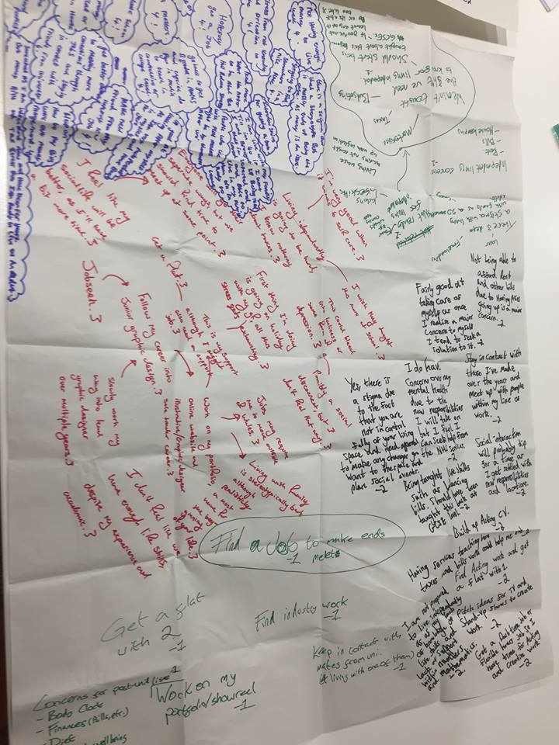 This image displays the raw data collected from the young people within the focus group, containing their answers and thoughts relative to the questions asked in the group. Each participant has used their own colour to be distinguished, writing varying on how strongly how much discussion occurred for each topic.

Appendix 7-Data Sheet 2

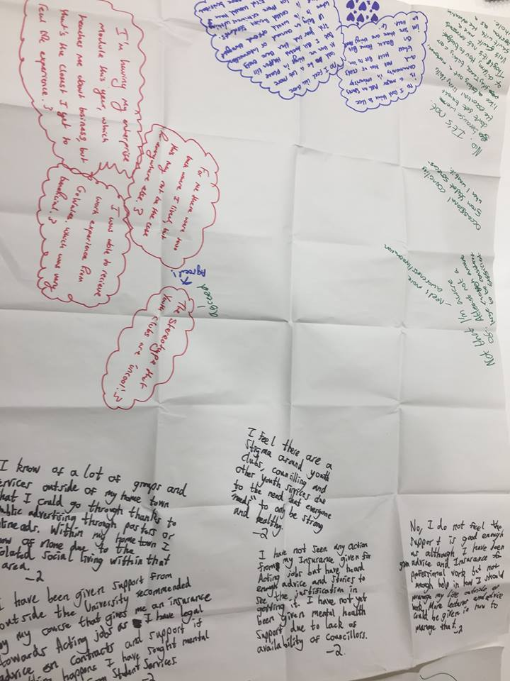 This is the second sheet depicting additional comments made by the focus group. Note in the centre-left three colours written, as both participant one and three agreed strongly with a point made by participant two.

