Theory and Methodology for the Study of the Ancient World – booklet for Unit 10
Modelling malnutrition in the Roman world

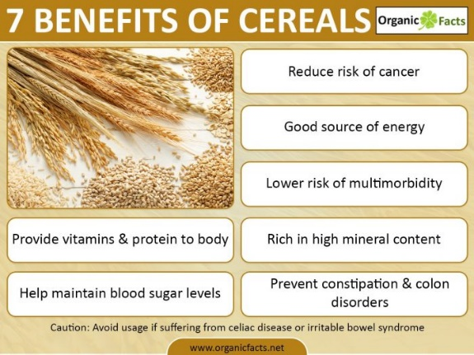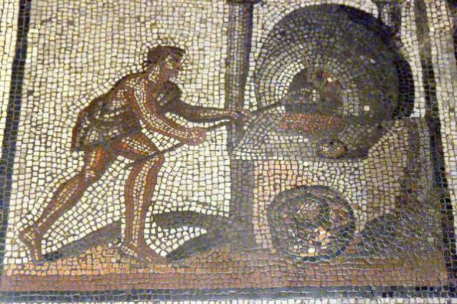

For this online task you should read the short article by Frits Heinrich and Paul Erdkamp (full citation below) which explores how osteological analysis (analysis of human skeletal remains) needs to be approach with greater caution as a proxy for levels of nutrition in the Roman world. While reading the article, consider the questions set out below. You do not need to respond to reach one, but please feel free to share your ideas via the unit forum.

Heinrich, F. and Erdkamp, P. 2018. ‘The role of modern malnutrition in modelling Roman malnutrition: Aid or anachronism?’, Journal of Archaeological Science: Reports, 19: 1016-1022.

Reflect on the following questions:
- What are the opportunities and pitfalls of drawing upon comparative evidence from later periods (especially from the early modern period and the 19th century)?
- What challenges are there is trying to use proxy data (like archaeometric analysis of bones and teeth, human skeletal morphology, etc.) to determine wider phenomena, such as levels of nutrition and health in a population?
- What issues of contextualisation need to be considered?
- What are the problems with assuming that higher (aggregate) income necessarily leads to better levels of nutrition?
- What issues are there with trying to determine nutritional content of some foodstuffs consumed in the Roman world?

