University of Wales Trinity Saint David

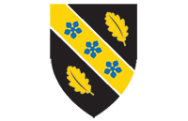

Title: Assessment 2 -Report on a Health Issue
Module Code: LCHS 4008 – Component 2
Module: Introduction to Public Health
Name of Student: Ashfaq Mohammad
Student ID: 2504711
Lecturer Name: Dr. Emmanuel Asante

Table of Contents
1. Introduction 3
2. Approaches Used to Measure and Monitor Stroke 4
3. Control of Stroke 5
4. Consequences of Stroke on People in the Community 6
5. Health and Social Care Support Services for Stroke Survivors 7
6. Conclusion 8
7. References 9

Introduction
Stroke is a severe health disorder, which happens when the blood flow to some part of the brain is disrupted or decreased and the brain tissue does not get oxygen and other nutrients. Lack of oxygen to the brain would cause death of brain cells in few minutes hence resulting in irreversible brain damage, disability or death. Stroke is thus a medical emergency that is needed to be treated urgently.
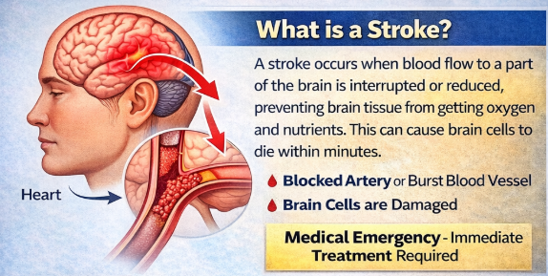
Fig. 1: What is Stroke?
Stroke has two broad categories of ischaemic stroke and haemorrhagic stroke. Ischaemic stroke takes place when a blood clot obstructs blood supply to the brain and haemorrhagic stroke takes place when a blood vessel in the brain ruptures and results in bleeding. The typical signs and symptoms of stroke are sudden weakness or lack of sensation on either side of the body, speech difficulty or poor speech comprehension, vision problems, dizziness and severe headache. Stroke is a significant health issue in the world. In 2021 an estimated 11.9 million new stroke cases occurred worldwide and approximately one out of every four adults can have a stroke during their lifetime. The prevalence of stroke in the United Kingdom is about 100,000 every year, which is an indication of the gravity of the disease.
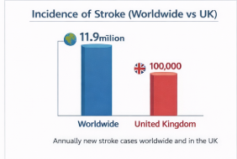
Fig. 2: Incidence of Stroke (Worldwide vs UK)

Approaches Used to Measure and Monitor Stroke
Medical workers employ several diagnostic and monitoring techniques to diagnose stroke and determine its severity. Very important is the early diagnosis since it will be in the decision-making of the treatment as it will be based on what kind of stroke and the extent of brain damage. Brain imaging is one of the most crucial diagnostic tools. The CT scans (Computed tomography) and MRI scans (magnetic resonance imaging) are popular to scan the brain and to identify whether the stroke is a result of a blood clot or a bleeding. A CT scan gives fine details of the brain and can reveal bleeding or any other anomalies quickly. MRI scans give an even more detailed picture and can also be used to identify smaller foci of brain damage. The imaging methods assist the physicians to determine the exact site and severity of the stroke.
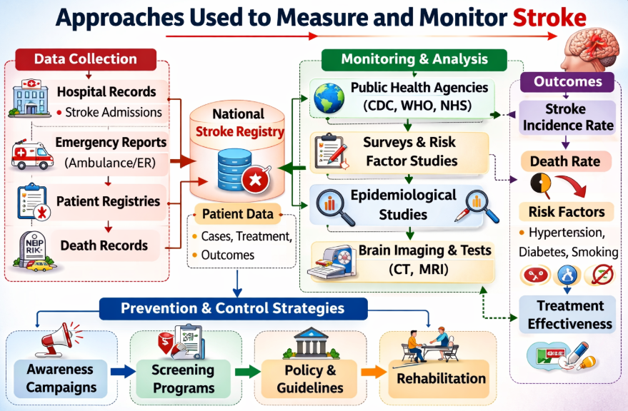
Fig. 3: Approaches to Measure and Monitor Stroke
Besides imaging tests, clinical assessment tools to assess stroke symptoms are also used by the healthcare professionals. The FAST test, or Face, Arm, Speech and Time is one of the tools that is actively employed. This is a test that can assist those who are responding in cases of emergency to identify the symptoms of stroke as fast as possible and provide patients with emergency medical treatment. Additional neurological systems comprise the National Institutes of Health Stroke Scale (NIHSS) that goes on to determine the degree of neurological impairment through the evaluation of various aspects such as speech, movement and consciousness. Blood tests are also taken to assist in diagnosing a stroke and also coming up with underlying factors. Such tests can be used to test blood sugar levels, cholesterol and blood clotting capacity. Deviant outcomes may point to diseases that predispose to stroke, e.g. diabetes or heart disease. The other significant technique of monitoring is the electrocardiography (ECG) that captures the electrical activity of the heart.

Control of Stroke
Stroke can be controlled by preventing the risk factors and controlling underlying conditions. Most of the strokes are related to lifestyle, which includes smoking, unhealthy eating, physical idleness and heavy drinking. Managing high blood pressure also referred to as hypertension is one of the most significant stroke control measures. One of the key risk factors of stroke is high blood pressure as it leads to the destruction of blood vessels and heightens the chances of their blockage or rupture. This risk can be lowered by regular examination of blood pressure and medication. Cholesterol management is another significant prevention action. Cholesterol may cause fatty deposits in the blood vessels that may result in blockage of blood flow to the brain when the levels are high. To address this risk, doctors tend to prescribe statins that are cholesterol-lowering drugs. Stroke can also be controlled with lifestyle changes. Cardiovascular health can be enhanced by adhering to a healthy diet with a low level of salt and saturated fats. The frequent exercise will help regulate weight, lower blood pressure and improve blood flow. It is also important to quit smoking as it harms blood vessels and puts a person at a high risk of stroke.
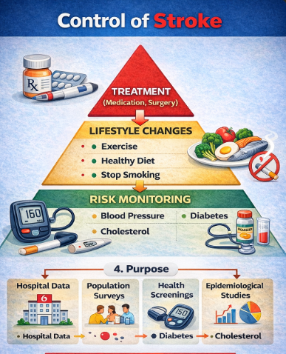
Fig. 4: Control of Stroke
Stroke prevention is also done through medical treatment. Medications like antiplatelet and anticoagulants may be prescribed by physicians and they are used to prevent the formation of blood clots. Surgical interventions can be necessary to eliminate the obstructions in blood vessels in other instances. The prevention of stroke through public health campaigns is also effective since it raises awareness about symptoms and early medical intervention. Stroke severity and survival can be improved by early stroke recognition and treatment.

Consequences of Stroke on People in the Community

The physical, psychological and social impacts of stroke can be very serious to both communities and individuals. Many survivors of strokes have long term disabilities which impact their living standards of independence. Stroke may lead to paralysis or weakness of one side of the body physically, thereby rendering normal activities like walking, dressing or eating hard. There are also those people who might have difficulties in speech or language, referred to as aphasia, which impairs the communication and social interaction. The post-stroke cognitive problems are also typical. These can be characterized by such things as memory loss, inability to focus and make proper decisions. The challenges may impact on the capacity of an individual to resume work or cope with daily chores. Emotional and psychological effects may also be caused by stroke.
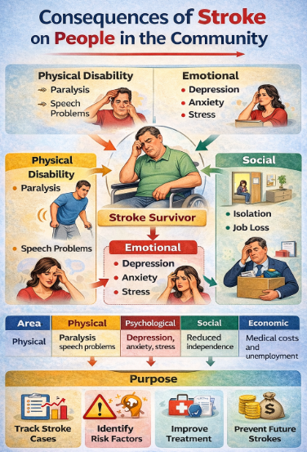
Fig. 5: Consequences of Stroke
A lot of survivors are depressed, anxious or frustrated by the fact that their physical capacity and lifestyle has changed. Stroke may occur abruptly, thus the person may find it hard to adapt to the changes. Caregivers and family might also be stressed to care about a stroke patient. Rehabilitating a stroke survivor can be a time consuming process that involves emotional support and monetary resources. The community and healthcare systems are also affected more by stroke. It is a significant disability-causing factor and imposes a significant burden on health care facilities and rehabilitation services. Stroke is among the main causes of morbidity and mortality in the UK and a significant number of survivors will need long-term care and assistance.

Health and Social Care Support Services for Stroke Survivors
Health and social care services usually need long-term assistance by the individuals who have had a stroke. These services attempt to enable the stroke survivors to be independent so that their quality of life can be improved and the long term impacts of the condition can be managed. Rehabilitation therapy is one of the most significant services. Rehabilitation typically implies a multidisciplinary team of medical workers that comprises physiotherapists, occupational therapists and speech and language therapists. These experts collaborate to re-establish physical movement, communication abilities and daily living skills in the patients. Physiotherapy aids in the recovery of stroke survivors in terms of strength, coordination and movement. Physical therapy programs and exercises are to enhance movement and minimize the risk of complications like stiffness of muscles. Occupational therapy is aimed at re-teaching individuals daily activities which include dressing, cooking and personal care. This form of therapy enables the stroke survivors to be more independent and enhances their functionality in their daily lives. Speech and language therapy helps stroke victims who find it hard to speak or swallow. The therapists employ specialised exercises and communication skills to enable patients to recover these skills.
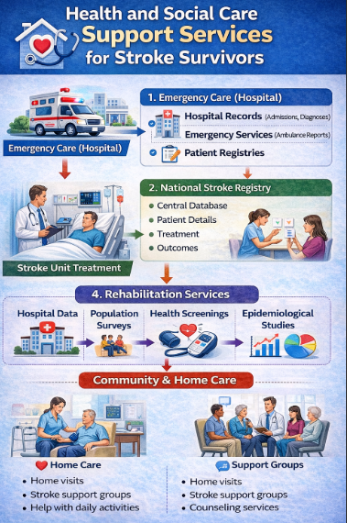
Fig. 6: Health and Social Care Support Services
Another key role in the recovery of stroke is community nursing services. The nurses observe the health status of patients, control the medications and assist the patients and their families. Home care can also be offered to people who are unable to perform their daily activities because of the social care services. Care workers can help in activities like personal hygiene, meal preparation and home chores. Besides the professional healthcare services, support groups and charities are also significant in assisting stroke survivors to cope with life after stroke. These organisations offer both emotional support, information and advice to both the patients and the caregivers. Support networks and community rehabilitation programs assist stroke survivors to find their way back into the society and become generally happier.

Conclusion
Stroke is a severe medical disorder, which happens when the blood flow to the brain gets blocked and damages or kills the brain cells. It is a cause of death and disability in the world and still remains a significant issue of public health concern. Every year millions of individuals are affected by stroke throughout the world and in the United Kingdom, stroke affects around 100,000 individuals each year. Timely reporting of stroke symptoms like drooping of the face, weak arm and speech problems are significant in timely medical care. To measure and monitor the disease, healthcare professionals make a number of diagnostic tools such as CT scans, MRI scans and neurological assessments. Such prevention measures as controlling blood pressure, healthy lifestyles and taking proper drugs can go a long way in eliminating stroke. Stroke may be very disastrous to both individuals and communities but proper health and social care services such as rehabilitation and community support has a critical role in assisting stroke survivors to resume normal lives and enhance their living standards.

References
- World Health Organization (WHO), 2023. Stroke, Cerebrovascular accident.
- World Stroke Organization, 2023. Global Stroke Fact Sheet.
- Feigin, V.L., Stark, B.A., Johnson, C.O., et al., 2021. Global, regional, and national burden of stroke and its risk factors.
- Johnson, W., Onuma, O., Owolabi, M. and Sachdev, S., 2016. Stroke: a global response is needed. Bulletin of the World Health Organization.
- NHS, 2024. Stroke – Causes, Symptoms and Treatment.
- Stroke Association, 2023. State of the Nation Stroke Statistics.
- Benjamin, E.J., Muntner, P., Alonso, A., et al., 2019. Heart disease and stroke statistics—2019 update.
- Campbell, B.C.V. and Khatri, P., 2020. Stroke.
- Centers for Disease Control and Prevention (CDC), 2023. About Stroke.
- O’Donnell, M.J., Chin, S.L., Rangarajan, S., et al., 2016. Global and regional effects of potentially modifiable risk factors associated with acute stroke.
- Public Health England, 2022. Stroke: public health guidance and statistics. London: PHE.
- Donkor, E.S., 2018. Stroke in the 21st century: a snapshot of the burden, epidemiology, and quality of life. Stroke Research and Treatment, 2018.
- Brainin, M., Teuschl, Y. and Kalra, L., 2007. Acute treatment and long-term management of stroke in developing countries.

