Problem solving and decision making (bmsw4004_card)
Azimul Haque
student number 1817417
Trinity St. David’s University Cardiff
Lecturer – M. Squire

This report was published on 04/09/2020

EXECTIVE SUMMARY

- Ford is a popular well- known brand.
- Many have relied on their products for years as they are recognised worldwide.
- Most recently there have been huge declines in sales with current recession issues in china leading to sales dropping by 15% in 2019.
- China markets have dropped, therefore ford is found to be relying heavily on US markets leading to less profitable earnings.
- Company is faced with competitive pressures as industry continues to grow yearly.
- Higher demand for eco-friendly products in comparison to diesel products, therefore a market shift is required

CONTENTS PAGE
INTRODUCTION…………………………………………………………………………………………………………….1.0
FINDINGS………………………………………………………………………………………………………………………2.0
HISTORY OF FORD…………2.1
INTRODUCTION OF THEORECTICAL FRAMEWORKS……………..………………………………………...3.0
SWOT ANALYSIS AND FORD………………………………………………………………………………………..…4.0
STRENGTH…………………4.1
GLOBAL PRESENCE…….4.2
BRAND EQUITY……………4.3
WEAKNESSES…………………………………………………………………………………………………..…………..5.0
BANKRUPTCY AND DECLINES IN SALES...5.1
HIGH DEPENDENCY ON US……………………5.2
OPPORTUNITIES…………………………………………………………………………………………………..…..…6.0
ONLINE DIGITAL MARKETING……………………6.1
AUTONOMOUS DRIVING………………………….6.2
PARTNERSHIP EXPANSIONS……………………..6.3
ENVIORNMENTALLY FRIENDLY PRODUCTS.6.4
THREATS…………………………………………………………………………………………………….7.0
COMPETITIVE PRESSURES…………………………………………………….7.1
REGULARTORY PRESSURES…………………….7.2
PESTLE ANALYSIS OF FORD………………………………………………………………………………………8.0
POLITICAL FACTORS……………………………….8.1
ECONOMICAL FACTORS………………………….8.2
SOCIAL FACTORS…………………………………...8.3
TECHNOLOGICAL FACTORS…….………………8.4
LEGAL FACTORS……………………………………..8.5
ENVIORNMENTAL FACTORS……………………8.6
CONCLUSION…………………………………………………………………………………………………………..9.0
OPTIONS AND ACTION PLAN…………………………………………………………….……………………10.0
ACKNOWLEDGEMENTS…………………………………………………………………………………………..11.0
REFERENCES……………………………………………………………………………………………………………12.0

- INTRODUCTION

The purposes of this report include an analysis of the current issues that are faced by the company Ford. The issues will be identified and analysed by using tools including SWOT and PESTLE. To gather important information which will then be incorporated throughout the report. The research method chosen for this report in order to assist with gathering information are credible internet sources. This report will be referenced using Harvard referencing. The report will also include a conclusion and any options of improvements and action plan that can be made at Ford.

2.0 FINDINGS
2.1 HISTORY OF FORD
Ford is an American motor company that was founded by Henry Ford in 1903 (Jury, 2012). The main headquarters for the company is based in Dearborn Michigan, suburb of Detroit (Jury, 2012). The ford company quickly became a very popular car brand and to this day, according to research, it remains a popular and dependable brand, favoured by first time buyers (Jury, 2012). Henry Ford deceased in 1947. However, the innovation and industry that he instilled continues to live on as Ford offer many different products to buyers as the company is ever changing and ever growing (Jury, 2012).
Ford motor company specialise in products including automobiles, commercial cars, luxury vehicles, automotive parts SUVs and pickup trucks (Ford, 2020). Ford products can be purchased through approved ford dealerships. The purchasing of Ford products is made easy for customers as, many different methods of purchase are provided including both remote and in remotely, bringing in a diverse range of customers (Ford, 2020). The Ford company provide ongoing support including customer service for all service users by providing different methods of communications and advice centres including emails, telephone contact, online webchats and in person communications (Ford, 2020).

3.0 INTRODUCTION OF THEORECTICAL FRAMEWORKS
Both PESTLE and SWOT theoretical frameworks will be used in this section to provide an analysis and thorough understanding of different factors both negative and positive issues faced by Ford motors company. Those including strengths, weaknesses, opportunities, and threats. It will also provide an insight of political, economic, social, technological, legal, and environmental factors that all effect ford motor company.
4.0 SWOT ANALYSIS AND FORD
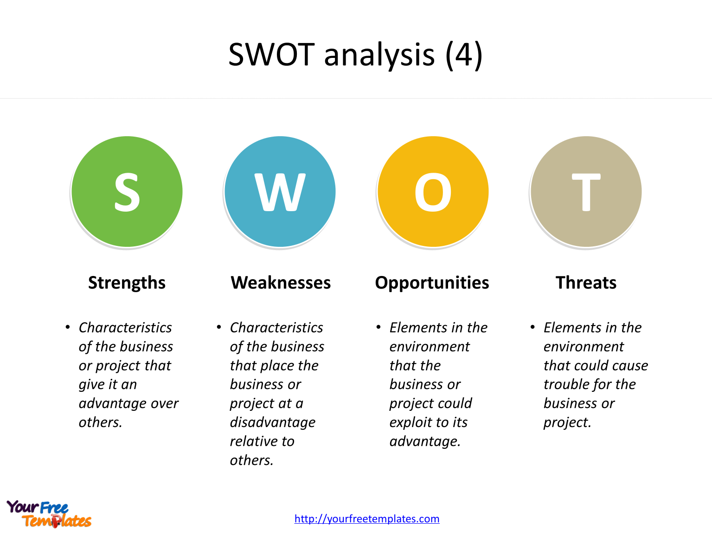

4.1 STRENGTHS
Ford is one of the oldest and most iconic vehicle manufacturers in the world. They have a global supply chain. Its global operations, research and development stands as a strength and is associated with the company’s success. Fords innovation processes are effective and have paved the way for the motoring industry.

4.2 GLOBAL PRESENCE
The company Ford motors has been around for many years, having a huge global footprint as it is a very well known. It is a popular brand favoured by the community (Farooq, 2019). According to research, Ford motors have manufacturing presence in over 60 countries, and continue to grow by distribution of networks and strengthening sales worldwide (Farooq, 2019).
In 2017, approximately 6,607,000 vehicles throughout the world were sold through wholesales (Jurevicius, 2020). All the vehicles, accessories and parts produced by ford are sold through dealers and distributors, majority of which are independently owned (Jurevicius, 2020). The company Ford does not have a dependency on any single customers or few customers to the extent that loss of customers would have materiel adverse effects on the business (Jurevicius, 2020). In addition to this, Ford sell vehicles to dealerships to fleet customers, that including commercial fleet customers, governments, and daily rental car companies (Jurevicius, 2020).
4.3 BRAND EQUITY
Brand equity is a vital factor to have in any global brand, as there is always an increased competition within the automobile industry with different brands (Pratap, 2019). It is also important to maintain revenues, leadership, and sales. Pratap, 2019) Ford motor company have managed to maintain a strong brand equity which is a strength for the business. The company have a large customer base worldwide suggesting, that they are trusted by many customers (Pratap, 2019).
Additionally, the company has built up leadership positions by branding and marketing and has worldwide upheld strong dealership networks including companies such as Suzuki and Isuzu, this is crucial for sales and customer service therefore, another perk within the company (Pratap, 2019).

Ford is also well known for distribution efficiency in operations, as it is found that manufacturing facilities operate in over 30 different countries, enhancing manufacturing processes in over 90 facilities worldwide (UK Essays, 2018). Ford have invested heavily in fuel sources and they have developed cars on standard procedures (UK Essays, 2018). Ford are known for employing qualified and skilled employees to provide top customer service for consumers and they maintain good relationships with them. Competitive wages are offered along with great work environments as the company are highly concerned about working environments and safety aspects for all employees (UK Essays, 2018).

5.0 WEAKNESSES
Fords weaknesses derive from the companies limitations. As a company, Fords maintenance and cost of running compares higher than its competitors, furthermore its closure of many production facilities in Europe has proved to be a loss for the company, both financially and in status.

5.1 BANKRUPTCY AND DECLINES IN SALES
Research shows us that, Fords credit rating is close to being downgraded and classed as ‘junk’ effecting any future opportunities of the business borrowing money (Singh, 2020). The company invested into restructuring plans which led to the company drowning in debt, leading to very low cash flow (Singh, 2020).
Research also tells us that, major ford markets have had amid declines in sales suggesting that, the company could go bankrupt sooner than expected (Singh, 2020) CEO of Ford Jim Hackett invested $11 billion in a bid to resuscitate the company however, despite these ideas investors have lost patience as earnings continue to drop, due to major losses incurred in China (Singh, 2020). The issues faced with decline sales in China has become a huge for the brand because, China have the leading automotive market in the world (Pratap, 2019).
However, within the past 3 years, Ford motors have declined in sales within China’s markets and continue to fall (Singh, 2020). Sales of vehicles have dropped from 1.3 million units in 2016, 1.2 million units in 2017 to then 0.8 million units in 2018 (Pratap, 2019). Most American car maker brands have been affected through the conditions in China with a recorded 15% drop in 2019.
(Singh, 2020). Moreover, with the most recent recession currently faced with the outbreak of coronavirus, it has affected the chinese economy in a negative light, due to this, Ford company are in for major loses with the lack of profitability faced in China and debt downgrade (Singh, 2020).
5.2 HIGHLY DEPEDENT OF US MARKETS
Ford motors was founded in America and the leading market of ford motors is current in the United States as it was accounted for over 50% of net revenue of ford motors in 2018 (Pratap, 2019). China’s position on the market has dropped therefore, this leaves a high dependency on US markets even though it is a worldwide known business market positions in other countries are not strong enough to reduce dependency on US markets (Pratap, 2019).
6.0 OPPORTUNITIES

There are quite a few opportunities for Ford to maximise their potential and profit. The new automative technologies such as the self- driving could increase the demand for new models which will mean more sales. At the same time, Fords alternative fuel cars (C-Max electric and the Fusion Hybrid) are growing in popularity and the market for these alternative cars are demanding as the concerns about air pollution is also growing.

6.1 ONLINE DIGITAL MARKETING
Online digital marketing is a great opportunity for motor brands, as it can be used for purposes such as branding, customer engagement and marketing Pratap, 2019). Ford can use online marketing to drive additional sales and strengthen connections with customers (Pratap, 2019) However, not only can technology be used for customers and driving sales, but it can also be used for the engagement of staff along with supply chain management (Pratap, 2019)
6.2 AUTONOMOUS DRIVING
This form of driving has become very popular within the automobile industry (Pratap, 2019). Several other brands including Ford have considered to invest into autonomous driving Pratap, 2019) This is packed with opportunities as there are offers of profitable options for the company, as there would be potential growing sales and profit increase Pratap, 2019).
6.3 PARTERSHIP EXPANSIONS

Partnering with other brands can help Ford extend their global presence to promote sales and distributions of channels worldwide (Pratap, 2019). Ford have some plans with partnering up with Volkswagen in the foreseeable future, that will offer opportunities that increase production of selective models (Pratap, 2019).
6.4 ENVIORNMENTALLY FRIENDLY PRODUCTS
Ford have made some significant energy saving and efficient vehicles such as the mustang and Ford explorer hybrid (Farooq, 2019). However, there remains a significant scope for further innovations within with sector. Ford should use their capabilities to establish themselves as a market leader for environmentally friendly vehicles as, there are competitors such as Tesla and Mercedes that have a huge range of eco-friendly vehicles (Farooq, 2019).
7.0 THREATS
Like all car manufacturers, Ford is facing a n industry which is constantly changing. New technologies are creating threats and the need to keep current and competitive in the market is proving to be costly. In recent years experts in the automotive industry predict that new technologies such as self-driving and Uber could limit the need for costly cars. Young people in this generation are driving less. That could be due to living in inner city where driving is not economical. This means less interest in cars which would lead to less cars being produced.
7.1 COMPETITIVE PRESSURES
There is constant competition in every business industry, however relating to the motor industry, there are several leading players battling for market shares worldwide. The major competitors of ford have and are investing heavily in innovation and research as well as marketing options (Pratap, 2019). As a result of high competition, the market share of Ford in markets including China have significantly shrunk Pratap, 2019). As mentioned previously, many competitors have electric cars available for purchase as vehicles that are electric currently stand as ‘less polluting’ than diesel vehicles (Ellsmoor, 2019).
7.2 REGULATORY PRESSURES
The increase in government regulations play a major role that threatens the profitability of ford motors. Globally, the trade wars between different countries and an increase level of regulatory inconveniences also contribute to performance declines in ford (Farooq, 2019).
8.0 PESTLE ANALYSIS OF FORD

8.1 POLITICAL FACTORS
Political instability in the European Union (EU), including Brexit have resulted to negative impacts on fords performance markets (Farooq, 2019). The UK could lose access to free trades with the EU which could cause massive loses within the company and potential reduction demands in the market (Farooq,2019).
8.2 ECONOMIC FACTORS
In 2019 fords financial performance was described as disappointing as the net income of the brand took a large dip. The reason for this was due to economic fluctuations in many markets (Farooq, 2019). Additionally, fluctuations in currency exchange rates have affected fords net income in a negative aspect, as car sales worldwide have decreased in demands, almost saturating playing fields (Farooq,2019).
8.3 SOCIAL FACTORS
Customers in society are flooded with many choices when it comes to motor sectors, as there are multiple choices on the market to date, ford motors may find it difficult to attract buyers as the market is spread out with competitors (Farooq,2019). There are higher demands globally in the market for electric and hybrid vehicles. As mentioned previously, with the risen interest in eco-friendly and fuel efficient vehicles, ford can position themselves as a major player in the hybrid car segment as there is still room for a larger selection of cars that are eco-friendly and fuel efficient.
8.4 TECHNOLOGICAL FACTORS
Technology in the recent years has become a popular aspect of everyday life with the population amongst us described as ‘tech-savy’ (Farooq, 2019). For this, technology has a huge role with consumers of motor vehicles. There seems to be a greater demand with high tech vehicles that are equipped with modern technological devices, including automatic windows and rear-view cameras and parking sensors (Farooq, 2019). Ford is not behind on these gadgets as the company continue to keep up with latest gadgets. (Farooq,2019). Competitor car brands including Mercedes, range rovers and tesla have a range of driverless cars, ford have hopes in the future to have a range of driverless cars however, they currently do not have this range (Farooq, 2019). Ford company provide services of the electric car known as ford mustang mach-e, this is an electric car however, it is the only one in comparison to the wide range that are offered by companies including Tesla (Farooq, 2019).
8.5 LEGAL FACTORS
Some legal factors that affect the growth of Ford are labour laws and intellectual property rights. Suggestions for increase of business it would be ideal that ford support their company with regulations to ensure that the design of products are safely tested and that they work environmentally meeting legal laws required (Farooq,2019).
8.6 ENVIORNMENTAL FACTORS
There in a global demand for environmentally friendly and eco-friendly motors, those including, electric and hybrid cars as these products have little to no emission, suggesting that they are environmentally safe and of high demand in current population (Farooq,2019). The economy in the UK and the UK government are currently focusing on a green economy and have enforced charges on diesel cars in areas including central London with heavy traffic (Woodhouse, 2020). There has been an introduction of ultra-low emissions zone (ULEZ) that aim to improve the quality of air, discouraging polluting vehicles as a charge applied when needing to enter. Low emission zones encourage the use of hybrids, electric and other alternative fuel vehicles (Woodhouse, 2020).

9.0 CONCLUSION
Overall, this report has successfully identified both the strengths and weaknesses faced by Ford company motors. The researcher has successfully applied both PESTLE and SWOT analysis to gather information on the different issues faced with ford motors. It is found that there are some positive aspects within the company but also balanced with negative aspects suggesting that there is room for improvement of services provided in order to make profitable incomes and promote sales.

10.0 OPTIONS AND ACTION PLAN
By conducting research through PESTLE and SWOT analysis, it has been made apparent of the issues faced with ford motors company. It is now important to provide options of improvements of the issues identified, including a plan of action.
ISSUES FACED
Firstly, majority of the products produced by Ford car motors are diesel cars, the research conducted shows us that, there is a higher demand with electric eco friendly vehicles and the demand continues to increase. It is predicted that by the year of 2040 electric cars will increase by 57% suggesting that diesel cars Could be at a less of a demand (Scott, 2019).
ACTION PLAN
Ford currently mainly produce diesel cars, therefore, should shift strategy sales with investing into more hybrid, eco-friendly products. Ford could predominantly use marketing to promote sales on their existing hybrid products to draw in customers. Investments in electric cars will push sales as they have worked for other competitors.
ISSUES FACED
Another issue identified whilst undergoing SWOT and PESTLE analysis was that there has been a huge drop in sales made by ford, it is important that there is a fixed action plan to rectify this issue.
ACTION PLAN
The CEO of Ford could review their statistical records and identify which vehicles are best selling and which are not, this is to ensure that the company are not over supplied with products that do not sell as effectively as others and this would also avoid excess waste that could hinder profitable income. Other car competitors including BMW and Mercedes promote a scheme that enable existing customers to test drive new products for free in the duration of two days. This helps to gain sales as well as the promotion of new products, ford could introduce this scheme for their company as it has worked for other competitors and it could help with the improvement of sales produced.

11.0 ACKNOWLEDGEMENTS

I would like to thank my lecturers for the teaching that they provide by going above and beyond. I have thoroughly enjoyed this module and believe that it will help me in the future. It has been a pleasure writing and researching for this report, I hope that you enjoy reading it as much as I enjoyed learning and writing it.

12.0 REFERENCES

- Jury, S., 2012. A Brief History Of Ford. [online] Car News. Available at: <https://news.motors.co.uk/news/a-brief-history-of-ford/> [Accessed 1 September 2020].
- Ford.co.uk. 2020. Ford Service. [online] Available at: <https://www.ford.co.uk/owner/owner-services/ford-service?searchid=ppc:Search_GB(eng)%7C%5BAO%5D_FCSD_SD_FCSD_Servicing:Service_CPPI_GBP%7CShp-T2%7CBMM:Ford-Service-BMM:%2Bford%20%2Bservicing:b:c:o:MICROSOFT&msclkid=8f5679870f6211fe3de326cdbdcb3d02&gclid=CPH7uvKYwesCFU6HhQodmzkFdw&gclsrc=ds> [Accessed 1 September 2020].
- Pratap, A., 2019. SWOT Analysis Of Ford Motors 2019. [online] notesmatic. Available at: <https://notesmatic.com/2019/04/swot-analysis-of-ford-motors-2019/#:~:text=Asian%20markets%20%3A%2D,in%20India%20is%20competitively%20weaker.> [Accessed 1 September 2020].

- Farooq, U., 2019. Ford SWOT Analysis | SWOT Analysis Of Ford Motor Company. [online] Marketing Tutor. Available at: <https://www.marketingtutor.net/ford-swot-analysis/> [Accessed 1 September 2020].

- Singh, A., 2020. Why Bankruptcy Is A Forgone Conclusion For Ford Motor Company. [online] CCN.com. Available at: <https://www.ccn.com/why-bankruptcy-forgone-conclusion-for-ford-motor-company/> [Accessed 1 September 2020].
- Farooq, U., 2019. Ford PESTLE Analysis | PESTEL Analysis Of Ford Motor Company. [online] Marketing Tutor. Available at: <https://www.marketingtutor.net/ford-pestle-analysis/> [Accessed 2 September 2020].
- Jurevicius, O., 2020. Ford SWOT Analysis (5 Key Strengths In 2020). [online] SM Insight. Available at: <https://strategicmanagementinsight.com/swot-analyses/ford-swot-analysis.html> [Accessed 2 September 2020].
- UKEssays. November 2018. Ford Motor Company SWOT Analysis. [online]. Available from: https://www.ukessays.com/essays/marketing/swot-analysis-of-ford-motor-company-marketing-essay.php?vref=1 [Accessed 2 September 2020].
- Ellsmoor, J., 2019. Are Electric Vehicles Really Better For The Environment?. [online] Forbes. Available at: <https://www.forbes.com/sites/jamesellsmoor/2019/05/20/are-electric-vehicles-really-better-for-the-environment/> [Accessed 2 September 2020].
- Woodhouse, A., 2020. ULEZ, LEZ And CAZ: UK Low Emission Zones Explained. [online] Autotrader.co.uk. Available at: <https://www.autotrader.co.uk/content/advice/ulez-lez-caz-low-emission-zones-explained> [Accessed 3 September 2020].
- Scott, M., 2019. Electric Models To Dominate Car Sales By 2040, Wiping Out 13M Barrels A Day Of Oil Demand. [online] Forbes. Available at: <https://www.forbes.com/sites/mikescott/2019/06/10/electric-models-to-dominate-car-sales-by-2040-wiping-out-13m-barrels-a-day-of-oil-demand/#6aa62a0342e1> [Accessed 3 September 2020].

