

Entrepreneurial Perspectives (LCDB7001_LON)

Review on: “Team formation Processes in New Ventures”.

Student name: Hemanta pun
Student ID: 1810795

Module Leader: Dr. Gladius Kulothungan
Date: 29th August 2019

Table of content:
- Introduction…………………………………………………….3
- Literature review…………………………………………….3-4
- Research method…………………………………………….4
- Findings and discussion…………………………………….4-5
- Research implications………………………………………5-7
- Conclusion……………………………………………………7
- Reference

1.0 Introduction
Conducting a review of an article is associated with the analysis of multiple aspects involved in a scholarly article (Fink, 2019). The aim of this study is based in the review of the article “Team formation Processes in New Ventures”. The scope of this study lies in the identification of multiple domains associated with a scholarly article.
This article is based on the presence of signs of the team on joint ventures. The article has shed light on the presence of an ideal combination based on the theory of data-centric. This is because the article focuses on three basic dimensions associated with team formation (Melillo, Folta and Delmar, 2013). This includes the “founder, employees and service provider”. Additionally, the authors included the theoretical aspect of labour market regulation; nature associated the product of a venture and the degree of innovation for the same. Similarly, the article related to multiple graphical presentations that are developed based on the natural logarithmic relationship identified for conduction of market estimation.
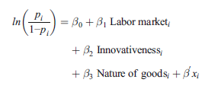
Figure 1: Natural logarithmic expression based on the theoretical dimensions
(Source: Held, Herrmann and Mossel, 2018)

2.0 Literature review
The literature of this article concerns with the core three dimensions that are factors founder employee and services provider. The article has emphasised the part of restrictions that delves with the propagation based on the specification of labour markets in the global context. The prime portion in which the article has come up with essential factors that revolve around the specification based on the importance of joint ventures (McMullen and Dimov, 2013). The article has come up with the presence of significant evaluation of concepts that has shed light on the part of joint ventures. This difference has studied based on the timeline of the formation of 344 companies in the USA and Germany. Additionally, multiple characteristics like the timeline associated with the founder of the organisation as well as the employee involvement with the inclusion of service providers modulate the team-building process. Hence, in the long end, the extended area of discussion would include a new dimension in entrepreneurship research like jig team formation.

3.0 Research methodology
It has come up with the presence of sample size and technique that has come up with the specification based on the implementation of concept related to the presence of joint ventures. The data so collected by the authors has sourced from the central data depository named “Perfect Timing” database. The data present in the central depository has developed through the help of computer-assisted telephonic interviews with multiple founders. The appropriateness of the data is essential in the positive manner as the data has sourced over four years by an “international research team” from multiple nations like The Netherlands, The USA, Germany, UK and Italy. For the conduction of this research, the available data and its sources are necessarily sufficient, as it has enabled the authors to meet their research hypothesis (Melillo, Folta and Delmar, 2013).
There has been a presence of essential restrictions on the part of the sample size. Though the authors have undertaken a good number of organisations, the impact of multiple labour markets and their institutions could be better analysed in the event that more nations are taken into consideration. Additionally, based on the regression analysis conducted by the authors, it is evident that there exist several variables that those undertaken for the research. Additional limitation relative to the undertaken article includes poor linking of team formation mechanism with venture success and other specific outcomes.
4.0 Findings and discussion
The positive outcome that has been found through the help of the article related to the portion of propositions that delve with the specification based on the part of two clusters of the article. Relative to the seven clusters and propositions that have been studies, it has been found by the authors that the apart from two clusters, all the remaining ones are mostly homogenous. The involvement of the founder was found to be .5 FTE in the first cluster. Hence, it could be deduced that such a bunch is essentially a static one. Similarly, it has been found by the authors that the groups that incorporate the size of the team; the founder aspect essentially becomes dynamic in nature.

5.0 Research implications
The implication of the journal can be constructing through the support of prime points that belongs to the portion of the article. The main issues, coupled with the questions addressed by the authors, included the relationship between labour markets and the team formation process of the organisation in the long end (Melillo, Folta and Delmar, 2013). The additional question consists of the impact of the size of the founding team in the team formation process. An issue that has been addressed by the authors includes the identification of the mathematical function associated with the seven services (Hjorth, Holt and Steyaert, 2015).
On the other hand, Hellerstedt (2009) has perceived that the implication of this article has come up with the projection based on the limitations of the subject that needs to be resolved. The issues mentioned above have discussed positively and effectively with minor limitations. This is because the authors mostly have a graphical presentation for the execution of their results. Additionally, skewness and the factor of homogeneity have regularly taken into consideration during the implementation of this research (Held, Herrmann and Mossel, 2018). The graphical presentation has additionally been associated with a standard variable and projection of the results comparatively and critically. However, Melillo, Folta and Delmar (2013) stated that in the segment of efficacy, the addressing has slightly faltered due to the limitation of consideration of only two nations.
Through the help of this article, the significant points can be illustrated that portrays the concept of joint ventures. Vital points made by the authors include the dynamicity in the impact of the labour-market institution on the team formation process associated in new ventures. However, significant interpretations have executed with graphs.
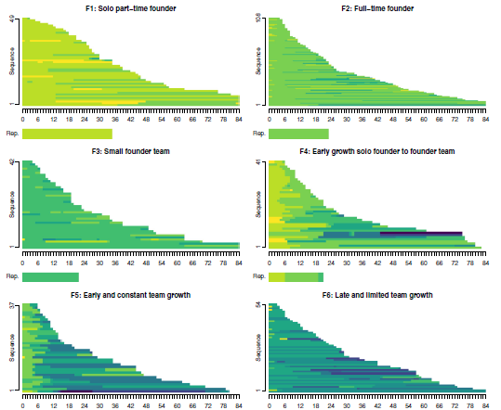
Figure 2: Graphical presentations
(Source: Held, Herrmann and Mossel, 2018)
Based on the diagrams mentioned above the authors interpreted that there is significant dynamicity in between the interference of the founders and the team size relative to the local labour market. This includes the inclusion of the multiple legislations associated with the labour market and labour rights.
Herrmann and Peine (2011) stated that the value of the database relevant to the subject. It could be deduced that the comments made by the authors are fair in nature. This would be due to two reasons. First, any deduction so obtained by the authors has been based on the graphical presentations and numbers associated with the research. As a result, this has limited the scope of personal interference in the section of deduction, analysis and interpretation. Second, this would be because the source of data has been an authentic one and characterised by a data collection mechanism of four years from multiple nations.
The authors do make the essential and unique contribution of the resources so undertaken. This would be through two mechanisms. First, the authors have identified the factors associated with the team formation processes involving new ventures. This has been characterised by labour markets, founder timeline, initial employee volume and others. Second, the authors have included the data from new ventures only from a central database. Additionally, the authors have identified the potential limitation associated with their project. As a result, they have provided scope for further research and original contribution to the mentioned topic.

6.0 Conclusion
The analysis of the concerned article has led to the formation of a singular and theoretical conclusive statement. This includes that in the segment of team formation, labour market substantially modulates the same through multiple layers. Some of the modulating factors would consist of team size, legislation and the type of business venture and product base.

References
Fink, A. (2019). Conducting research literature reviews: From the internet to paper. Sage publications.
Held, L., Herrmann, A.M. and Mossel, A.V. (2018). Team formation processes in new ventures. Small Business Economics, Vol.51 (2), pp.441-464.
Hellerstedt, K. (2009). The composition of new venture teams: Its dynamics and consequences. Jönköping International Business School. JIBS Dissertation Series No. 056.
Herrmann, A. M. and Peine, A. (2011). When national innovation system^ meet Bvarieties of capitalism^ arguments on labour qualifications: on the skill types and scientific knowledge needed for radical and incremental product innovations. Research Policy, Vol. 40(5), pp. 687–701.
Hjorth, D., Holt, R. and Steyaert, C. (2015). Entrepreneurship and process studies. International Small Business Journal, Vol. 33(6), pp. 599–611.
McMullen, J. S. and Dimov, D. (2013). Time and the entrepreneurial journey: the problems and promise of studying entrepreneurship as a process. Journal of Management Studies, Vol. 50(8), pp. 1481–1512.
Melillo, F., Folta, T. B. and Delmar, F. (2013). What determines the initial size of new ventures? 35th DRUID Celebration Conference 2013 Barcelona, Spain, June 17-19.

