Module Name: Introduction to Web and Database Concepts
Module Code: ACCA4023
Student Name: Carolina Capatina
Student ID: 2509818

Table of Contents
Introduction 3
Requirements 4
Implementation 6
HTML Section for Marlowe University 6
Overview of CSS Section 10
Evaluation 12
Usefulness (Usability and Utility) 12
Search Engine Optimisation (SEO) 13
Accessibility (WCAG 2.1) 14
Conclusion 18
References 19
Appendix 21

Introduction
Website design is a process which focuses on the visual aesthetics, layout and user experiences in a website. This is done while the emphasis of the work is on the database server which acts as a backend engine helping for storing, managing, and retrieving data for the functionality of the work [1]. The following report will be focusing on developing a website for a university where the students can enrol, go through the home page and check out all the services provided. Additionally, the report will also be discussing the key uses of the semantics of HTML which will help in understanding the structure of the website as a whole. The website will also be compared with the websites of BBC and Argos for better evaluation and functionality tests.

Requirements
Details:
The website developed through this work was done for Marlowe University which has helped it in providing a responsive, modern, and informative platform for all customers including the students and parents. It was built using HTML5 and CSS3, which has helped in demonstrating all fundamental web development concepts. This was done while delivering a professional appearance and an overall intuitive user experience. The overall implementation process included semantic HTML with the techniques of responsive CSS that helped in ensuring that the website remained visually consistent throughout. Further, the functionality across all devices like desktop, computers, tablets and smartphones were achieved through the help of this. The whole website is organised into several clearly defined sections, allowing all the visitors to navigate information efficiently. The homepage helped in acting as the primary entry point, introducing Marlowe University through a welcoming section, institutional branding, and a structured navigation menu. Further, Additional sections present information about academic programmes, campus facilities, student services, and opportunities available to prospective learners. Semantic HTML elements such as <header>, <nav>, <main>, <section> and <footer> have been used throughout the website to create a logical page structure. These elements not only improve readability for users but also helps in accessing search engines and accessibility technologies in understanding the organisation of the content. Here, CSS has been applied to the website to enhance typography, spacing, colours, Flexbox layouts, and responsive media queries, creating a clean and consistent visual design regardless of screen size [7].
Purpose:
The main purpose of this website was to create a digital platform for the university through which it could increase its digital presence in front of the students. This was done by presenting essential information to everyone through an accessible and well-structured format. Universities increasingly rely on their websites as the first point of contact for prospective students, making usability and presentation equally important. This website enables visitors to explore academic offerings, gain an understanding of campus life, and locate relevant information without unnecessary complexity. A responsive design further improves accessibility by ensuring that users receive the same browsing experience whether accessing the website from a mobile phone, tablet, or desktop computer [12].
Target Audience:
The primary target audience of this work includes students who are searching for good universities for higher education opportunities. In addition, the students who are looking for reliable information to find about the universities before making a decision for application are also targeted through this website. Further, parents and guardians also form an important audience, as they often seek details regarding courses, facilities, and the overall learning environment. Existing students may use the website to access university information and navigate available services, while academic staff, visitors, and external stakeholders can also benefit from its organised layout and straightforward navigation.

Implementation

HTML Section for Marlowe University
HTML Semantics
HTML semantics significantly indicates the practice of utilising HTML tags that inherently describe the meaning and purpose of their content rather than just how it looks. An effective structure of HTML semantics leads browsers, search engines and assistive devices to understand exactly what role each element plays on a web page [2].
<header>
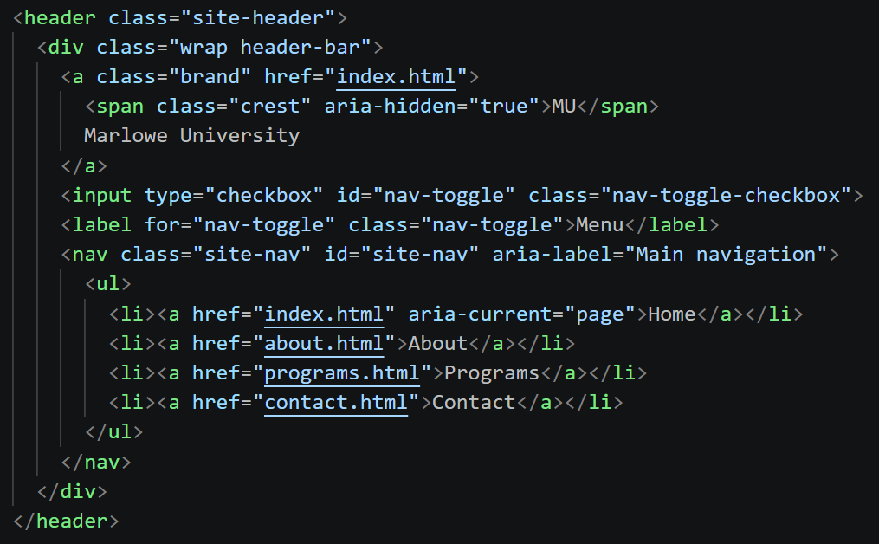
The header tag is used to group introductory content, logos or global site navigation. It wraps all top-level identity elements to tell browsers, screen readers and engines that this block represents the introduction banner of the website [3]. It also contains the university logo <span class="crest">MU</span> and the text title link for Marlowe University. The header tag is also used for holding the main website directory, which houses the links to Home, About, Contact and Programs.
<section>
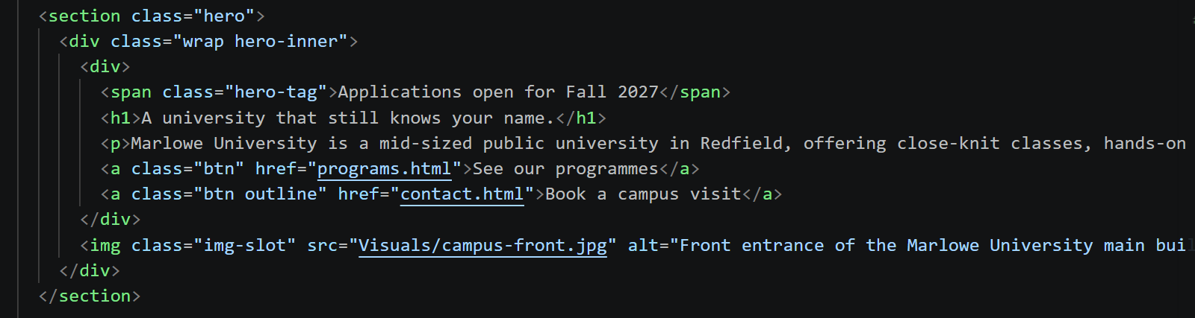
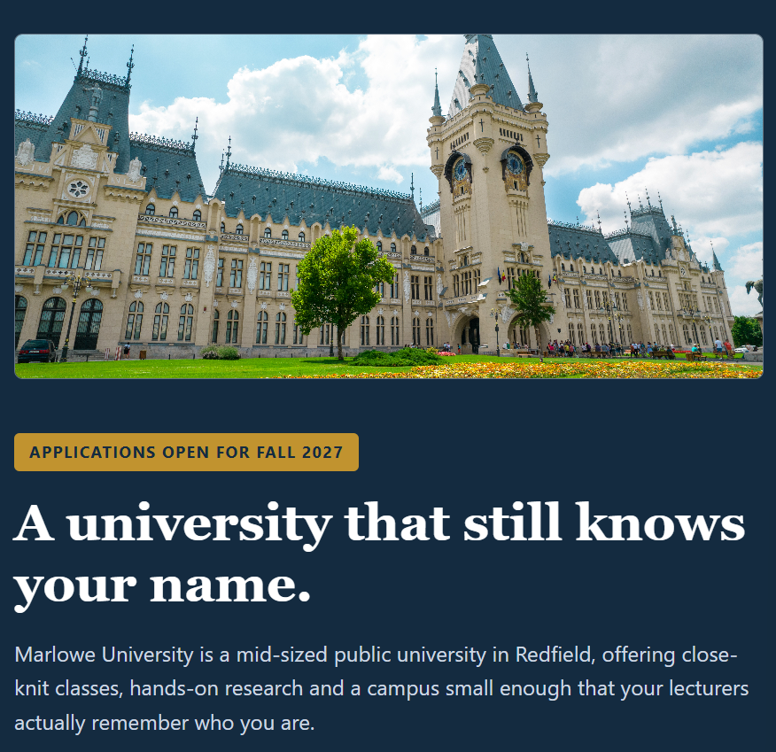
The <section> tag strongly defines a thematic grouping of related topic content [3]. It acts as a semantic container that wraps the complete "hero" area of the website, involving the headline, layout wrappers and buttons. It uses the class (class = "hero") to allow a range of developers to apply global styles such as background colours, specific padding or full-width layouts to this entire top engine. Based on this, the page is established as the dark blue background containing all the introduction elements.
<main>
The <main> tag in HTML specifies the dominant, core content related to a webpage’s body [4]. Therefore, it specifically acts as a structural and semantic wrapper around the unique data or central functionality that directly relates to the key topic of the page. In this website, the use of the main tag has helped to identify core content of a webpage for browsers, search engines and assistive technologies.
<footer>

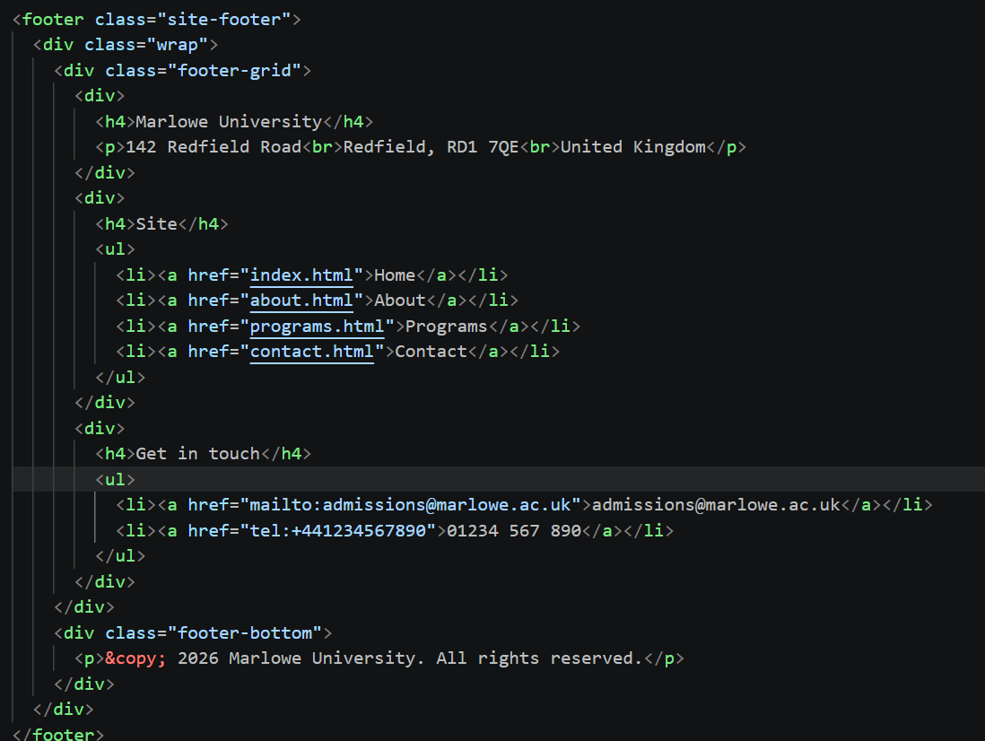
The <footer> tag in HTML is recognised as a semantic element used to define the footer or concluding section of a webpage or a specific content section. It communicates structural meaning directly to browsers, screen readers and search engines [5]. Based on the image, the footer tag tells browsers, engines and assistive technology such as screen readers exactly where the footer area begins and ends. The <footer class = "site-footer"> acts as the root parent element for the entire dark-blue block visible at the bottom of the page. It encloses a <div class = "footer-grid"> which has the layout of three distinct data columns such as MarloweUniversity, Site Menu and Get in Touch.
<nav>
The HTML <nav> tag is recognised as a semantic element explicitly used to define a section of a webpage that mainly contains navigation links. The use of this nav tag signals to browsers and search engines that the enclosed unordered list contains the primary navigation links for the website. The attribute aria-label = "Main navigation" works with the <nav> tag to communicate to screen readers what this section is, which helps visually impaired users skip directly to or identify the site navigation.

Overview of CSS Section
The main role of cascading style sheets is to control the visual presentation, formatting and layout related to a webpage structured by HTML. The use of CSS powers grid layouts, multi-column setups and element alignments through Flexbox and CSS Grid.
Class Selector

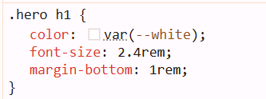
A CSS class selector targets HTML elements that have a specific class attribute, which allows the developer to apply the same styling rules to multiple elements simultaneously [6]. In the CSS file, it is always targeted by writing a period (.) followed by the designated class name. The class selector .hero groups styling rules so they only apply to elements inside a specific section of the webpage. It ensures the text styles only affect the major banner at the top of the page. It allows developers to apply these appropriate text styles to any container simply by adding class = “hero” to its HTML tag.
Flex Box
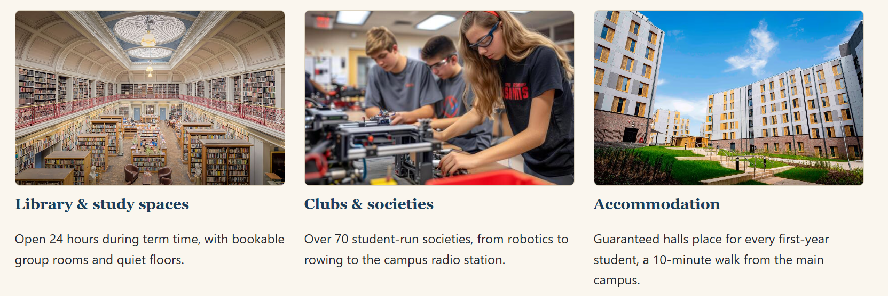
CSS Flexbox is recognised as a one-dimensional layout model which is designed to arrange, align and distribute space among items inside a container. Based on the image, the use of flexbox layout fits this specific image design. It helps to arrange the three cards horizontally, which also helps to keep all cards aligned in a single line.
Media Queries
CSS Media Queries allow developers to apply specific styles to their website based on the characteristics of the environment, such as screen width, orientation or user preferences [6]. The use of media queries serves as the foundation of responsive web design, which also enables a single HTML file to look polished on mobiles, desktops and tablets.
Responsiveness
Responsiveness in this web design is recognised as the approach of ensuring the layout and content of a website automatically adapt to fit any screen size, device or resolution. This is specifically achieved using fluid grids, flexible images and CSS media queries.
Validation
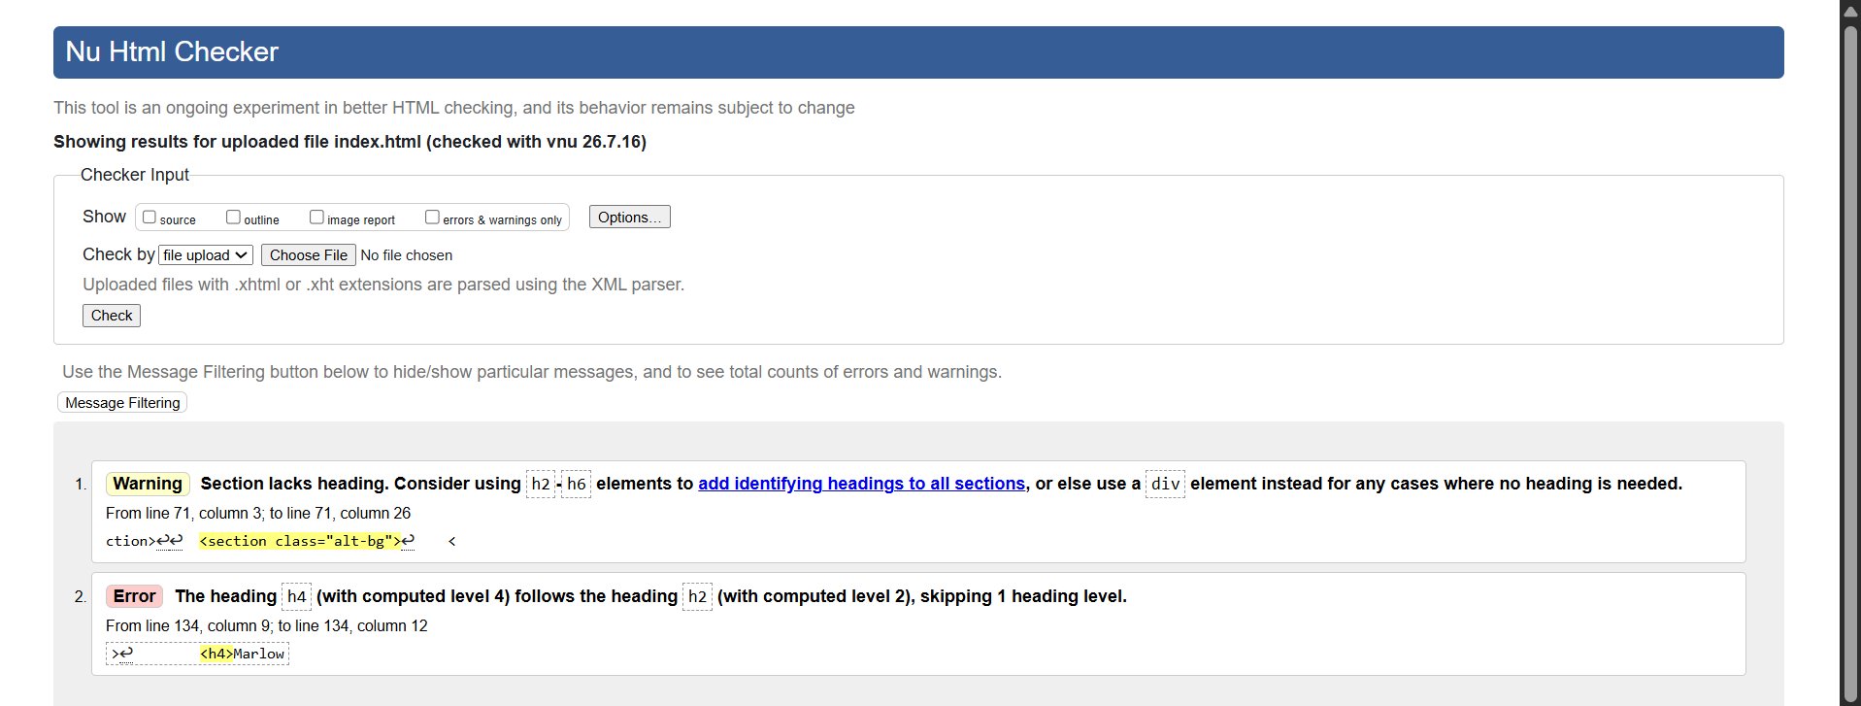
Figure 1: HTML Validator
Source: [10]
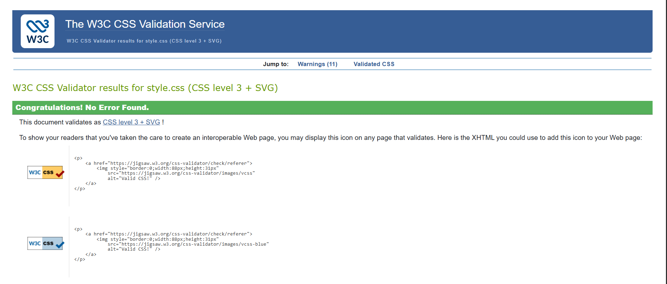
Figure 2: CSS Validator
Source: [11]

Evaluation

Usefulness (Usability and Utility)
This completed university website was created with the primary objective of supplying the students quick information while providing a simple but effective interface. From the usability perspective, the navigation bar never leaves its place on any of the pages, assisting the user in browsing the Home, Menu, About, and Cart pages without difficulty. This has significantly reduced the amount of time spent finding information, as well as giving a familiar browsing experience.
The layout effectively employs a hierarchy, where bold sections immediately stand out, with support text and imagery spaced to keep the page 'clean' without appearing too congested on the webpage. Call to action button is easily identifiable due to their use of contrasting colour and hover effects, giving users a simple and visually effective way of interacting with the system [8]. The responsive CSS makes it display correctly on desktops, tablets, and mobiles using different layouts for text, images, and navigation [9]. The website is static and has no provision for user registration at this time but works well for its intended purpose – a neat and organised collection of information relating to the university which the students can access. More work, in the future, might be carried out in the form of a reservation system, customer reviews, and an integrated payment gateway, all for added functionality.

Search Engine Optimisation (SEO)
In designing this website, meta tags, title headings, alt attributes, and heading structures were involved in making sure that the page ranks. The meta charset <meta charset = “UTF-8”> in the program allows the browser to understand raw code and translate it to readable output. As per the guidelines of HTML meta charset, using UTF-8 is important. This is because it is an umbrella for all emojis, mathematical symbols, and languages. In addition, the viewport meta tag has helped the Marlowe website to be mobile friendly for the users. This forces the width of the website layout to fit the screen size of the device which sets the zoom scale to 100% initially. The title tag is also crucial, as it is the clickable headline in SERPs (Seobility Meta Title). It also tells the search engines regarding the subject matter of the web page which makes it easier for users to find the website when searching using keywords. Also, throughout the work, logical heading structures were ensured, to help Google interpret the content of the webpage [12].

Accessibility (WCAG 2.1)
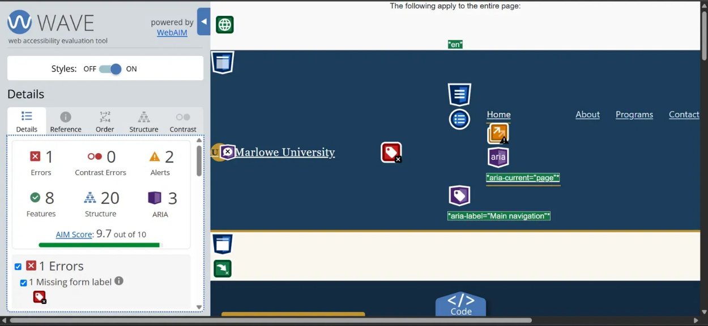
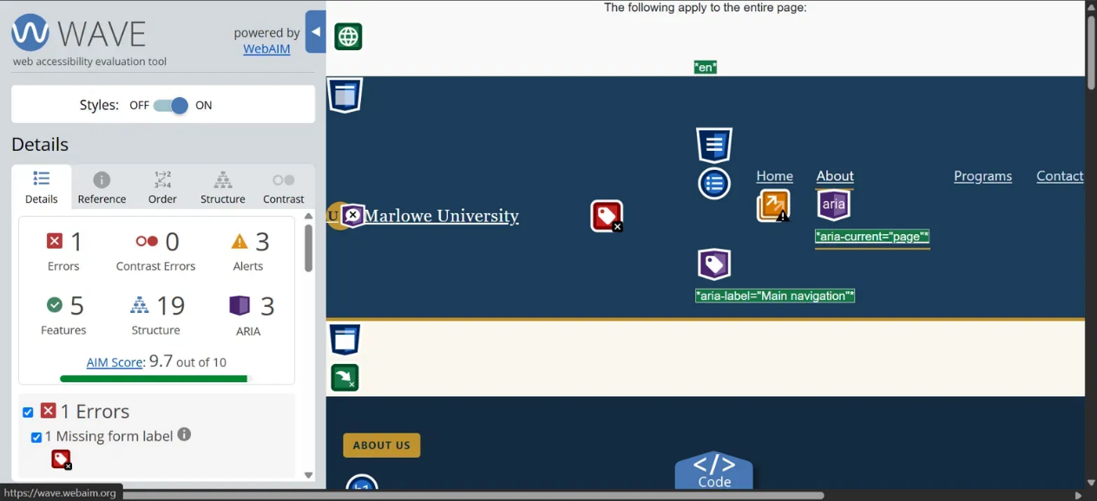
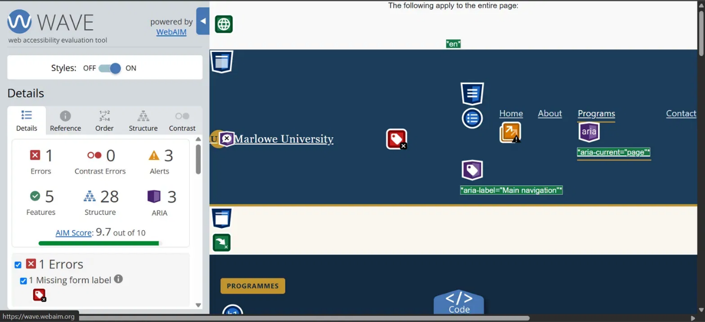
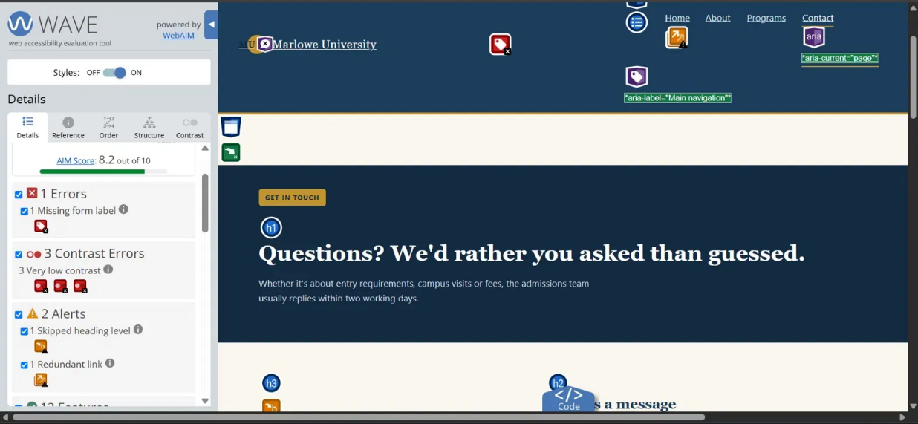
Figure 3: WAVE Evaluation
Source: (WAVE Browser Extension)
Accessibility was considered throughout the implementation to make the website usable for a wider range of users. Colour combinations were selected to maintain sufficient contrast between text and background, improving readability for users with visual impairments. Font sizes have been kept consistent across the website, and adequate spacing between sections reduced visual clutter [13]. Semantic HTML enhances compatibility with assistive technologies, including screen readers. It was made sure that navigation links remain consistent on every page, enabling users to predict where important content can be found. Further, interactive elements such as buttons provide visible hover states, giving users clear feedback during interaction.
The website was evaluated against the general principles of WCAG 2.1 using accessibility checking tools such as WAVE and browser inspection features. No major structural accessibility issues were identified during testing. However, some areas could still be improved such as keyboard navigation could be enhanced further by adding visible focus indicators. In addition, additional ARIA attributes could improve compatibility with more advanced assistive technologies. Therefore, these refinements would make the website more inclusive without requiring major design changes [14].
Comparison with Two Live UK Websites
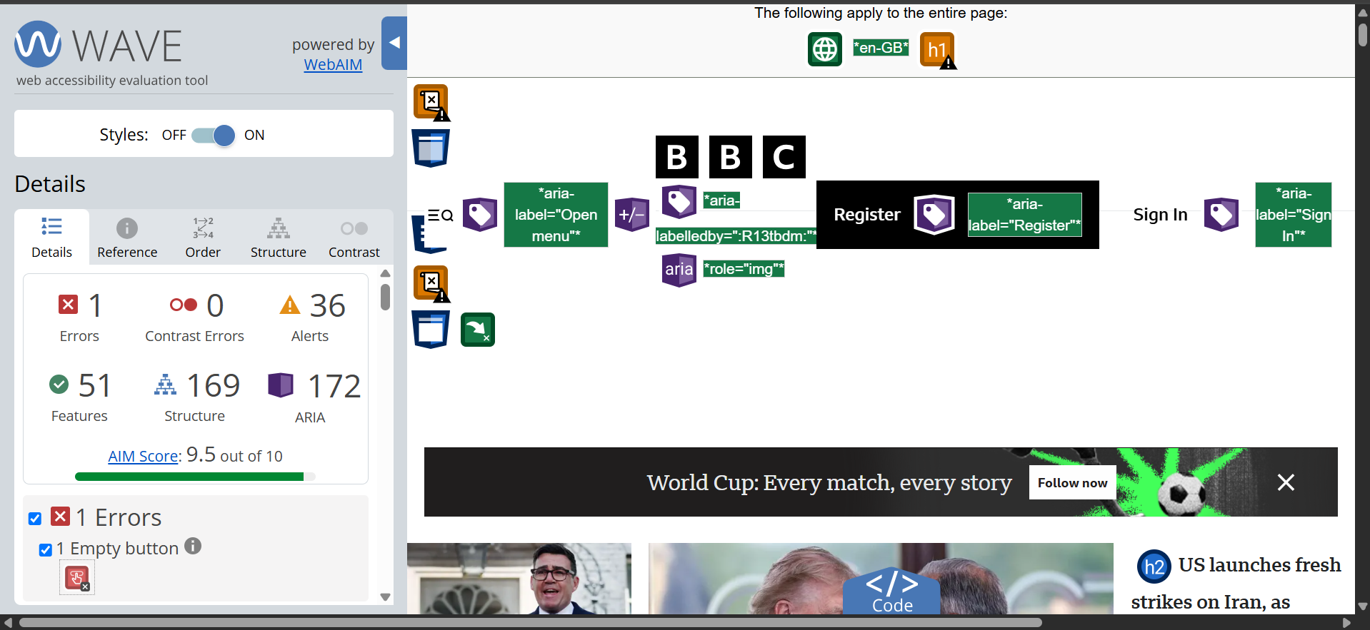
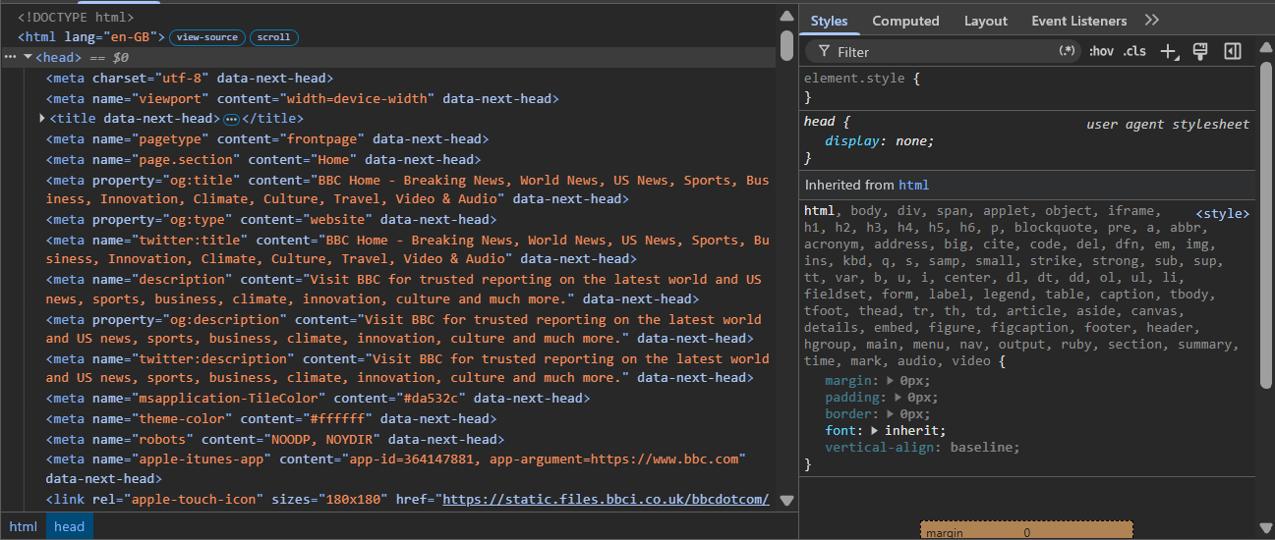
Figure 4: WAVE Evaluation
Source: (WAVE Browser Extension)
To evaluate the overall quality of the completed website, it was compared with the live UK websites of BBC and Argos. The BBC website demonstrates excellent usability through its consistent navigation, clear typography, and logical organisation of content. Information is grouped effectively, allowing visitors to locate news categories quickly despite the large amount of available content. While the university website is considerably smaller in scope, it adopts a similar principle by maintaining consistent navigation and straightforward page layouts.
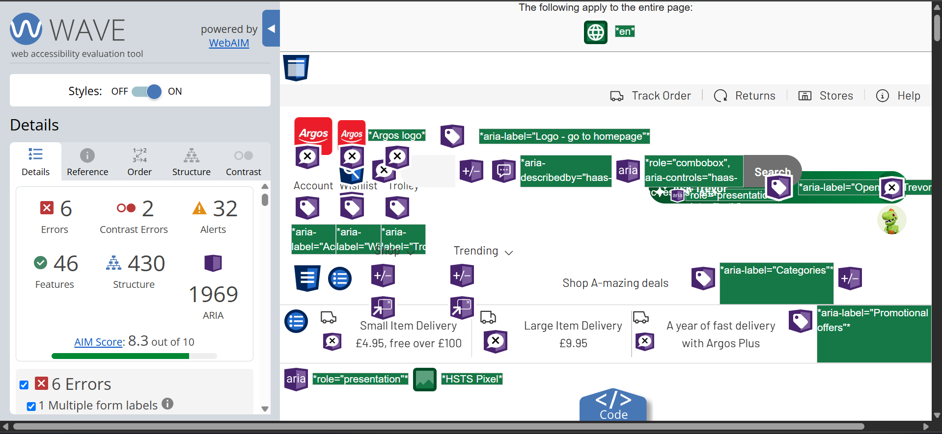
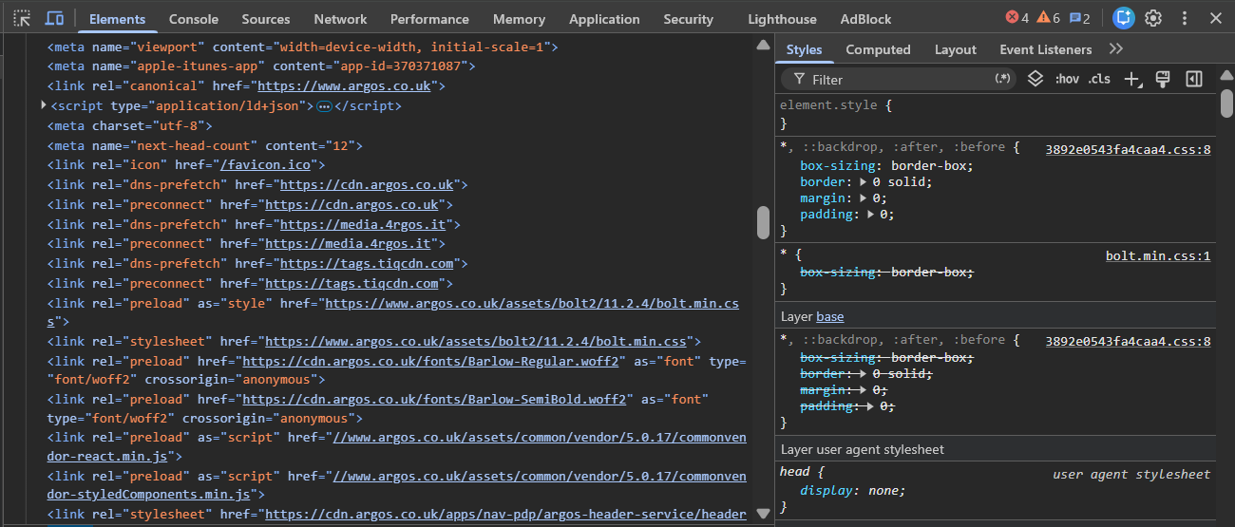
Figure 5: WAVE Evaluation
Source: (WAVE Browser Extension)
According to the WAVE evaluation report and the inspect element snips from both the websites, there are some further differences to be highlighted. The WAVE score of BBC (9.5/10) is significantly higher than that of Argos (8.5/10). A detailed view of Argos WAVE evaluation should show 6 Errors, 2 Contrast Errors and 32 Alerts. While in the case of BBC, there are only 1 Errors, 0 Contrast Errors, and 36 Alerts. The 1 error in the case of BBC is only due to an empty button, which means that its either empty or no value text. Also, the 2 contrast errors in the case of Argos shows that it might not be accessible to everyone, due to colour contrast issues.

Conclusion
The above-conducted report has helped in understanding that it is possible to create a highly functional, visually appealing and fully responsive static website without complex programming languages. While HTML has provided the structural skeleton of the site, CSS helped in delivering the style, presentation and layout formatting. It can also be stated that HTML and CSS websites load exceptionally fast as they require no heavy JavaScript engines, database queries or server-side rendering. Therefore, the site cannot process user-specific information, manage database logins or update content dynamically without a page refresh. Features such as interactive pop-up modals, advanced form validation or real-time updates are restricted unless the integration of a scripting language like JavaScript.

References
[1] R. Kogan, “Website development for beginners: basic concepts worth knowing,” WIX, 25 March 2026. [Online]. Available: https://www.wix.com/blog/website-development. [Accessed 16 July 2026].
[2] J. Kyrnin, “Why Use Semantic HTML?,” ThoughtCo, 16 April 2025. [Online]. Available: https://www.thoughtco.com/why-use-semantic-html-3468271. [Accessed 17 July 2026].
[3] Mozilla, “Semantics,” Mozilla, 2026. [Online]. Available: https://developer.mozilla.org/en-US/docs/Glossary/Semantics. [Accessed 17 July 2026].
[4] Webflow, “Semantic HTML5 tags,” Webflow, 2026. [Online]. Available: https://help.webflow.com/hc/en-us/articles/33961369965715-Semantic-HTML5-tags. [Accessed 17 July 2026].
[5] Lenovo, “What is the HTML <footer> tag?,” Lenovo, 2026. [Online]. Available: https://www.lenovo.com/us/en/glossary/html-footer-tag/?orgRef=https%253A%252F%252Fwww.google.com%252F&srsltid=AfmBOopKV5s9RR35xuBkc3bx7opoAWzVex5fR69LUrEw-Ueh2xIgsh2I. [Accessed 17 July 2026].
[6] Mozilla, “CSS styling basics,” Mozilla, 2026. [Online]. Available: https://developer.mozilla.org/en-US/docs/Learn_web_development/Core/Styling_basics. [Accessed 17 July 2026].
[7] Mozilla Developer Network (MDN), CSS: Cascading Style Sheets. [Online]. Available: https://developer.mozilla.org/en-US/docs/Web/CSS. [Accessed: 20-Jul-2026].
[8] Mozilla Developer Network (MDN), CSS Flexible Box Layout (Flexbox). [Online]. Available: https://developer.mozilla.org/en-US/docs/Web/CSS/CSS_flexible_box_layout. [Accessed: 20-Jul-2026].
[9] Mozilla Developer Network (MDN), CSS Media Queries. [Online]. Available: https://developer.mozilla.org/en-US/docs/Web/CSS/CSS_media_queries. [Accessed: 20-Jul-2026].
[10] World Wide Web Consortium (W3C), HTML Living Standard. [Online]. Available: https://html.spec.whatwg.org/. [Accessed: 20-Jul-2026].
[11] World Wide Web Consortium (W3C), Responsive Images. [Online]. Available: https://www.w3.org/TR/responsive-images/. [Accessed: 20-Jul-2026].
[12] Google, Search Central Documentation: SEO Starter Guide. [Online]. Available: https://developers.google.com/search/docs/fundamentals/seo-starter-guide. [Accessed: 20-Jul-2026].
[13] World Wide Web Consortium (W3C), Web Accessibility Initiative (WAI). [Online]. Available: https://www.w3.org/WAI/. [Accessed: 20-Jul-2026].
[14] Mozilla Developer Network (MDN), Accessibility. [Online]. Available: https://developer.mozilla.org/en-US/docs/Learn/Accessibility. [Accessed: 20-Jul-2026].

Appendix
index.html
<!DOCTYPE html>
<html lang="en">
<head>
<meta charset="UTF-8">
<meta name="viewport" content="width=device-width, initial-scale=1.0">
<title>Marlowe University | Home</title>
<meta name="description" content="Marlowe University - undergraduate, graduate and online programmes in Redfield, UK.">
<link rel="stylesheet" href="style.css">
</head>
<body>

<a class="skip-link" href="#main">Skip to main content</a>

<header class="site-header">
<div class="wrap header-bar">
<a class="brand" href="index.html">
<span class="crest" aria-hidden="true">MU</span>
Marlowe University
</a>
<input type="checkbox" id="nav-toggle" class="nav-toggle-checkbox">
<label for="nav-toggle" class="nav-toggle">Menu</label>
<nav class="site-nav" id="site-nav" aria-label="Main navigation">
<ul>
<li><a href="index.html" aria-current="page">Home</a></li>
<li><a href="about.html">About</a></li>
<li><a href="programs.html">Programs</a></li>
<li><a href="contact.html">Contact</a></li>
</ul>
</nav>
</div>
</header>

<main id="main">

<section class="hero">
<div class="wrap hero-inner">
<div>
<span class="hero-tag">Applications open for Fall 2027</span>
<h1>A university that still knows your name.</h1>
<p>Marlowe University is a mid-sized public university in Redfield, offering close-knit classes, hands-on research and a campus small enough that your lecturers actually remember who you are.</p>
<a class="btn" href="programs.html">See our programmes</a>
<a class="btn outline" href="contact.html">Book a campus visit</a>
</div>
<img class="img-slot" src="Visuals/campus-front.jpg" alt="Front entrance of the Marlowe University main building">
</div>
</section>

<section>
<div class="wrap">
<div class="section-head">
<h2>Why students choose Marlowe</h2>
<p>Three things come up again and again when we ask current students what made the difference.</p>
</div>
<div class="grid-3">
<div class="card">
<h3>Small class sizes</h3>
<p>Most first-year modules have fewer than 30 students, so you're not just a number on a spreadsheet — and neither is your final grade.</p>
</div>
<div class="card">
<h3>Real work experience</h3>
<p>Every degree includes a placement, live project or research opportunity, so you leave with a portfolio, not just a transcript.</p>
</div>
<div class="card">
<h3>Genuine support</h3>
<p>Academic advisors, a free counselling service and a student union that actually listens — support here isn't just a page on the website.</p>
</div>
</div>
</div>
</section>

<section class="alt-bg">
<div class="wrap">
<div class="stats">
<div>
<span class="num">6,400</span>
<span class="label">students</span>
</div>
<div>
<span class="num">38</span>
<span class="label">degree programmes</span>
</div>
<div>
<span class="num">14:1</span>
<span class="label">student-to-staff ratio</span>
</div>
<div>
<span class="num">89%</span>
<span class="label">in work or study 6 months after graduating</span>
</div>
</div>
</div>
</section>

<section>
<div class="wrap">
<div class="section-head">
<h2>Life on campus</h2>
<p>Marlowe isn't only lecture halls. Here's a flavour of what's around campus outside of class time.</p>
</div>
<div class="grid-3">
<div>
<img class="img-slot" src="Visuals/library.jpg" alt="Students studying at desks in the university library">
<h3 style="margin-top:0.75rem;">Library &amp; study spaces</h3>
<p>Open 24 hours during term time, with bookable group rooms and quiet floors.</p>
</div>
<div>
<img class="img-slot" src="Visuals/club-event.jpg" alt="Members of a student society at a campus event">
<h3 style="margin-top:0.75rem;">Clubs &amp; societies</h3>
<p>Over 70 student-run societies, from robotics to rowing to the campus radio station.</p>
</div>
<div>
<img class="img-slot" src="Visuals/accommodation.avif" alt="Student halls of residence near the main campus">
<h3 style="margin-top:0.75rem;">Accommodation</h3>
<p>Guaranteed halls place for every first-year student, a 10-minute walk from the main campus.</p>
</div>
</div>
</div>
</section>

<section class="cta-band">
<div class="wrap">
<h2>Not sure where to start?</h2>
<p>Browse our undergraduate, graduate and online programmes, or get in touch and one of our advisors will point you in the right direction.</p>
<a class="btn" href="programs.html">Browse programmes</a>
</div>
</section>

</main>

<footer class="site-footer">
<div class="wrap">
<div class="footer-grid">
<div>
<h4>Marlowe University</h4>
<p>142 Redfield Road<br>Redfield, RD1 7QE<br>United Kingdom</p>
</div>
<div>
<h4>Site</h4>
<ul>
<li><a href="index.html">Home</a></li>
<li><a href="about.html">About</a></li>
<li><a href="programs.html">Programs</a></li>
<li><a href="contact.html">Contact</a></li>
</ul>
</div>
<div>
<h4>Get in touch</h4>
<ul>
<li><a href="mailto:admissions@marlowe.ac.uk">admissions@marlowe.ac.uk</a></li>
<li><a href="tel:+441234567890">01234 567 890</a></li>
</ul>
</div>
</div>
<div class="footer-bottom">
<p>&copy; 2026 Marlowe University. All rights reserved.</p>
</div>
</div>
</footer>

</body>
</html>

programs.html
<!DOCTYPE html>
<html lang="en">
<head>
<meta charset="UTF-8">
<meta name="viewport" content="width=device-width, initial-scale=1.0">
<title>Marlowe University | Programs</title>
<meta name="description" content="Explore undergraduate, graduate and online programmes at Marlowe University.">
<link rel="stylesheet" href="style.css">
</head>
<body>

<a class="skip-link" href="#main">Skip to main content</a>

<header class="site-header">
<div class="wrap header-bar">
<a class="brand" href="index.html">
<span class="crest" aria-hidden="true">MU</span>
Marlowe University
</a>
<input type="checkbox" id="nav-toggle" class="nav-toggle-checkbox">
<label for="nav-toggle" class="nav-toggle">Menu</label>
<nav class="site-nav" id="site-nav" aria-label="Main navigation">
<ul>
<li><a href="index.html">Home</a></li>
<li><a href="about.html">About</a></li>
<li><a href="programs.html" aria-current="page">Programs</a></li>
<li><a href="contact.html">Contact</a></li>
</ul>
</nav>
</div>
</header>

<main id="main">

<section class="hero small">
<div class="wrap hero-inner">
<div>
<span class="hero-tag">Programmes</span>
<h1>Undergraduate, graduate and online study.</h1>
<p>Every course below includes at least one placement, live project or research opportunity — we don't think a degree should be three years of lectures and nothing else.</p>
</div>
</div>
</section>

<section>
<div class="wrap">
<div class="section-head">
<h2>Undergraduate degrees</h2>
<p>Three-year full-time courses (four with a placement year).</p>
</div>
<div class="grid-3">
<div class="card">
<h3>BSc Computer Science</h3>
<p>Covers software development, databases and networks, with an optional year in industry.</p>
<ul>
<li>3 years full-time / 4 with placement</li>
<li>Entry requirements: 112 UCAS points</li>
</ul>
</div>
<div class="card">
<h3>BA Business Management</h3>
<p>A broad grounding in marketing, finance and operations, with a live consultancy project in year two.</p>
<ul>
<li>3 years full-time / 4 with placement</li>
<li>Entry requirements: 104 UCAS points</li>
</ul>
</div>
<div class="card">
<h3>BSc Psychology</h3>
<p>British Psychological Society accredited, with a supervised research project in the final year.</p>
<ul>
<li>3 years full-time</li>
<li>Entry requirements: 120 UCAS points</li>
</ul>
</div>
</div>
</div>
</section>

<section class="alt-bg">
<div class="wrap">
<div class="section-head">
<h2>Graduate degrees</h2>
<p>One-year taught masters and two-year research degrees.</p>
</div>
<div class="grid-3">
<div class="card">
<h3>MSc Data Science</h3>
<p>Statistics, machine learning and a term-long project with a partner organisation.</p>
<ul>
<li>1 year full-time / 2 years part-time</li>
</ul>
</div>
<div class="card">
<h3>MA Education</h3>
<p>Designed for working teachers, taught in evening and weekend blocks.</p>
<ul>
<li>2 years part-time</li>
</ul>
</div>
<div class="card">
<h3>MBA</h3>
<p>For students with at least two years' work experience, run in partnership with local employers.</p>
<ul>
<li>1 year full-time / 2 years part-time</li>
</ul>
</div>
</div>
</div>
</section>

<section>
<div class="wrap grid-2">
<img class="img-slot" src="Visuals/lecture.jpg" alt="Students taking notes during a lecture">
<div>
<h2 style="border-bottom:3px solid var(--gold); display:inline-block; padding-bottom:0.3rem;">Online &amp; flexible study</h2>
<p style="margin-top:1rem;">Not everyone can move to Redfield for three years, so a growing number of our courses are available online or as evening/weekend blocks.</p>
<ul>
<li>Fully online BA in Business Studies</li>
<li>Part-time MA Education (see above)</li>
<li>Short professional certificates in project management and data analysis</li>
</ul>
</div>
</div>
</section>

<section class="cta-band">
<div class="wrap">
<h2>Ready to apply?</h2>
<p>Check entry requirements and deadlines, then get in touch — our admissions team replies within two working days.</p>
<a class="btn" href="contact.html">Contact admissions</a>
</div>
</section>

</main>

<footer class="site-footer">
<div class="wrap">
<div class="footer-grid">
<div>
<h4>Marlowe University</h4>
<p>142 Redfield Road<br>Redfield, RD1 7QE<br>United Kingdom</p>
</div>
<div>
<h4>Site</h4>
<ul>
<li><a href="index.html">Home</a></li>
<li><a href="about.html">About</a></li>
<li><a href="programs.html">Programs</a></li>
<li><a href="contact.html">Contact</a></li>
</ul>
</div>
<div>
<h4>Get in touch</h4>
<ul>
<li><a href="mailto:admissions@marlowe.ac.uk">admissions@marlowe.ac.uk</a></li>
<li><a href="tel:+441234567890">01234 567 890</a></li>
</ul>
</div>
</div>
<div class="footer-bottom">
<p>&copy; 2026 Marlowe University. All rights reserved.</p>
</div>
</div>
</footer>

</body>
</html>
about.html
<!DOCTYPE html>
<html lang="en">
<head>
<meta charset="UTF-8">
<meta name="viewport" content="width=device-width, initial-scale=1.0">
<title>Marlowe University | About</title>
<meta name="description" content="Learn about Marlowe University's history, mission and campus life.">
<link rel="stylesheet" href="style.css">
</head>
<body>

<a class="skip-link" href="#main">Skip to main content</a>

<header class="site-header">
<div class="wrap header-bar">
<a class="brand" href="index.html">
<span class="crest" aria-hidden="true">MU</span>
Marlowe University
</a>
<input type="checkbox" id="nav-toggle" class="nav-toggle-checkbox">
<label for="nav-toggle" class="nav-toggle">Menu</label>
<nav class="site-nav" id="site-nav" aria-label="Main navigation">
<ul>
<li><a href="index.html">Home</a></li>
<li><a href="about.html" aria-current="page">About</a></li>
<li><a href="programs.html">Programs</a></li>
<li><a href="contact.html">Contact</a></li>
</ul>
</nav>
</div>
</header>

<main id="main">

<section class="hero small">
<div class="wrap hero-inner">
<div>
<span class="hero-tag">About us</span>
<h1>Founded in 1968, still growing.</h1>
<p>Marlowe started as a small teacher-training college and has grown into a full university — but we've tried hard to keep the parts of it that made it feel like a community in the first place.</p>
</div>
</div>
</section>

<section>
<div class="wrap grid-2">
<div>
<h2 style="border-bottom:3px solid var(--gold); display:inline-block; padding-bottom:0.3rem;">Our mission</h2>
<p style="margin-top:1rem;">We want every student who studies here to leave more capable, more curious and more employable than when they arrived — regardless of their background or what they could afford to bring with them.</p>
<p>That means keeping fees manageable, offering real financial support, and building courses around skills employers actually ask for, not just what's easy to teach.</p>
</div>
<img class="img-slot" src="Visuals/graduation.jpg" alt="Graduates in gowns at a Marlowe University graduation ceremony">
</div>
</section>

<section class="alt-bg">
<div class="wrap">
<div class="section-head">
<h2>Our story</h2>
<p>A few of the moments that shaped the university we are today.</p>
</div>
<ul class="timeline">
<li>
<span class="year">1968</span>
Marlowe College is founded as a teacher-training college with just three subjects on offer.
</li>
<li>
<span class="year">1984</span>
The college merges with the neighbouring School of Engineering, adding its first science and technology courses.
</li>
<li>
<span class="year">1997</span>
Marlowe is granted full university status and admits its first postgraduate cohort.
</li>
<li>
<span class="year">2011</span>
The Redfield campus library and student union building open, both still in use today.
</li>
<li>
<span class="year">2020</span>
Online and hybrid degree options launch, opening study up to students who can't relocate.
</li>
</ul>
</div>
</section>

<section>
<div class="wrap">
<div class="section-head">
<h2>Campus life</h2>
<p>What a typical week outside lectures might look like.</p>
</div>
<div class="grid-3">
<div class="card">
<h3>Sport &amp; fitness</h3>
<p>A sports centre with a pool, gym and courts, plus 20+ intramural and competitive teams for every skill level.</p>
</div>
<div class="card">
<h3>Wellbeing</h3>
<p>Free, confidential counselling appointments, a quiet room in every building, and a peer-support scheme run by trained students.</p>
</div>
<div class="card">
<h3>Culture &amp; events</h3>
<p>Regular gigs, an international food festival each spring, and a student-run gallery in the arts building.</p>
</div>
</div>
</div>
</section>

<section class="alt-bg">
<div class="wrap">
<div class="stats">
<div>
<span class="num">120+</span>
<span class="label">nationalities on campus</span>
</div>
<div>
<span class="num">£2.1m</span>
<span class="label">given in bursaries last year</span>
</div>
<div>
<span class="num">4</span>
<span class="label">faculties</span>
</div>
<div>
<span class="num">1968</span>
<span class="label">the year we started</span>
</div>
</div>
</div>
</section>

<section class="cta-band">
<div class="wrap">
<h2>Want to see it for yourself?</h2>
<p>Open days run every month during term time. Get in touch and we'll save you a place.</p>
<a class="btn" href="contact.html">Get in touch</a>
</div>
</section>

</main>

<footer class="site-footer">
<div class="wrap">
<div class="footer-grid">
<div>
<h4>Marlowe University</h4>
<p>142 Redfield Road<br>Redfield, RD1 7QE<br>United Kingdom</p>
</div>
<div>
<h4>Site</h4>
<ul>
<li><a href="index.html">Home</a></li>
<li><a href="about.html">About</a></li>
<li><a href="programs.html">Programs</a></li>
<li><a href="contact.html">Contact</a></li>
</ul>
</div>
<div>
<h4>Get in touch</h4>
<ul>
<li><a href="mailto:admissions@marlowe.ac.uk">admissions@marlowe.ac.uk</a></li>
<li><a href="tel:+441234567890">01234 567 890</a></li>
</ul>
</div>
</div>
<div class="footer-bottom">
<p>&copy; 2026 Marlowe University. All rights reserved.</p>
</div>
</div>
</footer>

</body>
</html>

contact.html
<!DOCTYPE html>
<html lang="en">
<head>
<meta charset="UTF-8">
<meta name="viewport" content="width=device-width, initial-scale=1.0">
<title>Marlowe University | Contact</title>
<meta name="description" content="Get in touch with Marlowe University's admissions team.">
<link rel="stylesheet" href="style.css">
</head>
<body>

<a class="skip-link" href="#main">Skip to main content</a>

<header class="site-header">
<div class="wrap header-bar">
<a class="brand" href="index.html">
<span class="crest" aria-hidden="true">MU</span>
Marlowe University
</a>
<input type="checkbox" id="nav-toggle" class="nav-toggle-checkbox">
<label for="nav-toggle" class="nav-toggle">Menu</label>
<nav class="site-nav" id="site-nav" aria-label="Main navigation">
<ul>
<li><a href="index.html">Home</a></li>
<li><a href="about.html">About</a></li>
<li><a href="programs.html">Programs</a></li>
<li><a href="contact.html" aria-current="page">Contact</a></li>
</ul>
</nav>
</div>
</header>

<main id="main">

<section class="hero small">
<div class="wrap hero-inner">
<div>
<span class="hero-tag">Get in touch</span>
<h1>Questions? We'd rather you asked than guessed.</h1>
<p>Whether it's about entry requirements, campus visits or fees, the admissions team usually replies within two working days.</p>
</div>
</div>
</section>

<section>
<div class="wrap contact-layout">

<div>
<div class="info-block">
<h3>Admissions office</h3>
<address>
Marlowe University<br>
142 Redfield Road<br>
Redfield, RD1 7QE<br>
United Kingdom
</address>
</div>
<div class="info-block">
<h3>Email</h3>
<p><a href="mailto:admissions@marlowe.ac.uk">admissions@marlowe.ac.uk</a></p>
</div>
<div class="info-block">
<h3>Phone</h3>
<p><a href="tel:+441234567890">01234 567 890</a></p>
</div>
<div class="info-block">
<h3>Office hours</h3>
<p>Mon–Fri, 9am–5pm<br>Closed on public holidays</p>
</div>
<img class="img-slot" src="Visuals/map.jpg" alt="Map showing the Marlowe University campus on Redfield Road">
</div>

<div>
<h2 style="border-bottom:3px solid var(--gold); display:inline-block; padding-bottom:0.3rem; margin-bottom:1rem;">Send us a message</h2>
<form action="#" method="post">
<div class="field">
<label for="name">Full name <span class="required">*</span></label>
<input type="text" id="name" name="name" required autocomplete="name">
</div>

<div class="field">
<label for="email">Email address <span class="required">*</span></label>
<input type="email" id="email" name="email" required autocomplete="email">
</div>

<div class="field">
<label for="interest">I'm interested in</label>
<select id="interest" name="interest">
<option value="undergraduate">Undergraduate study</option>
<option value="graduate">Graduate study</option>
<option value="online">Online / part-time study</option>
<option value="visit">Booking a campus visit</option>
<option value="other">Something else</option>
</select>
</div>

<fieldset>
<legend>How should we get back to you?</legend>
<div class="radio-row">
<label><input type="radio" name="contact-method" value="email" checked> Email</label>
<label><input type="radio" name="contact-method" value="phone"> Phone</label>
</div>
</fieldset>

<div class="field">
<label for="message">Message <span class="required">*</span></label>
<textarea id="message" name="message" rows="5" required></textarea>
</div>

<button class="btn" type="submit">Send message</button>
</form>
</div>

</div>
</section>

<section class="alt-bg">
<div class="wrap">
<div class="section-head">
<h2>How applying works</h2>
<p>Three steps from first enquiry to your first day.</p>
</div>
<ol class="steps">
<li>
<h3>Apply</h3>
<p>Submit your application through UCAS (undergraduate) or directly through our website (graduate).</p>
</li>
<li>
<h3>Hear back</h3>
<p>We aim to respond within four weeks, sometimes with an offer of an interview or portfolio review.</p>
</li>
<li>
<h3>Enrol</h3>
<p>Accept your offer, sort accommodation and finance, and you're set for induction week in September.</p>
</li>
</ol>
</div>
</section>

</main>

<footer class="site-footer">
<div class="wrap">
<div class="footer-grid">
<div>
<h4>Marlowe University</h4>
<p>142 Redfield Road<br>Redfield, RD1 7QE<br>United Kingdom</p>
</div>
<div>
<h4>Site</h4>
<ul>
<li><a href="index.html">Home</a></li>
<li><a href="about.html">About</a></li>
<li><a href="programs.html">Programs</a></li>
<li><a href="contact.html">Contact</a></li>
</ul>
</div>
<div>
<h4>Get in touch</h4>
<ul>
<li><a href="mailto:admissions@marlowe.ac.uk">admissions@marlowe.ac.uk</a></li>
<li><a href="tel:+441234567890">01234 567 890</a></li>
</ul>
</div>
</div>
<div class="footer-bottom">
<p>&copy; 2026 Marlowe University. All rights reserved.</p>
</div>
</div>
</footer>

</body>
</html>

style.css
:root {
--navy: #1c3d5a;
--navy-dark: #142b40;
--gold: #c1932f;
--gold-dark: #a37a22;
--cream: #faf6ee;
--ink: #23262b;
--ink-light: #5b6169;
--line: #ddd4c2;
--white: #ffffff;

--font-heading: Georgia, 'Times New Roman', Times, serif;
--font-body: -apple-system, BlinkMacSystemFont, 'Segoe UI', Roboto, Arial, sans-serif;

--max-width: 1100px;
}

* {
box-sizing: border-box;
}

body {
margin: 0;
font-family: var(--font-body);
colour: var(--ink);
background: var(--cream);
line-height: 1.6;
}

h1{
font-family: var(--font-heading);
colour: var(--navy);
line-height: 1.2;
margin-top: 0;
}
h2{
font-family: var(--font-heading);
colour: var(--navy);
line-height: 1.2;
margin-top: 0;
}
h3{
font-family: var(--font-heading);
colour: var(--navy);
line-height: 1.2;
margin-top: 0;
}
h4 {
font-family: var(--font-heading);
colour: var(--navy);
line-height: 1.2;
margin-top: 0;
}

p {
margin-top: 0;
}

a {
colour: var(--navy);
}

a:hover {
colour: var(--gold-dark);
}

img {
max-width: 100%;
display: block;
}

a:focus-visible,
button:focus-visible,
input:focus-visible,
textarea:focus-visible {
outline: 3px solid var(--gold);
outline-offset: 2px;
}

.wrap {
max-width: var(--max-width);
margin: 0 auto;
padding: 0 1.25rem;
}

.visually-hidden {
position: absolute;
width: 1px;
height: 1px;
overflow: hidden;
clip: rect(0 0 0 0);
white-space: nowrap;
}

.skip-link {
position: absolute;
left: -999px;
top: 0;
background: var(--navy);
colour: var(--white);
padding: 0.75rem 1rem;
z-index: 200;
}

.skip-link:focus {
left: 0.5rem;
top: 0.5rem;
}

.site-header {
background: var(--navy);
colour: var(--white);
border-bottom: 4px solid var(--gold);
}

.header-bar {
display: flex;
align-items: center;
justify-content: space-between;
padding: 0.9rem 0;
}

.brand {
display: flex;
align-items: center;
gap: 0.6rem;
colour: var(--white);
font-family: var(--font-heading);
font-size: 1.25rem;
letter-spacing: 0.02em;
}

.brand:hover {
colour: var(--white);
}

.crest {
width: 2.1rem;
height: 2.1rem;
border-radius: 50%;
background: var(--gold);
colour: var(--navy-dark);
font-weight: 700;
font-family: var(--font-heading);
display: flex;
align-items: center;
justify-content: center;
font-size: 0.95rem;
flex-shrink: 0;
}

.nav-toggle-checkbox {
position: absolute;
opacity: 0;
pointer-events: none;
}

.nav-toggle {
display: none;
background: transparent;
border: 1px solid rgba(255, 255, 255, 0.4);
border-radius: 0.35rem;
colour: var(--white);
padding: 0.4rem 0.6rem;
font-size: 1rem;
cursor: pointer;
user-select: none;
}

.nav-toggle-checkbox:focus-visible + .nav-toggle {
outline: 3px solid var(--gold);
outline-offset: 2px;
}

.site-nav ul {
list-style: none;
display: flex;
gap: 1.6rem;
margin: 0;
padding: 0;
}

.site-nav a {
colour: #dbe4ee;
padding: 0.3rem 0.1rem;
border-bottom: 2px solid transparent;
}

.site-nav a:hover,
.site-nav a[aria-current="page"] {
colour: var(--white);
border-bottom-colour: var(--gold);
}

.hero {
padding: 3.5rem 0;
background: var(--navy-dark);
colour: var(--white);
}

.hero-inner {
display: grid;
grid-template-columns: 1.1fr 0.9fr;
gap: 2.5rem;
align-items: center;
}

.hero-tag {
display: inline-block;
background: var(--gold);
colour: var(--navy-dark);
font-weight: 700;
font-size: 0.75rem;
letter-spacing: 0.08em;
text-transform: uppercase;
padding: 0.3rem 0.7rem;
border-radius: 0.25rem;
margin-bottom: 1rem;
}

.hero h1 {
colour: var(--white);
font-size: 2.4rem;
margin-bottom: 1rem;
}

.hero p {
colour: #cdd8e3;
max-width: 38rem;
margin-bottom: 1.5rem;
}

.hero.small {
padding: 2.6rem 0;
}

.hero.small .hero-inner {
grid-template-columns: 1fr;
}

.btn {
display: inline-block;
background: var(--gold);
colour: var(--navy-dark);
font-weight: 700;
padding: 0.75rem 1.4rem;
border-radius: 0.3rem;
border: none;
font-size: 1rem;
}

.btn:hover {
background: var(--gold-dark);
colour: var(--white);
}

.btn.outline {
background: transparent;
colour: var(--white);
border: 2px solid var(--white);
margin-left: 0.75rem;
}

.btn.outline:hover {
background: var(--white);
colour: var(--navy);
}

.btn-outline {
background: transparent;
colour: var(--white);
border: 2px solid var(--white);
}

.img-slot {
width: 100%;
height: 220px;
object-fit: cover;
border-radius: .4rem;
border: 1px solid var(--line);
}

.hero .img-slot {
height: 260px;
border-colour: rgba(255,255,255,.35);
}

section {
padding: 3rem 0;
}

.section-head {
max-width: 40rem;
margin-bottom: 2rem;
}

.section-head h2 {
font-size: 1.7rem;
border-bottom: 3px solid var(--gold);
display: inline-block;
padding-bottom: 0.3rem;
}

.section-head p {
colour: var(--ink-light);
margin-top: 0.75rem;
}

.alt-bg {
background: var(--white);
border-top: 1px solid var(--line);
border-bottom: 1px solid var(--line);
}

.grid-3 {
display: grid;
grid-template-columns: repeat(3, minmax(0, 1fr));
gap: 1.5rem;
}

.grid-2 {
display: grid;
grid-template-columns: repeat(2, minmax(0, 1fr));
gap: 1.5rem;
}

.card {
background: var(--white);
border: 1px solid var(--line);
border-radius: 0.4rem;
padding: 1.5rem;
}

.card h3 {
font-size: 1.2rem;
margin-bottom: 0.5rem;
}

.card ul {
padding-left: 1.1rem;
margin: 0.75rem 0 0;
}

.card li {
margin-bottom: 0.4rem;
}

.stats {
display: grid;
grid-template-columns: repeat(4, minmax(0, 1fr));
gap: 1.5rem;
text-align: center;
}

.stats .num {
font-family: var(--font-heading);
font-size: 2rem;
colour: var(--gold-dark);
display: block;
}

.stats .label {
colour: var(--ink-light);
font-size: 0.9rem;
}

.timeline {
list-style: none;
margin: 0;
padding: 0;
border-left: 3px solid var(--gold);
}

.timeline li {
position: relative;
padding: 0 0 1.75rem 1.5rem;
}

.timeline li::before {
content: '';
position: absolute;
left: -8px;
top: 0.3rem;
width: 13px;
height: 13px;
border-radius: 50%;
background: var(--gold);
border: 2px solid var(--cream);
}

.timeline .year {
font-weight: 700;
colour: var(--navy);
display: block;
}

.steps {
counter-reset: step;
list-style: none;
padding: 0;
margin: 0;
display: grid;
grid-template-columns: repeat(3, minmax(0, 1fr));
gap: 1.5rem;
}

.steps li {
border: 1px solid var(--line);
background: var(--white);
border-radius: 0.4rem;
padding: 1.5rem;
padding-top: 2.5rem;
position: relative;
}

.steps li::before {
counter-increment: step;
content: counter(step);
position: absolute;
top: -0.8rem;
left: 1.2rem;
width: 2rem;
height: 2rem;
border-radius: 50%;
background: var(--navy);
colour: var(--white);
display: flex;
align-items: center;
justify-content: center;
font-weight: 700;
font-family: var(--font-heading);
}

.cta-band {
background: var(--navy);
colour: var(--white);
text-align: center;
padding: 3rem 0;
}

.cta-band h2 {
colour: var(--white);
}

.cta-band p {
colour: #cdd8e3;
max-width: 34rem;
margin: 0.75rem auto 1.5rem;
}

.contact-layout {
display: grid;
grid-template-columns: 1fr 1.2fr;
gap: 2rem;
align-items: start;
}

address {
font-style: normal;
}

.info-block {
margin-bottom: 1.5rem;
}

.info-block h3 {
font-size: 1rem;
text-transform: uppercase;
letter-spacing: 0.05em;
colour: var(--ink-light);
margin-bottom: 0.3rem;
}

form {
background: var(--white);
border: 1px solid var(--line);
border-radius: 0.4rem;
padding: 1.5rem;
display: grid;
gap: 1rem;
}

.field {
display: grid;
gap: 0.35rem;
}

.field label {
font-weight: 700;
font-size: 0.9rem;
}

input,
select,
textarea {
font: inherit;
padding: 0.65rem 0.75rem;
border: 1px solid #c7c0b0;
border-radius: 0.3rem;
background: var(--cream);
colour: var(--ink);
width: 100%;
}
select {
font: inherit;
padding: 0.65rem 0.75rem;
border: 1px solid #c7c0b0;
border-radius: 0.3rem;
background: var(--cream);
colour: var(--ink);
width: 100%;
}

textarea {
font: inherit;
padding: 0.65rem 0.75rem;
border: 1px solid #c7c0b0;
border-radius: 0.3rem;
background: var(--cream);
colour: var(--ink);
width: 100%;
}

.required {
colour: var(--gold-dark);
}

fieldset {
border: 1px solid var(--line);
border-radius: 0.3rem;
padding: 0.9rem;
}

legend {
font-weight: 700;
font-size: 0.9rem;
padding: 0 0.4rem;
}

.radio-row {
display: flex;
gap: 1.25rem;
flex-wrap: wrap;
}

.radio-row label {
display: flex;
align-items: center;
gap: 0.4rem;
font-weight: 400;
}

.radio-row input {
width: auto;
}

form button {
justify-self: start;
}

.site-footer {
background: var(--navy-dark);
colour: #bcc8d4;
padding: 2.5rem 0 1.5rem;
margin-top: 2rem;
}

.footer-grid {
display: grid;
grid-template-columns: 1.3fr 1fr 1fr;
gap: 2rem;
margin-bottom: 1.5rem;
}

.footer-grid h4 {
colour: var(--white);
font-size: 1rem;
margin-bottom: 0.6rem;
}

.footer-grid ul {
list-style: none;
margin: 0;
padding: 0;
}

.footer-grid li {
margin-bottom: 0.4rem;
}

.footer-grid a {
colour: #bcc8d4;
}

.footer-grid a:hover {
colour: var(--white);
}

.footer-bottom {
border-top: 1px solid rgba(255, 255, 255, 0.15);
padding-top: 1rem;
font-size: 0.85rem;
display: flex;
justify-content: space-between;
flex-wrap: wrap;
gap: 0.5rem;
}

@media (max-width: 900px) {
.hero-inner {
grid-template-columns: 1fr;
}

.hero .img-slot {
order: -1;
min-height: 180px;
}

.grid-3,
.stats,
.steps {
grid-template-columns: repeat(2, minmax(0, 1fr));
}

.contact-layout {
grid-template-columns: 1fr;
}

.footer-grid {
grid-template-columns: 1fr 1fr;
}
}

@media (max-width: 640px) {
.header-bar {
flex-wrap: wrap;
}

.nav-toggle {
display: inline-block !important;
}

.site-nav {
display: none;
width: 100%;
padding-bottom: 0.75rem;
}

.nav-toggle-checkbox:checked ~ .site-nav {
display: block;
}

.site-nav ul {
flex-direction: column;
gap: 0;
}

.site-nav li {
border-top: 1px solid rgba(255, 255, 255, 0.15);
}

.site-nav a {
display: block;
padding: 0.75rem 0.1rem;
}

.grid-3,
.grid-2,
.stats,
.steps {
grid-template-columns: 1fr;
}

.footer-grid {
grid-template-columns: 1fr;
}

.btn.outline {
margin-left: 0;
margin-top: 0.75rem;
}

section {
padding: 2.25rem 0;
}
}

