Individual Report
Module Name: Digital Skills and Research Methods
Module Code: LCHS 4007
Student name: FERNANDA EGYPC PONTA GARCA CARVALHO
Student ID: 2525127
Lecturer's Name: Kwame Assa-Agyei

University of Wales Trinity Saint David
LONDON CAMPUS

Table of Contents
Introduction 3
Task 1 - Research Topic. 4
1.1 The Problem and its Importance 4
1.2 Personal Reflection – Why I Chose This Topic 4
Task 2 - The assessment of Information Sources. 6
2.1 Source 1 6
2.2 Source 2 6
2.3 Source 3 7
2.4 Gaps in Current Research 7
Task 3 – Research Methodologies 8
3.1 Definitions and Examples 8
3.2 Selected Methodology and Rationale. 8
Task 4 – Data Collection 9
4.1 Primary vs Secondary Data. 9
4.2 Selected Type(s) of Data and Reason. 9
4.3 Advantages and Challenges 9
Conclusion 11
References 12

Introduction
Infection control is a collection of policies, procedures and practices within healthcare environments to avoid the spread of infectious diseases. It is an essential aspect of patient safety and health of the population. This report is devoted to the healthcare-associated infections (HAIs) in the NHS hospitals in the United Kingdom. HAIs have significant impacts on patients annually, raising their hospitalization, medical expenses, and mortality rates (Cassini et al., 2019).

Task 1 - Research Topic.

1.1 The Problem and its Importance
Healthcare-associated infections (HAIs) are those infections patients develop during their treatment of other conditions in a healthcare facility. Types of common HAIs are urinary tract infection, surgical site infection, bloodstream infection, and Clostridioides difficile (CDI). HAIs impact on patients, patient outcomes, and healthcare spending each year across NHS England hospitals, impacting a population of 300,000 patients annually (NHS England, 2022). Good infection control is then necessary. Major measures involve hand hygiene, wearing personal protective equipment (PPE), cleaning of the environment, and antimicrobial stewardship (World Health Organisation, 2022). Infection control protocols are still not followed consistently in most healthcare facilities, despite the existing guidelines (Gould et al., 2020). The patient harm, enhanced antibiotic resistance and avoidable deaths may be a result of this inconsistency (Lotfinejad et al., 2020).
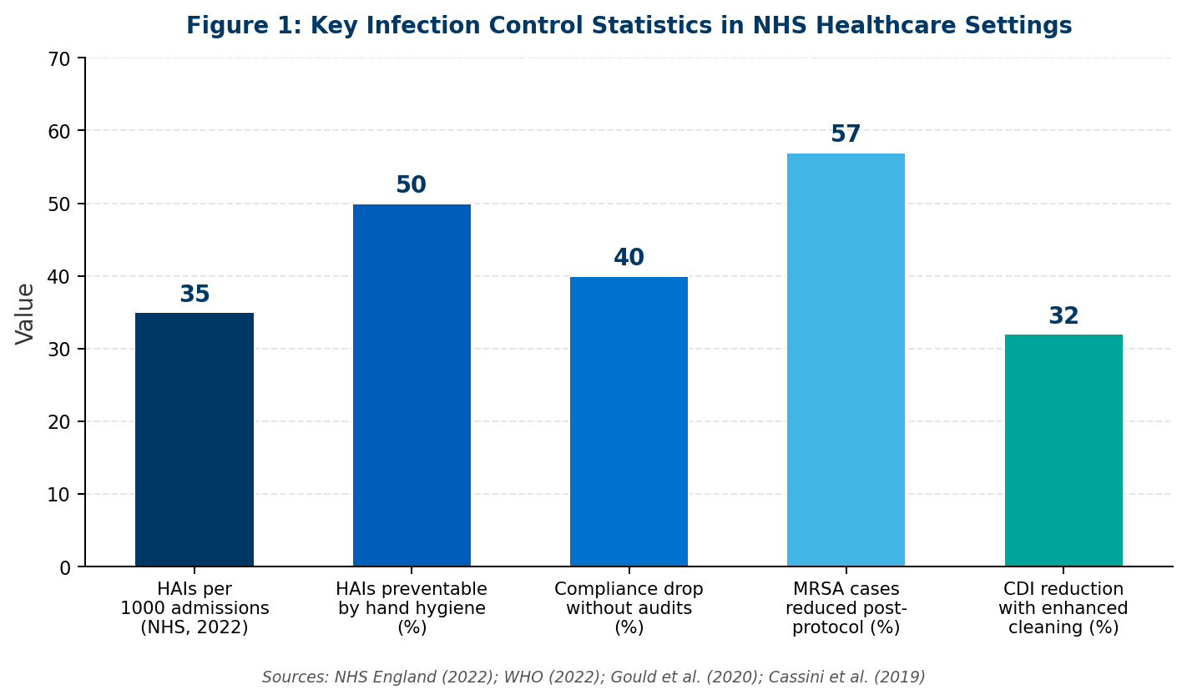
Figure 1: Key Infection Control Statistics in NHS Healthcare Settings

1.2 Personal Reflection – Why I Chose This Topic
The topic of infection control was selected as it has a direct impact on health and social care practice. Working or planning to work in a healthcare environment involves experiencing risks of infection on a daily basis. The topic is highly related to modules on care standards, public health, and clinical governance learned during the programme. The knowledge of how infections are transmitted in hospitals and effective interventions is critical to every future care provider. Moreover, the problem of infection control is more acute than ever due to the growing difficulty with antimicrobial resistance (Huttner et al., 2013). Such a topic is both theoretical and practical, with possible findings having a direct impact on enhancing care delivery.

Task 2 - The assessment of Information Sources.

2.1 Source 1
Reference: Gould, D.J., Moralejo, D., Drey, N., Chudleigh, J.H. and Taljaard, M. (2020) ‘Interventions to improve hand hygiene compliance in patient care’, Cochrane Database of Systematic Reviews, (9), pp. 1–58.
This source is Cochrane systematic review, and it is among the most valid evidence types of health research. It reviews various studies that have been conducted on hand hygiene intervention and its success in lowering the infection rate. The source is peer reviewed and published by well recognised health evidence organisation in the world. It is directly relevant to this topic as hand hygiene is the single most effective measure to prevent HAIs (Gould et al., 2020). This reference confirms the thesis statement that multi-modal approaches need to be targeted and enhanced to enhance compliance among healthcare professionals.

2.2 Source 2
Reference: Cassini, A., Högberg, L.D., Plachouras, D., Quattrocchi, A., Hoxha, A., Simonsen, G.S., Colomb-Cotinat, M., Kretzschmar, M.E., Devleesschauwer, B., Cecchini, M. and Ait Ouakrim, D., 2019. Attributable deaths and disability-adjusted life-years caused by infections with antibiotic-resistant bacteria in the EU and the European Economic Area in 2015: a population-level modelling analysis. The Lancet infectious diseases, 19(1), pp.56-66.

The article is in The Lancet Infectious Diseases, a high-impact, peer-reviewed journal. The paper provides an alternative perspective as it highlights antibiotic-resistant infections which are directly connected with the inadequate infection management. It presents data on a population level that indicate 33,000 deaths were brought about by antibiotic-resistant infections in Europe alone in 2015 (Cassini et al., 2019).

2.3 Source 3
Source: NHS England (2022) Infection prevention and control: resource for care homes. London: NHS England. Available at: https://www.england.nhs.uk/publication/infection-prevention-and-control-resource-for-care-homes/ (Accessed: 10 April 2025).
The document is a government-based source of guidelines, making it very credible and authoritative in the UK healthcare setting. It identifies national standards of infection prevention and control (IPC) that are applicable to NHS settings and social care settings. It is relevant because of its practical guidelines which are aligned to current UK policy. Being a statutory body, the publications of NHS England are fully valid as credible sources of academic health reports (NHS England, 2022).

2.4 Gaps in Current Research
Although there has been a wide amount of research on infection control, there are still a few gaps. The majority of the prior research is on acute inpatient environments, and there is little evidence of infection control in the community care homes or primary care environments (Huttner et al., 2013). Also, no studies have been done on long-term follow-up to determine the sustainability of behavioural changes in hand hygiene adherence. Limited research also focuses on the exact effect that digital tools and real-time monitoring systems have on infection rates (Tartari et al., 2019).

Task 3 – Research Methodologies

3.1 Definitions and Examples
Quantitative research is a method of gathering the numerical information to quantify the variables and discover patterns. Within the framework of health and social care, one such example would be an increase or decrease in the number of HAIs prior to and following the introduction of a new hand hygiene policy (Creswell and Creswell, 2017).
Qualitative research investigates experiences, perceptions, and meaning based on non-numerical data (interviews or observations). A case study in the healthcare industry would be to interview nurses regarding their feelings about wearing PPE during an outbreak of infection (Bryman, 2016).
The mixed-methods research involves the combination of both methods. As an example, a researcher might interview healthcare workers regarding their hand hygiene behaviour (quantitative) and follow-up with interviews to learn why they behave in this way (qualitative) (Doyle et al., 2020).

3.2 Selected Methodology and Rationale.
The most suitable methodology of research is a mixed-methods approach in the study of infection control compliance in NHS hospitals. The rate of HAIs and compliance scores of the staff can be measured using quantitative data, and qualitative research could be used to generate a lived experience of healthcare workers, the perceived barriers, and their feelings towards infection control measures (Doyle et al., 2020). This interdisciplinary approach gives a more holistic comprehension of the subject matter than any one of these approaches. The mixed methods are also becoming popular in health services studies because they can answer the question of what and the question of why of a specific issue (Fetters et al., 2019).

Task 4 – Data Collection

4.1 Primary vs Secondary Data.
Primary data are original data that is collected by the researcher himself or herself with the aim of a certain study. These include surveys, interviews, observations and experiments. Primary data is quite specific to the research question and is collected first-hand (Bryman, 2020).
The secondary data is the data which is already available and was gathered by other person with another purpose. These are published reports, medical records, hospital audit data, government statistics and available research studies (Creswell and Creswell, 2017). Secondary data will be utilized to give some context, background and evidence.

4.2 Selected Type(s) of Data and Reason.
The study would principally be based on secondary data, with the use of secondary data being supplementary. The secondary data used in the research would be a strong statistical base of the research in the form of NHS infection control audits and published HAI surveillance reports. This source is very easy to access, and very reliable because the NHS trusts regularly gather and release infection data (NHS England, 2022). Structured questionnaires would then be used to gather primary data by sending questionnaires to the nursing staff to investigate their own-reported compliance with hand hygiene protocols. This combination corresponds to the mixed-methods approach and will provide the breadth of evidence and depth of evidence (Tartari et al., 2019).

4.3 Advantages and Challenges
The benefits of Secondary Data are:
To begin with, secondary data is less expensive and time-intensive since it does not involve the acquisition of data through a collection process (Bryman, 2016). The NHS infection surveillance data will involve large populations, which will be of high statistical power. Second, it minimises ethical issues because data that can be identified with a particular patient has been run through an anonymisation algorithm prior to publication.
Difficulties of Secondary data:
To start with, secondary data might not be the best option to answer the research question since it was previously collected with a different objective, which could result in measurement bias (Creswell and Creswell, 2017). Second, there might be a problem with data currency; outdated data might not be indicative of recent practice changes or trends in infections.

Pros of Primary Data:
To begin with, primary data are directed directly to the research question which makes the data relevant and accurate. Second, it enables the researcher to regulate the quality and procedure of collecting data, minimizing external bias (Fetters et al., 2019).
Difficulties of Primary Data:
First, primary data gathering is both time-consuming and costly, particularly in NHS where ethical approval has to be sought. Second, social desirability bias also leads to reports on non-compliance being underreported by healthcare workers (Lotfinejad et al., 2020).

Conclusion
This report has analysed infection control as an important health and social care concern. HAIs continue to pose a significant problem in NHS environments, with thousands of patients falling ill annually, and thus adding to antibiotic resistance. Evidence-based approaches and regular policy implementation and the willingness to develop and improve clinical practice are essential to the effective address of infection control issues (World Health Organisation, 2022).

References
Bryman, A. (2016) Social research methods. 5th edn. Oxford: Oxford University Press.
Cassini, A., Högbom, L.D., Plachouras, D., Quattrocchi, A., Hoxha, A., Simonsen, G.S., Colomb-Cotinat, M., Kretzschmar, M.E., Devleesschauwer, B., Cecchini, M., Ouakrim, D.A. and Monnet, D.L. (2019) ‘Attributable deaths and disability-adjusted life-years caused by infections with antibiotic-resistant bacteria in the EU and EEA in 2015: a population-level modelling analysis’, The Lancet Infectious Diseases, 19(1), pp. 56–66.

Creswell, J.W. and Creswell, J.D. (2018) Research design: qualitative, quantitative, and mixed methods approaches. 5th edn. London: SAGE Publications.

Doyle, L., McCabe, C., Keogh, B., Brady, A. and McCann, M. (2020) ‘An overview of the qualitative descriptive design within nursing research’, Journal of Research in Nursing, 25(5), pp. 443–455.

Fetters, M.D., Curry, L.A. and Creswell, J.W. (2019) ‘Achieving integration in mixed methods designs: principles and practices’, Health Services Research, 48(6 Pt 2), pp. 2134–2156.

Gould, D.J., Moralejo, D., Drey, N., Chudleigh, J.H. and Taljaard, M. (2020) ‘Interventions to improve hand hygiene compliance in patient care’, Cochrane Database of Systematic Reviews, (9), pp. 1–58.

Huttner, A., Harbarth, S., Carlet, J., Cosgrove, S., Goossens, H., Holmes, A., Jarlier, V., Voss, A. and Pittet, D. (2013) 'Antimicrobial resistance: a global view from the 2013 World Healthcare-Associated Infections Forum', Antimicrobial Resistance and Infection Control, 2(1), p. 31.
Lotfinejad, N., Peters, A. and Pittet, D. (2020) ‘Hand hygiene and the novel coronavirus pandemic: the role of healthcare workers’, Journal of Clinical Medicine, 9(3), p. 757.

NHS England (2022) Infection prevention and control: resource for care homes. London: NHS England. Available at: https://www.england.nhs.uk/publication/infection-prevention-and-control-resource-for-care-homes/ (Accessed: 10 April 2025).
Tartari, E., Weterings, V., Gastmeier, P., Rodríguez Baño, J., Widmer, A., Kluytmans, J. and Voss, A. (2017) 'Patient engagement with surgical site infection prevention: an expert panel perspective', Antimicrobial Resistance and Infection Control, 6(1), p. 45.
World Health Organisation (2022) Health care-associated infections: fact sheet. Geneva: WHO. Available at: https://www.who.int/gpsc/country_work/gpsc_ccisc_fact_sheet_en.pdf (Accessed: 10 April 2025).

