University Of Wales Trinity Saint Davids
School of Engineering

Motorcycle Geometry Analysis and Dynamic Handling Investigation
Motorcycle Technology – ACHA4003

Student Name – Joshua Todd
Student Number – 2005986
Nov 2021

Contents
1 Introduction 1
1.1 Aims 1
1.2 Objectives 1
2 Literature Review 2
2.1 Front end geometry 2
2.2 Rear geometry 3
2.3 Centre of Gravity 4
3 Methodology 5
4 Analysis 6
5 Discussion 12
6 Conclusion 13
7 References 14

Figure 1 Diagram showing Rake, Trail, and Offset (Burns, 2017) 3
Figure 2 shows front geometry of CBR1000RR (Maintenance Schedules | Service Intervals , 2021) 7
Figure 3 BHP and Toque on the CBR1000RR 9
Figure 4 BHP and Toque chart for Zero in street mode 9
Figure 5 BHP and Toque chart for Zero in Eco mode 10
Figure 6 BHP and Toque chart for Zero in Rain mode 10
Figure 7 BHP and Toque chart for Zero in Race mode 11

Table 1 Raw weight and dimension data from CBR1000RR 6
Table 2 Raw weight and dimension data from Zero SR 6
Table 3 shows the weight split and the centre of gravity for the CBR1000 and Zero SR 7
Table 4 data of the diameter of wheels for CBR and Zero (Honda, 2004) (Zero, 2021) 8
Table 5 Gear ratios and theoretical top speed in Kmph for CBR1000RR (Honda, 2004) 8
Table 6 Top speeds of the Zero ZR in different modes Kmph (Zero, 2021) 8

Introduction

Aims
The aim of this report is to show a solid understanding of the main geometry of motorcycles and how they affect the motorcycle. The main areas looked at will be rake, trail, with an understanding of other frame dimensions and how they affect the motorcycle. All this information will be collected and combined to show how a motorcycles handling can be changed with small changes, whether they are static changes or dynamic.

Objectives
To use two production motorcycles to show different geometry and the amount of power needed to get to their theoretical top speed’s. then compare to two other motorcycle’s that may be either high end performance or used for a certain application.

Literature Review
When looking at the geometry of a motorcycle it is easy to think of it having two separate areas, this is useful for understanding the basics. All geometry on the motorcycle influences the entirety or the motorcycle.

Front end geometry
Rake angle and trail length are two large factors in the steering capabilities of a motorcycle. The way that these factor into altering the handling is that a longer trail length, and bigger rake angle, makes the motorcycle more stable at high speeds in a straight line. The problem with this though is the increased difficulty in getting the motorcycle to change direction. A smaller trail length and rake angle makes the motorcycle very easy to change direction, but with the drawback of less stability at speed in a straight line.
Rake angle is a measurement of the angle from the centre of the front axle (in a vertical plane) to the steering head. This is normally a fixed value with production machines and only changeable by other alterations to the motorcycle’s geometry. Some common ways include lowering or raising the top of the front forks up and down the triple clamps, bringing the steering head more in line with the vertical or away from it. But with prototype machines there is a lot more adjustment, such as adjustable steering stem housings that will directly alter the rake angle.

Trail is a measurement in length from where a straight line from the steering head hits the ground in relation to where the centre of the axle hits the ground. The most commonly referred to type of trail is mechanical trail, as this is easier to interpret and measure. There are some more ways to change the trail length than the rake angle, such as altering the tyre profile, but most things that alter the rake angle also alter the trail as well. When finding out the rake and the trail it is important to also find the offset. This is a measurement from the centre of the steering stem to the centre of the front forks. Through the use of triple clamps, it is possible to alter the front geometry with offset and also different size configurations of triple clams. Figure 1 shows the relation of rake, trail and offset.
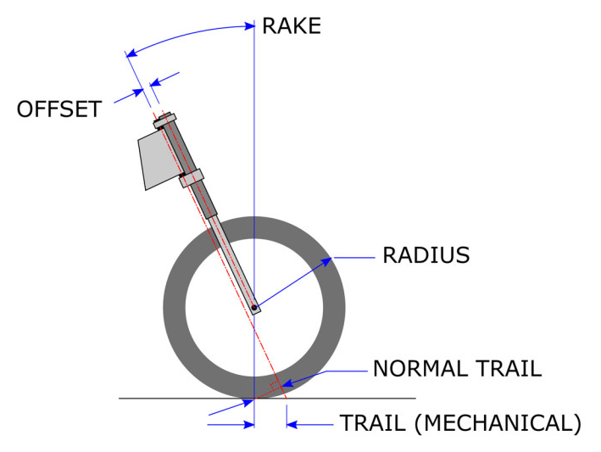
Figure 1 Diagram showing Rake, Trail, and Offset (Burns, 2017)

Rear geometry
From the rear there are a few different dynamic features that can alter how the motorcycle handles. These can also affect the front geometry, such as suspension sag and squat, in the rear depending on where in a ride cycle the bike is in can change how the bike will handle. It is important to have the correct level of sag in the rear suspension, this is due to the instantaneous force centre. If there is no sag when the rider gets on the motorcycle, then the instantaneous force centre will stay high on the bike near to what is known as the 1G line. The 1G line is normally drawn at 45 degrees from the rear contact patch forward.

The instantaneous force centre is constantly moving due to ‘squatting’ this is due to it being the joining point of two lines, one from the centre of the rear sprocket through the swing arm pivot and the other being the top of the chain. Squatting the motorcycle can help with staying away from the 1G line. Staying away from the 1G line with the CoG(Centre of Gravity) is important, as once the CoG is close to the 1G line it makes the bike very easy to wheelie, and lose forward power and a competitive edge when track racing.

Centre of Gravity
Alongside the changing values for the suspension, the centre of gravity is constantly changing along the motorcycle. The ride cycle of braking and accelerating will naturally alter where the centre of gravity is, alongside the constant alterations that the rider will make to assist with putting the centre of gravity at the right place at the right time. The generally desired distribution of weight on a motorcycle is 50/50 back and front. This split is a the most rounded split. More weight on the rear would be beneficial under heavy acceleration but would leave the front very ‘light’ and unresponsive when braking and cornering. And the same the other way around, a heavy front would make steering more responsive but would be lacking acceleration and give the rear less grip potentially making it want to spin and slip more.

Methodology
Two motorcycles, a Honda CBR1000RR and a Zero SR, were measured to find the appropriate geometry to then compare them both. The equipment used was, a tape measure, a plum bob, and a non-weight bearing stand to ensure the motorcycle was upright. There was also the use of digital scales and a metal stand to work out the centre of gravity of the motorcycles.

The method for the centre of gravity was as follows. Weigh the motorcycle on the flat, then again with the rear raised a set height. Then the procedure was repeated with a rider on the motorcycle. For the rest of the measurements, they were taken by hand with a tape measure and a plum bob. The plum bob was used to get more accurate measurements from the floor rather than ‘eyeing’ the points through.

The data was then put into a spreadsheet and the CoG for both motorcycles was worked out. After gathering the appropriate data from the manual, it was possible to work out the theoretical top speed of the gearbox inside the Honda CBR1000RR. the Zero has no gearbox due to the way that the electric motor has been developed, it is situated around the swing arm pivot point and as such only has a final drive modifier. Through further research it was found that the Zero SR uses RMP and BHP limiting from the ECU to control the motorcycles acceleration and top speed in various modes.

With the added help of a chassis dyno, it was possible to see the real output of the engine and motor, of both motorcycles.

Analysis
Tables 1 and 2 shows the raw data gathered from measuring the centre of gravity of the CBR1000RR and the Zero SR.
Table 1 Raw weight and dimension data from CBR1000RR
CBR 1000
 | Level | Level W/Rider | Lifted | Lifted W/Rider
Front Wheel | 104.4Kg | 134.Kg | 112.Kg | 147.2Kg
Rear Wheel | 94.65Kg | 137.2Kg | 109.2Kg | 146.Kg
 | 199.1 | 271.2 | 221.2 | 293.2
Wheelbase | 1.39m |  | Weight of Bike | 199.05Kg
Rav | .298m |  | Rider Weight | 72.15Kg
Stool Height | .35m |  | Total Weight | 271.2Kg
Lifted angle | 14.58˚
Stool Weight | 22.15Kg

Table 2 Raw weight and dimension data from Zero SR
Zero
 | Level | Level W/Rider | Lifted | Lifted W/Rider
Front Wheel | 117.7Kg | 145.3Kg | 124.7Kg | 159.2Kg
Rear Wheel | 106.55Kg | 152.6Kg | 122.8Kg | 161.1Kg
 | 224.3 | 297.9 | 247.5 | 320.3
Wheelbase | 1.45m |  | Weight of Bike | 224.25Kg
Rav | .305m |  | Rider Weight | 73.15Kg
Stool Height | .35m |  | Total Weight | 297.4Kg
Lifted angle | 13.97˚
Stool Weight | 22.15Kg

Tables 3 shows the weight split from front to rear and, the centre of gravity position for the height and the length using calculations.
$Xcog=\frac{Wr*L}{Wt}$ $Ycog=\frac{L*\left(Wr-Wrlifted\right)}{Wt*tanθ}+Rav$

Table 3 shows the weight split and the centre of gravity for the CBR1000 and Zero SR
CBR1000 | Bike Only | Bike + Rider |  | Zero SR | Bike Only | Bike + Rider
X CoG | .661m | .703m |  | X CoG | .689m | .744m
Y CoG | .501m | .56m |  | Y CoG | .458m | .573m
Weight Split f | 52.45% | 49.41% |  | Weight Split f | 52.49% | 48.69%
Weight Split r | 47.55% | 50.59% |  | Weight Split r | 47.51% | 51.31%

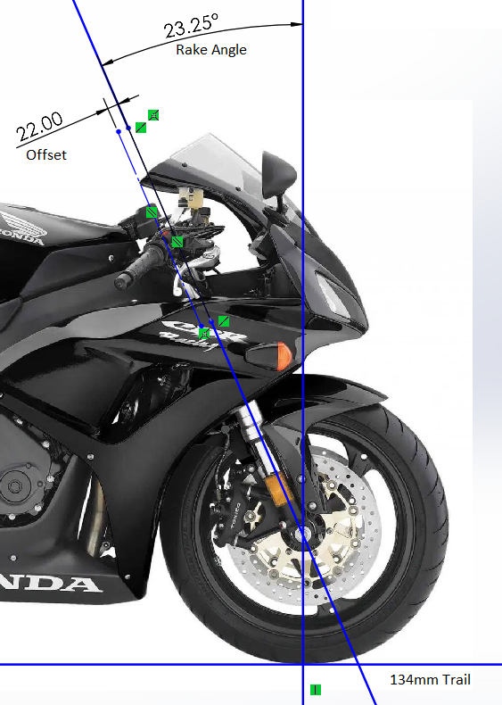
Figure 2 shows front geometry of CBR1000RR (Maintenance Schedules | Service Intervals , 2021)
The true trail length is the measured trail minus the offset from the steering stem to the forks, this makes the trail values of the motorcycle to be 102mm. this combined with the rake angle make for a more sports like handling.

Table 4 shows the data for working out the diameter of the wheels for the Zero and CBR using the equation $\frac{\left(\left(\left(\frac{Width}{25.4}\right)*\left(\frac{AspectRatio}{100}\right)+\left(\frac{Rim}{2}\right)\right)*2*π\right)*25.4}{π}/1000$
This data was then used in conjunction with the workshop manual to work out the top speed of the gear boxes
Table 4 data of the diameter of wheels for CBR and Zero (Honda, 2004) (Zero, 2021)
Wheel | CBR100RR
Width | Aspect ratio | rim size | Diameter
190 | 50 | 17 | 0.6218
wheel | Zero SR
width | aspect ratio | rim size | Diameter
180 | 55 | 17 | 0.6298

Table 5 Gear ratios and theoretical top speed in Kmph for CBR1000RR (Honda, 2004)
CBR
 | In | Out | speed | Diameter | 0.6218
Primary | 48 | 77 |  | RPM | 12000
1st | 13 | 33 | 134.787351
2nd | 17 | 33 | 176.260382
3rd | 19 | 30 | 216.696587
4th | 21 | 29 | 247.765608
5th | 20 | 25 | 273.722005
6th | 25 | 29 | 294.959057
Sprockets | 16 | 41

The data in table 5 was worked out with the equation.
$(\frac{RPM*60*\left(\frac{PrimaryIN}{PrimaryOUT}\right)*\left(\frac{GearIN}{GearOUT}\right)*Diameter*π}{1000}*(\frac{FrountSprocket}{RearSprocket})$
The same was worked for the Zero SR but with the variations in the drive mode selected.
Table 6 Top speeds of the Zero ZR in different modes Kmph (Zero, 2021)
zero
Primary | 20 | 90
mode | rpm | speed
normal | 7200 | 189.9432
rain | 6400 | 168.8384
race | 8500 | 224.2385
eco | 4700 | 123.9907
custom | 8000 | 211.048

Equation used was slightly different due to the lack of extra gear ratios present.
$$\left(\frac{\left(RPM*60*Diameter*π\right)}{1000}\right)*(\frac{FrontSprocket}{RearSprocket})$$

Figure 3 BHP and Toque on the CBR1000RR

Figure 4 BHP and Toque chart for Zero in street mode
Figures 4 to 7 show the difference that RPM and BHP limiting can make to an electric belt driven motorcycle. Compared to the workings of a mechanical gearbox in a traditional ICE powered motorcycle this method may be more efficient to overcoming the power needed to get to the desired top speed. This is due to the reduced power needed to overcome the moments of inertia that the motorcycle has, mainly by removing many of the components that increase the resistant force. The only barrier that would be met would be the increased weight with battery packs to power the motor. This in turn would affect the handling of the motorcycle, meaning that the development of electric motorcycle geometry will take a slightly different route to ICE geometry.

Figure 5 BHP and Toque chart for Zero in Eco mode

Figure 6 BHP and Toque chart for Zero in Rain mode

Figure 7 BHP and Toque chart for Zero in Race mode

Discussion
As can be seen from the data that has been gathered from the Honda CBR1000RR 2006 model, the Motorcycle has been designed to be a very sport like machine. With the development in engine efficiency the same set up has been able to produce more power. Going from the 2006 model that produces just short of 150BHP at the rear wheel to the 2022 model that is producing approximately 165BPH at the rear wheel, 214BHP (160KW) at the crankshaft (Honda, 2021).

The geometry has been altered to have a longer wheelbase to help with the increase in power. The most surprising thing though is the closeness in rake angle and trail length. This has meant that the motorcycle has been able to keep its sporty handling. The way that this has been achieved is by other developments in aerodynamics, being able to guide the airflow in a suitable way has helped keep the motorcycle stay stable at the new higher speeds neglecting the need to increases the rake angle and trail length. The new measurements are rake, 24.1 degrees and trail 101.4mm (Honda, 2021).

Conclusion
The affects that geometry have on a motorcycle are numerous. There is no correct way for the geometry to be set up but there are certain things that are understood should be set up in a certain way for a desired result. There is a give and take relationship with all geometry on a motorcycle, meaning that when one part is changed it then affects one or more other geometric measurements on the motorcycle. There are many developments in other areas beside geometry that can make a big impact on the overall geometry and characteristics of a motorcycle. Some of these developments may be dynamic and some static. This may end up with a platform that constantly alters the motorcycles geometry during the ride cycle, such as active aerodynamics assisting with straight line stability that then turns off during corning activities to make it possible to have a sharp rake angle to increase cornering ability.

References
Burns, J., 2017. What’s the Difference Between Rake and Trail?. [Online]
Available at: https://www.motorcycle.com/ask-mo-anything/whats-the-difference-between-rake-and-trail.html
[Accessed 02 12 2021].
Honda, 2004. Honda Service Manual CBR1000RR 2004. 1 ed. s.l.:Honda.
Honda, 2021. Specifications and Price. [Online]
Available at: https://www.honda.co.uk/motorcycles/range/super-sport/cbr1000rr-r-fireblade-sp/specifications-and-price.html
[Accessed 05 12 2021].
Maintenance Schedules | Service Intervals , 2021. Honda CBR1000RR (2006-2007) Fireblade Maintenance Schedule and Service Intervals. [Online]
Available at: https://maintenanceschedule.net/2006-honda-cbr1000rr-maintenance-schedule/
[Accessed 05 12 2021].
Zero, 2021. Zero SR/S. [Online]
Available at: https://www.zeromotorcycles.com/model/zero-srs
[Accessed 05 12 2021].

