Module EAEE404/C Portfolio
Lindsey Mullins Student No 1905851
Word count 3051

Section 1- Play

This section will discuss why play is important, what is the role of self- directed play.
Also, this section will discuss Play type and how the play type supports the children’s holistic development.
This section will discuss how the adult can support self-directed play.
There are many forms of play all of which are important to children’s growth and wellbeing. A good example is creative play, where children use their imagination and create new environments or use for the tools they use to play.
According to (Piaget 1981) there are four stages to this, one of them being the preoperational stage which occurs between the ages of 2-7 years Piaget indicates that during this play children are using imagination to create, for example a child could use a cardboard box as a boat and create an imaginary environment whilst immersed in play but when play has finished the child still knows this is just a box, so the child has dual processed this.
Creative skills play a part in the cognitive skills developing knowledge and intelligence that children acquire from birth through play.

Self-directed play is important to children and stems from early years as it essential for development and learning. (Hirsh-Pasek et al. 2009).
Play is important as it is stated it helps children to develop creativity which enables imagination, Play also helps with the development of children’s cognitive. Physical and emotional strength. According to Rogers and Sawyer (1988) cognitive skills function are best in children up till the age of nine. But Piaget (1962) defined play as an assimilation, where the child will match his/her own concepts to the environment. Piaget claims that play is just for pleasure and believed children only practiced things they had learned and not result in learning new things.
Fromberg and Gullo (1992), believe that through play children develop and enhance skills such as language, creativity, imagination and thinking skills. All of which enables future learning and skills to take into adulthood.
According to Garvey (1990) Play is most common when a child has knowledge of self. Play is most common using verbal and non-verbal communication also the understanding of the social and physical world.
Play is important to children as it has been shown that children use many skills in play. Children use fine and gross motor skills, reaction to each other socially. As stated above by many theorists and studies it clear play has a major effect on a child’s development. The integration of all different play types is key to cognitive development.
Self- directed play is play that occurs on a child’s own terms, led by their own motivation and interest.
The Montessori Theory is a method can be applied across all ages in self directed play. Below is an example of the Montessori Theory?

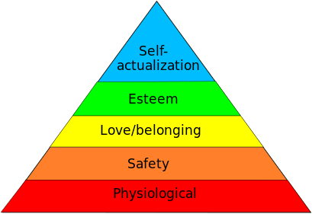
(Source Children’s House Montessori School)
If a child is using toys in a creative way without any adult interaction it is possible, they are using self-directed play already.
Self-directed play is best shown when a child for example finds an object such as a stick. The play scenarios can be endless the child can turn it into a wand, a sword, a cane the possibilities are endless. The materials children use for self-directed play can be as simple as a cardboard box to general toys.
Self-directed play helps children with confidence by exploring and doping things for themselves. It stimulates imagination, teaches problem solving and helps children learn at their own pace.
Self-directed play also supports the holistic development by using tools such a forest school setting. These settings help with intellectual, social, emotional and physical skills the schools use settings such as mini villages where they address a number of elements related to the holistic development in self-directed play. Children are left to play in the setting whilst adults observe from a distance.
Adults can help children with self-directed play by offering them the tools to do it such as the picture below.

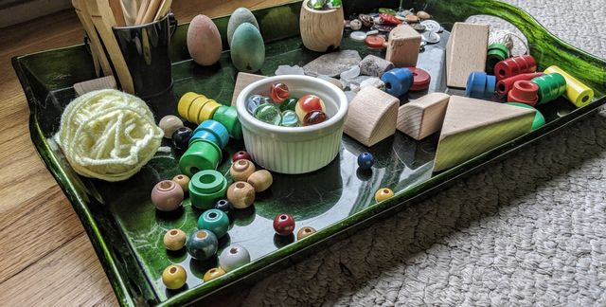
(Source Montessori School of The Berkshires)
According to Montessori “Play is the work of children”.
The adult can help assist children in self directed play by planning for play by providing the tools for play, an example is seen in the picture above.
Adults can also choose the environment such as indoor or outdoor play. The adult can also add to play by providing more tools as the play goes on. The adult can help by observing the child’s play by checking in and listening to the child. By observing the child’s play the adult can plan and build upon a child’s needs further enhancing the child’s play experience.
The way an adult engages verbally with the child also has an impact on self-directed play. Tizard and Hughes (1984) described that the verbal between school and home were different and were more opportunities in learning through language in the home. The ORACLE study (Galton et al. 1999) looked at the language used by teachers where they were seen to use closed questions when interacting with children. Using closed questions can stop play as the use of imagination and creativity has been halted, always try and use open ended questions as this will prolong the play and help with the skills needed for self-directed play. There have been many studies on the analysis of talk between child/adult interactions in class. and activity time where they focused on open and closed questions the findings can be found in a study where categories were chosen to which ones would co-construct activities clearer. (Howard and Mclinnes2010)

Section 2- Risk

This section will discus why is risk beneficial for children.
How do we balance exposing children to risk whilst keeping them safe from harm?
According to Brussoni putting boundaries into play only hinders development in children as they are naturally drawn to risk taking. Introducing risk to children’s play also prevent injury that could incur if they had not been put at risk as through play, they are learning how to test their physical limits, avoid and adjust to dangerous situations and environments all these skills are beneficial in a child’s growth.
Risk is beneficial for children to develop their self-confidence and resilience whilst also helping them gain risk management skills of their own.
Brussoni suggests that many parents let their own fears get in the way of children’s free play as they fear the risk of the child getting injured or even being kidnapped.
Parents/carers can use the online tool made by Brussoni called Outsideplay.ca this tool helps with making informed choices in regard to risky play.
When it comes to risk and children most adults/parents seem to think risk taking is far more acceptable for boys rather than girls according to (Morrongiello and Hogg, 2004). To define risk would simply be behaviour where the uncertainty of an outcome, and the probability of success and failure, according to (Little 2006)
Risk goes hand in hand with play adding to children’s wellbeing by helping children to develop in their resilience (Play Wales 2016).
First adults and practitioners should use a form of risk assessment when in a professional setting. The risk assessment should cover what activity is going to be undertaken, such as building a fortress, experimenting with water and so on.
The benefits of the activity and risk such as creativity, imagination. holistic benefits for the children.
Ensure the activity is enjoyable and safe for the children, give the tools for self for the activity directed play, let children explore by themselves, observe from a distance and check in the play.
The risk should enable children not disable. Provide adequate time, tools, staff members.
There are many examples of risk assessments that can be undertaken one such as the ABC model from play wales. This model looks at many situations risk and play go together to enable safe play for children where risk could occur. (ABC Model to dynamic risk management 2016)
According to Play Wales every child regardless of any culture, background, behaviour or impairment all need and want to take risks both emotional and physical.
Every child and every adult are all different and have different views on what risk is.
Some may see crossing the road as a major risk where some may see it as a low risk. When risk is involved it gives the child the chance to gain skills to take with them into adulthood such as giving the child the opportunity to see potential hazards and face the consequence of actions taken during play this helps with a child’s growth into adulthood.
Risk is a great holistic approach for children as not every child is the same, it enables boundaries to be pushed and helps with emotional and well-being of the child, by introducing risk to play it enables a safe environment rather than the child seeking risk elsewhere.
Adding risk to play helps children feel in control of their actions, helps them to push boundaries and capability whilst being in a safe and secure environment whilst being supported direct or indirect by a practitioner.
So, the benefit of risk for children through play helps them gain much needed life and emotional skills thy will take with them into adulthood.
Exposing risk to children through play needs to be safe so there must be measures put in place to keep them safe from harm such as a risk assessment. Below is an example of an outdoor risk assessment checklist that keeps both children and adults safe.

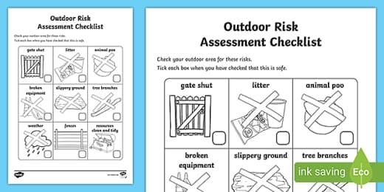
(Source Child- Friendly School Risk Assessment Templates | Classroom)

Section 3- Observation
This section will discuss observation benefits and limitations.
The strength’s and limitations of observation and to see if observation gives a holistic view of the child.
Observation is a key tool used to understand children and find out more about them. Early years observation is especially vital as every child is unique and have different abilities therefor observing what children choose to do and what resources they seem to enjoy whilst participating in play provides relevant information about them as individuals. Observation can also determine the needs of a child and also if children will need additional help. (Bandura0)
According to Albert Bandura people learn through observation, modelling and imitation, therefore observation benefits practitioners to further help children or catch any red flags in a child’s behaviour.
Observation is a beneficial tool to professionals working with children as they can gather useful and informal information about a child without direct contact or verbally.

Parents can also benefit from observing their child in order to relay information of any concerns or worries they may have. Practitioners and parents can learn from each other and further help children both in and out of a school setting.
There are limitations on observation, and it is benefits such as the child may feel uncomfortable in a situation and may not be willing to be observed. The introduction of an adult in play can stop the child’s play or the child could just simply not be willing to co-operate, as well as non-correspondence between parent and practitioner can have an impact on observation.
There are many tools used for observation in an early year setting that focus on children. One being Anecdotal records this is a useful tool as it involves factual information about events and document what a child has said or done whilst being observed. The observation can relay what reactions and behaviour the child has given to certain events it also documents cues such as expressions and body language. (According to Child Observation Safety-Culture)
Below is an example of an Anecdotal observation record:

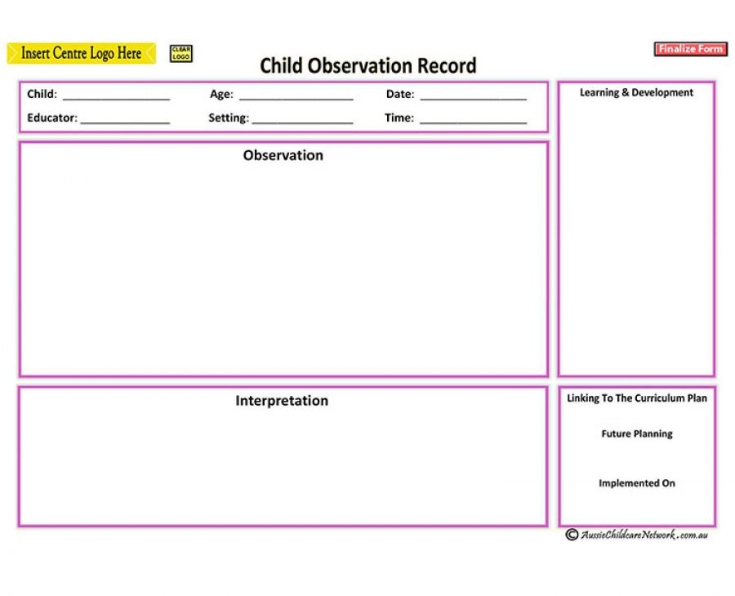
(source Aussie Childcare Network)

The Anecdotal record offers a holistic view of the child as it covers many forms of a child’s behaviour and needs giving a varied amount of relevant information of events that occurred during the observation. From this practitioner can make tailored learning programmes and activities to best suit the child’s needs further enabling them to progress.
Although there are some limitations on this such as the person conducting the observation may miss out recording certain types of behaviour displayed.
Incidents can often be taken out of context; the observation also relies on the memory of the person documenting the observation.
Therefor it is best to use different observation tools to get helpful and informative information to help children progress both mentally and physically throughout early years into adulthood.

Section 4- How does observation help

This section will discuss why play is important to observation, how observing children through play gives a more accurate reflection of where the child is in their development and how we know this. Also, how can adults aid in the support of this.
Play leads a crucial part in observation as children learn through play and practitioners teach through play, whilst preforming a task a child considers to be play. There is some evidence regarding adult presence having a negative effect on play therefore inhibiting learning through play (McInnes et al. 2010; Whitebread et al. 2007).
Play is important to observation as using this tool professionals can gather important and relevant information for instance through play observation can evaluate the child/children by the way they play with others or behaviour patterns displayed.
Observation can assess development through play such as language and cognitive skills. (Earlyyearscareers.com)
Play has a holistic approach to observation as it helps better understand the individual needs and strengths of each child therefor helping to create a personalised learning structure for the child. The holistic approach can record the child’s expressions through body language facial expressions and verbal expression, also physical actions, gestures, behaviours and listening and talking to the child shows how the child is developing.
Observing children through play should be accurate and factual documenting as much detail as possible of the play seen and heard. The observations held will be reviewed and analysed over time so practitioners holding future observations can reflect on past observation to aid the child’s development. (Azilo Training)
Through Play children are using many skills such as fine motor skills, cognitive skills, creative skills, language, motor memory and many more which have all at one point been observed by professionals, practitioners and parents. Observing children through play helps reflect on the child’s development as past observations would have documented in detail about the child helping to see if the child has progressed or if the child needs additional help.
(Vygotsky Socialcultural Theory) suggests that all children learn from a hands-on approach and that learning is a social process where parents, peers and practitioners all play a part. Children behave different towards others such as the child may be dependant on the parent at home but in a school environment the child is more independent so by observation by both parties the information gathered can help in the reflection of the child’s behaviour. This observation can inform the child’s proximal development, what the child can do with help and what the child can do without help. The observation can determine where the child is in their development through the details documented.
Adults can support observation through play using many approaches such as directing an activity for the child or a child lead activity. Findings from the
(REPEY) project (Siraj-Blatchford et al. 2002) states the effect use of these settings but also brings to light the problems this may have as adult’s perception of play may differ from the children. Studies have come to show that some practitioners are uncomfortable with play and see it as a hindrance as to activities that are seen as work.
Mclnnes et al. (2011) analysed adult child interaction where a study was undertaken to see how open and closed questions had an impact on children’s play.
Open ended questions can be used to start a conversation with a child such as “what are you going to play” this gives the child an opportunity to decide whether they want to invite the adult to play or end the play. Whereas if the adult used a closed question such as “I’m going to play with you in the sand” the child may feel uncomfortable and stop play.
Using open questions indicates choice and control for the child so the child remains in control of play where closed questions put the adult in control of play. When engaging with children through play the adult should focus on the process rather than the end goal as during play there is no end goal in sight. Adults can provide varied materials and tools to encourage exploration and play. Adults can build the child’s play using open questions.
It is important for adults to support children through paly as by doing this it helps to encourage children’s motivation and enthusiasm for learning. The adult can help build the child’s confidence by praise during play aiding in the child’s self esteem which helps to develop the child’s wellbeing.
The adult can support observation through play by simply letting the child lead and observe in case of danger only engage if the child is willing as play is self-chosen and self-directed. The adult can provide open ended objects for the continuity pf play as play as it is an activity in which means are more valued than ends.

References
Garvey, C. Play. Cambridge, Mass.: Harvard University Press, 1977.
17/01/21)
Fromberg, D.P. & Gullo, D.F. (1992). Perspectives on children. In L.R. Williams & D.P. Fromberg (Eds.), Encyclopedia of early childhood education, (pp. 191-194). New York: Garland Publishing, Inc
Galton, M, L, Hargreaves, C, Comber, D, Wall, and A. Pell. 1999, inside the primary classroom 20 years on.
Howard, J., & McInnes, K. (2010). Thinking through the challenge of a play-based curriculum: increasing playfulness via co-construction. In J. Moyles (Ed.), Thinking about Play – Developing a Reflective Approach. Maidenhead: Open
https://azilotraining.com/2019/08/16/the-importance-of-observation-in-childcare-settings.html (Accessed on 18/01/21)
https://www.earlyyearscareers.com/eyc/ (Accessed on 17/01/21)
https://www.fundacionmontessori.org/the-montessori-method.htm (Accessed on
https://www.playwales.org.uk/eng/news/644-the-abc- (Accessed on 14/01/21)
https://www.playwales.org.uk/eng/walesplaypolicy (Accesed on 14/01/21)
https://www.youtube.com/watch?v=Z0CQxL38RE4 (Accessed on 16/01/21)
LRogers, C. & Sawyers, J. (1988). Play in the lives of children. Washington, DC: NAEYC.ondon, Routledge.
McLeod, S. A. (2018, August 05). Lev Vygotsky. Simply Psychology. https://www.simplypsychology.org/vygotsky.htmlPiaget, J. (1981). Intelligence and affectivity: Their relationship during child development
Piaget, J. (1962). Play, dreams, and imitation in childhood. New York: W.W. Norton & Co

